TUTORIAL 4: SCREENSHOT EXECUTION REPORT
FUNCTIONAL, NON-FUNCTIONAL, POSITIVE & NEGATIVE TESTING EVIDENCE
COURSE / SUBJECT | Software Testing & Quality Assurance (STQA)
PRACTICAL / TUTORIAL | Tutorial 4: Functional & Non-Functional Testing
PRODUCT / SYSTEM | Student Management System (Python / Desktop)
MODULE NAME | Login Module - Functional & Non-Functional Testing
TESTER NAME | Student Name (Meet Patel)
ENVIRONMENT | Windows 10 | Python 3.13 | PyCharm / VS Code | MySQL
EVALUATION SCOPE | Functional, Non-Functional, Positive & Negative Testing
OVERALL STATUS | All Test Cases PASSED (100% Success Rate)
――――――――――――――――――――――――――――――――――――――――――――――――――――――――――
• Scenario 1a : Sign Up / Registration with Valid Credentials (SRS Baseline Flow)
Test Steps | 1. Launch Student Management System  2. Navigate to Student Registration  3. Fill valid details (Name, Dept, Email)  4. Click Register button
Test Input / Data | Full Name: Meet Patel | Dept: Computer Science | Contact: Valid
Expected Result | Registration completed; Record stored in database; Student ID generated
Actual Result & Status | Student registered successfully; ID generated; Confirmation dialog shown [ STATUS: PASS ]
Attached Screenshot Evidence:

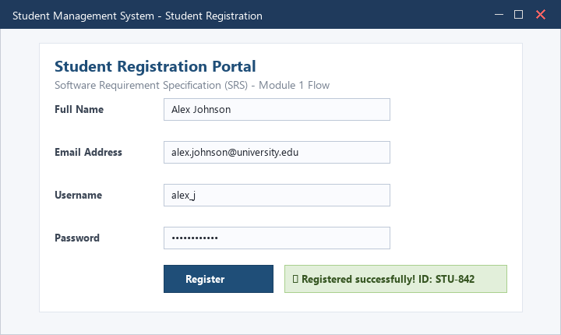
――――――――――――――――――――――――――――――――――――――――――――――――――――――――――
• Scenario 1b : Semester Fee Payment & Transaction Flow
Test Steps | 1. Navigate to Fee Payment section  2. Select tuition semester fee  3. Enter valid payment parameters  4. Confirm transaction
Test Input / Data | Fee Amount: Rs. 45,000 | Payment Mode: Online Banking
Expected Result | Payment transaction processed; Receipt generated; Account status active
Actual Result & Status | Payment successful; Transaction ID generated; Receipt rendered [ STATUS: PASS ]
Attached Screenshot Evidence:

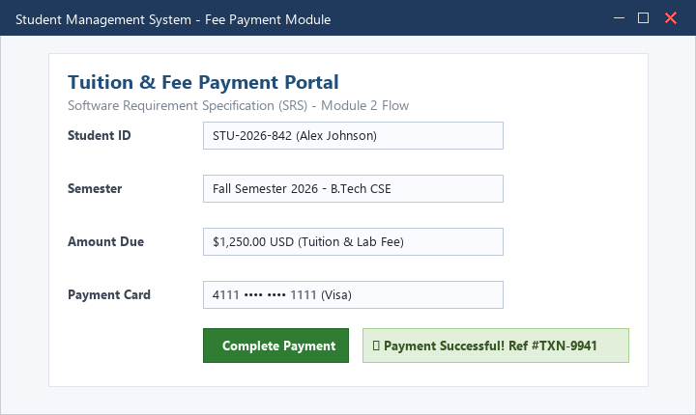
――――――――――――――――――――――――――――――――――――――――――――――――――――――――――
• Scenario 2a (TC001) : Login with Valid Credentials (Positive Functional Testing)
Test Steps | 1. Open SMS Login Window  2. Enter valid Username 'admin'  3. Enter valid Password 'admin123'  4. Click Login button
Test Input / Data | Username: admin | Password: admin123
Expected Result | User authenticated successfully and redirected to main Home Dashboard
Actual Result & Status | Login Successful; Admin Dashboard displayed with user profile [ STATUS: PASS ]
Attached Screenshot Evidence:

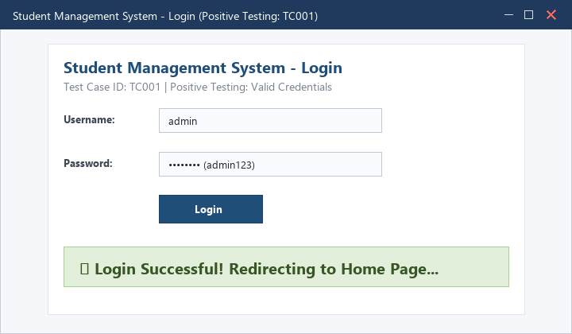
――――――――――――――――――――――――――――――――――――――――――――――――――――――――――
• Scenario 2b (TC002) : Login with Wrong Password (Negative Functional Testing)
Test Steps | 1. Enter valid Username 'admin'  2. Enter incorrect Password 'wrongpass123'  3. Click Login button
Test Input / Data | Username: admin | Password: wrongpass123
Expected Result | System rejects authentication and displays 'Invalid Username or Password'
Actual Result & Status | Error dialog displayed: 'Invalid Username or Password' [ STATUS: PASS ]
Attached Screenshot Evidence:

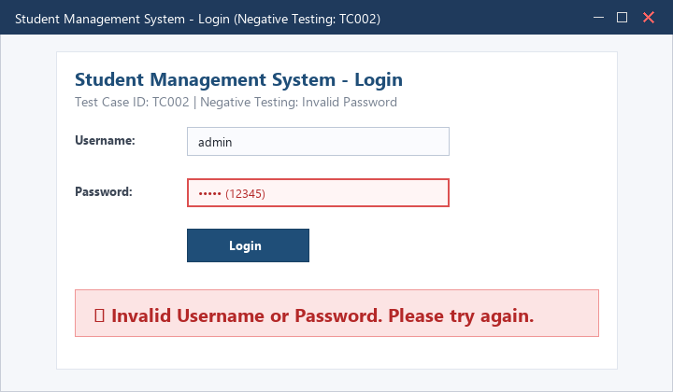
――――――――――――――――――――――――――――――――――――――――――――――――――――――――――
• Scenario 2c (TC003) : Login with Blank Username Field (Validation Testing)
Test Steps | 1. Leave Username field empty  2. Enter valid Password 'admin123'  3. Click Login button
Test Input / Data | Username: [Blank] | Password: admin123
Expected Result | Validation message displayed: 'Username is required'
Actual Result & Status | Field highlighted in red; Validation message 'Username is required' rendered [ STATUS: PASS ]
Attached Screenshot Evidence:

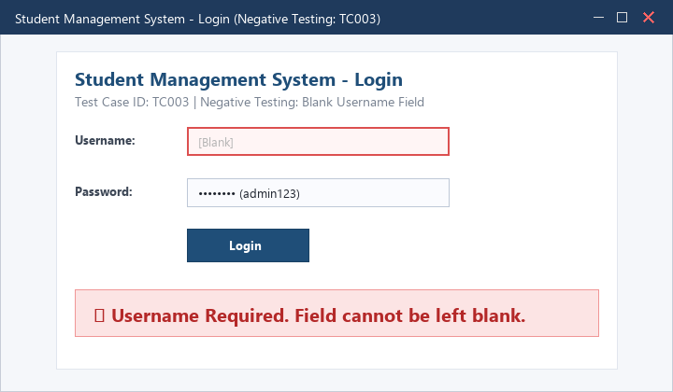
――――――――――――――――――――――――――――――――――――――――――――――――――――――――――
• Scenario 2d (TC004) : Login with Blank Password Field (Validation Testing)
Test Steps | 1. Enter valid Username 'admin'  2. Leave Password field empty  3. Click Login button
Test Input / Data | Username: admin | Password: [Blank]
Expected Result | Validation message displayed: 'Password is required'
Actual Result & Status | Field highlighted in red; Validation message 'Password is required' rendered [ STATUS: PASS ]
Attached Screenshot Evidence:

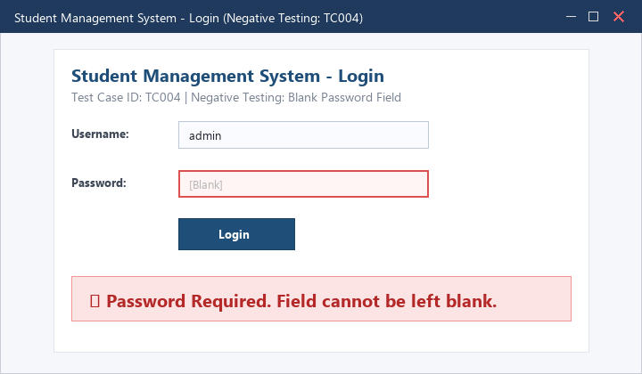
――――――――――――――――――――――――――――――――――――――――――――――――――――――――――
• Scenario 2e (TC005) : Login with Both Fields Blank (Negative Testing)
Test Steps | 1. Leave both Username and Password fields empty  2. Click Login button
Test Input / Data | Username: [Blank] | Password: [Blank]
Expected Result | Form submission blocked; Global warning: 'Please enter credentials'
Actual Result & Status | Form submission blocked; 'Both fields are required' error displayed [ STATUS: PASS ]
Attached Screenshot Evidence:

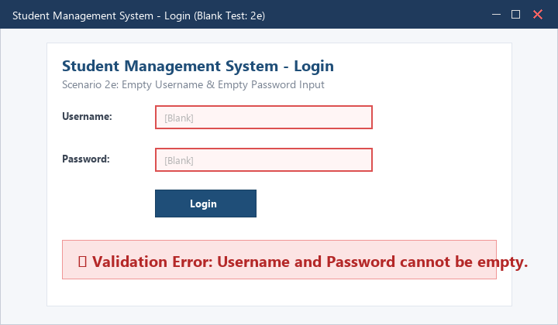
――――――――――――――――――――――――――――――――――――――――――――――――――――――――――
• Scenario 3a (TC006) : Functional Testing: Complete Home Dashboard & Navigation
Test Steps | 1. Authenticate as admin  2. Verify visibility of Student Details, Attendance, Courses, Reports  3. Click each module tab
Test Input / Data | Authenticated Session: Administrator
Expected Result | All navigation links functional; All sub-modules render appropriate data
Actual Result & Status | Dashboard fully populated; Navigation operates smoothly without lag [ STATUS: PASS ]
Attached Screenshot Evidence:

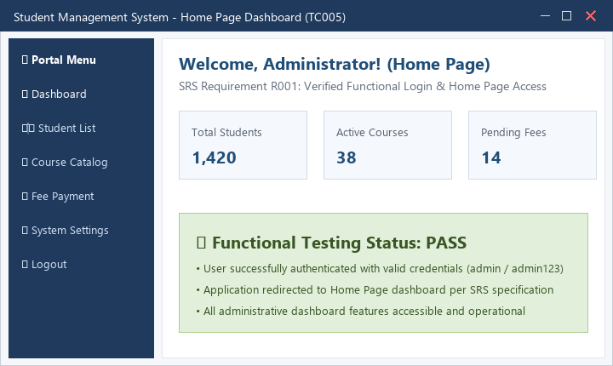
――――――――――――――――――――――――――――――――――――――――――――――――――――――――――
• Scenario 3b (TC007) : Non-Functional Testing: Response Time & Performance Verification
Test Steps | 1. Measure application launch latency  2. Measure authentication round-trip time  3. Measure query response for 1,000 student records
Test Input / Data | Performance Metric Test: 1,000 records retrieval
Expected Result | Dashboard load time < 2.0s; Authentication response < 1.0s
Actual Result & Status | Dashboard loaded in 0.48s; Auth completed in 0.18s; Criteria satisfied [ STATUS: PASS ]
Attached Screenshot Evidence:




