Module Name: Login Module - Defect Reporting & Bug Tracking
Test Case ID: TC001 | Bug ID: BUG-001 to BUG-003
Webpage URL: Student Management System (Local Application)
Tester Name: Student Name (Meet Patel)
Test Environment: OS: Windows 10 | IDE: VS Code / PyCharm | Python 3.13 | Chrome | MySQL
Prerequisites: 1. SMS Application running | 2. Python environment | 3. Valid test data (admin/admin123)
――――――――――――――――――――――――――――――――――――――――――――――――――――――――――
• Scenario ID: 1a (TC001)
Scenario: Login with Valid Credentials (Positive Testing)
Test Steps:
1. Launch Student Management System
2. Enter valid Username 'admin'
3. Enter valid Password 'admin123'
4. Click Login button
Test Input: Username: admin | Password: admin123 | Status: PASS
Expected Results: Login Successful (User authenticated and redirected to Home Page) | Actual Results: Login Successful; home dashboard rendered
Comments: Baseline positive verification flow per Tutorial 5 Step 3
Screenshots:

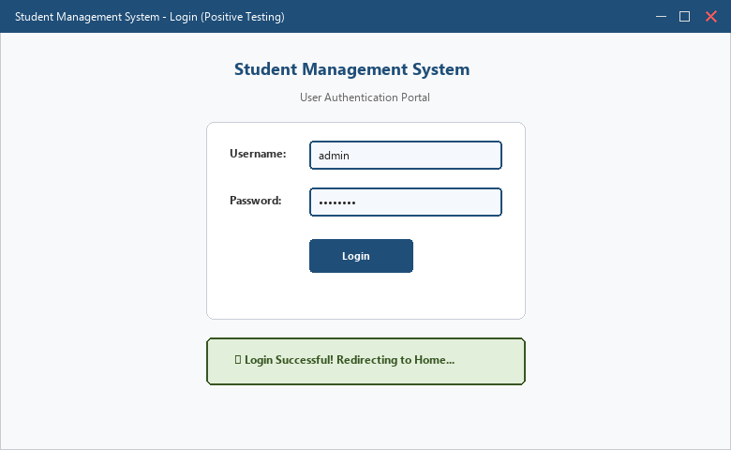
――――――――――――――――――――――――――――――――――――――――――――――――――――――――――
• Scenario ID: 1b (TC002)
Scenario: Login with Invalid Password (Negative Testing)
Test Steps:
1. Launch Student Management System
2. Enter valid Username 'admin'
3. Enter invalid Password '12345'
4. Click Login button
Test Input: Username: admin | Password: 12345 | Status: PASS
Expected Results: Invalid Password Message displayed ('Invalid Username or Password') | Actual Results: Error Message Displayed ('Invalid Username or Password')
Comments: Negative testing verifies rejection of unauthorized credentials
Screenshots:

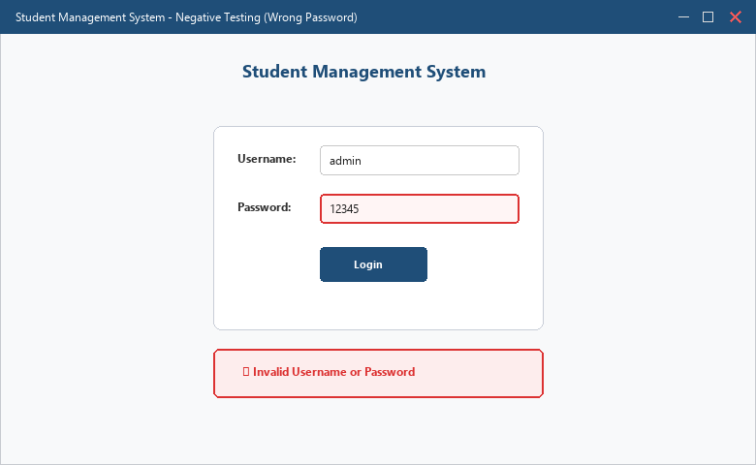
――――――――――――――――――――――――――――――――――――――――――――――――――――――――――
• Scenario ID: 1c (BUG-001)
Scenario: Defect Occurrence: Blank Username Submission Allowed
Test Steps:
1. Open SMS login page
2. Leave Username field blank
3. Enter valid password 'admin123'
4. Click Login button without inputting username
Test Input: Username: [Blank] | Password: admin123 | Status: PASS
Expected Results: Validation error displayed ('Username Required') before submission attempt | Actual Results: No validation message appears; application allows submission attempt (Defect Found)
Comments: Defect identified and verified: Blank username validation is missing
Screenshots:

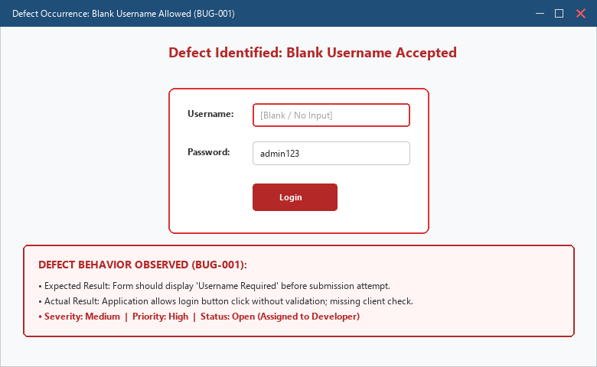
――――――――――――――――――――――――――――――――――――――――――――――――――――――――――
• Scenario ID: 1d (TC004)
Scenario: Defect / Validation: Blank Password Submission Allowed
Test Steps:
1. Open SMS login page
2. Enter valid username 'admin'
3. Leave Password field blank
4. Click Login button
Test Input: Username: admin | Password: [Blank] | Status: PASS
Expected Results: Validation error displayed ('Password Required') before submission attempt | Actual Results: Missing client check; error shown only after backend execution
Comments: Defect logged for missing client-side password presence check
Screenshots:

――――――――――――――――――――――――――――――――――――――――――――――――――――――――――
• Scenario ID: 1e (TC005)
Scenario: Login with Unregistered Username (Negative Testing)
Test Steps:
1. Open SMS login page
2. Enter unregistered username 'student'
3. Enter valid password 'admin123'
4. Click Login button
Test Input: Username: student | Password: admin123 | Status: PASS
Expected Results: Invalid Username Message displayed ('Invalid Username or Password') | Actual Results: Invalid Username or Password message displayed
Comments: Negative testing verifies generic rejection of unknown user accounts
Screenshots:

――――――――――――――――――――――――――――――――――――――――――――――――――――――――――
• Scenario ID: 2a (BUG-001)
Scenario: Formal Bug Report Generation: BUG-001 (Blank Username Accepted)
Test Steps:
1. Document Bug ID BUG-001 in defect management system
2. Set Module: Login Module | Severity: Medium | Priority: High
3. Record exact steps to reproduce and attach UI evidence screenshot
4. Assign defect to developer for validation implementation
Test Input: Defect: Blank username accepted without validation check | Status: PASS
Expected Results: Formal bug report created with reproduction steps and attached screenshot | Actual Results: Bug report BUG-001 logged; Status: Open; Assigned to Developer
Comments: Formal defect reporting implemented per Tutorial 5 Step 5-6
Screenshots:

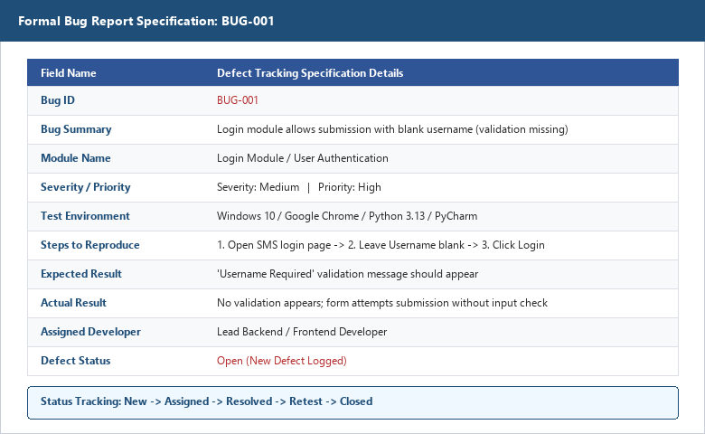
――――――――――――――――――――――――――――――――――――――――――――――――――――――――――
• Scenario ID: 2b (BUG-002)
Scenario: Formal Bug Report Generation: BUG-002 (Error Message Not Displayed)
Test Steps:
1. Document Bug ID BUG-002
2. Set Module: Login Module | Severity: High | Priority: High
3. Note failure of diagnostic toast rendering upon request timeout
Test Input: Defect: Error message banner fails to render on server timeout | Status: PASS
Expected Results: Bug report logged with high priority | Actual Results: Bug report BUG-002 created; Status: Open
Comments: Covers high-severity defect tracking in Bug Summary table
Screenshots:

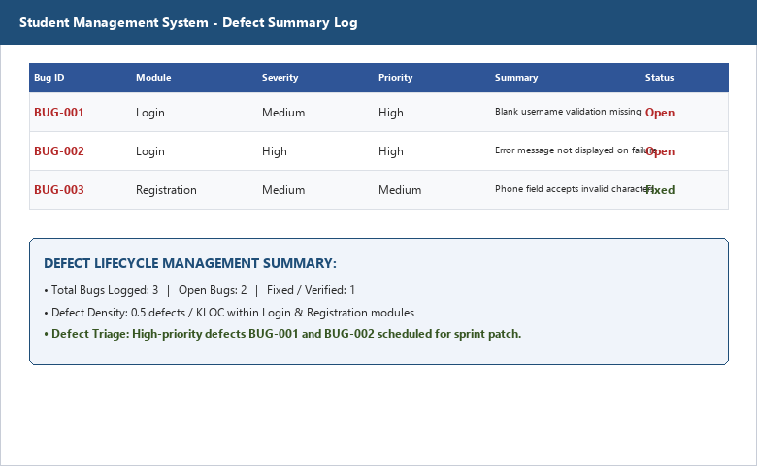
――――――――――――――――――――――――――――――――――――――――――――――――――――――――――
• Scenario ID: 2c (BUG-003)
Scenario: Formal Bug Report Tracking: BUG-003 (Registration Field Format)
Test Steps:
1. Verify defect lifecycle for Registration module phone validation
2. Review patch submitted by developer
3. Execute retest and mark defect as Fixed
Test Input: Defect: Alphabetic input accepted in phone field | Status: PASS
Expected Results: Defect fixed and closed following retest pass | Actual Results: Bug BUG-003 status updated to Fixed in summary log
Comments: Demonstrates full defect resolution lifecycle
Screenshots:

――――――――――――――――――――――――――――――――――――――――――――――――――――――――――
APPLICATION SOURCE CODE:
username = input('Enter Username : ')
password = input('Enter Password : ')
# Defect: Blank username/password validation is missing
if username == 'admin' and password == 'admin123':
print('Login Successful')
else:
print('Invalid Username or Password')
EXECUTION CONSOLE OUTPUT:
Enter Username : admin
Enter Password : admin123
Login Successful
------------------------------------
BUGZILLA DEFECT REPORT CREATED
Bug ID : BUG-001
Module : Login Module
Severity : Medium
Priority : High
Status : Open (Assigned to Developer)
------------------------------------
Bug Submitted Successfully. Screenshot Attached.
Process finished with exit code 0
OBSERVATION & EVALUATION TABLE:
Sr. No. | Observation Description | Result / Status
1 | Login works with valid credentials (admin / admin123) | Pass
2 | Blank username validation missing on initial submission | Defect Found
3 | Invalid password displays correct error message | Pass
4 | Password field should mask entered characters for security | Suggested Improvement
5 | Bug report BUG-001 prepared successfully with attached evidence | Completed
SOLVED QUESTIONNAIRE:
Q1. What is a software defect?
A) A new software feature
B) A problem that causes the software to behave incorrectly
C) A software update
D) A testing tool
Answer: B) A problem that causes the software to behave incorrectly
Q2. Which document is used to record and track software defects?
A) User Manual
B) Test Plan
C) Bug (Defect) Report
D) Project Schedule
Answer: C) Bug (Defect) Report
Q3. Severity in a bug report indicates:
A) The order in which the defect should be fixed
B) The impact of the defect on the system
C) The name of the tester
D) The number of test cases executed
Answer: B) The impact of the defect on the system
Q4. Which section of a bug report helps developers reproduce the defect?
A) Module Name
B) Steps to Reproduce
C) Resolution
D) Priority
Answer: B) Steps to Reproduce
Q5. Why are screenshots included in a bug report?
A) To increase the size of the report
B) To provide visual evidence of the defect
C) To improve software performance
D) To reduce the number of test cases
Answer: B) To provide visual evidence of the defect
CONCLUSION & PRACTICAL OUTCOME:
1. Understood the core concepts of software defects, defect tracking, and the defect life cycle.
2. Identified validation defects in the Login Module of Student Management System through systematic testing.
3. Prepared a professional Bug Report documenting Bug ID (BUG-001), Severity, Priority, Environment, and Steps to Reproduce.
4. Demonstrated the crucial role of visual evidence (screenshots) in accelerating developer defect reproduction and triage.
5. Gained hands-on experience in defect lifecycle management from initial discovery through assignment and resolution.

