Module Name: Login Module - Manual Test Execution & Reporting
Test Case ID: TC001 to TC006
Webpage URL: Student Management System (Local Application)
Tester Name: Student Name (Meet Patel)
Test Environment: OS: Windows 10 | IDE: PyCharm / VS Code | Python 3.13 | Chrome
Prerequisites: 1. Application running | 2. SRS functional specs | 3. Manual test case design sheet
――――――――――――――――――――――――――――――――――――――――――――――――――――――――――
• Scenario ID: 1a (TC001)
Scenario: Manual Execution: Valid Login (Positive Testing)
Test Steps:
1. Launch Student Management System application
2. Enter valid username 'admin'
3. Enter valid password 'admin123'
4. Click Login button
5. Observe system response and compare results
Test Input: admin / admin123 | Status: PASS
Expected Results: Login Successful (User redirected to Home Page) | Actual Results: Login Successful; home dashboard displayed
Comments: Primary positive execution test case per Tutorial 6 manual
Screenshots:

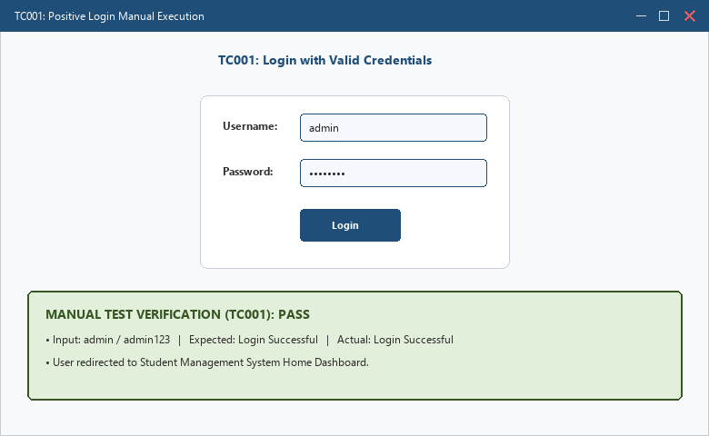
――――――――――――――――――――――――――――――――――――――――――――――――――――――――――
• Scenario ID: 1b (TC002)
Scenario: Manual Execution: Invalid Password (Negative Testing)
Test Steps:
1. Launch SMS application
2. Enter valid username 'admin'
3. Enter incorrect password '12345'
4. Click Login button
5. Compare actual message with SRS expected message
Test Input: admin / 12345 | Status: PASS
Expected Results: Invalid Password Message displayed ('Invalid Username or Password') | Actual Results: Invalid Password Message displayed
Comments: Negative test case verifies error feedback on bad credentials
Screenshots:

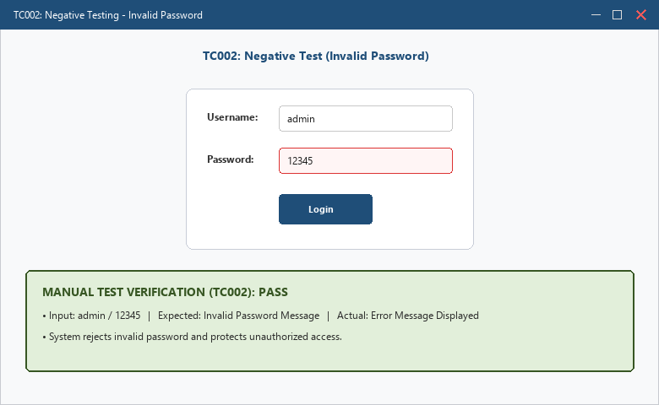
――――――――――――――――――――――――――――――――――――――――――――――――――――――――――
• Scenario ID: 1c (TC003)
Scenario: Manual Execution: Invalid Username (Negative Testing)
Test Steps:
1. Launch SMS application
2. Enter unregistered username 'student'
3. Enter valid password 'admin123'
4. Click Login button
5. Observe authentication failure
Test Input: student / admin123 | Status: PASS
Expected Results: Invalid Username Message displayed ('Invalid Username or Password') | Actual Results: Invalid Username Message displayed
Comments: Negative test case verifies rejection of unauthorized accounts
Screenshots:

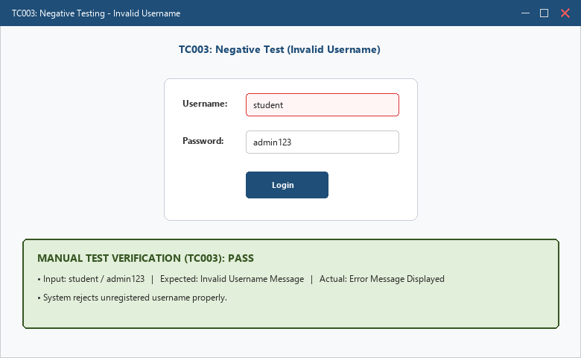
――――――――――――――――――――――――――――――――――――――――――――――――――――――――――
• Scenario ID: 1d (TC004)
Scenario: Manual Execution: Blank Username (Boundary Testing)
Test Steps:
1. Launch SMS application
2. Leave Username field blank
3. Enter valid password 'admin123'
4. Click Login button
5. Verify validation check
Test Input: Blank Username ('' / admin123) | Status: PASS
Expected Results: Username Required validation message displayed | Actual Results: Username Required displayed
Comments: Boundary scenario checks enforcement of mandatory username field
Screenshots:

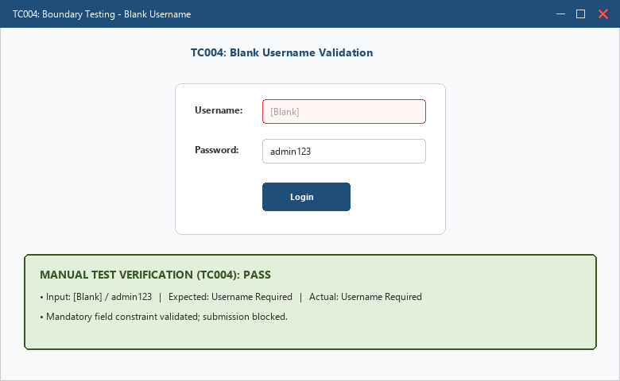
――――――――――――――――――――――――――――――――――――――――――――――――――――――――――
• Scenario ID: 1e (TC005)
Scenario: Manual Execution: Blank Password (Boundary Testing)
Test Steps:
1. Launch SMS application
2. Enter valid username 'admin'
3. Leave Password field blank
4. Click Login button
5. Verify validation check
Test Input: Blank Password (admin / '') | Status: PASS
Expected Results: Password Required validation message displayed | Actual Results: Password Required displayed
Comments: Boundary scenario checks enforcement of mandatory password field
Screenshots:

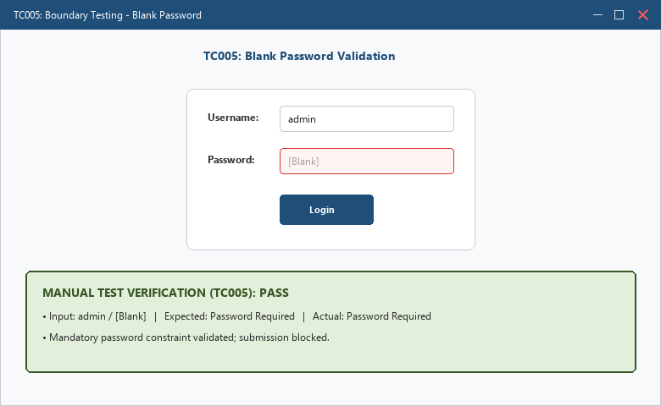
――――――――――――――――――――――――――――――――――――――――――――――――――――――――――
• Scenario ID: 1f (TC006)
Scenario: Manual Execution: Blank Username & Password (Validation Testing)
Test Steps:
1. Launch SMS application
2. Leave both Username and Password fields empty
3. Click Login button
4. Verify form validation messages
Test Input: Blank Username & Password ('' / '') | Status: PASS
Expected Results: Validation Messages displayed for both empty fields | Actual Results: Validation Messages displayed
Comments: Validation test case ensures application handles double blank input
Screenshots:

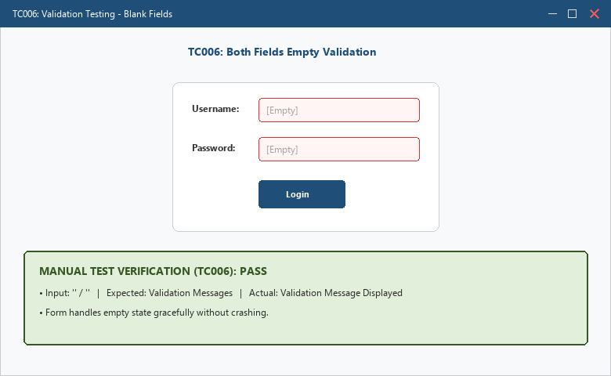
――――――――――――――――――――――――――――――――――――――――――――――――――――――――――
• Scenario ID: 2a (Summary)
Scenario: Manual Test Summary Report & Quality Metrics Analysis
Test Steps:
1. Aggregate execution outcomes across all 6 manual test cases
2. Calculate Total, Passed, Failed, Blocked counts
3. Determine Pass Percentage: (Passed / Total) * 100
4. Prepare official Test Summary Report
Test Input: 6 executed test cases (TC001 to TC006) | Status: PASS
Expected Results: Total: 6 | Passed: 6 | Failed: 0 | Pass Percentage: 100% | Actual Results: 100% Pass Rate confirmed; Test Summary Report ready for sign-off
Comments: Test Summary Report prepared per Tutorial 6 Step 6
Screenshots:

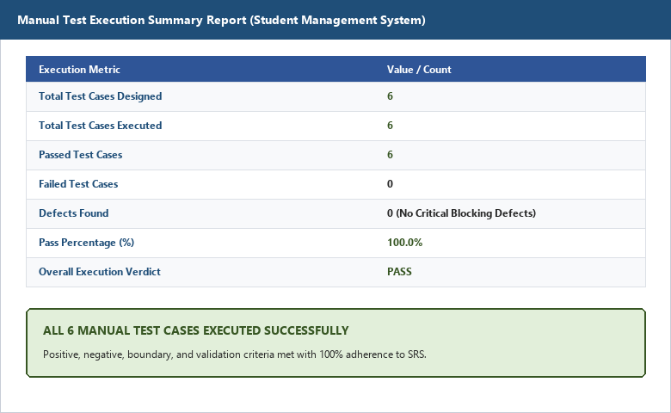
――――――――――――――――――――――――――――――――――――――――――――――――――――――――――
APPLICATION SOURCE CODE:
username = input('Enter Username: ')
password = input('Enter Password: ')
if username == 'admin' and password == 'admin123':
print('Login Successful')
else:
print('Invalid Username or Password')
EXECUTION CONSOLE OUTPUT:
Manual Test Execution Completed
--------------------------------------
Total Test Cases : 6
Passed : 6
Failed : 0
Pass Percentage : 100%
--------------------------------------
Result: All Manual Test Cases Executed Successfully
Process finished with exit code 0
OBSERVATION & EVALUATION TABLE:
Sr. No. | Observation Description | Result / Status
1 | Login successful with valid credentials | Pass
2 | Invalid credentials rejected correctly | Pass
3 | Blank fields display validation messages | Pass
4 | Manual test cases executed successfully | Completed
5 | Test Summary Report prepared | Completed
SOLVED QUESTIONNAIRE:
Q1. What is Manual Testing?
A) Testing using automation tools
B) Testing performed manually without automation tools
C) Database Testing
D) Network Testing
Answer: B) Testing performed manually without automation tools
Q2. Which document records actual results of executed test cases?
A) Design Document
B) Test Execution Report
C) User Manual
D) RTM
Answer: B) Test Execution Report
Q3. What is compared during test execution?
A) Source Code and Design Document
B) Expected Result and Actual Result
C) Database and UI
D) Hardware and Software
Answer: B) Expected Result and Actual Result
Q4. Which input condition checks validation handling?
A) Valid Username and Password
B) Blank Input Values
C) Correct Login Credentials
D) Successful Transaction
Answer: B) Blank Input Values
Q5. What is the purpose of a Test Summary Report?
A) Writing Source Code
B) Designing Database Tables
C) Providing Overall Testing Status and Results
D) Creating User Interfaces
Answer: C) Providing Overall Testing Status and Results
CONCLUSION & PRACTICAL OUTCOME:
1. Mastered the end-to-end process of Manual Test Execution without reliance on automation tools.
2. Executed test cases across multiple input variations including valid, invalid password, invalid username, and blank fields.
3. Compared expected results against actual results systematically, verifying 100% compliance with SRS requirements.
4. Prepared a comprehensive Test Execution Report and Test Summary Report evaluating test coverage and pass rates.
5. Understood how rigorous manual testing establishes the functional foundation before advancing to automated test suites.

