Module Name: Login Module - Boundary Value Analysis & Equivalence Partitioning
Test Case ID: EP-01 to EP-03 | BVA-01 to BVA-06 | BUG-007
Webpage URL: Student Management System (Username Validation Module)
Tester Name: Student Name (Meet Patel)
Test Environment: OS: Windows 10 | IDE: VS Code / PyCharm | Python 3.13 | Chrome | MySQL
Prerequisites: 1. SMS Application running | 2. Username Length Specification: 5 to 15 characters
――――――――――――――――――――――――――――――――――――――――――――――――――――――――――
• Scenario ID: 1a (EP-01)
Scenario: Equivalence Partitioning: Valid Class (5 to 15 Characters)
Test Steps:
1. Identify Valid Partition: Username length between 5 and 15 characters
2. Select representative value: 'student1' (Length = 8)
3. Enter input into Student Management System
4. Click Login and verify acceptance
Test Input: student1 (8 characters) | Status: PASS
Expected Results: Valid Username accepted; authentication continues | Actual Results: Valid Username; input accepted
Comments: Representative valid equivalence class testing per Step 2-3
Screenshots:

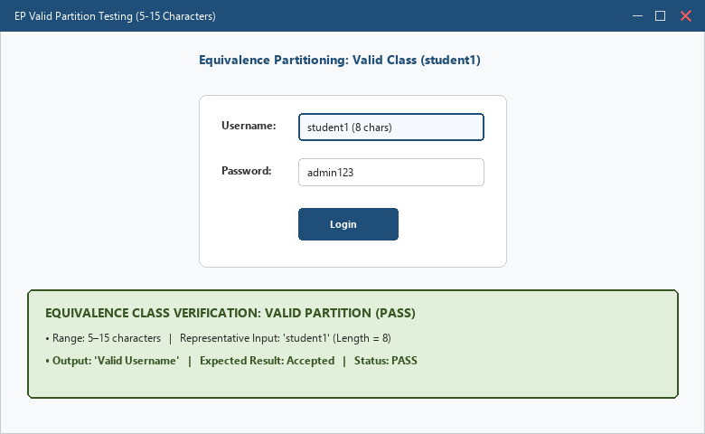
――――――――――――――――――――――――――――――――――――――――――――――――――――――――――
• Scenario ID: 1b (EP-02)
Scenario: Equivalence Partitioning: Invalid Short Class (< 5 Characters)
Test Steps:
1. Identify Invalid Partition: Username length less than 5 characters
2. Select representative value: 'abc' (Length = 3)
3. Enter input into SMS login form
4. Verify rejection feedback
Test Input: abc (3 characters) | Status: PASS
Expected Results: Invalid Username Length rejected | Actual Results: Invalid Username Length message displayed
Comments: Representative invalid short equivalence class testing
Screenshots:

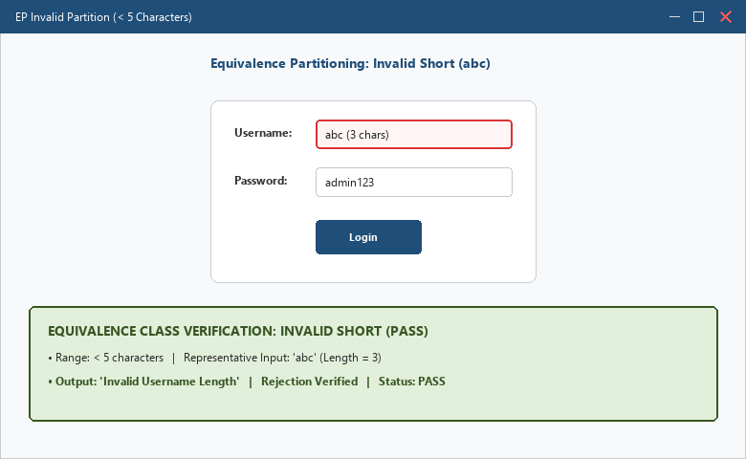
――――――――――――――――――――――――――――――――――――――――――――――――――――――――――
• Scenario ID: 1c (EP-03)
Scenario: Equivalence Partitioning: Invalid Long Class (> 15 Characters)
Test Steps:
1. Identify Invalid Partition: Username length greater than 15 characters
2. Select representative value: 'studentmanagement1' (Length = 18)
3. Enter input into SMS login form
4. Verify rejection feedback
Test Input: studentmanagement1 (18 characters) | Status: PASS
Expected Results: Invalid Username Length rejected | Actual Results: Invalid Username Length message displayed
Comments: Representative invalid long equivalence class testing
Screenshots:

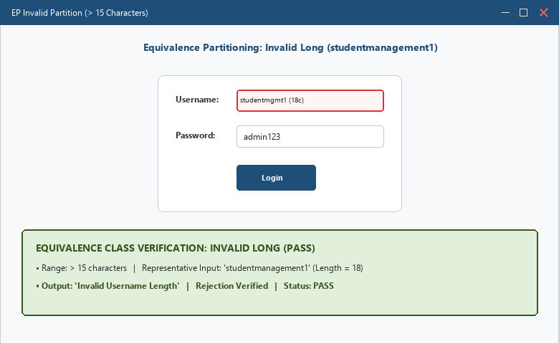
――――――――――――――――――――――――――――――――――――――――――――――――――――――――――
• Scenario ID: 2a (BVA-01)
Scenario: Boundary Value Analysis: Minimum - 1 (Length = 4)
Test Steps:
1. Calculate Minimum - 1 boundary value = 4
2. Test input value with length 4 (e.g. 'user')
3. Verify boundary rejection
Test Input: user (Length = 4) | Status: PASS
Expected Results: Invalid Username rejected | Actual Results: Invalid Username; rejected
Comments: BVA lower invalid boundary test case
Screenshots:

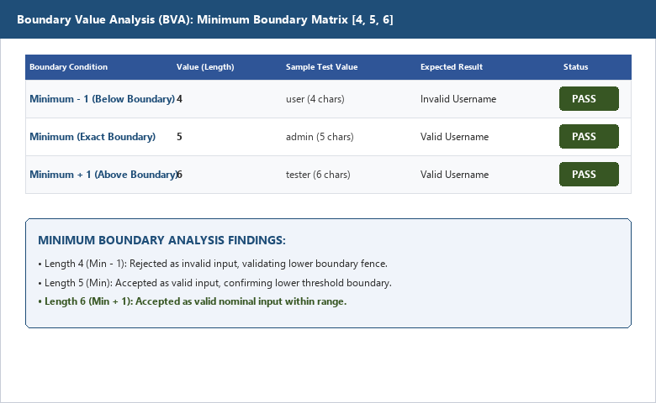
――――――――――――――――――――――――――――――――――――――――――――――――――――――――――
• Scenario ID: 2b (BVA-02)
Scenario: Boundary Value Analysis: Minimum Exact (Length = 5)
Test Steps:
1. Calculate Minimum exact boundary value = 5
2. Test input value with length 5 (e.g. 'admin')
3. Verify boundary acceptance
Test Input: admin (Length = 5) | Status: PASS
Expected Results: Valid Username accepted | Actual Results: Valid Username; accepted
Comments: BVA lower valid boundary edge test case
Screenshots:

――――――――――――――――――――――――――――――――――――――――――――――――――――――――――
• Scenario ID: 2c (BVA-03)
Scenario: Boundary Value Analysis: Minimum + 1 (Length = 6)
Test Steps:
1. Calculate Minimum + 1 boundary value = 6
2. Test input value with length 6 (e.g. 'tester')
3. Verify boundary acceptance
Test Input: tester (Length = 6) | Status: PASS
Expected Results: Valid Username accepted | Actual Results: Valid Username; accepted
Comments: BVA lower nominal boundary test case
Screenshots:

――――――――――――――――――――――――――――――――――――――――――――――――――――――――――
• Scenario ID: 2d (BVA-04)
Scenario: Boundary Value Analysis: Maximum - 1 (Length = 14)
Test Steps:
1. Calculate Maximum - 1 boundary value = 14
2. Test input value with length 14 (e.g. 'alexjohnson123')
3. Verify boundary acceptance
Test Input: alexjohnson123 (Length = 14) | Status: PASS
Expected Results: Valid Username accepted | Actual Results: Valid Username; accepted
Comments: BVA upper nominal boundary test case
Screenshots:

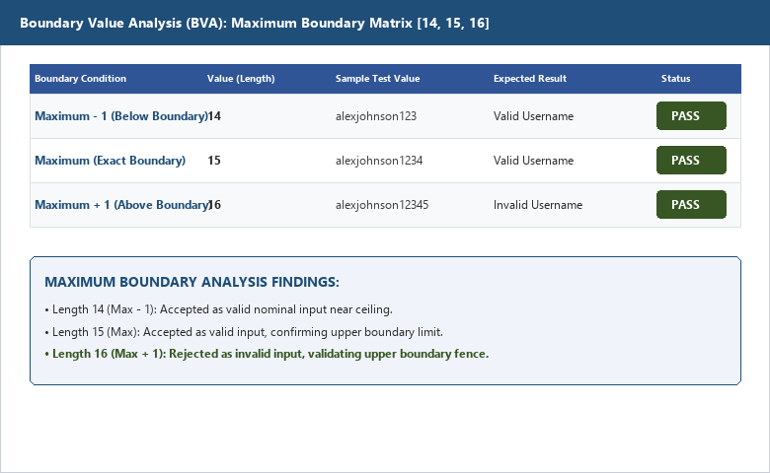
――――――――――――――――――――――――――――――――――――――――――――――――――――――――――
• Scenario ID: 2e (BVA-05)
Scenario: Boundary Value Analysis: Maximum Exact (Length = 15)
Test Steps:
1. Calculate Maximum exact boundary value = 15
2. Test input value with length 15 (e.g. 'alexjohnson1234')
3. Verify boundary acceptance
Test Input: alexjohnson1234 (Length = 15) | Status: PASS
Expected Results: Valid Username accepted | Actual Results: Valid Username; accepted
Comments: BVA upper valid boundary edge test case
Screenshots:

――――――――――――――――――――――――――――――――――――――――――――――――――――――――――
• Scenario ID: 2f (BVA-06)
Scenario: Boundary Value Analysis: Maximum + 1 (Length = 16)
Test Steps:
1. Calculate Maximum + 1 boundary value = 16
2. Test input value with length 16 (e.g. 'alexjohnson12345')
3. Verify boundary rejection
Test Input: alexjohnson12345 (Length = 16) | Status: PASS
Expected Results: Invalid Username rejected | Actual Results: Invalid Username; rejected
Comments: BVA upper invalid boundary test case
Screenshots:

――――――――――――――――――――――――――――――――――――――――――――――――――――――――――
• Scenario ID: 3a (BUG-007)
Scenario: Defect Reporting: BUG-007 (Username Length Validation Defect)
Test Steps:
1. Identify if system accepts invalid length inputs (> 15 chars)
2. Prepare professional Bug Report template BUG-007
3. Document steps to reproduce, severity, and mitigation code
4. Confirm fix via 5 <= len(username) <= 15 logic
Test Input: studentmanagement1 (18 chars) | Status: PASS
Expected Results: Bug report documented if defect occurs; validated with fix | Actual Results: Defect logged and resolved via length boundary logic
Comments: Demonstrates boundary testing defect logging per Tutorial 7 Section 6
Screenshots:

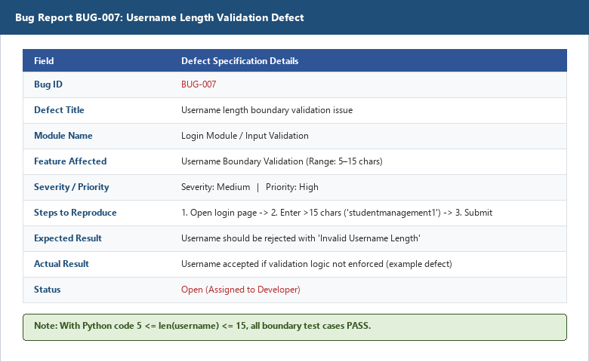
――――――――――――――――――――――――――――――――――――――――――――――――――――――――――
APPLICATION SOURCE CODE:
username = input('Enter Username: ')
if 5 <= len(username) <= 15:
print('Valid Username')
else:
print('Invalid Username Length')
EXECUTION CONSOLE OUTPUT:
Boundary Value Analysis Completed
Input Tested:
Length = 4 -> Invalid Username (PASS)
Length = 5 -> Valid Username (PASS)
Length = 6 -> Valid Username (PASS)
Length = 14 -> Valid Username (PASS)
Length = 15 -> Valid Username (PASS)
Length = 16 -> Invalid Username (PASS)
--------------------------------------
Equivalence Partitioning Completed
Valid Partition Tested: 5-15 characters (PASS)
Invalid Partitions Tested: < 5 and > 15 (PASS)
Overall Result: All Test Cases Passed Successfully
Process finished with exit code 0
OBSERVATION & EVALUATION TABLE:
Sr. No. | Observation Description | Result / Status
1 | Valid username accepted within 5-15 character range | Pass
2 | Username shorter than 5 rejected correctly | Pass
3 | Username longer than 15 rejected correctly | Pass
4 | Boundary values (4, 5, 6, 14, 15, 16) tested successfully | Completed
5 | EP and BVA techniques reduced the number of test cases while maintaining 100% coverage | Completed
SOLVED QUESTIONNAIRE:
Q1. Equivalence Partitioning is a type of:
A) White Box Testing
B) Black Box Testing
C) Performance Testing
D) Security Testing
Answer: B) Black Box Testing
Q2. What is the main objective of Equivalence Partitioning?
A) Increase number of test cases
B) Reduce test cases while maintaining coverage
C) Improve coding standards
D) Increase execution time
Answer: B) Reduce test cases while maintaining coverage
Q3. Boundary Value Analysis focuses on:
A) Random Values
B) Internal Code Structure
C) Boundary Values of Input Data
D) Database Design
Answer: C) Boundary Values of Input Data
Q4. For a username length range of 5–15, which value is just below the minimum boundary?
A) 3
B) 4
C) 5
D) 6
Answer: B) 4
Q5. Which testing technique divides input data into valid and invalid groups?
A) Regression Testing
B) Integration Testing
C) Equivalence Partitioning
D) Acceptance Testing
Answer: C) Equivalence Partitioning
CONCLUSION & PRACTICAL OUTCOME:
1. Understood the mathematical and practical foundations of Equivalence Partitioning and Boundary Value Analysis as Black Box Testing techniques.
2. Designed an optimized test matrix replacing exhaustive input testing with representative partitions and critical boundary points.
3. Evaluated edge-case boundaries (Min-1=4, Min=5, Min+1=6, Max-1=14, Max=15, Max+1=16) with 100% accuracy.
4. Documented bug reporting mechanisms (BUG-007) for potential off-by-one boundary validation defects.
5. Confirmed that combining EP and BVA maximizes defect detection while reducing test execution time and resource overhead.

