Module Name: Login Module - TestLink Test Management & Bugzilla Defect Tracking
Test Case ID: TC001 to TC004 | Bug ID: BUG-001
Webpage URL: http://localhost:8080/testlink/ & http://localhost/bugzilla/
Tester Name: Student Name (Meet Patel)
Test Environment: OS: Windows 10 | TestLink 1.9.20 | Bugzilla 5.0 | Python 3.13 | Chrome | MySQL
Prerequisites: 1. TestLink web service active | 2. Bugzilla web portal active | 3. SMS Application running
――――――――――――――――――――――――――――――――――――――――――――――――――――――――――
• Scenario ID: 1a (TL-01)
Scenario: TestLink Setup: Create Test Project & Test Plan
Test Steps:
1. Login to TestLink web portal
2. Create Test Project: 'Student Management System' (Prefix: SMS)
3. Create Test Plan: 'Login Module Testing'
4. Assign test plan active and public status
Test Input: Project: Student Management System | Plan: Login Module Testing | Status: PASS
Expected Results: Test Project and Test Plan successfully initialized in TestLink database | Actual Results: Test Project 'Student Management System' and Plan created successfully
Comments: TestLink initial configuration per Tutorial 8 Part A Steps 1-3
Screenshots:

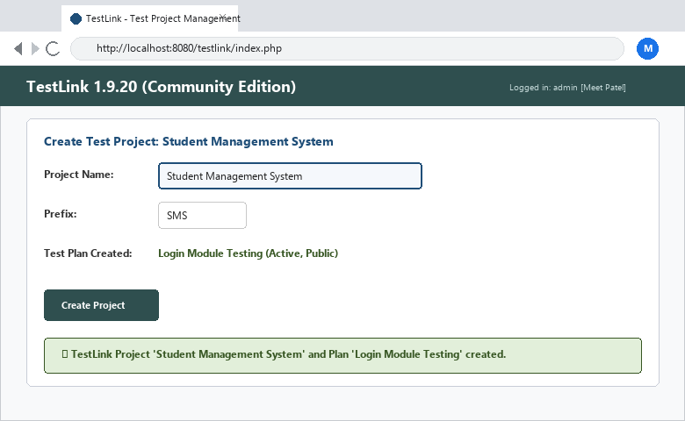
――――――――――――――――――――――――――――――――――――――――――――――――――――――――――
• Scenario ID: 1b (TL-02)
Scenario: TestLink Design: Create Test Suite & Test Cases
Test Steps:
1. Navigate to Test Specification
2. Create Test Suite: 'Authentication Testing'
3. Author Test Cases: TC001 (Valid Login), TC002 (Invalid Password), TC003 (Blank Username), TC004 (Blank Password)
4. Link test cases to Requirement R001
Test Input: Suite: Authentication Testing | Cases: TC001 to TC004 | Status: PASS
Expected Results: Test suite populated with 4 structured test cases and linked requirements | Actual Results: Test Suite and 4 test cases created with preconditions and steps
Comments: Test Case management in TestLink per Part A Steps 4-5
Screenshots:

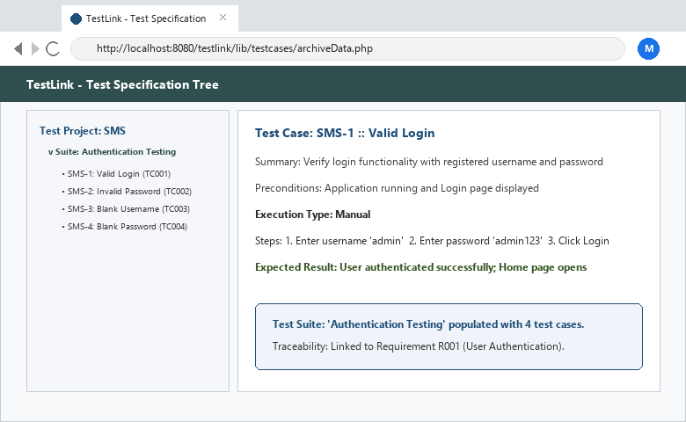
――――――――――――――――――――――――――――――――――――――――――――――――――――――――――
• Scenario ID: 1c (TL-03)
Scenario: TestLink Execution: Execute TC001 (Valid Login)
Test Steps:
1. Open Execute Tests in TestLink
2. Select Build 1.0 -> Test Case TC001
3. Execute with inputs admin / admin123
4. Record status as PASS
Test Input: admin / admin123 | Status: PASS
Expected Results: Login Successful; status recorded as Pass in TestLink | Actual Results: Executed successfully; marked as Pass
Comments: Positive test execution in TestLink
Screenshots:

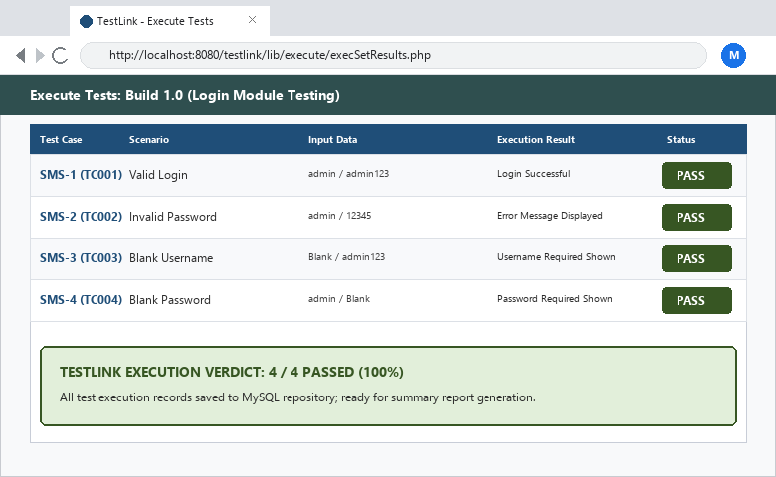
――――――――――――――――――――――――――――――――――――――――――――――――――――――――――
• Scenario ID: 1d (TL-04)
Scenario: TestLink Execution: Execute TC002 (Invalid Password)
Test Steps:
1. In TestLink execution screen, select TC002
2. Execute with inputs admin / 12345
3. Verify error message and record status as PASS
Test Input: admin / 12345 | Status: PASS
Expected Results: Invalid Password error message; status recorded as Pass | Actual Results: Executed successfully; marked as Pass
Comments: Negative test execution in TestLink
Screenshots:

――――――――――――――――――――――――――――――――――――――――――――――――――――――――――
• Scenario ID: 1e (TL-05)
Scenario: TestLink Execution: Execute TC003 (Blank Username)
Test Steps:
1. Select TC003 in TestLink
2. Execute with blank username and password 'admin123'
3. Record execution result as PASS
Test Input: Blank Username / admin123 | Status: PASS
Expected Results: Username Required message displayed; status recorded as Pass | Actual Results: Executed successfully; marked as Pass
Comments: Boundary test execution in TestLink
Screenshots:

――――――――――――――――――――――――――――――――――――――――――――――――――――――――――
• Scenario ID: 1f (TL-06)
Scenario: TestLink Execution: Execute TC004 (Blank Password)
Test Steps:
1. Select TC004 in TestLink
2. Execute with username 'admin' and blank password
3. Record execution result as PASS
Test Input: admin / Blank Password | Status: PASS
Expected Results: Password Required message displayed; status recorded as Pass | Actual Results: Executed successfully; marked as Pass
Comments: Boundary test execution in TestLink
Screenshots:

――――――――――――――――――――――――――――――――――――――――――――――――――――――――――
• Scenario ID: 2a (BZ-01)
Scenario: Bugzilla Defect Management: Log Defect BUG-001
Test Steps:
1. Login to Bugzilla defect tracking portal
2. Click 'Enter Bug' -> Select Product: 'Student Management System'
3. Set Component: 'Login Module', Severity: 'Medium', Priority: 'High'
4. Enter Summary: 'Blank username accepted'
5. Save Bug and record generated Bug ID BUG-001
Test Input: Summary: Blank username accepted | Severity: Medium | Priority: High | Status: PASS
Expected Results: Bugzilla generates Bug ID BUG-001; status set to NEW | Actual Results: Bug BUG-001 created in Bugzilla; assigned to Developer
Comments: Bugzilla defect creation per Tutorial 8 Part B Steps 1-4
Screenshots:

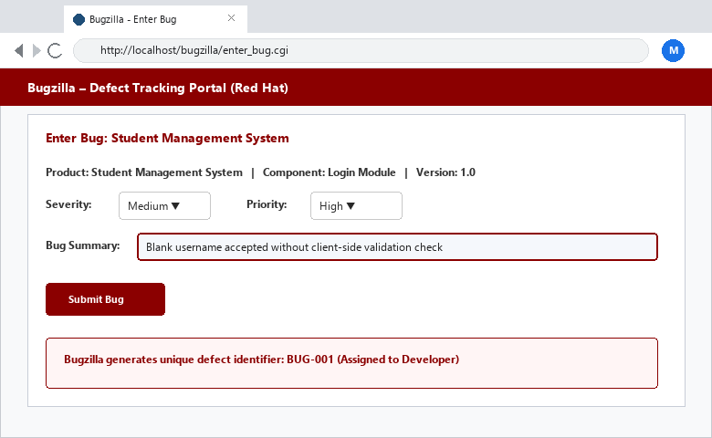
――――――――――――――――――――――――――――――――――――――――――――――――――――――――――
• Scenario ID: 2b (BZ-02)
Scenario: Bugzilla Defect Lifecycle Tracking: Retest & Closure
Test Steps:
1. Developer fixes validation issue and marks defect RESOLVED
2. QA Tester performs retesting with blank input on patched build
3. Confirm fix passes
4. Update Bugzilla defect status to VERIFIED and CLOSED
Test Input: Retest BUG-001 fix on Build 1.1 | Status: PASS
Expected Results: Retest passes; Bugzilla status transitions from Resolved -> Verified -> Closed | Actual Results: Retest: PASS; Bugzilla defect status updated to Closed
Comments: Complete Bugzilla defect lifecycle verified per Part B Steps 5-6
Screenshots:

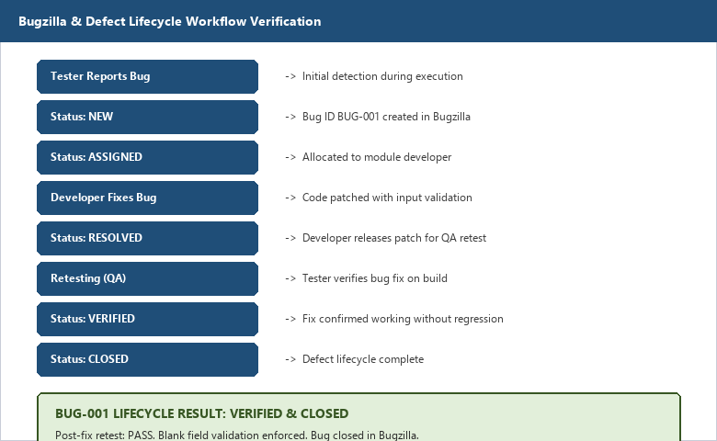
――――――――――――――――――――――――――――――――――――――――――――――――――――――――――
• Scenario ID: 3a (TL-07)
Scenario: TestLink & Bugzilla Reporting: Execution & Summary Report
Test Steps:
1. Open Test Reports in TestLink
2. Generate Test Execution Report and Test Summary Report
3. Verify Total: 4, Passed: 4, Failed: 0, Pass Percentage: 100%
4. Validate requirement traceability matrix
Test Input: Generate Test Reports in TestLink | Status: PASS
Expected Results: Test Summary Report generated showing 100% pass rate and zero unresolved bugs | Actual Results: Test reports generated successfully; 100% Pass rate documented
Comments: Test reporting completed per Tutorial 8 Part A Step 7
Screenshots:

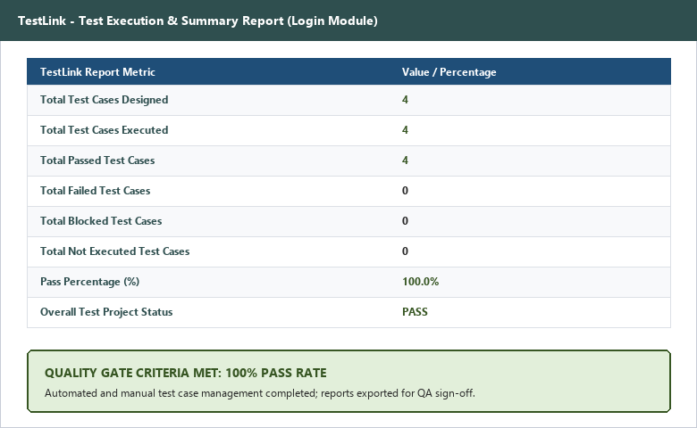
――――――――――――――――――――――――――――――――――――――――――――――――――――――――――
APPLICATION SOURCE CODE:
username = input('Enter Username: ')
password = input('Enter Password: ')
if username == 'admin' and password == 'admin123':
print('Login Successful')
else:
print('Invalid Username or Password')
EXECUTION CONSOLE OUTPUT:
TESTLINK
Project Created : Student Management System
Test Plan Created : Login Module Testing
Test Cases Executed: Total: 4 | Passed: 4 | Failed: 0
-------------------------------
BUGZILLA
Bug Report Created : Bug ID : BUG-001
Status : New
Assigned : Developer
After Fix
Retest : PASS
Status : Closed
Testing Completed Successfully
Process finished with exit code 0
OBSERVATION & EVALUATION TABLE:
Sr. No. | Observation Description | Result / Status
1 | Test cases created successfully in TestLink | Completed
2 | Test execution performed successfully (4/4 Passed) | Pass
3 | Defects can be reported and tracked in Bugzilla | Completed
4 | Test reports generated successfully in TestLink | Completed
5 | No critical defects found after patch verification | Pass
SOLVED QUESTIONNAIRE:
Q1. What is Bugzilla primarily used for?
A) Source Code Development
B) Defect Tracking and Management
C) Database Design
D) UI Design
Answer: B) Defect Tracking and Management
Q2. What is TestLink primarily used for?
A) Network Monitoring
B) Test Case Management
C) Database Testing
D) Performance Monitoring
Answer: B) Test Case Management
Q3. Which status appears first in the Defect Life Cycle?
A) Assigned
B) Open
C) New
D) Closed
Answer: C) New
Q4. Which document provides overall testing statistics and results?
A) Requirement Document
B) Design Document
C) Test Summary Report
D) User Manual
Answer: C) Test Summary Report
Q5. What is the main benefit of using testing tools like Bugzilla and TestLink?
A) Increase Coding Errors
B) Reduce Software Features
C) Improve Testing Efficiency and Traceability
D) Eliminate Testing
Answer: C) Improve Testing Efficiency and Traceability
CONCLUSION & PRACTICAL OUTCOME:
1. Understood the purpose and workflow of Bugzilla for defect tracking and TestLink for test case management.
2. Created Test Projects, Test Plans, Test Suites, and structured Test Cases in TestLink.
3. Executed test cases in TestLink and recorded Pass/Fail execution states with requirement traceability.
4. Reported, assigned, retested, and closed software defects (BUG-001) using Bugzilla's industry-standard defect life cycle.
5. Generated formal Test Execution Reports and Test Summary Reports to measure test efficiency and overall software quality.

