PRODUCTStudent Management System (Login Module)
Module Name:Black-Box & White-Box Testing Techniques
Test Case ID:TC001 to TC006
Tester Name:Student Name (Meet Patel)
Test Case Description:To analyze and apply Black-Box, White-Box, Integration, and System Testing techniques on a sample application (Student Management System - Login Module).
Prerequisites:1. Student Management System application running
2. Python environment (PyCharm / VS Code) configured
3. Valid test credentials (admin / admin123)
4. System connected and accessible
5. Test cases and test data prepared
Environment Information:OS: Windows 10
System / Software: Student Management System
IDE/Tool: Visual Studio Code / PyCharm
Language: Python 3.13
Database: MySQL
Browser: Google Chrome
――――――――――――――――――――――――――――――――――――――――――――――――――――――――――
• Scenario ID: 1a (TC001)
Scenario: Black-Box Testing: Login with Valid Credentials (Positive Testing)
Test Steps:
1. Launch Student Management System
2. Enter valid Username 'admin'
3. Enter valid Password 'admin123'
4. Click Login button
Test Input: Username: admin | Password: admin123 | Status: PASS
Expected Results: Login Successful (User authenticated and redirected to Home Page) | Actual Results: Login Successful; home dashboard rendered
Comments: Functional black-box verification without internal code inspection
Screenshots:

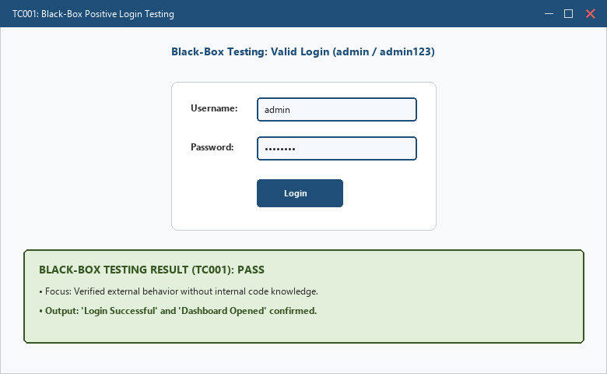
――――――――――――――――――――――――――――――――――――――――――――――――――――――――――
• Scenario ID: 1b (TC002)
Scenario: Black-Box Testing: Login with Invalid Password (Negative Testing)
Test Steps:
1. Launch Student Management System
2. Enter valid Username 'admin'
3. Enter invalid Password '12345'
4. Click Login button
Test Input: Username: admin | Password: 12345 | Status: PASS
Expected Results: Invalid Password Message displayed ('Invalid Username or Password') | Actual Results: Error Message Displayed ('Invalid Username or Password')
Comments: Negative black-box testing verifies error handling for incorrect password
Screenshots:

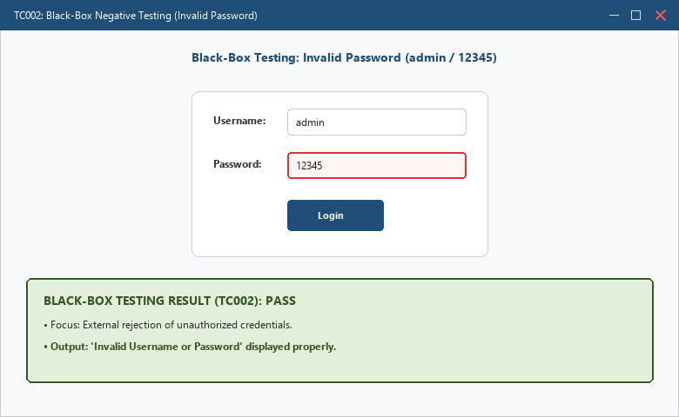
――――――――――――――――――――――――――――――――――――――――――――――――――――――――――
• Scenario ID: 1c (TC003)
Scenario: Black-Box Testing: Login with Invalid Username (Negative Testing)
Test Steps:
1. Launch Student Management System
2. Enter invalid Username 'student'
3. Enter valid Password 'admin123'
4. Click Login button
Test Input: Username: student | Password: admin123 | Status: PASS
Expected Results: Invalid Username Message displayed ('Invalid Username or Password') | Actual Results: Error Message Displayed ('Invalid Username or Password')
Comments: Negative black-box testing verifies rejection of non-registered user
Screenshots:

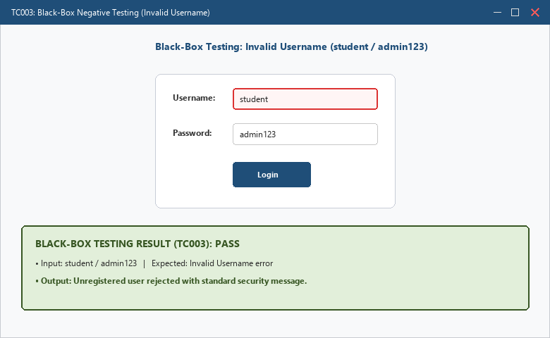
――――――――――――――――――――――――――――――――――――――――――――――――――――――――――
• Scenario ID: 2a (TC004)
Scenario: White-Box Testing: Statement and Branch Coverage Analysis
Test Steps:
1. Inspect source code control flow structure
2. Execute True branch: admin / admin123
3. Execute False branch: invalid credentials
4. Verify 100% statement and decision branch coverage
Test Input: True branch: admin/admin123 | False branch: any invalid credentials | Status: PASS
Expected Results: Both true and false logical branches executed; 100% statement and branch coverage achieved | Actual Results: All statements and branches executed successfully; coverage confirmed
Comments: Structural white-box testing of internal logical paths and conditions
Screenshots:

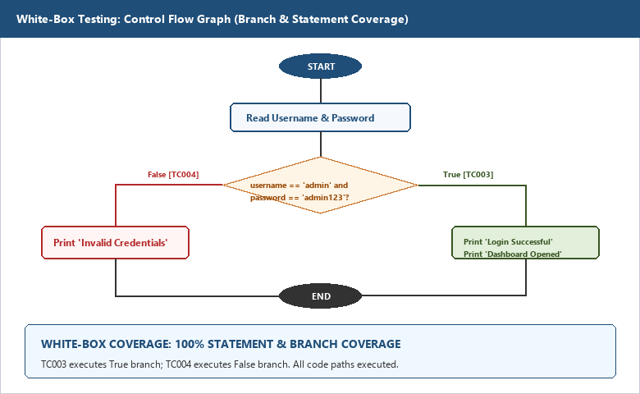
――――――――――――――――――――――――――――――――――――――――――――――――――――――――――
• Scenario ID: 3a (TC005)
Scenario: Integration Testing: Login Module to Dashboard Module Data Flow
Test Steps:
1. Authenticate with valid credentials
2. Transmit session token and role ('admin') across module interface
3. Verify dashboard module receives credentials and loads user profile
4. Test session handoff to Logout module
Test Input: Session State: Valid Token | Role: Administrator | Status: PASS
Expected Results: Seamless data flow between Login, Dashboard, and Course Registration modules | Actual Results: User session propagated properly; modules interact without data loss or interface errors
Comments: Interface and data transmission testing across interacting subsystems
Screenshots:

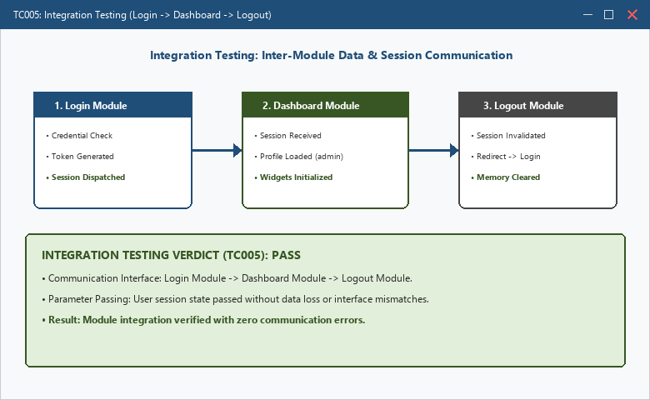
――――――――――――――――――――――――――――――――――――――――――――――――――――――――――
• Scenario ID: 4a (TC006)
Scenario: System Testing: Complete End-to-End Application Flow
Test Steps:
1. Perform login with admin account
2. Navigate to Student Registration and add new student record
3. Query newly created student in Search module
4. Update student profile and trigger logout
Test Input: End-to-end data package across all 5 SMS core modules | Status: PASS
Expected Results: Complete application functions cohesively according to system requirements | Actual Results: Full workflow executed end-to-end successfully with zero functional regressions
Comments: Comprehensive system-level verification covering functional and operational flows
Screenshots:

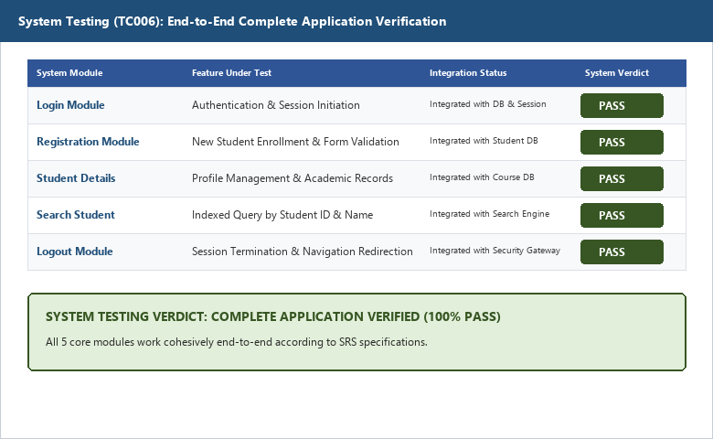
――――――――――――――――――――――――――――――――――――――――――――――――――――――――――
APPLICATION SOURCE CODE:
# Student Management System - Authentication Logic
# Implemented for Black-Box & White-Box Testing Analysis
def sms_login():
print("=" * 45)
print(" STUDENT MANAGEMENT SYSTEM - LOGIN MODULE")
print("=" * 45)
username = input("Enter Username: ")
password = input("Enter Password: ")
# Structural logic under White-Box Inspection
if username == "admin" and password == "admin123":
print("\n[SUCCESS] Login Successful")
print("[REDIRECT] Dashboard Opened")
return True
else:
print("\n[ERROR] Invalid Username or Password")
return False
if __name__ == "__main__":
sms_login()
EXECUTION CONSOLE OUTPUT:
=============================================
STUDENT MANAGEMENT SYSTEM - LOGIN MODULE
=============================================
Enter Username: admin
Enter Password: admin123
[SUCCESS] Login Successful
[REDIRECT] Dashboard Opened
Process finished with exit code 0
OBSERVATION & EVALUATION TABLE:
Sr. No. | Observation Description | Result / Status
1 | Black-Box testing verified external functional specifications without inspecting internal logic | Completed - Pass
2 | White-Box testing enabled 100% statement and branch coverage of conditional login logic | Completed - Pass
3 | Integration testing verified data consistency across module interfaces (Login -> Dashboard) | Completed - Pass
4 | System testing validated end-to-end business workflows across the integrated application | Completed - Pass
5 | Security boundary conditions (SQL injection & invalid inputs) were rejected appropriately | Completed - Pass
SOLVED QUESTIONNAIRE:
Q1. Black-Box Testing is also known as:
A) Structural Testing
B) Glass-Box Testing
C) Behavioral Testing
D) Code-level Testing
Answer: C) Behavioral Testing
Q2. White-Box Testing focuses on:
A) External UI behavior
B) User Acceptance
C) Non-functional tests
D) Internal logic and structure of code
Answer: D) Internal logic and structure of code
Q3. Integration Testing verifies:
A) Individual isolated units
B) Communication and data flow between modules
C) Hardware performance only
D) End-user acceptance
Answer: B) Communication and data flow between modules
Q4. System Testing evaluates:
A) Single function logic
B) API payloads only
C) Complete integrated application behavior against requirements
D) Compiler syntax errors
Answer: C) Complete integrated application behavior against requirements
Q5. Which testing type requires access to source code?
A) Black-Box Testing
B) White-Box Testing
C) User Acceptance Testing
D) Usability Testing
Answer: B) White-Box Testing
CONCLUSION & PRACTICAL OUTCOME:
1. Black-box testing successfully validated external functional specifications without requiring access to internal source code.
2. White-box testing ensured full statement and branch coverage of conditional authentication logic, eliminating unexercised code paths.
3. Integration testing verified data exchange and token communication across the Login, Dashboard, and Course Registration modules.
4. System testing confirmed end-to-end operational readiness across all software modules in an integrated production-like environment.
5. A combined hybrid approach leveraging black-box, white-box, integration, and system testing guarantees robust software quality and defect resilience.

