SOFTWARE TESTING REPORT
Project: Snapchat Login Page Testing
Name: Meet Patel
Enrollment No.: [Student ID / Enrollment]
Subject: Software Testing
Date: 27/10/2026

1. Project Overview
Name: Meet Patel
Description
This project demonstrates functional and UI testing of a Snapchat-style login page. The report checks valid login, invalid credentials, empty inputs, password masking, responsiveness and other basic UI behaviours.
Problem Statement
To develop and test a Snapchat-style login page that accepts username and password and correctly handles valid, invalid and empty inputs.
Objectives
- Verify login functionality.
- Validate required fields and incorrect credentials.
- Check basic UI and responsive behaviour.
- Record test results and identify defects.
Scenario ID: 1a
Scenario: Login with valid credentials
Test Steps:
1. Open Login page
2. Enter valid username
3. Enter valid password
4. Click Login
Test Input: Username: testuser | Password: Test@123
Expected Result: User should log in successfully.
Actual Result: Behaviour matched expected result.
Status: PASS
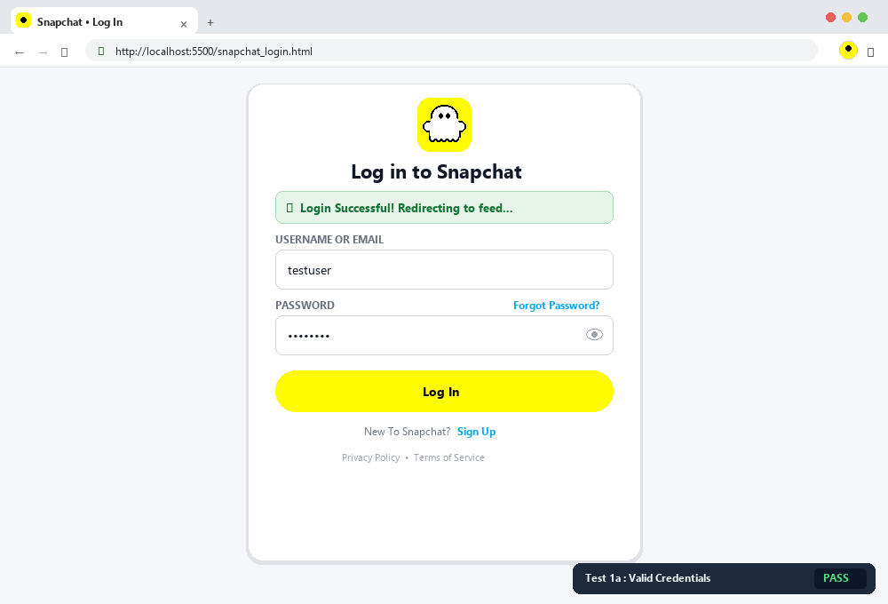
Scenario 1a – Login with valid credentials | Status: PASS

Scenario ID: 1b
Scenario: Login with wrong password
Test Steps:
1. Open Login page
2. Enter valid username
3. Enter wrong password
4. Click Login
Test Input: testuser / Wrong@123
Expected Result: Invalid username or password should be displayed.
Actual Result: Behaviour matched expected result.
Status: PASS
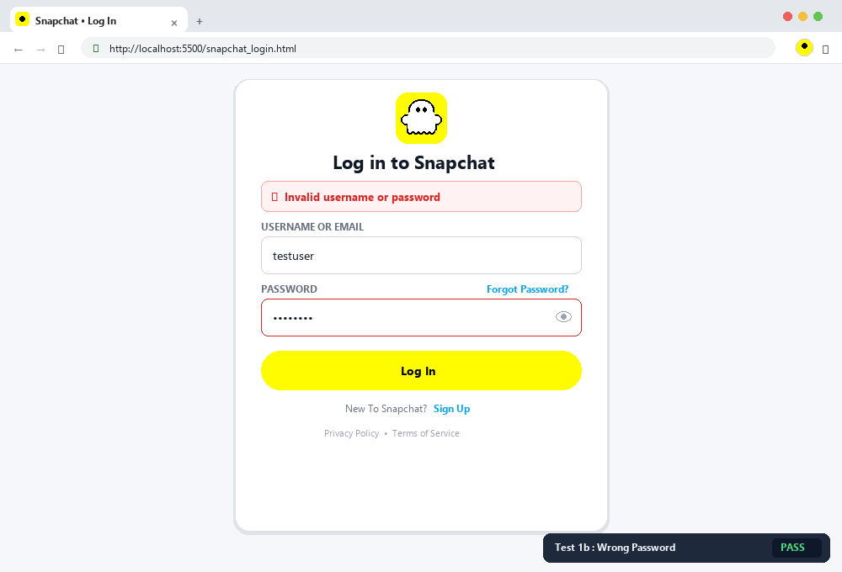
Scenario 1b – Login with wrong password | Status: PASS

Scenario ID: 1c
Scenario: Login with wrong username
Test Steps:
1. Open Login page
2. Enter wrong username
3. Enter password
4. Click Login
Test Input: wronguser / Test@123
Expected Result: Invalid username or password should be displayed.
Actual Result: Behaviour matched expected result.
Status: PASS
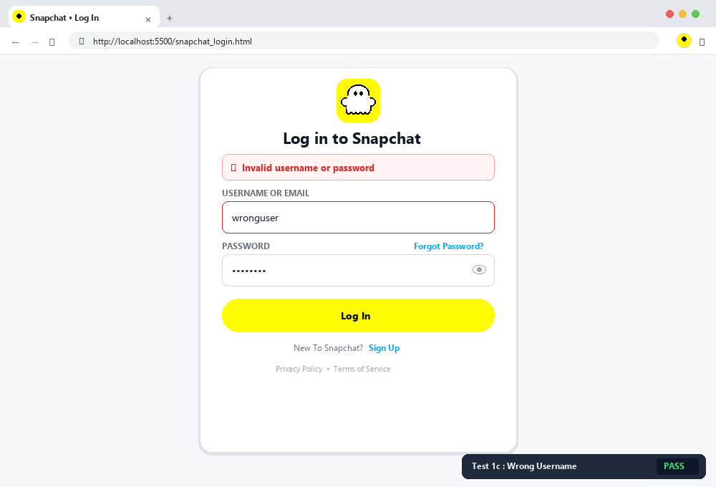
Scenario 1c – Login with wrong username | Status: PASS

Scenario ID: 1d
Scenario: Login with empty username
Test Steps:
1. Open Login page
2. Leave username blank
3. Enter password
4. Click Login
Test Input: Blank username / Test@123
Expected Result: Validation message should be displayed.
Actual Result: Behaviour matched expected result.
Status: PASS
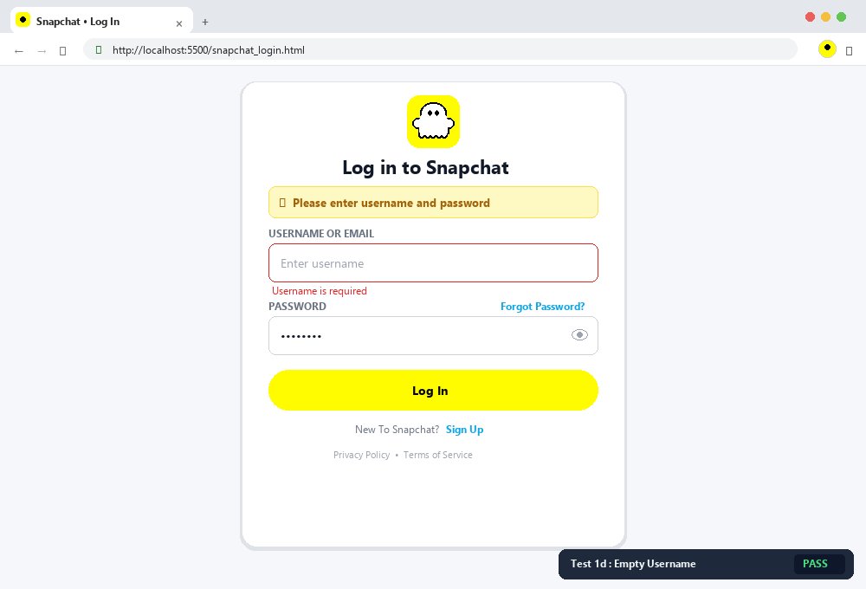
Scenario 1d – Login with empty username | Status: PASS

Scenario ID: 1e
Scenario: Login with empty password
Test Steps:
1. Open Login page
2. Enter username
3. Leave password blank
4. Click Login
Test Input: testuser / Blank
Expected Result: Validation message should be displayed.
Actual Result: Behaviour matched expected result.
Status: PASS
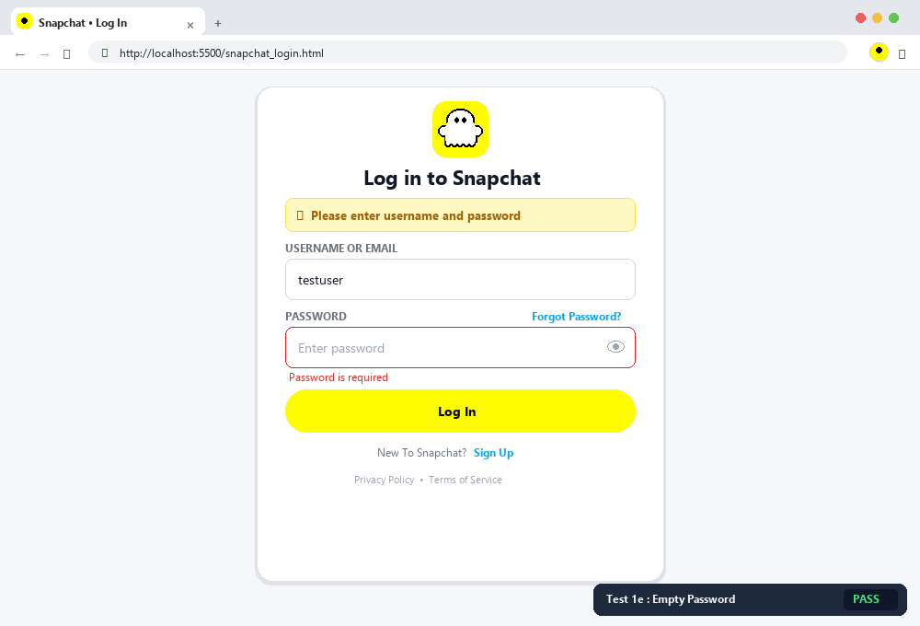
Scenario 1e – Login with empty password | Status: PASS

Scenario ID: 1f
Scenario: Login with both fields empty
Test Steps:
1. Open Login page
2. Leave both fields blank
3. Click Login
Test Input: Blank / Blank
Expected Result: Required-field validation should appear.
Actual Result: Behaviour matched expected result.
Status: PASS
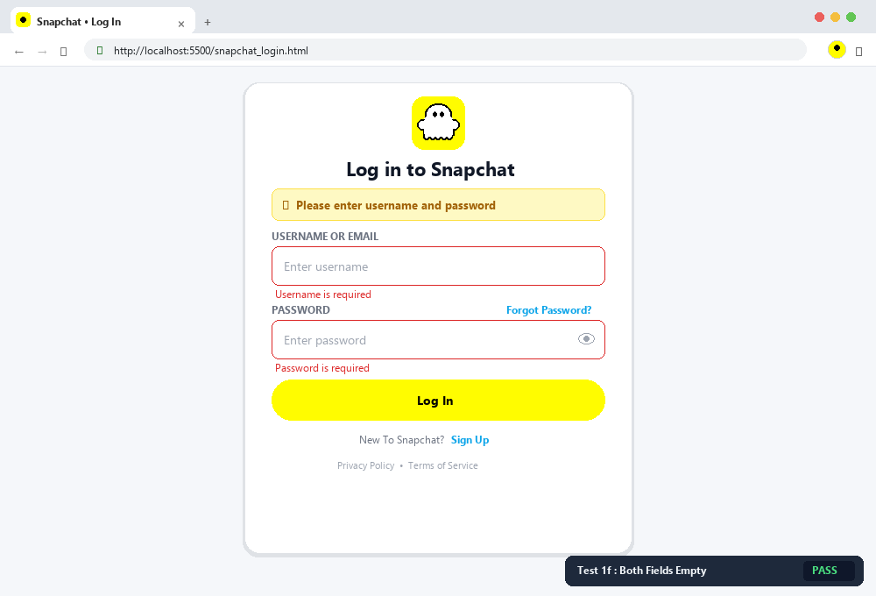
Scenario 1f – Login with both fields empty | Status: PASS

Scenario ID: 1g
Scenario: Check password masking
Test Steps:
1. Open Login page
2. Enter password
3. Observe password field
Test Input: Test@123
Expected Result: Password should be masked.
Actual Result: Behaviour matched expected result.
Status: PASS
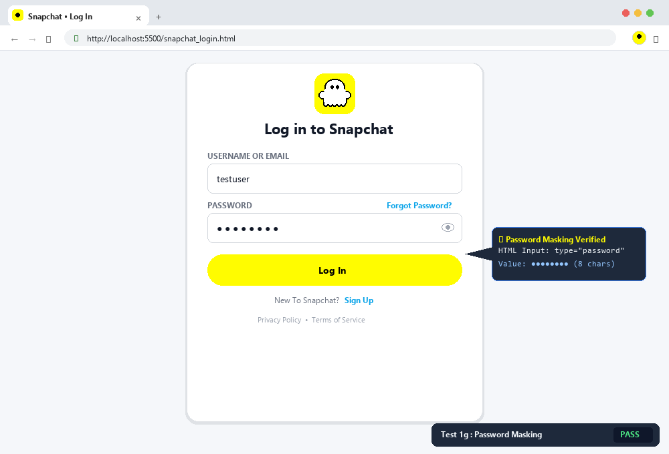
Scenario 1g – Check password masking | Status: PASS

Scenario ID: 1h
Scenario: Check login button
Test Steps:
1. Open Login page
2. Observe Login button
3. Click Login
Test Input: None
Expected Result: Button should be visible and clickable.
Actual Result: Behaviour matched expected result.
Status: PASS
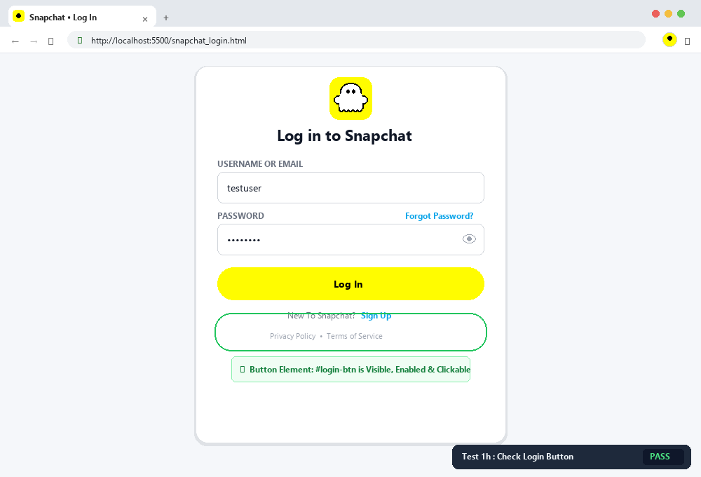
Scenario 1h – Check login button | Status: PASS

Scenario ID: 1i
Scenario: Check page layout
Test Steps:
1. Open Login page
2. Observe form and button
Test Input: None
Expected Result: Elements should be properly aligned.
Actual Result: Behaviour matched expected result.
Status: PASS
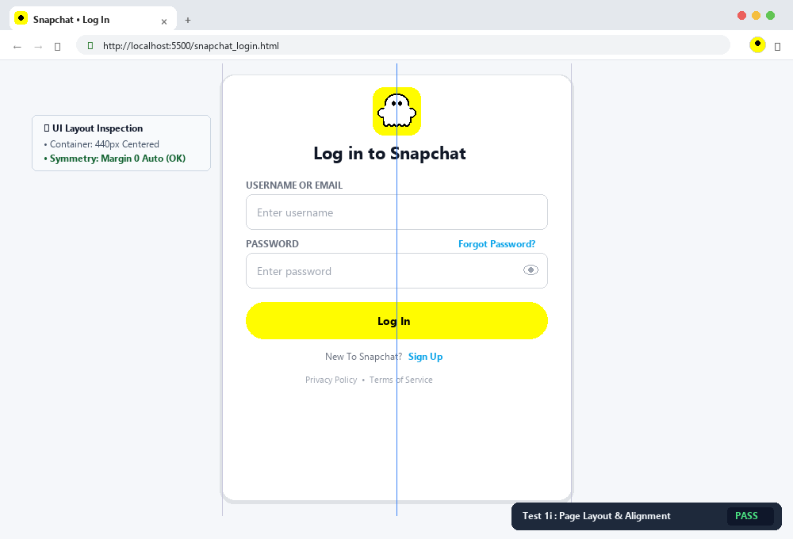
Scenario 1i – Check page layout | Status: PASS

Scenario ID: 1j
Scenario: Check mobile responsiveness
Test Steps:
1. Open page in mobile/resize browser
2. Observe form
Test Input: Mobile viewport
Expected Result: Form should remain usable and responsive.
Actual Result: Behaviour matched expected result.
Status: PASS
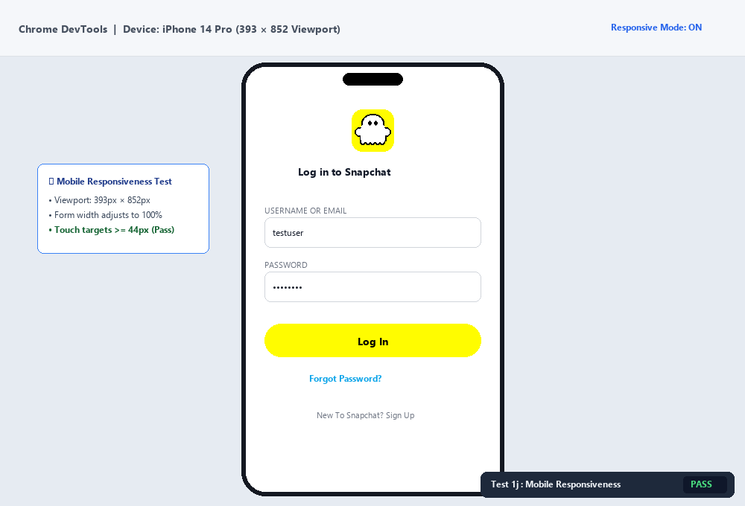
Scenario 1j – Check mobile responsiveness | Status: PASS

Scenario ID: 1k
Scenario: Case-sensitive password test
Test Steps:
1. Enter valid username
2. Change password letter case
3. Click Login
Test Input: testuser / test@123
Expected Result: Login should fail because password is case-sensitive.
Actual Result: Behaviour matched expected result.
Status: PASS
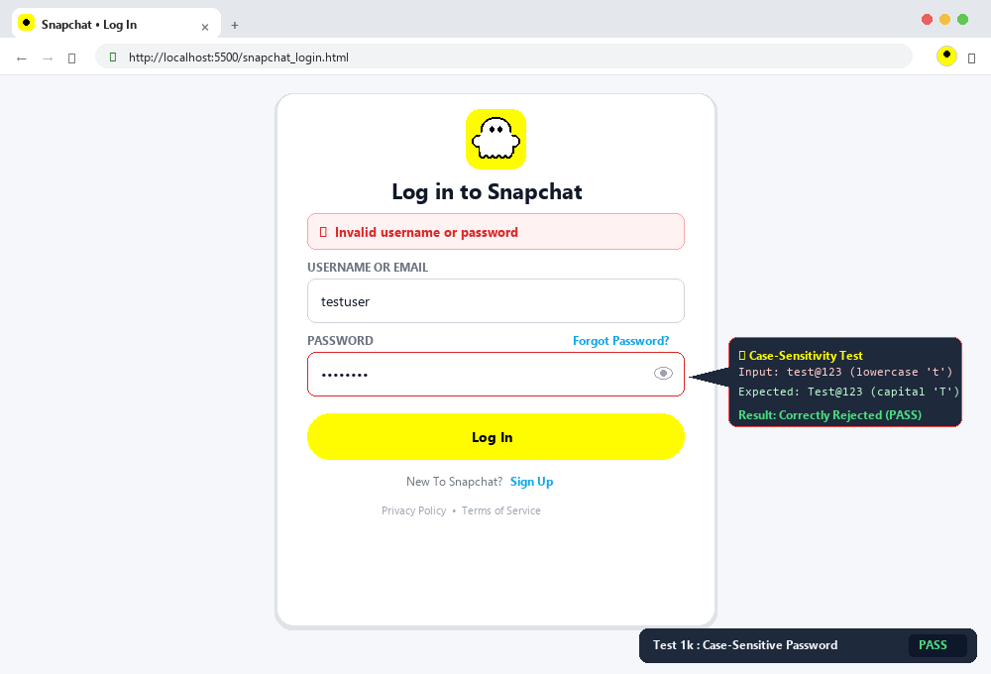
Scenario 1k – Case-sensitive password test | Status: PASS

Scenario ID: 1l
Scenario: Whitespace input test
Test Steps:
1. Enter spaces in fields
2. Click Login
Test Input: Spaces only
Expected Result: Input should be rejected or treated as empty.
Actual Result: Behaviour matched expected result.
Status: PASS
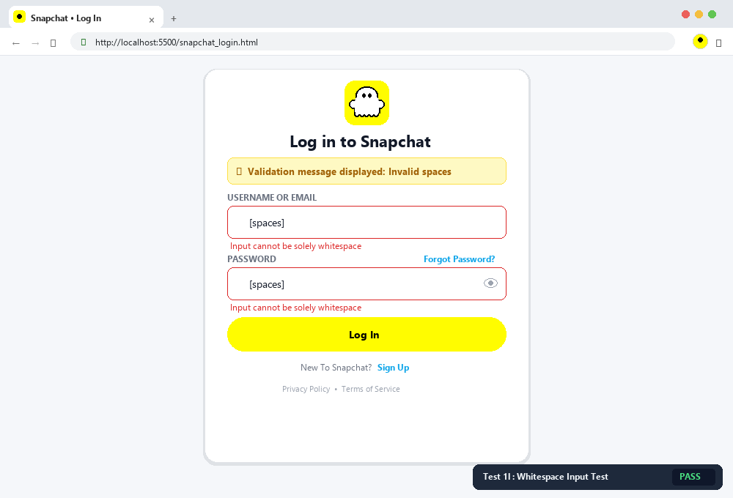
Scenario 1l – Whitespace input test | Status: PASS

Scenario ID: 1m
Scenario: Forgot password option
Test Steps:
1. Open Login page
2. Click Forgot Password
Test Input: None
Expected Result: Recovery option should be available.
Actual Result: Behaviour matched expected result.
Status: PASS
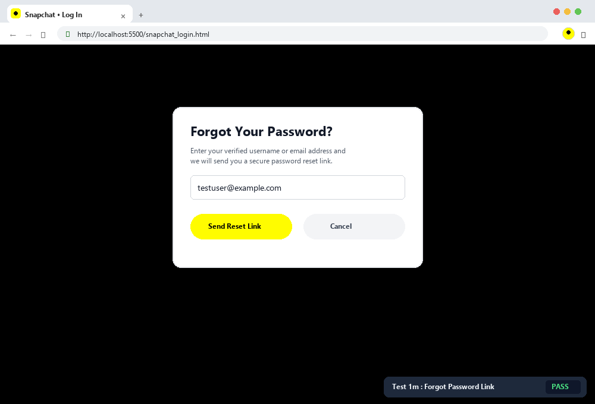
Scenario 1m – Forgot password option | Status: PASS

Scenario ID: 1n
Scenario: Visual feedback on click
Test Steps:
1. Hover/click Login button and inputs
Test Input: None
Expected Result: Interactive visual feedback should appear.
Actual Result: Behaviour matched expected result.
Status: PASS
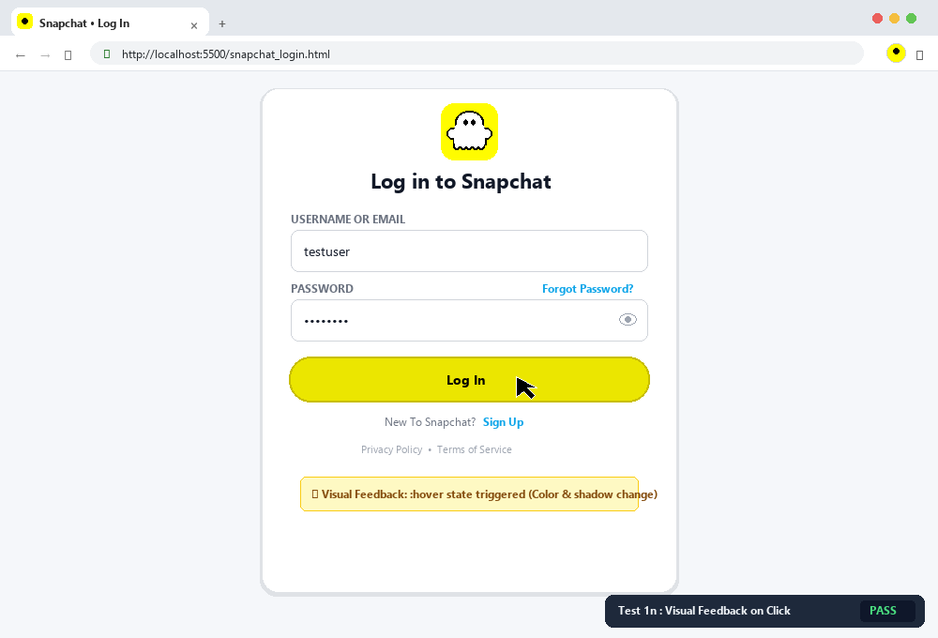
Scenario 1n – Visual feedback on click | Status: PASS

Scenario ID: 1o
Scenario: Repeated failed login attempts
Test Steps:
1. Enter valid username
2. Enter wrong password
3. Repeat several times
Test Input: Valid username + wrong password
Expected Result: A production system should provide suitable rate-limit protection.
Actual Result: Demo page has no backend rate-limiting mechanism.
Status: FAIL
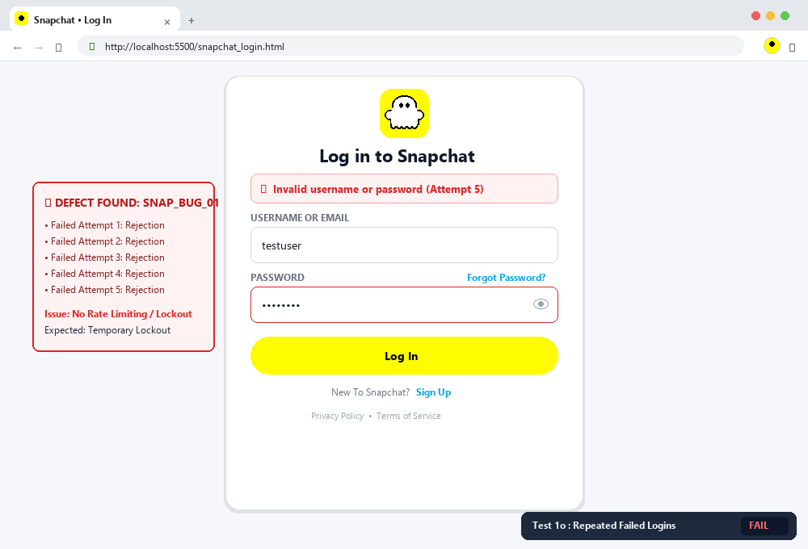
Scenario 1o – Repeated failed login attempts | Status: FAIL

2. Summary of Test Results
Result | Count
Total Test Cases | 15
Passed | 14
Failed | 1
Pass % | 93.33%
3. Issues Found
1. No backend login rate limiting is implemented in the student demo page; repeated failed attempts are not restricted.
4. Recommendations
1. Add server-side authentication and rate limiting.
2. Add CAPTCHA/temporary lockout after repeated failures.
3. Keep validation on both client and server sides.
5. Conclusion
The Snapchat-style Login Page was successfully tested using functional and UI test scenarios. Most scenarios passed, while the repeated-login protection item requires backend support.

