**P18 GPS activity space and Twitter Data Analysis Plan**

1. **Datastets:**

**General Description of GPS Data:**

* 250 participants over 2 weeks with GPS coordinates every 10 seconds (protocol but actual data varies between individuals)
* Max size = 30,240,000 data points
* Missing/erroneous data via participant attrition, subway use (tracker does not function underground), tracker malfunction/interference
* Participants in two waves (different times of year)
* Cross streets of home
* Longitudinal survey data on behaviors, etc.
* Total N might vary from ~250-211 depending on limiting data

1. **General Description of Twitter Data:**

* (NYC-RacismNHomophobia_till013118.csv) updated using the data till 01/31/2018. The details of the data including the description of each column can be found in DataDictionary.txt file

1. **Plan for Analysis:**

We are trying to find out the relationship between discrimination and sexual risk behavior. The plan are listed below:

a. Perform areal weighted mean of Twitter grid cell variables (“SSSOM_Rac_grid”, “SSSOM_Hom_grid” and “Rac_tweets_grid”) within GPS activity space variables as an indicator of individual exposure to neighborhoods and corresponding risk a single-number summary of risk

“areal weighted mean” will take a mean sum over all grid cells, *c*:

$$\sum_{c}{{SSSOM_Rac}_{c}×{time_spent_in_grid_cell}_{c}}$$

b. This will give us an average unit for further analysis of the AWM variables (“AWM_SSSOM_Rac”, “AWM_Rac_tweets”, “AWM_SSSOM_Hom” “AWM_Zip_Hom”, and “AWM_Zip_Rac))

c. Right now we are not controlling for time, rather this is a cross sectional design.

d. The idea is to include the AWM variable (“AWM_SSSOM_RAC”, etc.) as a covariate in a regression model (e.g. quasi-poisson regression, negative binomial regression). Other covariates and outcomes for the model are described below.

**Table 1: codebook for grid cell variables.** Spreadsheet: NYC-RacismNHomophobia.csv

|  |  |  |
| --- | --- | --- |
| **Variables Name** | **Description** | **Name in spreadsheet** |
| SSSOM_Rac_grid | Prevalence of racism in the grid cell based on the SS-SOM cluster it belongs to. | SSSOM_Rac (in %) |
| SSSOM_Hom_grid | Prevalence of homophobia in the grid cell based on the SS-SOM cluster it belongs to. | SSSOM_Hom (in %) |
| Rac_tweets_grid | Prevalence of racist tweets in the grid cell based on the SS-SOM cluster it belongs to. | NormalRacistTweets (in %) |
| Zip_Rac_grid | Prevalence of racism in the grid cell based on the zip code it belongs to | Zip_Rac (in %) |
| Zip_Hom_grid | Prevalence of homophobia in the grid cell based on the zip code it belongs to | Zip_Hom (in %) |

Twitter data and one participants GPS activity space (200m)

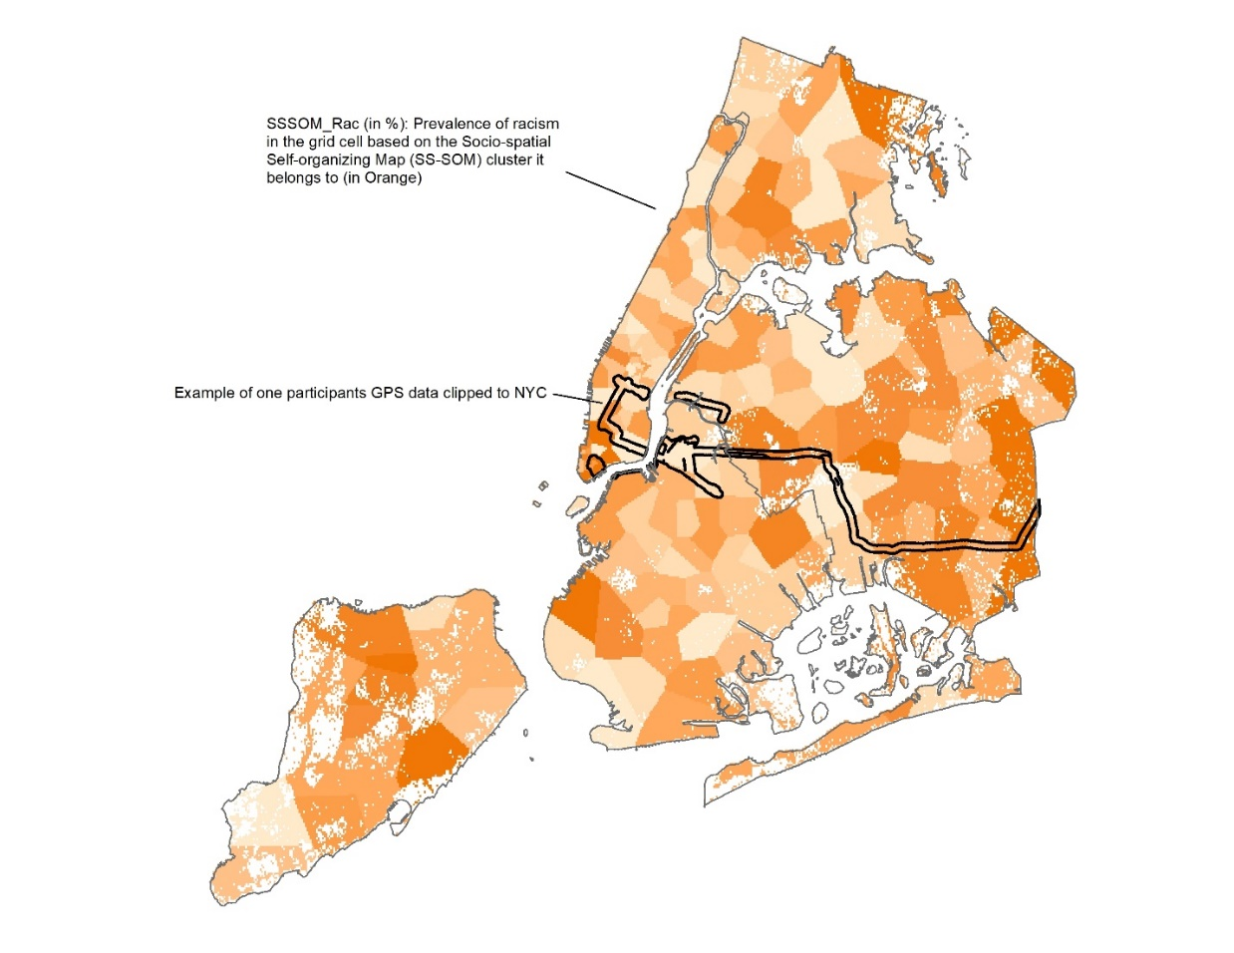

1. **Descriptive Statistics of GPS Activity Derived Variables:**

**Table 2: codebook for AWM variables.** Spreadsheet: P18_GPS_AWM_Twitter_data_summarystats.csv

|  |  |
| --- | --- |
| **Variables Name** | **Description** |
| AWM_SSSOM_Rac | Areal weighted mean of SSSOM_Rac_grid. |
| AWM_SSSOM_Hom | Areal weighted mean of SSSOM_Hom_grid. |
| AWM_Rac_tweets | Areal weighted mean of Rac_tweets_grid. |
| AWM_Zip_Rac | Areal weighted mean of Zip_Rac_grid. |
| AWM_Zip_Hom | Areal weighted mean of Zip_Hom_grid. |
| Area_km | Area in square kilometers of activity spaces. |

Field: AWM_SSSOM_Rac

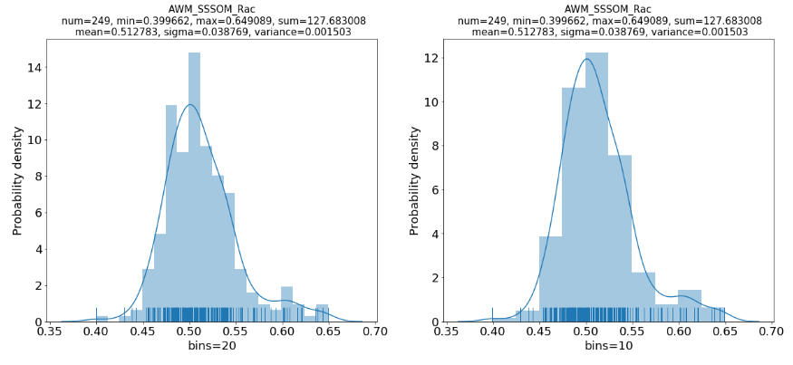

Field: AWM_SSSOM_Hom

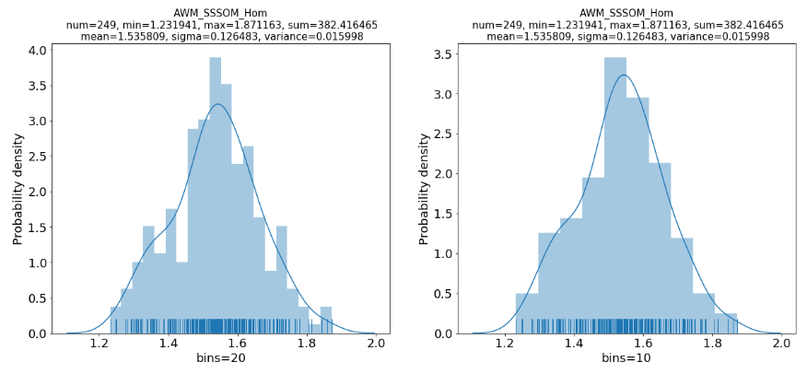

Field: AWM_Rac_tweets

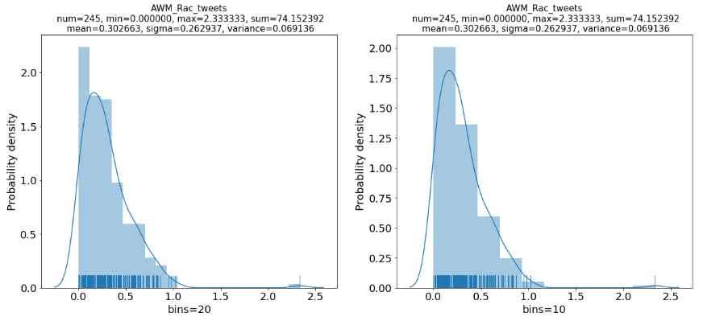

Field: AWM_Zip_Rac

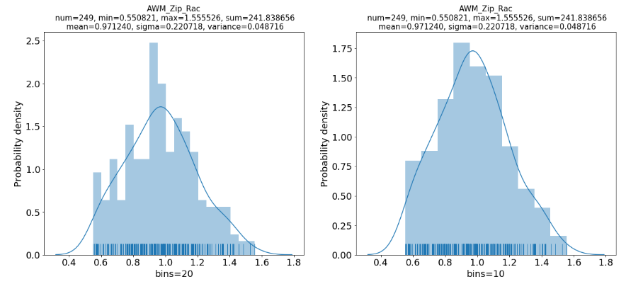

Field: AWM_Zip_Hom

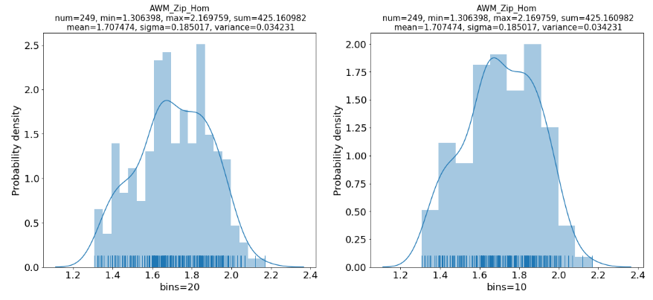

Field: Area_km

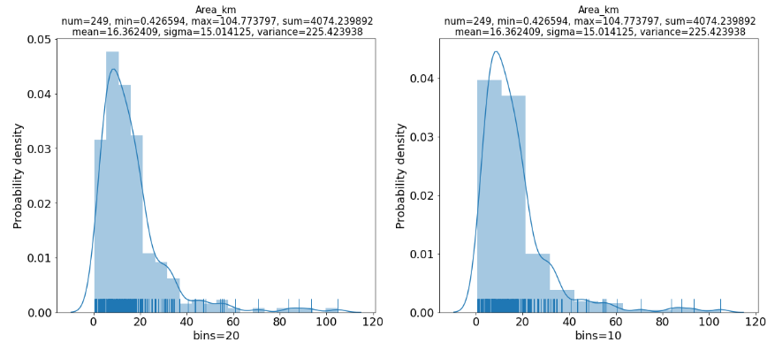

1. **Covariates:**

*Potential list of covariates pulled from our recent manuscript Associations of Spatial Mobility with Sexual Risk Behaviors among Young Men Who Have Sex with Men in New York City: The Project 18 Neighborhood Study. I think we still need to discuss what statistical model we want to run. I am less familiar with the survey level data but the covariates from the manuscript are listed below.*

-age (years), ethnicity (Hispanic or non-Hispanic), race (Black, Asian, White, and others), education attainment (high school or less, some college/ technical school, college degree or more), current school enrollment status (yes/no), and foreign-born status (yes/no), Homelessness, total individual annual income was categorized as less than $15,000, between $15,000 and $35,000, more than $35,000 per year, which approximates national poverty level (<$15,000)

1. **Outcomes:**

Potential outcomes: sexual behaviors associated with risk of HIV infection among MSM. The Project 18 Cohort Study collected data on sexual behaviors including number of male sexual partners and number of condomless sexual encounters in past six months. The number of male sexual partners was assessed from two questions: (1) “In the past 6 months, how many male steady partners have you have anal or oral sex with?,” (2) “In the past 6 months, how many casual male partners have you had anal or oral sex with casual or non-steady partners?”.The total number from those two questions was used as one outcome and was considered a count type variable in the analyses [35-39]. In addition, numbers and types of sexual encounters were assessed to create three variables: total numbers of condomless anal intercourse acts, (2) total numbers of condomless insertive anal intercourse acts, and (3) total number of condomless receptive anal intercourse acts in past six months [35-40].

To be more specific, the outcome variables can be:

Anal Intercourse variables: "AI_Total", "AI_Condom", "AI_Condomless"

Insertive Anal Intercourse variables: "IAI_Total", "IAI_Condom", "IAI_Condomless"

Receptive Anal Intercourse variables: "RAI_Total", "RAI_Condom", "RAI_Condomless"

Others: "drug_use"