RAMDEOBABA UNIVERSITY, NAGPUR
IPR CELL
DESIGN REQUISITES DRAFT

Instructions for writing DESIGN APPLICATION Draft:
1. Please write as much as possible.
2. The First Applicant is always RAMDEOBABA UNIVERSITY, NAGPUR
3.From the SECOND applicant onwards you can add as many applicants as required.
The applicant must be faculty/UG/PG student/research scholar of RBU/RCOEM.
4. Write contact details of each applicant like email and mobile number
5. Address of all applicants will be department name and college name/address. Do not write Personal address
6. The completed soft copy is to be emailed to ipr@ rknec.edu

RAMDEOBABA UNIVERSITY, NAGPUR
IPR CELL DESIGN REQUISITES DRAFT

- Full Name and Address of the inventor(s) and applicant(s)
SN | Name of applicant | Designation  Faculty /UG/PG student/Research scholar | E mail ID | Mobile Number | Address
1 | RAMDEOBABA UNIVERSITY, NAGPUR | RBU | ipr@rknec.edu | -- | RBU, Katol road, Nagpur.
2 | Vineet Shah | UG Student | vineetshah701@gmail.com | __________ | Dept. of ______________, RBU, Katol Road, Nagpur.
3 | Arya Dhanule | UG Student | __________ | __________ | Dept. of ______________, RBU, Katol Road, Nagpur.
4 | Meet Agrawal | UG Student | __________ | __________ | Dept. of ______________, RBU, Katol Road, Nagpur.
5 | Mohammad Ejaz Mehendi | UG Student | __________ | __________ | Dept. of ______________, RBU, Katol Road, Nagpur.
6 | Vaishnavi Banait | UG Student | __________ | __________ | Dept. of ______________, RBU, Katol Road, Nagpur.
7
- What is the suggested title of the Design?
GRAPHICAL USER INTERFACE FOR A FIRE-SAFETY COMPLIANCE MONITORING DISPLAY SCREEN
- Write one page information about your design. Like working, Advantages, innovations, new etc.
The article
The article to which the design is applied is a display screen or a portion thereof, bearing a graphical user interface for monitoring the fire-safety condition of a multi-storey building. The design resides in the visual appearance of that interface — the shape, configuration, arrangement and composition of lines and colours presented on the screen — and is judged solely by the eye. Registration is sought under Class 14-04 (screen displays and icons) of the Locarno Classification.
Overall composition
The screen is laid out as a dark ground carrying two vertical panels of unequal width. The wider panel holds a rectangular array of live camera view tiles arranged four to a row, each tile framed by a thin luminous border. The narrower panel holds a rectangular schematic of one storey of the building, drawn as an arrangement of abutting rectangular room tiles that together fill the panel, followed by a vertical stack of status cards. The consistent visual motif throughout is the round-cornered rectangular tile with a thin bright edge on a dark field, repeated at three scales — camera tile, room tile and status card — which gives the whole screen a single, immediately recognisable character.
The storey schematic
Each room of the storey appears as a labelled round-cornered rectangle positioned and proportioned to the room it represents, so the array of tiles reads as a floor plan rather than as a chart. Every tile carries, in its upper region, the room name in small capitals with a category word beneath it in a lighter tone, and in its lower region a large numeral paired with a small occupancy figure. The tile is filled with one of four graded colours — green, amber, orange and pink-red — in ascending order of severity, so the condition of the whole storey is read as a colour pattern before any figure is read.
The storey selector
Immediately above the schematic runs a horizontal row of selector tabs, one per storey. Each tab is a round-cornered rectangle bearing, from left to right, a small luminous circular dot, the storey name in capitals above a line of small-capital descriptive text, and a right-aligned pair consisting of a large numeral above a smaller one. The dot takes the same four-colour scale as the room tiles, so the row of tabs forms a compact colour summary of the whole building. The row scrolls horizontally so that buildings of any number of storeys are presented in the same visual form.
The camera panel
The camera tiles are of uniform size and 4:3 proportion, arranged on a regular grid. Each tile shows a live view within its frame and carries a small caption strip and a row of compact round-cornered control buttons bearing pictorial symbols. When a tile's view is in an alarm condition its frame changes colour and gains a soft outer glow, so the affected tile is distinguished from its neighbours by edge treatment alone, without altering the grid.
Working
In use, the interface presents the condition of every monitored space of the building on a single screen. Camera views occupy the larger panel for continuous observation; the storey schematic beside them renders the same information spatially, each room tile taking the colour of its present condition. Selecting a storey tab exchanges the schematic for that storey while the surrounding composition is unchanged. Where a room is under camera observation, its live view is shown inset within the corresponding room tile of the schematic, so the picture and its place in the building are seen together. A route overlay may be drawn across the schematic as a dashed path between room tiles.
Advantages of the design
The arrangement allows the state of an entire multi-storey building to be apprehended at a glance and from a distance, because severity is carried by colour and position rather than by text. Placing the storey selector directly above the schematic, with its own colour dots, means a condition on an unviewed storey remains visible while another storey is being examined. The repetition of one tile motif at three scales, and the use of a single four-step colour scale throughout, give a coherent appearance that remains legible on a large wall-mounted display and on a small screen alike.
Novelty of the design
The novelty resides in the shape, configuration and composition of lines and colours of the interface as a whole, and in particular in: the side-by-side composition of a live-view tile array with a proportionally drawn storey schematic of abutting room tiles; the storey selector tabs each combining a colour dot, two lines of text and a paired numeral; the inset of a live view within the room tile of the schematic that represents that room; and the repetition of the round-cornered tile with a thin luminous edge on a dark ground as the unifying motif of the screen. No claim is made to any mode or principle of construction, to any mechanical device, or to the manner in which the displayed information is obtained or computed; the claim is to the visual appearance only.
- Photographs/Drawings of the article in SEVEN VIEWS [front, rear, top plan, bottom plan, left and right side elevation and isometric] .These seven views/ design should be a line diagram, photographs or CAD drawings.
Note on the views
The article of this design is a display screen bearing a graphical user interface, which is two-dimensional. The customary seven views of a three-dimensional article — rear, bottom plan and the two side elevations — do not arise, and are therefore disclaimed. The following seven views of the design are submitted in their place, each as a reproduction of the screen display:
1. Front view — the complete interface in its normal condition.
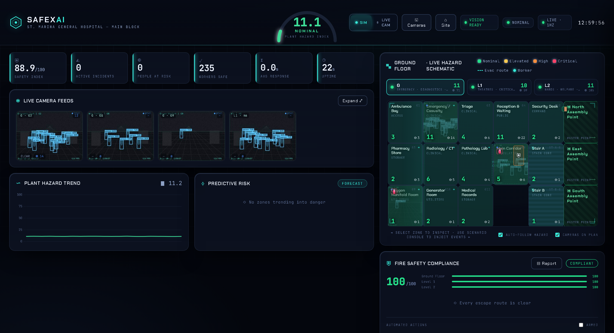
2. Front view — the complete interface in an alarm condition, showing the four-colour scale in use.
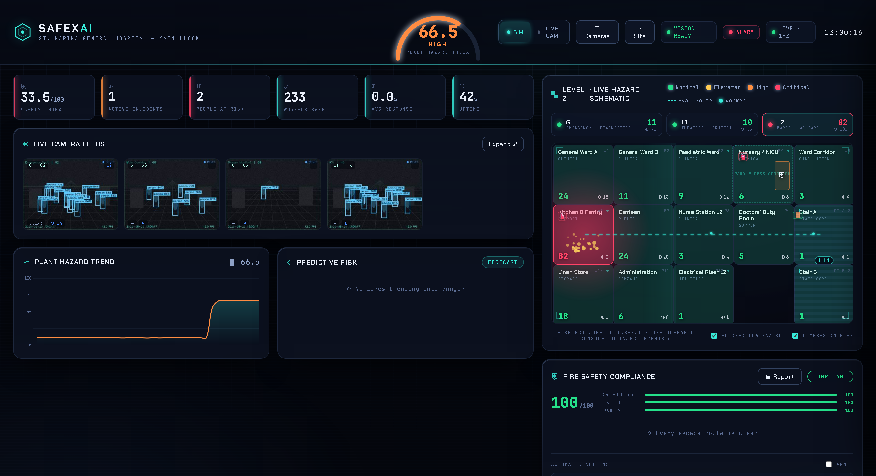
3. Enlarged view of the storey schematic panel.
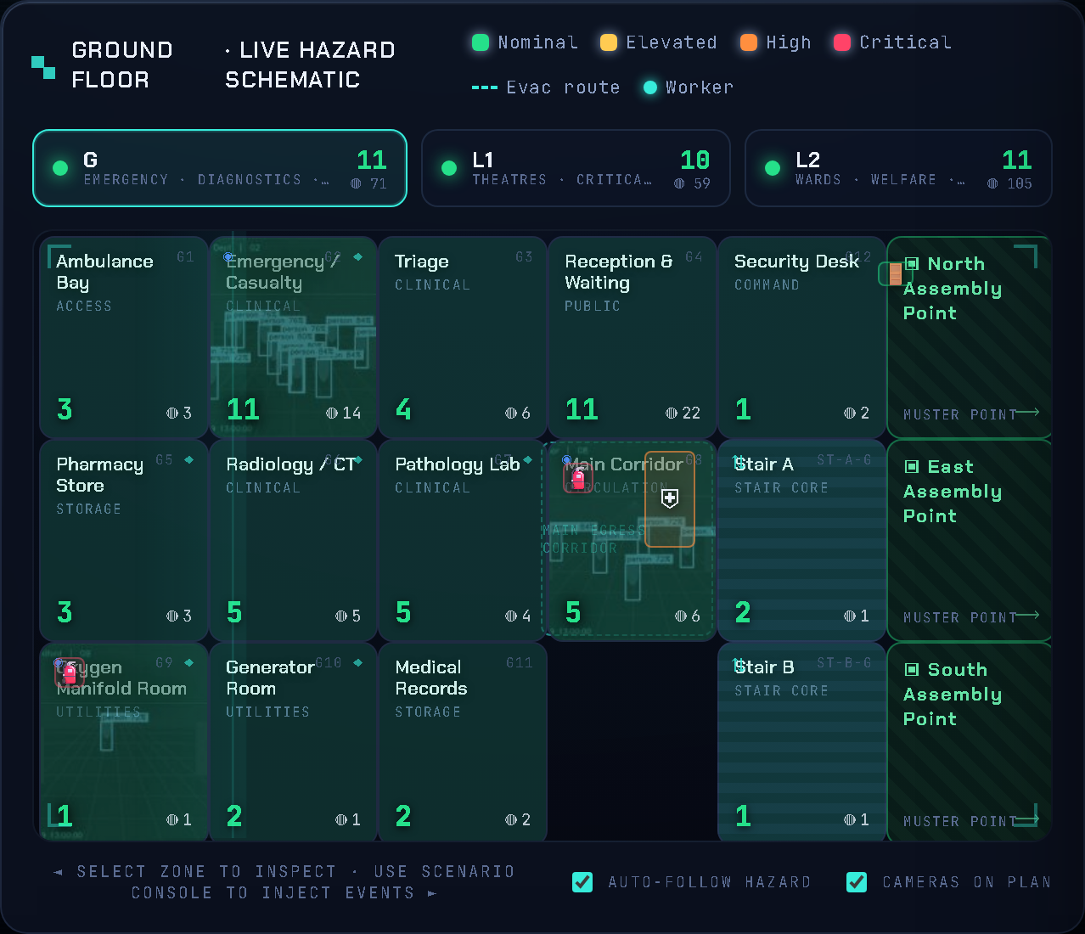
4. Enlarged view of the storey selector tab row.
5. Enlarged view of a single camera tile, normal and alarm states.
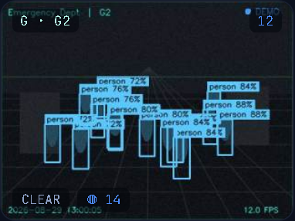
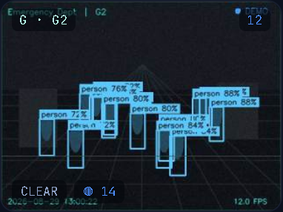
6. Enlarged view of a room tile carrying an inset live view.
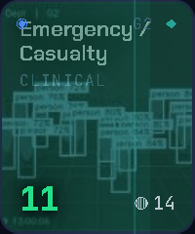
7. View of the interface with the route overlay drawn across the schematic.
