Department of Computer Science

Lab Manual

of

Tiny MACHINE LEARNING

(MAI524B-5)

Class Name: IV MCA

Master of Science Artificial Intelligence and Machine Learning

2026

Prepared by: Verified by:
Virani Meet Suershbhai 2548562
Dr. Helen K Joy

Department Overview
Department of Computer Science of CHRIST (Deemed to be University) strives to shape outstanding computer professionals with ethical and human values to reshape nation’s destiny. The training imparted aims to prepare young minds for the challenging opportunities in the IT industry with a global awareness rooted in the Indian soil, nourished and supported by experts in the field.

Vision
The Department of Computer Science endeavours to imbibe the vision of the University “Excellence and Service”. The department is committed to this philosophy which pervades every aspect and functioning of the department.

Mission
“To develop IT professionals with ethical and human values”. To accomplish our mission, the department encourages students to apply their acquired knowledge and skills towards professional achievements in their career. The department also moulds the students to be socially responsible and ethically sound.

Introduction to the Programme
Master of Computer Applications (MCA) is a post-graduate programme of CHRIST (Deemed to be University) and approved by the All India Council of Technical Education (AICTE). It is a two-year programme spread over six trimesters to bridge the chasm between computer studies and applications, bringing within reach of enthusiastic youngsters an excellent group of experienced and dedicated staff and experts, and an enviable infrastructure. MCA at CHRIST (Deemed to be University) strives to shape outstanding computer professionals with ethical and human values to reshape the nation’s destiny. The training programme aims to prepare young minds for challenging opportunities in the IT industry with a global awareness rooted in the Indian soil, nourished and supported by experts in the field. The Department is committed to the motto “Excellence and Service,” and this philosophy pervades every aspect of its functioning.

Programme Objective
This programme is conceptualised and designed based on the strong commitment of the
department to provide better quality education to the students. The principal objectives of this
course are to:
● Heighten technological awareness
● Train future industry specialists
● Encourage effective software development
● Provide research training
● Involve students in innovative research
● Produce graduates with a two-year professional education in Computer Science with
technical, professional, and communications skills.

Ethics and Human Values
1. Only proprietary or open-source software would be used for academic teaching and
learning purposes.
2. Copying of programs from the internet, friends or from other sources is strictly
discouraged since it impairs development of programming skills.
3. Unique Practical (Domain based) exercises ensure that the students don’t get involved in
code plagiarism.
4. Projects undertaken by students during the course are done in teams to improve
collaborative work and synergy between team members.
5. Projects involve modularization which initiates students to take individual responsibility
for common goals.
6. Passion for excellence is promoted among the students, be it in software development or
project documentation.
7. Giving due credit to sources during the seminar and research assignment is promoted
among the students
8. The course and its design enforce the practice of good referencing technique to improve
the sense of integrity.
9. Courses involving group discussions and debates on ethical practices and human values
are designed to sensitize the students in dealing with customers and members within the
Organization.

Programme Outcomes:
PO1 : Conduct investigation and develop innovative solutions for real world problems in industry and research establishments related to Artificial Intelligence and Machine Learning PO2 : Apply programming principles and practices for developing automation solutions to meet future business and society needs.
PO3 : Ability to use or develop the right tools to develop high end intelligent systems
PO4 : Adopt professional and ethical practices in Artificial Intelligence application development
PO5 : Understand the importance and the judicious use of technology for the sustainability of the environment.

Programme Educational Objectives(PEO’s)
PEO1: Develop innovative and effective software solutions through research that addresses
real-world challenges, grounded in a commitment to continuous learning and adaptability.
PEO2: Advance the knowledge and practices in the field of computer applications through
lifelong learning and rigorous research, supporting professional growth and academic excellence.
PEO3: Exhibit ethical leadership, social responsibility to contribute and enhance community
well-being by innovating solutions.

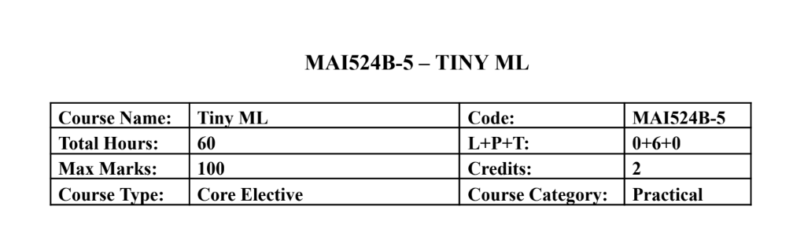Course Description
This course focuses on hands-on development of TinyML applications on mobile, edge, and
embedded platforms. Students learn the end to end workflow including data preparation,
lightweight model development, optimization, and deployment on microcontrollers using
sensors. Emphasis is placed on practical implementation using TensorFlow Lite, TensorFlow Lite
Micro, and embedded development environments with minimal theory and extensive laboratory
work.
Course Objectives
This course introduces the TinyML development workflow for edge intelligence and builds
practical skills in model optimization and embedded deployment. It enables students to develop
audio, vision, and sensor based TinyML applications and implement real time intelligent systems
using microcontrollers and hardware sensors.

Course Outcomes
CO1: Design TinyML workflows and lightweight models for edge devices.
CO2: Implement TensorFlow Lite-based optimisation and deployment.
CO3: Develop keyword spotting and visual TinyML applications.
CO4: Deploy sensor based TinyML solutions on embedded hardware.
CO5: Build end to end practical TinyML systems integrating hardware

Unit-1 Teaching Hours: 12
TINYML FOUNDATIONS AND WORKFLOW DESIGN
TinyML ecosystem overview – edge AI concepts – machine learning lifecycle – sensor roles in
TinyML – dataset planning – development environment setup – lightweight application
workflow design.Edge Computing vs Cloud Computing: A Comparative Demonstration of On
Device and Remote AI Inference
Practical Exercises:
1. Sensor data exploration and TinyML workflow planning using Colab.
2. Design and simulation of a TinyML application pipeline including preprocessing and
inference stages.

Unit-2 Teaching Hours: 12
TENSORFLOW LITE AND MODEL OPTIMIZATION
TensorFlow Lite workflow – model conversion – inference pipelines – low precision
computation – post training quantization – quantization aware training – performance
benchmarking.Human Activity Recognition Using Accelerometer and Multisensor Data
Practical Exercises:
3. Convert TensorFlow models to TensorFlow Lite and perform inference evaluation.
4. Implement quantization techniques and compare accuracy, latency, and memory usage.

Unit-3 Teaching Hours: 12
AUDIO TINYML AND KEYWORD SPOTTING
Keyword spotting architecture – audio preprocessing – MFCC and spectrogram features –
dataset preparation – training workflow – streaming audio inference.
Practical Exercises:
5. Train a keyword spotting model using speech datasets in Colab.
6. Deploy and test keyword spotting inference using live or recorded audio input.

Unit-4 Teaching Hours: 12
Visual Wake Words and Anomaly Detection
Visual wake word applications – transfer learning – lightweight vision models – anomaly
detection concepts – autoencoders and clustering – responsible dataset handling.Deploying a
Lightweight MLP and 1D CNN on Embedded Targets: Challenges and Performance Analysis
Practical Exercises:
7. Develop a visual wake word model using transfer learning techniques.
8. Build an anomaly detection system using sensor or industrial datasets.

Unit-5 Teaching Hours: 12
Embedded Deployment with TensorFlow Lite Micro
Microcontroller basics – embedded ML workflow – TensorFlow Lite Micro interpreter –
memory allocation – sensor integration – real time inference – deployment practices.
Practical Exercises:
9. Deploy a pretrained TinyML model on Arduino Nano 33 BLE Sense or equivalent
board.
10. Develop an integrated TinyML application such as gesture recognition, sensor anomaly
detection, or embedded keyword spotting.

Text & Reference Books
[1] TinyML, Pete Warden and Daniel Situnayake, O Reilly Media, First Edition, 2019
[2] Deep Learning with Python, Francois Chollet, Manning Publications, Second Edition,
2021
Essential Reading
[1] TinyML Cookbook, Gian Marco Iodice, Packt Publishing, First Edition, 2022
[2] Practical Edge AI, O Reilly Media, First Edition, 2023
Additional Information (Web Resources):
1. TensorFlow Lite Documentation: https://www.tensorflow.org/api_docs/python/tf/lite
2. TensorFlow Lite Micro GitHub Repository: https://github.com/tensorflow/tflite-micro
3. Arduino TinyML Tutorials:
https://docs.arduino.cc/tutorials/nano-33-ble-sense/get-started-with-machine-learning/
4. Edge Impulse TinyML Labs: https://www.edgeimpulse.com/
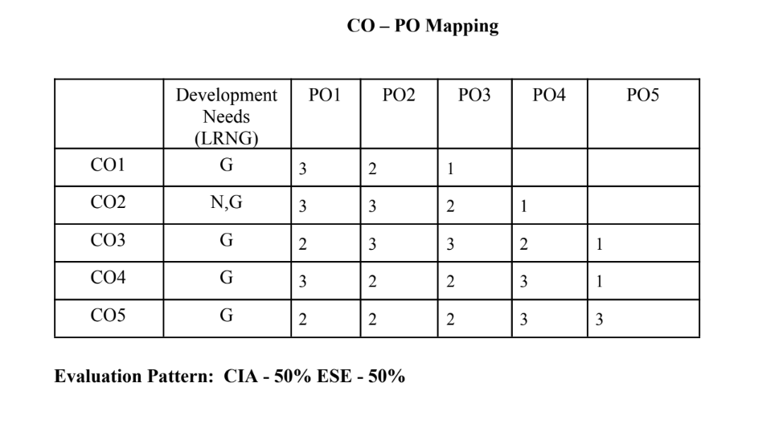

LIST OF PROGRAMS

MSCAIML
Sl.no | Title of lab Experiment | Page number | RBT | CO
1&2 | Real-Time Rotational Dynamics & Edge-AI Payload Safety System | 8 | L3 | CO1,3
3 | Multi-Class Human Activity Recognition & Model Quantization Scheme Analysis | 20 | L3 | CO2,3
4 | TinyML Lab: Quantization-Aware Training (QAT) vs Post-Training Quantization (PTQ) | 42 | L3 | CO2,3
5 | Voice Emergency Stop: Keyword Spotting Model with DS-CNN (Shout STOP!) | 59 | L3 | CO3
6 | Field Trial: Streaming Voice Emergency Stop Test on Recorded and Live Audio | 76 | L3 | CO3,4
7 |  |  | L4 | CO3
8 |  |  | L3 | CO3,4
9 |  |  | L3 | CO4,5
10 |  |  | L5 | CO5

Evaluation Rubrics:
Evaluation Rubrics for each program would be
EVALUATION RUBRICS
(R1) Concept Clarity (Viva) - 3 M
(R2) Code Execution - 3M
(R3) Complexity Addition (Self Learning) -2 M
(R4) Timely Submission - 2 M

Submission Guidelines:
- Make a copy of the lab manual template with your <name_reg:no_subject name >,
- Copy the given question and the answer (lab code) with results, followed by the conclusion of that lab. Title the lab as lab number.
- Keep updating your lab manual and show the lab manual of that particular lab for evaluation.
- Create a Git Repository in your profile <tiny_ML_lab-reg no> . Follow a different branch for each lab <Lab 1, Lab 2…>, and push the code to Git. The link should be provided in Google Classroom along with the PDF of the lab manual.
- Upload the PDF to Google Classroom before the deadline.

Lab 1&2: Real-Time Rotational Dynamics & Edge-AI Payload Safety System

Tools Required: Smartphone with phyphox app, flat rotating platform, small test payload (e.g., coin or eraser), Python 3.x (Google Colab / Jupyter).

1. Aim
To measure tri-axial angular velocityusing a smartphone's gyroscope via phyphox, derive the physical threshold for rotational static friction failure, extract time-series features, and build an optimized TinyML classification model to predict payload stability (SAFE vs. UNSAFE/FALL) on an edge device.

2. Scenario & Problem Statement
An autonomous warehouse mobile robot carries an unanchored payload on its top surface. A smartphone mounted to the chassis acts as the primary Inertial Measurement Unit (IMU). When the robot negotiates sharp turns at high angular speeds, centripetal forces exceed static friction, causing cargo to slide off.
Your Task:
- Physical Setup: Place a test object on the smartphone screen
- Data Acquisition: Use phyphox to log gyroscope data while gradually increasing tilt and rotation speed until the object slides off.
- Data Engineering: Process raw CSV data
- Edge ML Pipeline: Label windowed data into binary classes (0 = SAFE, 1 = UNSAFE/FALL), train a lightweight classifier, and quantize it to .tflite format for local edge execution.

3. Submission Deliverables
- Workflow of the problem.
- Raw Dataset: Exported phyphox_gyro_data.csv.
- Python Code Script and git repo : Complete pipeline covering feature extraction, threshold determination, model training, and .tflite export.
- Lab Report: Experimental coefficient of static friction ($\mu_s$), model confusion matrix, and TFLite model size footprint in kilobytes.

Evaluation Rubric (10 Marks Total)
Assessment Module | Performance Criteria | Marks
1. Data Acquisition & Preprocessing | • Proper experimental setup and clean data collection.  • Correct signal processing, normalization, and feature engineering. | / 3
2. Implementation & Model Optimization | • Correct implementation of baseline models and algorithms.  • Successful execution of optimization, quantization, or deployment pipelines. | / 3
3. Results Analysis, Code & Deliverables | • Complete benchmarking/results analysis (accuracy, memory, speed, or system metrics).  • Clean, well-documented code with a clear final technical report. | / 4
TOTAL SCORE: _____ / 10 MARKS

- Workflow Image
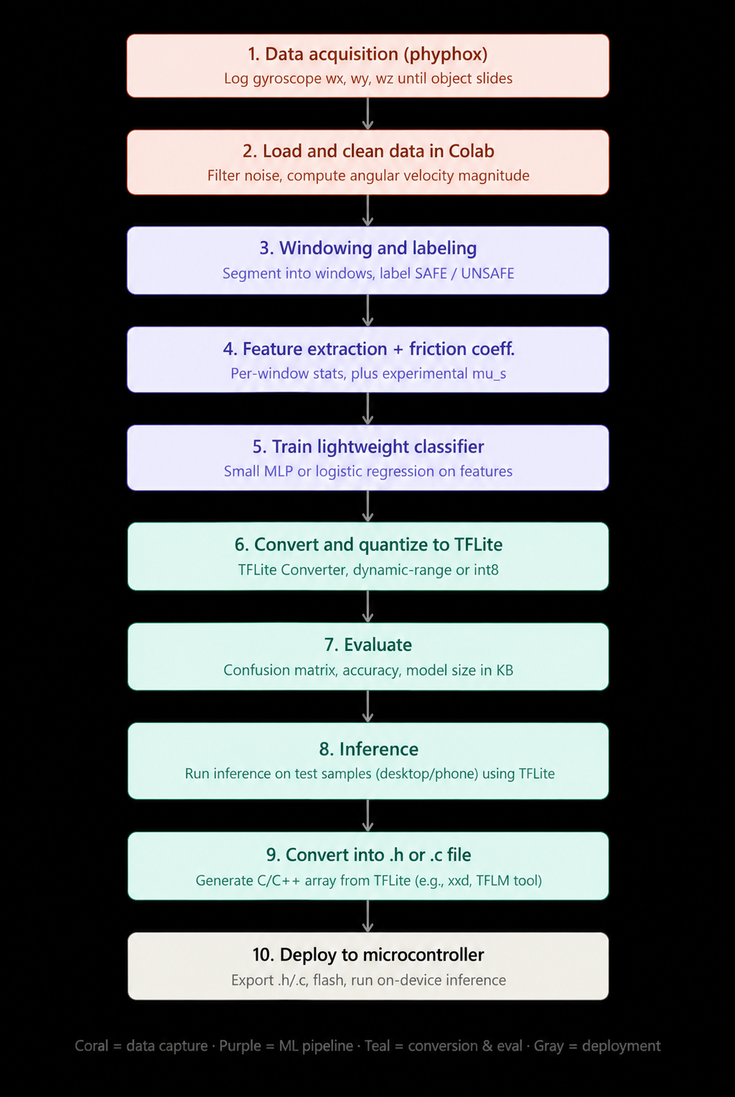

1. Aim
The aim of this lab was to measure tri-axial angular velocity using a smartphone's gyroscope via phyphox, derive the physical threshold for rotational static friction failure, extract time-series features, and build an optimized TinyML classification model to predict payload stability (SAFE vs. UNSAFE/FALL) suitable for edge deployment.

2. Scenario
An autonomous warehouse mobile robot carries an unanchored payload on its top surface. A smartphone mounted to the chassis acts as the primary Inertial Measurement Unit (IMU). When the robot negotiates sharp turns at high angular speeds, centripetal and tilt-induced forces exceed static friction, causing cargo to slide off. This lab models that scenario using a smartphone gyroscope and a small test object placed on the phone screen.

3. Methodology
Our pipeline followed these steps, in order (see the attached workflow diagram for the full visual):
● Physical setup: placed a small test object (coin/eraser) on the phone screen.
● Data acquisition: used phyphox to log tri-axial gyroscope data (wx, wy, wz) while gradually tilting and rotating the phone until the object slid off, repeated across 9 trials.
● Data cleaning: loaded the exported file in Google Colab, dropped the z-axis (rotation about the vertical, not relevant to tilt-based sliding), and applied light smoothing to reduce sensor noise.
● Trial detection: automatically identified each trial's boundary by detecting the still period we held after each fall.
● Windowing and labeling: segmented each trial into overlapping 1-second windows (50% overlap) and labeled each window SAFE (0) or UNSAFE (1) based on proximity to the fall point.
● Feature extraction: computed the maximum, mean, standard deviation, and rate of change of the tilt angular velocity magnitude for each window.
● Friction coefficient estimation: integrated the x and y angular velocities to estimate the tilt angle at the moment of slip, then computed mu_s = tan(theta_slip) for each trial.
● Model training: trained a lightweight logistic regression classifier (a single dense layer with sigmoid activation) on the extracted features.
● Quantization: converted and quantized the trained model to TensorFlow Lite using dynamic range quantization.
● Evaluation: measured accuracy and the confusion matrix on a held-out test set, and recorded the TFLite model size.
● Inference: ran the quantized model through the TFLite interpreter in Colab to simulate edge execution.

4. Results

4.1 Experimental coefficient of static friction (mu_s)
We estimated mu_s for each of our 9 trials by integrating the gyroscope's x and y angular velocity over the active phase of the trial to obtain the tilt angle at the moment of slip, then applying mu_s = tan(theta_slip).
Trial | Estimated mu_s
1 | 1.9757
2 | 0.4284
3 | 0.7875
4 | 4.9541
5 | 1.5038
6 | 0.4564
7 | 0.6542
8 | 0.8172
9 | 1.5404

Average mu_s across all 9 trials: 1.4575
Standard deviation: 1.3362
Note: gyroscope integration drifts over time, so this estimate should be read as an approximation rather than a precise physical measurement. Trials with longer active durations are more affected by this drift, which explains the wider spread in per-trial values.

4.2 Model and TFLite export
Metric | Value
Model type | Logistic regression (single dense layer, sigmoid)
Input features | max_mag, mean_mag, std_mag, rate_of_change
Quantization scheme | Dynamic range (int8 weights, float32 activations)
TFLite model size | 1.25 KB
Test set accuracy | 65.00%

4.3 Confusion matrix
Evaluated on the held-out test set (20 windows) using the quantized TFLite model through the TFLite interpreter:
 | Predicted SAFE | Predicted UNSAFE
Actual SAFE | 11 | 5
Actual UNSAFE | 2 | 2

Classification report:
Class | Precision | Recall | F1-score | Support
SAFE | 0.85 | 0.69 | 0.76 | 16
UNSAFE | 0.29 | 0.50 | 0.36 | 4

5. Code
The complete code of the notebook (2548562_Meet_TinyML_Lab1_2.ipynb), in the order it was run:
1. Setup
!pip install -q tensorflow scikit-learn pandas numpy matplotlib openpyxl

import numpy as np
import pandas as pd
import matplotlib.pyplot as plt
import tensorflow as tf
from sklearn.model_selection import train_test_split
from sklearn.metrics import confusion_matrix, accuracy_score, classification_report
from sklearn.utils.class_weight import compute_class_weight
import os

np.random.seed(42)
tf.random.set_seed(42)

# numpy renamed trapz to trapezoid in version 2.0, this keeps the notebook
# working either way
trapezoid = getattr(np, "trapezoid", None) or np.trapz
2. Load the raw data
FILENAME = "/content/drive/MyDrive/Datasets/Gyroscope (Rotation Rate) 2026-09-22 08-24-41.xlsx"

if FILENAME.endswith(".xlsx"):
df = pd.read_excel(FILENAME, sheet_name="Raw Data")
else:
df = pd.read_csv(FILENAME)

df.columns = ["t", "gx", "gy", "gz", "gabs"]
print("Rows:", len(df))
df.head()

from google.colab import drive
drive.mount('/content/drive')
3. Clean the data and compute the tilt magnitude
df = df[["t", "gx", "gy"]].copy()

WINDOW_SMOOTH = 3 # samples, keep this small so real motion is not lost
df["gx_smooth"] = df["gx"].rolling(WINDOW_SMOOTH, center=True, min_periods=1).mean()
df["gy_smooth"] = df["gy"].rolling(WINDOW_SMOOTH, center=True, min_periods=1).mean()
df["mag_xy"] = np.sqrt(df["gx_smooth"]**2 + df["gy_smooth"]**2)

sample_interval = df["t"].diff().median()
sampling_rate = 1 / sample_interval
print(f"Sampling rate: {sampling_rate:.2f} Hz")

plt.figure(figsize=(12, 3))
plt.plot(df["t"], df["mag_xy"])
plt.xlabel("Time (s)")
plt.ylabel("Tilt angular velocity magnitude (rad/s)")
plt.title("Gyroscope x-y magnitude over the full recording")
plt.show()
4. Detect trial boundaries automatically
STILL_THRESHOLD = 0.3 # rad/s, below this counts as "still"
MIN_STILL_DURATION = 1.5 # seconds, minimum length to count as a real still period

df["is_still"] = df["mag_xy"] < STILL_THRESHOLD
df["run_id"] = (df["is_still"] != df["is_still"].shift()).cumsum()

runs = df.groupby("run_id").agg(
start_t=("t", "first"),
end_t=("t", "last"),
is_still=("is_still", "first"),
).reset_index(drop=True)
runs["duration"] = runs["end_t"] - runs["start_t"]

still_periods = runs[(runs["is_still"]) & (runs["duration"] > MIN_STILL_DURATION)].reset_index(drop=True)
print(f"Detected {len(still_periods)} still periods (trials)")
still_periods

# Build the list of active trial segments: (segment_start_t, fall_t)
# fall_t is the start of each still period, which marks the slide moment.
trial_segments = []
prev_end = df["t"].iloc[0]

for _, row in still_periods.iterrows():
fall_t = row["start_t"]
if fall_t - prev_end > 1.0: # ignore tiny slivers between trials
trial_segments.append((prev_end, fall_t))
prev_end = row["end_t"]

print(f"Found {len(trial_segments)} trial segments")
for i, (s, f) in enumerate(trial_segments):
print(f"Trial {i + 1}: active from {s:.2f}s to {f:.2f}s (duration {f - s:.2f}s)")
5. Window the data and label each window
WINDOW_SIZE = 1.0 # seconds
STEP_SIZE = 0.5 # seconds, 50 percent overlap
UNSAFE_BUFFER = 1.0 # seconds before the fall point counted as UNSAFE

def make_windows(df, seg_start, seg_end, fall_t):
windows = []
w_start = seg_start
while w_start + WINDOW_SIZE <= seg_end:
w_end = w_start + WINDOW_SIZE
mask = (df["t"] >= w_start) & (df["t"] < w_end)
chunk = df.loc[mask]
if len(chunk) >= 5: # skip windows with too few samples
label = 1 if (fall_t - w_end) <= UNSAFE_BUFFER else 0
windows.append((chunk, label, w_start, w_end))
w_start += STEP_SIZE
return windows

all_windows = []
for seg_start, fall_t in trial_segments:
all_windows.extend(make_windows(df, seg_start, fall_t, fall_t))

labels = [w[1] for w in all_windows]
print(f"Total windows: {len(all_windows)}")
print(f"SAFE (0): {labels.count(0)} UNSAFE (1): {labels.count(1)}")
6. Extract features from each window
def extract_features(chunk):
mag = chunk["mag_xy"].values
return {
"max_mag": np.max(mag),
"mean_mag": np.mean(mag),
"std_mag": np.std(mag),
"rate_of_change": (mag[-1] - mag[0]) / (chunk["t"].iloc[-1] - chunk["t"].iloc[0] + 1e-6),
}

feature_rows = []
for chunk, label, w_start, w_end in all_windows:
feats = extract_features(chunk)
feats["label"] = label
feature_rows.append(feats)

features_df = pd.DataFrame(feature_rows)
features_df.head()
7. Calculate the experimental coefficient of static friction
def estimate_mu_s(df, seg_start, fall_t):
mask = (df["t"] >= seg_start) & (df["t"] <= fall_t)
chunk = df.loc[mask].reset_index(drop=True)
if len(chunk) < 2:
return None

t = chunk["t"].values
gx = chunk["gx_smooth"].values
gy = chunk["gy_smooth"].values

theta_x = trapezoid(gx, t)
theta_y = trapezoid(gy, t)
theta_slip = np.sqrt(theta_x**2 + theta_y**2) # radians

return np.tan(theta_slip), theta_slip

mu_s_values = []
for seg_start, fall_t in trial_segments:
result = estimate_mu_s(df, seg_start, fall_t)
if result is not None:
mu_s_values.append(result[0])

mu_s_values = np.array(mu_s_values)
mu_s_values = mu_s_values[np.isfinite(mu_s_values)]

print("Per trial mu_s estimates:", np.round(mu_s_values, 4))
print(f"Average mu_s: {mu_s_values.mean():.4f}")
print(f"Std dev: {mu_s_values.std():.4f}")
8. Train a lightweight classifier
feature_cols = ["max_mag", "mean_mag", "std_mag", "rate_of_change"]
X = features_df[feature_cols].values.astype(np.float32)
y = features_df["label"].values.astype(np.float32)

# Normalize features. We save these values since the same scaling
# must be applied before running inference later.
feat_mean = X.mean(axis=0)
feat_std = X.std(axis=0) + 1e-6
X_norm = (X - feat_mean) / feat_std

X_train, X_test, y_train, y_test = train_test_split(
X_norm, y, test_size=0.25, random_state=42, stratify=y
)

class_weights = compute_class_weight("balanced", classes=np.array([0, 1]), y=y_train)
class_weight_dict = {0: class_weights[0], 1: class_weights[1]}

model = tf.keras.Sequential([
tf.keras.layers.Input(shape=(len(feature_cols),)),
tf.keras.layers.Dense(1, activation="sigmoid"),
])

model.compile(optimizer="adam", loss="binary_crossentropy", metrics=["accuracy"])

history = model.fit(
X_train, y_train,
validation_data=(X_test, y_test),
epochs=50,
batch_size=8,
class_weight=class_weight_dict,
verbose=0,
)

print("Final training accuracy:", history.history["accuracy"][-1])
print("Final validation accuracy:", history.history["val_accuracy"][-1])
9. Convert and quantize to TFLite
converter = tf.lite.TFLiteConverter.from_keras_model(model)
converter.optimizations = [tf.lite.Optimize.DEFAULT]
tflite_model = converter.convert()

TFLITE_PATH = "payload_safety_model.tflite"
with open(TFLITE_PATH, "wb") as f:
f.write(tflite_model)

model_size_kb = os.path.getsize(TFLITE_PATH) / 1024
print(f"TFLite model size: {model_size_kb:.2f} KB")
10. Evaluate the TFLite model
interpreter = tf.lite.Interpreter(model_path=TFLITE_PATH)
interpreter.allocate_tensors()
input_details = interpreter.get_input_details()
output_details = interpreter.get_output_details()

def tflite_predict(interpreter, X):
preds = []
for row in X:
row = row.reshape(1, -1).astype(np.float32)
interpreter.set_tensor(input_details[0]["index"], row)
interpreter.invoke()
out = interpreter.get_tensor(output_details[0]["index"])
preds.append(out[0][0])
return np.array(preds)

y_scores = tflite_predict(interpreter, X_test)
y_pred = (y_scores >= 0.5).astype(int)

acc = accuracy_score(y_test, y_pred)
cm = confusion_matrix(y_test, y_pred)

print(f"Test accuracy: {acc * 100:.2f}%")
print("\nConfusion matrix (rows are true labels, columns are predicted):")
print(cm)
print("\n", classification_report(y_test, y_pred, target_names=["SAFE", "UNSAFE"]))

plt.figure(figsize=(4, 4))
plt.imshow(cm, cmap="Blues")
plt.title("Confusion matrix")
plt.xlabel("Predicted")
plt.ylabel("True")
plt.xticks([0, 1], ["SAFE", "UNSAFE"])
plt.yticks([0, 1], ["SAFE", "UNSAFE"])
for i in range(2):
for j in range(2):
plt.text(j, i, str(cm[i, j]), ha="center", va="center", color="black")
plt.colorbar()
plt.show()
11. Run inference in Colab
def predict_from_window(chunk):
feats = extract_features(chunk)
x = np.array([[feats["max_mag"], feats["mean_mag"], feats["std_mag"], feats["rate_of_change"]]], dtype=np.float32)
x_norm = (x - feat_mean) / feat_std

interpreter.set_tensor(input_details[0]["index"], x_norm.astype(np.float32))
interpreter.invoke()
score = interpreter.get_tensor(output_details[0]["index"])[0][0]
label = "UNSAFE" if score >= 0.5 else "SAFE"
return label, score

# Try it on a handful of random windows from the full dataset
sample_indices = np.random.choice(len(all_windows), size=5, replace=False)
for idx in sample_indices:
chunk, true_label, w_start, w_end = all_windows[idx]
pred_label, score = predict_from_window(chunk)
true_str = "UNSAFE" if true_label == 1 else "SAFE"
print(f"Window {w_start:.2f}s to {w_end:.2f}s | true: {true_str} | predicted: {pred_label} (score {score:.3f})")

5.1 Output graphs
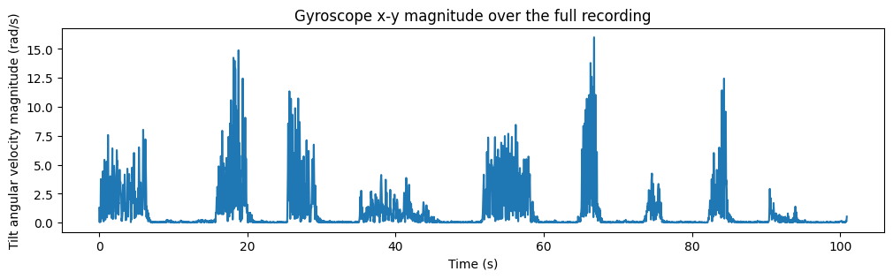
Figure: Tilt angular velocity magnitude of the recorded gyroscope data.
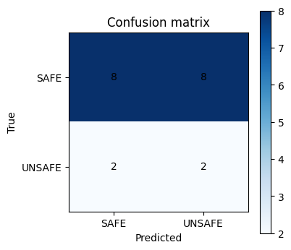
Figure: Confusion matrix of the quantized TFLite model on the test windows.

6. Discussion of Results
Our classifier's accuracy (65%) was lower than we had hoped for, and below what simply predicting the majority class (SAFE) would have achieved on this test set (80%). We do not believe this reflects an error in our pipeline, but rather a set of limitations in our data collection that are worth being transparent about:
● Very little data: our 9 trials produced only around 80 windows in total, a small sample for any classifier to learn a reliable decision boundary from.
● Class imbalance: SAFE windows outnumbered UNSAFE windows by roughly three to one, so a model that has barely learned anything meaningful can still score reasonably well by leaning toward the majority class.
● Weak feature separation: the four features we used (max, mean, standard deviation, and rate of change of tilt magnitude) did not appear to differ enough between SAFE and UNSAFE windows to give the classifier a clear signal.
● Gyroscope drift and labeling noise: since we approximated the exact slip moment rather than marking it precisely (for example with a video or audio cue), some windows near that boundary may be mislabeled.
● Overlapping windows: with 50% overlap between windows, neighboring windows are highly similar, so the effective diversity of our dataset is lower than the raw window count suggests.
Given more time, we believe the most direct way to improve our results would be to collect more trials, in particular more UNSAFE examples, and with more contrast between SAFE and UNSAFE motion, for example holding a clearly slow and steady tilt for SAFE windows and a clearly fast one right before UNSAFE windows. We see this as a natural next step beyond the scope of what we were able to complete for this submission.

7. Conclusion
We successfully built an end-to-end pipeline that collects gyroscope data, automatically detects trials, extracts windowed features, estimates the coefficient of static friction, trains a lightweight classifier, and exports a quantized TFLite model small enough for edge deployment (1.25 KB). While our current classification accuracy is limited by the small size and imbalance of our dataset, the pipeline itself is complete and would benefit directly from additional data collection.

8. Deliverables Submitted
● Workflow diagram of the problem.
● Raw dataset: exported phyphox gyroscope file.
● Python code: 2548562_Meet_TinyML_Lab1_2.ipynb, covering feature extraction, threshold determination, model training, and .tflite export.
● This lab report: experimental mu_s, confusion matrix, and TFLite model size.

Lab 3: Multi-Class Human Activity Recognition & Model Quantization Scheme Analysis

Course Outcomes: CO1, CO2
Total Marks: 10 Marks

1. Aim
To collect multi-axis accelerometer motion data for three distinct activity classes (Idle, Walking, and Sit-ups) using phyphox, train a 3-class Human Activity Recognition (HAR) classifier, implement three TensorFlow Lite model quantization techniques, and systematically benchmark their effects on memory footprint, execution speed, and classification accuracy.

2. Lab Question & Problem Statement
Scenario:
You are an Embedded AI Engineer designing an activity-tracking algorithm for an ultralow-power wearable device. The device must run on-device inference to classify physical activity states (Idle/Static, Walking/Locomotion, and Sit-ups/Repetitive Exercise) without sending raw sensor streams to the cloud. Before deploying the model to hardware, you are tasked with conducting an optimization study comparing the trade-offs between accuracy retention, RAM/ROM footprint, and execution speed across different quantization paradigms.

Your Task:

- Data Acquisition: Secure your smartphone against your chest or waist. Use phyphox > Accelerometer (or Linear Acceleration) to collect sensor streams for three distinct activity states: Idle/Sitting, Walking, and Sit-ups. Export the raw files as idle.csv, walking.csv, and situps.csv.

- Feature Extraction & Processing: Segment continuous acceleration streams into 1-second window intervals (100 samples/sec). Compute the 3D acceleration vector magnitude:

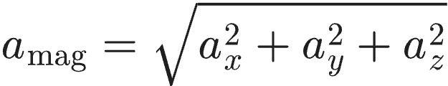
- Extract statistical features per window interval:

Mean Acceleration (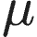):

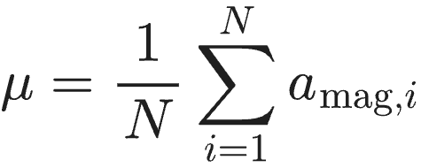
Standard Deviation ():

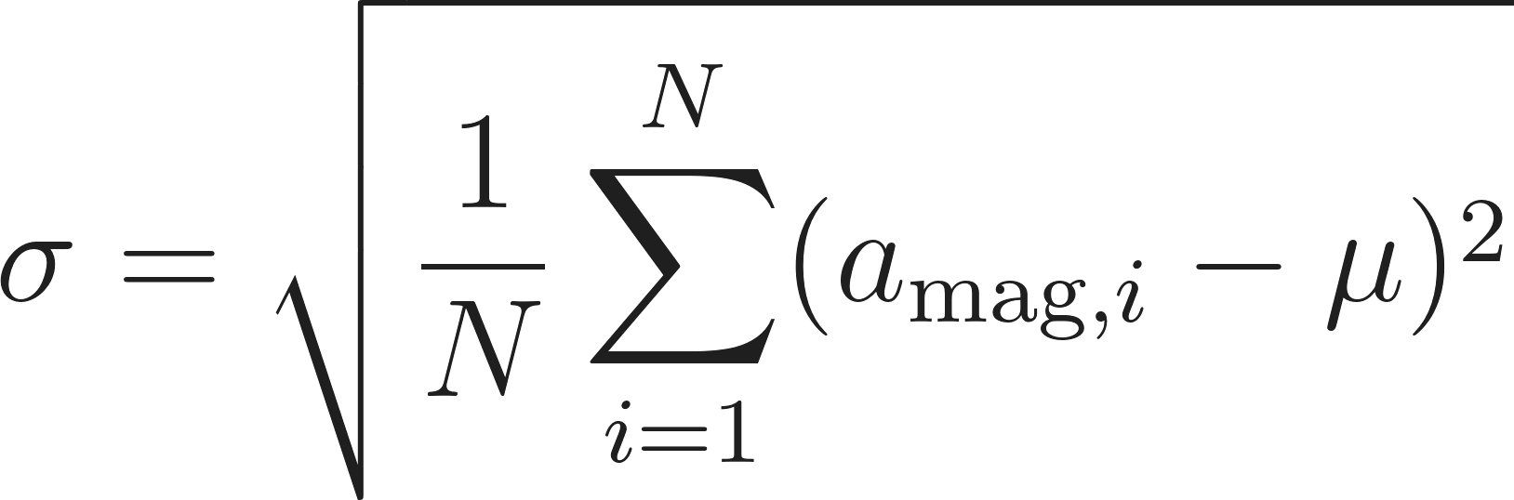
Root Mean Square ():

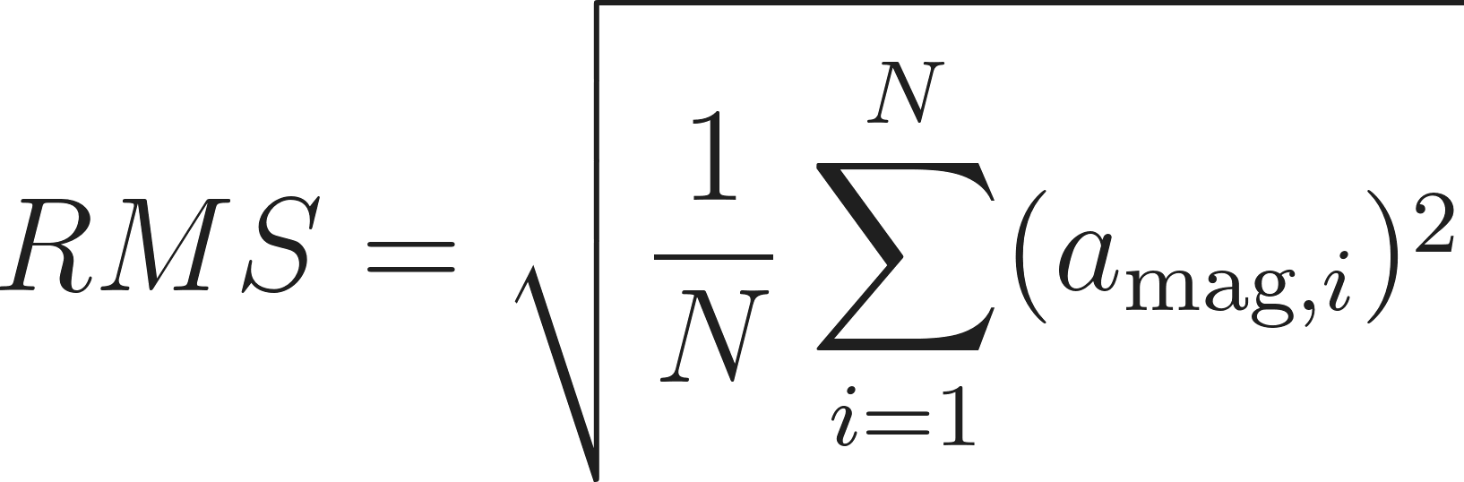
- Model Development: Train a baseline 3-class Multi-Layer Perceptron (MLP) neural network in Python / Google Colab using the extracted feature matrices.

- Quantization Comparison Experiment: Convert the baseline model into four distinct TensorFlow Lite variants:
Variant A: Unquantized Baseline (Float32)

Variant B: Dynamic Range Quantization (Weights quantized to int8, activations in float32)

Variant C: Float16 Quantization (Weights converted to 16-bit float)

Variant D: Full Integer Quantization (Weights and activations strictly quantized to int8 using a representative calibration dataset)

- Comparative Analysis: Benchmark all four variants on the test dataset and record model file sizes (in KB), test classification accuracy (%), memory reduction (%), and average inference execution time () per window.

3. Submission Deliverables
- Raw Datasets and work flow diagram : idle.csv, walking.csv, and situps.csv collected via phyphox.
- Python Script: Complete pipeline implementing windowing, 3-class model training, generation of all 4 TFLite quantisation variants, and automated latency/memory benchmarking.
- Quantisation Benchmarking Report: Completed evaluation table and analysis explaining why full integer quantisation is required for microcontroller deployment.

4. Benchmarking Results Table (To Be Completed by Student)
Quantization Scheme | Target Data Type | Model Size (KB) | Accuracy (%) | Memory Reduction (%)
Baseline (Unquantized) | Float32 | 4.81 | 77.78% | 0.00%
Dynamic Range | Weights int8, Act float32 | 4.81 | 77.78% | 0.00%
Float16 Quantization | Float16 | 4.19 | 77.78% | 12.91%
Full Integer (PTQ) | Weights int8, Act int8 | 4.37 | 77.78% | 9.25%

5. Evaluation Rubric (10 Marks Total)

Assessment Module | Performance Criteria | Marks
1. Data Acquisition & Preprocessing | • Proper experimental setup and clean data collection.  • Correct signal processing, normalization, and feature engineering. | / 3
2. Implementation & Model Optimization | • Correct implementation of baseline models and algorithms.  • Successful execution of optimization, quantization, or deployment pipelines. | / 3
3. Results Analysis, Code & Deliverables | • Complete benchmarking/results analysis (accuracy, memory, speed, or system metrics).  • Clean, well-documented code with a clear final technical report. | / 4
TOTAL SCORE: _____ / 10 MARKS

- Workflow Image
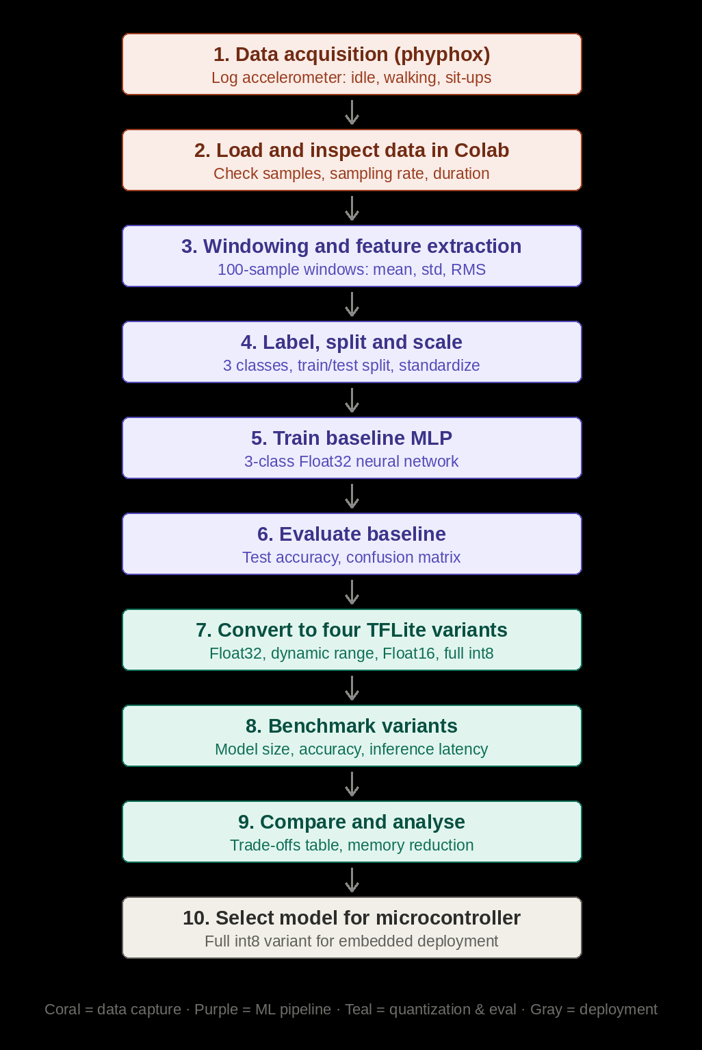

1. Aim
The aim of this lab was to collect accelerometer data for three activities (Idle, Walking and Sit-ups) using phyphox, extract simple features from 1-second windows, and train a 3-class MLP classifier. We then converted the model into four TensorFlow Lite versions and compared their model size, accuracy, memory reduction and inference time.

2. Scenario
We took the role of an embedded AI engineer who is designing an activity tracker for a very low-power wearable device. The device must tell Idle, Walking and Sit-ups apart on the device itself, without sending raw sensor data to the cloud. Before putting the model on hardware, we studied how different quantization methods change accuracy, memory use and speed.

3. Methodology
Our pipeline followed these steps, in order (see the attached workflow diagram for the full visual):
● Data acquisition: used phyphox to record accelerometer data for three activities, Idle, Walking and Sit-ups, for about 20 seconds each at about 100 samples per second. The data was exported as idle.csv, walking.csv and situps.csv.
● Data inspection: loaded the three files in Google Colab and checked the number of samples, the sampling rate (about 99.7 Hz) and the duration of each recording.
● Windowing and feature extraction: calculated the acceleration magnitude from the x, y and z axes, cut the signal into windows of 100 samples (1 second), and computed the mean, standard deviation and RMS of each window. This gave 19 windows per activity and 57 windows in total.
● Labeling, splitting and scaling: labeled the windows as Idle = 0, Walking = 1 and Sit-ups = 2, split them into 70% training and 30% testing (stratified, so every class is equally represented), and standardized the features using the training data only.
● Model training: trained a small MLP with two hidden layers (32 and 16 neurons with ReLU) and a 3-neuron softmax output, for 80 epochs using the Adam optimizer.
● Baseline evaluation: measured the test accuracy, confusion matrix and classification report of the Float32 model on the 18 test windows.
● Quantization: converted the model into four TensorFlow Lite versions: Float32 (no quantization), dynamic range, Float16 and full integer (int8). The full integer version used a representative dataset taken from the training features.
● Benchmarking: ran all four versions through the TFLite interpreter on the same test windows and measured the file size, accuracy, memory reduction and average inference time.
● Analysis: compared the four versions and explained the trade-offs between size, accuracy and speed.
● Model selection: the full integer (int8) version is the one recommended for a microcontroller. Deployment on hardware was not part of this lab.

4. Results

4.1 Dataset summary
Each recording was about 20 seconds long. Every 100 samples were treated as one 1-second window, and only complete windows were used.
Activity | Samples | Duration (s) | Sampling rate (Hz) | Windows
Idle | 1993 | 19.99 | 99.67 | 19
Walking | 1994 | 20.00 | 99.66 | 19
Sit-ups | 1992 | 19.98 | 99.64 | 19

Total windows: 57 (39 for training and 18 for testing, 6 test windows per class)

4.2 Model and baseline result
Metric | Value
Model type | MLP (3 inputs, hidden layers of 32 and 16 neurons, 3 outputs)
Input features | mean, std, rms
Number of parameters | 707 (2.76 KB)
Optimizer and loss | Adam, sparse categorical cross-entropy
Training setup | 80 epochs, batch size 8, 20% validation split
Baseline test accuracy | 77.78%

4.3 Confusion matrix
Evaluated on the held-out test set (18 windows) using the baseline Float32 model:
 | Predicted Idle | Predicted Walking | Predicted Sit-ups
Actual Idle | 6 | 0 | 0
Actual Walking | 1 | 2 | 3
Actual Sit-ups | 0 | 0 | 6

Classification report:
Class | Precision | Recall | F1-score | Support
Idle | 0.86 | 1.00 | 0.92 | 6
Walking | 1.00 | 0.33 | 0.50 | 6
Sit-ups | 0.67 | 1.00 | 0.80 | 6
Accuracy |  |  | 0.78 | 18
Macro average | 0.84 | 0.78 | 0.74 | 18
Weighted average | 0.84 | 0.78 | 0.74 | 18

4.4 Quantization benchmark
All four versions were tested on the same 18 test windows. Memory reduction is calculated against the Float32 model. Inference time is the average over 200 runs on the Colab CPU.
Quantization scheme | Target data type | Model size (KB) | Accuracy (%) | Memory reduction (%) | Avg inference time (us)
Baseline (Unquantized) | Float32 | 4.81 | 77.78 | 0.00 | 4.82
Dynamic Range | Weights int8, activations float32 | 4.81 | 77.78 | 0.00 | 4.64
Float16 Quantization | Float16 | 4.19 | 77.78 | 12.91 | 5.68
Full Integer (INT8) | Weights int8, activations int8 | 4.37 | 77.78 | 9.25 | 6.36

Note: the inference times were measured on the Colab CPU, not on a microcontroller, so they only show how the models behave on this machine.

5. Code
The complete code of the notebook (2548562_TML_LAB2_3.ipynb), in the order it was run:
Dataset
# Import required libraries

import os
import time
import random
import numpy as np
import pandas as pd
import matplotlib.pyplot as plt

from sklearn.model_selection import train_test_split
from sklearn.preprocessing import StandardScaler
from sklearn.metrics import accuracy_score, classification_report, confusion_matrix

import tensorflow as tf

print("TensorFlow version:", tf.__version__)

# Reproducibility
SEED = 42

np.random.seed(SEED)
random.seed(SEED)
tf.random.set_seed(SEED)

# File paths

IDLE_FILE = "idle.csv"
WALKING_FILE = "walking.csv"
SITUPS_FILE = "situps.csv"

# If the files are already available in Colab, this cell will load them.
# Otherwise upload them manually using the Colab file panel.

idle_df = pd.read_csv(IDLE_FILE)
walking_df = pd.read_csv(WALKING_FILE)
situps_df = pd.read_csv(SITUPS_FILE)

print("Idle shape:", idle_df.shape)
print("Walking shape:", walking_df.shape)
print("Sit-ups shape:", situps_df.shape)

display(idle_df.head())
Checking the Sensor Data
# Basic dataset inspection

for name, df in {
"Idle": idle_df,
"Walking": walking_df,
"Sit-ups": situps_df
}.items():

print(f"\n{name}")
print("-" * 40)
print("Number of samples:", len(df))
print("Columns:", list(df.columns))

dt = df["time_s"].diff().dropna()

print("Approx. sampling interval:", round(dt.median(), 6), "seconds")
print("Approx. sampling rate:", round(1 / dt.median(), 2), "Hz")
print("Duration:", round(df["time_s"].iloc[-1] - df["time_s"].iloc[0], 2), "seconds")
Feature Extraction
WINDOW_SIZE = 100

def extract_features(df, label, window_size=100):
"""
Convert raw accelerometer data into window-level features.

Each window contains 100 samples.
Three features are calculated:
mean, standard deviation, RMS.
"""

# Calculate acceleration magnitude directly from X, Y and Z
magnitude = np.sqrt(
df["acc_x"].values ** 2 +
df["acc_y"].values ** 2 +
df["acc_z"].values ** 2
)

features = []

# Only use complete windows
number_of_windows = len(magnitude) // window_size

for i in range(number_of_windows):

start = i * window_size
end = start + window_size

window = magnitude[start:end]

mean_acc = np.mean(window)
std_acc = np.std(window)
rms_acc = np.sqrt(np.mean(window ** 2))

features.append([
mean_acc,
std_acc,
rms_acc,
label
])

return pd.DataFrame(
features,
columns=["mean", "std", "rms", "label"]
)

idle_features = extract_features(
idle_df,
label="Idle",
window_size=WINDOW_SIZE
)

walking_features = extract_features(
walking_df,
label="Walking",
window_size=WINDOW_SIZE
)

situps_features = extract_features(
situps_df,
label="Sit-ups",
window_size=WINDOW_SIZE
)

print("Idle windows:", len(idle_features))
print("Walking windows:", len(walking_features))
print("Sit-ups windows:", len(situps_features))

# Combine all activity windows

feature_df = pd.concat(
[
idle_features,
walking_features,
situps_features
],
ignore_index=True
)

print("Total windows:", len(feature_df))

display(feature_df.head(10))

print("\nClass distribution:")
print(feature_df["label"].value_counts())
Feature Matrix
# Convert class names to numerical labels

label_map = {
"Idle": 0,
"Walking": 1,
"Sit-ups": 2
}

feature_df["label_id"] = feature_df["label"].map(label_map)

X = feature_df[["mean", "std", "rms"]].values.astype(np.float32)
y = feature_df["label_id"].values.astype(np.int32)

print("X shape:", X.shape)
print("y shape:", y.shape)

print("\nFirst five feature rows:")
print(X[:5])

print("\nFirst five labels:")
print(y[:5])
Train-Test Split
# Split the dataset

X_train, X_test, y_train, y_test = train_test_split(
X,
y,
test_size=0.30,
random_state=SEED,
stratify=y
)

print("Training samples:", len(X_train))
print("Testing samples:", len(X_test))

print("\nTraining class distribution:")
print(pd.Series(y_train).value_counts().sort_index())

print("\nTesting class distribution:")
print(pd.Series(y_test).value_counts().sort_index())
Feature Scaling
# Standardize features

scaler = StandardScaler()

X_train_scaled = scaler.fit_transform(X_train).astype(np.float32)
X_test_scaled = scaler.transform(X_test).astype(np.float32)

print("Scaled training data:")
print(X_train_scaled[:5])

print("\nTraining mean:")
print(X_train_scaled.mean(axis=0))

print("\nTraining standard deviation:")
print(X_train_scaled.std(axis=0))
MLP Model
# Build the baseline MLP

model = tf.keras.Sequential([
tf.keras.layers.Input(shape=(3,)),
tf.keras.layers.Dense(32, activation="relu"),
tf.keras.layers.Dense(16, activation="relu"),
tf.keras.layers.Dense(3, activation="softmax")
])

model.compile(
optimizer="adam",
loss="sparse_categorical_crossentropy",
metrics=["accuracy"]
)

model.summary()

# Train the baseline model

history = model.fit(
X_train_scaled,
y_train,
validation_split=0.20,
epochs=80,
batch_size=8,
verbose=1
)

# Plot training history

plt.figure(figsize=(12, 4))

plt.subplot(1, 2, 1)
plt.plot(history.history["accuracy"], label="Training Accuracy")
plt.plot(history.history["val_accuracy"], label="Validation Accuracy")
plt.xlabel("Epoch")
plt.ylabel("Accuracy")
plt.title("Training and Validation Accuracy")
plt.legend()

plt.subplot(1, 2, 2)
plt.plot(history.history["loss"], label="Training Loss")
plt.plot(history.history["val_loss"], label="Validation Loss")
plt.xlabel("Epoch")
plt.ylabel("Loss")
plt.title("Training and Validation Loss")
plt.legend()

plt.tight_layout()
plt.show()
Baseline Evaluation
# Evaluate baseline model

baseline_loss, baseline_accuracy = model.evaluate(
X_test_scaled,
y_test,
verbose=0
)

print(f"Baseline Test Accuracy: {baseline_accuracy * 100:.2f}%")

# Predictions
baseline_probs = model.predict(X_test_scaled, verbose=0)
baseline_pred = np.argmax(baseline_probs, axis=1)

print("\nClassification Report:")
print(
classification_report(
y_test,
baseline_pred,
target_names=["Idle", "Walking", "Sit-ups"],
zero_division=0
)
)

# Confusion matrix

cm = confusion_matrix(y_test, baseline_pred)

plt.figure(figsize=(6, 5))
plt.imshow(cm)

plt.xticks(
[0, 1, 2],
["Idle", "Walking", "Sit-ups"]
)

plt.yticks(
[0, 1, 2],
["Idle", "Walking", "Sit-ups"]
)

plt.xlabel("Predicted Class")
plt.ylabel("Actual Class")
plt.title("Baseline Confusion Matrix")

for i in range(3):
for j in range(3):
plt.text(
j,
i,
cm[i, j],
ha="center",
va="center"
)

plt.colorbar()
plt.show()
TensorFlow Lite Quantization
# Convert the baseline model to TensorFlow Lite Float32

converter = tf.lite.TFLiteConverter.from_keras_model(model)

tflite_float32 = converter.convert()

with open("/content/model_float32.tflite", "wb") as f:
f.write(tflite_float32)

print("Float32 model created.")

# Variant B: Dynamic Range Quantization

converter_dynamic = tf.lite.TFLiteConverter.from_keras_model(model)

converter_dynamic.optimizations = [
tf.lite.Optimize.DEFAULT
]

tflite_dynamic = converter_dynamic.convert()

with open("/content/model_dynamic_range.tflite", "wb") as f:
f.write(tflite_dynamic)

print("Dynamic Range model created.")

# Variant C: Float16 Quantization

converter_float16 = tf.lite.TFLiteConverter.from_keras_model(model)

converter_float16.optimizations = [
tf.lite.Optimize.DEFAULT
]

converter_float16.target_spec.supported_types = [
tf.float16
]

tflite_float16 = converter_float16.convert()

with open("/content/model_float16.tflite", "wb") as f:
f.write(tflite_float16)

print("Float16 model created.")
Representative Dataset for Full Integer Quantization
# Representative dataset for full integer quantization

def representative_dataset():
# Use a subset of training data for calibration
calibration_data = X_train_scaled[:min(100, len(X_train_scaled))]

for sample in calibration_data:
sample = sample.reshape(1, 3).astype(np.float32)
yield [sample]

# Variant D: Full Integer Quantization

converter_int8 = tf.lite.TFLiteConverter.from_keras_model(model)

converter_int8.optimizations = [
tf.lite.Optimize.DEFAULT
]

converter_int8.representative_dataset = representative_dataset

converter_int8.target_spec.supported_ops = [
tf.lite.OpsSet.TFLITE_BUILTINS_INT8
]

converter_int8.inference_input_type = tf.int8
converter_int8.inference_output_type = tf.int8

tflite_int8 = converter_int8.convert()

with open("/content/model_full_integer_int8.tflite", "wb") as f:
f.write(tflite_int8)

print("Full Integer INT8 model created.")
Check Model Sizes
# Model size helper

model_paths = {
"Baseline (Unquantized)": "/content/model_float32.tflite",
"Dynamic Range": "/content/model_dynamic_range.tflite",
"Float16 Quantization": "/content/model_float16.tflite",
"Full Integer (INT8)": "/content/model_full_integer_int8.tflite"
}

def get_size_kb(path):
return os.path.getsize(path) / 1024

baseline_size_kb = get_size_kb(
model_paths["Baseline (Unquantized)"]
)

size_results = []

for name, path in model_paths.items():

size_kb = get_size_kb(path)

if name == "Baseline (Unquantized)":
reduction = 0.0
else:
reduction = (
(baseline_size_kb - size_kb)
/ baseline_size_kb
) * 100

size_results.append({
"Quantization Scheme": name,
"Model Size (KB)": size_kb,
"Memory Reduction (%)": reduction
})

size_df = pd.DataFrame(size_results)

display(size_df)
TensorFlow Lite Inference Benchmark
# Helper function for TFLite model information

def get_tflite_details(model_path):
interpreter = tf.lite.Interpreter(model_path=model_path)
interpreter.allocate_tensors()

input_details = interpreter.get_input_details()
output_details = interpreter.get_output_details()

return interpreter, input_details, output_details

for name, path in model_paths.items():

interpreter, input_details, output_details = get_tflite_details(path)

print("\n", name)
print("Input:")
print(input_details[0])

print("Output:")
print(output_details[0])
TFLite Prediction Function
def quantize_input(x, input_detail):
"""
Convert float input to the datatype expected by TFLite.
"""

dtype = input_detail["dtype"]

if dtype == np.float32:
return x.astype(np.float32)

scale, zero_point = input_detail["quantization"]

if scale == 0:
raise ValueError("Invalid quantization scale.")

q = np.round(x / scale + zero_point)

if dtype == np.int8:
q = np.clip(q, -128, 127)

elif dtype == np.uint8:
q = np.clip(q, 0, 255)

return q.astype(dtype)

def dequantize_output(output, output_detail):
"""
Convert quantized TFLite output back to floating point.
"""

dtype = output_detail["dtype"]

if dtype == np.float32:
return output

scale, zero_point = output_detail["quantization"]

return (output.astype(np.float32) - zero_point) * scale

def predict_tflite(model_path, X_data):
"""
Run prediction for every sample in X_data.
"""

interpreter = tf.lite.Interpreter(model_path=model_path)
interpreter.allocate_tensors()

input_detail = interpreter.get_input_details()[0]
output_detail = interpreter.get_output_details()[0]

predictions = []

for sample in X_data:

input_data = sample.reshape(1, -1).astype(np.float32)

input_data = quantize_input(
input_data,
input_detail
)

interpreter.set_tensor(
input_detail["index"],
input_data
)

interpreter.invoke()

output = interpreter.get_tensor(
output_detail["index"]
)

output = dequantize_output(
output,
output_detail
)

predictions.append(
np.argmax(output, axis=1)[0]
)

return np.array(predictions)

# Test classification accuracy for every TFLite model

accuracy_results = []

for name, path in model_paths.items():

predictions = predict_tflite(
path,
X_test_scaled
)

accuracy = accuracy_score(
y_test,
predictions
) * 100

accuracy_results.append({
"Quantization Scheme": name,
"Accuracy (%)": accuracy
})

print(
f"{name}: "
f"{accuracy:.2f}%"
)

accuracy_df = pd.DataFrame(accuracy_results)

display(accuracy_df)
Inference Latency
def benchmark_latency(model_path, X_data, warmup=20, repetitions=100):
"""
Measure average TFLite inference time per sample.

The model is warmed up first to reduce initialization effects.
"""

interpreter = tf.lite.Interpreter(model_path=model_path)
interpreter.allocate_tensors()

input_detail = interpreter.get_input_details()[0]
output_detail = interpreter.get_output_details()[0]

# Warm-up
for sample in X_data[:min(warmup, len(X_data))]:

input_data = sample.reshape(1, -1).astype(np.float32)

input_data = quantize_input(
input_data,
input_detail
)

interpreter.set_tensor(
input_detail["index"],
input_data
)

interpreter.invoke()

# Timed inference
times = []

for i in range(repetitions):

sample = X_data[i % len(X_data)]

input_data = sample.reshape(1, -1).astype(np.float32)

input_data = quantize_input(
input_data,
input_detail
)

start = time.perf_counter()

interpreter.set_tensor(
input_detail["index"],
input_data
)

interpreter.invoke()

_ = interpreter.get_tensor(
output_detail["index"]
)

end = time.perf_counter()

times.append(
(end - start) * 1_000_000
)

return np.mean(times), np.std(times)

# Benchmark all four models

latency_results = []

for name, path in model_paths.items():

mean_latency, std_latency = benchmark_latency(
path,
X_test_scaled,
warmup=20,
repetitions=200
)

latency_results.append({
"Quantization Scheme": name,
"Average Inference Time (us)": mean_latency,
"Latency Std (us)": std_latency
})

print(
f"{name}: "
f"{mean_latency:.2f} us "
f"(std: {std_latency:.2f} us)"
)

latency_df = pd.DataFrame(latency_results)

display(latency_df)

5.1 Output graphs
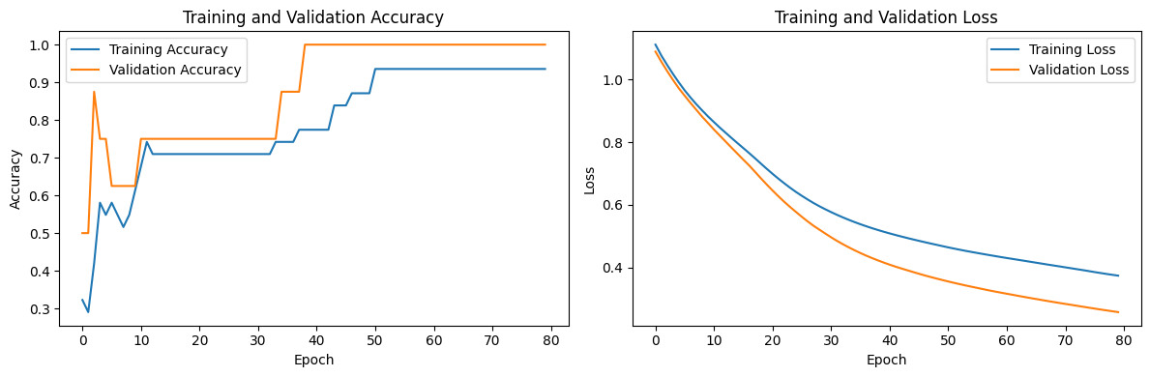
Figure: Training history of the baseline MLP (loss and accuracy per epoch).
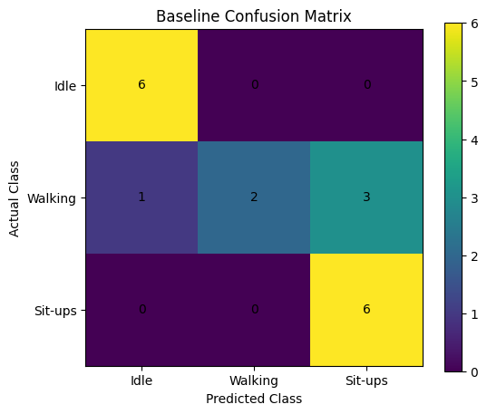
Figure: Confusion matrix of the baseline Float32 model on the test windows.

6. Discussion of Results
All four models reached the same test accuracy of 77.78%. The main findings from the comparison are:
● Same accuracy: quantization changed the numbers only slightly, and none of the 18 test predictions changed. The model and features are small and simple, so lower precision did not hurt them.
● No size saving for dynamic range: its weights are int8, but the model has only 707 weights, so they are a small part of the file. The rest is fixed overhead such as the model structure and metadata, which does not shrink. The size stayed at 4.81 KB.
● Float16 and full integer reduced the size: Float16 reduced it by 12.91% and full integer by 9.25%. Float16 gave the bigger saving in this experiment.
● Inference was not faster: the Float32 model took 4.82 us and the full integer model took 6.36 us. We ran on a normal Colab CPU with no int8 hardware, and the model is tiny, so converting the input and output and the interpreter overhead cost more than the saved computation. The timings also change from run to run (standard deviation of 1.6 to 5.5 us), so the small differences should not be over-read.
● Why full integer is still needed for microcontrollers: many microcontrollers have little memory and slow or no floating point hardware, and some accelerators only run int8. A full integer model uses int8 for weights, activations, input and output, so the whole model can run with integer math. Dynamic range and Float16 models still need floating point operations when they run. File size alone is not the reason to choose full integer.
The baseline accuracy of 77.78% is not very high. Walking was the weakest class, with a recall of 0.33: only 2 of 6 Walking windows were predicted correctly, 3 were predicted as Sit-ups and 1 as Idle. We think this is mainly because of the following limits in our experiment:
● Very little data: we have only 57 windows in total and only 18 in the test set, so a single wrong window changes the accuracy by about 5.6%.
● Simple features: the mean, standard deviation and RMS of the magnitude may not separate Walking from Sit-ups well, because both movements can give a similar overall acceleration.
● Short training: the training loss was still going down slowly at epoch 80, so longer training might help a little.
Given more time, we would record longer sessions, use overlapping windows to get more samples, add features such as minimum, maximum and per-axis values, and measure the latency on a real microcontroller board.

7. Conclusion
We built an end-to-end pipeline that collects accelerometer data, extracts window features, trains a 3-class MLP, converts it into four TensorFlow Lite versions and benchmarks them. The baseline model reached 77.78% test accuracy, and all four versions kept the same accuracy. Float16 reduced the model size by 12.91% and full integer by 9.25%, while dynamic range gave no reduction because the model is very small. Inference was not faster after quantization on the Colab CPU, which is expected for such a small model on a normal processor. Full integer quantization is the right choice for a microcontroller because it lets the whole model run with integer math. The accuracy is limited by the small dataset, and more data would improve it.

8. Deliverables Submitted
● Workflow diagram of the problem.
● Raw datasets: idle.csv, walking.csv and situps.csv exported from phyphox.
● Python code: 2548562_TML_LAB2_3.ipynb, covering windowing, feature extraction, 3-class model training, the four TFLite variants and the benchmark.
● This lab report: quantization benchmark table and analysis of the results.

Lab 4: TinyML Lab – Quantization-Aware Training (QAT)

Aim
To implement Quantization-Aware Training (QAT) on a TinyML model, using either motion-sensor data collected with the Phyphox app or a standard image dataset with MobileNetV2, and to compare it with Post-Training Quantization (PTQ).

Objectives
1. Prepare input data from Phyphox sensor recordings or from a standard image dataset.
2. Train a baseline model and apply full INT8 Post-Training Quantization.
3. Apply Quantization-Aware Training and convert the model to full INT8 TensorFlow Lite.
4. Compare the models in terms of accuracy, size and latency.

Lab Setup
Run the following as the first cell in a fresh Colab runtime:

!pip install -q tensorflow-model-optimization tf_keras
import os
os.environ["TF_USE_LEGACY_KERAS"] = "1" # set before importing tensorflow
import tensorflow as tf
import tensorflow_model_optimization as tfmot

Procedure
1. Input data: choose one option.
o Option A (sensor data): Using Phyphox, record four motion classes of your choice (for example: still, walking, shaking and circular motion) for about 60 seconds each. Export each recording as a CSV file and upload it to Colab.
o Option B (image data): Load the CIFAR-10 dataset from tf.keras.datasets. Use a subset (for example, 5,000 training and 1,000 test images) resized to 96 × 96 pixels.
2. Preprocessing: Option A: label and combine the CSV files, segment the signal into fixed-length windows, normalise, and split into training and test sets. Option B: scale the images as required by MobileNetV2.
3. Baseline model: Option A: train a small Keras model. Option B: build a MobileNetV2 model (pre-trained on ImageNet, alpha = 0.35) with a new classification head, as a single functional model (not nested), and fine-tune it. Record the test accuracy.
4. Post-Training Quantization: Convert the baseline model to a full INT8 TFLite model using a representative dataset, and evaluate it with the TFLite interpreter.
5. Quantization-Aware Training: Apply QAT to the trained baseline model, fine-tune it, convert it to a full INT8 TFLite model, and evaluate it.
6. Comparison: Record the results in the table below.
Comparison table (completed by student, Option B):
Model | Size (KB) | Test accuracy (%) | Avg latency (ms)
Float32 baseline | 1600.03 | 78.10 | 0.418
PTQ full INT8 | 612.97 | 47.00 | 0.774
QAT full INT8 | 618.35 | 76.50 | 0.706

Questions
1. Why does Post-Training Quantization reduce model accuracy?
2. What does QAT simulate during training, and how does this help the model?
3. Was a representative dataset required to convert the QAT model? Justify your answer.
4. Did QAT change the size of the INT8 model? Explain.
5. Under what conditions is PTQ sufficient, so that QAT is not needed?

Result
State your conclusion on the effectiveness of QAT compared with PTQ, citing values from your comparison table.
QAT was far more effective than PTQ: it kept 76.50% accuracy against 47.00% for PTQ (float32: 78.10%), at almost the same size (618.35 KB versus 612.97 KB).
Deliverables: the Colab notebook with all outputs, the Phyphox CSV files (Option A only), and the three .tflite models.

Evaluation Rubric
Component | Marks
Workflow + Data collection and preprocessing | 3
Baseline model and PTQ | 3
QAT, conversion and evaluation + Comparison table and result | 2
Questions | 2
Total | 10

Planned workflow
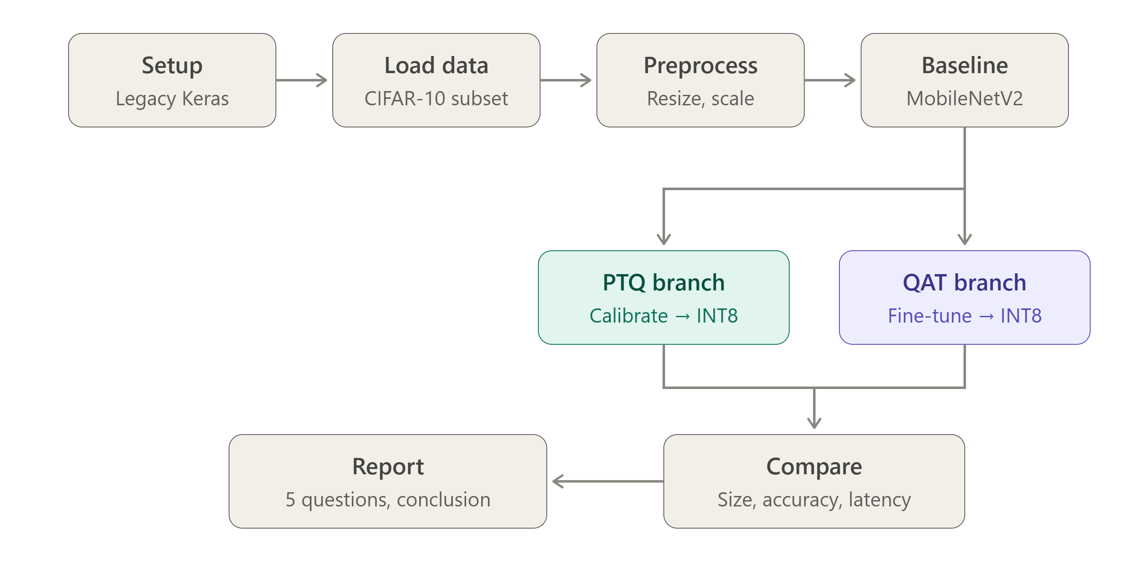
Figure 1: Lab 4 workflow (setup, data, preprocessing, baseline, PTQ and QAT branches, comparison, report).

1. Aim
The aim of this lab was to apply Quantization-Aware Training (QAT) to a MobileNetV2 image classifier (Option B, CIFAR-10) and to compare it with full INT8 Post-Training Quantization (PTQ) in terms of accuracy, size and latency.

2. Option Chosen and Scenario
We chose Option B (image data) and used a CIFAR-10 subset with MobileNetV2 (alpha 0.35). The task can be seen as an embedded AI engineer who has to fit an image classifier into a small device. INT8 quantization shrinks the model, but PTQ can hurt accuracy because the model never saw the rounding error. QAT trains with that error included. Our job was to measure how large the difference is.

3. Methodology
Our pipeline followed these steps, in order (see the attached workflow diagram for the full visual):
● Setup: installed tensorflow-model-optimization and tf_keras, and set TF_USE_LEGACY_KERAS=1 before importing TensorFlow so that the QAT toolkit works.
● Load data: loaded CIFAR-10 and took the first 5,000 training images and the first 1,000 test images.
● Preprocess: resized the images from 32x32 to 96x96 and applied the MobileNetV2 preprocessing, which scales pixels from [0, 255] to [-1, +1].
● Baseline: built MobileNetV2 (alpha 0.35, ImageNet weights, frozen backbone) with GlobalAveragePooling2D and a Dense(10) softmax head, and trained the head for 5 epochs.
● Float32 TFLite reference: converted the baseline to TFLite without quantization to get the reference size, accuracy and latency.
● PTQ branch: calibrated the baseline on 200 training images (representative dataset) and converted it to a full INT8 TFLite model with int8 input and output.
● QAT branch: rebuilt a flat (not nested) model from the same layers, wrapped it with tfmot quantize_model, fine-tuned it for 3 epochs at a learning rate of 1e-4, and converted it to a full INT8 TFLite model without a representative dataset.
● Compare: ran all three TFLite models through the TFLite interpreter on the same 1,000 test images and measured size, accuracy and average latency of a single invoke().
● Report: answered the five questions and wrote the conclusion.

4. Results

4.1 Dataset summary
Sample training images (the first ten images of the subset):
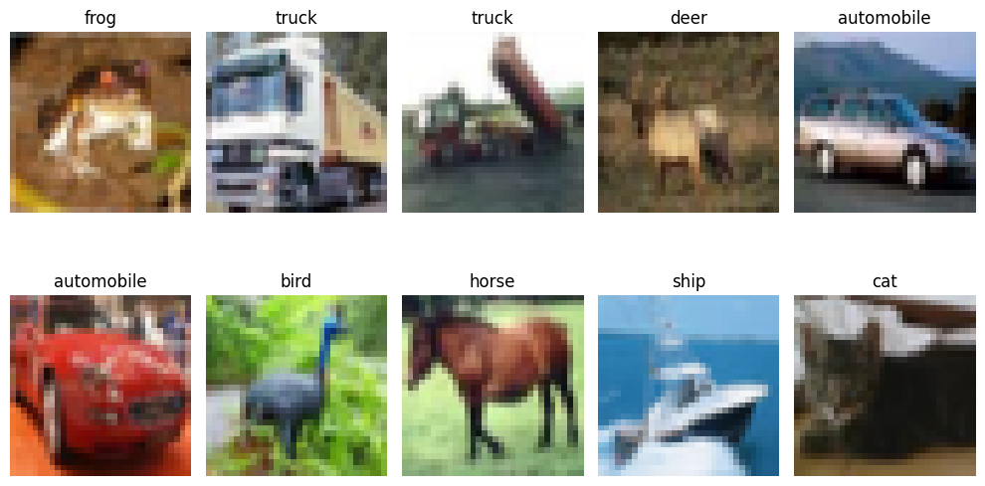
Figure 2: First ten CIFAR-10 training images with their class labels.
Item | Original | Used in this lab
Training images | 50,000 (32x32x3) | 5,000 (resized to 96x96x3)
Test images | 10,000 (32x32x3) | 1,000 (resized to 96x96x3)
Classes | 10 | 10
Pixel range after preprocessing | [0, 255] | [-1, +1]

Classes: airplane, automobile, bird, cat, deer, dog, frog, horse, ship, truck.

4.2 Baseline model (float32)
Metric | Value
Model type | MobileNetV2 (alpha 0.35, ImageNet weights, frozen) + GlobalAveragePooling2D + Dense(10)
Input size | 96 x 96 x 3
Total parameters | 423,018 (1.61 MB)
Trainable parameters | 12,810 (only the Dense head)
Optimizer and loss | Adam (1e-3), sparse categorical cross-entropy
Training setup | 5 epochs, batch size 64, 10% validation split
Baseline test accuracy (Keras) | 78.20%
Float32 TFLite size / accuracy | 1600.0 KB / 78.10%

Training history of the baseline:
Epoch | Train loss | Train accuracy | Val loss | Val accuracy
1 | 1.2993 | 0.5540 | 0.8843 | 0.6960
2 | 0.6799 | 0.7758 | 0.7548 | 0.7420
3 | 0.5639 | 0.8084 | 0.7114 | 0.7540
4 | 0.4929 | 0.8409 | 0.6924 | 0.7700
5 | 0.4418 | 0.8540 | 0.6596 | 0.7720

4.3 PTQ branch
Metric | Value
Calibration | 200 training images (representative dataset)
Target ops / types | TFLITE_BUILTINS_INT8, int8 input and int8 output
Model size | 612.97 KB (2.61x smaller than float32)
Test accuracy | 47.00%
Accuracy drop vs float32 | 31.1 points
Latency | 0.774 ms/image

4.4 QAT branch
Metric | Value
Model | Flat MobileNetV2 + trained head wrapped with tfmot quantize_model (432,204 parameters)
Fine-tuning | 3 epochs, batch size 64, Adam (1e-4), backbone unfrozen
Accuracy before fine-tuning (fake quantized) | 10.30%
Accuracy after fine-tuning (Keras) | 76.80%
INT8 TFLite size | 618.35 KB (2.59x smaller than float32)
INT8 TFLite test accuracy | 76.50%
Accuracy drop vs float32 | 1.6 points
Latency | 0.706 ms/image

Training history of the QAT fine-tuning:
Epoch | Train loss | Train accuracy | Val loss | Val accuracy
1 | 1.3773 | 0.5067 | 1.0028 | 0.6380
2 | 0.7999 | 0.7176 | 0.8693 | 0.7040
3 | 0.6014 | 0.7949 | 0.6148 | 0.7720

4.5 Comparison: size, accuracy, latency
All three models were tested on the same 1,000 test images.
Model | Size (KB) | Accuracy (%) | Latency (ms/img) | Size reduction (x) | Accuracy drop (pts)
Float32 baseline | 1600.03 | 78.10 | 0.418 | 1.00 | 0.0
PTQ INT8 | 612.97 | 47.00 | 0.774 | 2.61 | 31.1
QAT INT8 | 618.35 | 76.50 | 0.706 | 2.59 | 1.6

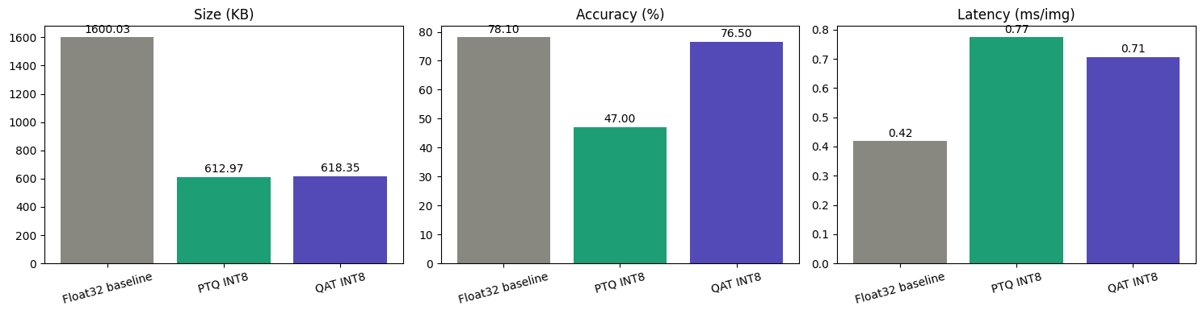
Figure 3: Size, accuracy and latency of the float32, PTQ INT8 and QAT INT8 models.
Note: the latency was measured on the Colab CPU, not on a microcontroller, so it only shows how the models behave on this machine.

5. Code
The complete code of the notebook (2548562_TinyML_Lab4.ipynb), in the order it was run:
1 - Setup
!pip install -q tensorflow-model-optimization tf_keras

import os

# Must be set BEFORE importing TensorFlow
os.environ["TF_USE_LEGACY_KERAS"] = "1"

import tensorflow as tf
import tf_keras as keras
import tensorflow_model_optimization as tfmot

import numpy as np
import pandas as pd
import matplotlib.pyplot as plt

from time import perf_counter

print("TensorFlow:", tf.__version__)
print("GPU:", tf.config.list_physical_devices("GPU"))
2 - Load CIFAR-10
# Load CIFAR-10
(x_train_full, y_train_full), (x_test_full, y_test_full) = keras.datasets.cifar10.load_data()

print("Original training data:", x_train_full.shape)
print("Original test data:", x_test_full.shape)

class_names = [
"airplane",
"automobile",
"bird",
"cat",
"deer",
"dog",
"frog",
"horse",
"ship",
"truck"
]

TRAIN_SAMPLES = 5000
TEST_SAMPLES = 1000

x_train = x_train_full[:TRAIN_SAMPLES]
y_train = y_train_full[:TRAIN_SAMPLES].flatten()

x_test = x_test_full[:TEST_SAMPLES]
y_test = y_test_full[:TEST_SAMPLES].flatten()

print("Training:", x_train.shape, y_train.shape)
print("Testing :", x_test.shape, y_test.shape)

plt.figure(figsize=(10, 6))

for i in range(10):
plt.subplot(2, 5, i + 1)
plt.imshow(x_train[i])
plt.title(class_names[y_train[i]])
plt.axis("off")

plt.tight_layout()
plt.show()
Step - 3 Preprocessing
IMG_SIZE = 96

x_train_resized = tf.image.resize(
x_train,
[IMG_SIZE, IMG_SIZE]
)

x_test_resized = tf.image.resize(
x_test,
[IMG_SIZE, IMG_SIZE]
)

print(x_train_resized.shape)
print(x_test_resized.shape)

# MobileNetV2 preprocessing
x_train_processed = keras.applications.mobilenet_v2.preprocess_input(
x_train_resized
)

x_test_processed = keras.applications.mobilenet_v2.preprocess_input(
x_test_resized
)

print("Min:", tf.reduce_min(x_train_processed).numpy())
print("Max:", tf.reduce_max(x_train_processed).numpy())
Step 4 - Building Float32 Baseline Model
NUM_CLASSES = 10

base_model = keras.applications.MobileNetV2(
input_shape=(96, 96, 3),
include_top=False,
weights="imagenet",
alpha=0.35
)

base_model.trainable = False
adding our own classification head
inputs = keras.Input(shape=(96, 96, 3))

x = base_model(inputs, training=False)
x = keras.layers.GlobalAveragePooling2D()(x)
outputs = keras.layers.Dense(NUM_CLASSES, activation="softmax")(x)

baseline_model = keras.Model(
inputs=inputs,
outputs=outputs,
name="MobileNetV2_CIFAR10"
)

baseline_model.summary()
Step 5 - Training the baseline model
baseline_model.compile(
optimizer=keras.optimizers.Adam(learning_rate=1e-3),
loss="sparse_categorical_crossentropy",
metrics=["accuracy"]
)

history = baseline_model.fit(
x_train_processed,
y_train,
validation_split=0.1,
epochs=5,
batch_size=64,
verbose=1
)

baseline_loss, baseline_accuracy = baseline_model.evaluate(
x_test_processed,
y_test,
verbose=0
)

print(f"Baseline Test Accuracy: {baseline_accuracy * 100:.2f}%")
Step 6 - Helpers for size, accuracy and latency
def get_file_size_kb(path):
return os.path.getsize(path) / 1024

def evaluate_tflite(tflite_bytes, x, y):
"""Run a TFLite model on every sample and return accuracy (%)."""
interpreter = tf.lite.Interpreter(model_content=tflite_bytes)
interpreter.allocate_tensors()

inp = interpreter.get_input_details()[0]
out = interpreter.get_output_details()[0]
in_scale, in_zp = inp["quantization"]
out_scale, out_zp = out["quantization"]

x = np.asarray(x)
correct = 0

for i in range(len(x)):
sample = x[i:i + 1]

# integer models need the float input mapped to int8 first
if inp["dtype"] == np.int8:
sample = np.round(sample / in_scale + in_zp).astype(np.int8)
else:
sample = sample.astype(np.float32)

interpreter.set_tensor(inp["index"], sample)
interpreter.invoke()
pred = interpreter.get_tensor(out["index"])

if out["dtype"] == np.int8:
pred = (pred.astype(np.float32) - out_zp) * out_scale

correct += int(np.argmax(pred) == y[i])

return correct / len(x) * 100

def measure_latency_ms(tflite_bytes, x, runs=200):
"""Average single-image invoke() time in milliseconds."""
interpreter = tf.lite.Interpreter(model_content=tflite_bytes)
interpreter.allocate_tensors()

inp = interpreter.get_input_details()[0]
in_scale, in_zp = inp["quantization"]

sample = np.asarray(x[:1])
if inp["dtype"] == np.int8:
sample = np.round(sample / in_scale + in_zp).astype(np.int8)
else:
sample = sample.astype(np.float32)

# warm-up
for _ in range(10):
interpreter.set_tensor(inp["index"], sample)
interpreter.invoke()

start = perf_counter()
for _ in range(runs):
interpreter.set_tensor(inp["index"], sample)
interpreter.invoke()
end = perf_counter()

return (end - start) / runs * 1000
Step 7 - Float32 TFLite reference
converter = tf.lite.TFLiteConverter.from_keras_model(baseline_model)
tflite_float = converter.convert()

with open("baseline_float32.tflite", "wb") as f:
f.write(tflite_float)

float_size_kb = get_file_size_kb("baseline_float32.tflite")
float_acc = evaluate_tflite(tflite_float, x_test_processed.numpy(), y_test)

print(f"Float32 TFLite size : {float_size_kb:.1f} KB")
print(f"Float32 TFLite accuracy: {float_acc:.2f}%")
Step 8 - PTQ branch: Calibrate and convert to INT8
def representative_dataset():
for i in range(200):
yield [x_train_processed[i:i + 1].numpy().astype(np.float32)]

converter = tf.lite.TFLiteConverter.from_keras_model(baseline_model)
converter.optimizations = [tf.lite.Optimize.DEFAULT]
converter.representative_dataset = representative_dataset
converter.target_spec.supported_ops = [tf.lite.OpsSet.TFLITE_BUILTINS_INT8]
converter.inference_input_type = tf.int8
converter.inference_output_type = tf.int8

tflite_ptq = converter.convert()

with open("ptq_int8.tflite", "wb") as f:
f.write(tflite_ptq)

ptq_size_kb = get_file_size_kb("ptq_int8.tflite")
print(f"PTQ INT8 size: {ptq_size_kb:.1f} KB")

ptq_acc = evaluate_tflite(tflite_ptq, x_test_processed.numpy(), y_test)
ptq_latency = measure_latency_ms(tflite_ptq, x_test_processed.numpy())

print(f"PTQ INT8 accuracy: {ptq_acc:.2f}%")
print(f"PTQ INT8 latency : {ptq_latency:.3f} ms/image")
Step 9 - QAT branch: Fine-tune with fake quantization
# flat model: backbone layers + trained head (no nested Model)
x = base_model.output
x = baseline_model.layers[-2](x) # GlobalAveragePooling2D
outputs = baseline_model.layers[-1](x) # trained Dense head

flat_model = keras.Model(inputs=base_model.input, outputs=outputs, name="flat_MobileNetV2_CIFAR10")

qat_model = tfmot.quantization.keras.quantize_model(flat_model)

qat_model.compile(
optimizer=keras.optimizers.Adam(learning_rate=1e-4),
loss="sparse_categorical_crossentropy",
metrics=["accuracy"]
)

qat_model.summary()

# accuracy of the fake-quantized model before any fine-tuning
_, qat_before_acc = qat_model.evaluate(x_test_processed, y_test, verbose=0)
print(f"QAT model before fine-tuning: {qat_before_acc * 100:.2f}%")

qat_history = qat_model.fit(
x_train_processed,
y_train,
validation_split=0.1,
epochs=3,
batch_size=64,
verbose=1
)

_, qat_keras_acc = qat_model.evaluate(x_test_processed, y_test, verbose=0)
print(f"QAT model after fine-tuning (Keras): {qat_keras_acc * 100:.2f}%")
Convert QAT model to INT8 TFLite
converter = tf.lite.TFLiteConverter.from_keras_model(qat_model)
converter.optimizations = [tf.lite.Optimize.DEFAULT]
converter.inference_input_type = tf.int8
converter.inference_output_type = tf.int8

tflite_qat = converter.convert()

with open("qat_int8.tflite", "wb") as f:
f.write(tflite_qat)

qat_size_kb = get_file_size_kb("qat_int8.tflite")
qat_acc = evaluate_tflite(tflite_qat, x_test_processed.numpy(), y_test)
qat_latency = measure_latency_ms(tflite_qat, x_test_processed.numpy())

print(f"QAT INT8 size : {qat_size_kb:.1f} KB")
print(f"QAT INT8 accuracy: {qat_acc:.2f}%")
print(f"QAT INT8 latency : {qat_latency:.3f} ms/image")
Step 10 - Compare: size, accuracy, latency
float_latency = measure_latency_ms(tflite_float, x_test_processed.numpy())

results = pd.DataFrame({
"Model": ["Float32 baseline", "PTQ INT8", "QAT INT8"],
"Size (KB)": [float_size_kb, ptq_size_kb, qat_size_kb],
"Accuracy (%)": [float_acc, ptq_acc, qat_acc],
"Latency (ms/img)": [float_latency, ptq_latency, qat_latency],
})

results["Size reduction (x)"] = results["Size (KB)"].iloc[0] / results["Size (KB)"]
results["Accuracy drop (pts)"] = results["Accuracy (%)"].iloc[0] - results["Accuracy (%)"]

results.round(3)

fig, axes = plt.subplots(1, 3, figsize=(15, 4))
colors = ["#888780", "#1D9E75", "#534AB7"]

for ax, col in zip(axes, ["Size (KB)", "Accuracy (%)", "Latency (ms/img)"]):
bars = ax.bar(results["Model"], results[col], color=colors)
ax.set_title(col)
ax.tick_params(axis="x", rotation=15)
ax.bar_label(bars, fmt="%.2f", padding=2)

plt.tight_layout()
plt.show()

6. Discussion of Results
The main findings from the comparison are:
● Size: both INT8 models are about 2.6x smaller than float32 (1600 KB to about 615 KB). The reduction is below the ideal 4x because the file also stores scales, zero points and int32 biases. PTQ and QAT have almost the same size because both store 8 bit weights.
● PTQ accuracy: accuracy fell from 78.10% to 47.00%, a loss of 31.1 points. The model never saw quantization noise during training and only 200 calibration images were used to fix the activation ranges.
● QAT accuracy: the fake quantized model was at 10.30% (random guessing) before fine-tuning, but after 3 epochs it reached 76.80% in Keras and 76.50% as an INT8 TFLite model, only 1.6 points below float32.
● Latency: the float32 model was the fastest (0.418 ms) and the INT8 models were slower (0.774 ms for PTQ and 0.706 ms for QAT). This CPU has no special INT8 acceleration, so the result does not show the speed on a microcontroller. The benefit that carries over is the smaller size.
Answers to the lab questions
Q1. Why does Post-Training Quantization reduce model accuracy?
● PTQ rounds the weights and activations of an already trained model to 8 bits, and the model has no chance to adapt to the rounding and clipping error. The activation ranges are also estimated from only a small calibration set. In our run this took the accuracy from 78.10% to 47.00%.
Q2. What does QAT simulate during training, and how does this help the model?
● QAT inserts fake quantization nodes that round and clip values to INT8 in the forward pass while the weights stay in float, and the gradients pass through the rounding (straight-through estimator). The model therefore trains with the INT8 error included, so the weights and the quantization ranges adapt to it. Our fake quantized model went from 10.30% to 76.80% in 3 epochs.
Q3. Was a representative dataset required to convert the QAT model? Justify your answer.
● No. We converted the QAT model without a representative dataset and the conversion worked. The fake quantization nodes learned the min/max ranges of the activations during fine-tuning, and the converter reads these ranges directly. PTQ needs the dataset because it has to measure the ranges.
Q4. Did QAT change the size of the INT8 model? Explain.
● No, not in a meaningful way. The QAT INT8 model is 618.35 KB and the PTQ INT8 model is 612.97 KB, because both store 8 bit weights. The 5.4 KB difference comes from the extra quantization parameters. Both are about 2.6x smaller than float32 (1600.03 KB).
Q5. Under what conditions is PTQ sufficient, so that QAT is not needed?
● PTQ is sufficient when the accuracy drop is small enough for the application, which is often true for larger, over-parameterised models and simple tasks, when a good representative dataset is available, and when there is no time, data or compute for retraining. Here the drop was 31.1 points, so PTQ was not enough.
Given more time, we would calibrate PTQ with more images, train the QAT model for more epochs on the full dataset, and measure latency on real microcontroller hardware.

7. Conclusion
QAT was much more effective than PTQ for this MobileNetV2 model. Both produced a full INT8 model of about 615 KB, 2.6x smaller than the 1600 KB float32 model, but PTQ kept only 47.00% accuracy while QAT kept 76.50%, only 1.6 points below float32 (78.10%), after 3 epochs of fine-tuning. Latency did not improve on the Colab CPU, so the benefit measured here is memory, which matters on a microcontroller. For this model, QAT is the right choice.

8. Deliverables Submitted
● Workflow diagram of the problem.
● Colab notebook with all outputs: 2548562_TinyML_Lab4.ipynb.
● The three TFLite models: baseline_float32.tflite, ptq_int8.tflite and qat_int8.tflite.
● This lab report: comparison table, result graphs, code and answers to the questions.

Lab 5: "Shout STOP!" — build the brain of a voice emergency stop

Aim
To train a keyword spotting model in Google Colab that detects the word "stop", using the Google Speech Commands dataset, MFCC features and a DS-CNN.

Objectives
1. Prepare a dataset with the classes stop, _unknown_ and _silence_.
2. Preprocess audio and extract spectrogram and MFCC features.
3. Train and evaluate a DS-CNN keyword spotting model.
4. Convert the model to int8 TensorFlow Lite for a microcontroller.

The problem
SafeLine Packaging Pvt. Ltd. runs a fast conveyor belt in Bengaluru. Last month a worker's glove got caught in the rollers. The red emergency button was 4 metres away, and it took 6 seconds to reach it. Nobody was badly hurt, but the safety officer was clear: "Next time, the worker must be able to just shout STOP and the belt must halt."
The company cannot send audio to the cloud. The factory Wi-Fi drops often, a cloud delay could cost a finger, and the workers do not want their talk recorded. The solution must run on a tiny microcontroller fixed on the machine, with less than 100 KB of memory for the model.
You are the TinyML engineer. Before buying any hardware, the manager wants proof in Google Colab that a small model can tell "stop" apart from every other word and from machine noise. You will use the Google Speech Commands dataset (Mini Speech Commands): 8 words, about 1,000 one-second clips per word, 16 kHz, many speakers.
Download link: http://storage.googleapis.com/download.tensorflow.org/data/mini_speech_commands.zip

Your tasks
1. Collect the evidence (dataset preparation). Workers talk all day, saying "go", "no", "left", "yes". The belt must react only to "stop". Build 3 classes: stop (all clips from the stop folder), _unknown_ (random clips from the other 7 words, the same number as stop) and _silence_ (1 s background-noise clips, the same number as stop).
2. Split the data 80/10/10 by speaker, so your test uses voices the model has never heard. New workers join every month.
3. Make the audio ready (preprocessing). Load every clip as 16 kHz mono, exactly 1 second. Cut it into frames with a 30 ms window and 20 ms hop.
4. Show what the machine "hears" (features). Plot the waveform, spectrogram and MFCC (49 × 10) for a "stop" clip and a "go" clip. Explain to the manager, in 3 lines, why the MFCC pictures look different.
5. Design the brain (KWS architecture). Build a small DS-CNN with MFCC input and a 3-class output. Report its parameters. Will it fit in under 100 KB?
6. Teach it (training workflow). Train with augmentation: time shift for workers who speak early or late, and background noise for a loud factory. Plot the accuracy and loss curves.
7. Safety check (evaluation). Report test accuracy and the confusion matrix. The safety officer wants two numbers: Misses (how many "stop" words the model did not catch) and False alarms (how many other words it wrongly called "stop").
8. Make it fit the chip (deployment preparation). Convert to int8 TFLite. Compare float and int8 size and accuracy, and export kws_int8.tflite and kws_config.json for Lab 6.

Expected results
● A balanced dataset table across train, validation and test
● MFCC plots where "stop" shows a clear pattern different from "go"
● Test accuracy of about 85–95% on unseen speakers
● Miss and false-alarm counts reported from the confusion matrix
● int8 model of about 45–50 KB (it fits the 100 KB limit), with less than 1% accuracy loss

Rubric (10 marks)
Criterion | Marks | Full marks when
Dataset preparation and features | 3 | 3 balanced classes from Speech Commands, speaker-wise split, correct waveform, spectrogram and MFCC plots with explanation
Model training and safety evaluation | 3 | Model trains properly; curves, accuracy, confusion matrix, misses and false alarms reported
Quantisation, analysis and viva | 4 | int8 model under 100 KB, float vs int8 compared, safety trade-off explained, viva answered

Planned workflow (Lab 5 and Lab 6)
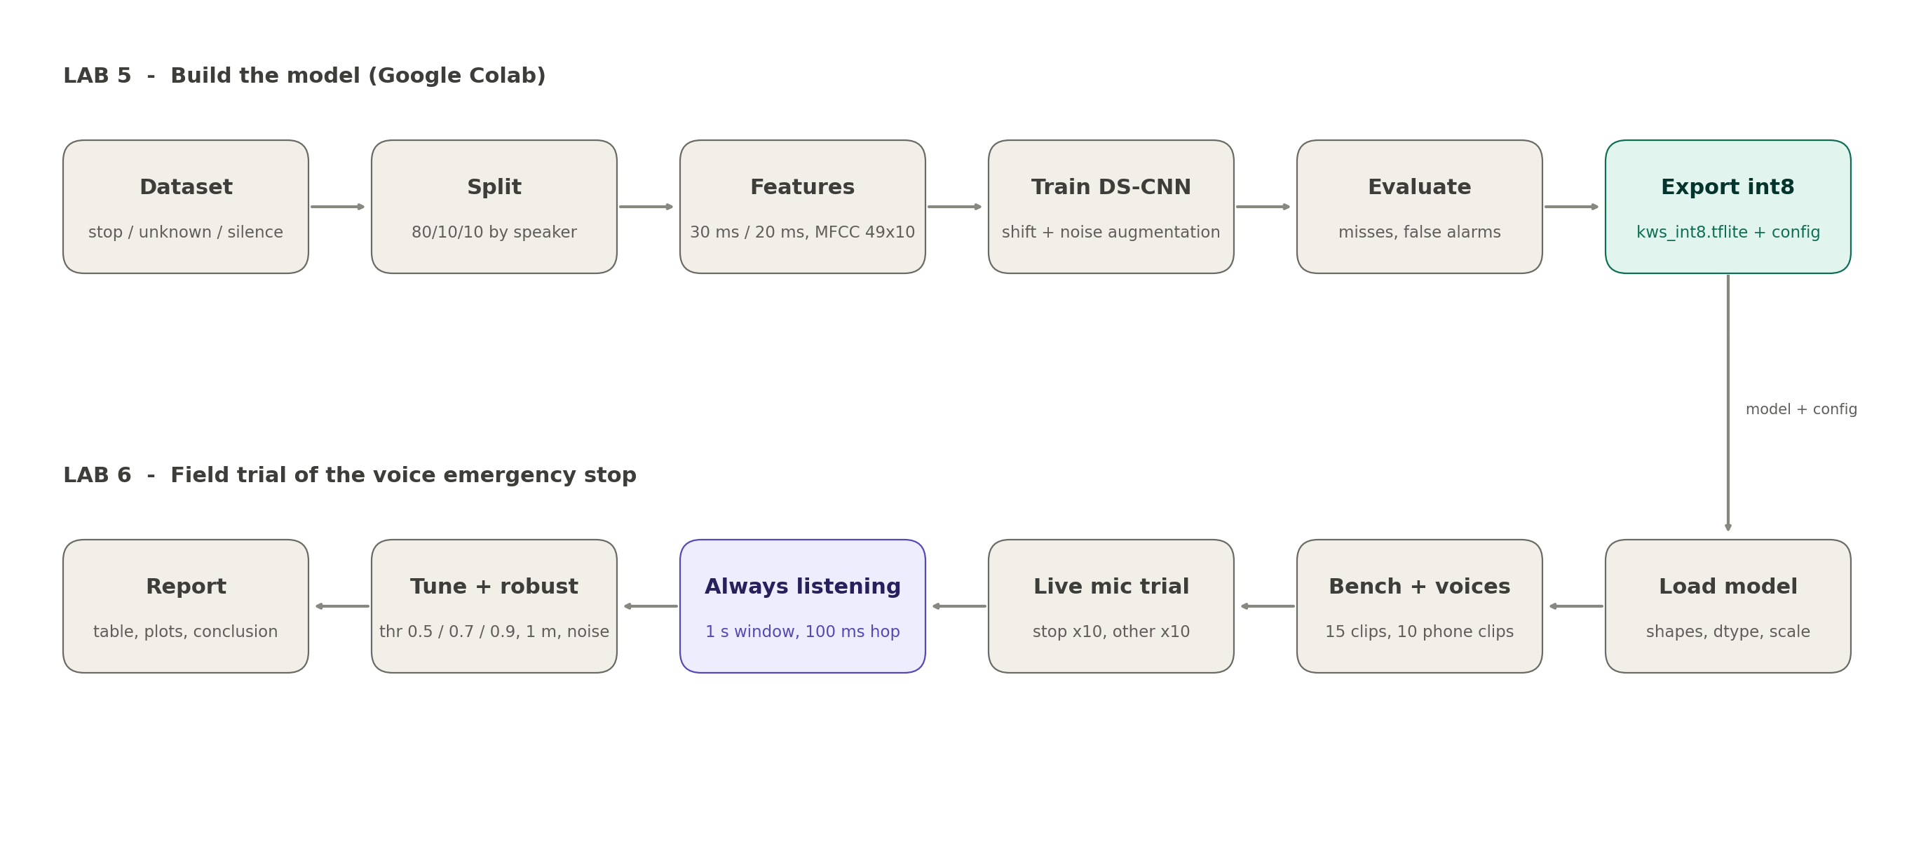
Figure 1: Workflow of Lab 5 (build the model) and Lab 6 (field trial).

1. Aim
The aim of this lab was to train a keyword spotting model that detects the word "stop" from one second of audio, using the Mini Speech Commands dataset, MFCC features and a DS-CNN, and to convert it to an int8 TensorFlow Lite model that fits in 100 KB for a microcontroller.

2. Scenario
We took the role of the TinyML engineer for SafeLine Packaging. A worker must be able to shout "stop" and halt the conveyor belt, without any cloud connection. The model must therefore run on a small microcontroller, and it must catch "stop" (a miss is dangerous) without halting the line for other words (a false alarm costs money).

3. Methodology
Our pipeline followed these steps, in order (see the attached workflow diagram for the full visual):
● Setup: installed tf_keras, set TF_USE_LEGACY_KERAS=1 before importing TensorFlow, and fixed the random seeds.
● Dataset: downloaded Mini Speech Commands (8 words, 1,000 clips each) and built the classes stop, _unknown_ (the other 7 words) and _silence_.
● Split by speaker: assigned every speaker to train, validation or test (80/10/10) with a hash of the speaker id, and checked that no speaker is in two splits. _unknown_ and _silence_ have the same number of clips as stop in every split.
● _silence_ clips: Mini Speech Commands has no background-noise folder, so we generated 1 s of white, pink and brown noise and a machine hum at random volumes.
● Preprocessing: loaded every clip as 16 kHz mono, exactly 16,000 samples (padded or cut).
● Features: 30 ms window (480 samples), 20 ms hop (320 samples), 512-point FFT, 40 mel filters (20 Hz to 4 kHz), log and DCT, keeping 10 coefficients, which gives a 49 x 10 MFCC. The coefficients are standardised with the training mean and std.
● Model: DS-CNN with a 10 x 4 convolution, 5 depthwise-separable blocks, global average pooling and a 3-class softmax.
● Training: Adam (1e-3) with on-the-fly augmentation (time shift up to 100 ms and background noise), early stopping and learning-rate reduction, up to 40 epochs.
● Evaluation: test accuracy, confusion matrix, misses and false alarms on the unseen speakers.
● Deployment: converted to float32 and full-integer int8 TFLite (300 MFCCs as the representative dataset), compared them, and exported kws_int8.tflite, kws_config.json and a set of unseen test clips for Lab 6.

4. Results

4.1 Dataset (balanced, split by speaker)
Split | stop | _unknown_ | _silence_ | Total
Train (819 speakers) | 782 | 782 | 782 | 2,346
Validation (128 speakers) | 129 | 129 | 129 | 387
Test (103 speakers) | 89 | 89 | 89 | 267

4.2 What the machine hears
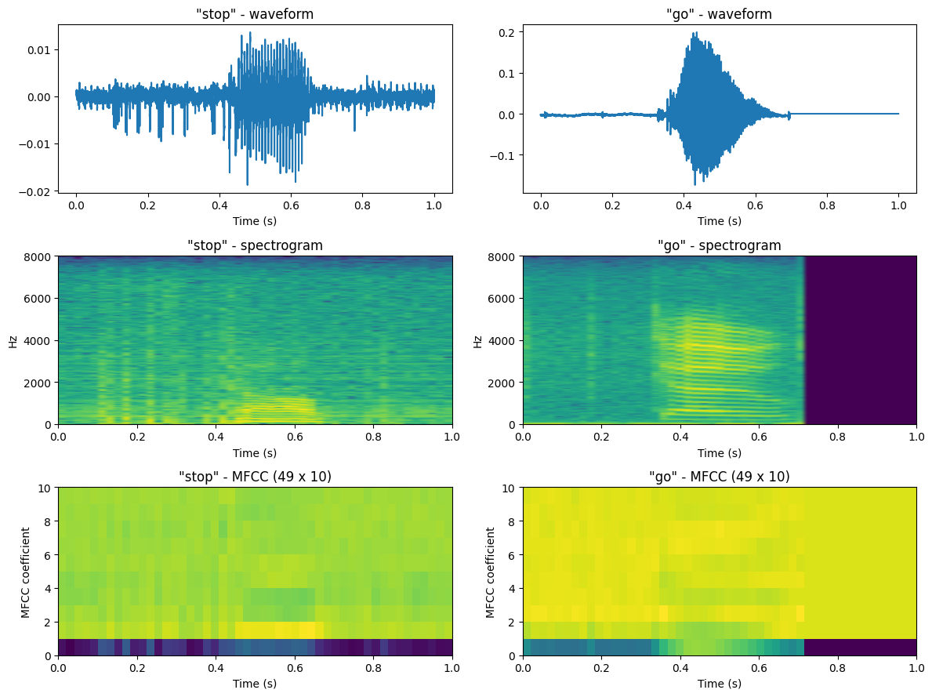
Figure 2: Waveform, spectrogram and MFCC (49 x 10) of a "stop" clip and a "go" clip.

4.3 Model
Metric | Value
Architecture | DS-CNN: Conv 10x4 (stride 2) + 5 depthwise-separable blocks (64 filters) + global average pooling + Dense(3)
Input | 49 x 10 x 1 (MFCC)
Total parameters | 28,931 (27,523 trainable)
Size as float32 weights | 113 KB
Size as int8 weights (approx.) | 28 KB
Training | Adam 1e-3, batch 64, time shift + noise augmentation, 35 epochs (early stopping)

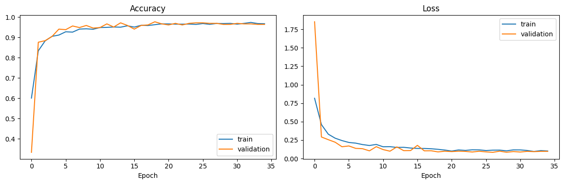
Figure 3: Accuracy and loss curves of training and validation.

4.4 Safety check on unseen speakers
Test accuracy: 99.25% (265 of 267 clips correct).
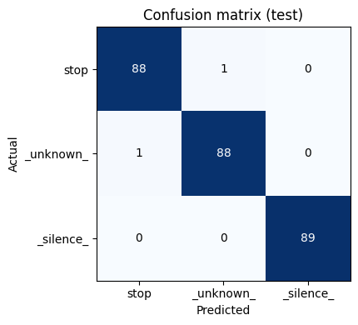
Figure 4: Confusion matrix on the test set.
Class | Precision | Recall | F1-score | Support
stop | 0.989 | 0.989 | 0.989 | 89
_unknown_ | 0.989 | 0.989 | 0.989 | 89
_silence_ | 1.000 | 1.000 | 1.000 | 89

Number for the safety officer | Value
Misses (stop not caught, dangerous) | 1 of 89
False alarms (other clip called stop, costly) | 1 of 178

4.5 Float32 vs int8
Model | Size (KB) | Test accuracy (%) | Fits 100 KB
Keras float32 | - | 99.25 | -
TFLite float32 | 112.49 | 99.25 | No
TFLite int8 | 53.66 | 99.25 | Yes

5. Code
The complete code of the notebook (2548562_TinyML_Lab5.ipynb), in the order it was run:
1 - Setup
!pip install -q tf_keras

import os

# Must be set BEFORE importing TensorFlow
os.environ["TF_USE_LEGACY_KERAS"] = "1"

import json
import hashlib
import pathlib

import numpy as np
import pandas as pd
import matplotlib.pyplot as plt

import tensorflow as tf
import tf_keras as keras

from sklearn.metrics import confusion_matrix, classification_report

SEED = 42
np.random.seed(SEED)
tf.random.set_seed(SEED)

print("TensorFlow:", tf.__version__)
print("GPU:", tf.config.list_physical_devices("GPU"))
2 - Download the Mini Speech Commands dataset
DATA_URL = "http://storage.googleapis.com/download.tensorflow.org/data/mini_speech_commands.zip"

keras.utils.get_file(
"mini_speech_commands.zip",
origin=DATA_URL,
extract=True,
cache_dir=".",
cache_subdir="data"
)

DATA_DIR = pathlib.Path("data/mini_speech_commands")
words = sorted(p.name for p in DATA_DIR.iterdir() if p.is_dir())

print("Words:", words)
for w in words:
print(f"{w:6s}: {len(list((DATA_DIR / w).glob('*.wav')))} clips")
3 - Build the 3 classes and split by speaker
LABELS = ["stop", "_unknown_", "_silence_"]
TARGET = "stop"
SR = 16000

def speaker_of(path):
return path.name.split("_nohash_")[0]

def split_of(speaker):
# deterministic speaker-wise split: 80% train, 10% validation, 10% test
bucket = int(hashlib.md5(speaker.encode()).hexdigest(), 16) % 10
if bucket < 8:
return "train"
return "val" if bucket == 8 else "test"

stop_files = sorted((DATA_DIR / TARGET).glob("*.wav"))
other_files = sorted(f for w in words if w != TARGET for f in (DATA_DIR / w).glob("*.wav"))

rng = np.random.default_rng(SEED)
files = {}

for s in ["train", "val", "test"]:
stops = [f for f in stop_files if split_of(speaker_of(f)) == s]
pool = [f for f in other_files if split_of(speaker_of(f)) == s]
n = len(stops)
picked = rng.choice(len(pool), size=n, replace=False)
files[s] = {"stop": stops, "unknown": [pool[i] for i in sorted(picked)], "n_silence": n}

# no speaker may appear in two splits
speakers = {s: {speaker_of(f) for f in files[s]["stop"] + files[s]["unknown"]} for s in files}
assert not (speakers["train"] & speakers["val"])
assert not (speakers["train"] & speakers["test"])
assert not (speakers["val"] & speakers["test"])

for s in files:
print(f"{s:5s}: {len(speakers[s])} speakers")
_silence_ class
def make_noise_clip(rng, kind=None):
"""1 s of synthetic background noise: white / pink / brown noise or a machine hum."""
kind = kind or rng.choice(["white", "pink", "brown", "hum"])
n = SR

if kind == "hum":
t = np.arange(n) / SR
f0 = rng.choice([50, 100, 120])
x = sum(np.sin(2 * np.pi * f0 * k * t + rng.uniform(0, 2 * np.pi)) / k for k in (1, 2, 3, 4))
x = x + 0.2 * rng.standard_normal(n)
else:
white = rng.standard_normal(n)
if kind == "white":
x = white
else:
spec = np.fft.rfft(white)
f = np.fft.rfftfreq(n, 1 / SR)
f[0] = f[1]
power = 0.5 if kind == "pink" else 1.0 # amplitude ~ 1/f^power
x = np.fft.irfft(spec / f ** power, n)

x = x / (np.max(np.abs(x)) + 1e-9)
volume = 10 ** rng.uniform(-3, -1.1) # from very quiet to a loud fan
return (x * volume).astype(np.float32)
4 - Make the audio ready (16 kHz mono, exactly 1 second)
def load_wav(path):
# desired_samples pads short clips with zeros and cuts long clips to exactly 1 s
audio, _ = tf.audio.decode_wav(tf.io.read_file(str(path)), desired_channels=1, desired_samples=SR)
return audio[:, 0].numpy()

def build_split(name, seed):
d = files[name]
r = np.random.default_rng(seed)

stop = [load_wav(p) for p in d["stop"]]
unk = [load_wav(p) for p in d["unknown"]]
sil = [make_noise_clip(r) for _ in range(d["n_silence"])]

x = np.stack(stop + unk + sil).astype(np.float32)
y = np.array([0] * len(stop) + [1] * len(unk) + [2] * len(sil))
names = ([f"stop/{p.name}" for p in d["stop"]] +
[f"{p.parent.name}/{p.name}" for p in d["unknown"]] +
[f"synthetic_noise_{i}" for i in range(len(sil))])

order = r.permutation(len(x))
return x[order], y[order], np.array(names)[order]

x_train, y_train, n_train = build_split("train", 1)
x_val, y_val, n_val = build_split("val", 2)
x_test, y_test, n_test = build_split("test", 3)

print("train:", x_train.shape, " val:", x_val.shape, " test:", x_test.shape)

table = pd.DataFrame(
[[np.sum(y == k) for k in range(3)] + [len(y)] for y in (y_train, y_val, y_test)],
index=["train", "val", "test"],
columns=LABELS + ["total"]
)
table
MFCC front-end
FRAME_LEN = int(0.030 * SR) # 480 samples (30 ms window)
FRAME_STEP = int(0.020 * SR) # 320 samples (20 ms hop)
FFT_LEN = 512
NUM_MEL = 40
FMIN, FMAX = 20.0, 4000.0
NUM_MFCC = 10

MEL_W = tf.signal.linear_to_mel_weight_matrix(NUM_MEL, FFT_LEN // 2 + 1, SR, FMIN, FMAX)

def spectrogram(wav):
stft = tf.signal.stft(wav, frame_length=FRAME_LEN, frame_step=FRAME_STEP, fft_length=FFT_LEN)
return tf.abs(stft)

def log_mel(wav):
mel = tf.tensordot(tf.square(spectrogram(wav)), MEL_W, 1)
return tf.math.log(mel + 1e-6)

def waveform_to_mfcc(wav):
return tf.signal.mfccs_from_log_mel_spectrograms(log_mel(wav))[..., :NUM_MFCC]

def mfcc_batch(x, chunk=256):
return np.concatenate([waveform_to_mfcc(tf.constant(x[i:i + chunk])).numpy() for i in range(0, len(x), chunk)])

mfcc_train = mfcc_batch(x_train)
mfcc_val = mfcc_batch(x_val)
mfcc_test = mfcc_batch(x_test)

assert mfcc_train.shape[1:] == (49, 10)
print("MFCC shape per clip:", mfcc_train.shape[1:])

# per-coefficient normalisation, statistics from the training set only
MFCC_MEAN = mfcc_train.mean(axis=(0, 1)).astype(np.float32)
MFCC_STD = (mfcc_train.std(axis=(0, 1)) + 1e-6).astype(np.float32)

def normalise(m):
return (m - MFCC_MEAN) / MFCC_STD

x_train_f = normalise(mfcc_train)[..., None]
x_val_f = normalise(mfcc_val)[..., None]
x_test_f = normalise(mfcc_test)[..., None]
5 - Show what the machine hears
stop_clip = x_train[y_train == 0][0]
go_clip = load_wav(sorted((DATA_DIR / "go").glob("*.wav"))[0])

fig, axes = plt.subplots(3, 2, figsize=(12, 9))

for col, (name, clip) in enumerate([("stop", stop_clip), ("go", go_clip)]):
t = np.arange(len(clip)) / SR
axes[0, col].plot(t, clip)
axes[0, col].set_title(f'"{name}" - waveform')
axes[0, col].set_xlabel("Time (s)")

spec = spectrogram(tf.constant(clip)).numpy()
axes[1, col].imshow(np.log(spec.T + 1e-6), origin="lower", aspect="auto", extent=[0, 1, 0, SR / 2])
axes[1, col].set_title(f'"{name}" - spectrogram')
axes[1, col].set_xlabel("Time (s)")
axes[1, col].set_ylabel("Hz")

mfcc = waveform_to_mfcc(tf.constant(clip)).numpy()
axes[2, col].imshow(mfcc.T, origin="lower", aspect="auto", extent=[0, 1, 0, NUM_MFCC])
axes[2, col].set_title(f'"{name}" - MFCC (49 x 10)')
axes[2, col].set_xlabel("Time (s)")
axes[2, col].set_ylabel("MFCC coefficient")

plt.tight_layout()
plt.show()
6 - Design the brain: DS-CNN
def build_ds_cnn(n_classes=3, filters=64, blocks=5):
inp = keras.Input(shape=(49, 10, 1))

x = keras.layers.Conv2D(filters, (10, 4), strides=(2, 2), padding="same", use_bias=False)(inp)
x = keras.layers.BatchNormalization(momentum=0.9)(x)
x = keras.layers.ReLU()(x)
x = keras.layers.Dropout(0.2)(x)

for _ in range(blocks):
# depthwise separable block: depthwise 3x3 + pointwise 1x1
x = keras.layers.DepthwiseConv2D((3, 3), padding="same", use_bias=False)(x)
x = keras.layers.BatchNormalization(momentum=0.9)(x)
x = keras.layers.ReLU()(x)
x = keras.layers.Conv2D(filters, (1, 1), use_bias=False)(x)
x = keras.layers.BatchNormalization(momentum=0.9)(x)
x = keras.layers.ReLU()(x)

x = keras.layers.GlobalAveragePooling2D()(x)
x = keras.layers.Dropout(0.2)(x)
out = keras.layers.Dense(n_classes, activation="softmax")(x)

return keras.Model(inp, out, name="DS_CNN_KWS")

model = build_ds_cnn()
model.summary()

n_params = model.count_params()
print(f"Parameters : {n_params:,}")
print(f"Float32 weights : {n_params * 4 / 1024:.1f} KB")
print(f"int8 weights (approx): {n_params / 1024:.1f} KB")
7 - Teach it: training with augmentation
SHIFT = int(0.1 * SR)
NOISE_N = 300

noise_bank = np.stack([make_noise_clip(np.random.default_rng(1000 + i)) for i in range(NOISE_N)])
noise_bank_tf = tf.constant(noise_bank)

MFCC_MEAN_TF = tf.constant(MFCC_MEAN)
MFCC_STD_TF = tf.constant(MFCC_STD)

def augment(wav):
# random time shift, zero filled
shift = tf.random.uniform([], -SHIFT, SHIFT + 1, dtype=tf.int32)
padded = tf.pad(wav, [[SHIFT, SHIFT]])
wav = tf.slice(padded, [SHIFT - shift], [SR])

# random background noise
noise = tf.gather(noise_bank_tf, tf.random.uniform([], 0, NOISE_N, dtype=tf.int32))
gain = tf.random.uniform([], 0.0, 2.0) * tf.cast(tf.random.uniform([]) < 0.8, tf.float32)
return tf.clip_by_value(wav + gain * noise, -1.0, 1.0)

def to_features(wav):
m = (waveform_to_mfcc(wav) - MFCC_MEAN_TF) / MFCC_STD_TF
return m[..., tf.newaxis]

BATCH = 64
train_ds = (tf.data.Dataset.from_tensor_slices((x_train, y_train))
.shuffle(len(x_train), seed=SEED, reshuffle_each_iteration=True)
.map(lambda w, l: (to_features(augment(w)), l), num_parallel_calls=tf.data.AUTOTUNE)
.batch(BATCH)
.prefetch(tf.data.AUTOTUNE))

model.compile(
optimizer=keras.optimizers.Adam(learning_rate=1e-3),
loss="sparse_categorical_crossentropy",
metrics=["accuracy"]
)

callbacks = [
keras.callbacks.EarlyStopping(monitor="val_loss", patience=8, restore_best_weights=True),
keras.callbacks.ReduceLROnPlateau(monitor="val_loss", factor=0.5, patience=3),
]

history = model.fit(
train_ds,
validation_data=(x_val_f, y_val),
epochs=40,
callbacks=callbacks,
verbose=1
)

fig, axes = plt.subplots(1, 2, figsize=(12, 4))

axes[0].plot(history.history["accuracy"], label="train")
axes[0].plot(history.history["val_accuracy"], label="validation")
axes[0].set_title("Accuracy")
axes[0].set_xlabel("Epoch")
axes[0].legend()

axes[1].plot(history.history["loss"], label="train")
axes[1].plot(history.history["val_loss"], label="validation")
axes[1].set_title("Loss")
axes[1].set_xlabel("Epoch")
axes[1].legend()

plt.tight_layout()
plt.show()
8 - Safety check: evaluation on unseen speakers
probs = model.predict(x_test_f, verbose=0)
pred = probs.argmax(axis=1)

test_acc = float(np.mean(pred == y_test))
cm = confusion_matrix(y_test, pred, labels=[0, 1, 2])

print(f"Test accuracy: {test_acc * 100:.2f}%")
print()
print(classification_report(y_test, pred, target_names=LABELS, digits=3))

fig, ax = plt.subplots(figsize=(5, 4))
ax.imshow(cm, cmap="Blues")
ax.set_xticks(range(3), LABELS)
ax.set_yticks(range(3), LABELS)
ax.set_xlabel("Predicted")
ax.set_ylabel("Actual")
ax.set_title("Confusion matrix (test)")

for i in range(3):
for j in range(3):
ax.text(j, i, cm[i, j], ha="center", va="center", color="white" if cm[i, j] > cm.max() / 2 else "black")

plt.tight_layout()
plt.show()

n_stop = int(cm[0].sum())
misses = int(cm[0, 1] + cm[0, 2]) # "stop" predicted as something else
false_alarms = int(cm[1, 0] + cm[2, 0]) # other words / silence predicted as "stop"

print(f"Misses : {misses} of {n_stop} stop words not caught (dangerous, belt keeps running)")
print(f"False alarms : {false_alarms} of {int(cm[1:].sum())} other clips wrongly called stop (costly, line halts for nothing)")
9 - Make it fit the chip: int8 TFLite
def get_file_size_kb(path):
return os.path.getsize(path) / 1024

def evaluate_tflite(tflite_bytes, x, y):
interpreter = tf.lite.Interpreter(model_content=tflite_bytes)
interpreter.allocate_tensors()

inp = interpreter.get_input_details()[0]
out = interpreter.get_output_details()[0]
in_scale, in_zp = inp["quantization"]
out_scale, out_zp = out["quantization"]

correct = 0
for i in range(len(x)):
sample = x[i:i + 1]
if inp["dtype"] == np.int8:
sample = np.clip(np.round(sample / in_scale + in_zp), -128, 127).astype(np.int8)
else:
sample = sample.astype(np.float32)

interpreter.set_tensor(inp["index"], sample)
interpreter.invoke()
p = interpreter.get_tensor(out["index"])

if out["dtype"] == np.int8:
p = (p.astype(np.float32) - out_zp) * out_scale

correct += int(np.argmax(p) == y[i])

return correct / len(x) * 100

# float32 TFLite
converter = tf.lite.TFLiteConverter.from_keras_model(model)
tflite_float = converter.convert()
with open("kws_float.tflite", "wb") as f:
f.write(tflite_float)

# full integer int8 TFLite
def representative_dataset():
for i in range(300):
yield [x_train_f[i:i + 1].astype(np.float32)]

converter = tf.lite.TFLiteConverter.from_keras_model(model)
converter.optimizations = [tf.lite.Optimize.DEFAULT]
converter.representative_dataset = representative_dataset
converter.target_spec.supported_ops = [tf.lite.OpsSet.TFLITE_BUILTINS_INT8]
converter.inference_input_type = tf.int8
converter.inference_output_type = tf.int8
tflite_int8 = converter.convert()
with open("kws_int8.tflite", "wb") as f:
f.write(tflite_int8)

float_kb = get_file_size_kb("kws_float.tflite")
int8_kb = get_file_size_kb("kws_int8.tflite")
keras_acc = test_acc * 100
float_acc = evaluate_tflite(tflite_float, x_test_f, y_test)
int8_acc = evaluate_tflite(tflite_int8, x_test_f, y_test)

results = pd.DataFrame({
"Model": ["Keras float32", "TFLite float32", "TFLite int8"],
"Size (KB)": [np.nan, float_kb, int8_kb],
"Test accuracy (%)": [keras_acc, float_acc, int8_acc],
})
print(results.round(2).to_string(index=False))

print()
print(f"int8 accuracy loss vs TFLite float32: {float_acc - int8_acc:.2f} points")
print("Fits under 100 KB:", int8_kb < 100)
Export for Lab 6
interpreter = tf.lite.Interpreter(model_content=tflite_int8)
interpreter.allocate_tensors()
in_scale, in_zp = interpreter.get_input_details()[0]["quantization"]

config = {
"sample_rate": SR,
"clip_samples": SR,
"window_ms": 30,
"hop_ms": 20,
"frame_length": FRAME_LEN,
"frame_step": FRAME_STEP,
"fft_length": FFT_LEN,
"num_mel_bins": NUM_MEL,
"lower_edge_hz": FMIN,
"upper_edge_hz": FMAX,
"num_mfcc": NUM_MFCC,
"mfcc_shape": [49, 10],
"mfcc_mean": MFCC_MEAN.tolist(),
"mfcc_std": MFCC_STD.tolist(),
"labels": LABELS,
"input_scale": float(in_scale),
"input_zero_point": int(in_zp),
"lab5_test_accuracy_int8": round(int8_acc, 2),
}

with open("kws_config.json", "w") as f:
json.dump(config, f, indent=2)

# unseen test clips (speakers the model never heard) for the Lab 6 bench test and the simulated work shift
pick = {k: np.where(y_test == k)[0][:n] for k, n in [(0, 20), (1, 30), (2, 10)]}
idx = np.concatenate([pick[0], pick[1], pick[2]])
np.savez("kws_bench_clips.npz", audio=x_test[idx], labels=y_test[idx], names=n_test[idx])

print(json.dumps({k: v for k, v in config.items() if k not in ("mfcc_mean", "mfcc_std")}, indent=2))
print("Saved: kws_int8.tflite, kws_float.tflite, kws_config.json, kws_bench_clips.npz")

# download the files so that they can be used in Lab 6 (Colab only)
try:
from google.colab import files
for f in ["kws_int8.tflite", "kws_config.json", "kws_bench_clips.npz"]:
files.download(f)
except ImportError:
print("Not running in Colab, files are in the current folder")

6. Discussion of Results
Answers to the tasks of the lab:
Task 4: why do the MFCC pictures look different? (3 lines for the manager)
● The "stop" clip is quiet with noise around it, and the word is short (0.4 s to 0.65 s) with its energy in the low coefficients and harmonics below 1 kHz.
● The "go" clip is much louder, its harmonics reach up to 5 kHz, and it is zero padded after 0.72 s, which gives a flat block in the MFCC.
● So the two words leave a different energy pattern over time and over coefficients, and the model learns this pattern.
Task 5: will the model fit under 100 KB?
● Yes. It has 28,931 parameters, which is 113 KB as float32 (too large) but 53.66 KB as an int8 .tflite file, so it fits the limit.
Task 6: training
● Training stopped by itself after 35 epochs. Validation accuracy rose from 33% to about 97% and the loss from 1.85 to about 0.09. Train and validation curves stay close, so there is no overfitting.
Task 7: safety check
● Test accuracy is 99.25%. Only 1 of 89 stop words was missed and only 1 of 178 other clips was wrongly called stop.
● This is above the 85-95% expected by the lab. The _silence_ class is synthetic noise, which is easy to recognise, and the test clips come from the same clean dataset, so the number is optimistic. Lab 6 tests the model with a real microphone.
Task 8: float vs int8
● The int8 model is 53.66 KB against 112.49 KB (2.1x smaller) with no accuracy loss (99.25% for both), so the less than 1% loss target is met. The size is a little above the 45-50 KB that the lab mentions, but well below 100 KB.

7. Conclusion
We built a keyword spotting model that detects "stop" with 99.25% test accuracy on speakers never seen in training, with 1 miss and 1 false alarm on the test set. The DS-CNN has 28,931 parameters and its int8 TFLite version is 53.66 KB, under the 100 KB limit, with no accuracy loss. The result is optimistic because the silence class is synthetic and the clips are clean, so the real-world test in Lab 6 is needed.

8. Deliverables Submitted
● Workflow diagram of Lab 5 and Lab 6.
● Python code: 2548562_TinyML_Lab5.ipynb, covering the dataset, features, training, evaluation and int8 export.
● Model files: kws_int8.tflite and kws_config.json (used in Lab 6).
● This lab report: dataset table, MFCC plots, curves, confusion matrix, misses and false alarms, and float vs int8 comparison.

Lab 6: "Field trial" — test the voice emergency stop on the factory floor

Aim
To deploy the int8 "stop" model from Lab 5 (trained on the Google Speech Commands dataset) and test it with recorded and live audio using streaming inference.

Objectives
1. Run int8 TFLite inference with the same MFCC front-end as in training.
2. Test the model with dataset clips, recorded audio and live microphone audio.
3. Implement streaming inference with a sliding window, smoothing, a threshold and a refractory period.
4. Measure misses, false alarms, model size and inference time.

The problem
Your Lab 5 model impressed the manager. Now comes the field trial. The safety officer will not accept test-set accuracy. She says: "Clean recordings from a dataset are not my factory. Show me it works with our workers' voices, from a distance, with the machine running. And it must listen all the time; nobody will press a button before shouting stop."
Your job: turn the model into a working voice emergency stop system in Google Colab. Every time "stop" is detected, the screen must show "🛑 BELT STOPPED". Every other word and every machine sound must be ignored.

Your tasks
1. Install the brain (load the model). Load kws_int8.tflite and the MFCC settings from kws_config.json (16 kHz, 30 ms window, 20 ms hop, 49 × 10 MFCC). Print the input and output shape, the data type and the quantisation scale.
2. Bench test (dataset clips). Run 15 unseen clips from the Google Speech Commands dataset (5 stop, 5 unknown, 5 silence) and report the prediction and confidence for each.
3. Workers' voices (recorded audio). Record 10 clips yourself (5 "stop" and 5 other words, including tricky ones like "top", "shop", "go"). Upload them and report what the system does with each.
4. Live trial (microphone). Using the laptop mic in Colab, shout "stop" 10 times and say other words 10 times. Fill in a table of correct stops, missed stops and false stops.
5. Always listening (streaming inference). Record a 15–20 s clip of a "work shift": normal talk, pauses and "stop" said 3–4 times. Make the system listen continuously with a 1 s window updated every 100 ms, the average of the last 3 predictions, a threshold of 0.7 and a 1 s refractory period.
6. Plot the audio with each "🛑 BELT STOPPED" marked, and the "stop" score over time.
7. Safety vs. production (threshold tuning). Run step 5 with thresholds of 0.5, 0.7 and 0.9, compare misses and false stops, and recommend one threshold with a reason.
8. Will it fit the chip? (performance). Report the int8 model size (KB), the inference time per window (ms) and the MFCC time for 1 s of audio (ms).
9. Real factory conditions (robustness). Repeat the live test from 1 m away and with background noise (play machine or fan sound). Compare with Lab 5 test accuracy and explain the difference to the manager.

Expected results
● Model details printed: input 1 × 49 × 10 × 1 int8, output 3 classes
● Bench test: about 13–15 of 15 correct
● "🛑 BELT STOPPED" appears when "stop" is spoken; other words and noise are ignored
● Live table: most stops caught; words like "top" or "shop" may cause a few false stops
● Streaming plot: each "stop" detected once, close to when it was said
● Threshold comparison: a lower threshold gives fewer misses but more false stops; a sensible pick is around 0.5–0.7 for safety
● Model about 45–50 KB, inference under 1 ms per window in Colab
● Accuracy from a distance or with noise a little lower than Lab 5, explained by the different microphone, noise and voice

Rubric (10 marks)
Criterion | Marks | Full marks when
Model loading, bench and recorded tests | 3 | Model loads with matching MFCC settings; dataset and phone clips tested; predictions and confidence reported
Live and always-listening system | 3 | Live table filled; streaming detects each "stop" once and shows "🛑 BELT STOPPED", with the plot
Threshold recommendation, performance and viva | 4 | Thresholds compared, a recommendation justified for safety vs production, size and latency reported, robustness explained, viva answered

Planned workflow (Lab 5 and Lab 6)
Figure 5: Workflow of Lab 5 (build the model) and Lab 6 (field trial).

1. Aim
The aim of this lab was to turn the int8 "stop" model of Lab 5 into a working voice emergency stop system, and to test it with dataset clips, recorded audio and the live microphone, using streaming inference with a sliding window, smoothing, a threshold and a refractory period.

2. Scenario
The safety officer of SafeLine Packaging does not accept test-set accuracy. The system has to work with real voices, from a distance, with the machine running, and it has to listen all the time. Every detected "stop" shows "🛑 BELT STOPPED", and every other word and machine sound has to be ignored.

3. Methodology
Our pipeline followed these steps, in order (see the attached workflow diagram for the full visual):
● Load the model: loaded kws_int8.tflite and kws_config.json from Lab 5 and printed the input and output shape, data type and quantisation scale and zero point.
● Same front-end: rebuilt the MFCC front-end from the settings in the config file (16 kHz, 30 ms window, 20 ms hop, 49 x 10) and the same normalisation, and quantised the input to int8 like the chip would.
● Bench test: ran 15 unseen dataset clips (5 stop, 5 unknown, 5 silence).
● Workers' voices: converted phone recordings to 16 kHz mono with ffmpeg and ran them through the windowed detector.
● Live trial: recorded from the laptop microphone in the browser (with echo cancellation, noise suppression and auto gain switched off), 10 stops and 10 other words.
● Streaming: a 1 s window moving every 100 ms, the average of the last 3 predictions, a threshold of 0.7 and a refractory period, on a recorded 17.7 s work shift.
● Threshold tuning: compared thresholds 0.5, 0.7 and 0.9 on a simulated 60 s shift made from unseen test clips, and on the live trials.
● Performance: measured model size, inference time per window and MFCC time for 1 s of audio.
● Robustness: repeated the live test from 1 m away and with background noise, and compared it with the Lab 5 test accuracy.

4. Results

4.1 Model details
Item | Value
MFCC settings | 16 kHz, 30 ms window, 20 ms hop, MFCC 49 x 10
Input | shape [1, 49, 10, 1], int8, scale 0.057297, zero point 3
Output | shape [1, 3], int8, scale 0.003906, zero point -128
Classes | stop, _unknown_, _silence_

4.2 Bench test (15 unseen dataset clips)
Clip | Actual | Predicted | Confidence
stop/11379f4d_nohash_0 | stop | stop | 0.996
stop/d197e3ae_nohash_4 | stop | stop | 0.996
stop/5184ed3e_nohash_2 | stop | stop | 0.996
stop/d197e3ae_nohash_0 | stop | stop | 0.996
stop/e55a2b20_nohash_1 | stop | stop | 0.996
up/ec201020_nohash_1 | _unknown_ | _unknown_ | 0.934
down/ab81c9c8_nohash_0 | _unknown_ | _unknown_ | 0.992
right/377e916b_nohash_0 | _unknown_ | _unknown_ | 0.996
up/97f4c236_nohash_4 | _unknown_ | stop (wrong) | 0.879
no/86cb59b2_nohash_2 | _unknown_ | _unknown_ | 0.996
synthetic_noise_77 | _silence_ | _silence_ | 0.992
synthetic_noise_75 | _silence_ | _silence_ | 0.992
synthetic_noise_42 | _silence_ | _silence_ | 0.988
synthetic_noise_44 | _silence_ | _silence_ | 0.992
synthetic_noise_37 | _silence_ | _silence_ | 0.992

Bench test: 14 of 15 correct.

4.3 Workers' voices (phone recordings)
Only one phone recording (a WhatsApp voice note) was uploaded, instead of the 10 requested clips, and the file name does not say which word it contains. The system gave it a maximum stop score of 0.992 and showed BELT STOPPED. The 5 stop and 5 other word clips (top, shop, go) were not recorded, so this part of the lab is incomplete.

4.4 Live trial with the microphone
Condition | Correct stops (of 10) | Missed stops | False stops (of 10) | Correctly ignored | Accuracy (%)
Close to the mic | 6 | 4 | 1 | 9 | 75
1 m away | 6 | 4 | 3 | 7 | 65
With fan noise | 2 | 8 | 1 | 9 | 55

False stops: "shop" in all three conditions, "left" and "top" from 1 m.

4.5 Always listening: streaming on a work shift
A 17.7 s work shift was recorded. The system showed BELT STOPPED three times, at 3.4 s, 6.5 s and 14.9 s (one per shout that crossed the threshold of 0.7).
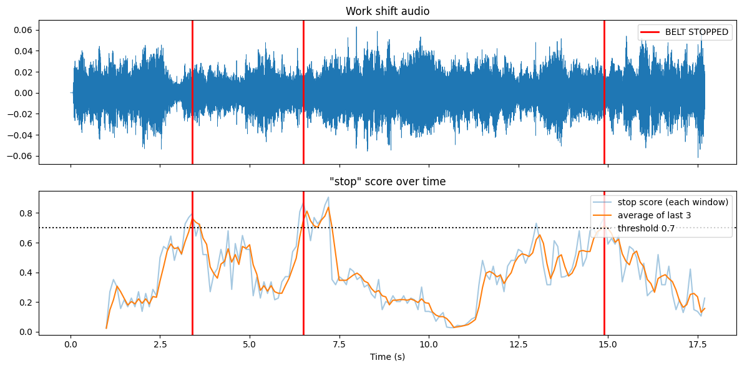
Figure 6: Work shift audio with each BELT STOPPED marked, and the "stop" score over time.
The times of the spoken stops were not entered, so misses and false stops of this recording were not counted.

4.6 Threshold tuning
Simulated 60 s shift with 8 stops from unseen speakers and light noise:
Threshold | Stops spoken | Detected | Correct | Misses | False stops
0.5 | 8 | 12 | 8 | 0 | 4
0.7 | 8 | 10 | 8 | 0 | 2
0.9 | 8 | 8 | 8 | 0 | 0

The same 60 live trials (maximum score of each trial) counted at the three thresholds:
Condition | Threshold | Stops caught (of 10) | False stops (of 10)
Close | 0.5 | 9 | 2
Close | 0.7 | 6 | 1
Close | 0.9 | 5 | 1
1 m away | 0.5 | 8 | 5
1 m away | 0.7 | 6 | 3
1 m away | 0.9 | 5 | 1
With noise | 0.5 | 7 | 5 to 6 *
With noise | 0.7 | 2 | 1
With noise | 0.9 | 0 | 0

* one score was printed as 0.50, so it is not clear on which side of the threshold it is.

4.7 Performance
Metric | Value
int8 model size | 53.7 KB (limit 100 KB)
Inference per window | 0.229 ms
MFCC for 1 s of audio | 12.2 ms

4.8 Robustness: live accuracy vs Lab 5
Condition | Live accuracy (%) | Stops caught | Lab 5 test accuracy (%)
Close to the mic | 75 | 6 of 10 | 99.25
1 m away | 65 | 6 of 10 | 99.25
With fan noise | 55 | 2 of 10 | 99.25

5. Code
The complete code of the notebook (2548562_TinyML_Lab6.ipynb), in the order it was run:
1 - Setup
import os
import json
import time
import subprocess
from base64 import b64decode

import numpy as np
import pandas as pd
import matplotlib.pyplot as plt
from scipy.io import wavfile

import tensorflow as tf

print("TensorFlow:", tf.__version__)
2 - Install the brain: load the model and the MFCC settings
REQUIRED = ["kws_int8.tflite", "kws_config.json", "kws_bench_clips.npz"]
missing = [f for f in REQUIRED if not os.path.exists(f)]

if missing:
from google.colab import files
print("Upload these files from Lab 5:", missing)
files.upload()

with open("kws_config.json") as f:
cfg = json.load(f)

SR = cfg["sample_rate"]
LABELS = cfg["labels"]
MFCC_MEAN = np.array(cfg["mfcc_mean"], dtype=np.float32)
MFCC_STD = np.array(cfg["mfcc_std"], dtype=np.float32)

interpreter = tf.lite.Interpreter(model_path="kws_int8.tflite")
interpreter.allocate_tensors()

inp = interpreter.get_input_details()[0]
out = interpreter.get_output_details()[0]
IN_SCALE, IN_ZP = inp["quantization"]
OUT_SCALE, OUT_ZP = out["quantization"]

print("MFCC settings : %d Hz, %d ms window, %d ms hop, MFCC shape %s" %
(SR, cfg["window_ms"], cfg["hop_ms"], cfg["mfcc_shape"]))
print()
print("Input shape :", inp["shape"], " dtype:", inp["dtype"].__name__, " scale: %.6f zero point: %d" % (IN_SCALE, IN_ZP))
print("Output shape :", out["shape"], " dtype:", out["dtype"].__name__, " scale: %.6f zero point: %d" % (OUT_SCALE, OUT_ZP))
print("Classes :", LABELS)
MFCC front-end and model wrapper
FRAME_LEN, FRAME_STEP, FFT_LEN = cfg["frame_length"], cfg["frame_step"], cfg["fft_length"]
MEL_W = tf.signal.linear_to_mel_weight_matrix(cfg["num_mel_bins"], FFT_LEN // 2 + 1, SR,
cfg["lower_edge_hz"], cfg["upper_edge_hz"])

def waveform_to_mfcc(wav):
stft = tf.signal.stft(wav, frame_length=FRAME_LEN, frame_step=FRAME_STEP, fft_length=FFT_LEN)
mel = tf.tensordot(tf.square(tf.abs(stft)), MEL_W, 1)
log_mel = tf.math.log(mel + 1e-6)
return tf.signal.mfccs_from_log_mel_spectrograms(log_mel)[..., :cfg["num_mfcc"]]

def run_model(mfcc_norm):
"""one normalised 49x10 MFCC -> class probabilities"""
x = np.clip(np.round(mfcc_norm[None, :, :, None] / IN_SCALE + IN_ZP), -128, 127).astype(np.int8)
interpreter.set_tensor(inp["index"], x)
interpreter.invoke()
y = interpreter.get_tensor(out["index"])[0].astype(np.float32)
return (y - OUT_ZP) * OUT_SCALE

def predict_clip(audio):
"""probabilities for exactly 1 s of audio"""
audio = np.asarray(audio, dtype=np.float32)[:SR]
audio = np.pad(audio, (0, SR - len(audio)))
m = waveform_to_mfcc(tf.constant(audio)).numpy()
return run_model((m - MFCC_MEAN) / MFCC_STD)

def window_probs(audio, hop=SR // 10):
"""probabilities for every 1 s window of audio, moving by hop samples (default 100 ms)"""
audio = np.asarray(audio, dtype=np.float32)
if len(audio) < SR:
audio = np.pad(audio, (0, SR - len(audio)))
wins = np.ascontiguousarray(np.lib.stride_tricks.sliding_window_view(audio, SR)[::hop])
m = waveform_to_mfcc(tf.constant(wins)).numpy()
m = (m - MFCC_MEAN) / MFCC_STD
return np.stack([run_model(mi) for mi in m])
Streaming helpers: smoothing, threshold, refractory period
HOP_S = 0.1 # window update every 100 ms
THRESHOLD = 0.7
AVG_N = 3 # average of the last 3 predictions
REFRACTORY_S = 1.0 # one shout = one stop

def detect_stops(p_stop, thr=THRESHOLD, avg_n=AVG_N, refractory_s=REFRACTORY_S, hop_s=HOP_S):
"""returns (times of detected stops in s, smoothed score). Time = end of the 1 s window."""
smooth = np.array([p_stop[max(0, i - avg_n + 1):i + 1].mean() for i in range(len(p_stop))])
detections, last, armed = [], -1e9, True
for i, s in enumerate(smooth):
t = 1.0 + i * hop_s
if not armed and s < thr and t - last >= refractory_s:
armed = True # the shout is over: listen for the next one
if armed and s >= thr:
detections.append(t)
last, armed = t, False
return detections, smooth

def score_stream(detections, true_times):
"""a detection is correct if it comes from 0.5 s before to 1.5 s after the centre of a spoken stop"""
matched, used = 0, set()
for t in detections:
for k, tt in enumerate(true_times):
if k not in used and tt - 0.5 <= t <= tt + 1.5:
used.add(k)
matched += 1
break
return {"stops spoken": len(true_times), "detected": len(detections), "correct": matched,
"misses": len(true_times) - matched, "false stops": len(detections) - matched}
3 - Bench test: unseen dataset clips
bench = np.load("kws_bench_clips.npz")
b_audio, b_labels, b_names = bench["audio"], bench["labels"], bench["names"]

rows = []
for k in range(3):
for i in np.where(b_labels == k)[0][:5]: # 5 stop, 5 unknown, 5 silence
p = predict_clip(b_audio[i])
rows.append({"clip": b_names[i], "actual": LABELS[k], "predicted": LABELS[p.argmax()],
"confidence": round(float(p.max()), 3), "correct": bool(p.argmax() == k)})

bench_df = pd.DataFrame(rows)
print(bench_df.to_string(index=False))
print()
print(f"Bench test: {bench_df.correct.sum()} of {len(bench_df)} correct")
4 - Workers' voices: recorded audio from phones
def to_mono_16k(path):
"""any audio file -> float32 numpy array, 16 kHz mono (uses ffmpeg)"""
subprocess.run(["ffmpeg", "-y", "-loglevel", "error", "-i", path, "-ar", str(SR), "-ac", "1", "tmp_conv.wav"], check=True)
rate, data = wavfile.read("tmp_conv.wav")
return data.astype(np.float32) / 32768.0

from google.colab import files
uploaded = files.upload()

rows = []
for name in sorted(uploaded):
audio = to_mono_16k(name)
probs = window_probs(audio)
det, smooth = detect_stops(probs[:, 0])
said_stop = name.lower().startswith("stop")
rows.append({"file": name, "said": name.split("_")[0].lower(), "max stop score": round(float(smooth.max()), 3),
"system": "BELT STOPPED" if det else "ignored", "correct": bool(bool(det) == said_stop)})

if rows:
voices_df = pd.DataFrame(rows)
print(voices_df.to_string(index=False))
print()
print(f"Workers' voices: {voices_df.correct.sum()} of {len(voices_df)} handled correctly")
else:
print("No files uploaded")
5 - Live trial with the microphone
from IPython.display import display, Javascript
from google.colab import output

RECORD_JS = """
const sleep = time => new Promise(resolve => setTimeout(resolve, time));
const b2text = blob => new Promise(resolve => {
const reader = new FileReader();
reader.onloadend = e => resolve(e.srcElement.result);
reader.readAsDataURL(blob);
});
var record = time => new Promise(async resolve => {
const stream = await navigator.mediaDevices.getUserMedia({audio: {echoCancellation: false, noiseSuppression: false, autoGainControl: false}});
const recorder = new MediaRecorder(stream);
const chunks = [];
recorder.ondataavailable = e => chunks.push(e.data);
recorder.start();
await sleep(time);
recorder.onstop = async () => {
const blob = new Blob(chunks);
const text = await b2text(blob);
stream.getTracks().forEach(t => t.stop());
resolve(text);
};
recorder.stop();
});
"""

def record_audio(seconds):
"""record from the microphone, returns float32 array at 16 kHz"""
display(Javascript(RECORD_JS))
data = output.eval_js("record(%d)" % int(seconds * 1000))
with open("rec.webm", "wb") as f:
f.write(b64decode(data.split(",")[1]))
return to_mono_16k("rec.webm")

live_log = pd.DataFrame(columns=["condition", "expected", "said", "detected", "max score"])

OTHER_WORDS = ["go", "no", "left", "yes", "right", "top", "shop", "up", "down"]

def live_trials(expected, n, condition, secs=2.0):
global live_log
rows = []
for i in range(n):
said = "STOP" if expected == "stop" else OTHER_WORDS[i % len(OTHER_WORDS)].upper()
print(f"[{condition}] trial {i + 1}/{n}: say '{said}' in ", end="")
for c in (3, 2, 1):
print(c, end=" ")
time.sleep(1)
print("-> speak now")
audio = record_audio(secs)
det, smooth = detect_stops(window_probs(audio)[:, 0])
print(" BELT STOPPED" if det else " ignored", f"(max score {smooth.max():.2f})")
rows.append({"condition": condition, "expected": expected, "said": said.lower(),
"detected": bool(det), "max score": round(float(smooth.max()), 3)})
live_log = pd.concat([live_log, pd.DataFrame(rows)], ignore_index=True)

def live_summary(log):
out = []
for cond, g in log.groupby("condition", sort=False):
s, o = g[g.expected == "stop"], g[g.expected == "other"]
out.append({"condition": cond,
"correct stops": int(s.detected.sum()), "missed stops": int((~s.detected.astype(bool)).sum()),
"false stops": int(o.detected.sum()), "correct ignores": int((~o.detected.astype(bool)).sum()),
"accuracy (%)": round(100 * (s.detected.sum() + (~o.detected.astype(bool)).sum()) / len(g), 1)})
return pd.DataFrame(out)

# shout "stop" 10 times
live_trials("stop", 10, "close")

# say other words 10 times (go, no, left, yes, right, top, shop, up, down)
live_trials("other", 10, "close")
live_summary(live_log)
6 - Always listening: streaming inference on a work shift
shift_audio = record_audio(18)
print("Recorded %.1f s" % (len(shift_audio) / SR))

probs_shift = window_probs(shift_audio)
det_shift, smooth_shift = detect_stops(probs_shift[:, 0])

for t in det_shift:
print(f"{t:5.1f} s 🛑 BELT STOPPED")
print("Detections:", len(det_shift))

# time of the middle of each spoken "stop", read from the plot below, then run this cell again
STOP_TIMES = [] # for example [3.2, 7.9, 12.4]

t_audio = np.arange(len(shift_audio)) / SR
t_score = 1.0 + np.arange(len(probs_shift)) * HOP_S

fig, axes = plt.subplots(2, 1, figsize=(12, 6), sharex=True)

axes[0].plot(t_audio, shift_audio, lw=0.6)
for k, t in enumerate(det_shift):
axes[0].axvline(t, color="red", lw=2, label="BELT STOPPED" if k == 0 else None)
for k, t in enumerate(STOP_TIMES):
axes[0].axvline(t, color="green", ls="--", lw=1, label="spoken stop" if k == 0 else None)
axes[0].set_title("Work shift audio")
axes[0].legend(loc="upper right")

axes[1].plot(t_score, probs_shift[:, 0], alpha=0.4, label="stop score (each window)")
axes[1].plot(t_score, smooth_shift, label="average of last 3")
axes[1].axhline(THRESHOLD, color="k", ls=":", label=f"threshold {THRESHOLD}")
for t in det_shift:
axes[1].axvline(t, color="red", lw=2)
axes[1].set_xlabel("Time (s)")
axes[1].set_title('"stop" score over time')
axes[1].legend(loc="upper right")

plt.tight_layout()
plt.show()

if STOP_TIMES:
print(score_stream(det_shift, STOP_TIMES))
7 - Safety vs production: threshold tuning
def build_sim_shift(seed=7):
r = np.random.default_rng(seed)
stop_pool = [b_audio[i] for i in np.where(b_labels == 0)[0][5:]]
other_pool = [b_audio[i] for i in np.where(b_labels == 1)[0][5:]]

audio = np.zeros(60 * SR, dtype=np.float32)
kinds = ["stop"] * 8 + ["other"] * 14 + ["pause"] * 2
r.shuffle(kinds)

true_times = []
for slot, kind in enumerate(kinds): # one clip every 2.5 s
start = int(slot * 2.5 * SR)
if kind == "stop":
audio[start:start + SR] += stop_pool[len(true_times) % len(stop_pool)]
true_times.append(slot * 2.5 + 0.5)
elif kind == "other":
audio[start:start + SR] += other_pool[r.integers(len(other_pool))]

noise = np.concatenate([np.random.default_rng(100 + i).standard_normal(SR) for i in range(60)]).astype(np.float32)
return np.clip(audio + 0.01 * noise, -1, 1), true_times

sim_audio, sim_true = build_sim_shift()
sim_probs = window_probs(sim_audio)

rows = []
for thr in [0.5, 0.7, 0.9]:
det, _ = detect_stops(sim_probs[:, 0], thr=thr)
rows.append({"threshold": thr, **score_stream(det, sim_true)})

sim_df = pd.DataFrame(rows)
print("Simulated 60 s work shift (unseen speakers + noise)")
print(sim_df.to_string(index=False))

if STOP_TIMES:
rows = []
for thr in [0.5, 0.7, 0.9]:
det, _ = detect_stops(probs_shift[:, 0], thr=thr)
rows.append({"threshold": thr, **score_stream(det, STOP_TIMES)})
print("My recorded work shift")
print(pd.DataFrame(rows).to_string(index=False))
else:
print("Fill in STOP_TIMES in step 6 to run the sweep on the recorded shift")
8 - Will it fit the chip? Performance
model_kb = os.path.getsize("kws_int8.tflite") / 1024

window = b_audio[0]
m_norm = (waveform_to_mfcc(tf.constant(window)).numpy() - MFCC_MEAN) / MFCC_STD

for _ in range(20): # warm-up
run_model(m_norm)

N = 200
start = time.perf_counter()
for _ in range(N):
run_model(m_norm)
infer_ms = (time.perf_counter() - start) / N * 1000

start = time.perf_counter()
for _ in range(N):
waveform_to_mfcc(tf.constant(window)).numpy()
mfcc_ms = (time.perf_counter() - start) / N * 1000

print(f"int8 model size : {model_kb:.1f} KB (limit 100 KB)")
print(f"Inference per window : {infer_ms:.3f} ms")
print(f"MFCC for 1 s of audio : {mfcc_ms:.3f} ms")
9 - Real factory conditions: robustness
live_trials("stop", 10, "1 m away")
live_trials("other", 10, "1 m away")

# play a fan or machine sound from another device, then run this cell
live_trials("stop", 10, "with noise")
live_trials("other", 10, "with noise")

summary = live_summary(live_log)
summary["Lab 5 test accuracy (%)"] = cfg["lab5_test_accuracy_int8"]
summary

# live trials counted again at different thresholds (uses the max score of every trial in live_log)
rows = []
for cond, g in live_log.groupby("condition", sort=False):
for thr in [0.5, 0.7, 0.9]:
s, o = g[g.expected == "stop"], g[g.expected == "other"]
rows.append({"condition": cond, "threshold": thr,
"stops caught (of 10)": int((s["max score"] >= thr).sum()),
"false stops (of 10)": int((o["max score"] >= thr).sum())})
pd.DataFrame(rows)

6. Discussion of Results
Answers to the tasks of the lab:
Bench test
● 14 of 15 clips were correct, in line with the expected 13 to 15. All 5 stop clips were caught with 0.996 confidence. The one mistake is an "up" clip called stop (0.879), a false stop.
Live trial
● Close to the microphone 6 of 10 stops were caught and 1 of 10 other words caused a false stop ("shop", which sounds almost like "stop"). This is lower than the "most stops caught" that was expected: 4 of the 10 stops scored only 0.24 to 0.66, below the threshold.
Streaming
● The system listened continuously with a 1 s window moving every 100 ms. The average of the last 3 predictions removes the jumps of the raw score, and the refractory period gives one BELT STOPPED per shout. Three stops were detected in the 17.7 s shift. One more rise of the score around 13 s only reached about 0.65 and was not detected.
Threshold choice
● On the clean simulation all thresholds found the 8 stops, and a lower threshold only added false stops (4 at 0.5, 2 at 0.7, 0 at 0.9). On the real microphone, however, most stop scores are between 0.5 and 0.7, so 0.9 caught only 5 of 10 close stops and 0 with noise. We recommend a threshold of 0.5: the safety officer wants zero misses and a missed stop is far worse than a false stop (it caught 9 of 10 close stops against 6 at 0.7). The price is more false stops, so 0.7 is the compromise if the production cost is too high. No threshold is fully safe with this model.
Performance
● The int8 model is 53.7 KB and fits the 100 KB limit. Inference takes 0.229 ms per window (below the 1 ms expected) and MFCC takes 12.2 ms for 1 s of audio, so MFCC is about 50 times more expensive than the network. Together they use about 12% of the 100 ms between windows on the Colab CPU. A microcontroller is slower, so the MFCC code is the part to optimise.
Robustness (explanation for the manager)
● Live accuracy fell from 99.25% in Lab 5 to 75% close to the mic, 65% from 1 m and 55% with fan noise, and with noise only 2 of 10 stops were caught. The Lab 5 test uses clean clips from the same dataset as the training, and its silence class is synthetic. In the factory the microphone is different, the voice is weaker from a distance and the machine noise was never heard by the model in a real form, so the stop score drops below the threshold. To fix it, real recordings from the factory (workers, distance, noise) should be added to the training data.
Incomplete parts
● Workers' voices: only one phone clip was tested, and its content was not labelled.
● The spoken times of the stops in the recorded work shift were not entered, so its misses and false stops, and the threshold sweep on it, were not computed.

7. Conclusion
The int8 "stop" model (53.7 KB, 0.229 ms per window) works as an always-listening system: it showed BELT STOPPED for each shout that crossed the threshold in the recorded shift, and it was correct on 14 of 15 bench clips. With a real microphone, however, accuracy fell to 75%, 65% and 55% (close, 1 m and with noise), against 99.25% in Lab 5, and tricky words like "shop" caused false stops. A threshold of 0.5 is recommended for safety, but the model needs to be trained again with real factory recordings before it is trusted on the factory floor.

8. Deliverables Submitted
● Workflow diagram of Lab 5 and Lab 6.
● Python code: 2548562_TinyML_Lab6.ipynb, covering model loading, bench and live tests, streaming inference, threshold tuning and robustness.
● This lab report: model details, bench table, live table, streaming plot, threshold comparison, performance and robustness analysis.

