Department of Computer Science

Lab Manual

of

Tiny MACHINE LEARNING

(MAI524B-5)

Class Name: IV MCA

Master of Science Artificial Intelligence and Machine Learning

2026

Prepared by: Verified by:
Virani Meet Suershbhai 2548562
Dr. Helen K Joy

Department Overview
Department of Computer Science of CHRIST (Deemed to be University) strives to shape outstanding computer professionals with ethical and human values to reshape nation’s destiny. The training imparted aims to prepare young minds for the challenging opportunities in the IT industry with a global awareness rooted in the Indian soil, nourished and supported by experts in the field.

Vision
The Department of Computer Science endeavours to imbibe the vision of the University “Excellence and Service”. The department is committed to this philosophy which pervades every aspect and functioning of the department.

Mission
“To develop IT professionals with ethical and human values”. To accomplish our mission, the department encourages students to apply their acquired knowledge and skills towards professional achievements in their career. The department also moulds the students to be socially responsible and ethically sound.

Introduction to the Programme
Master of Computer Applications (MCA) is a post-graduate programme of CHRIST (Deemed to be University) and approved by the All India Council of Technical Education (AICTE). It is a two-year programme spread over six trimesters to bridge the chasm between computer studies and applications, bringing within reach of enthusiastic youngsters an excellent group of experienced and dedicated staff and experts, and an enviable infrastructure. MCA at CHRIST (Deemed to be University) strives to shape outstanding computer professionals with ethical and human values to reshape the nation’s destiny. The training programme aims to prepare young minds for challenging opportunities in the IT industry with a global awareness rooted in the Indian soil, nourished and supported by experts in the field. The Department is committed to the motto “Excellence and Service,” and this philosophy pervades every aspect of its functioning.

Programme Objective
This programme is conceptualised and designed based on the strong commitment of the
department to provide better quality education to the students. The principal objectives of this
course are to:
● Heighten technological awareness
● Train future industry specialists
● Encourage effective software development
● Provide research training
● Involve students in innovative research
● Produce graduates with a two-year professional education in Computer Science with
technical, professional, and communications skills.

Ethics and Human Values
1. Only proprietary or open-source software would be used for academic teaching and
learning purposes.
2. Copying of programs from the internet, friends or from other sources is strictly
discouraged since it impairs development of programming skills.
3. Unique Practical (Domain based) exercises ensure that the students don’t get involved in
code plagiarism.
4. Projects undertaken by students during the course are done in teams to improve
collaborative work and synergy between team members.
5. Projects involve modularization which initiates students to take individual responsibility
for common goals.
6. Passion for excellence is promoted among the students, be it in software development or
project documentation.
7. Giving due credit to sources during the seminar and research assignment is promoted
among the students
8. The course and its design enforce the practice of good referencing technique to improve
the sense of integrity.
9. Courses involving group discussions and debates on ethical practices and human values
are designed to sensitize the students in dealing with customers and members within the
Organization.

Programme Outcomes:
PO1 : Conduct investigation and develop innovative solutions for real world problems in industry and research establishments related to Artificial Intelligence and Machine Learning PO2 : Apply programming principles and practices for developing automation solutions to meet future business and society needs.
PO3 : Ability to use or develop the right tools to develop high end intelligent systems
PO4 : Adopt professional and ethical practices in Artificial Intelligence application development
PO5 : Understand the importance and the judicious use of technology for the sustainability of the environment.

Programme Educational Objectives(PEO’s)
PEO1: Develop innovative and effective software solutions through research that addresses
real-world challenges, grounded in a commitment to continuous learning and adaptability.
PEO2: Advance the knowledge and practices in the field of computer applications through
lifelong learning and rigorous research, supporting professional growth and academic excellence.
PEO3: Exhibit ethical leadership, social responsibility to contribute and enhance community
well-being by innovating solutions.

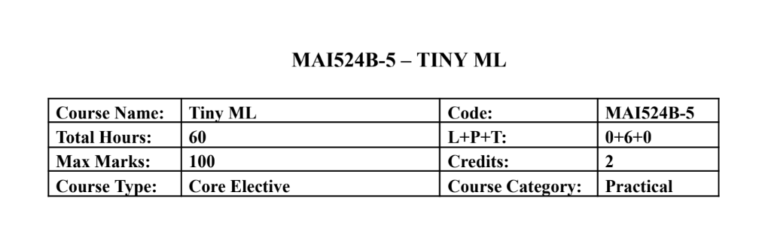Course Description
This course focuses on hands-on development of TinyML applications on mobile, edge, and
embedded platforms. Students learn the end to end workflow including data preparation,
lightweight model development, optimization, and deployment on microcontrollers using
sensors. Emphasis is placed on practical implementation using TensorFlow Lite, TensorFlow Lite
Micro, and embedded development environments with minimal theory and extensive laboratory
work.
Course Objectives
This course introduces the TinyML development workflow for edge intelligence and builds
practical skills in model optimization and embedded deployment. It enables students to develop
audio, vision, and sensor based TinyML applications and implement real time intelligent systems
using microcontrollers and hardware sensors.

Course Outcomes
CO1: Design TinyML workflows and lightweight models for edge devices.
CO2: Implement TensorFlow Lite-based optimisation and deployment.
CO3: Develop keyword spotting and visual TinyML applications.
CO4: Deploy sensor based TinyML solutions on embedded hardware.
CO5: Build end to end practical TinyML systems integrating hardware

Unit-1 Teaching Hours: 12
TINYML FOUNDATIONS AND WORKFLOW DESIGN
TinyML ecosystem overview – edge AI concepts – machine learning lifecycle – sensor roles in
TinyML – dataset planning – development environment setup – lightweight application
workflow design.Edge Computing vs Cloud Computing: A Comparative Demonstration of On
Device and Remote AI Inference
Practical Exercises:
1. Sensor data exploration and TinyML workflow planning using Colab.
2. Design and simulation of a TinyML application pipeline including preprocessing and
inference stages.

Unit-2 Teaching Hours: 12
TENSORFLOW LITE AND MODEL OPTIMIZATION
TensorFlow Lite workflow – model conversion – inference pipelines – low precision
computation – post training quantization – quantization aware training – performance
benchmarking.Human Activity Recognition Using Accelerometer and Multisensor Data
Practical Exercises:
3. Convert TensorFlow models to TensorFlow Lite and perform inference evaluation.
4. Implement quantization techniques and compare accuracy, latency, and memory usage.

Unit-3 Teaching Hours: 12
AUDIO TINYML AND KEYWORD SPOTTING
Keyword spotting architecture – audio preprocessing – MFCC and spectrogram features –
dataset preparation – training workflow – streaming audio inference.
Practical Exercises:
5. Train a keyword spotting model using speech datasets in Colab.
6. Deploy and test keyword spotting inference using live or recorded audio input.

Unit-4 Teaching Hours: 12
Visual Wake Words and Anomaly Detection
Visual wake word applications – transfer learning – lightweight vision models – anomaly
detection concepts – autoencoders and clustering – responsible dataset handling.Deploying a
Lightweight MLP and 1D CNN on Embedded Targets: Challenges and Performance Analysis
Practical Exercises:
7. Develop a visual wake word model using transfer learning techniques.
8. Build an anomaly detection system using sensor or industrial datasets.

Unit-5 Teaching Hours: 12
Embedded Deployment with TensorFlow Lite Micro
Microcontroller basics – embedded ML workflow – TensorFlow Lite Micro interpreter –
memory allocation – sensor integration – real time inference – deployment practices.
Practical Exercises:
9. Deploy a pretrained TinyML model on Arduino Nano 33 BLE Sense or equivalent
board.
10. Develop an integrated TinyML application such as gesture recognition, sensor anomaly
detection, or embedded keyword spotting.

Text & Reference Books
[1] TinyML, Pete Warden and Daniel Situnayake, O Reilly Media, First Edition, 2019
[2] Deep Learning with Python, Francois Chollet, Manning Publications, Second Edition,
2021
Essential Reading
[1] TinyML Cookbook, Gian Marco Iodice, Packt Publishing, First Edition, 2022
[2] Practical Edge AI, O Reilly Media, First Edition, 2023
Additional Information (Web Resources):
1. TensorFlow Lite Documentation: https://www.tensorflow.org/api_docs/python/tf/lite
2. TensorFlow Lite Micro GitHub Repository: https://github.com/tensorflow/tflite-micro
3. Arduino TinyML Tutorials:
https://docs.arduino.cc/tutorials/nano-33-ble-sense/get-started-with-machine-learning/
4. Edge Impulse TinyML Labs: https://www.edgeimpulse.com/
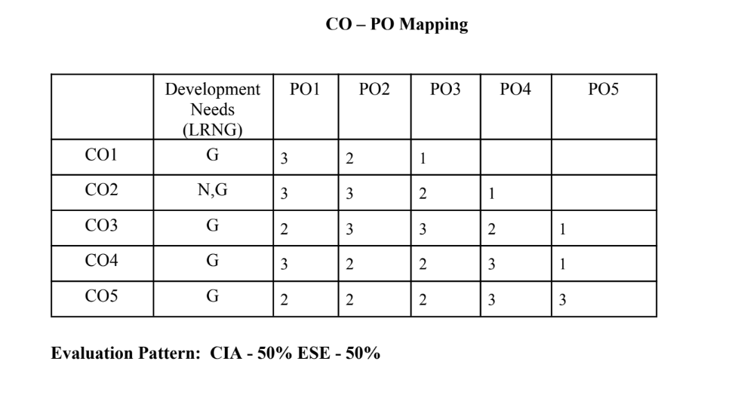

LIST OF PROGRAMS

MSCAIML
Sl.no | Title of lab Experiment | Page number | RBT | CO
1 | Lab Question: Real-Time Rotational Dynamics & Edge-AI Payload Safety System |  | L3 | CO1,3
2 |  |  | L3 | CO2,3
3 |  |  | L3 | CO3
4 |  |  | L3 | CO3
5 |  |  | L3 | CO3
6 |  |  | L3 | CO3,4
7 |  |  | L4 | CO3
8 |  |  | L3 | CO3,4
9 |  |  | L3 | CO4,5
10 |  |  | L5 | CO5

Evaluation Rubrics:
Evaluation Rubrics for each program would be
EVALUATION RUBRICS
(R1) Concept Clarity (Viva) - 3 M
(R2) Code Execution - 3M
(R3) Complexity Addition (Self Learning) -2 M
(R4) Timely Submission - 2 M

Submission Guidelines:
- Make a copy of the lab manual template with your <name_reg:no_subject name >,
- Copy the given question and the answer (lab code) with results, followed by the conclusion of that lab. Title the lab as lab number.
- Keep updating your lab manual and show the lab manual of that particular lab for evaluation.
- Create a Git Repository in your profile <tiny_ML_lab-reg no> . Follow a different branch for each lab <Lab 1, Lab 2…>, and push the code to Git. The link should be provided in Google Classroom along with the PDF of the lab manual.
- Upload the PDF to Google Classroom before the deadline.

Lab Question: Real-Time Rotational Dynamics & Edge-AI Payload Safety System

Tools Required: Smartphone with phyphox app, flat rotating platform, small test payload (e.g., coin or eraser), Python 3.x (Google Colab / Jupyter).

1. Aim
To measure tri-axial angular velocityusing a smartphone's gyroscope via phyphox, derive the physical threshold for rotational static friction failure, extract time-series features, and build an optimized TinyML classification model to predict payload stability (SAFE vs. UNSAFE/FALL) on an edge device.

2. Scenario & Problem Statement
An autonomous warehouse mobile robot carries an unanchored payload on its top surface. A smartphone mounted to the chassis acts as the primary Inertial Measurement Unit (IMU). When the robot negotiates sharp turns at high angular speeds, centripetal forces exceed static friction, causing cargo to slide off.
Your Task:
- Physical Setup: Place a test object on the smartphone screen
- Data Acquisition: Use phyphox to log gyroscope data while gradually increasing tilt and rotation speed until the object slides off.
- Data Engineering: Process raw CSV data
- Edge ML Pipeline: Label windowed data into binary classes (0 = SAFE, 1 = UNSAFE/FALL), train a lightweight classifier, and quantize it to .tflite format for local edge execution.

3. Submission Deliverables
- Workflow of the problem.
- Raw Dataset: Exported phyphox_gyro_data.csv.
- Python Code Script and git repo : Complete pipeline covering feature extraction, threshold determination, model training, and .tflite export.
- Lab Report: Experimental coefficient of static friction ($\mu_s$), model confusion matrix, and TFLite model size footprint in kilobytes.

Evaluation Rubric (10 Marks Total)
Assessment Module | Performance Criteria | Marks
1. Data Acquisition & Preprocessing | • Proper experimental setup and clean data collection.  • Correct signal processing, normalization, and feature engineering. | / 3
2. Implementation & Model Optimization | • Correct implementation of baseline models and algorithms.  • Successful execution of optimization, quantization, or deployment pipelines. | / 3
3. Results Analysis, Code & Deliverables | • Complete benchmarking/results analysis (accuracy, memory, speed, or system metrics).  • Clean, well-documented code with a clear final technical report. | / 4
TOTAL SCORE: _____ / 10 MARKS

- Workflow Image
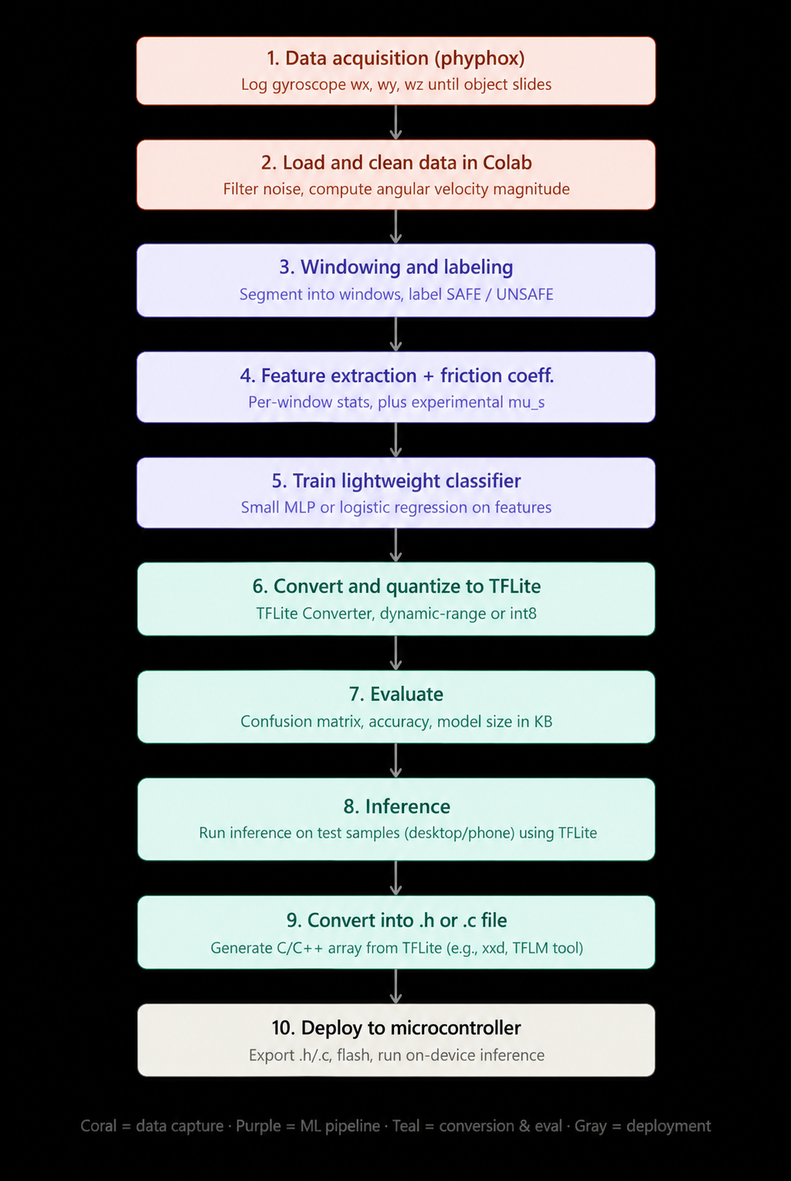

1. Aim
The aim of this lab was to measure tri-axial angular velocity using a smartphone's gyroscope via phyphox, derive the physical threshold for rotational static friction failure, extract time-series features, and build an optimized TinyML classification model to predict payload stability (SAFE vs. UNSAFE/FALL) suitable for edge deployment.

2. Scenario
An autonomous warehouse mobile robot carries an unanchored payload on its top surface. A smartphone mounted to the chassis acts as the primary Inertial Measurement Unit (IMU). When the robot negotiates sharp turns at high angular speeds, centripetal and tilt-induced forces exceed static friction, causing cargo to slide off. This lab models that scenario using a smartphone gyroscope and a small test object placed on the phone screen.

3. Methodology
Our pipeline followed these steps, in order (see the attached workflow diagram for the full visual):
● Physical setup: placed a small test object (coin/eraser) on the phone screen.
● Data acquisition: used phyphox to log tri-axial gyroscope data (wx, wy, wz) while gradually tilting and rotating the phone until the object slid off, repeated across 9 trials.
● Data cleaning: loaded the exported file in Google Colab, dropped the z-axis (rotation about the vertical, not relevant to tilt-based sliding), and applied light smoothing to reduce sensor noise.
● Trial detection: automatically identified each trial's boundary by detecting the still period we held after each fall.
● Windowing and labeling: segmented each trial into overlapping 1-second windows (50% overlap) and labeled each window SAFE (0) or UNSAFE (1) based on proximity to the fall point.
● Feature extraction: computed the maximum, mean, standard deviation, and rate of change of the tilt angular velocity magnitude for each window.
● Friction coefficient estimation: integrated the x and y angular velocities to estimate the tilt angle at the moment of slip, then computed mu_s = tan(theta_slip) for each trial.
● Model training: trained a lightweight logistic regression classifier (a single dense layer with sigmoid activation) on the extracted features.
● Quantization: converted and quantized the trained model to TensorFlow Lite using dynamic range quantization.
● Evaluation: measured accuracy and the confusion matrix on a held-out test set, and recorded the TFLite model size.
● Inference: ran the quantized model through the TFLite interpreter in Colab to simulate edge execution.

4. Results

4.1 Experimental coefficient of static friction (mu_s)
We estimated mu_s for each of our 9 trials by integrating the gyroscope's x and y angular velocity over the active phase of the trial to obtain the tilt angle at the moment of slip, then applying mu_s = tan(theta_slip).
Trial | Estimated mu_s
1 | 1.9757
2 | 0.4284
3 | 0.7875
4 | 4.9541
5 | 1.5038
6 | 0.4564
7 | 0.6542
8 | 0.8172
9 | 1.5404

Average mu_s across all 9 trials: 1.4575
Standard deviation: 1.3362
Note: gyroscope integration drifts over time, so this estimate should be read as an approximation rather than a precise physical measurement. Trials with longer active durations are more affected by this drift, which explains the wider spread in per-trial values.

4.2 Model and TFLite export
Metric | Value
Model type | Logistic regression (single dense layer, sigmoid)
Input features | max_mag, mean_mag, std_mag, rate_of_change
Quantization scheme | Dynamic range (int8 weights, float32 activations)
TFLite model size | 1.25 KB
Test set accuracy | 65.00%

4.3 Confusion matrix
Evaluated on the held-out test set (20 windows) using the quantized TFLite model through the TFLite interpreter:
 | Predicted SAFE | Predicted UNSAFE
Actual SAFE | 11 | 5
Actual UNSAFE | 2 | 2

Classification report:
Class | Precision | Recall | F1-score | Support
SAFE | 0.85 | 0.69 | 0.76 | 16
UNSAFE | 0.29 | 0.50 | 0.36 | 4

5. Discussion of Results
Our classifier's accuracy (65%) was lower than we had hoped for, and below what simply predicting the majority class (SAFE) would have achieved on this test set (80%). We do not believe this reflects an error in our pipeline, but rather a set of limitations in our data collection that are worth being transparent about:
● Very little data: our 9 trials produced only around 80 windows in total, a small sample for any classifier to learn a reliable decision boundary from.
● Class imbalance: SAFE windows outnumbered UNSAFE windows by roughly three to one, so a model that has barely learned anything meaningful can still score reasonably well by leaning toward the majority class.
● Weak feature separation: the four features we used (max, mean, standard deviation, and rate of change of tilt magnitude) did not appear to differ enough between SAFE and UNSAFE windows to give the classifier a clear signal.
● Gyroscope drift and labeling noise: since we approximated the exact slip moment rather than marking it precisely (for example with a video or audio cue), some windows near that boundary may be mislabeled.
● Overlapping windows: with 50% overlap between windows, neighboring windows are highly similar, so the effective diversity of our dataset is lower than the raw window count suggests.
Given more time, we believe the most direct way to improve our results would be to collect more trials, in particular more UNSAFE examples, and with more contrast between SAFE and UNSAFE motion, for example holding a clearly slow and steady tilt for SAFE windows and a clearly fast one right before UNSAFE windows. We see this as a natural next step beyond the scope of what we were able to complete for this submission.

6. Conclusion
We successfully built an end-to-end pipeline that collects gyroscope data, automatically detects trials, extracts windowed features, estimates the coefficient of static friction, trains a lightweight classifier, and exports a quantized TFLite model small enough for edge deployment (1.25 KB). While our current classification accuracy is limited by the small size and imbalance of our dataset, the pipeline itself is complete and would benefit directly from additional data collection.

7. Deliverables Submitted
● Workflow diagram of the problem.
● Raw dataset: exported phyphox gyroscope file.
● Python code: TinyML_Lab1_Notebook.ipynb, covering feature extraction, threshold determination, model training, and .tflite export.
● This lab report: experimental mu_s, confusion matrix, and TFLite model size.

Lab 2: Multi-Class Human Activity Recognition & Model Quantization Scheme Analysis

Course Outcomes: CO1, CO2
Total Marks: 10 Marks

1. Aim
To collect multi-axis accelerometer motion data for three distinct activity classes (Idle, Walking, and Sit-ups) using phyphox, train a 3-class Human Activity Recognition (HAR) classifier, implement three TensorFlow Lite model quantization techniques, and systematically benchmark their effects on memory footprint, execution speed, and classification accuracy.

2. Lab Question & Problem Statement
Scenario:
You are an Embedded AI Engineer designing an activity-tracking algorithm for an ultralow-power wearable device. The device must run on-device inference to classify physical activity states (Idle/Static, Walking/Locomotion, and Sit-ups/Repetitive Exercise) without sending raw sensor streams to the cloud. Before deploying the model to hardware, you are tasked with conducting an optimization study comparing the trade-offs between accuracy retention, RAM/ROM footprint, and execution speed across different quantization paradigms.

Your Task:

- Data Acquisition: Secure your smartphone against your chest or waist. Use phyphox > Accelerometer (or Linear Acceleration) to collect sensor streams for three distinct activity states: Idle/Sitting, Walking, and Sit-ups. Export the raw files as idle.csv, walking.csv, and situps.csv.

- Feature Extraction & Processing: Segment continuous acceleration streams into 1-second window intervals (100 samples/sec). Compute the 3D acceleration vector magnitude:

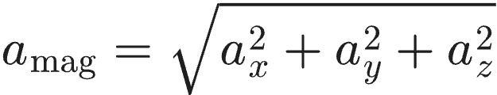
- Extract statistical features per window interval:

Mean Acceleration ():

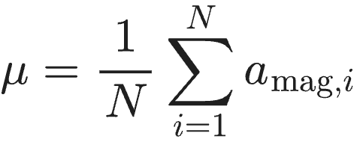
Standard Deviation ():

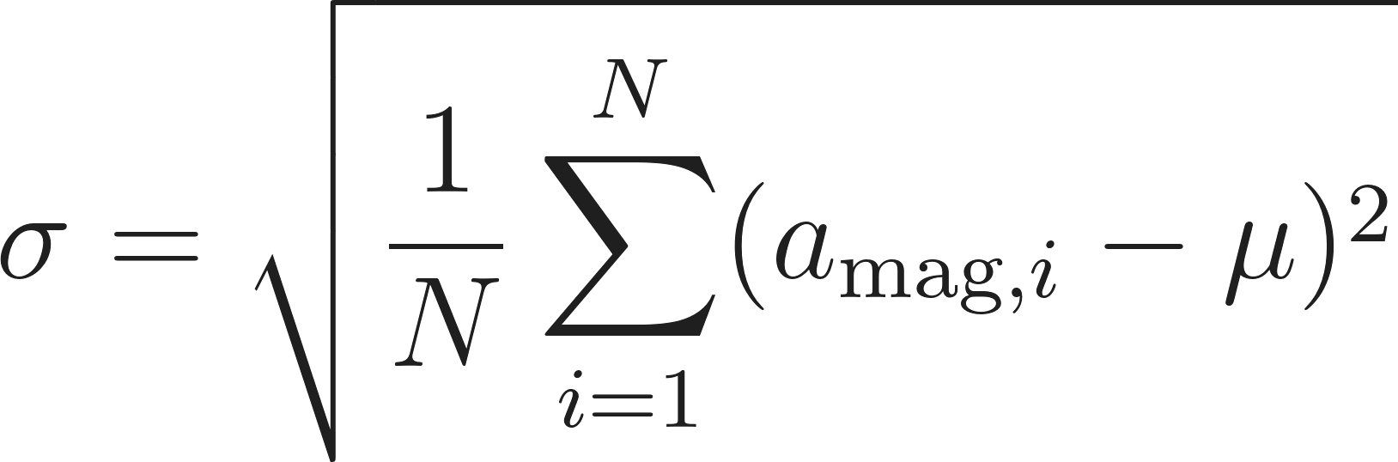
Root Mean Square ():

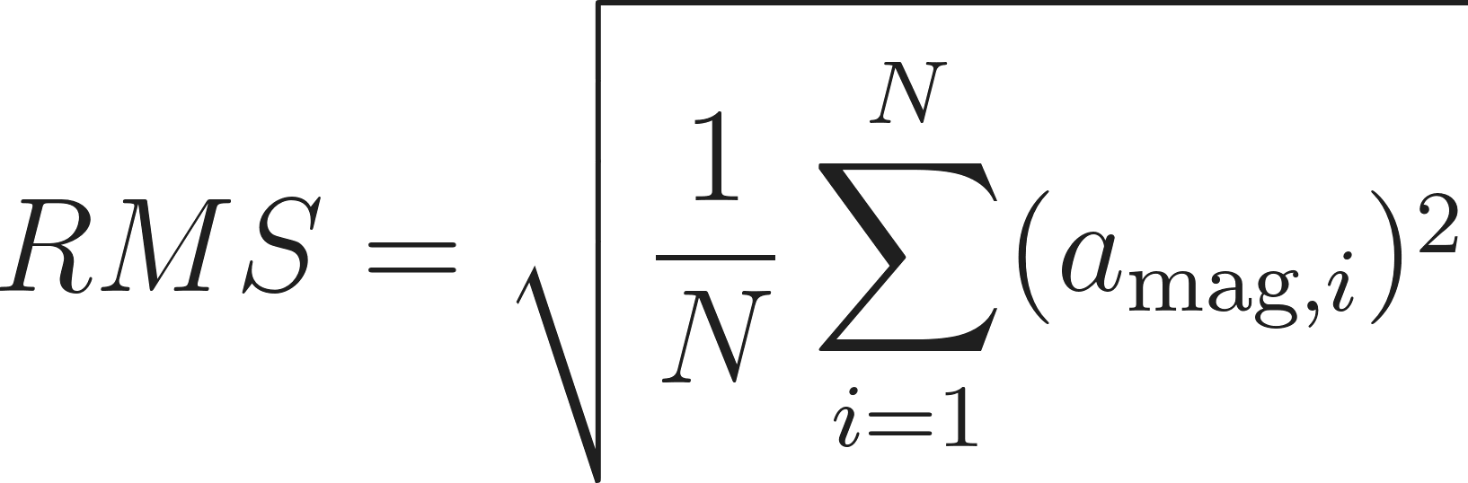
- Model Development: Train a baseline 3-class Multi-Layer Perceptron (MLP) neural network in Python / Google Colab using the extracted feature matrices.

- Quantization Comparison Experiment: Convert the baseline model into four distinct TensorFlow Lite variants:
Variant A: Unquantized Baseline (Float32)

Variant B: Dynamic Range Quantization (Weights quantized to int8, activations in float32)

Variant C: Float16 Quantization (Weights converted to 16-bit float)

Variant D: Full Integer Quantization (Weights and activations strictly quantized to int8 using a representative calibration dataset)

- Comparative Analysis: Benchmark all four variants on the test dataset and record model file sizes (in KB), test classification accuracy (%), memory reduction (%), and average inference execution time () per window.

3. Submission Deliverables
- Raw Datasets and work flow diagram : idle.csv, walking.csv, and situps.csv collected via phyphox.
- Python Script: Complete pipeline implementing windowing, 3-class model training, generation of all 4 TFLite quantisation variants, and automated latency/memory benchmarking.
- Quantisation Benchmarking Report: Completed evaluation table and analysis explaining why full integer quantisation is required for microcontroller deployment.

4. Benchmarking Results Table (To Be Completed by Student)
Quantization Scheme | Target Data Type | Model Size (KB) | Accuracy (%) | Memory Reduction (%)
Baseline (Unquantized) | Float32 | Baseline | Baseline | 0.0%
Dynamic Range | Weights int8, Act float32
Float16 Quantization | Float16
Full Integer (PTQ) | Weights int8, Act int8

5. Evaluation Rubric (10 Marks Total)

Assessment Module | Performance Criteria | Marks
1. Data Acquisition & Preprocessing | • Proper experimental setup and clean data collection.  • Correct signal processing, normalization, and feature engineering. | / 3
2. Implementation & Model Optimization | • Correct implementation of baseline models and algorithms.  • Successful execution of optimization, quantization, or deployment pipelines. | / 3
3. Results Analysis, Code & Deliverables | • Complete benchmarking/results analysis (accuracy, memory, speed, or system metrics).  • Clean, well-documented code with a clear final technical report. | / 4
TOTAL SCORE: _____ / 10 MARKS

