Index
1) Type of Robot: 2
Autonomous Underwater Vehicle 2
2) Robot Design and Assembly: 2
a) Autonomous Underwater Vehicle design 2
b) Autonomous Underwater Vehicle (exploded view) 3
c) Thruster 4
d) Labelled Diagram of components 5
e) Enclosure assembly 6
3) Components to be used: 7
a) Structure Components: 7
b) Electronics Components: 7
c) Motion Components: 9
d) Software: 9
4) Methodology of Making Robots: 10
a) For making of prototype 10
(i) Design and 3D Printing of Structural Components. 10
(ii) Fabrication of Electronic component enclosure Box. 10
b) Perception and Object Handling 11
(i) Obstacle and Object Detection 11
(ii) Mapping, Acoustic Localisation and Object Handling 11
c) Mechanical verification 12
(i) Analysis of Propeller Thrust 12
(ii) Stress Analysis of Propeller 13
(iii) Analysis of forces on AUV’s frame 14
(iv) Analysis of O-ring seal 17
(v) Computational Fluid Dynamics of Frame 18
(vi) Analysis of Gasket Design 21
(vii) Motions performed by AUV 22
(viii) Calculations 24
d) Block Diagram 25
e) Electrical verification 26
(i) Communication workflow 26
(ii) Circuit diagram 27
(iii) Integration of Electronics 27
f) Command and control 27
(i) Algorithm for detection of pinger 27
(ii) Algorithm for operation of thrusters 28
5) Application of proposed Robot in a Societal Context: 29
6) Size of Robot for Proof of Concept: 29
7) Size of Robot for Actual Prototype 29

Technical Report: Autonomous Underwater Vehicle (AUV)

Type of Robot:

Autonomous Underwater Vehicle

Robot Design and Assembly:

Autonomous Underwater Vehicle design

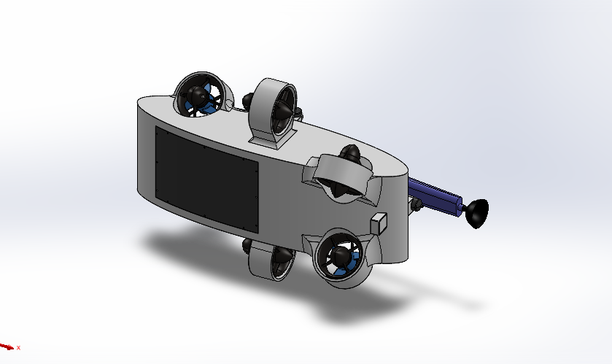
Figure 2. 1 Trimetric View
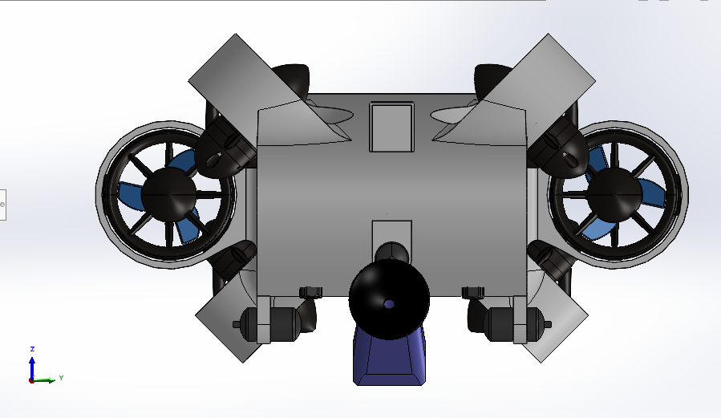  Figure 2. 2 Front View | 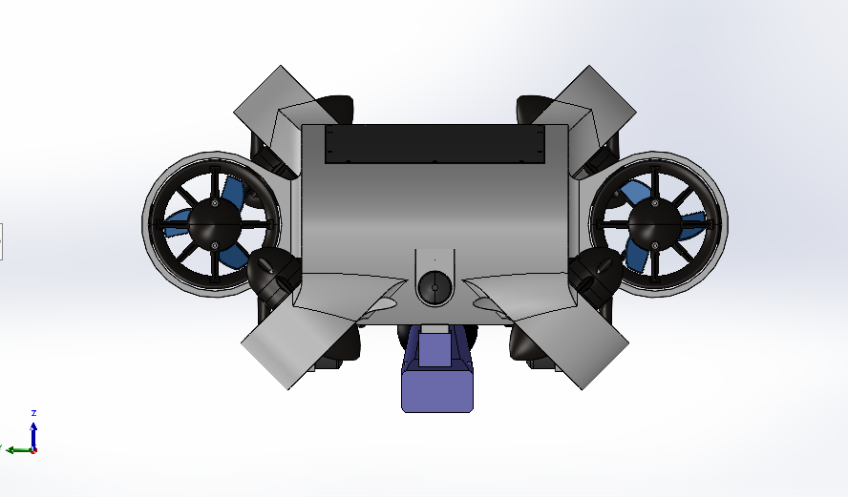  Figure 2. 3 Back View
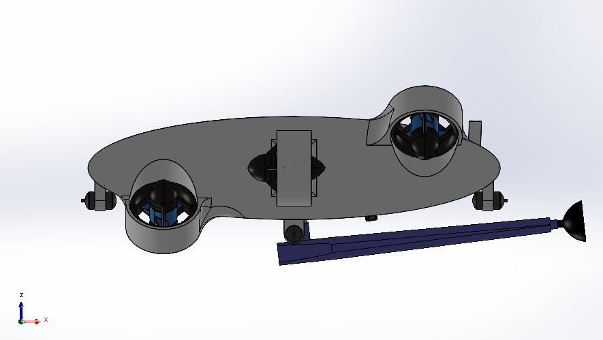  Figure 2. 4 Left View | 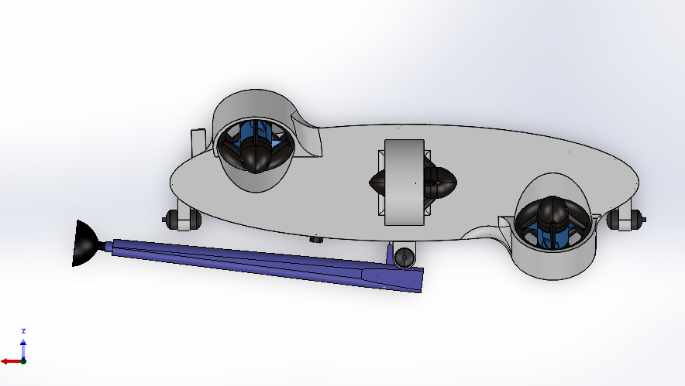  Figure 2. 5 Right View
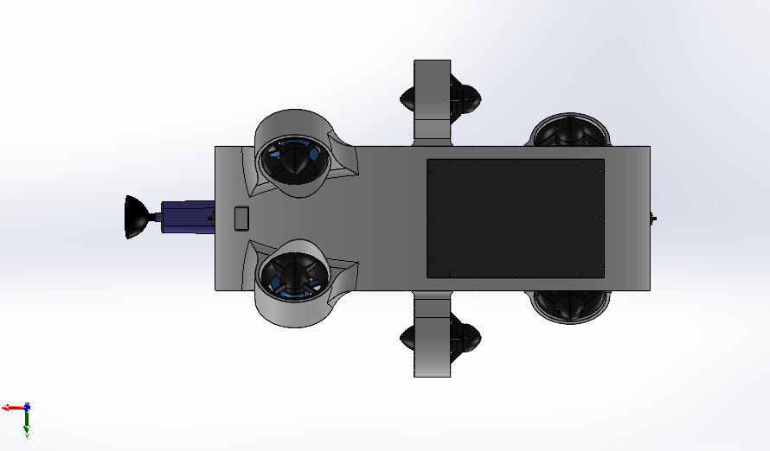  Figure 2. 6 Top View | 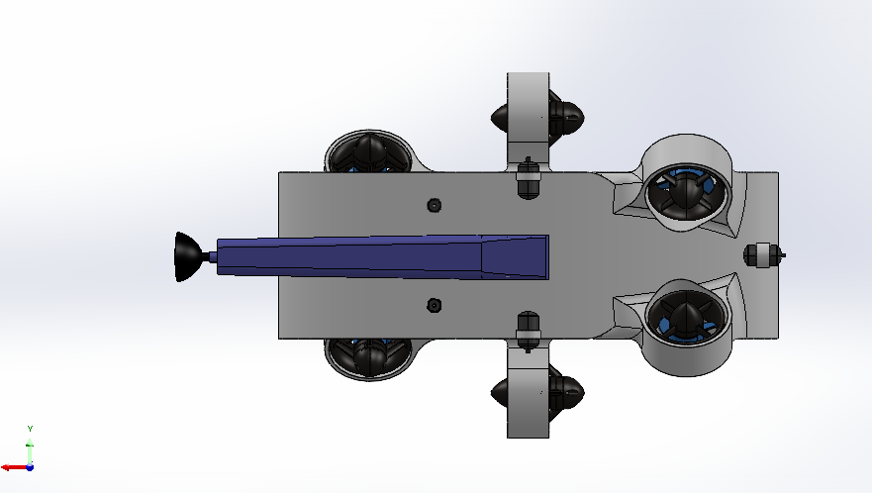  Figure 2. 7 Bottom View

Table 2. 1 AUV design

Autonomous Underwater Vehicle (exploded view)
Figure 2. 8 AUV exploded view (i) | Figure 2. 9 AUV exploded view (ii)
Table 2. 2 AUV exploded view

Thruster

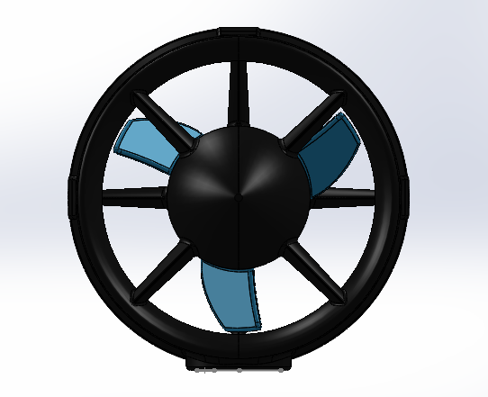  Figure 2. 100 front view | 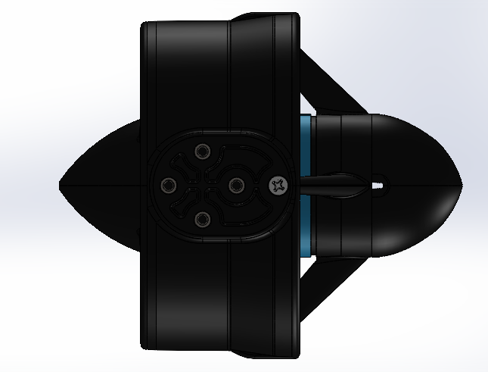  Figure 2. 111 side view
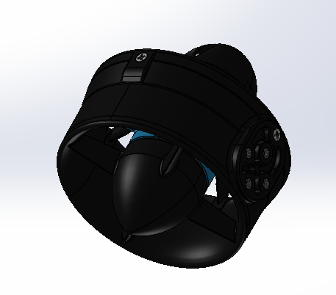  Figure 2. 122 trimetric view | This thruster is pre-built and needs to be ordered. It can provide thrust of up to 3 Kgf forces (~29.43 N) underwater, which is more than sufficient for this AUV beast.
Table 2. 3 Thruster

Thruster Number | Thruster Direction (I, J, K) | Thruster Point (X, Y, Z)
1 | (0,-1,1) | (0.000, -105.000, 0.000)
2 | (0,1,1) | (0.000, 165.000, 0.000)
3 | (1,0,0) | (190.000, -94.770, 63.270)
4 | (0,-1,1) | (190.000, 94.770, 63.270)
5 | (0,1,1) | (-190.000, -89.630, -68.410)
6 | (1,0,0) | (-190.000, 89.630, 68.410)
Table 2. 4 Thruster direction and points
Table 2.4 shows the thrust direction of thruster along with the origin of thruster from where the thrust origin does to easily calculate the torques and forces which helps to close loop whole system and keep AUV stabilize.

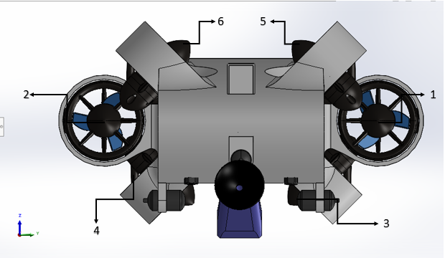
Figure 2. 13 Labelled diagram of thrusters
(1 means Forward Thrust; - means No Thrust; -1 means Backward Thrust)

Motion | Thruster
 | 1 | 2 | 3 | 4 | 5 | 6
Forward (+X) | +1 | +1 | - | - | - | -
Backward (-X) | -1 | -1 | - | - | - | -
Left (+Y) | - | - | +1 | -1 | -1 | +1
Right (-Y) | - | - | -1 | +1 | +1 | -1
Up (+Z) | - | - | +1 | +1 | +1 | +1
Down (-Z) | - | - | -1 | -1 | -1 | -1
Pitch (+Ry) | - | - | -1 | -1 | +1 | +1
Pitch (-Ry) | - | - | +1 | +1 | -1 | -1
Yaw (+Rz) | +1 | -1 | - | - | - | -
Yaw (-Rz) | -1 | +1 | - | - | - | -
Table 2. 5 Direction of thrust for each motion

Labelled Diagram of components
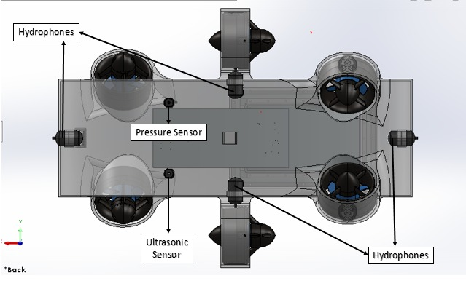Figure 2. 134 Bottom view | 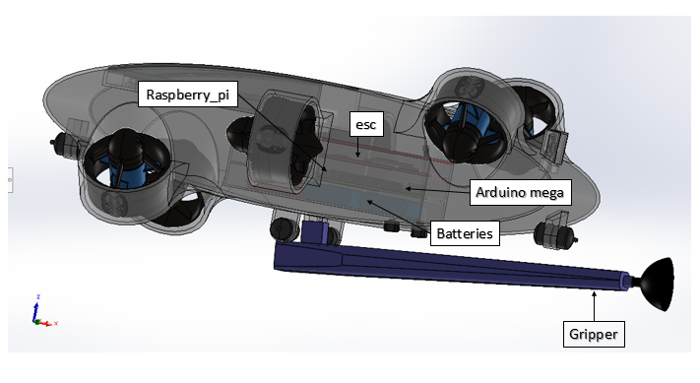  Figure 2. 145 Side View
Table 2. 6 Labelled diagram of components

Enclosure assembly
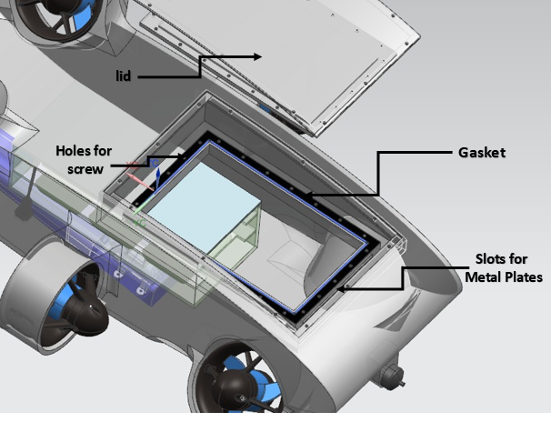

Figure 2. 156 Enclosure Assembly
The figure 2.14 shows the method to be employed for waterproofing of whole frame using gasket, metal plates and screws of size 3 mm. The slots will be provided to the metal plates, and the gasket will then be securely covered for better water proofing. The metal plates will be drilled and using the screws fastening will be done. A constant force will be applied on gaskets to prevent water entering inside the system.

Components to be used:

Structure Components:
Components | Specifications | Application
Frame(shell) | 3-D printed external cover of the robot. | To provide the initial layer of waterproofing and to withstand the pressure exerted by water.
Acrylic box for Electronic Components | Length-255 mm  height 120mm | To hold all the electronic controllers and the power source.
Acrylic box for Camera | Multiple options are aimed at for better visual image capturing. | For protecting the camera.
Rubber Seals | Width of 0.5 mm | To be used for the sealing of all the mating surfaces and to provide waterproofing to electronics components.
Gasket | Rubber (EPDM / Nitrile) | To be used for waterproofing
Table 3. 1 Structure Components

Electronics Components:
Components | Specifications | Application
Raspberry pi 4B | Memory: 8GB SRAM  Processor: Broadcom BCM2711  CPU: Quad-core Cortex-A72(ARM v8)  Architecture: 64- bit SoC  Clock speed: 1.5 Ghz | To be used as main controller for complex computing. It will act as receiver of the data from the camera and for Image Processing
Arduino Mega | ATMEGA 2560 Controller with 16MHz clock,  low- power CMOS 8-bit microcontroller based on the AVR enhanced RISC architecture | To be used as brain controller for most of the functionalities. It will perform the operations such as driving the actuators and relevant tasks to accomplish and mainly for controlling all the sensors.
Buck converter | Input voltage: 3-40V  Output voltage: 1.35V(Adjustable)  Output current Rated current is 2A, maximum 3A  Switching Frequency: 150KHz | To convert battery voltage from 12 Volt to 5 Volt
MPU-6050 | Power supply 3-5  Communication protocol: I2C  Gyroscope range +250, 500, 1000, +2000/s | For obtaining the angular position of the robot.
USB Camera module | For obtaining the angular position of the robot | To be used for obstacle avoidance and will be extended for 2D mapping.
ESC Motor drivers | Control the speed of brushless motor  Integrated BEC provides the necessary power for control systems ensuring smooth operation | To control the thrusters.
MS5837-02BA Pressure sensor | High resolution module: 13 cm  Supply voltage: 1.5 to 3.6 V  Low power: 0.6 µA (standby ≤ 0.1 µA at 25°C)  Operating range: 300 to 1,200 mbar, -20 to +85 °C  I 2C interface | For measuring pressure
Li- Ion Battery | Nominal voltage 3.7V  Capacity: 12000/15000 mAh  12 V dc output | To be used to power the AUV.
SRD-05V DC-SL-C relay | Switching capacity available by 10A despite small size design for high-density P.C. board mounting technique.  UL, CUL, TUV recognized. | Isolating and protecting the sensitive electronics.
QR50H water pump | Standard voltage: three phase 230/400V 50Hz.  Liquid temperature range: up to 50°C.  Maximum ambient temperature: up to 50°C.  Maximum operating pressure: 2,5 bar | For actuating the vacuum gripper to carry objects.
Hydrophone | Act as underwater microphone | Will be used to detect the sound of an underwater acoustic pinger
Underwater ultra sonic sensor | Measurement Range: 5-600cm Operating Voltage: 5-24V  Operating Current: ≤10mA  Output Response Time: 14ms  Angle: 8-16°  Operating Temperature: -15~50°C  Storage Temperature: -25~80°C  RH (non-condensing)  Waterproof level of IP68 | For obstacle detection, mapping, and precise navigation by emitting sound pulses and analyzing the returning echoes.
Preamplifier | Boost weak electronic signals | Will boost weak electronic signals of hydrophone
Table 3. 2 Electronics Components

Motion Components:
Components | Specifications | Application
A total of 6 thrusters of Blue Robotics, model No. T200 | 2x for forward/backward and yaw  4x for upward/downward and left /right and pitch | For propulsion, manoeuvring, and altitude control to navigate and perform tasks underwater.
Table 3. 3 Motion Components

Software:
Software | Application
NX CAD | For 3D design
MATLAB | For mathematical proof and application
Ansys | For simulate and optimize fluid flow, heat transfer, and turbulence in complex systems like underwater thrusters or cooling channels.
Kicad | For designing custom PCBs for the AUV’s Power Distribution Board, sensor interface circuits, and signal conditioning boards, ensuring compact, reliable, and waterproof electronics integration.
Table 3. 4 Software

Methodology of Making Robots:
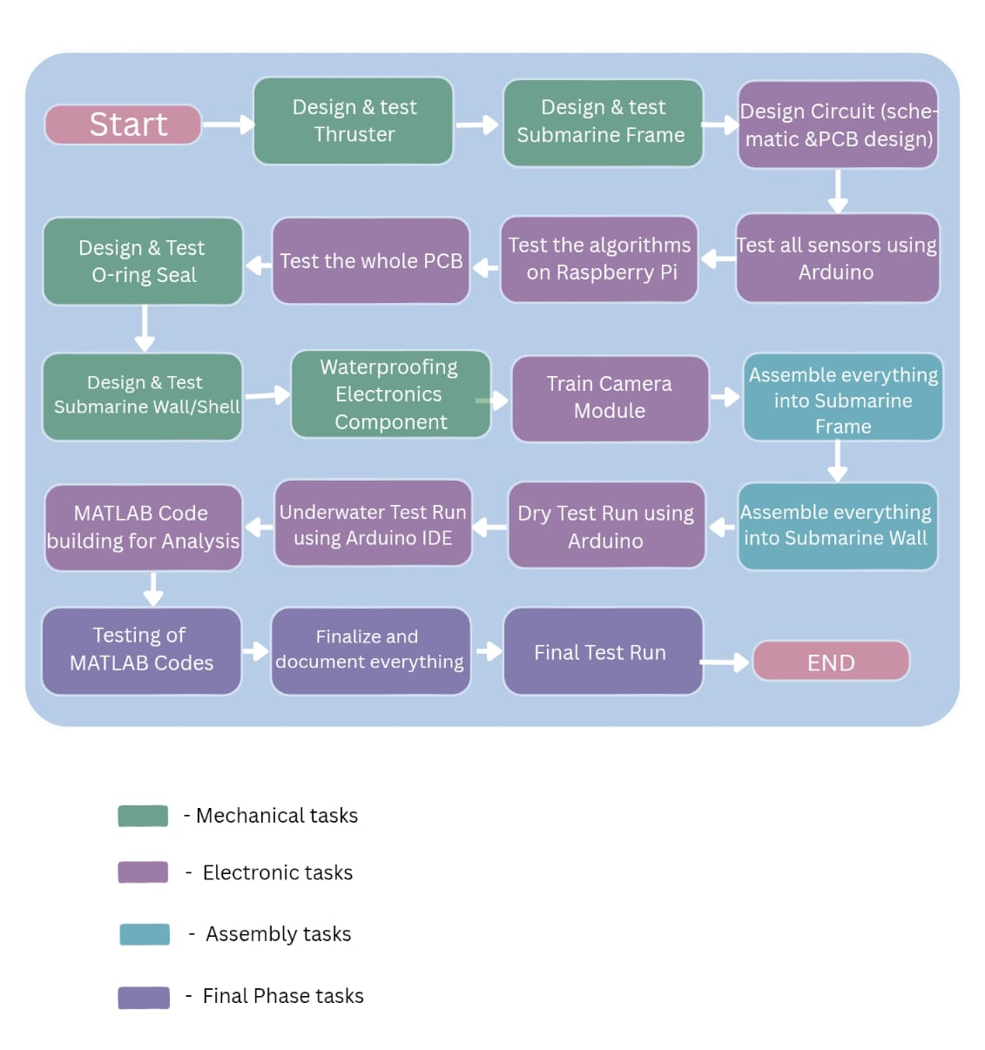
Figure 4. 1 Methodology Flowchart

For making of prototype

Design and 3D Printing of Structural Components.
- > CAD Design
Process: We began by designing the robot's structural components using CAD software like Siemens NX12. This included detailed modeling of the frame, propellers, and thruster casings. The design included all necessary mounting points for the acrylic box, motors, and electronics.

- > 3D Printing
Materials and Steps: Using ABS, we will 3D-print the robot’s external shell, including the bottom and top covers, side supports, and thruster casings.

- Fabrication of Electronic component enclosure Box.
Acrylic box: We will cut and machine acrylic box to specified dimensions: 230mm length 100mm width and height 70mm for electronics, and 18mm length with 33mm width and 36.42mm height for the camera. The edges will be smoothed to ensure a tight seal with the end caps.n

Perception and Object Handling

Obstacle and Object Detection
Object Detection:

For detection of objects and obstacles we are using the camera mainly for visualization and the underwater ultrasonic sensor for distance measurement and obstacle/object avoidance.

Mapping, Acoustic Localisation and Object Handling
2D Mapping:

- For 2D Mapping we will use Camera module. The camera would capture the image of the underwater surface and based on our custom trained object detection module it would border box the area and map the image in 2 dimensions which would then be saved in the local memory of the Submarine.

Pinger detection:

- We are going to detect the pinger by using a 4-hydrophone array. First, the received signals will be filtered to isolate the pinger frequency. Next, we will apply GCC-PHAT to estimate the Time Difference of Arrival (TDOA) between hydrophones. Finally, the calculated time delays will be converted into the source bearing, providing the direction of the pinger.
Object Handling:

- The AUV uses a motor-driven suction system. We will be using the QR50H DC brushless water submersible pump to create suction through a soft-sealing cup. It takes input of 12V DC and 10Wpower and gives the output flow rate of 400 litres per hour. Pressure compensation and sensor feedback ensure reliable handling of objects even at depth, while low power consumption keeps the system energy efficient. A constant suction force is maintained during gripping, and the object is released cleanly by removing the suction at the target location.

Mechanical verification

Analysis of Propeller Thrust

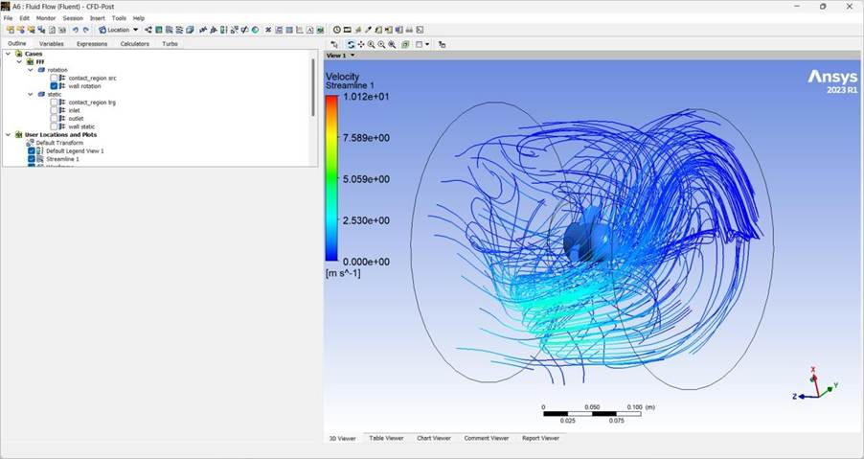
Figure 4. 2 analysis of propeller thrust (i)
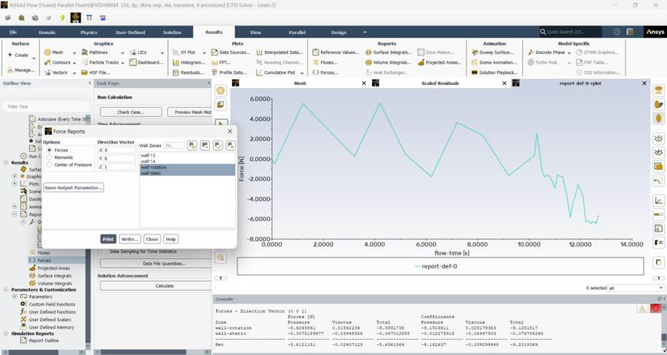
Figure 4. 3 analysis of propeller thrust (ii)

Employing the T200 propeller for this AUV enables the generation of approximately 5 N of thrust at 2500 RPM underwater within approximately 1.2 seconds. This force is sufficient to propel the robot at a considerable velocity beneath the water's surface.

Stress Analysis of Propeller

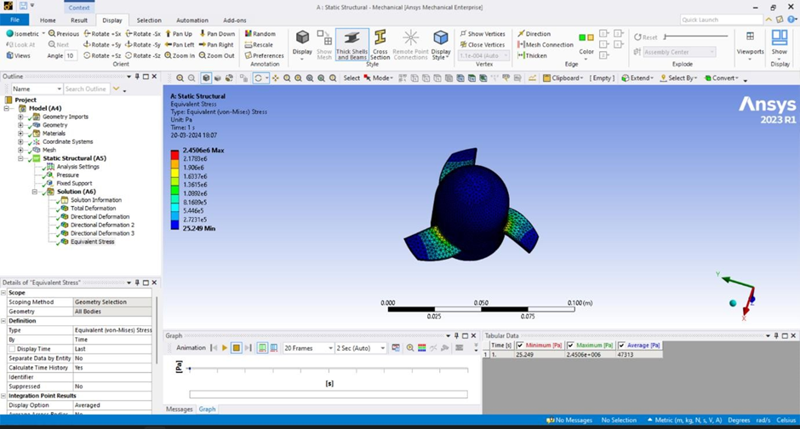
Figure 4. 4 stress analysis of propeller (i)

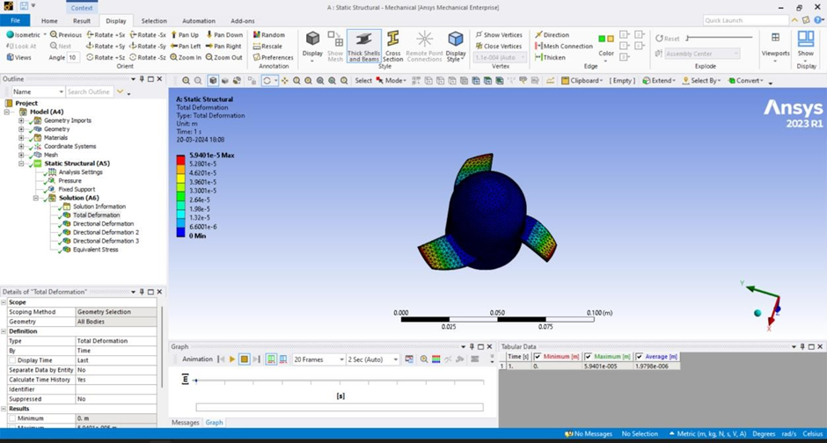
Figure 4. 5 stress analysis of propeller (ii)
For this T200 propeller used in the robot, PLA (Poly-Lactic Acid) with a tensile strength of 46 MPa is used as the material. When rotated at 10K RPM, the tip stress reaches nearly 2.5 MPa, indicating that the propeller operates safely at this speed. The measured deformation is about 0.06 mm, which is minimal compared to the overall propeller size.

Analysis of forces on AUV’s frame
- On tilted sections
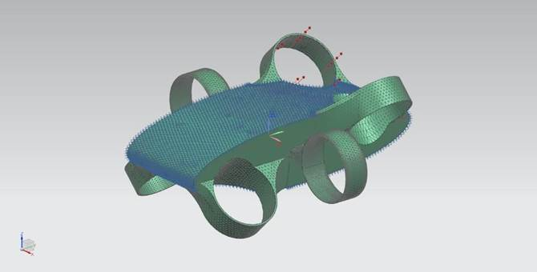  Figure 4. 6 Ansys of frame (i) | AUV frame is given fixed constraint (Blue) and a load Force of 100 N on tilted section of AUV Frame (Red)
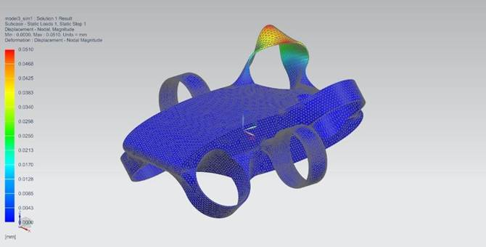  Figure 4. 7 Ansys of frame (ii) | This figure shows maximum deformation of 0.051 mm when this load and constraint is applied.
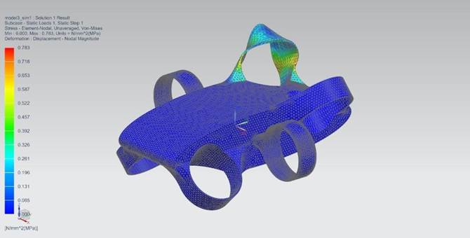  Figure 4. 8 Ansys of frame (iii) | This figure shows maximum stress of 0.783 MPa when this load and constraint is applied which is far greater than material strength PLA (46 MPa). This design is safe.
Table 4. 1 Ansys of forces on tilted sections of frame

- On tilted sections (opposite thrust)

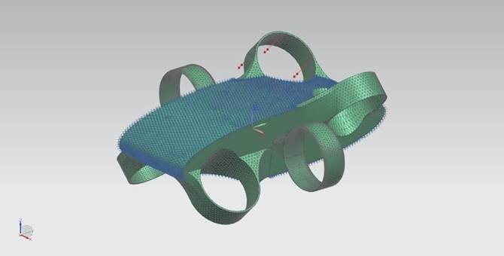  Figure 4. 9 Ansys of frame (iv) | AUV frame is given fixed constraint (Blue) and a load Force of 100 N on tilted section of AUV Frame (Red)
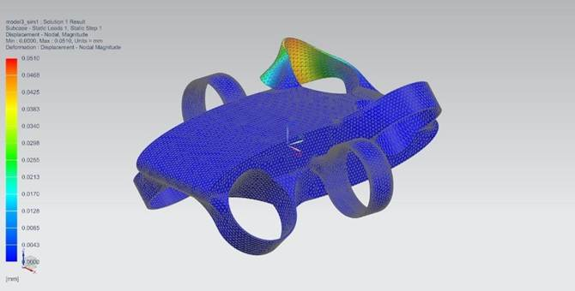  Figure 4. 10 Ansys of frame (v) | This figure shows maximum deformation of 0.051 mm when this load and constraint is applied.
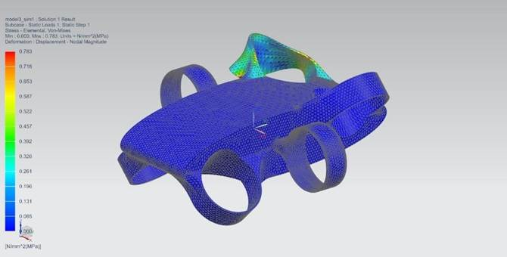  Figure 4. 11 Ansys of frame (vi) | This figure shows maximum stress of 0.783 MPa when this load and constraint is applied which is far greater than material strength PLA (46 MPa). This design is safe.
Table 4. 2 Ansys of forces on tilted sections (opp. thrust) of frame

- On side sections

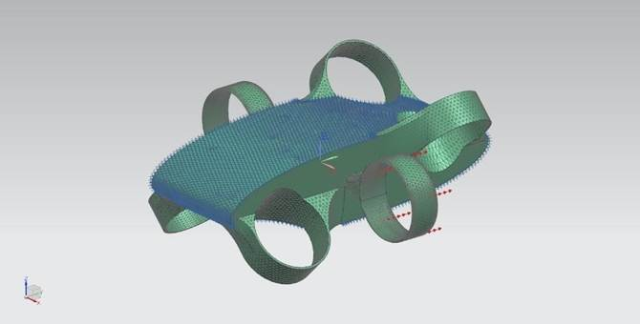  Figure 4. 12 Ansys of frame (vii) | AUV frame is given fixed constraint (Blue) and a load Force of 100 N on tilted section of AUV Frame (Red)
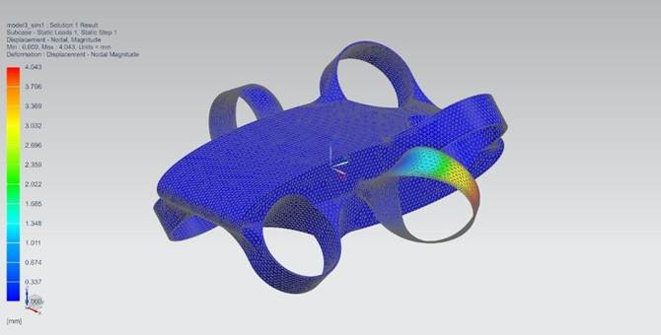  Figure 4. 13 Ansys of frame (viii) | This figure shows maximum deformation of 4 mm when this load and constraint is applied which is quite high. In next iteration, thickness of that section will be increased.
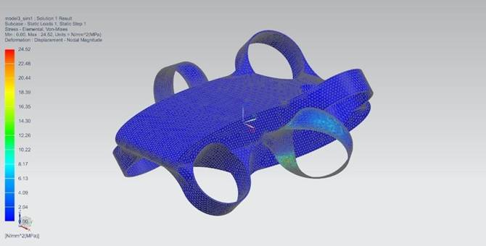  Figure 4. 14 Ansys of frame (ix) | This figure shows maximum stress of 24.52 MPa when this load and constraint is applied which is far greater than material strength PLA (46 MPa). Although this design is safe, in next iteration, thickness of that section will increase.
Table 4. 3 Ansys of forces on side sections of frame

Analysis of O-ring seal

Figure 4. 15 Ansys of O-ring seal (i)

Figure 4. 16 Ansys of O-ring seal (ii)

O-rings seal is used to create a water-tight environment and separate water from inside contents of AUV. O-rings are elastic material which can easily deform and produce a lot of force when small amount of force is applied.
The force exerted on the side of the O-ring is 1000 N, resulting from the tightening of the screw. The maximum pressure generated is 373.29 MPa, which can be sufficient to withstand water pressure at a depth of 100 meters. a depth of 100 meters. The maximum displacement is 2.3 × 10⁻⁵ m, ensuring that plastic deformation of the O-ring does not occur under the applied force and pressure conditions.
Conclusion of this simulation is that small displacement helps us to do water-tight at a great extent.

Computational Fluid Dynamics of Frame

- Flow in X-axis (v=100m/s)

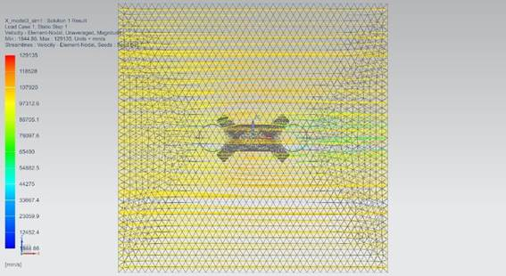  Figure 4. 17 CFD of frame (i) | The AUV cruises at 100 m/s along the X-axis, with no visible vortex. Water flow speeds vary from 1.8 m/s to 129 m/s, illustrating a fluid, serene flow around the AUV.
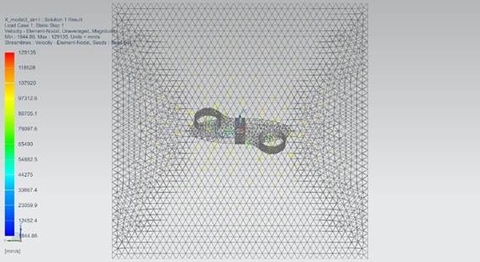
Figure 4. 18 CFD of frame (ii)
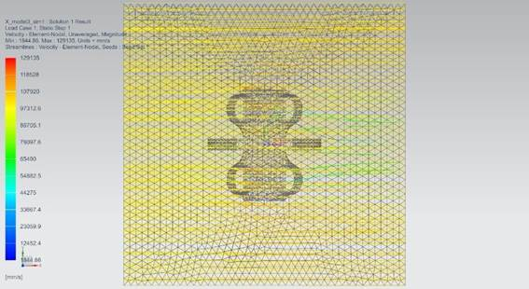
Figure 4. 19 CFD of frame (iii)
Table 4. 4 CFD of frame for flow in x-axis

- Flow in Y-axis (v=100m/s)

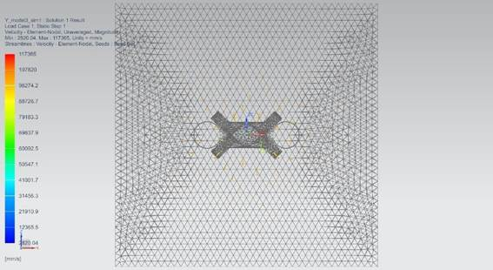  Figure 4. 20 CFD of frame (iv) | The AUV cruises at 100 m/s along the Y-axis, with no visible vortex. Water flow speeds vary from 2.8 m/s to 117 m/s, illustrating a fluid, serene flow around the AUV.
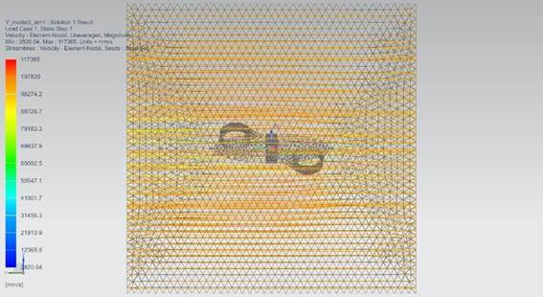
Figure 4. 21 CFD of frame (v)
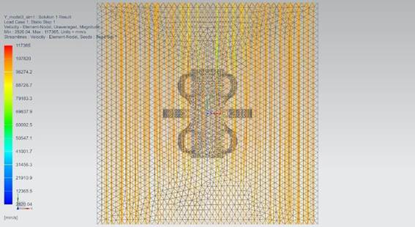
Figure 4. 22 CFD of frame (vi)
Table 4. 5 CFD of frame for flow in y-axis

- Flow in Z-axis (v=100m/s)

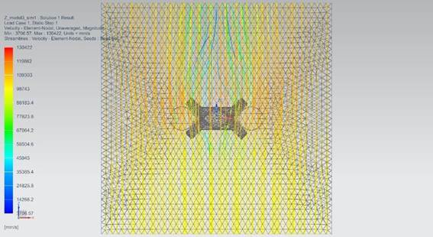  Figure 4. 23 CFD of frame (vii) | The AUV cruises at 100 m/s along the Z-axis, with no visible vortex. Water flow speeds vary from 3.7 m/s to 130 m/s, illustrating a fluid, serene flow around the AUV.
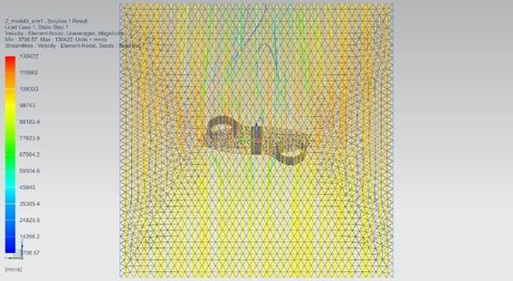
Figure 4. 24 CFD of frame (viii)
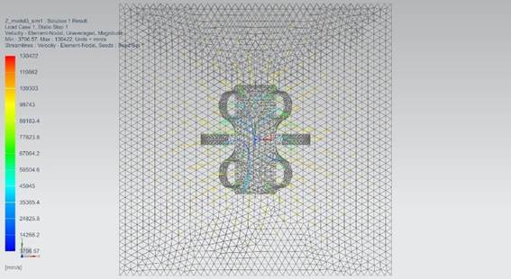
Figure 4. 25 CFD of frame (ix)
Table 4. 6 CFD of frame for flow in z-axis

Analysis of Gasket Design

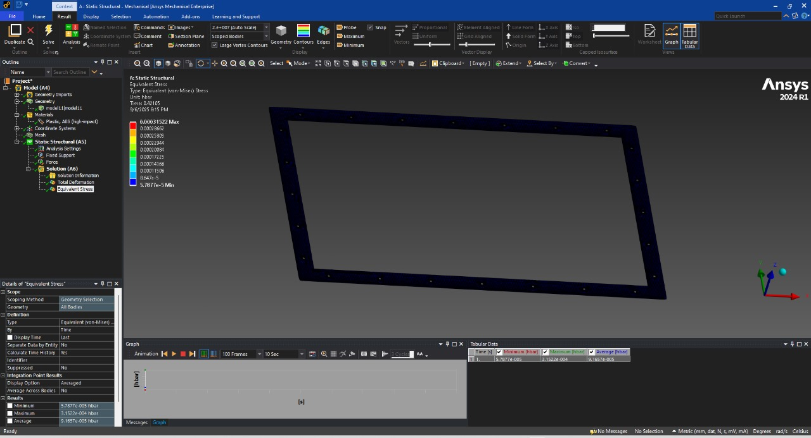  Figure 4. 26 Equivalent Stress (i) | The gasket design material is BUNA-N. The force exerted on the side of the gasket is 1000 N, resulting from the tightening of the screw. The maximum pressure generated is 0.0315 MPa, which can be sufficient to withstand water pressure at a depth of 100 meters. The maximum displacement is 8.1727 × 10⁻⁷ mm, ensuring that plastic deformation of the gasket does not occur under the applied force and pressure conditions.
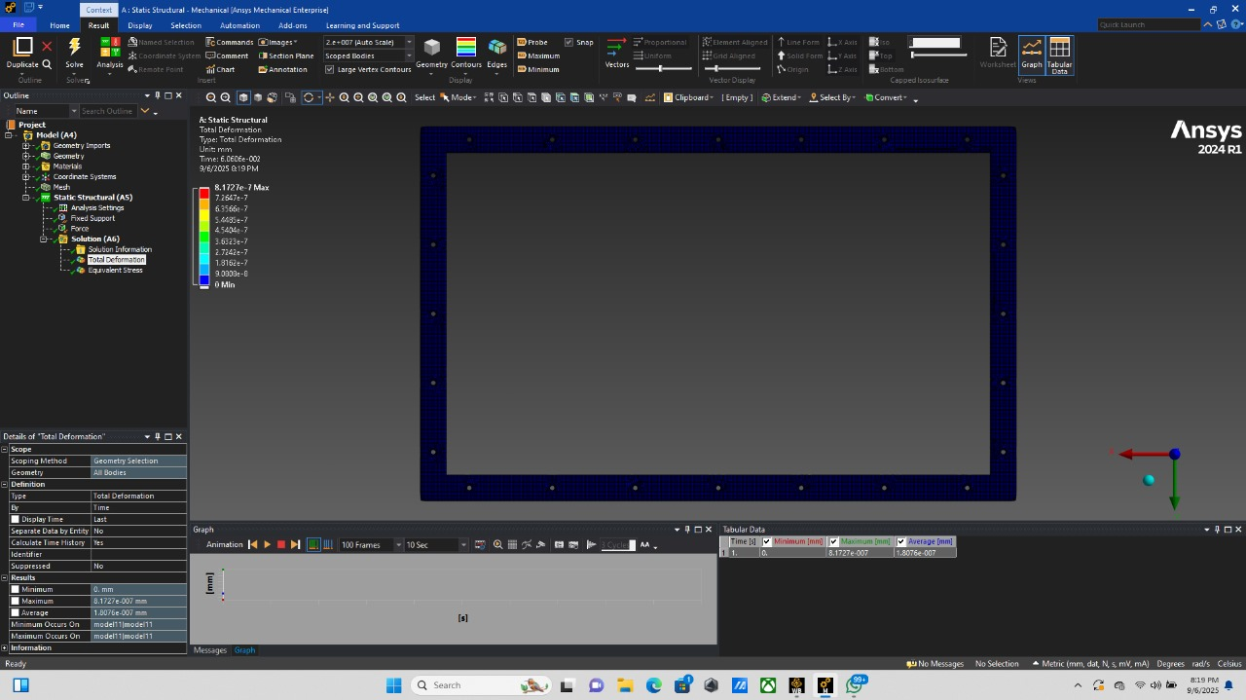
Figure 4. 27 Total Deformation (ii)
Table 4. 7 Ansys of Gasket

Motions performed by AUV

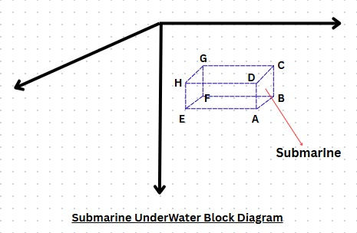  Figure 4. 28 motion by AUV (i) | 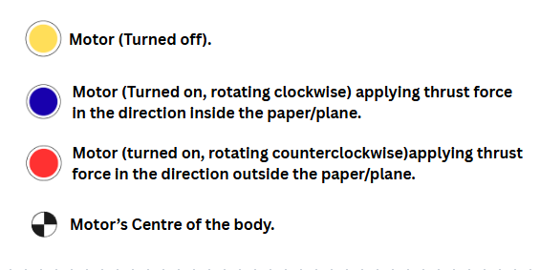Figure 4. 29 motion by AUV (ii)
Table 4. 8 Motions by AUV
- Forward and Backward Motion
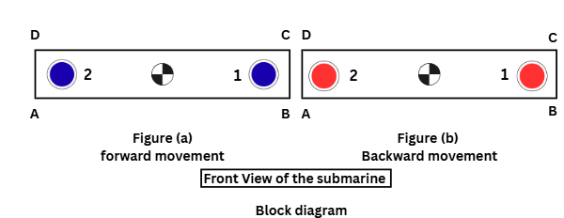
Figure 4. 30 Forward and Backward movement

Forward Motion: - In Figure (a), both motors 2 and 1 are activated and rotate in a clockwise direction, generating a net forward thrust. This mechanism facilitates the forward motion of the AUV.
Backward Motion: - In Figure (b), when both motors 2 and 1 are engaged and rotate in an anticlockwise direction, they produce a net backward thrust. This arrangement enables the AUV to move in the backward direction.

- Yaw Motion
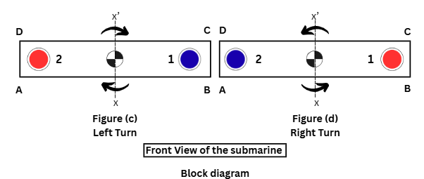
Figure 4. 31 Yaw motion

Left Turn: - In Figure (c), Motor 2 rotates in an anticlockwise direction while Motor 1 rotates in a clockwise direction. This configuration results in a net moment about the xx' axis, causing the body to turn to the left, towards side AD.
Right Turn: - In Figure (d), Motor 2 rotates in a clockwise direction, and Motor 1 rotates in an anticlockwise direction. Consequently, this arrangement produces a net moment about the zz' axis, leading the body to turn to the right, towards side BC.

- Upward and Downward Motion
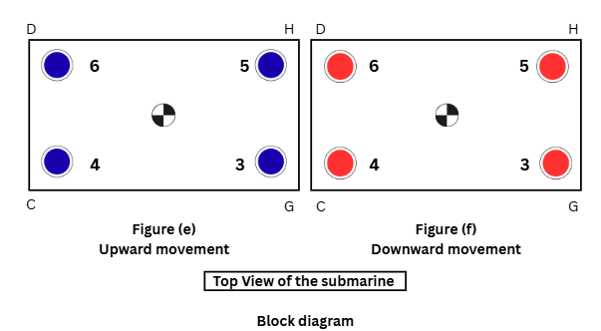
Figure 4. 32 Upward and Downward motion
Upward Motion: - In Figure (e), both motors 3,4,5 and 6 are activated and rotate in a clockwise direction, generating a net Upward thrust. This mechanism facilitates the Upward motion of the AUV.
Backward Motion: - In Figure (f), when both motors 3,4,5 and 6 are engaged and rotate in an anticlockwise direction, they produce a net downward thrust. This arrangement enables the AUV to move in the downward direction.

- Pitch Motion
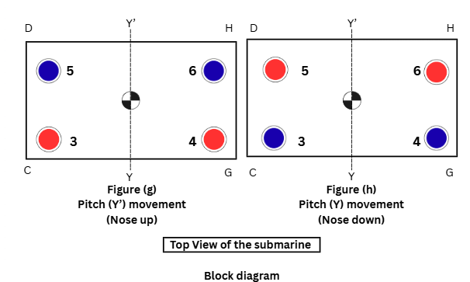
Figure 4. 33 Pitch motion

Pitch (Nose up) movement: - In Figure (g), both motors 5and 6are activated and are rotated in clockwise direction, generating an upward thrust. And 3 and 4 are activated and are rotated in anticlockwise direction, generating a downward thrust. Hence results in upward and downward thrust from both sides, which results in nose up moment

Pitch (Nose down) movement: - In Figure (h), both motors 3and 4are activated and are rotated in clockwise direction, generating an upward thrust. And 5and 6are activated and are rotated in anticlockwise direction, generating a downward thrust. Hence results in upward and downward thrust from both sides, which results in nose down moment.
Because of this upward and downward thrust from both sides, the AUV tilt towards y axis.

- Left and Right Motion
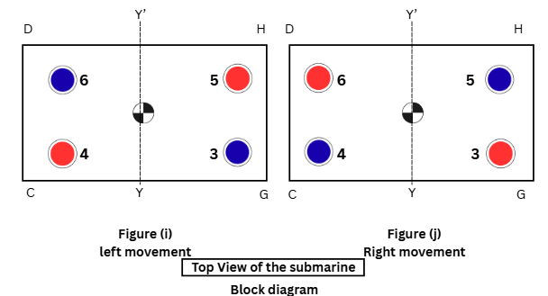
Figure 4. 34 Left and Right motion

Left Side Moment: - in figure (i) motors 4and5 are rotating anticlockwise generating a downward thrust, while 3and 6 are rotating clockwise generating an upward thrust, because of this a net force is generating in left direction
Right Side Moment: - in figure (j) motors 3 and 6 are rotating anticlockwise generating a downward thrust, while 4 and 5 are rotating clockwise generating an upward thrust, because of this a net force is generating in right direction

Calculations
Buoyancy balance sheet
Components | Value (N)
Upward Force
Buoyancy Submarine Frame | 133.28
Downward Force
Frame Weight | 23.5
T 200 Motor | 29.4
Basic ESC | 01.40
Battery | 33.00
Electronics and Wires | 10.40
Total force | 97.7
Table 4. 90 Buoyancy calculation
*External weight can be placed if during constructing more buoyant force is there.

Here, since the downward force is less than upward force (Buoyant Force). Hence it won’t sink and go to the bottom. The AUV will sink a little bit and then with the help of thruster we can push our AUV in downward direction.

Block Diagram
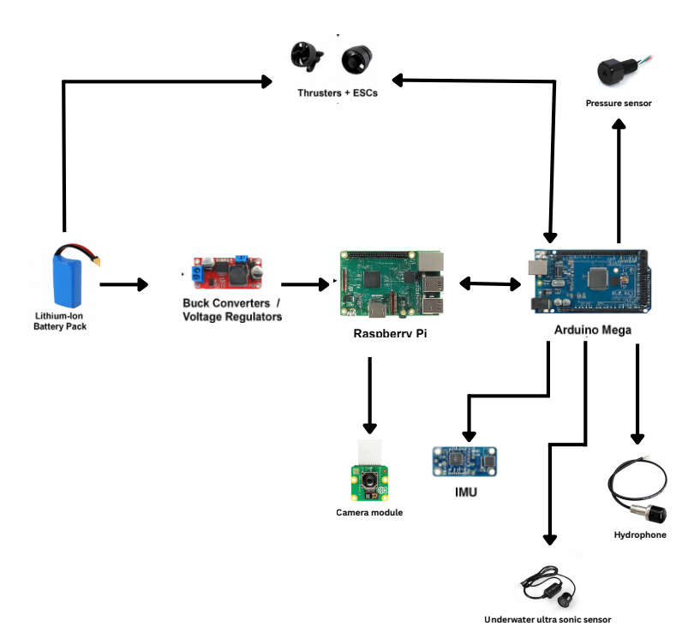
Figure 4. 357 Block Diagram

Electrical verification

(i) Communication workflow
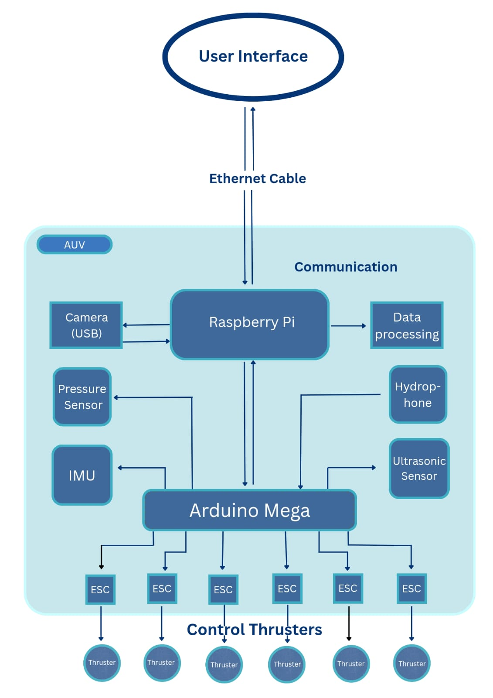
Figure 4. 368 Communication Workflow

(ii) Circuit diagram
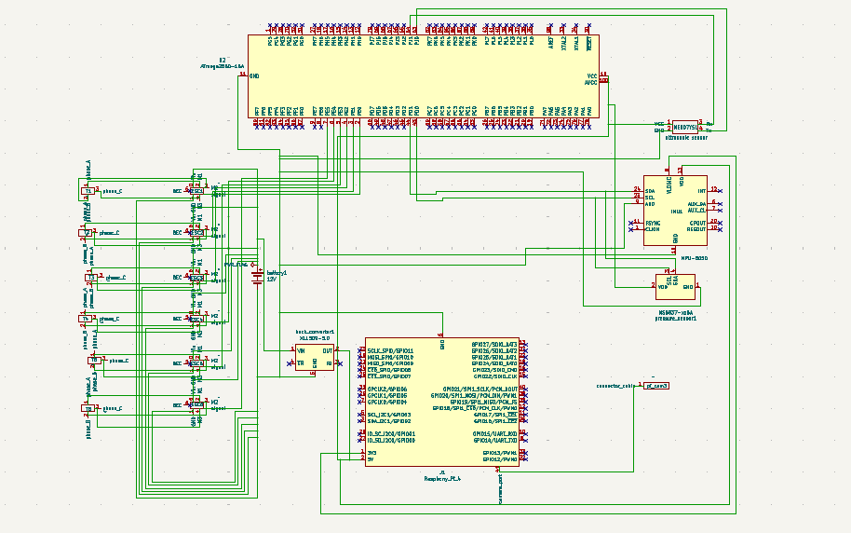
Figure 4. 379 Circuit Diagram

(iii) Integration of Electronics
- Power System
We are going to use 12V DC battery pack and connect it to buck converter, which will convert 12V DC to 5V DC for powering the electronics. Wiring will be carefully managed to avoid short circuit.

- Microcontrollers and Sensors
Components and steps: buck converter output will be provided to Raspberry Pi 4B, Camera module will be connected to Raspberry pi. Raspberry pi will be used for data processing and communication. The header pin of 5V and GND from raspberry pi, will be connected to Vin and GND of Arduino Mega 2560. All sensors like MPU-6050, pressure sensor, hydrophone and underwater ultrasonic sensor will be connected to Arduino mega also Arduino mega will send signals to the 6 ESCs for thruster control.

- Communication
Ethernet cable will be used for communication and data transfer between Laptop and AUV while the communication flow inside AUV will be as shown in figure 4.36.

Command and control

(i) Algorithm for detection of pinger
- System Setup
- Inputs: 4 hydrophone signals (TC4013 + EC6081 amplified outputs).
- Parameters:
  - Sampling rate Fs (≥ 200 kS/s).
  - Speed of sound c = 1500m/s.
  - Array geometry (e.g., square, ~15mm spacing).
- Preprocessing
- Band-limit broadly to the expected pinger range (e.g., 20–60 kHz).
  - Use a wide bandpass filter instead of a narrow-matched filter.
  - This captures pingers at unknown frequencies without bias.
- (Energy / Envelope Detection
- Compute short-time energy or Hilbert envelope of each channel.
- Detect candidate ping times by thresholding the energy envelope (ping bursts stand out against noise).
- Extract a windowed segment around the detection (e.g., 4–5ms).
- GCC-PHAT TDOA Estimation
- For each hydrophone pair (relative to a reference):
  - Compute FFT cross-spectrum.
  - Apply PHAT weighting (normalize by magnitude).
  - IFFT → correlation function.
  - Find delay at correlation peak → Δτ (time difference).
- Convert Delays to Bearing
- Convert Δτ → Δr = c·Δτ.
- Solve linear system using hydrophone geometry → estimate bearing.
- Output
- Estimated arrival times and TDOAs.
- Bearing angle of source.

(ii) Algorithm for operation of thrusters
- Define Allocation Matrix
- Construct a thruster configuration matrix where:
  - Rows = motion DOFs (Fx, Fy, Fz, Ry, Rz)
  - Columns = thrusters T1…T6
- Each entry represents the contribution of a thruster to a particular motion.
- Form Control Input Vector
- Pack desired forces/torques into a column vector.
- Compute Thruster Commands
- Multiply input vector by allocation matrix to distribute forces.
- Normalize Thruster Outputs
- Check if any thruster exceeds maximum allowed value.
- If so, scale all thruster commands proportionally.
- Send Commands to ESCs
- Final values are sent to actuators.
- Range: [-1, 1] (negative = reverse thrust, positive = forward thrust).

Application of proposed Robot in a Societal Context:
The application of the AUV includes:

(a)Underwater exploration and environmental monitoring, thus by collecting data from the aquatic environments helping in advancement in the marine science and effects of various human activities in the water bodies.

(b) Inspection of underwater structures and monitoring marine life as well as the exploration of new marine life.

Size of Robot for Proof of Concept:

Length (in cm) | 60
Width (in cm) | 15
Height (in cm) | 20
Weight (in kgs) | Around 10.67Kg
Table 6. 1 Size of robot for POC

Size of Robot for Actual Prototype

Length (in cm) | 60
Width (in cm) | 15
Height (in cm) | 20
Weight (in kgs) | Around 10.67Kg
Table 7. 1 Actual prototype size

