菜单

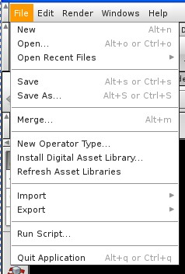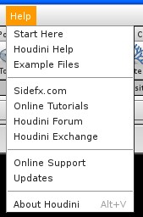

打开档案File 新建New, 打开储存的档案Open , 打开最近的档案Open Recent Files 储存Save, 储存为选择的格式Save As , 合并Merge 新操作模式New Operation Type, 安装数字图书馆Install Digital Asset Library, , 刷新既有数字图书馆Refresh Asset Libraies, 进口Import, 出口Export , 运行特别程序Run Script, 离开 Quit Application, 求助Help 开始 Start Here , 胡迪尼公司帮助Houdini Help, 范例档案Example Files, Sidefx网站的帮助 Sidefx.com , 在线图例Online Tutorial 胡迪尼论坛 Houdini Forum, 胡迪尼交流Houdini Exchange, 快速在线支持Online Support Update, 胡迪尼公司介绍 About Houdini

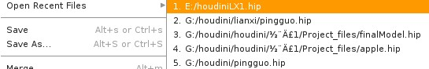

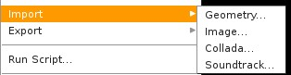

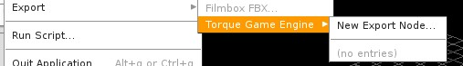

进口Import 几何Geometry, 图像Image, 3D的dae格式文件 Collada, 音效轨迹Soundtrack 出口Export 扭力游戏机Torque Game Engine, 新的出口节点 New Export Node

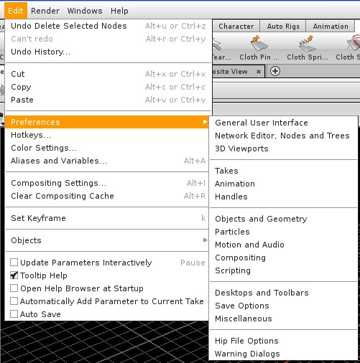

编辑 Edit 回复消除的节点 Undo Delete Selected Nodes, 不能回复Can’t redo, 回复的历史 Undo History, 裁切Cut, copy 拷贝, 黏贴Paste,热键Hotkeys,颜色设定Color Setting,指令与变量Aliases and Variables, 合成设定Composition Settings, 设关键祯Set Keyframe ,对象Objects , 参数互动Update Parameters Interactively , 工具技巧Tooltip Help,开始即打开帮助页面 Open Help Browser at Startup, 自动添加参数Automatically Add parameter to Current Take, 自动储存, 参数偏好设定 Preference, 一般界面General User Interface, 网状编辑Network Editor, 节点与树状编辑 Nodes and Tree 3D Viewports, 作成品选择::: 动画 Animation 结构矩阵Handle, 对象与几何模型Objects and Geometry , 粒子Particles, 动作与 声音Motion and Audio , 合成Compositing, 其它程序Scirpting, 桌面与工具条 Desktop and Toolbars, 储存选项 Save Options,其它Miscellaneous
熟悉的档案选项 Hip File Options, 警告对话 Warning Dialogs
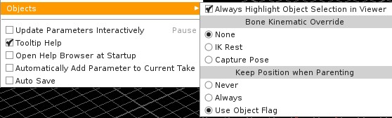

对象被选择时点亮表示Always Highlight Object Selection in Viewer 骨头运动覆盖Bone Kinematic Overide, None没有, Capture Pose与姿态互连 , 当父母关系时 保持位置Keep Position when Parents, 从不Never, 经常Always, Use Object Flag使用对象旗帜,

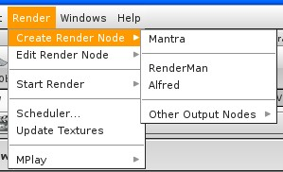

宣染Render 创造宣染节点 Create Render Node 编辑宣染节点Edit Render Node, 开始宣染Start Render,排程 Scheduler, 目前的材质 Update Texture, 在那宣染节点曼陀罗Mantra ,RenderMan, Alfred, 或其它软件Other Output Nodes
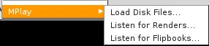

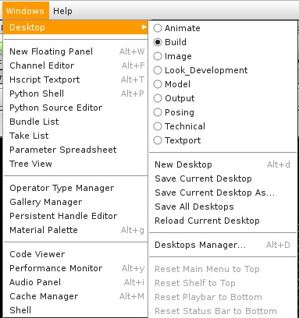

桌面Desktop 新浮动面板New Floating Panel,通道编辑channel Editor, Hscript的程序语言 Hscript Textport,Python程序语言Python Shell,Python来源编辑Python Source Editor,笔刷表列Bundle List, Take List Take表列, 参数空白表Parameter Spreadsheet,树状观看Tree View, 操作模式管理Operation Type Manager,图像管理Gallery Manager,保留的Handle编辑Persistent Handle Editor,材料图层Material Palette,编码观看Code Viewer,屏幕显示Performance Monitor,声音面板Audio Panel,Catch管理 Catch Manager,Shell
动画Animate,建构Build,Image图像,观察发展Look Development,模型Model,输出Output,姿态Posing,技术Technical,Textport,新桌面New Desktop,储存目前桌面Save Current Desktop,以指定格示储存桌面Save Current Desktop As,储存所有桌面Save All Desktop,重做桌面Reload Desktop,桌面管理Desktop Manager,

工具

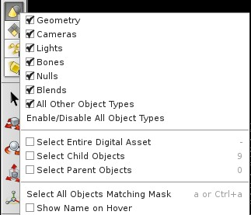
几何Geometry,摄影机Cameras,灯光Lights,骨头Bones,隐藏式目标(一般用在动画)Null,混合Blends, 其它对象模式All Other Object Types,赋予或消除所有对象Enable/DisableAll object Types,选择所有数字资产Select Entire Digital Asset,选择子女对象Select Child Objects,选择父母对象Select Parent Objects,选择所有对象配合屏蔽Select All Objects Matching Mask,以Hover显示名字(通常是颜色)Show Name on Hover
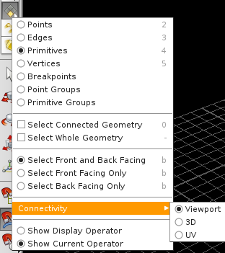
点Point,边缘Ediges,原始状态Primitives,顶点Vertices ,突破点Breakpoints, 以点做群组Point Groups,以原始状态群组Primitive Groups
选择关连的几何Select Connected Geometry,选择整个几何Select Whole Geometry,选择前面Select Front Facing Only,选择后面Select Back Facing Only 关连Connectivity,显示操作Show Display Operator,显示目前操作Show Current Operator,检示窗格ViewPort,3D,UV(原始是解释为紫外线)

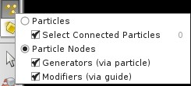
粒子Particles,选择相连粒子Select Connected Particles,粒子节点Particle Nodes,产生器(经由粒子) Generator via particle, 改质(经由指导) Modifier via guide

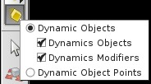
动态对象Dynamic Object ,多个动态对象 Dynamic Objects,动态对象改质Dynamic mmodifiers,动态对象点Dynamic Object points

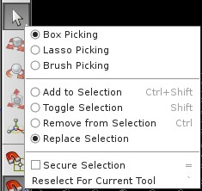
箱型捕捉Box Picking,套索捕捉Lasso Picking,笔刷捕捉Brush Picking,加入选择Add to Selection,连结选择Toggle Selection,移除选择Remove from Selection, 置换选择Replace Selection, 保护选择Secure Selection, 在目前工具中 再选择Reselect For Current Tool,

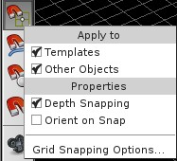
应用到…Apply to…,样板Templates,其它对象Other Objects, 性质Properties, 获取深度Depth Snapping,获取方向Orient on Snap, 获取方格选项Grid Snapping Options…

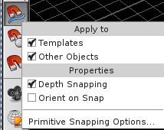
获取原始选项…Primitive Snapping Options…

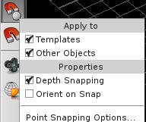
获取点的选项…Point Snapping OPtions

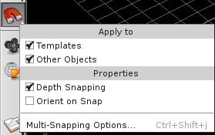
获取多重选项…Mul-Snapping Options…


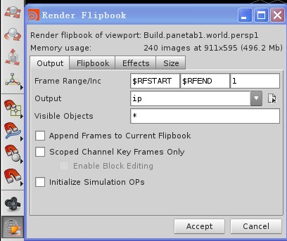
宣染检窗口口Render flipbook of viewport, 使用的记忆容量Memory useage,出口output,翻页书Flipbook,Effects效果,体积Size,祯范围Frame Range,output出口,可见的对象Visible Objects,在目前翻页书上附加的祯Append Frame to Current Flipbook,仅显示关键祯 Scope Channel Key Frame Only,开始模拟操作Initialize Simulation OPS
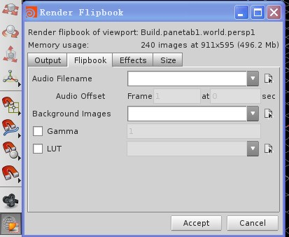
声音文件名Audio Filename,声音补偿Audo Offset,背景图像Background Images
声音的Gamma 颜色的LUT

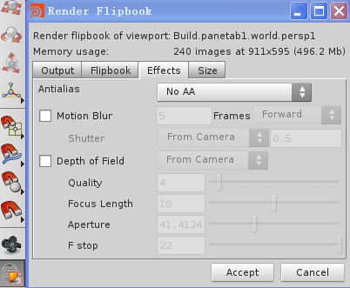
抗锯齿Antialias, 模糊Motion Blur, 场景深度Depth of Field, 质量Quality,
焦距长度Focus Length, 光圈Aperture, F 停止 F Stop, 接受Accept,删除Cancel,

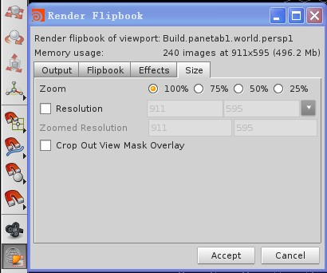

扩大zoom,分辨率Resolution, 除掉重迭的屏蔽Crop Out Mask Overlay,接受Accept,删除Cancel

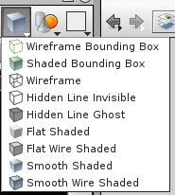
网状周界箱Wireframe Bounding Box,阴影周界箱Shaded Bounding Box,网状图Wireframe,隐藏可见线条Hidden Line Invisible,隐藏线条鬼影Hidden Line Ghost,单调阴影Flat Shaded,单调网状阴影Flat Wire Shaded,平滑阴影Smooth Shaded, 平滑网状阴影Smooth Wire Shaded

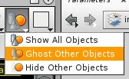
显示所有对象Show All Objects,其它对象以鬼影处理Ghost Other Objects,隐藏其它对象 Hide Other Objects

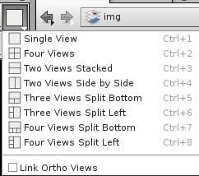
图像img,单元格窗口Single view,四格窗口Four view,
堆栈二格Two Views Stacked,横向二格排列Two Views Side by Side
底部三格分列Three Views Splite Bottom, 左边三格分列Three Views Splite Left
底部四格分列Three Views Splite Bottom, 左边四格分列Three Views Splite Left

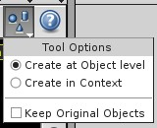
工具选择Tool Options,以对象的等级创造Create at Object Level, 以脉络创造Create in Context,保持原本对象Keep Original Objects

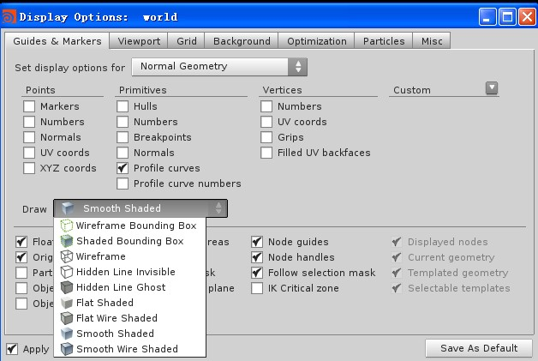
显示的选择:世界空间 Display Options:world,指标Guide & Marker,窗口viewport,方格Grid,背景Background, 最佳化optimization ,粒子Particles,其它 Misc,
设定显示的选择Set display options for,正常几何 Normal Geometry,点points,指针Markers, 数字Numbers,正常Normals,UV坐标 UV coords, XYZ坐标 XYZ cords,
原型Primitives,外壳Hull,数字Numbers,突破点Breakpoints,正常Normals, 分布曲线Profile curve, 分布曲线数字Profile curve numbers
立方体顶点 Vertices,数字Numbers, UV坐标 UV cords,着力点Grips,填充UV背面 Filled UV backfaces
平滑阴影Smooth Shaded

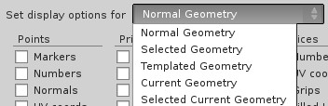
正常几何Normal Geometry, 选择的几何Selected Geometry,
模板的几何Templated Geometry, 目前的几何Current Geometry
选择目前的几何Selected Current Geometry

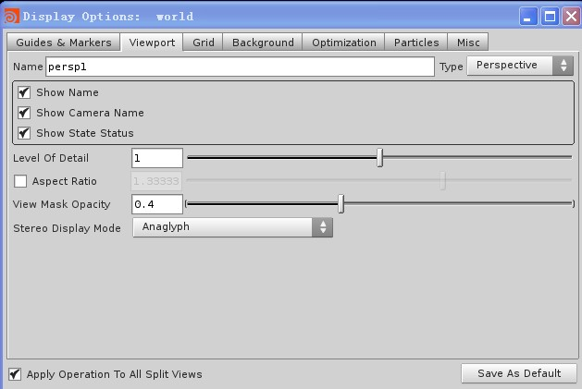
窗口viewport,显示名字Show Name,显示摄影机名字Show Cammer Name,显示状态数据Show State Status,细部等级Level of Detail,概念率Aspect Ratio,屏蔽不透明度 View Mask Opacity,立体显示模式Stereo Display Mode
应用操作模式到其它分裂的窗口 Apply Operation To All Split Views
储存为预设Save As Default
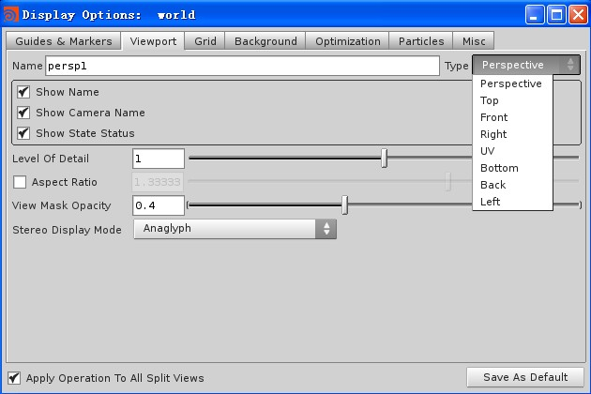
摄影机观景perspective,顶面看Top,前面看Front,右面看Right,UV,底面看Bottom,后面看Back,左面看Left

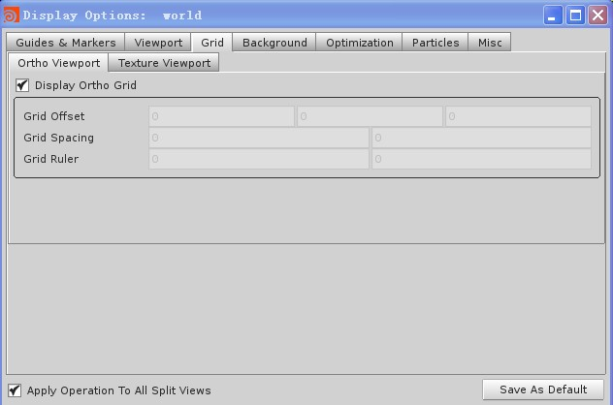
邻位窗口Ortho Viewport,材质窗口Texture Viewport,显示邻位格Display Ortho Grid

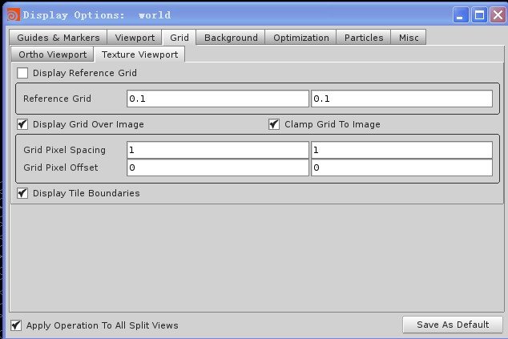
显示参考方格Display Reference Grid
在图像上显示方格Display Grid Over Image,方格钳入图像Clamp Grid To Image
显示砖形排列周界Display Tile Boundaries

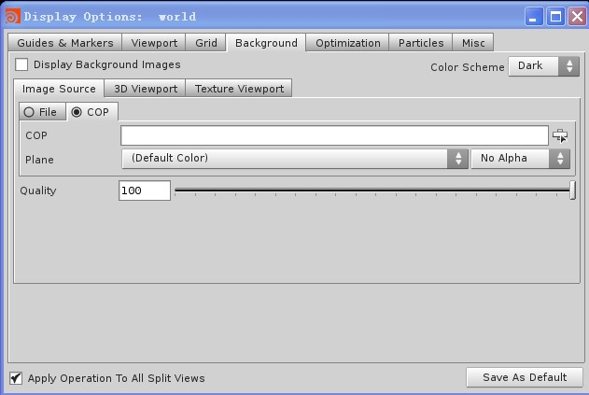
图像来源Image Source,3D窗口 3D Viewport,材质窗口Texture Viewport
色调Color scheme,档案File,质量Quality
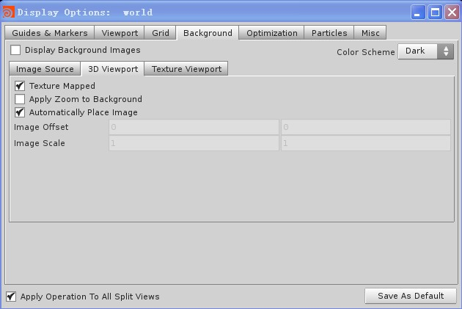
材质图Texturemapped,放大应用Apply Zoom To Background,自动放至图像位置Automatically Place Image

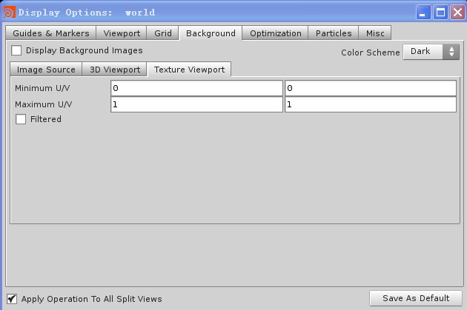
Minimum最小U/V,Maximum最大 U/V

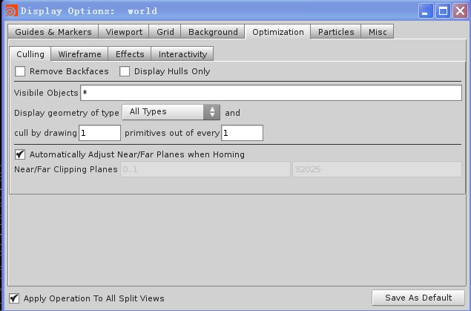
最佳化Optimization,排除Culling,移除背面Remove Backfaces,仅显示外壳Display Hulls Only,可见对象Visible Objects, 显示几何型态Display geometry of type,从原型中每多少 排除多少个画像 Cull by drawing primitives out of every
自动调整平面的远近 Automatically Adjust Near/Far Planes when Homing
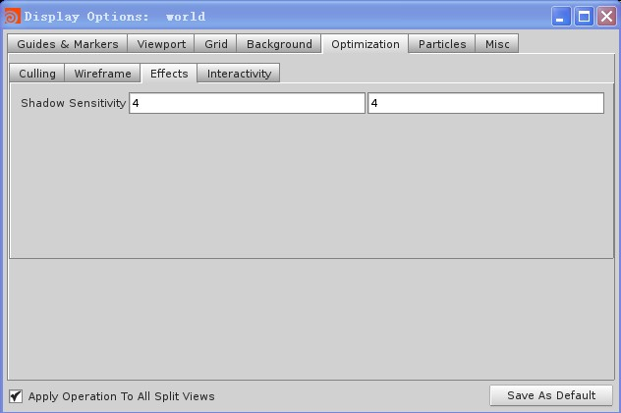
效果Effect,阴影敏感度Shadow Sensitivity

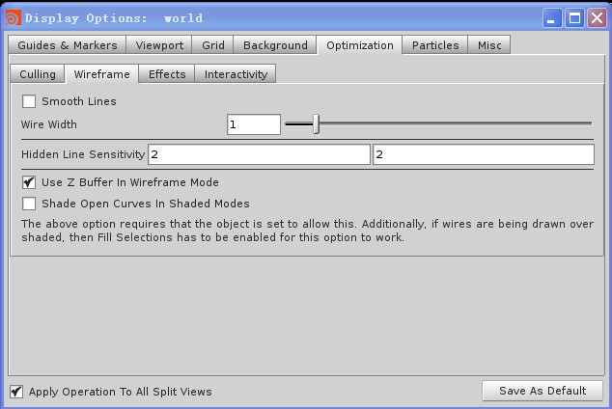
网状图Wireframe,网宽Wire Width,隐藏线的敏感度Hidden Line Sensitivity,使用Z-Buffer控制场景深度 Use Z Buffer In Wireframe Mode
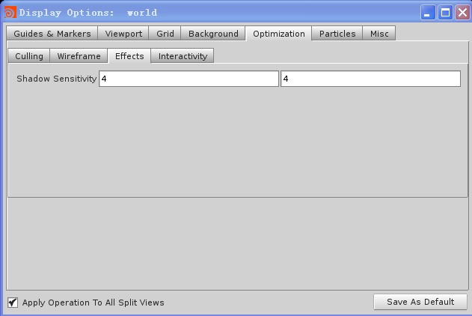
阴影敏感度 Shadow Sensitivity

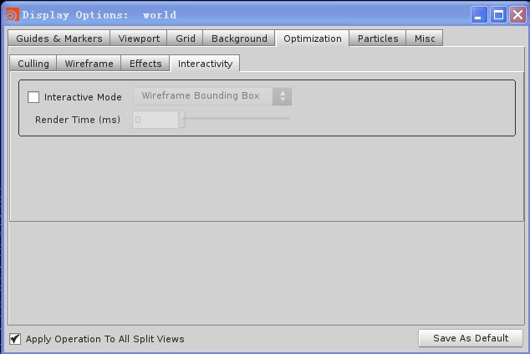
互动模式interactive mode

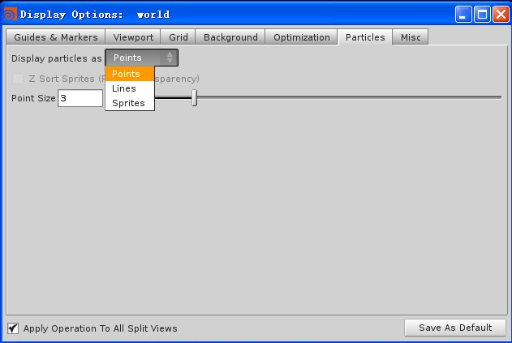
点 Points,线 Lines,人形sprite

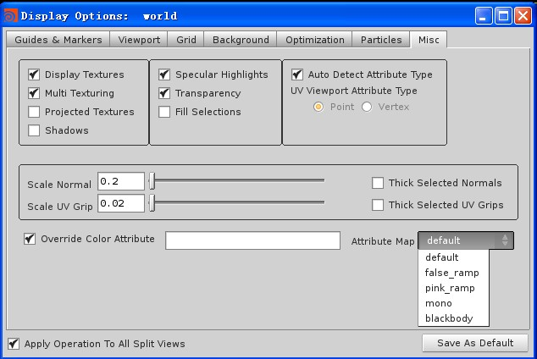
其它Misc,显示材质Display Texture,多重材质Multi Texture,提案材质Projected Texture,强调反射 Specular Highlight,透明Transparency,自动侦测特质型态Auto Detect Attribute Type,比例调整大小Scale Normal.厚度选择 Thick Selected Normals,使颜色特质无效Override Color Attribute,
特质图Attribute Map,预设Default,虚假梯度false-ramp, 粉红梯度pink-ramp.mono 单独 , blackbody黑体

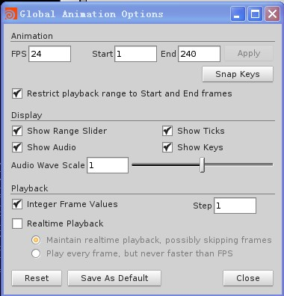
全域动画选择Global Animation Options,Animation动画,FPS每秒祯数,开始Start,结束End,应用Apply,中断的关键祯Snap Keys,限制播放从头到尾Restrict Playback range to Start and End Frames,显示范围滑轨Show Range Slider,显示网状Show Ticks,显示声音Show Audio,显示关键祯Show Keys,播放Playback,整体祯integer Frame Values,步调Step

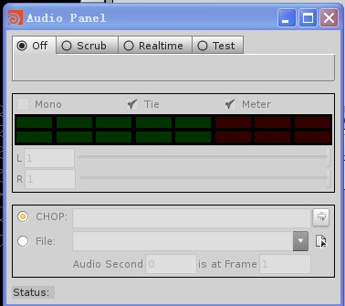
关掉Off,清除Scrub,实时Realtime,试验Test
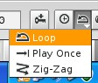
环绕Loop,播放一次Play Once,蛇行zig zag

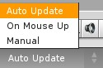
自动Auto Update,依鼠标On Mouse Up,手动Manual
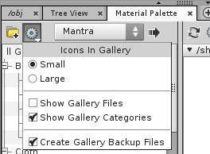
,画廊的雕像Icon In Gallery,小Small,大Large,显示画廊图文件Show Gallery Files,显示画廊类别Show gallery Categories,创造画廊支持图档Create Gallery Backup Files
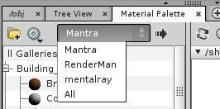
曼陀螺Mantra(一种宣染模式 )
Renderman(一种宣染模式 )
Mentalray(一种宣染模式 )

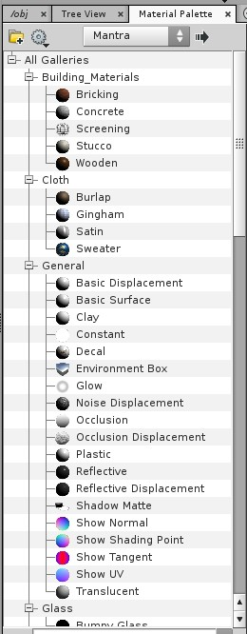
所有分类图像All Gallery,建筑材料Building Material,砖Bricking,水泥Concrete,筛选Screening,灰泥Stucco,木头Wooden,
布Cloth,粗麻Burlap,棉布Gingham, 缎子Satin, 毛线Sweater
普通General,基本置换Basic Displacement,基本表面Basic Surface,黏土Clay,连续一致Constant,印花decal,环境箱Environment Box,光环Glow,干扰置换Noise Displacement.吻合occlusion, 吻合置换occlusion Displacement,塑料Plastic,反射Reflective. 反射置换Reflective Displacement ,阴影平光Shodow Matte,正常显示Show Normal,显示阴影点Show Shading Point,显示切线Show Tangent,显示UV,透明translucent

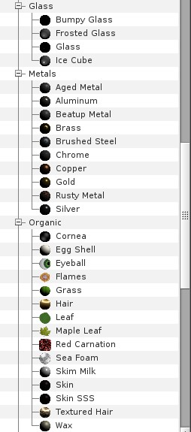
玻璃Glass,凸面玻璃Bumpy Glass,雾状玻璃Frosted Glass,冰块Ice Cube
金属Metal,老化金属Aged Metal,铝Aluminum,用坏的金属Beatup Metal,青铜Brass,铁刷Brushed steel, 铬chrome,红铜copper,金Gold,生锈的金属Rusted Metal,银Silver
有机物Organic,角膜Cornea,蛋壳Egg Shell,眼球Eye Ball,火焰Flames,草Grass,头发Hair,树叶Leaf,枫叶Maple Leaf,红康乃馨Red carnation,海浪Sea Form,牛奶
skim milk,皮肤Skin,Skin SSS,特定的头发Textured hair,腊Wax,

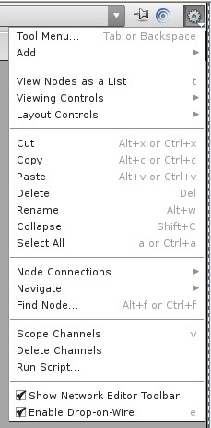
工具菜单Tool Menu,增加Add,表列节点View Nodes As a List,观看控制点View Controls,布置控制点Layout Controls,裁剪Cut,拷背Copy,粘贴Paste,消除Delete,重命名Rename,崩溃Collapse,选择所有Select All,连接节点Node Connections,导航navigate,寻找节点Find Node, 通道范围Scope Channel,消除通道Delete Channels,运行Script档案 Run Script ,显示网络编辑工具条Show Network Edit Toolbar,使用drop on wire

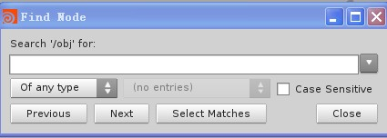
搜寻obj文件 Search obj for,任何型式of any type,敏感事件Case Sensitive前一个Previous,下一个Next,选择配合的Select Matches,关闭Close
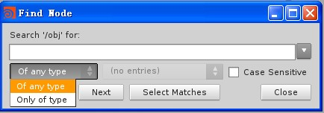
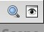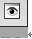

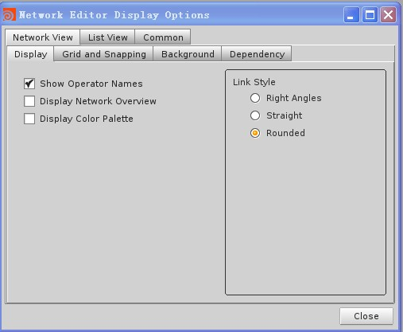
网络编辑显示选项Network Editor Display Options 网络观察Network Views,显示Display
显示操作者名字Show Operator Names显示网络综观Display Network Overview,
显示颜色图层Display Color Palette ,连接型式Link Style,角度Right Angles,直线Straight,圆形Rounged
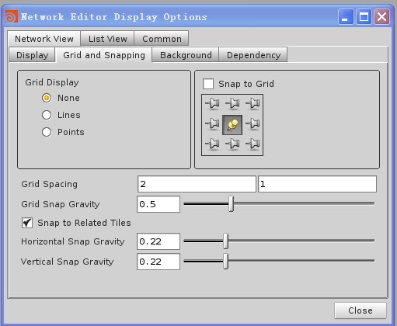
网络观察Network View表列观察List View 方格与中断Grid and Snapping,方格显示Grid Display,没有None线Lines,点Points,中断到方格Snap to Grid.方格空间Grid Spacing,方格中断重力Grid to Grativity,中断到相关位置Snap to Related Tiles,水平中断重力Horizontal Snap Gravity,垂直中断重力Vertical Snapping Gravity,
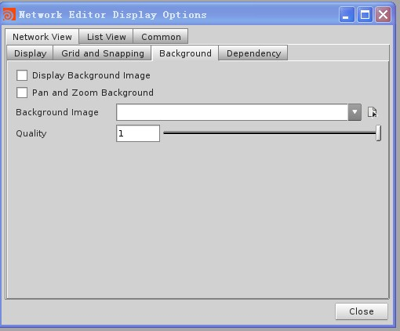
背景Background,显示背景图像Display Background Imagem,拖拉与放大背景Pan and Zoom Background,背景图像Background Image,质量Quality

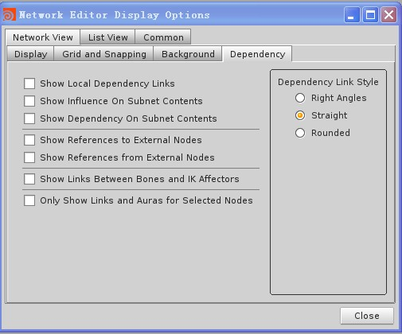
附属dependency,显示地区付属连结Show Local Dependency Links,显示在子网络下有影响的内容Show Influence On Subnet Contents,显示在子网络下附属内容Show Dependency On Subnet Contents,显示参考在外部节点Show Reference to External Nodes, 从外部节点显示参考Show Reference From External Nodes,显示骨头与IK Affectors间的连接Show Link Between Bones and IK Affectors,显示选择的节点连接与周围光环
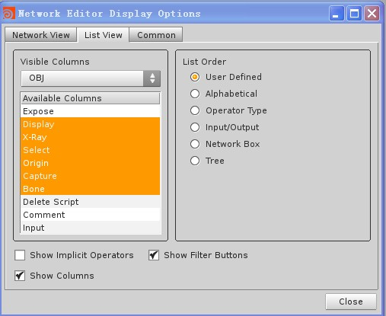
表列List View,可见直列Visible Columns,Obj檔,有效直列Available Columns,展示Expose,显示Display,X光 X-Ray,选择Select,原点Origin,捕捉Capture,骨头Bone,消除指令Delete Script,评论Comment,输入Input.表列次序List Order,使用者定义User Defined,字母alphabetital,操作型式Operator Type,输入/输入Inout/Output,网络盒子Network Box,显示操作者Show implicit Opertor,显示过滤按钮Show Filter Button,显示直列Show Columns

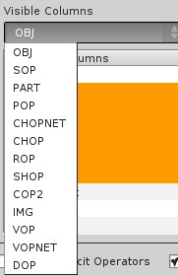
可见直列选项Visible Columns
表面操作SOP(Surface Operator),粒子操作POP(Particle Operator)
信道操作CHOP(Channel Operator),阴影操作SHOP(Shader Operator),合成操作COP(Compostion Operation),VOP提供与VEX语言互动界面,动态结构DOP(Dynamic Architecture)宣染操作ROP(Render Operator)
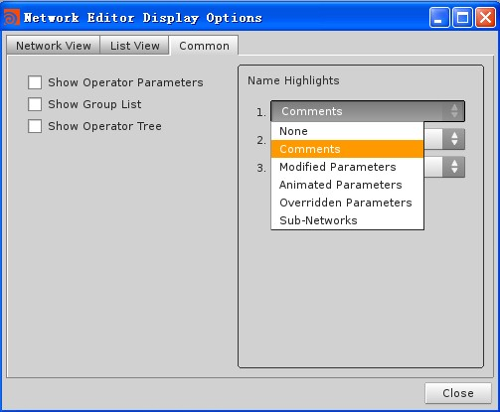
普通Common,显示操作参数Show Opera,显示群组表Show Group List,显示操树Show Operator Tree,点亮名字Name Highlights,批注Comments,没有None,批注Comments,修改参数modified Parameters,动画参数Animated Parameter,排除参数Overridden Parameters,子网页Sub-Networks
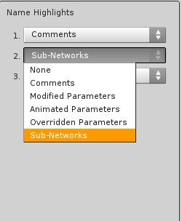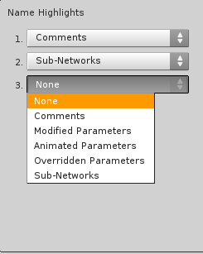

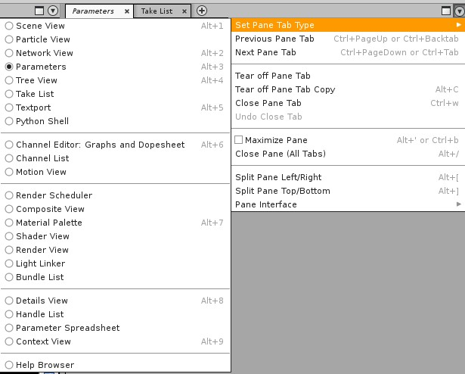
参数Parameter,场景观Scene View,粒子观Particle View,网络观Network View,参数Parameter,树状观Tree View,取表Take List,文字窗口Textport, Python语言 Python Shell,信道编辑Channel Editor,信道表列Channel List,动作观Motion View,宣染排程Render Scheduler,合成观Composition View,材料图层Material Paltte,阴影观Shade View,宣染观Render View,光线连结Light Linker,笔刷表Bundle List,细部观Detail View,手把表列Handle List,参数空白表Parameter Spreadsheet,脉络观Context View,

设定钳板钮Set Pane Tab Type,前面钳板按钮Previous PaneTab,下一个钳板按钮Next Pane Tab,触动鼠标即显示钳板的按钮Tear off Pane Tab,拷贝钳板的按钮Tear off Pane Tab Copy,关闭钳板的按钮Close Pane Tab,cjo6回复关闭的按钮Un,do Close Tab,最大化钳板Maximize Pane,关闭所有钳板按钮Close Pane(All TAb),分裂钳板左/右 Split Pane Left/Right, 分裂钳板上/下 Split Pane Top/Bottom,钳板界面Pane Interface,

显示区右键菜单

动画Animation,特性Character,创造与精致化Create and Refine,光线与对象Lights and Objects,光线 摄影机 动作 Lights. Camera. Acton,技术指导Technical Director,新工具架设定New Shelf Set,编辑工具架Edit Shelf Set, 储存工具架Save Shelf As,工具架组合Shelf Sets,移动工具架Remove Shelf Set,消除工具架Delete Shelf Set,以何种形式显示工具Display Tool As
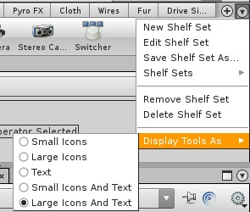
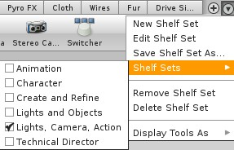
操作选择Operator Selected,小图标Small Icons,大图标Large Icons,文字Text, 小图标加文字Small Icons And Text,大图标加文字Big Icons And Text
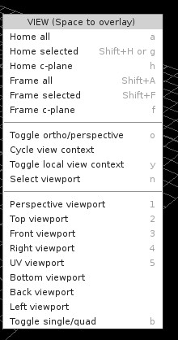
观看窗(空间重迭)VIEW(Space To Overlay)
所有在家的Home All,在家的选择项Home Selected,在家的c-Plane,所有祯Frame All,所有选择的祯Frame Selected,所有c-Plane的祯
打开垂直或透视图Toggle ortho/perspect,打开观察上下文Toggle view context,打开地区观察上下文Toggle local view context,选择窗口口Selected viewport,
透视窗口Perspective viewport,顶面窗口Top viewport,前面窗口Front viewport,右面窗口Right viewport,UV窗口UV viewport,底面窗口Bottom viewport,后面窗口Back viewport,左面窗口Left viewport,打开单元格/四格Toggle Single/quad,

结点区右键菜单

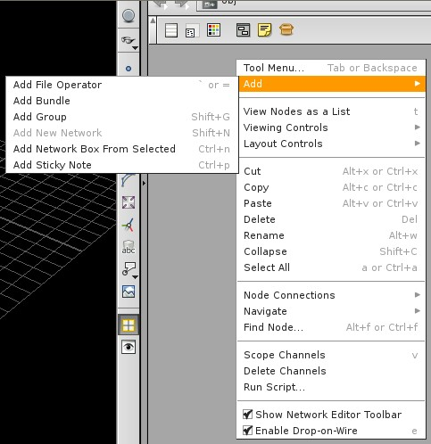
加入档案操作Add File Operator,加入包裹Add Bundle,加入群组Add Group,加入网络Add Network,加入选择的盒型网络Add Network Box From Selected,加入粘着批注Add Sticky Note,工具菜单Tool Menu,加入Add,表列结点View Nodes as a List,观察控制点Viewing Controls,布置控制点Layout Controls,裁剪Cut,拷贝Copy,粘贴Paste,消除Delete,重命名Rename,毁坏Collapse,选择所有Select All,结点连接Node Connrction,导航Navigate,发现结点Find Node,范围信道Scope Channel,消除信道Delete Channel,运作Script Run Script, 显示网络编辑工具条Show Network Editor Toolbar,使落在网上Enable Drop-on-Wire.
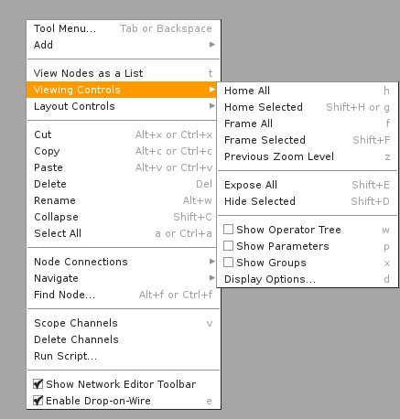
所有在家的Home All,在家的选择项Home Selected,所有祯Frame All,所有选择的祯Frame Selected,原先拉近或远的程度Previous Zoom Level,暴露所有的Expose All,隐藏选择的Hide Selected,显示操作树Show Operator Tree,显示参数Show Parameters,显示群组Show Groups,显示选项Display Options
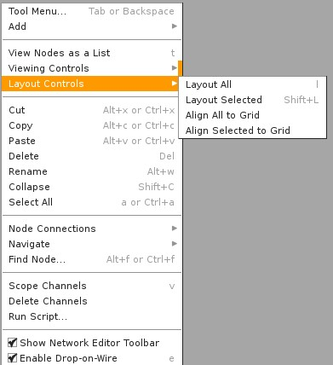
布置所有Layout All,布置选择的Layout Selected,所有都格状排列Align All To Grid,
选择的格状排列Align Selected To Grid
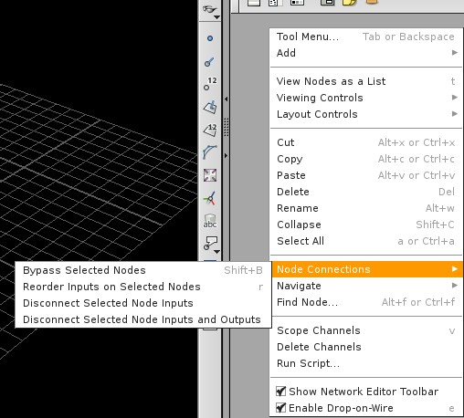
结点连接Node Connections,绕过选择的结点Bypass Selected Nodes, 在选择的结点 重设进入点Recorder Inputs on Selected Nodes,解除选择结点的进入点Disconnect Selected Node Inputs,解除选择结点的进入点与出口点Disconnect Selected Node Inputs and Outputs,
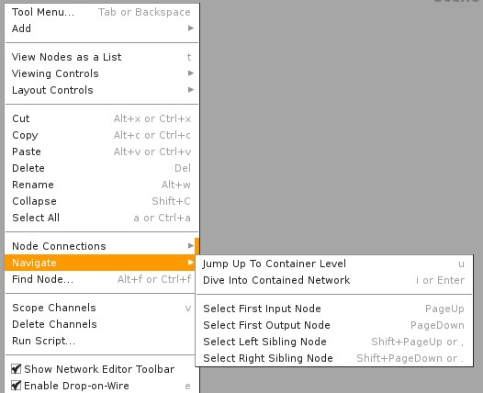
导航Navigate,跳至柜形窗口Jump To Container Level,潜入柜形网络Dive into Container network,选择第一个进入的结点Select First Input Node, 选择第一个出去的结点Select First output Node,选择左边血统结点 Select First Sibling Node, 选择右边血统结点 Select Right Sibling Node

树结构右键菜单

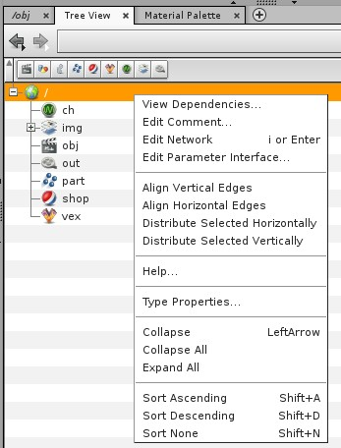
观察附属View Dependence,编辑批注Edit Comment,编辑网络Edit Network,编辑参数界面Edit Parameter Interface,排列垂直边缘Edit Vertical Edges,排列水平边缘Align Horizontal Edges,分配选择的水平Distribute Selected Horizontally, 分配选择的垂直Distribute Selected Vertically,帮助Help,性质形式Type Properties,毁坏Collapse, 毁坏所有Collapse All, 追朔分类Sort Ascending, 追朔不分类Sort Deascending, 不分类Sort None

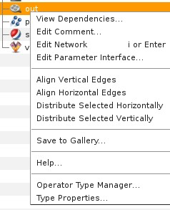
输出Out, 观察附属View Dependence,编辑批注Edit Comment,编辑网络Edit Network,编辑参数界面Edit Parameter Interface,排列垂直边缘Edit Vertical Edges,排列水平边缘Align Horizontal Edges,分配选择的水平Distribute Selected Horizontally, 分配选择的垂直Distribute Selected Vertically,储存至画廊Save To Gallery帮助Help,操作模式管理Operator Type Manger, 性质模式Type Properties,
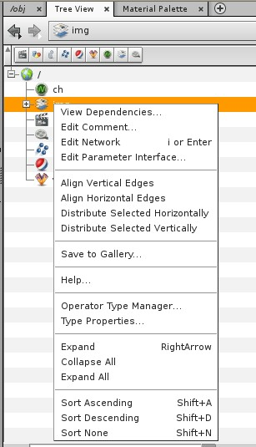
观察附属View Dependence,编辑批注Edit Comment,编辑网络Edit Network,编辑参数界面Edit Parameter Interface,排列垂直边缘Edit Vertical Edges,排列水平边缘Align Horizontal Edges,分配选择的水平Distribute Selected Horizontally, 分配选择的垂直Distribute Selected Vertically,储存至画廊Save To Gallery帮助Help,操作模式管理Operator Type Manger, 性质模式Type Properties,
扩散Expand,毁坏所有Colapse All,扩散所有Expand All,
追朔分类Sort Ascending, 追朔不分类Sort Deascending, 不分类Sort None

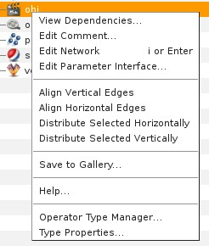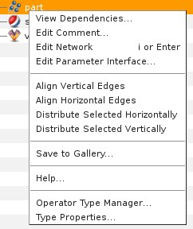
观察附属View Dependence,编辑批注Edit Comment,编辑网络Edit Network,编辑参数界面Edit Parameter Interface,排列垂直边缘Edit Vertical Edges,排列水平边缘Align Horizontal Edges,分配选择的水平Distribute Selected Horizontally, 分配选择的垂直Distribute Selected Vertically,
储存至画廊Save To Gallery帮助Help,操作模式管理Operator Type Manger, 性质模式Type Properties,
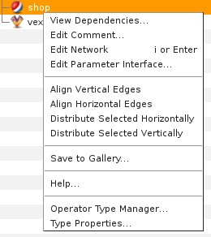
观察附属View Dependence,编辑批注Edit Comment,编辑网络Edit Network,编辑参数界面Edit Parameter Interface,排列垂直边缘Edit Vertical Edges,排列水平边缘Align Horizontal Edges,分配选择的水平Distribute Selected Horizontally, 分配选择的垂直Distribute Selected Vertically,
储存至画廊Save To Gallery帮助Help,操作模式管理Operator Type Manger, 性质模式Type Properties,

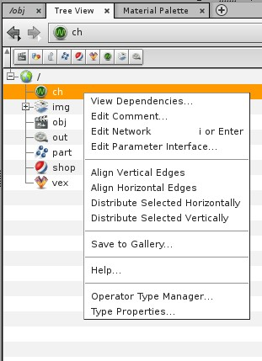
观察附属View Dependence,编辑批注Edit Comment,编辑网络Edit Network,编辑参数界面Edit Parameter Interface,排列垂直边缘Edit Vertical Edges,排列水平边缘Align Horizontal Edges,分配选择的水平Distribute Selected Horizontally, 分配选择的垂直Distribute Selected Vertically,
储存至画廊Save To Gallery帮助Help,操作模式管理Operator Type Manger, 性质模式Type Properties,

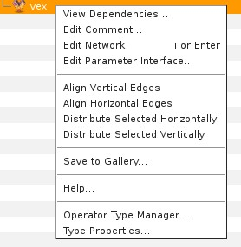
VEX语言项下 选项
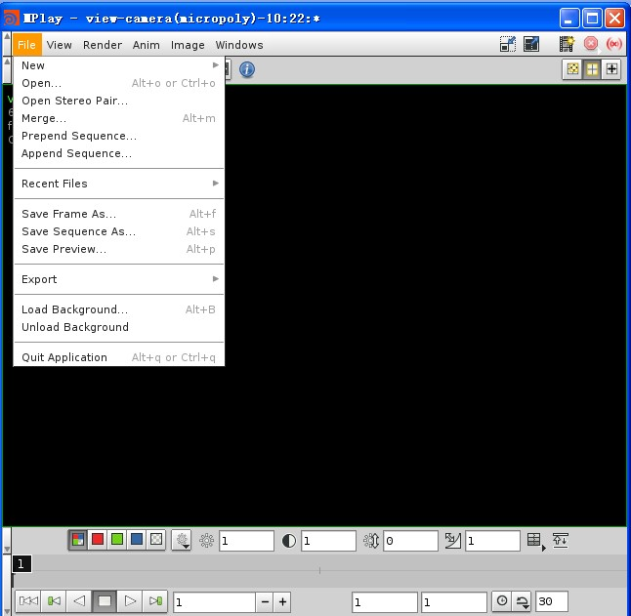
新的New,打开Open,打开立体对Open Stereo Pair,合并Merge,前端序列Prepend Sequence,后端序列Append Sequence,最近档案Recent Files,储存画祯Save Frame As,储存序列Save Sequence As,储存预览Save Preview,出口Export,载入背景Load background,卸载背景Unload Background,离开应用Quit Application,

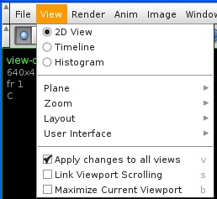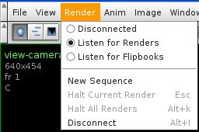
窗口View,2D观2D View,时间线Timeline,长方形统计图histogram,平面Plane,大小Zoom,布置Layout,使用者界面User Interface,变化应用在所有观景窗Apply change to all views,连接窗口滚轴Link Viewport Scrolling,最大化目前窗口Maximize Current Viewport,
宣染Render,不连接Disconnected,听到宣染Listen for Renders,听到翻书声Listen for Flipbooks,新序列New Sequence,停止目前宣染Halt Current Render, 停止所有宣染Halta All Render, 不连接Disconnect
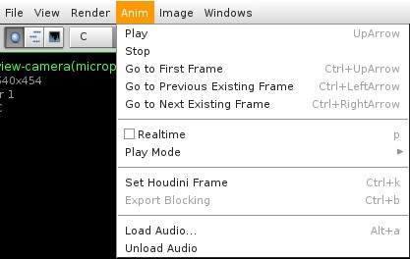
动画Anim,播放Play,停止Stop,到第一祯Go to first Frame,到前一祯Go to Previous Frame,到后一祯Go to Next Frame,实时realtime,播放模式Play Mode,设定胡迪尼图祯Set Houdini Frame,出口整块Export Blocking,载入声音Load Audio,卸载声音Unload Audio

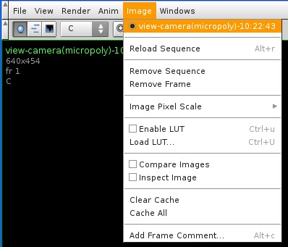
图像IMG,重载序列Reload Sequence,移开序列Remove Sequence,移开图祯Remove Frame,调整图像画素Image Pixel Scale,使用LUTEnable LUT,加载LUT Load LUT,比较图像Compare Image,检视图像Inspect Image,清除缓冲区Clear Cache,清除所有Clear All,加入图祯批注Add Frame Comment
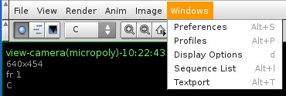
窗口Window,优先Preference,概略Profile,显示选项Display Options,序列表Sequence List,跳出窗口Textport
右键菜单
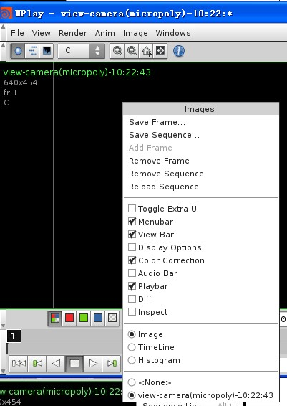
储存画祯Save Frame,储存序列Save Sequence ,加入图祯Add Frame,移开图祯Remove Frame,移开序列Remove Sequence,重载序列Reload Sequence,导入特殊UI Toggle Extra UI,菜单条Menubar,观景条View Bar,显示选项Display Options,颜色修正Color Correction,声音条Audio Bar,播放条Playbar,Diff,检视Inspect,图像Image,时间线Timeline,方个图Histogram
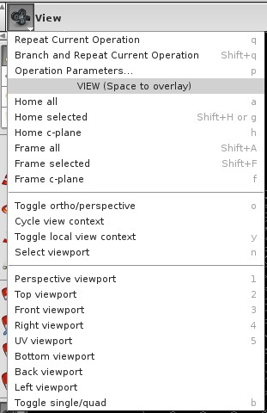
重复目前操作Repeat Current Operation,分枝并重复目前操作 Branch and Repeat Current Operation,操作参数Operation Parameters, 所有的都回家Home All,选择项回家Home Selected, c-Plane回家Home C-Plane,所有祯Frame All,所有选择的祯Frame Selected,所有c-Plane的祯Frame C-Plane,转换邻位/透视Toggle ortho/perpective,循环观察内容Cycle View context,转换地区观察内容Toggle local view context,选择窗口Select Viewport透视窗口Perpective viewport,顶面窗口Top Viewport前面窗口Front Viewport右面窗口Right ViewportUV窗口UV Viewport底面窗口Bottom Viewport后面窗口Back Viewport左面窗口Left Viewport

