**API**

**Please remember set up db first**

1. Set ‘MYCompany’ as startup project
2. Open package manager console,  
   Default project: MyService\Infrastructure\MY
3. Run command: update-database context MYDBContext

(rmb change ur connection string first at appSettings.json)

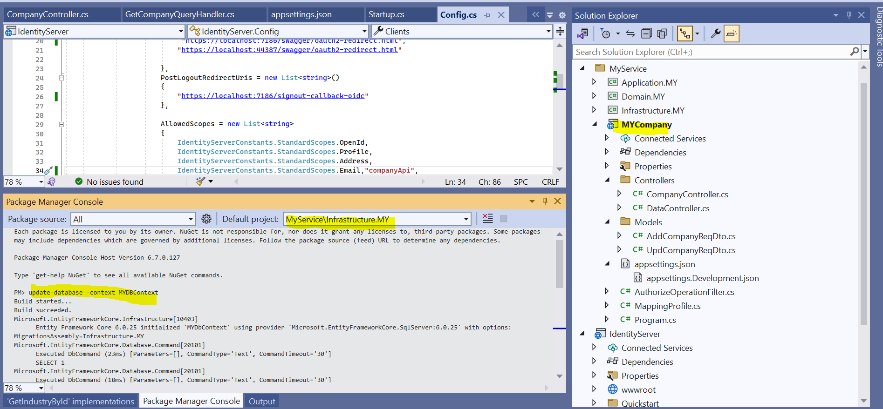

**UI**

**Listing page** (Management > Company)

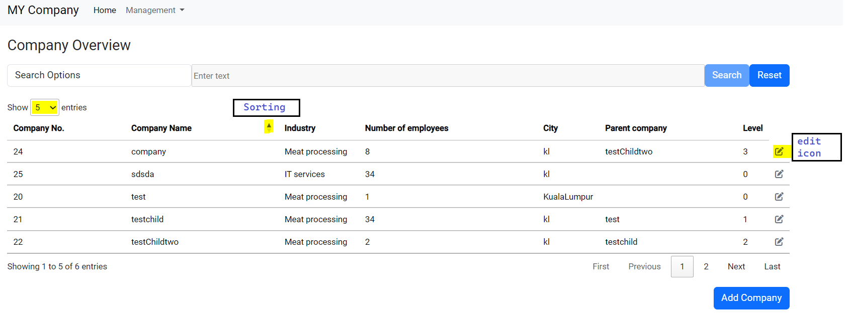

_________________________________________________________________________________

**Search Option:**

1. Company No, Company Name, City, Parent Company -> free text
2. Industry -> industry drop down list

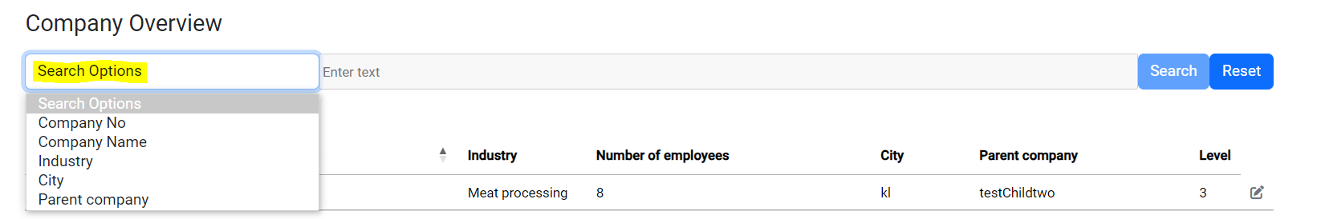

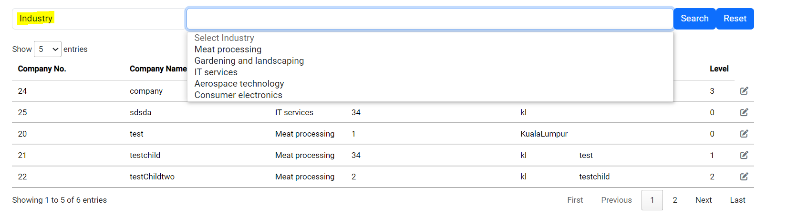

_________________________________________________________________________________

**Sorting:** (by clicking the column)

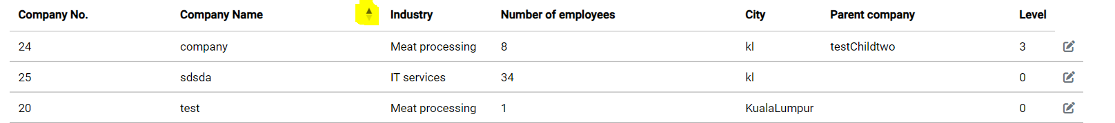

**Add Page:**

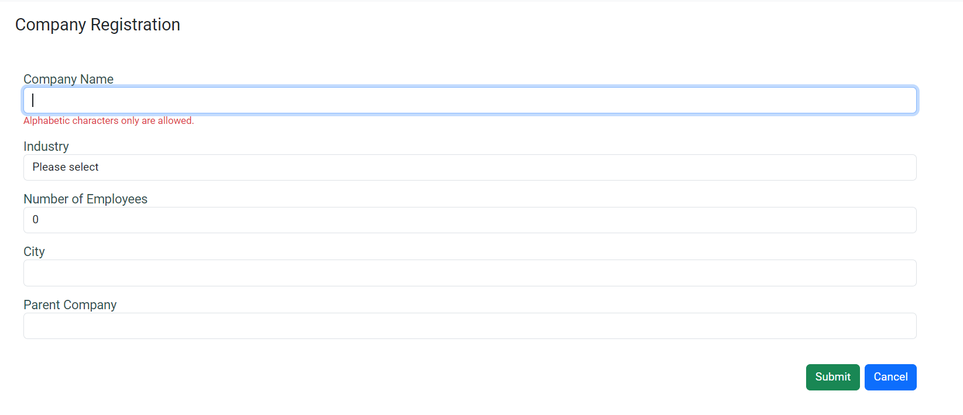

**Error toast message:**

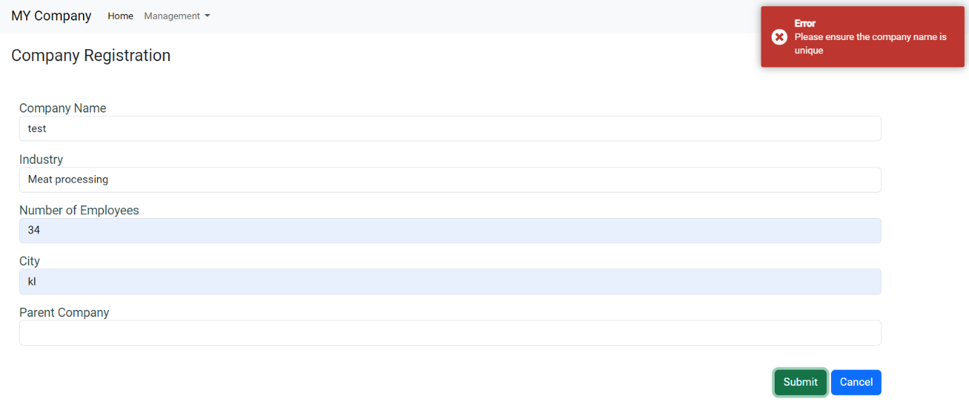

**Success:**

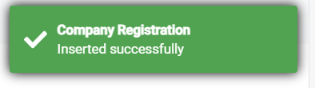

**Update Page:**

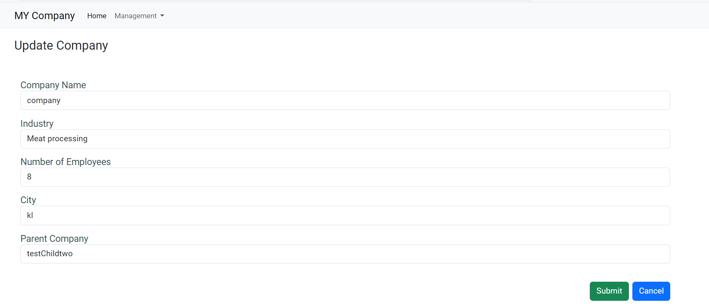

**Toast Message:**

