User Manual

FOR

CSEKU_WPL_2018_Calendar

Project Manager

Dr. Kazi Masudul Alam

Assistant Professor

CSE Discipline, Khulna University

Khulna - 9208

Developed By

A. K. M. Fahim Rahman (160215)

Tausif Ahmed Turzo (160207)

Moushan Naznin (160226)

We have developed a Calendar for Digital University to show event(s) in organized way. There are two part of this module. They are –

1. Show the Calendar with Events with Month view, Week view and Day view
2. Add Events in the Calendar

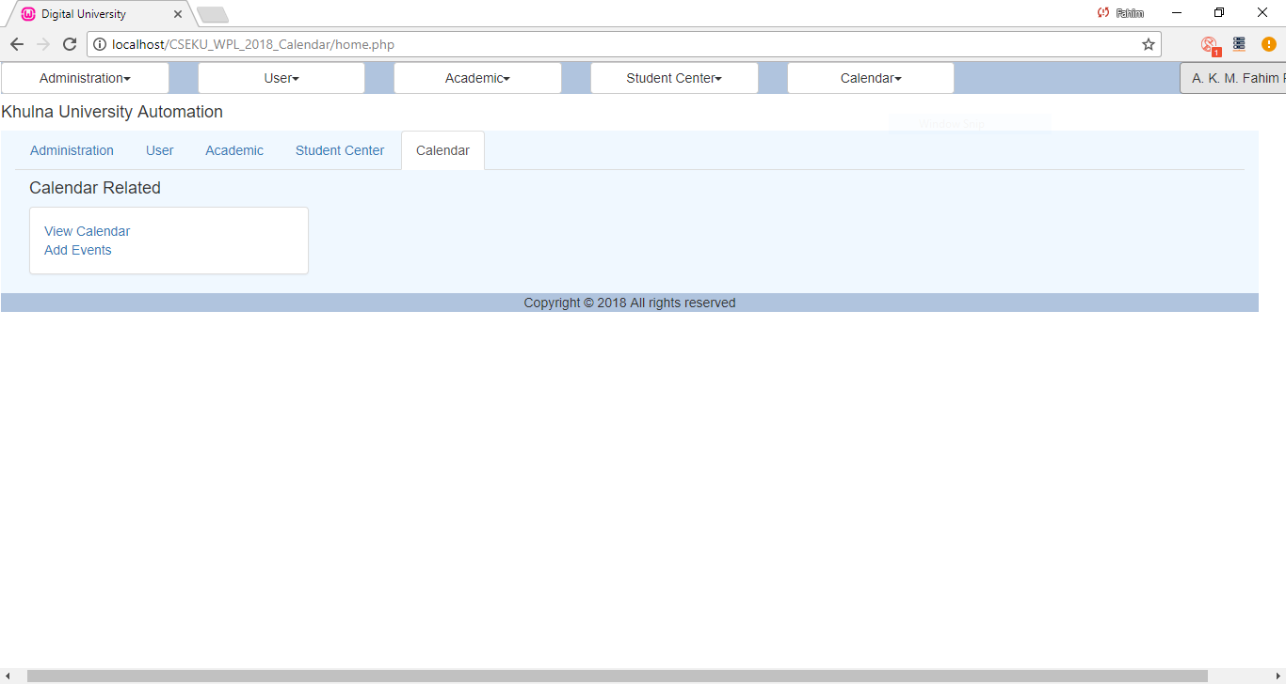

1. Show the Calendar with events

A user (like Students, Teachers) can see only their discipline’s events and some general events (like PL, Registration, and Other Govt. leaves).

Students and other users (except the Administrator and Teachers) cannot add any event.

Student View:

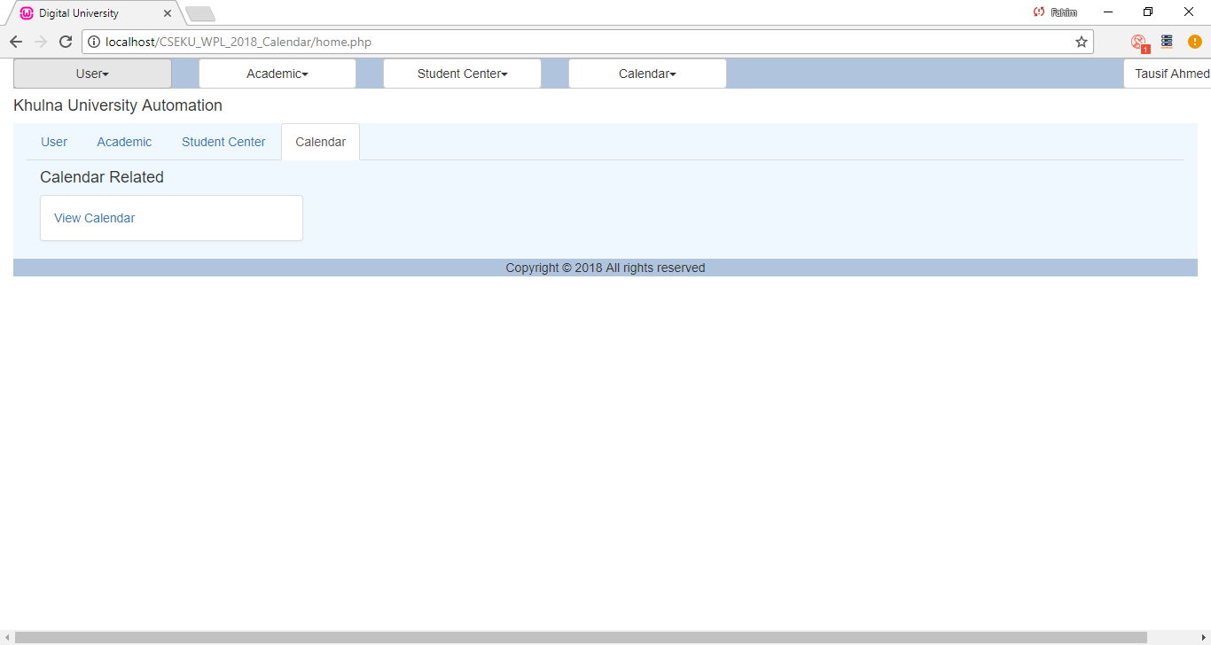

Fig 2: Student View

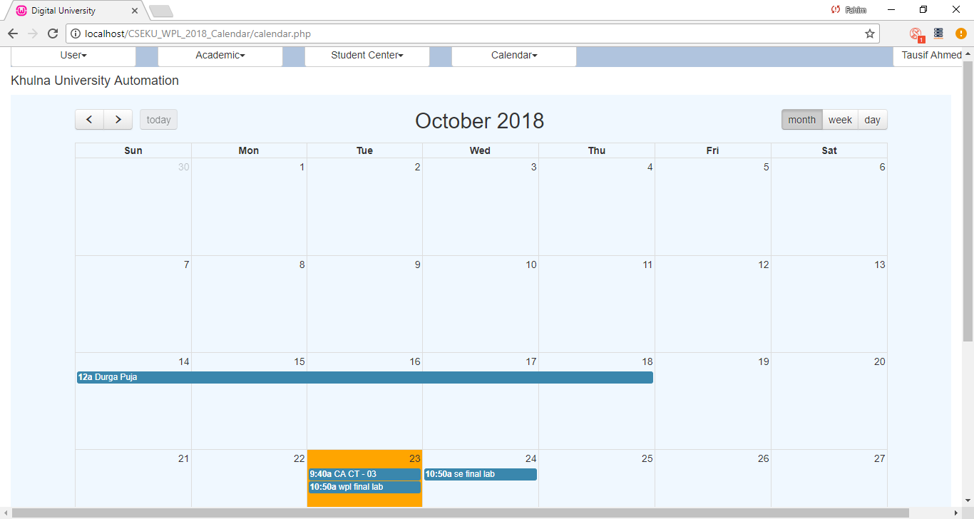

Fig 3: Students can see their Discipline’s event

1. Add Events in the Calendar

Administrator and the Teachers can add events in this Calendar. Administrator will add the general events (like Govt. vacation, Term Final Exam routine etc.) and Teachers can add the Class Test schedules.

Administrator/Teachers View:

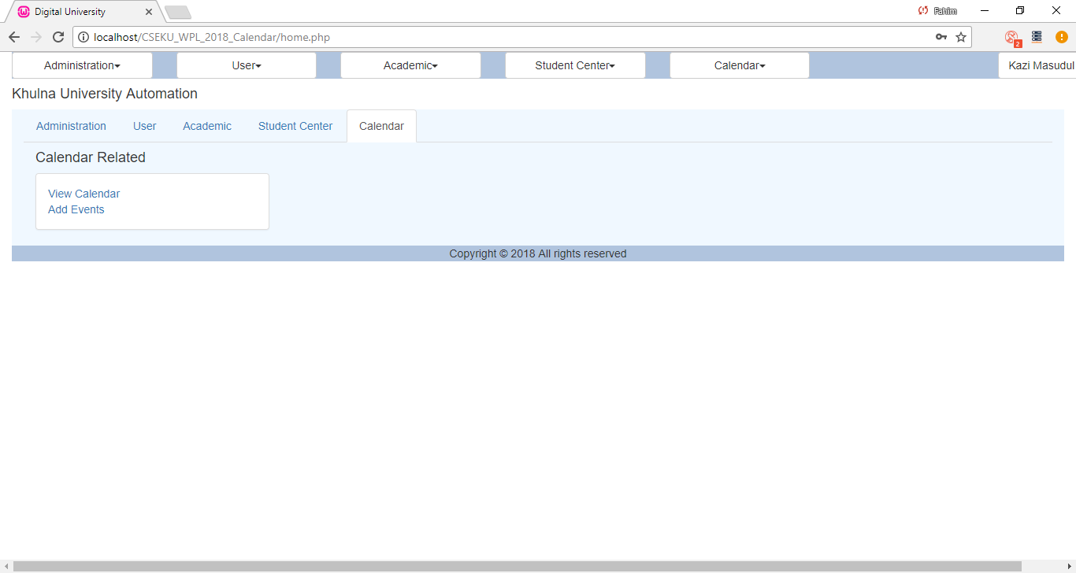

Fig 4: Administrator’s view

Add Event Page:

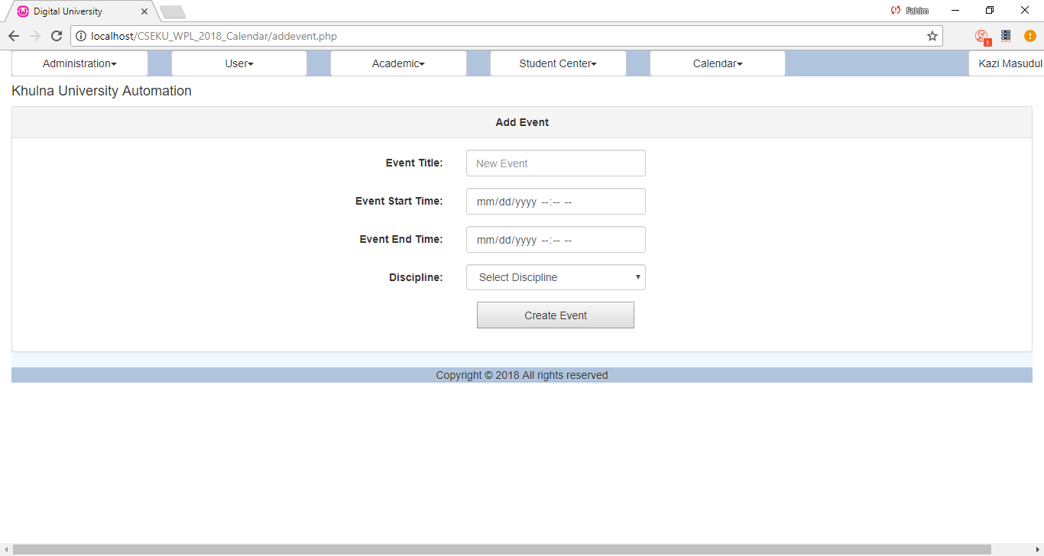

Only Administrator can see all events in the Calendar:

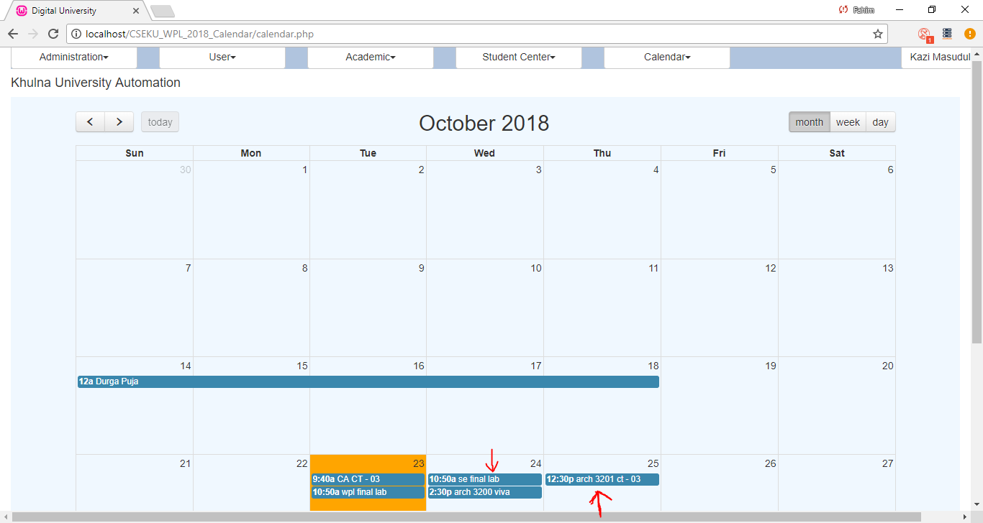

Fig 6: Administrator view (All events shown)

Views in Calendar:

This Calendar has three views like Month view, Week view and Day view. User can click and find any of them by clicking the buttons in the Right side top corner.

Month View:

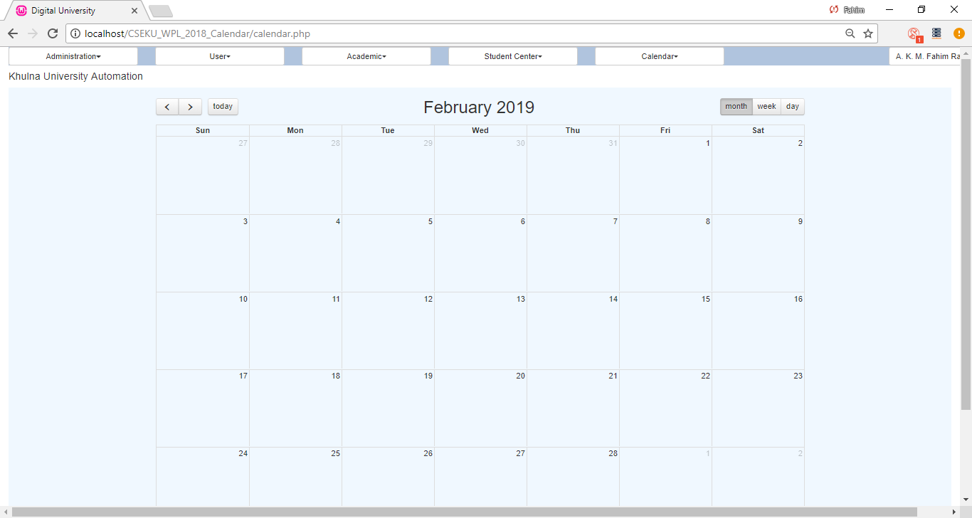

Week View:

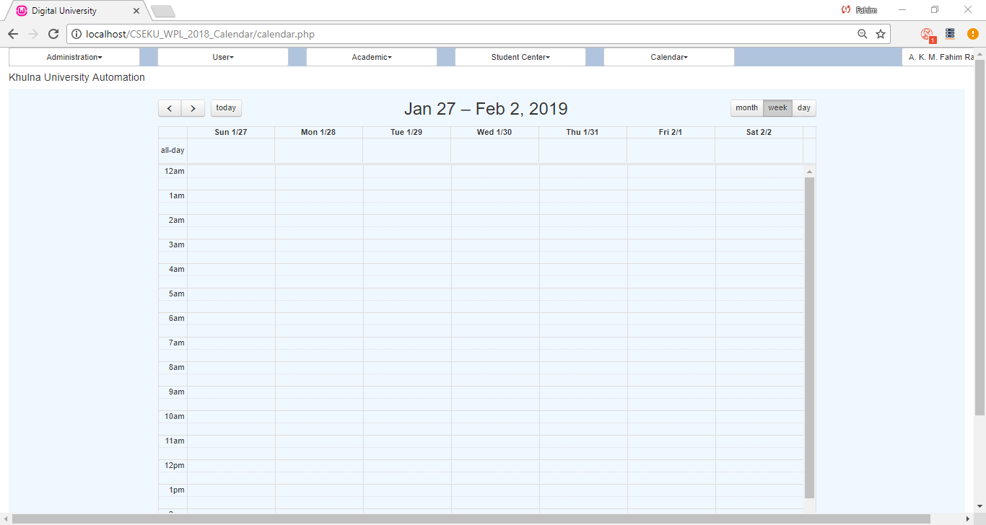

Day View:

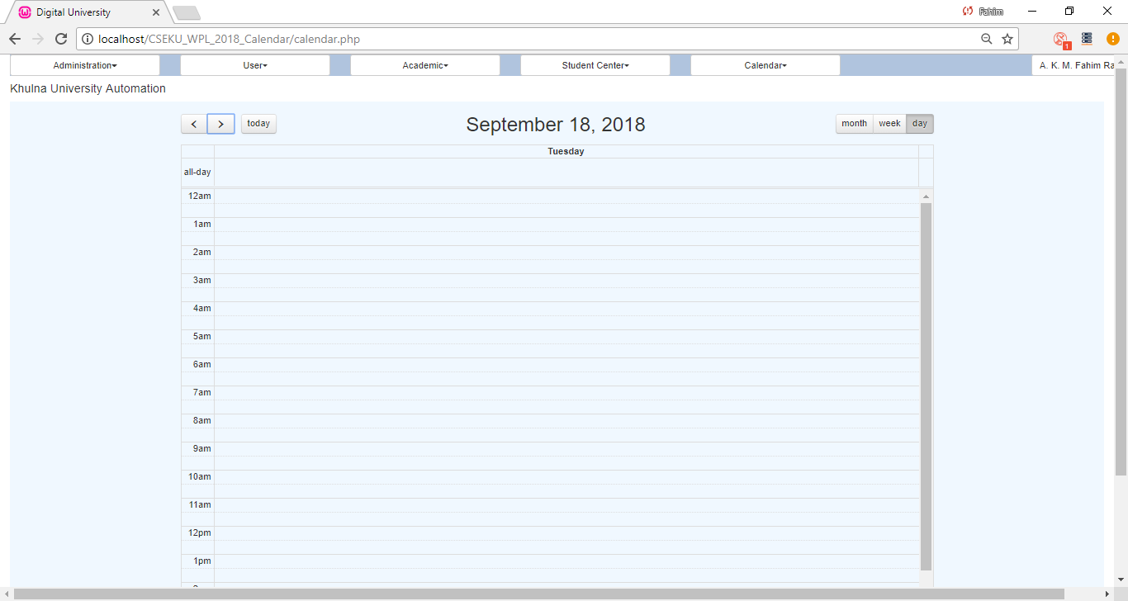

Today Button:

