Maintenance Plan

When developing any sort of application, there are a variety of different costs to consider. These include updating the software (stability and performance updates, code optimization, improvements, bug fixes, etc.), potential cost for hiring developers, and monthly fees of any kind. There are ways to cut down on these costs, of course, and smart planning contributes to this.

**Software Maintenance**

In general, it is said that the industry norm for costs in software maintenance is about 15 to 20 percent of the original development costs. It is good practice for a developer to start with small, simple app releases and formulate changes/additions based on consumer feedback, known as “end user development.” This helps to greatly cut down on long-term and short-term costs. Releasing a “lite” version and preparing to release small patches, tweaks, updates, and improvements throughout the upcoming few months is less costly than having to completely redo or eliminate features gone wrong. Many of these small tweaks should be planned for before release, similar to how videogame industry dishes out add-ons. This allows for consumers to let you know what features they most want and lets you, the developer, know which issues to work on first.

We have adopted many of these practices in the creation of our PaceTrainer App. In addition, we have built a hybrid application using Adobe PhoneGap. For the future, this would cut down on costs when placing our application onto the app store. Hybrid applications are a mix of native and web applications which allow you to build an app once (meaning it would work on multiple platforms) and submit it to multiple app stores. Native applications, in contrast, would have to have separate development teams, with each working on a version of the app for the intended app store in which they were planning on releasing the product (i.e.: iTunes vs Google Play).

Since we have no complex features at the moment, such as push notifications, logins, chat messaging, etc., the costs for maintaining the software are going to be lower than a more complex application. It cost us $0 to create this application, thus it is fair to say that without any external hired talent, maintenance would cost around the same.

**Cost of Hiring Developers**

When hiring developers, there are different factors to take into account. There are two types of developers you must consider when hiring: local vs. outsourced. Since we live in the U.S., the costs for hiring a developer locally are much higher than outsourcing. The cost usually ranges from $20-$250 an hour for local developers. In contrast, the cost to hire a developer from India, as an example, can cost between $18-$80 an hour. Below is an infographic which shows the differences in developer rates around the world:

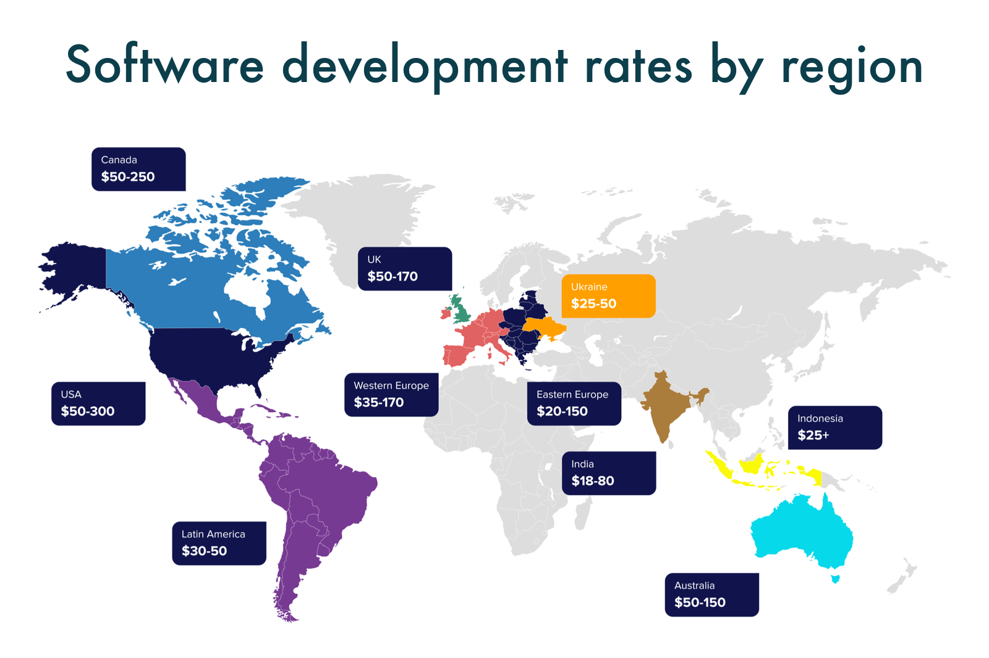

Source: <https://www.cleveroad.com/blog/how-much-does-it-cost-to-create-an-app>

There are also differences besides cost when hiring developers locally vs. outsourced. Local developers are going to be easier to communicate with, are more likely to attend face-to-face meetings, and will be more deeply involved. However, there will also be a broader talent pool to choose from when considering outsourced developers. They often have a high level of expertise and are flexible with their schedules. A big downside to outsourcing development, however, is time zone challenges.

As first-time app developers, we would most likely hire outsourced talent to help with our app maintenance for the first year. After the first year, we would reassess our situation and make changes if needed. Thus, depending on how many people we chose to hire, let’s say 2 people for now, working around 3 hours a day, 100 days out of 365 at $20/hr, that would drive our cost to approximately $12,000.

**Monthly/Annual Fees**

Each app store has their own fees associated with distribution. The Apple App Store has a membership program known as the Apple Developer Program. It costs $99 a year to be a member and be able to publish applications. If you charge for your app, Apple takes 30% of profits. There is no charge for the distribution of free apps. More info about the Apple Developer Program and the steps required to publish an app can be found in the DeploymentPlan document in the documentation.

The Microsoft App Store charges a one time $19 developer fee for individual accounts and no renewal is required. For company accounts, they charge a one time $99 fee. Microsoft takes 15% of profits made from paid apps found through the app store. However, if the app is downloaded through a direct URL, the company only takes 5% and lets the developer keep 95% of app revenue. These do not apply to games, in which Microsoft takes 30% and the developer keeps 70%. Microsoft does not charge for the distribution of free applications.

On the Google Play Store, you are charged a one-time developer fee of $25 to publish applications. Much like Apple, Google takes 30% of profits made from paid apps and charges no distribution fees for free applications.