***Filter Design***

**Author: Matthew Felsen**

**Abstract**

This lab’s goal was to design, build, and test a Low Pass filter using a LM318 OP AMP. This was done using OrCAD’s Pspice for circuit analysis and PCB Editor to convert the circuit into a physical design as well as route the PCB traces. By using circuit analysis, a Low Pass filter was designed to have a voltage gain of 15V and a cutoff frequency of 2 kHz.

**Introduction**

A Low Pass filter is a device that allows signals to pass that have a lower frequency than the cut off frequency. It also attenuates signals with frequencies higher than the cut off frequency. Low Pass filters are usually one component that are part of a greater application. They are typically used to clean up or reduce noise from incoming signals that can be fed into other parts of a circuit. Low Pass filters are used in a variety of applications than span anywhere from acoustics to optics.

**Design Procedure**

A Low Pass Filter is supposed to have frequency response according to the Figure 1.

Frequency Response of a Low Pass Filter

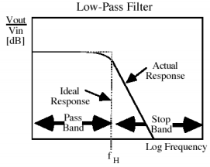

Figure 1

The gain is constant to a certain cutoff frequency fH. Ideally, the gain drops to 0 after the cutoff frequency. In reality, the gain drops off steeply as frequency increases. To create a frequency response similar to Figure 1, a circuit was created according to Figure 2.

Low Pass Filter Circuit

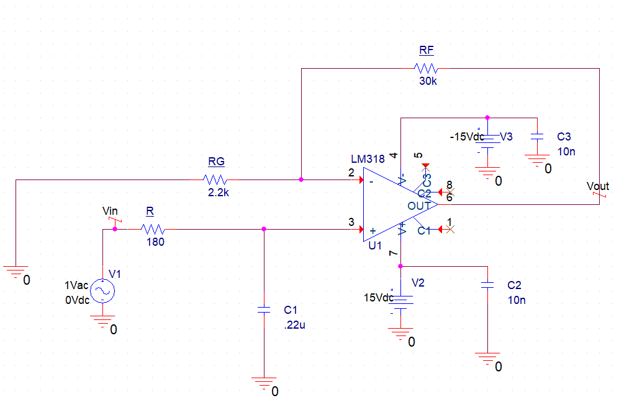

Figure 2

The components that dictate cutoff frequency are resistor R and capacitor C1. Equation 1 was used to find component values to give a cutoff frequency of 2 kHz

$$f_{H}= \frac{1}{2πRC}$$

Equation 1

After using Equation 1, a 180Ω resistor and 0.22 µF capacitor were chosen to create a cutoff frequency of 2 kHz.

The components that dictate the gain were Rf and Rg. A ratio had to be found to create a gain of 15. The values of Rf and Rg were found using Equation 2.

$$A_{v}=1+ \frac{R_{f}}{R_{g}}$$

Equation 2

The resistor Rf was chosen to be 30kΩ and resistor Rg was chosen to be 2.2kΩ. This created a theoretical gain of 14.63, these resistor values were the closest to the theoretical gain as only standard resistor values could be used.

**Fabrication**

To prepare the circuit show in Figure 2 to be converted to a PCB, test points were used to replace the voltage sources and output in Pspice. No connects were also put onto the unused pins on the OP AMP so the PCB software knew not to route traces at these pins. The circuit was then exported, and parts were placed in the PCB software. The pad stacks were modified on each component so there would be a larger surface area for the solder points. The board was then routed using the auto route feature. This was done on a single layer PCB so traces could not overlap one another. The PCB design is shown in Figure 3.

Low Pass Filter PCB Design

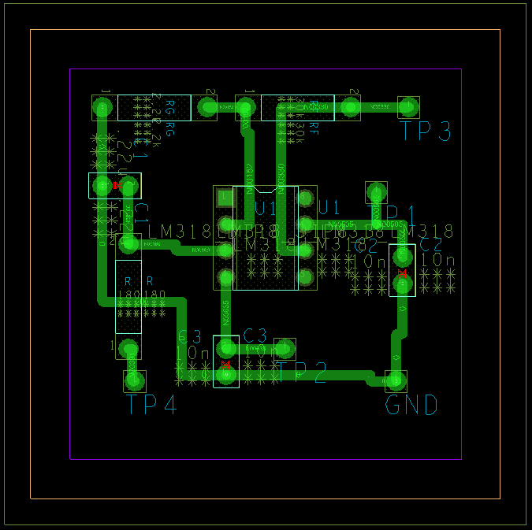

Figure 3

This design was printed out on toner paper and then laminated to a copper board. The ink was used to seal the copper so when the copper board was placed in a chemical bath, the exposed copper would erode and come off the board while the sealed parts would stay in place. Figure 4 illustrates the board post-chemical bath.

Etched PCB Board

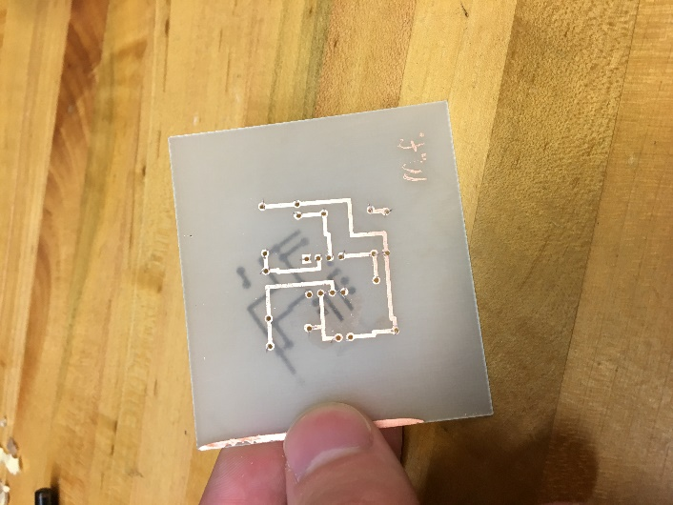

Figure 4

Figure 4 also shows the holes drilled where the pad stacks are shown. The drill holes are where the components will be inserted into the PCB. The board was now ready for components to be installed, the components were inserted into the board according the design shown in Figure 3 and then soldered in place. Figure 5 shows the completely assembled Low Pass filter.

Assembled Low Pass Filter PCB

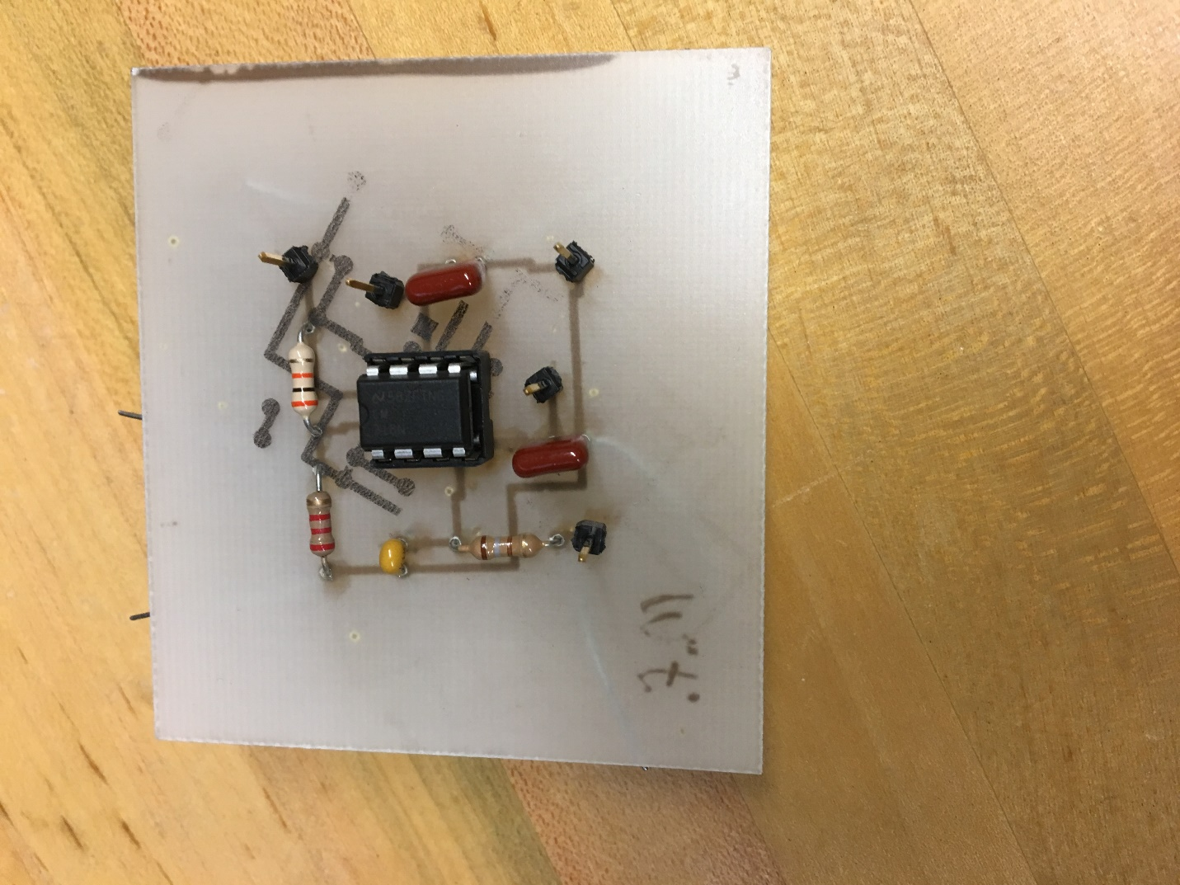

Figure 5

**Measured Performance**

The simulated frequency response of this Low Pass filter design is shown according to Figure 6.

Simulated Frequency Response of Low Pass Filter

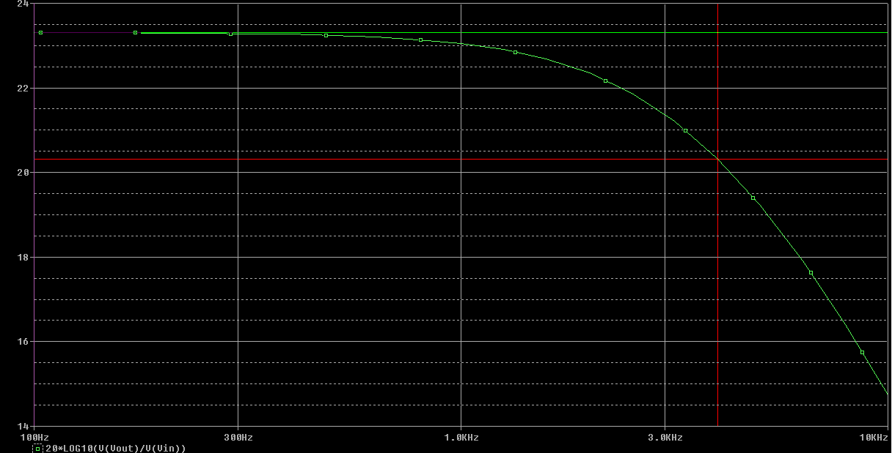

Figure 7 shows the actual response of the Low Pass Filter.

Figure 7

The response shown in Figure 7 was based off the data shown in Figure 8.

Low Pass Filter Gain vs Frequency



Figure 8

**Discussion**

The simulated response agrees with the design requirements. A constant gain of 15 or 23.5 dB is seen for frequencies between 100 Hz and the cutoff frequency 2kHz. The gain attenuates to 0 at frequencies higher than the cutoff frequency. The same can be seen of the experimental response. The simulated response and experimental response are almost identical. The gain and attenuation of the response are not identical, but this is due real components not being completely ideal and true to their nominal value. Figure 8 shows a voltage gain of approximately 15 at frequencies leading up to 2 kHz. Ideally, the gain would stay constant. However, it’s slope is fairly close to 0 leading up to the cutoff frequency. Once it hits the cutoff frequency of 2 kHz, there is a sharp decline in gain and approaches 0 dB.

The frequency response of the simulated and experimental circuit both agree that the design is a Low Pass filter. It filters the signal at frequencies higher than the cutoff and allows signals to pass through the OP AMP at frequencies lower than the cut off at a given gain.

**Conclusions**

In conclusion, the experimental circuit built based on the simulated circuit in PSpice acted as a Low Pass Filter. The circuit’s output voltage held a near constant gain at frequencies below the cutoff frequency and the signal attenuated at frequencies higher than the cutoff frequency. The Bode plot of the simulated and experimental circuit were nearly identical, so the fabrication and design of the Low Pass Filter was successfully replicated from the simulation.