CLOUDBASKET
Cloud Retail Analytics Platform

PROJECT CASE STUDY
End-to-End Azure Data Engineering & Business Intelligence Portfolio Project

1. Executive Summary
CloudBasket is a cloud-native retail analytics platform built entirely on the Microsoft Azure ecosystem. The project ingests nine relational CSV files from the Olist Brazilian E-Commerce dataset, processes them through a fully automated Azure Data Factory pipeline, transforms them into a dimensional star schema inside Azure Synapse Analytics, and delivers actionable business insights through a three-page Power BI dashboard.

This project was built to demonstrate end-to-end data engineering and business intelligence capability across the full Microsoft stack — from raw file ingestion through cloud ETL, data warehousing, and executive-level dashboard delivery. The platform answers a core business question:

"How is the Olist marketplace performing across order revenue, seller reliability, product categories, and customer satisfaction — and which sellers and product categories are driving the most value versus the most complaints?"

Project Name | CloudBasket — Cloud Retail Analytics Platform
Target Roles | Data Engineer · Cloud Data Engineer · BI Developer
Industry | E-Commerce · Retail · Marketplace
Dataset | Olist Brazilian E-Commerce (Kaggle) — 9 relational CSV files
Data Scale | 100,000+ real orders · 9 source tables · 118,310 fact rows
Core Stack | Azure Data Factory · Azure Blob Storage · Azure Synapse Analytics · Power BI
Timeline | ~20 days part-time (2–3 hours/day)
Estimated Cost | $10–$20 (covered by $200 Azure free credit)

2. Problem Statement & Business Context
The Olist marketplace connects small Brazilian businesses with customers across the country. With over 100,000 orders across hundreds of product categories and thousands of sellers operating in different states, the business lacked a centralised view of performance. Key questions remained unanswered:

- Which product categories generate the most revenue and receive the highest customer satisfaction scores?
- Which sellers are consistently delivering late and damaging the marketplace's reputation through poor review scores?
- How has monthly revenue trended over the 2016–2018 period and which periods show the strongest growth?
- Which Brazilian states have the longest delivery times and what is the geographic distribution of the customer base?
- How do customers prefer to pay and does payment method correlate with order value?

Without a unified analytics platform, answering these questions required manual data joining across nine separate CSV files — an unreliable, slow, and non-scalable approach. CloudBasket solves this by building a production-grade cloud data pipeline that automates ingestion, transformation, and reporting end to end.

3. Dataset Overview
The Olist Brazilian E-Commerce dataset is a real, anonymised transaction dataset from a Brazilian marketplace covering orders placed between September 2016 and October 2018. It consists of nine relational CSV files with over 100,000 orders linked across customers, sellers, products, payments, reviews, and geolocation data.

The 9 Source Files
CSV File | Contents | Rows
olist_orders_dataset.csv | Core order records with status and timestamps | ~100K
olist_customers_dataset.csv | Customer details with zip code and state | ~100K
olist_order_items_dataset.csv | Line items per order with product and seller | ~112K
olist_order_payments_dataset.csv | Payment details with type and value | ~103K
olist_order_reviews_dataset.csv | Customer reviews with scores 1–5 | ~100K
olist_products_dataset.csv | Product catalogue with category and dimensions | ~33K
olist_sellers_dataset.csv | Seller details with location | ~3K
olist_geolocation_dataset.csv | ZIP code coordinates for mapping | ~1M
product_category_name_translation.csv | Portuguese to English category names | 71

Data Quality Challenges Encountered
- Product category names were in Portuguese — required joining to the translation file for English names in all dashboard visuals
- Geolocation file contained ~1M rows with highly precise decimal coordinates exceeding VARCHAR(20) — required column resizing to VARCHAR(50)
- Review comments contained commas inside quoted text — required configuring double-quote escape characters in ADF to prevent CSV parsing errors
- Orders with NULL delivery timestamps for undelivered orders — handled with TRY_CAST and NULL-safe joins in the fact table load
- Products file had a typo in two column names (product_name_lenght, product_description_lenght) — matched exactly in staging table DDL

4. Solution Architecture
CloudBasket follows a classic medallion-style data architecture across four Azure services working in sequence. Raw files land in Blob Storage, ADF pipelines move them into Synapse staging tables, SQL transformations build the star schema, and Power BI connects directly to the analytics layer for reporting.

SOURCE CSVs → Azure Blob Storage → Azure Data Factory → Azure Synapse Analytics → Power BI

Azure Services Used
Service | Role in Architecture | Why Chosen
Azure Blob Storage (ADLS Gen2) | Raw landing zone for all 9 CSV files | Standard enterprise data lake on Azure; required by Synapse
Azure Data Factory | Automated ETL pipeline with 9 Copy Activities | Most-used cloud ETL tool in Microsoft enterprise environments
Azure Synapse Analytics | Dedicated SQL Pool hosting star schema and views | Enterprise data warehouse with HASH distribution and Columnstore indexing
Power BI Desktop | 3-page interactive dashboard connected to Synapse | Native Synapse integration; industry-standard BI tool

Key Architecture Decisions
- ADLS Gen2 over regular Blob Storage: Hierarchical namespace enables Synapse workspace creation and proper data lake semantics
- Parameterised ADF datasets: One source dataset and one sink dataset serve all 9 files via fileName and tableName parameters — production pattern avoiding 18 separate datasets
- Storage Event Trigger: Pipeline fires automatically when new files land in the container — zero manual intervention, event-driven architecture
- ROUND_ROBIN + HEAP for staging: Optimised for maximum load speed on raw tables with no query requirements
- HASH distribution on fact_orders: Distributes rows by customer_key across 60 Synapse compute nodes — optimises customer-level join performance
- REPLICATE on dimension tables: Copies small dimension tables to all 60 nodes — eliminates data shuffling during joins
- Clustered Columnstore Index: Compresses analytics tables by column — optimal for SUM/AVG/COUNT across millions of rows

5. Implementation

5.1 Phase 1 — Azure Environment Setup
All Azure resources were provisioned inside a single resource group (cloudbasket-rg) in East US for cost management and easy cleanup. The storage account was created with hierarchical namespace enabled to meet Synapse's ADLS Gen2 requirement — a critical step that caused repeated deployment failures until identified. The Synapse workspace (cbsynapse2026) was deployed via Azure Cloud Shell after portal-based deployment failed due to regional SQL capacity restrictions in East US 2. The dedicated SQL pool RetailDW was provisioned at DW100c — the minimum tier — and paused after every work session to control costs.

5.2 Phase 2 — Data Upload
All nine Olist CSV files were downloaded from Kaggle and uploaded directly to the raw-retail-data Blob container. The geolocation file at ~97MB was the largest upload. All files were verified present in the container before ADF pipeline development began.

5.3 Phase 3 — Synapse Staging Tables
Nine staging tables were created in the raw schema inside RetailDW. All columns were defined as VARCHAR to avoid type conversion errors during ingestion — type casting happens in the analytics layer, not the raw layer. ROUND_ROBIN distribution and HEAP storage were used on all staging tables for maximum insert speed. A data quality issue was encountered where the products CSV had a typo in two column names (lenght instead of length) which was matched exactly in the DDL to ensure successful loading.

5.4 Phase 4 — ADF Pipeline
Two linked services were created connecting ADF to Blob Storage and Synapse. Two parameterised datasets were built — DS_BlobCSV and DS_SynapseRaw — each accepting dynamic parameters (fileName and tableName) so a single dataset serves all nine files. Pipeline PL_01_IngestAllFiles was built with nine Copy Activities running in parallel, each passing specific file and table name parameters. A Storage Event Trigger (TRG_NewFileUploaded) was configured to fire the pipeline automatically when new files land in the container.

Several data quality issues were resolved during pipeline testing. The reviews file contained commas inside quoted comment text causing CSV parsing failures — fixed by setting the escape character to double-quote in the DS_BlobCSV dataset. The geolocation file failed due to coordinate values exceeding VARCHAR(20) — resolved by increasing the column size to VARCHAR(50). After fixes, all nine Copy Activities completed successfully.

5.5 Phase 5 — Star Schema
The analytics schema was built with six dimension tables and one central fact table. Dimension tables use REPLICATE distribution and Clustered Columnstore Index. The fact_orders table uses HASH distribution on customer_key and Clustered Columnstore Index. The dim_products table joins to the category translation file during load to store English category names alongside Portuguese originals. The fact_orders INSERT joins across seven source tables in a single statement covering orders, customers, sellers, products, payments, reviews, and the date dimension.

Five analytical views were created to support dashboard development covering monthly revenue trends, seller performance metrics, product category analytics, review score analysis, and delivery performance by state.

Table | Rows | Distribution | Index
fact_orders | 118,310 | HASH(customer_key) | Clustered Columnstore
dim_customers | 99,441 | REPLICATE | Clustered Columnstore
dim_sellers | 3,095 | REPLICATE | Clustered Columnstore
dim_products | 32,951 | REPLICATE | Clustered Columnstore
dim_date | 634 | REPLICATE | Clustered Columnstore
dim_payment_types | 5 | REPLICATE | Clustered Columnstore
dim_order_status | 16 | REPLICATE | Clustered Columnstore

6. Power BI Dashboard
Power BI Desktop was connected directly to the Synapse dedicated SQL endpoint (cbsynapse2026.sql.azuresynapse.net) using SQL authentication. All analytics schema tables were imported and relationships were established between fact_orders and all six dimension tables. DAX measures were created for all KPIs including total revenue, order counts, average review scores, late delivery rates, and month-on-month growth calculations.

The dashboard consists of three pages, each targeting a different business audience — executive leadership for revenue overview, operations management for seller performance, and customer experience teams for review analytics.

6.1 Page 1 — Revenue & Order Overview
The first page provides an executive-level view of marketplace performance. The top strip contains interactive slicers for Order Status, State, and Date range allowing full cross-filtering of all visuals. Three KPI cards display Total Revenue ($16.64M), Total Orders (118K), and Average Order Value ($140.68). The monthly revenue and orders trend line chart reveals strong growth from early 2017 through mid-2018. The top 10 categories bar chart identifies health_beauty as the highest revenue category at $1.49M followed by watches_gifts and bed_bath_table. The order status donut confirms that the vast majority of orders were delivered successfully with a small proportion remaining shipped.
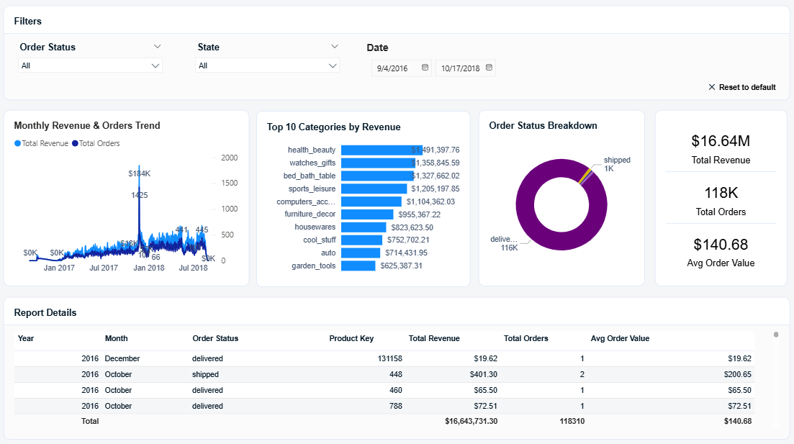
Figure 1 — Revenue & Order Overview Dashboard (Page 1)

6.2 Page 2 — Seller Performance
The seller performance page gives operations teams visibility into which sellers are driving revenue and where delivery reliability issues exist. Slicers for State, Category, Is Late, and Date range allow targeted analysis. KPI cards show 3K total sellers, a 4.03 average review score, and a 12.4 day average delivery time. The top 10 sellers bar chart shows the highest revenue sellers reaching approximately $258K each. The seller performance matrix scatter chart plots revenue against review score with bubble size representing order volume — enabling instant identification of high-revenue low-review sellers that represent business risk. The delivery days distribution column chart reveals a right-skewed distribution with most deliveries completed within 10–15 days but a long tail of late deliveries. The full seller scorecard table at the bottom provides a complete ranked view of all sellers with revenue, review score, late rate, and average delivery days.

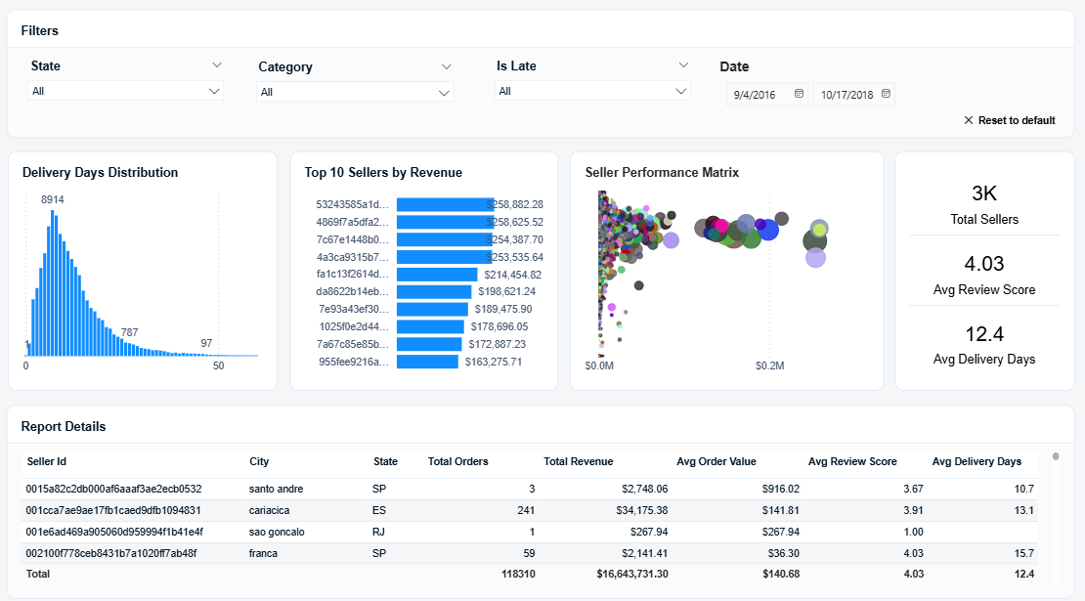
Figure 2 — Seller Performance Dashboard (Page 2)

6.3 Page 3 — Customer & Review Analytics
The third page focuses on customer behaviour and product quality signals. Slicers for Order Status, Category, and Payment Type allow segmented analysis. KPI cards show 99K total customers, $168.69 revenue per customer, and $172.58 average payment value. The review score distribution column chart reveals a strongly bimodal pattern — the majority of reviews are 5-star (66,264) with a secondary peak at 1-star (14,857) indicating polarised customer experiences. The payment type donut confirms credit card dominates at 87K transactions, followed by boleto at 23K. The top 15 categories by review score chart identifies cds_dvds_musicals (4.64) and fashion_childrens_clothes (4.50) as the highest-rated categories. The detailed customer state summary table and payment analysis table provide drill-down capability for regional and payment pattern analysis.

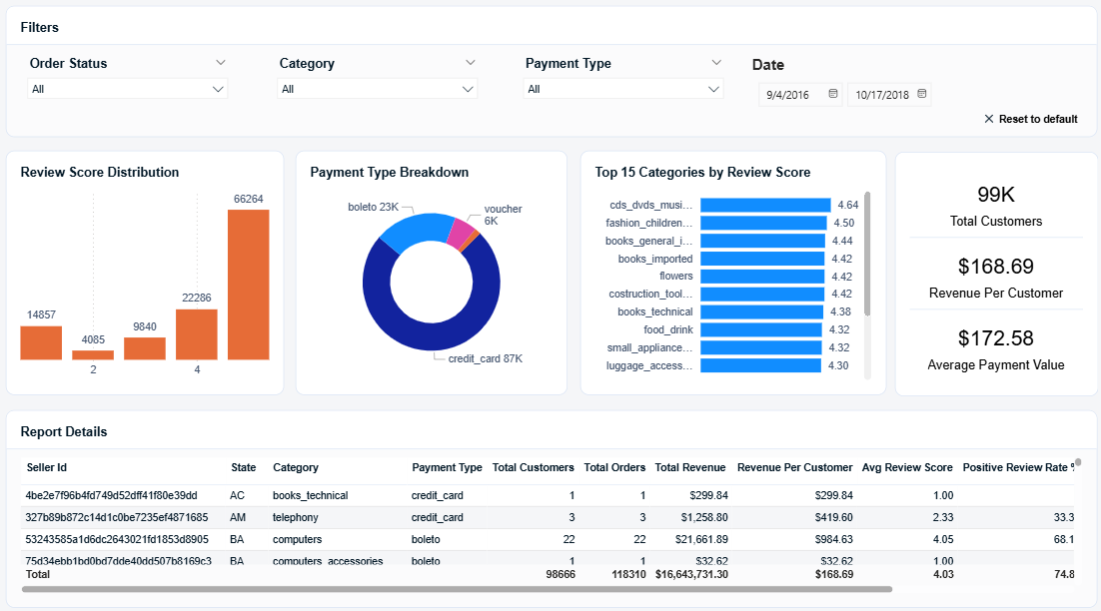
Figure 3 — Customer & Review Analytics Dashboard (Page 3)

7. Key Business Findings
Revenue & Orders
- Total marketplace revenue across 2016–2018 reached $16.64M across 118,310 order line items
- Health & beauty is the single largest revenue category at $1.49M, significantly ahead of watches & gifts at $1.36M
- Revenue grew substantially through 2017 and into early 2018 before stabilising, reflecting marketplace maturity
- Average order value of $140.68 suggests a mid-market positioning with room for higher-value category growth

Seller Performance
- The top 10 sellers by revenue each generated over $160K — the top two sellers are nearly identical at ~$258K suggesting strong competition at the top
- Average delivery time of 12.4 days across the marketplace indicates significant improvement opportunity — customer expectations in e-commerce are typically 3–5 days
- The seller performance scatter reveals a cluster of high-revenue sellers with below-average review scores — these represent the highest business risk to marketplace reputation
- Delivery days distribution shows a long right tail with some orders taking 50+ days — these extreme cases likely drive the 1-star review spike

Customer & Review Insights
- The bimodal review distribution (majority 5-star, secondary peak at 1-star) is classic marketplace behaviour — satisfied customers rarely review, while very unhappy customers always do
- Credit card dominates at 74% of transactions — boleto (Brazilian bank slip) accounts for 20%, reflecting Brazil's unique payment landscape where not all consumers have credit cards
- cds_dvds_musicals achieves the highest average review score at 4.64 — likely because product quality expectations are well-defined for media products
- 99K unique customers with $168.69 revenue per customer suggests most customers are single-purchase — a repeat purchase programme could significantly increase lifetime value

8. Technical Skills Demonstrated
Skill | Where Applied | Relevance
Azure Blob Storage (ADLS Gen2) | Raw file landing zone with hierarchical namespace | Standard in all Azure DE pipelines
Azure Data Factory | Parameterised pipelines, Copy Activities, Event Triggers | Core DE skill in every Azure job description
ADF Parameterised Datasets | Single dataset serving 9 files via dynamic parameters | Production pattern — not a beginner approach
Storage Event Trigger | Auto-fires pipeline on new file upload | Event-driven architecture — separates junior from senior DE
Azure Synapse Analytics | Dedicated SQL Pool DDL, DML, schema design | Enterprise warehouse — key differentiator on CV
HASH vs REPLICATE distribution | Fact table HASH, dimension tables REPLICATE | Synapse-specific — shows platform depth
Clustered Columnstore Index | All analytics tables | Synapse best practice for analytical workloads
Multi-table JOIN SQL | 7-table JOIN in single fact table INSERT | Complex SQL — demonstrates real data modelling
Star Schema Design | 6 dims + 1 fact with surrogate keys | Dimensional modelling — core BI/DE competency
Power BI DAX | 15+ measures for KPIs, rates, growth % | Essential for any BI Developer role
Power BI Data Modelling | 6 relationships, import mode, Synapse connector | Full-stack BI capability
Data Quality Handling | CSV parsing, column size fixes, NULL handling | Real-world DE problem solving

CloudBasket — Cloud Retail Analytics Platform

