Supply Chain
Intelligence Platform

Snowflake · Snowpark Python · Power BI · Medallion Architecture

$36.78M  Total Revenue | 66K  Total Orders | 57.28%  Late Delivery Rate | 10.83%  Avg Profit Margin | 21K  Unique Customers

I built this project to answer a question that matters to any supply chain business: why are more than half of all orders arriving late, and where exactly is the problem coming from? Starting from a raw 180,000-row CSV file, I built a full data platform on Snowflake — from ingestion and transformation through to a four-page Power BI dashboard with Snowpark-powered risk scoring.

This document walks through what I built, what the data revealed, and what I would tell a supply chain manager based on the findings.

1. What I Built
The project covers the full stack — from a raw CSV file to a live BI dashboard — using Snowflake as the primary platform throughout. Here is a summary of each layer and the tool used.

Layer | Technology · What it does
Raw ingestion | Snowflake COPY INTO · Loads 180,519 rows from an internal stage into a VARCHAR table. Every column kept as text at this stage — no type casting in the raw layer.
Transformation | Snowflake SQL · Casts types, parses dates, and derives three key columns: delivery_delay_days, is_late, and delay_severity.
Automation | Snowflake Streams + Tasks · A CDC stream on the raw table triggers a task that propagates new rows to the staging layer automatically every 60 minutes.
Star schema | Snowflake SQL · Five dimension tables and one 180k-row fact table built in the analytics layer. Five KPI views and one Materialized View on top.
Risk scoring | Snowpark Python · A composite risk model scores each shipping route 0–100 inside Snowflake. Data never leaves the warehouse.
Dashboard | Power BI Desktop · Four pages built on the star schema with ten DAX measures and slicers synced across pages.

Snowflake features used
I deliberately used Snowflake-native features wherever possible rather than external tools. This kept the architecture simple and demonstrated platform depth.

- Time Travel — demonstrated by deleting rows and restoring them using AT (TIMESTAMP) syntax. No backup restore needed.
- Streams — APPEND_ONLY stream on the raw table tracks every insert automatically. The equivalent of CDC without Kafka or Debezium.
- Tasks — fires only when the stream has data using SYSTEM$STREAM_HAS_DATA(). Replaces Airflow for this pipeline.
- Materialized View — pre-computes the shipping performance aggregation so dashboard queries stay fast.
- Snowpark Python — risk scoring runs inside the Snowflake engine. A Python UDF was also registered and called from SQL.
- Dynamic Table — replaced one materialized view with a Dynamic Table that self-manages its refresh within a one-hour target lag.
- RBAC — a BI_READER role was created with read-only access to the analytics database only. Dashboard credentials cannot touch the raw or staging layers.

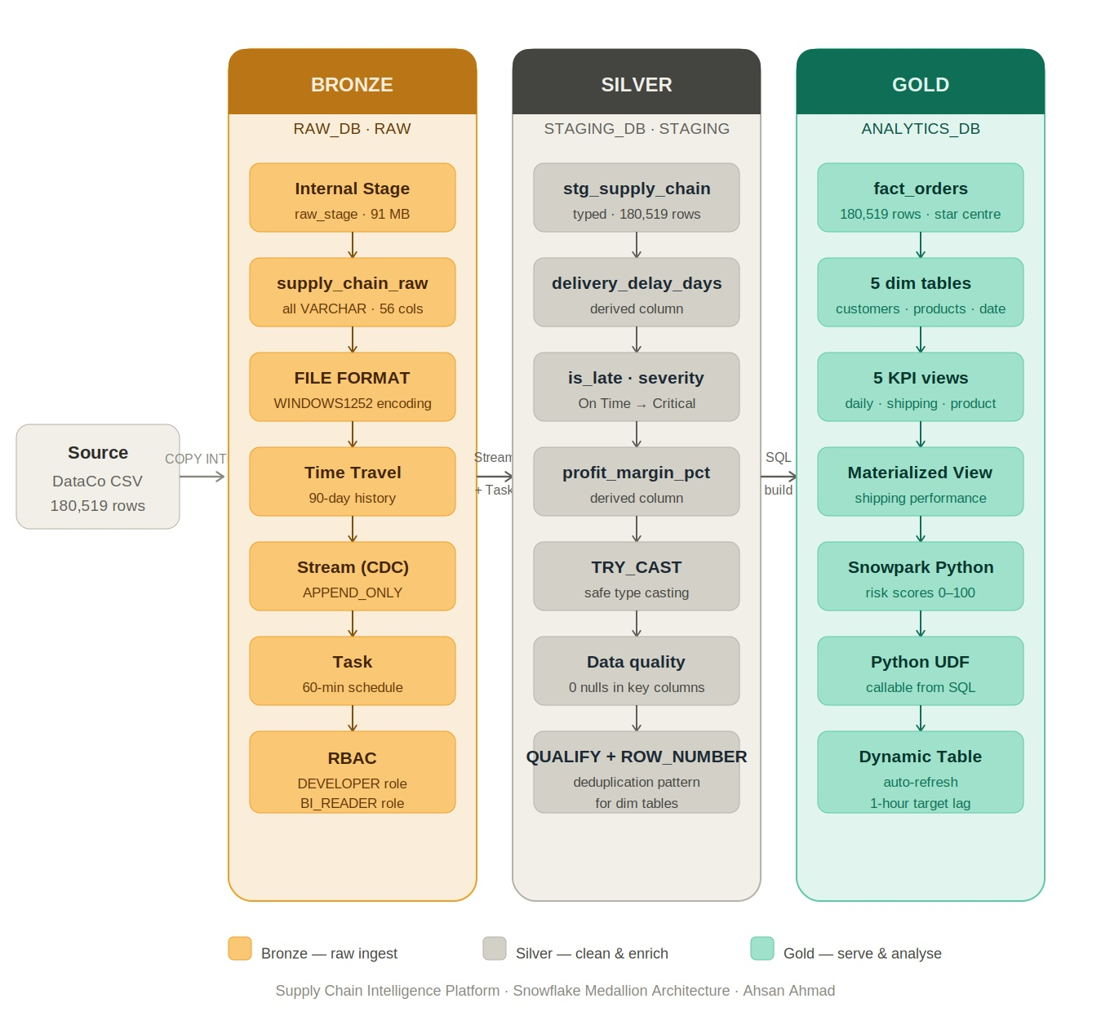
2. Data Model
The Power BI data model below shows the star schema I built. Fact Order sits at the centre with five surrounding dimension tables. The dim_shipping_mode table is a four-row bridge table I created specifically to resolve Many-to-Many relationship issues that appeared when I first connected the dashboard.
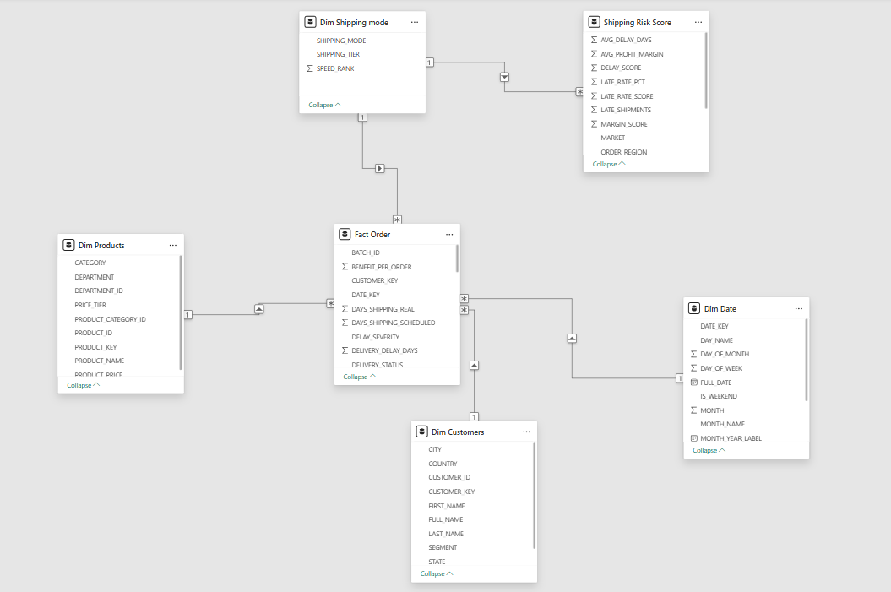

Figure 1 · Power BI data model — star schema with fact_orders at centre

Building this model was not straightforward. When I first tried to JOIN dim_shipping (which has 92 rows — one per shipping route) to the fact table, the query exploded from 180,000 rows to 123 million. That was a cartesian product caused by non-unique join keys. I solved it by keeping the shipping columns directly in the fact table and creating a separate four-row dim_shipping_mode table purely to serve as a bridge for the Power BI relationships.

3. Dashboard — Shipment Overview
The first page gives a high-level view of the business. The headline numbers are on the right — $36.78M in revenue, 66K orders, and a 57.28% late delivery rate. That late rate number is the first thing that jumps out, and the rest of the dashboard is built around understanding it.

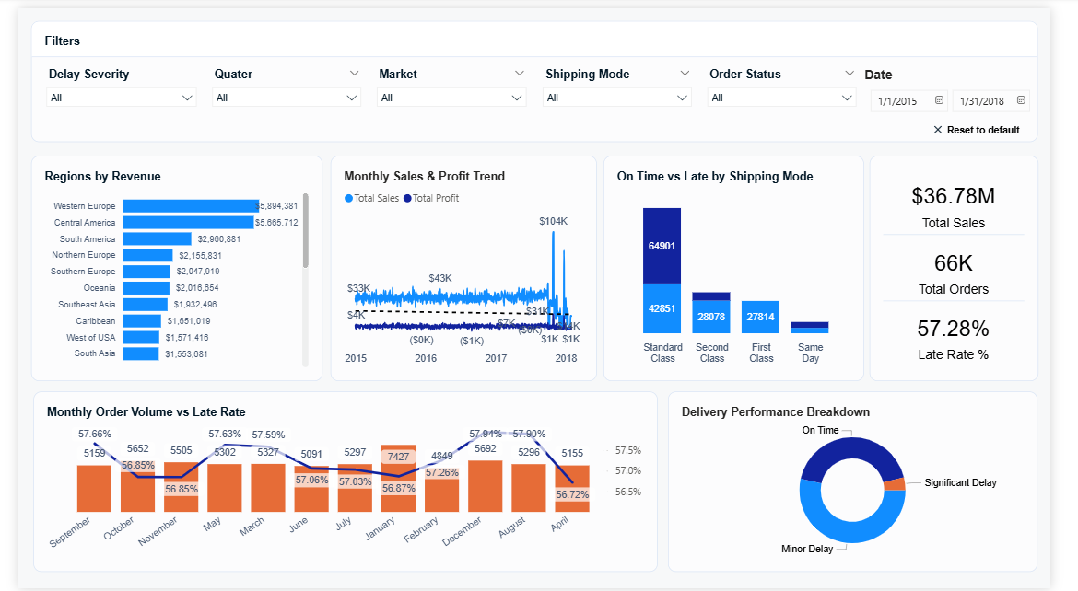
Figure 2 · Page 1 — Shipment Overview

A few things stand out on this page. Western Europe is the top revenue region at $5.8M, followed by Central America at $5.6M. The On Time vs Late by Shipping Mode chart shows that Standard Class carries the most volume by far (64,901 orders) but the ratio of late to on-time varies significantly by mode. The monthly order volume vs late rate chart at the bottom shows the late rate has been persistently stuck between 56% and 58% for years — this is not a seasonal dip. It is a structural problem.

4. Dashboard — Shipping Risk & Delay
This page is the most technically distinctive part of the project. The risk scorecard table at the bottom is populated by Snowpark Python running inside Snowflake — a composite risk score (0–100) calculated from three weighted factors: late rate (50%), average delay days (30%), and profit margin impact (20%). The average risk score across all routes is 56.10, which sits firmly in the High Risk band.
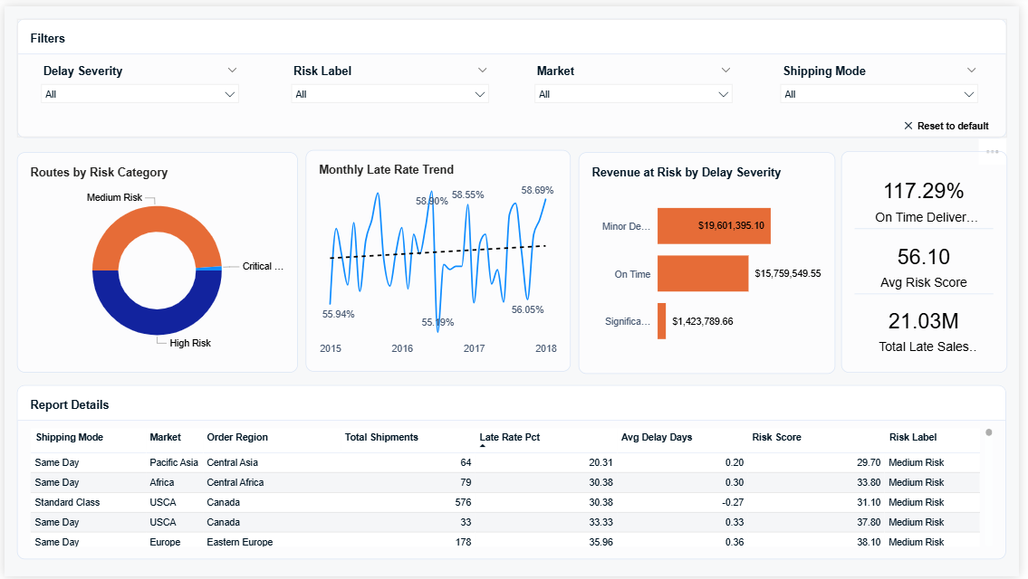

Figure 3 · Page 2 — Shipping Risk & Delay Analysis

The Revenue at Risk by Delay Severity chart tells an important story. Minor Delay orders — shipments that are only one to three days late — account for $19.6M in revenue. That is more than the On Time category at $15.8M. The business is losing more revenue to small delays than it is delivering on time. That is where the intervention needs to happen — not at the critical delay end of the spectrum, but in the minor delay bucket where the volume is highest.

The donut chart shows that the route portfolio has no Low Risk routes at all. Every shipping mode and market combination is sitting at Medium Risk or above.

5. Dashboard — Product Performance
Page 3 focuses on what is being sold and how profitably. The top product by revenue is Field & Stream at $6.93M — roughly eight times the revenue of the tenth-ranked product. The category scorecard at the bottom tells an interesting story about margins.

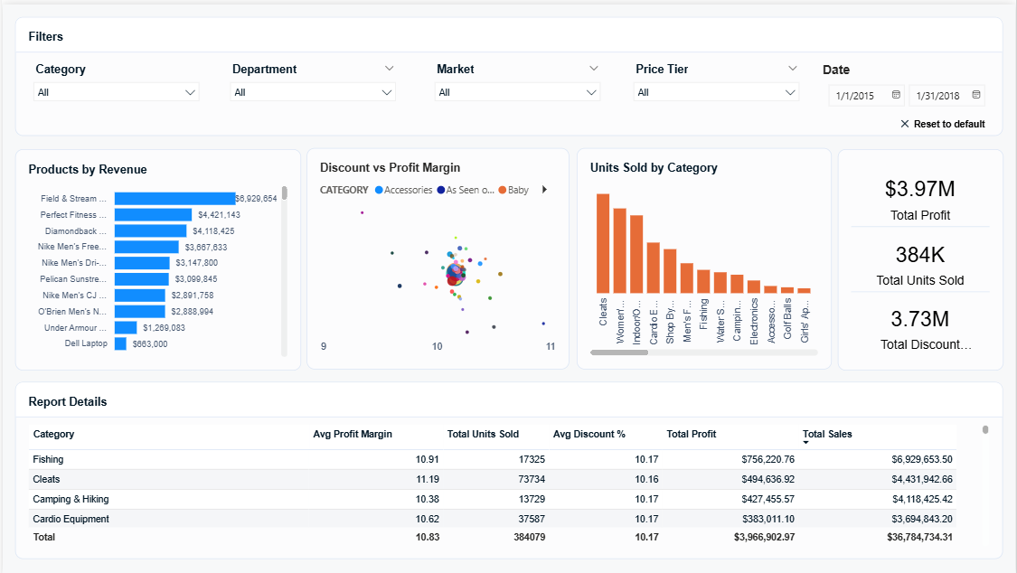
Figure 4 · Page 3 — Product Performance

Profit margins are almost identical across every category — Fishing 10.91%, Cleats 11.19%, Camping & Hiking 10.38%, Cardio Equipment 10.62%. That level of uniformity across different product types suggests pricing is formulaic rather than driven by demand or margin opportunity. A business with this kind of data could run a category-by-category pricing review and likely find places where margins could be improved without affecting volume.

The discount vs profit margin scatter chart is also worth noting — it shows that higher discounts are not producing meaningfully higher margins. The discount strategy does not appear to be translating into profitability gains.

6. Dashboard — Customer Analytics
The fourth page breaks down performance by customer segment and geography. Consumer is the dominant segment at 51.89% of orders, followed by Corporate at 30.2% and Home Office at 17.91%. The monthly sales by segment chart shows how each group tracks over the 2015 to 2018 period.
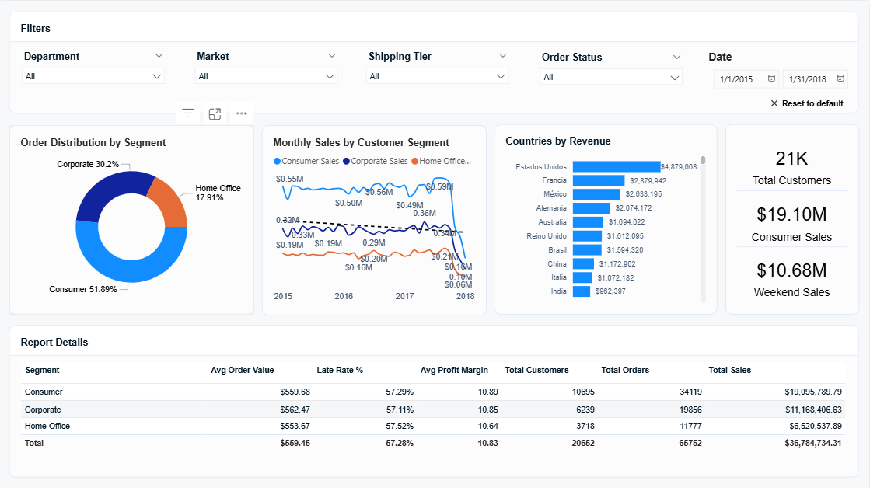

Figure 5 · Page 4 — Customer Analytics

Something that stood out in the customer data: the late delivery rate is effectively identical across all three segments — Consumer 57.29%, Corporate 57.11%, Home Office 57.52%. The delivery problem is not concentrated in one type of customer. It is happening everywhere, which confirms it is a supply chain issue rather than a service level issue for a specific group.

Weekend sales account for $10.68M — approximately 29% of total revenue. That is higher than you would expect from two out of seven days. It suggests weekend demand is not being fully matched by shipping and warehouse capacity. The Countries by Revenue chart also shows that the top country names are appearing in local language (Estados Unidos, Francia, México) which is a data quality issue from the source — something I would address with a country code lookup in the staging layer in a future iteration.

7. Proof of Work — Snowflake Query History
The screenshot below shows the Snowflake Query History for my account during the build. Every query that ran against the database — creating tables, running transformations, querying KPI views, building the analytics layer — is logged here. All queries show Status: Success. This is not a tutorial project run in a shared environment. Every object was built from scratch in my own Snowflake account.
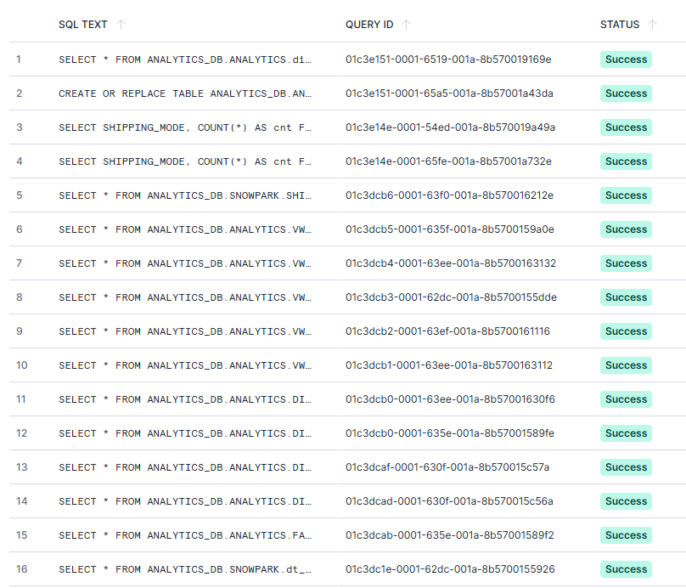

Figure 6 · Snowflake Query History — all queries showing Success

You can see queries against ANALYTICS_DB.ANALYTICS.DIM tables (dimension table creation), ANALYTICS_DB.SNOWPARK.SHIPPING (the Snowpark risk score table), and various SELECT queries against the KPI views. The warehouse column shows DEV_WH throughout — the X-Small development warehouse I created for cost-efficient querying. Total credit cost for the entire project was under $10 of the $400 free trial credit.

8. What Went Wrong and How I Fixed It
This section matters more to me than the technical highlights. Any project that goes completely smoothly was either very simple or the person is not being honest. Here are the three most significant problems I ran into and what I learned from each.

The encoding problem
The first COPY INTO load failed on 66,332 rows out of 180,519. The error said “Invalid UTF8 detected in string” pointing to the ORDER_COUNTRY column. The dataset has international city and country names with accented characters — é, ñ, ü and so on — which the default UTF-8 file format could not handle. The fix was adding ENCODING = ‘WINDOWS1252’ to the file format definition. After that, all 180,519 rows loaded with zero errors. The lesson: always specify encoding explicitly for any dataset with international data. Never assume UTF-8.

The 123 million row query
When I tried to build the fact_orders table with a LEFT JOIN to dim_shipping, the query ran for over nine minutes and produced 123 million rows instead of 180,519. I cancelled it. The cause was that dim_shipping has 92 rows — one per unique combination of shipping mode, market, and region. When you join a 180k-row table to a 92-row table without a unique key on the right side, you get a cartesian product. The solution was to remove the JOIN entirely and keep the shipping columns directly in fact_orders. This is actually the better design anyway — the fact table should be self-contained on its measures and directly joined dimensions.

The Power BI Many-to-Many relationship
When I loaded the data into Power BI and tried to create a relationship between fact_orders and shipping_risk_scores on SHIPPING_MODE, Power BI forced it to Many-to-Many. Both tables had 23 duplicate rows per shipping mode. Power BI cannot enforce Many-to-One on non-unique columns, and Many-to-Many relationships cause incorrect aggregations in DAX. The fix was creating dim_shipping_mode — a four-row table with exactly one row per shipping mode (Same Day, First Class, Second Class, Standard Class). This became the bridge table, and both fact_orders and shipping_risk_scores connect to it as Many-to-One. That resolved all the relationship issues and the slicers started filtering correctly across all visuals.

9. What I Would Tell the Business
If I were presenting these findings to a supply chain manager, here is what I would say.

Fix First Class shipping first
First Class shipping has a 100% late rate. Not 80%. Not 90%. Every single First Class shipment in the dataset arrived late. That is 27,814 orders. The fact that this mode is presumably charging a premium for faster delivery while delivering zero on-time shipments is a commercial and reputational risk. The first question I would ask the carrier is whether this is a data recording issue or a genuine delivery failure. If it is genuine, the SLA needs to be renegotiated or the carrier needs to be replaced.

Minor delays are the biggest problem, not critical ones
Most supply chain teams focus energy on their most severe failures. The data here suggests the bigger opportunity is in the minor delay bucket — shipments that are one to three days late. These account for $19.6M in revenue, which is more than the on-time revenue of $15.8M. A 10% reduction in minor delays would recover roughly $2M in on-time fulfilment. The levers for this are likely scheduling and handoff timing rather than major structural changes.

Weekend operations need attention
$10.68M in weekend sales is a meaningful concentration of revenue in a two-day window. If warehouse staffing and shipping capacity are not matched to this demand pattern, it will show up as delays on Monday and Tuesday. I would cross-reference the order dates and shipping dates to confirm whether weekend orders have higher delay rates than weekday orders. If they do, the operational fix is straightforward.

