

Hanseatic Global Terminals
TRAINING IN THE PROBLEM-SOLVING TOOL

BEST
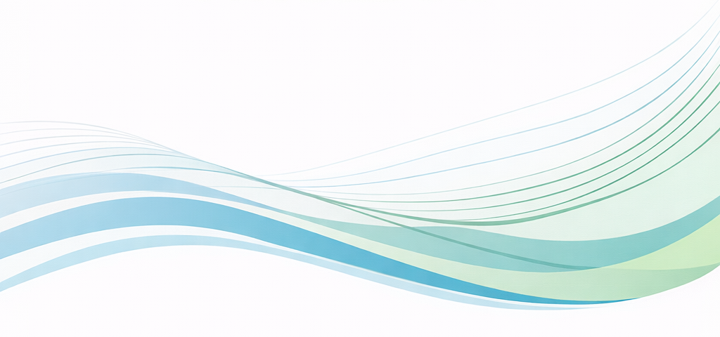

PORT™
A Problem Solving tool
BEST - ACADEMIA DE LA EXCELENCIA | Rev. 00 | 21 de enero 2026
TABLE OF CONTENTS

OBJECTIVE
Provide institutional guidelines for the proper facilitation of training in the PORT™ problem-solving tool, to be implemented consistently across all Hanseatic Global Terminals terminals. The guidelines define responsibilities, methodology, activities, required materials, and execution standards to ensure the quality and consistency of problem-solving competency development.
SCOPE
This manual is intended for facilitators, area leaders, supervisors, and personnel appointed to implement and roll out PORT™, regardless of the type of operation, terminal size, or maturity level within the BEST excellence model.
TRAINING DURATION
The training is designed to be delivered over a six-week period, with each session lasting approximately 3 to 4 hours to ensure participants remain fully engaged.
TRAINING MATERIALS
The training materials are available at the following path: Operational Excellence – Documents – SPA – All Documents. This folder contains the six-week PowerPoint presentation, the facilitator’s manual, and activity templates.Operational Excellence - Documentos - SPA - Todos los documentos
TIPS FOR THE FACILITATOR
Note: The information below highlights key points to consider for selected presentation slides; it does not cover every slide.
Week 1: Introduction to the System
This is where participants develop an awareness of the importance of building skills at every level of the organization, the Excellence Academy, and how PORT™ relates to Hanseatic Global Terminals’ objectives.

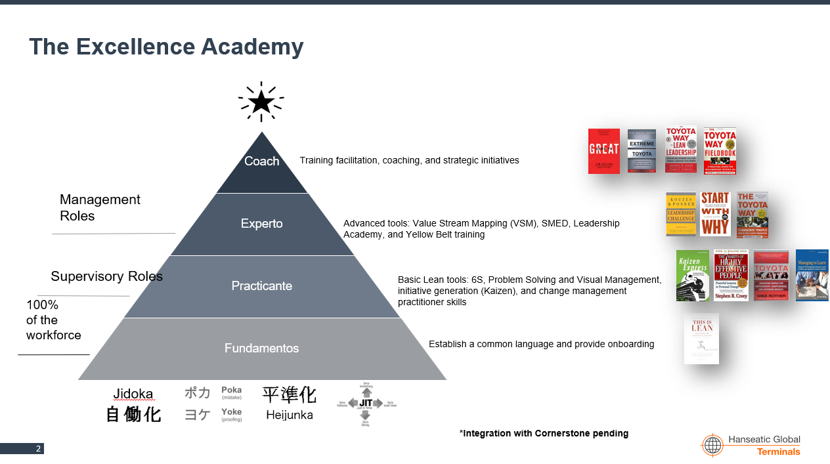
Some key definitions are introduced for new team members who are unfamiliar with the BEST program. Since the target audience is frontline personnel, it is important to explain the concepts with examples to ensure understanding.

Note: The presentation includes animations that make it visually engaging and dynamic. The facilitator should become familiar with them to maintain control of the narrative as the presentation progresses.

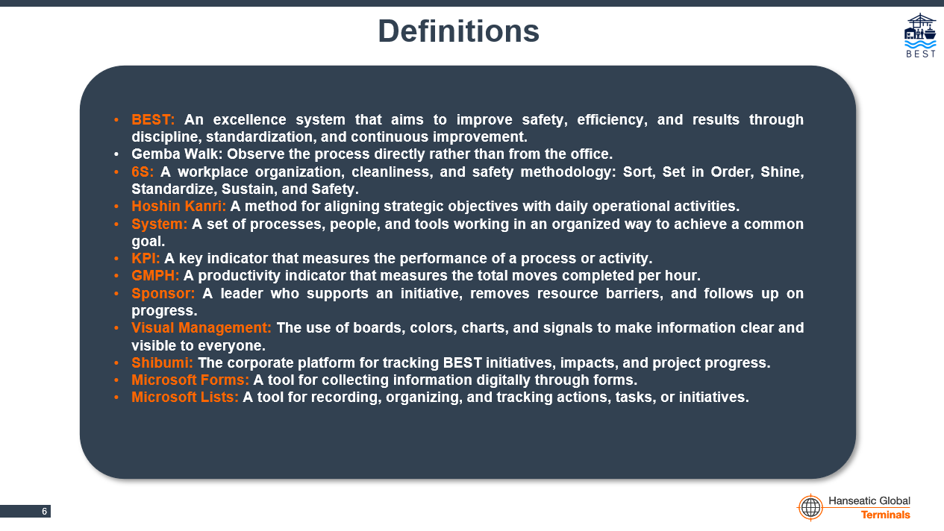
On the “Problem Solving as a System” slide, explain the concept using a clear example that helps the audience identify and understand the elements. The facilitator may choose any system they consider suitable for the audience.

For Activity 1 and subsequent activities, refer to the “Activity Instructions” section later in this document.

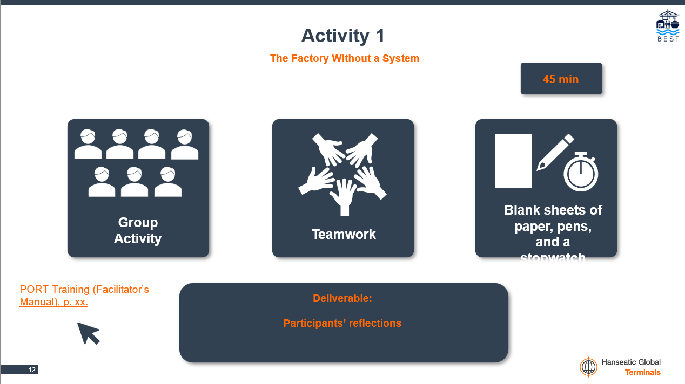
On the “What Is Problem Solving?” slide, provide examples of problems and their causes so the audience can clearly distinguish between them.
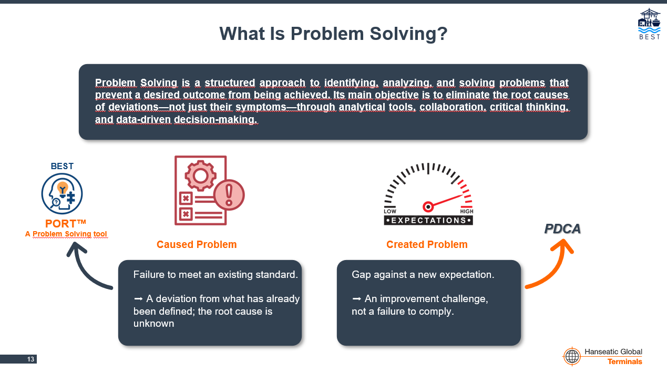
Explaining the different roles in the Problem Solving system is essential to help team members understand the importance of their participation and influence.
Some slides have a label in the upper-left corner indicating that the content is intended specifically for leaders.

Providing examples of how Problem Solving connects with the other systems within the BEST program will help the audience put all the pieces of the puzzle together.
The video on how to conduct a Gemba walk is in English, so Spanish subtitles will need to be enabled.


Week 2: Define the Problem Precisely
Each PORT™ phase begins with a well-known quote and related bullet points.
When explaining the tree diagram, include an example relevant to the group’s work: performance in a container-loading operation. The “Problem” section uses a shortened problem statement to save space; the full statement appears later in the presentation.

The “Articulate the Problem Statement” slide explains the same example used in the tree diagram, but in greater detail and including the six required elements, highlighted in orange.
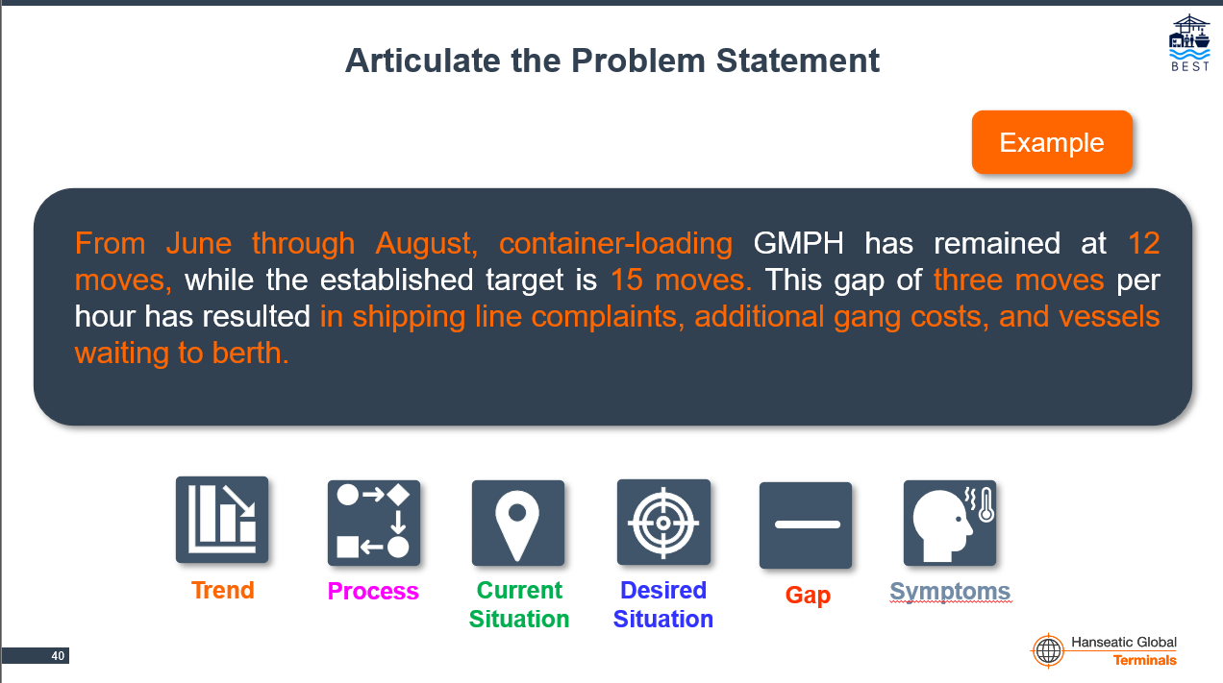

At the end of each PORT™ stage, the presentation covers common mistakes and tips for leaders.
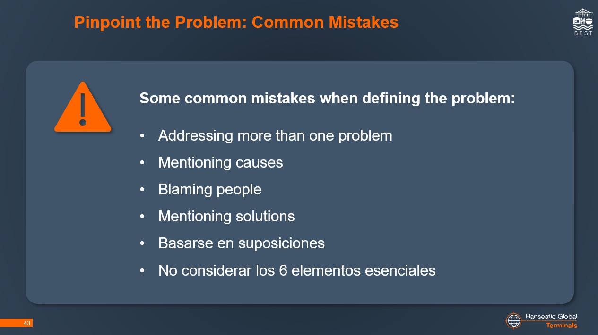

Week 3: Observe and Analyze, Part 1
When identifying possible causes, introduce the cause-and-effect diagram and explain how it relates to the tree diagram.

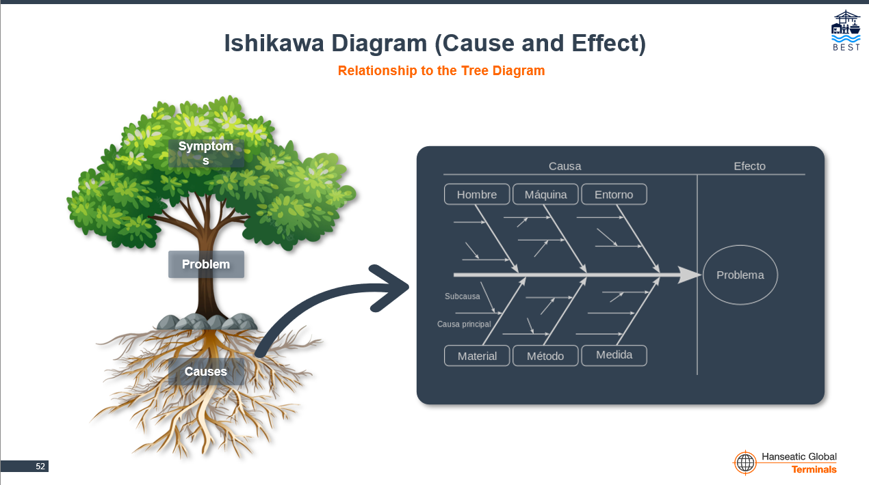
Emphasize that the cause-and-effect diagram exercise should first be completed individually to encourage participation and avoid bias.
The “Next Steps” slide for the cause-and-effect diagram explains its connection to the next tool: the multivoting matrix.
Week 4: Observe and Analyze, Part 2
When introducing the 5 Whys, highlight how this tool connects to the multivoting matrix.

Branching paths are common in 5 Whys analyses. They often point to the same root cause, but this is not always the case.
On the slide covering the eight countermeasure criteria, explain that a countermeasure may fail to meet more than one criterion without necessarily being unfeasible. However, it must be carefully assessed, and its implementation justified.
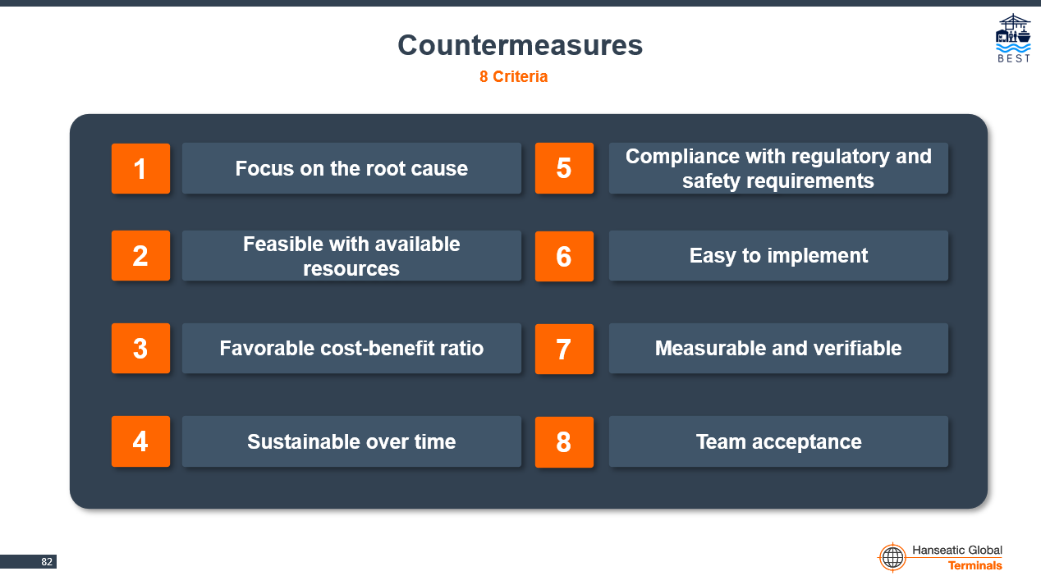
Week 5: Solve Through Action
The action plan is validated using two measures of effectiveness: whether most of the criteria are met and whether the defined KPIs are achieved.

When presenting the steps for piloting countermeasures, a transition is shown in Step 1 to explain the importance of the communication plan.
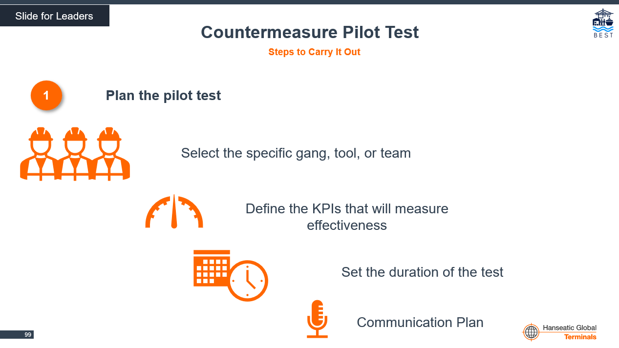

Week 6: Follow-up and Sustainability
Shibumi becomes the global platform for recording sessions and evaluating countermeasures. For this training, leaders are expected to already know how to use the platform, so this session focuses on how the PORT™ phases relate to L0–L5.

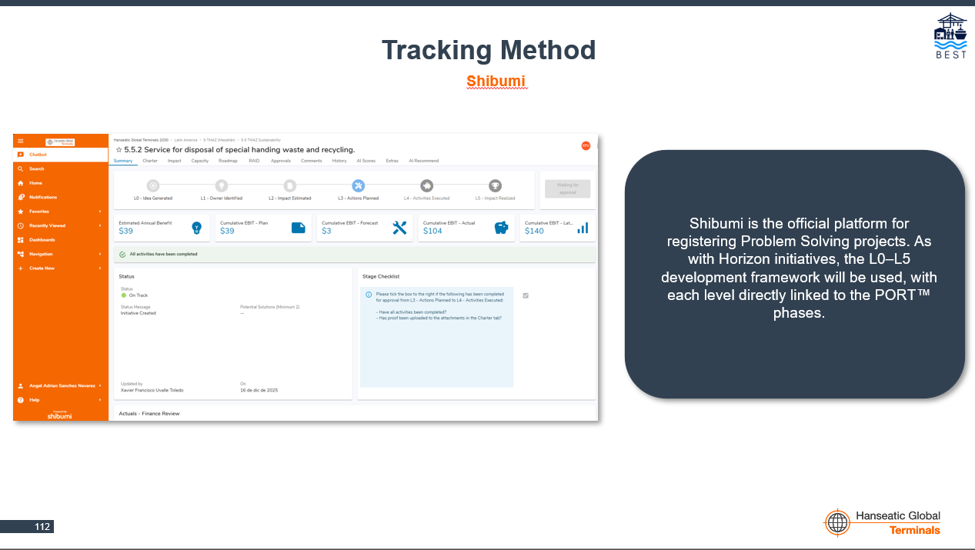

ACTIVITY INSTRUCTIONS
Activity 1: The Factory Without a System
Materials: Blank sheets of paper, pencils, stopwatch, cardboard box or container
Choose one participant to act as the “customer.” Then divide the group into three teams, each with a role in a “fictional company that manufactures paper airplanes”:
- Production team: Builds the airplanes.
- Quality team: Checks that the airplanes meet specifications.
- Logistics team: Delivers the finished airplanes.
Give them a simple instruction: “You have 5 minutes to make and deliver as many paper airplanes as possible.” Do not provide any processes, rules, or metrics.
Each team is expected to work in its own way, creating a sense of chaos and frustration.
After five minutes, review the results of the activity. Then introduce a simple system:
Defined workflow: Production → Quality → Logistics
Standards: Airplane size, straight and sustained flight, and an identification symbol (freely chosen)
Clear roles:
- Production builds according to the standards.
- Quality verifies the standards using a checklist.
- Logistics delivers the airplanes and records them in the box or container.
Metrics:
- Productivity
- Defective products
- Deliveries completed
Compare the results before and after by asking the following reflection questions:
- What changed when the system was implemented?
- Were errors reduced?
- Did communication improve?
- Was production easier?
- How did you feel when there was no system?

Activity 2: Hunting for Problems
Materials: Genba formFormulario Genba
In pairs, conduct a Gemba walk in a process and/or area of your choice to identify issues related to areas such as safety, quality, the environment, and resource waste. At the next session, share your observations with the group and answer these basic questions:
- What process did you observe?
- What is the ideal condition?
- What is the current situation?
- What did you learn from the people performing the activity?
At the end, each team must select at least one identified problem to work on during the next phases of PORT™.
Activity 3: Symptoms or Causes
Materials: Symptom/cause cards, whiteboard or flip-chart paper, markers, tape
Divide the group into three equal teams and randomly distribute six cards to each team. On a whiteboard or flip-chart paper, create three sections (one per team). In each section, write the headings “Symptoms” and “Causes.” Team members place their cards under the heading they think is appropriate.
Each card is related to another; that is, all symptoms are connected to causes.
Finally, review the results as a group and make any necessary corrections.
Activity 4: Before Solving, Learn to Define…
Materials: Problem definition template.Plantilla para definir un problema.
In pairs (the same pairs from Activity 2), formulate the problem statement using the six elements:
- Trend
- Process
- Current situation
- Desired situation
- Gap
- Symptoms
Finally, each team presents its problem statement to the group to verify that it meets all the criteria.
Activity 5: Problem-Solving Team
Materials: Team definition template.Plantilla definición de equipos.
Working in pairs, propose the members who should be part of their Problem Solving team. The goal is to learn how to identify the right people and use their knowledge to effectively find the root cause of problems.
At the next session, present the proposed team members and answer the following questions:
- Who are the team members?
- What roles do they have in the organization?
- Why do you think these are the right people to participate in solving the problem?

Activity 6: No Idea Is a Bad Idea
Materials: Cause-and-effect diagram template, whiteboard, markersPlantilla de diagrama Causa y efecto, pizarra, plumones
As a group, brainstorm possible causes of a hypothetical problem chosen by the facilitator or a group member.
First, each participant completes the exercise individually using the template provided by the facilitator. This helps avoid bias and ensures everyone participates. After the individual exercise, the facilitator draws a fishbone diagram on the whiteboard and consolidates everyone’s ideas.
Group related ideas and remove duplicates. Finally, select those considered to have a direct impact on the problem.
Activity 7: Moving Forward in the Search for the Root Cause
Materials: Cause-and-effect diagram template, multivoting matrix template.Plantilla de diagrama Causa y efecto, Plantilla de Matriz multivotación.
In pairs, work on the problem defined in Activity 4 using the cause-and-effect diagram and multivoting matrix templates to put what you learned in the session into practice.
The facilitator will address the teams’ questions during the next session.

Activity 8: Uncovering the Truth
Materials: 5 Whys template, pencilPlantilla 5 porqués,
In pairs, perform a 5 Whys analysis on the causes selected using the multivoting matrix, in order to practice the tool.
At the end, hold a group reflection by answering the following questions:
- Do you think finding the root cause is difficult?
- What were the main challenges during the analysis?
- What advice would you give a newcomer to help them conduct a good analysis?

Activity 9: From Cause to Solution
Materials: Countermeasure definition template.Plantilla de definición de contramedidas.
In pairs, prepare a proposal for countermeasures addressing the root causes identified in Activity 8. The countermeasures must meet the following criteria:
- Focus on the root cause
- Feasible with available resources
- Favorable cost-benefit ratio
- Sustainable over time
- Compliance with regulatory and safety requirements
- Easy to implement
- Measurable and verifiable
- Team acceptance
Teams will present their proposed countermeasures by answering these basic questions:
- What countermeasures are being proposed?
- Why do you think these countermeasures will eliminate the root cause of the problem?

Activity 10: Plan, Test, Succeed
Materials: Countermeasure definition template.Plantilla de definición de contramedidas.
In pairs, prepare a proposed implementation plan for piloting the countermeasures, along with a communication plan. Each countermeasure must have its own separate plan.
The facilitator will address the teams’ questions during the next session.
Activity 11: What Is Visible Is Sustained
Materials: Poster board, pencil, markers
Each team selects one countermeasure from its Problem Solving project. The facilitator provides poster board, a pencil, and a marker so the team can develop a visual management proposal to help sustain the countermeasure.
Finally, the teams hand their poster to the facilitator.

