Documentation:

My website is a personal website used to explain who I am, some of my interests, as well as my goals for my career alongside a resume.

**Home Page:** used to introduce people to me and give a bit of background on myself including my schooling, some of my previous job experience, and one of my many interests.

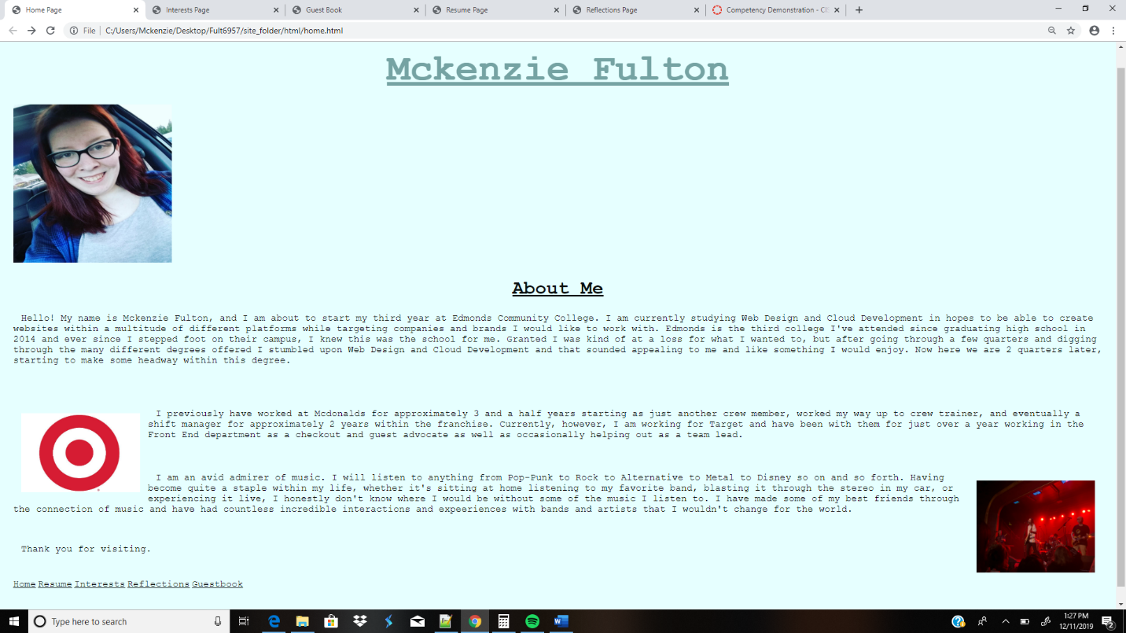

**Interests Page:** used to describe what I enjoy (i.e. concerts, Harry Potter, Disney, and photography). This page also includes hyperlinks to the Washington Concerts page for concerts, the Wizarding World home page for Harry Potter, the Disneyland home page for Disney and a photography site giving basics on photography.

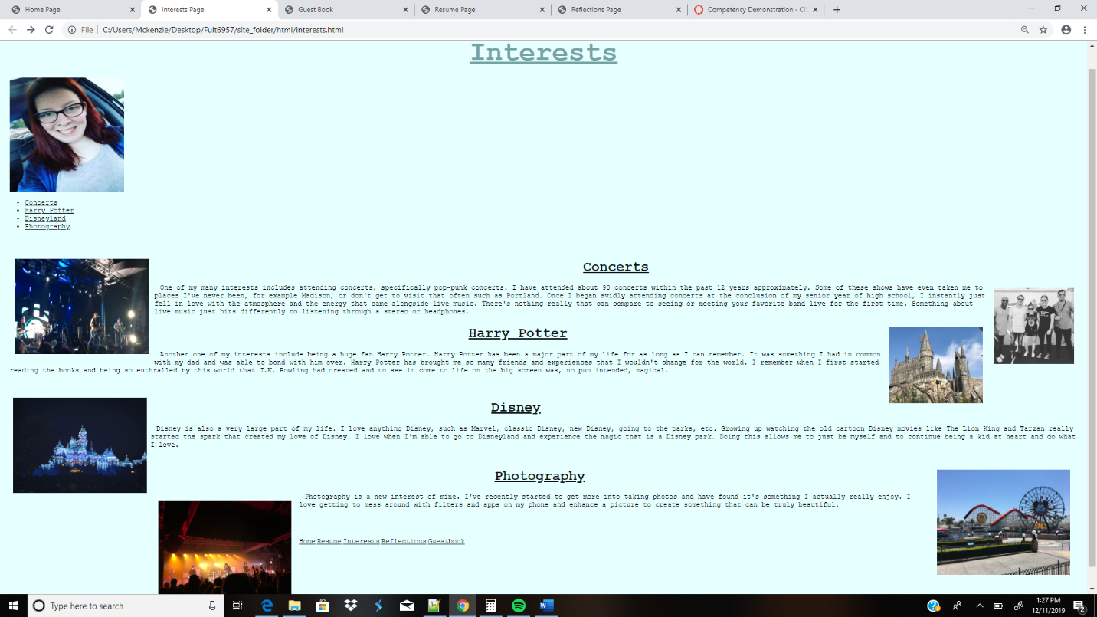

**Guestbook Page:** used for people who visit my page to say how they came to my page, their experience within Web Design and coding, as well as any comments they may have.

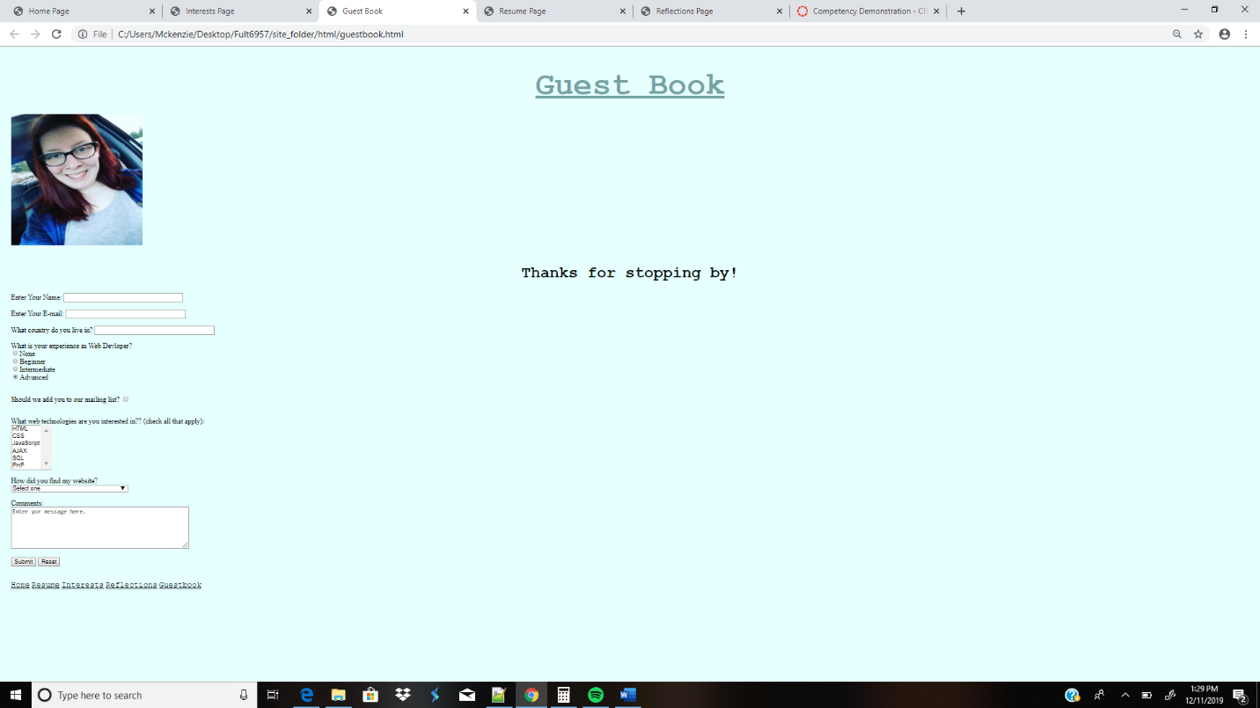

**Resume Page:** used to explain my current skills and previous job experience to potential employers

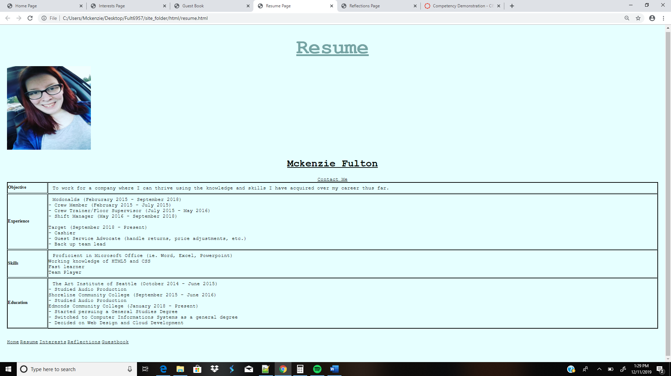

**Reflections Page:** used to explain my final thoughts on CIS241.

