The Impact of Employee Engagement

Meggie Ayoub

Sacred Heart University

Abstract

Strong employee engagement is a key factor in the success of a company. Engaged employees will work harder to ensure the company’s achievement. Turnover rates are lessened and workers enjoy a greater satisfaction rate, thus increasing a company’s overall profit. Traditionally, companies who employ union workers have a lower employee engagement rate. It is the challenge of a company to improve union employee relationships. In a Gallup poll, it was found that when employees are satisfied in 12 key areas, their reliance on unions will lessen. Unions, however, are a fact of life that companies must deal with. One company that has developed successful strategies with three different unions is Pacific Gas and Electric Co. (PG&E). By studying their tactics, other companies will realize that engaging union workers is not only possible, but desired to increase a company’s overall success. Employee engagement can be defined as “the level of an employee's commitment and connection to an organization” (Society for Human Resource Management, 2017). Employee engagement directly effects employees. Organizations that utilize engagement initiatives are more likely to have employees who are motivated, in turn, creating a higher retention rate, which will ultimately benefit the company’s bottom line. Through research, the impact that employee engagement has on labor relations shows that only 39% of union employees are engaged compared to 45% of non-union employees (Tyler, 2009). Throughout history, labor unions have responded to employee engagement initiatives. The impact that employee engagement has on an organizations, employees, and labor unions plays a crucial role in how motivated and engaged employees will be, leading to the ultimate success or failure of the organization.

The impact that employee engagement has on an organization’s employees is essential because it can be a predictor of employee productivity and performance. Employees who are more engaged are “more likely to behave in positive and cooperative ways,” which will affect their work effort (Rees, Alfes, & Gatenby, 2013, p. 2780-2781). Engaged employees will often “go the extra mile” for their organization because they will feel as if they are contributing to the company and they view their work as “more meaningful and fulfilling” (Rees, Alfes, & Gatenby, 2013, p. 2781). Organizations with engaged employees have a lower turnover rate because employees who feel as if they are adding to their organization and enjoying their work will be less likely to leave their company. Having a low turnover rate, through employee engagement, will increase the bottom line, substantially contributing to the overall profitably of the organization.

Statistics show that only 38% of union employees are engaged and fall in the 39th percentile in Gallup’s global database (Tyler, 2009). Employee engagement initiatives in unions are critical to the success of unionized organizations. Managers of organizations need to take a more “active role in engaging its unionized workers” (Crabtree, 2006). Since unionized workers are more likely to be disengaged, there are initiatives that managers can take to ensure a more engaged workforce. Managers can “make the engagement-building process open, inclusive, and non-threatening” (Crabtree, 2006). Employee engagement surveys that are “secretive” and “threatening,” are more likely to create biased responses from employees and unions will encourage employees not to participate (Crabtree, 2006). By creating constructive employee engagement surveys, an organization can create a non-threating environment. Managers can also “involve union officials in the survey and resulting change processes” (Crabtree, 2006). By working with union officials, an organization places emphasis on the fact that the company is not undermining the union (Crabtree, 2006). Since union officials may not be too keen on teaming up with a company, there must a connecting point, which is the link between employee engagement and workplace safety – creating trust among the company, employees and unions (Crabtree, 2006). Companies can also use action planning to create new ways to communicate with employees (Crabtree, 2006). With action planning, employees can meet with leaders of the organization, creating avenues in which their voices will be heard. Lastly, a way for organizations to improve employee engagement initiatives in unions is to “recognize that unions can help the company” and “increase employee engagement” (Crabtree, 2006). Labor unions can pose a threat to companies, but they can also benefit the company with improving employee engagement. When a company comes together with union management, it can create opportunities that will be beneficial to all employees by focusing on engagement. By working together, managers can create a more engaged workforce of unionized employees.

Interestingly, it has been found by the Gallup poll that if “12 Elements of Great Managing” are met, workers are less dependent on unions for piece of mind.

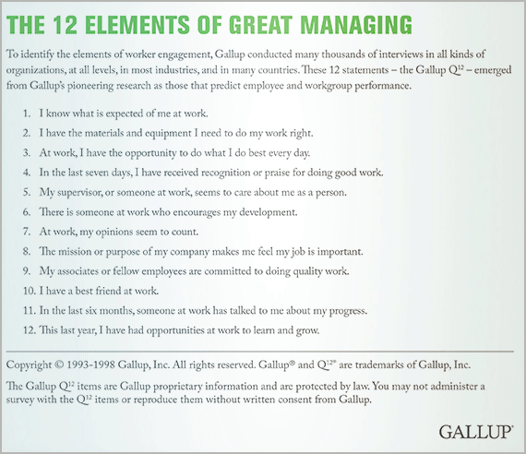

This Gallup poll shows that regardless of unionization efforts, employee engagement increases when these 12 elements are met. This is important information for management to realize, as providing these 12 elements to their employees may lower unionization rates.

One company, Pacific Gas and Electric (PG&E) has successfully reached collective bargaining agreements with three different labor unions, International Brotherhood of Electrical Workers (IBEW) Local 1245, the Engineers and Scientists of California International Federation of Professional and Technical Engineers (ESC/IFPTE) Local 20 and the Service Employees International Union (SEIU) United Service Workers West (PG&E, 2017). PG&E works closely with their unions on employee engagement initiatives, including: enhancing technical training programs, fostering health and wellness, building career pathways and implementing numerous initiatives to promote a stronger culture of safety (PG&E, 2017). Not only does PG&E work closely with their unions, but they encourage employees to take initiatives on engaging other employees. At PG&E, it is seen that that when a company is able to collaborate and work with unions, they can create a more engaged workplace for their employees.

Employee engagement has a direct impact on an organization’s employees, including unionized workers. Employee engagement in unions can be difficult, but when utilized in the correct ways, organizations can create a more engaged workplace. PG&E is a strong example of how a company can successfully work with unions in order to create a safe, engaged workforce. Companies should work to improve employee engagement by instituting elements that will make their workers happy and engaged in the workplace. In creating strong employee engagement initiatives, both in dealing with union and non-union employees, the bottom line of a company will benefit immensely.

References

Crabtree, S. (2006). Can Mangers Engage Union Employees?. *Gallup Business Journal.* [http://news.gallup.com/businessjournal/22735/can-managers-engage-union- employees.aspx](http://news.gallup.com/businessjournal/22735/can-managers-engage-union-employees.aspx)

PG&E. (2017). Corporate Responsibility and Sustainability Report 2016. Retrieved November 05, 2017, from [http://www.pgecorp.com/corp_responsibility/reports/2016/em01_employee_engagem ent.jsp](http://www.pgecorp.com/corp_responsibility/reports/2016/em01_employee_engagem%09ent.jsp)

Rees, C., Alfes, K., & Gatenby, M. (2013). Employee voice and engagement: Connections and consequences. *The International Journal of Human Resource Management,* *24*(14), 2780-2798. Retrieved October 26, 2017.

Society for Human Resource Management. (2017, March 17). *Developing and Sustaining* *Employee Engagemen*t. Retrieved October 26, 2017, from https://www.shrm.org/resourcesandtools/tools-and samples/toolkits/pages/sustainingemployeeengagement.aspx

Tyler, J. (2009). Employee Engagement and Labor Relations. *Gallup Management Journal Online*, 1.