**Department Project**

**Vision**

“Department project” is web-application which can provide management groups of employees in company.

Application should provide:

* Login/Logout into system
* View user own profile
* View other users profile
* Send messages to other users
* View user’s own departments
* View user’s own total paycheck
* View other users departments
* View and filter all users list
* View and filter all departments list

Admin features:

* Add new users
* Update users data
* Delete Users
* Add new departments
* Update departments info
* Delete departments
* Change department members
* Customize employee roles in departments

**Login page**

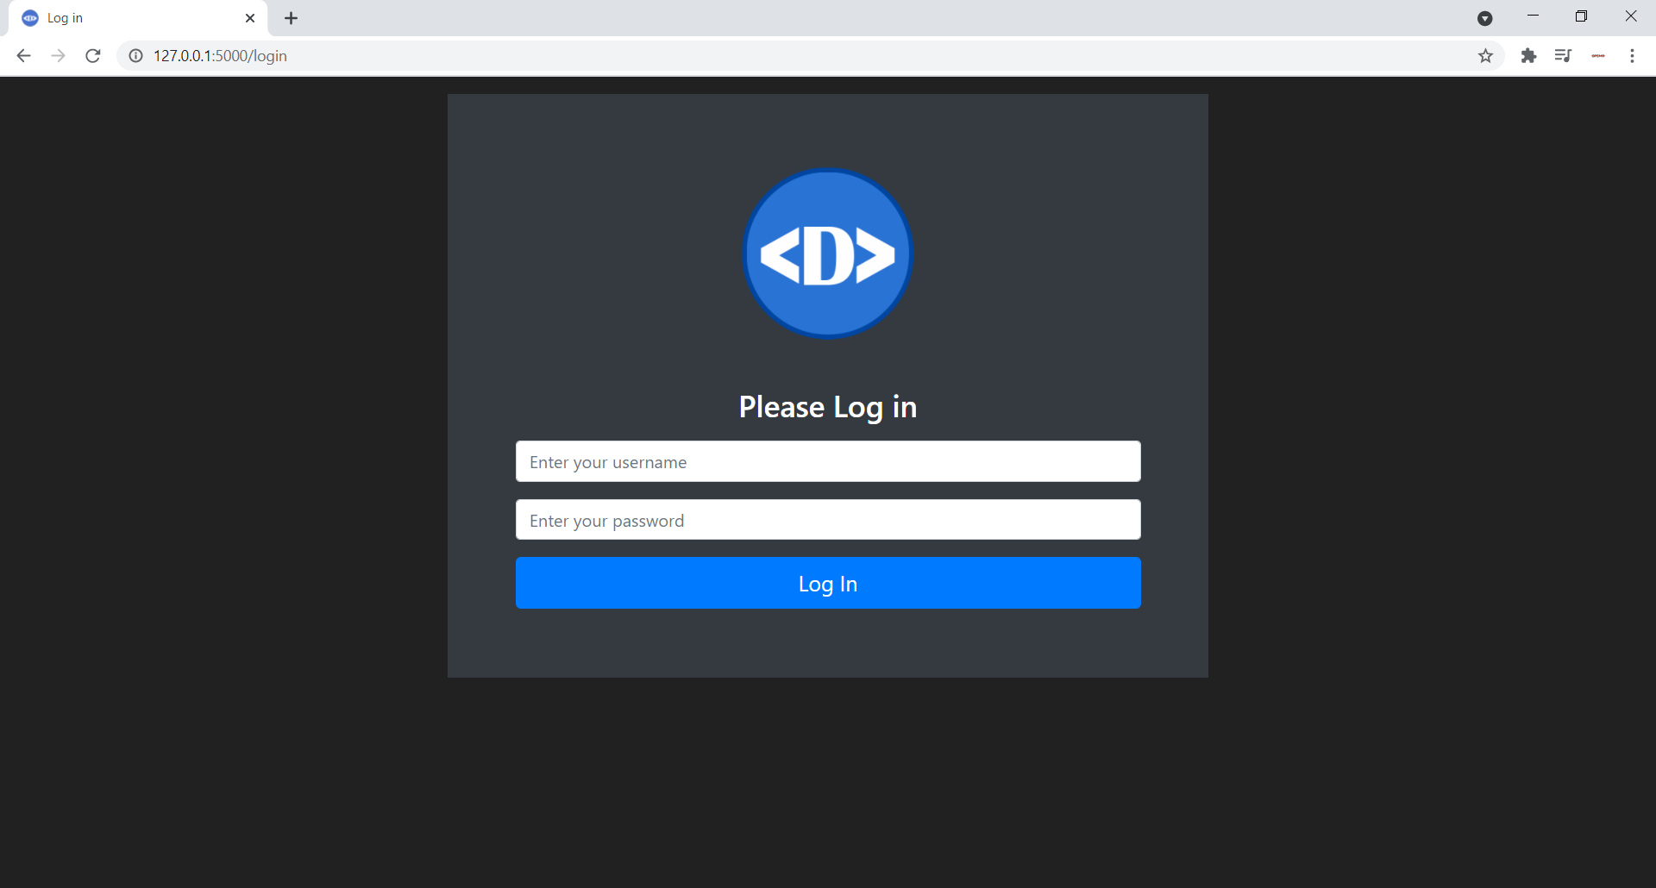

**Main page**

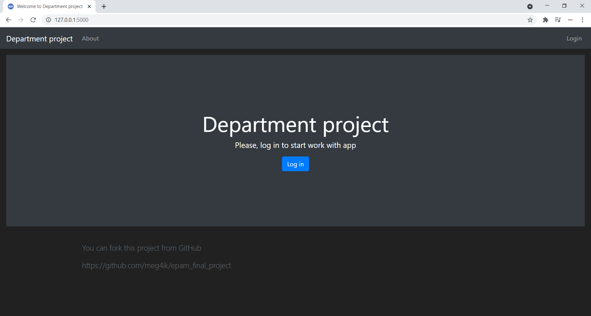

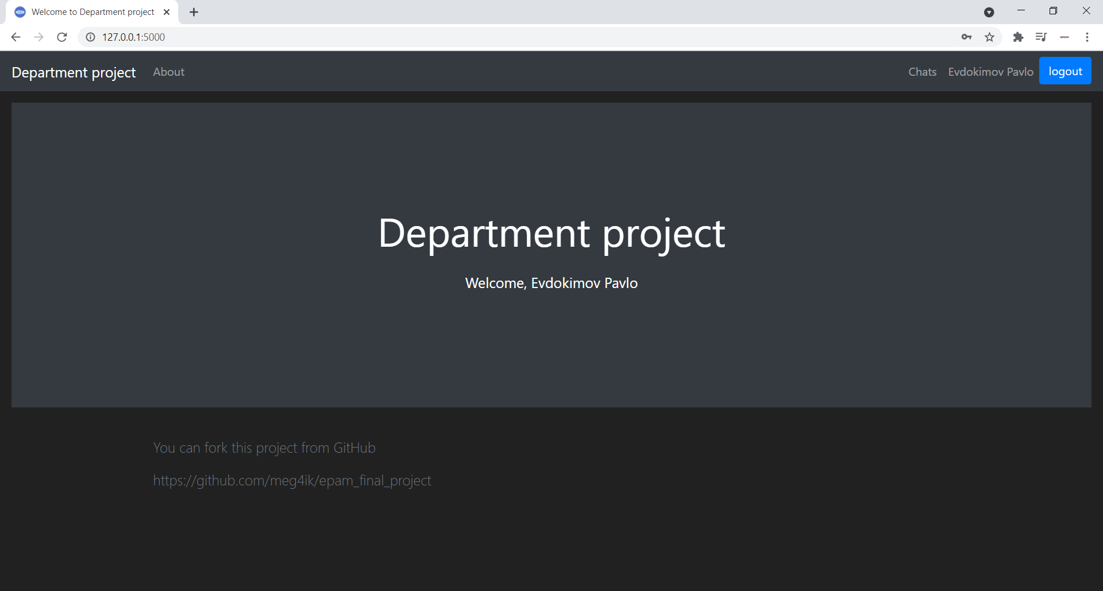

**About page**

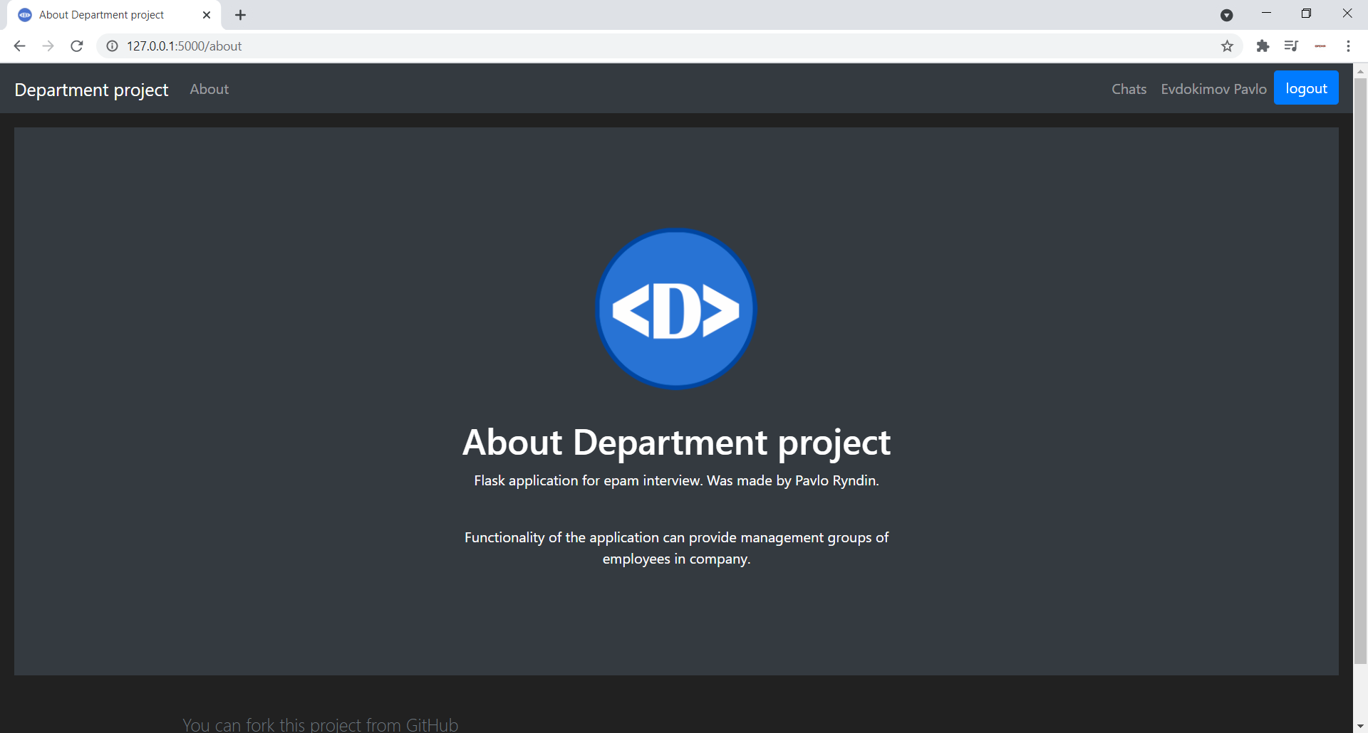

**Profile page**

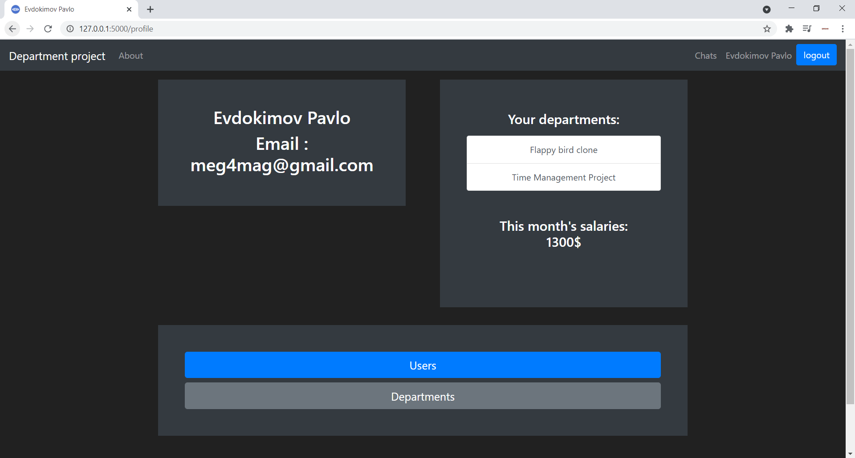

**Chats page**

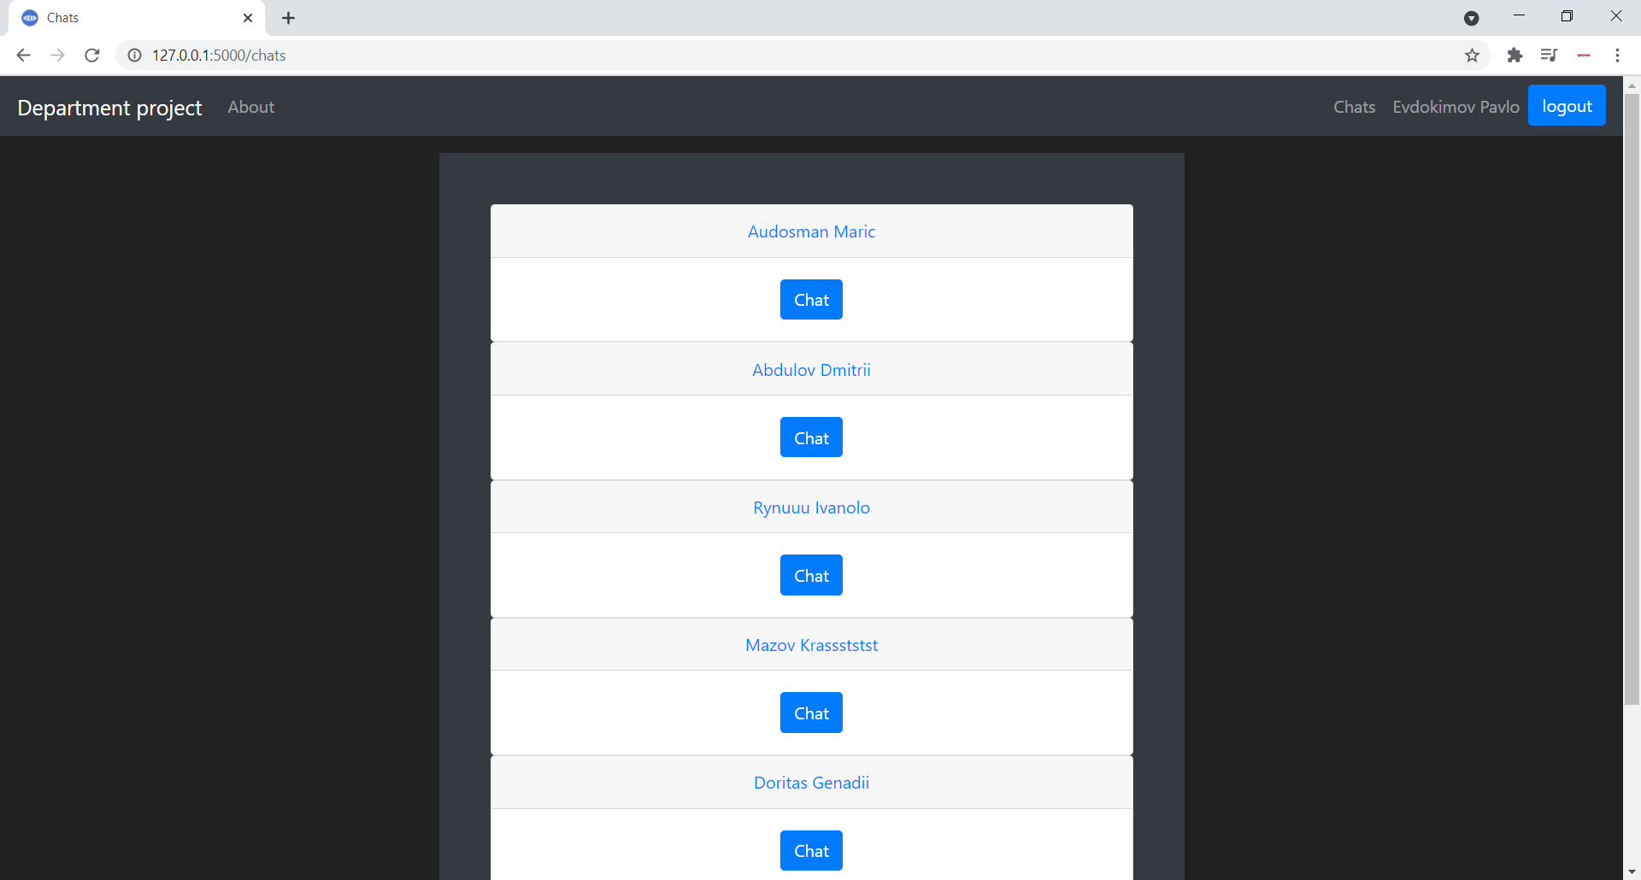

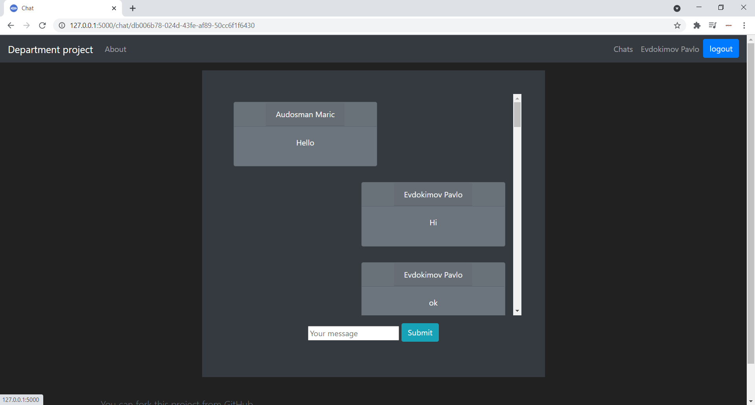

**Department page**

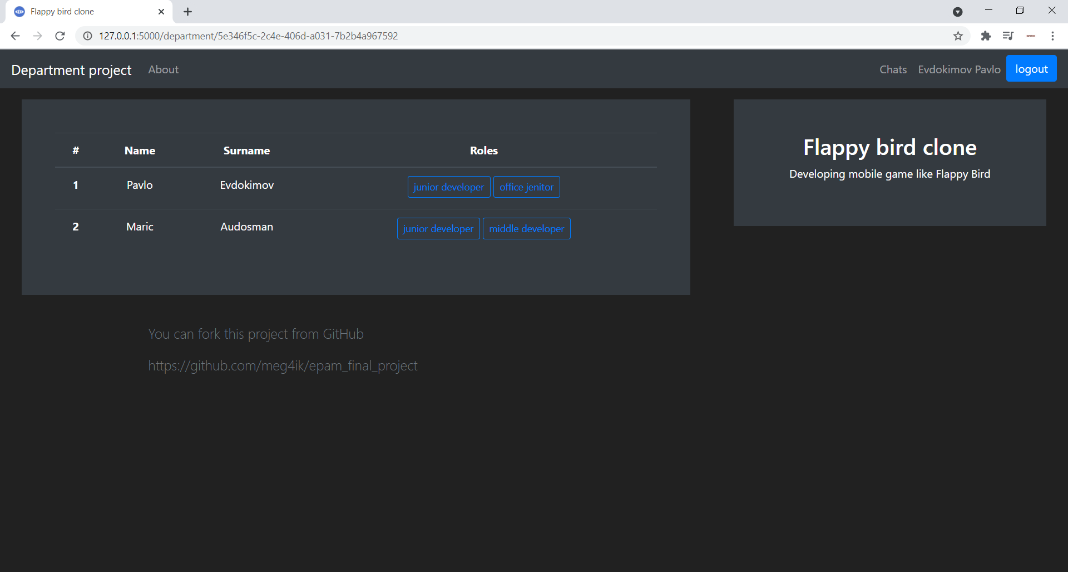

**User page**

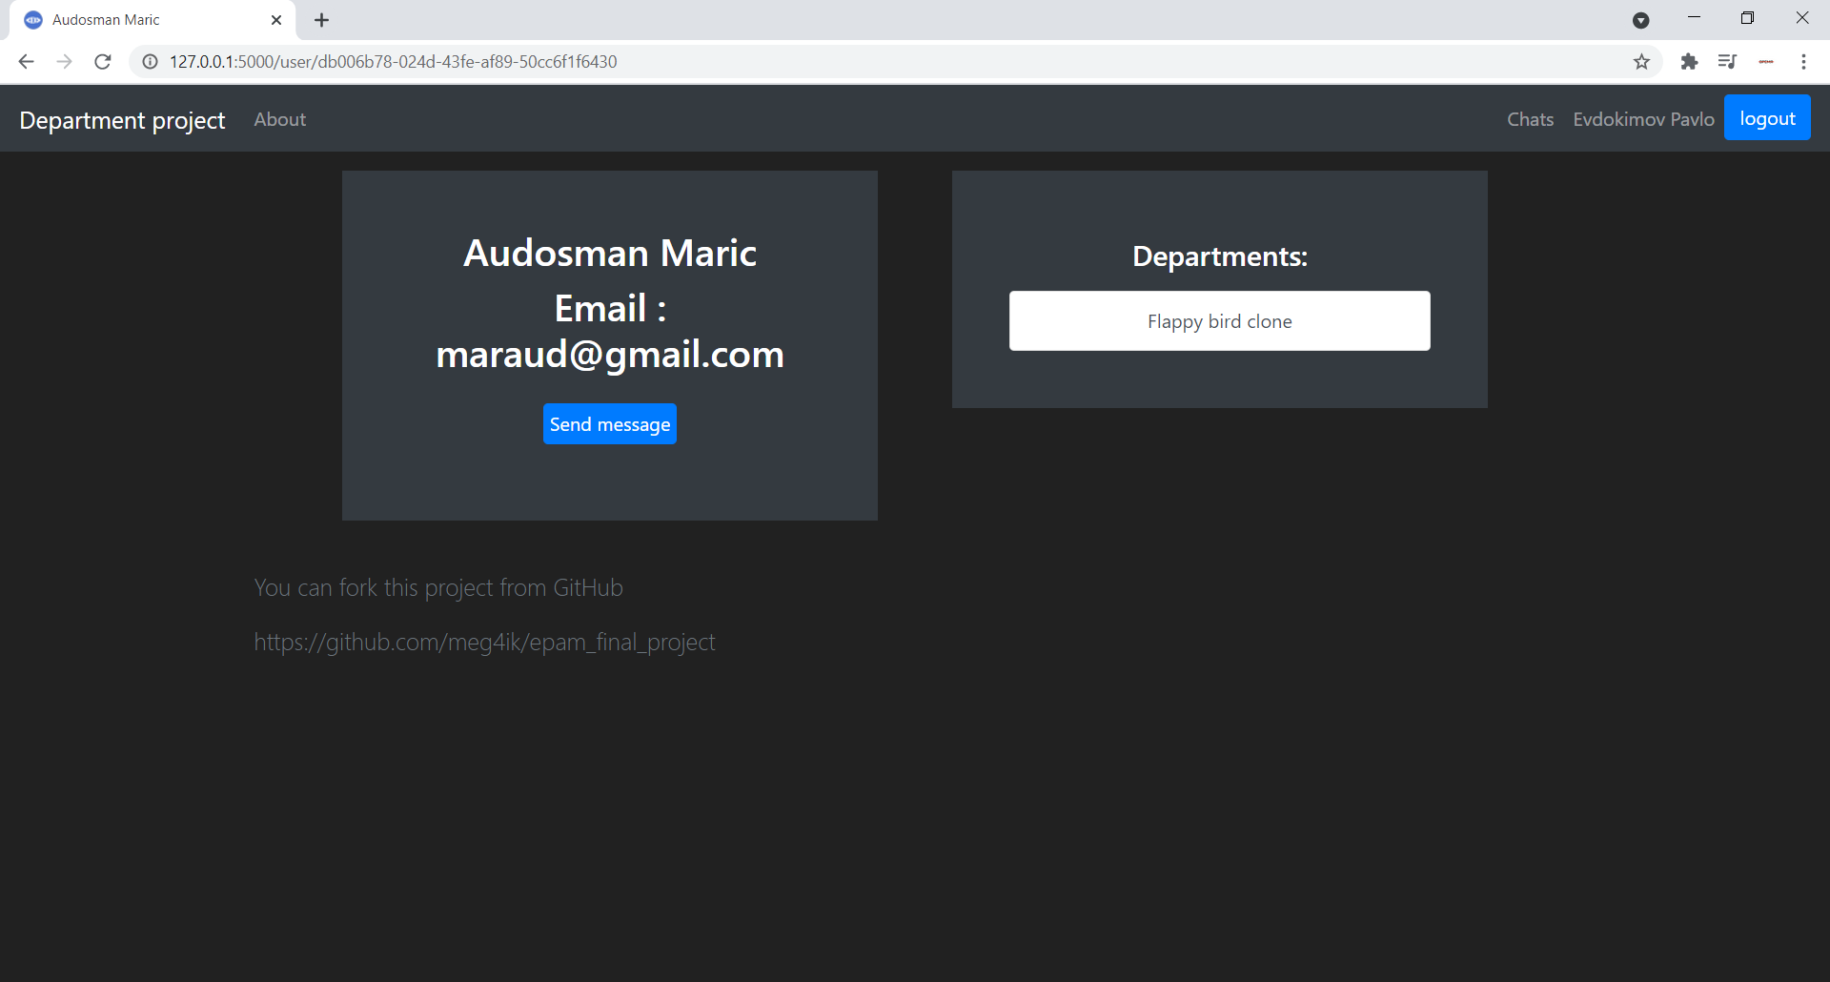

**Users list page**

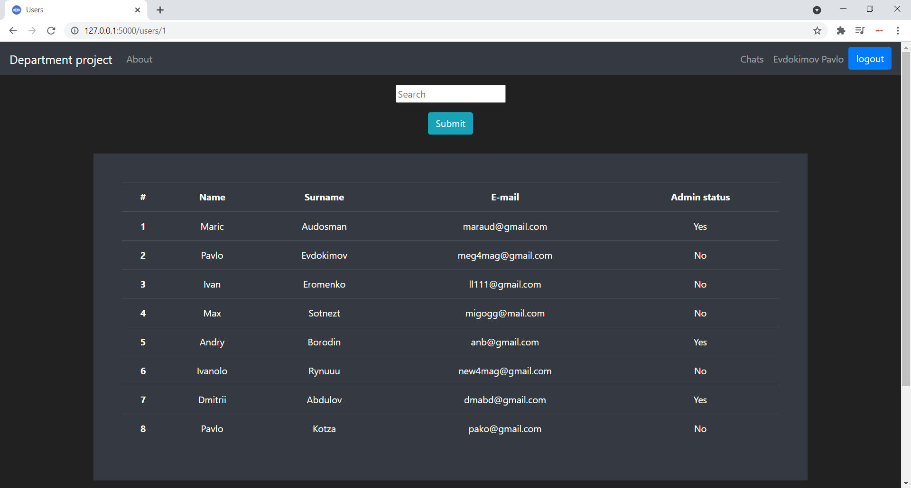

**Departments list page**

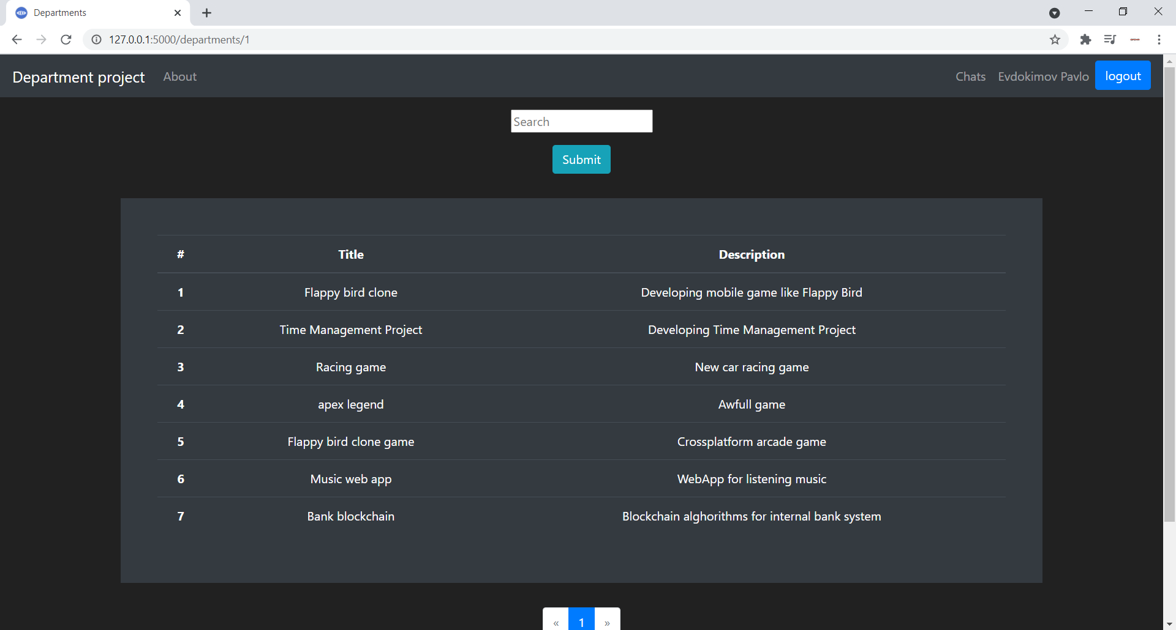

**Admin user-model page**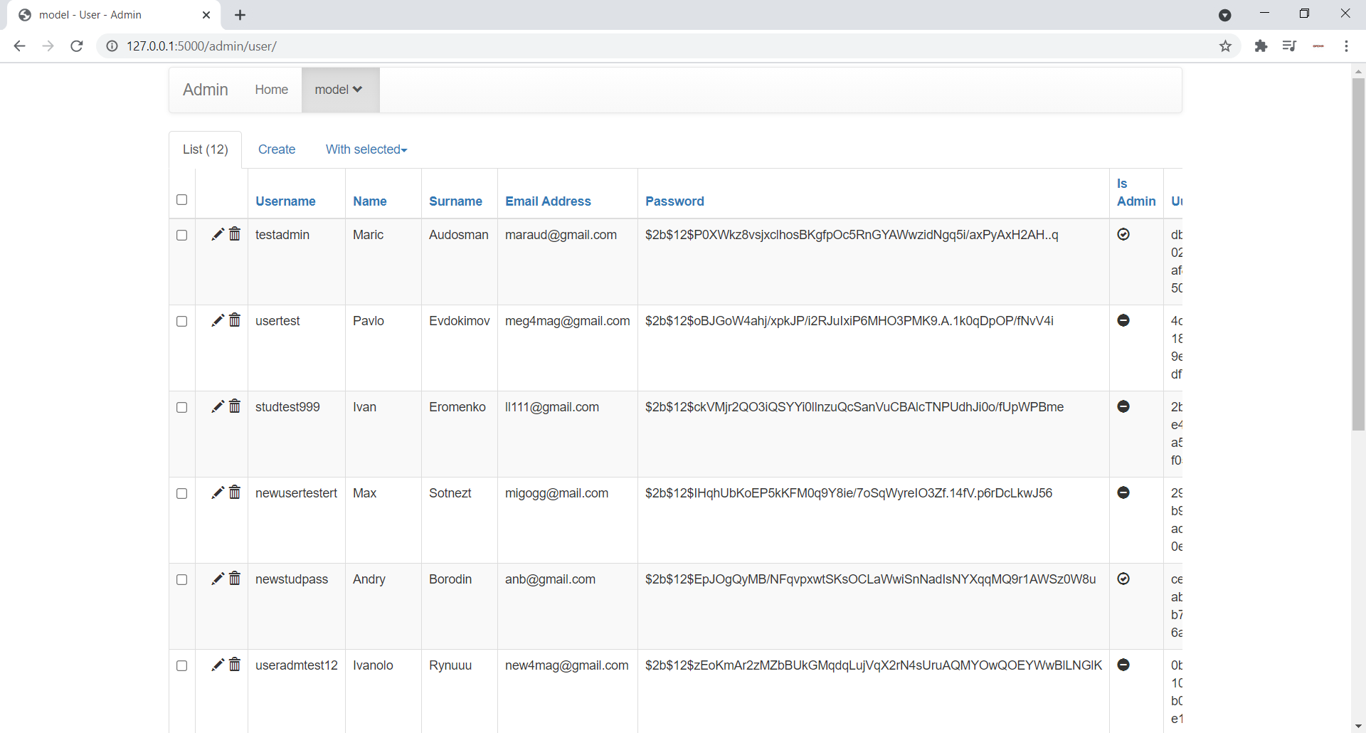

**Admin department-model page**

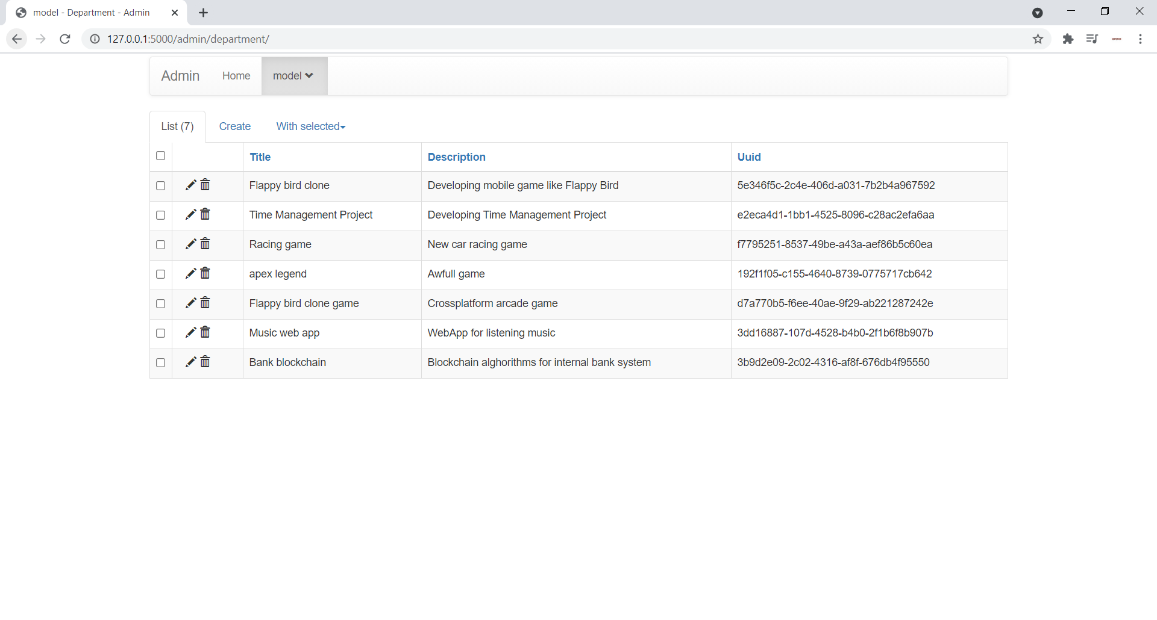

**Admin role-model page**

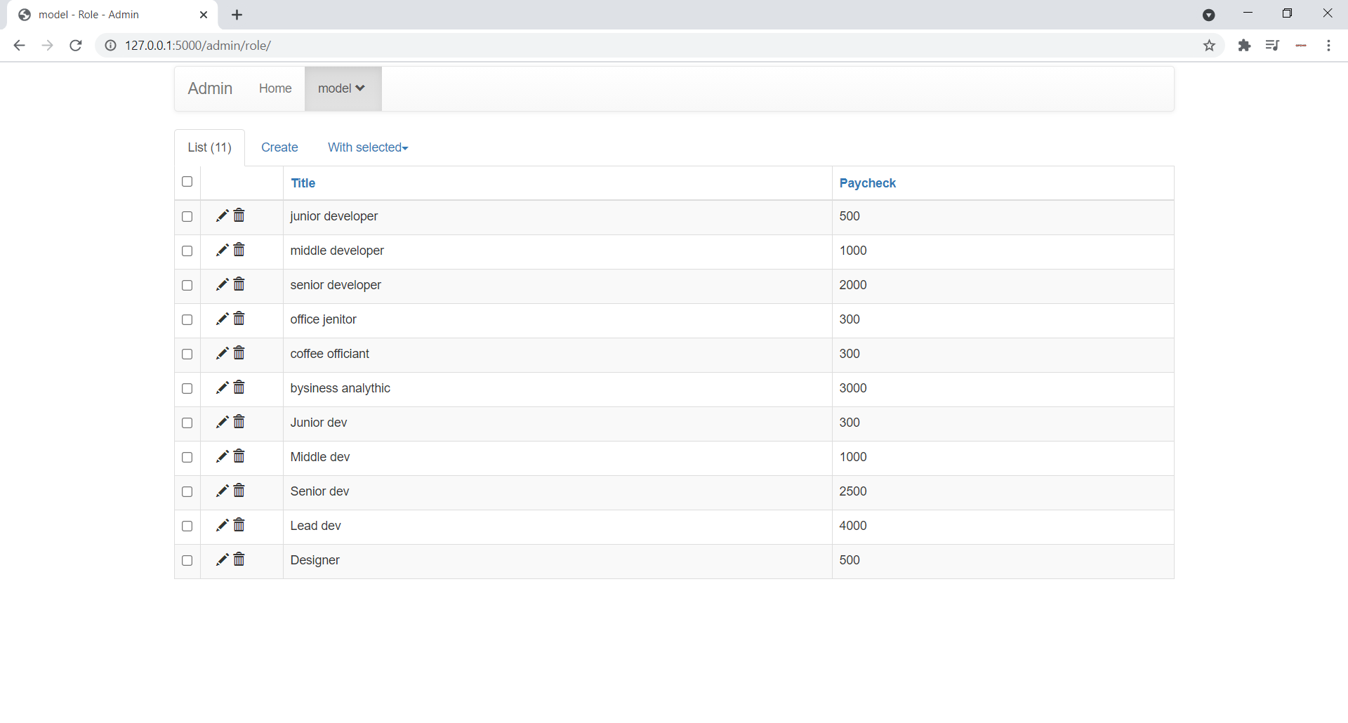

**Admin userdepartmentrole-model page**

