Step 1 : Create a new repository in the github

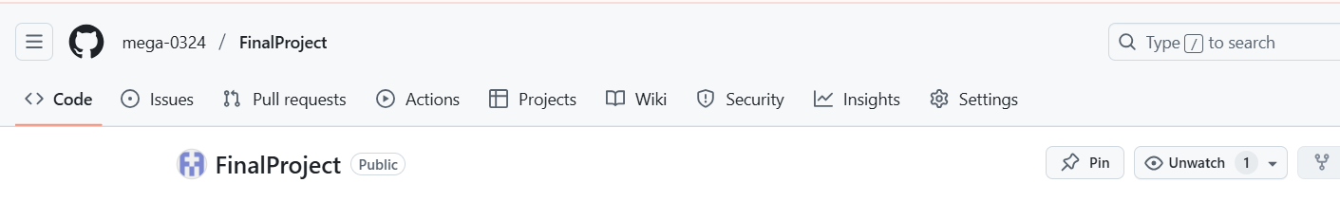

Step 2 : Move the frontend, backend, and k8s folders from the kubernetes directory to the Dev directory to organize project files.

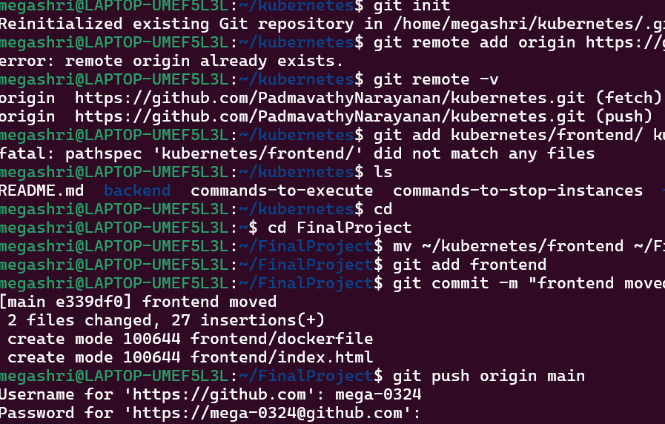

Step 3 : Initialized a Git repository in the Dev folder, added the frontend, backend, and k8s folders, committed the changes, and attempted to push to GitHub. Authentication failed due to password authentication being removed; using a personal access token (PAT) is required.

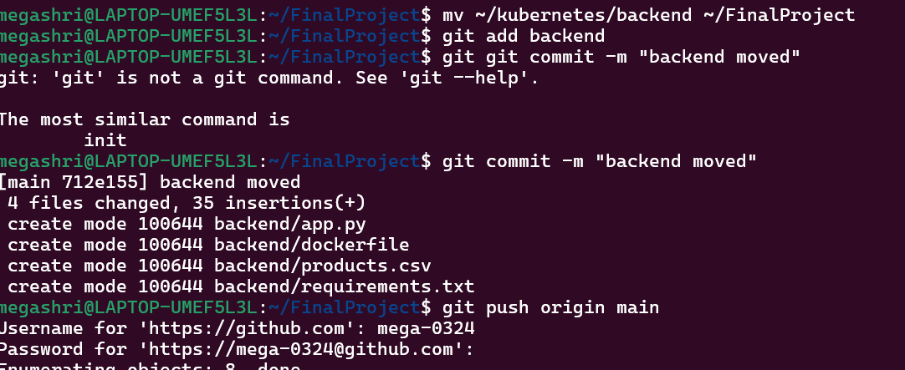

Step 4 : Initialized a Git repository in the Dev folder, created a Jenkinsfile, added it to the repository, committed the changes, and successfully pushed the commit to the remote GitHub repository.

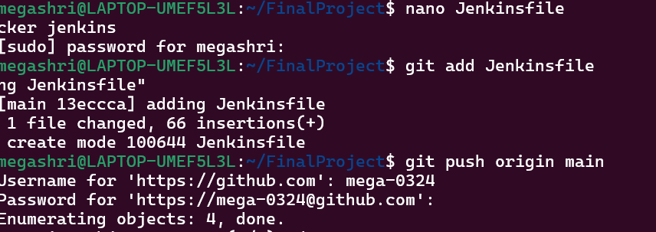

Step 5 : Create a new pipeline item in the jenkins



Step 6 : The Jenkins dashboard displays the status of the "kubernetes" pipeline. The latest build (#5) was successful, while previous builds (#1 to #4) failed. The status section confirms that the last stable and successful build was #5, completed 3 hours and 37 minutes ago.

