

FBT

V1

2021/09/02

HOPEX360 for HOPEXV4

How to customize the Dashboard

Content

1. Overview 3

1.1. Technical limitations 3

1.2. Presentation 3

1.3. Structure 5

2. How to Customize the Dashboard 6

2.1. Export the data 6

2.2. Configure the Report 7

3. How to Translate the Dashboards 9

# Overview

## Technical limitations

HOPEX Version

This document applies to the combination of:

* the HOPEX V4 and newer versions
* HOPEX360 v2.1 and newer

## Presentation

The inbuilt dashboards in HOPEX 360 are broken down in 6 sections:

* Applications: this dashboard shows widgets around application data, including 5 filters

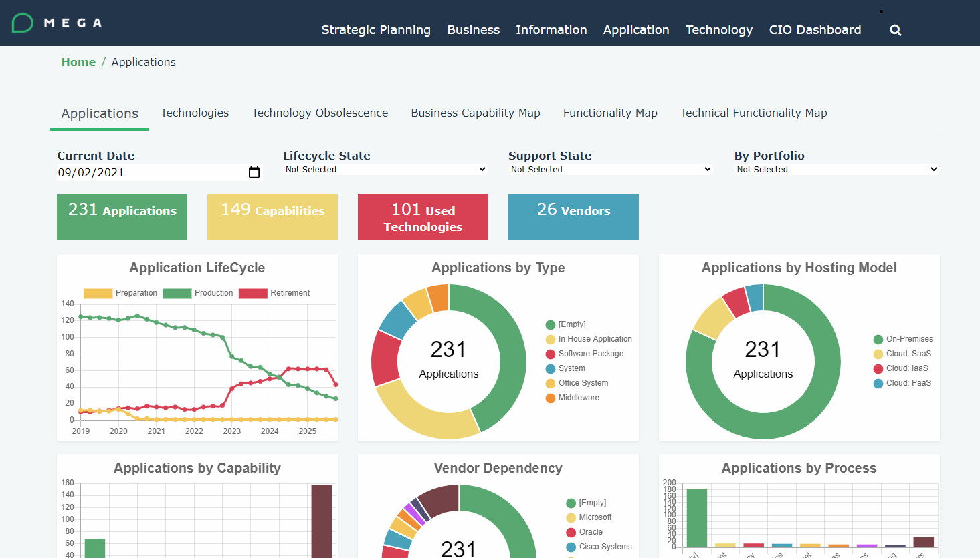

* Technologies: this dashboard shows widgets around technologies data, including 5 filters

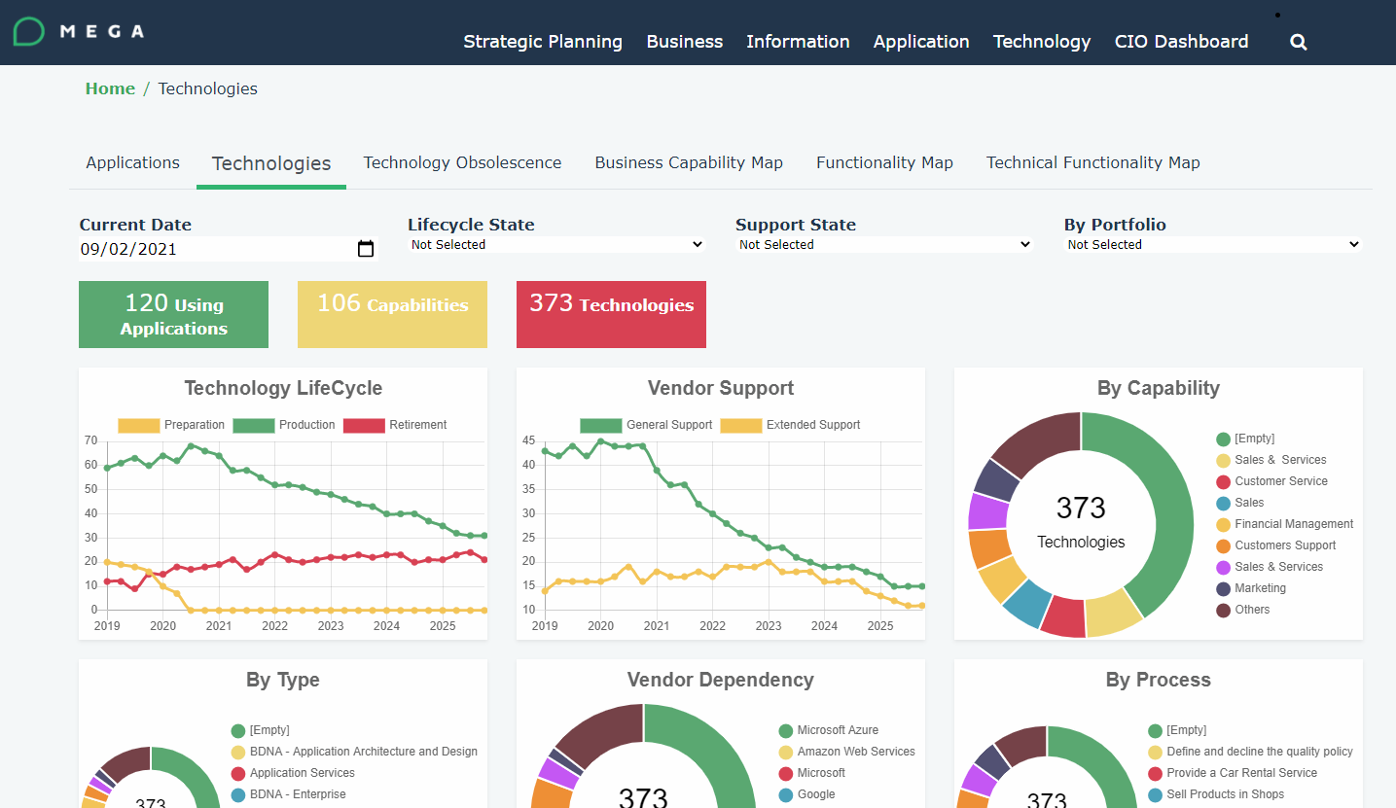

* Technology Obsolescence: this dashboard shows the obsolescence status of the technologies over the next 2 years

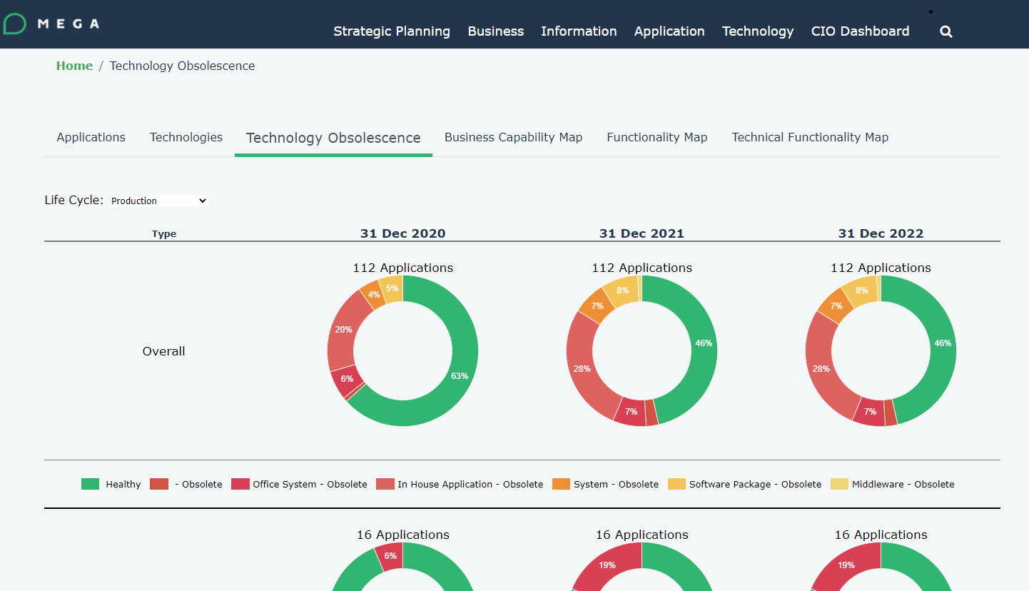

* Business Capability Map: this dashboard shows the BCM breakdown and their application overlay, together with filters and the ability to colour code the map

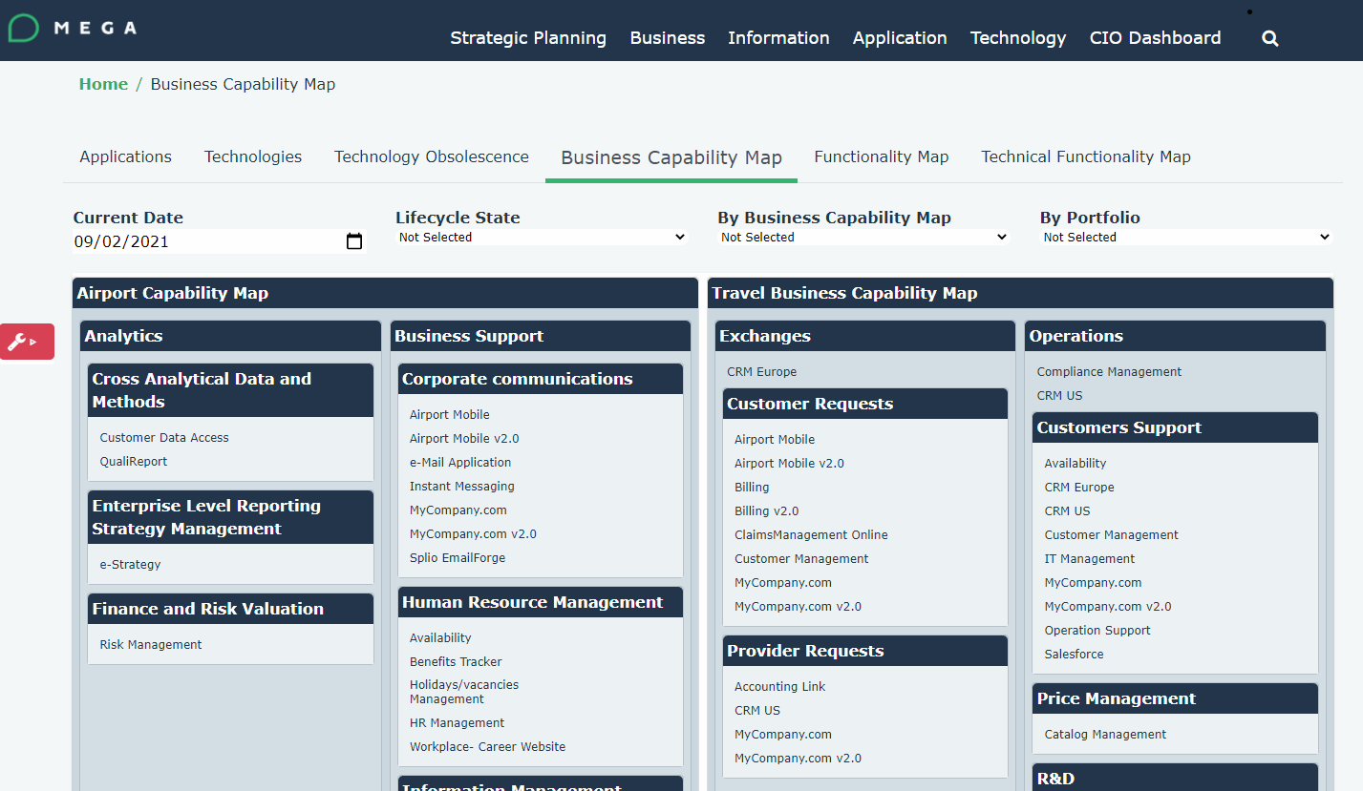

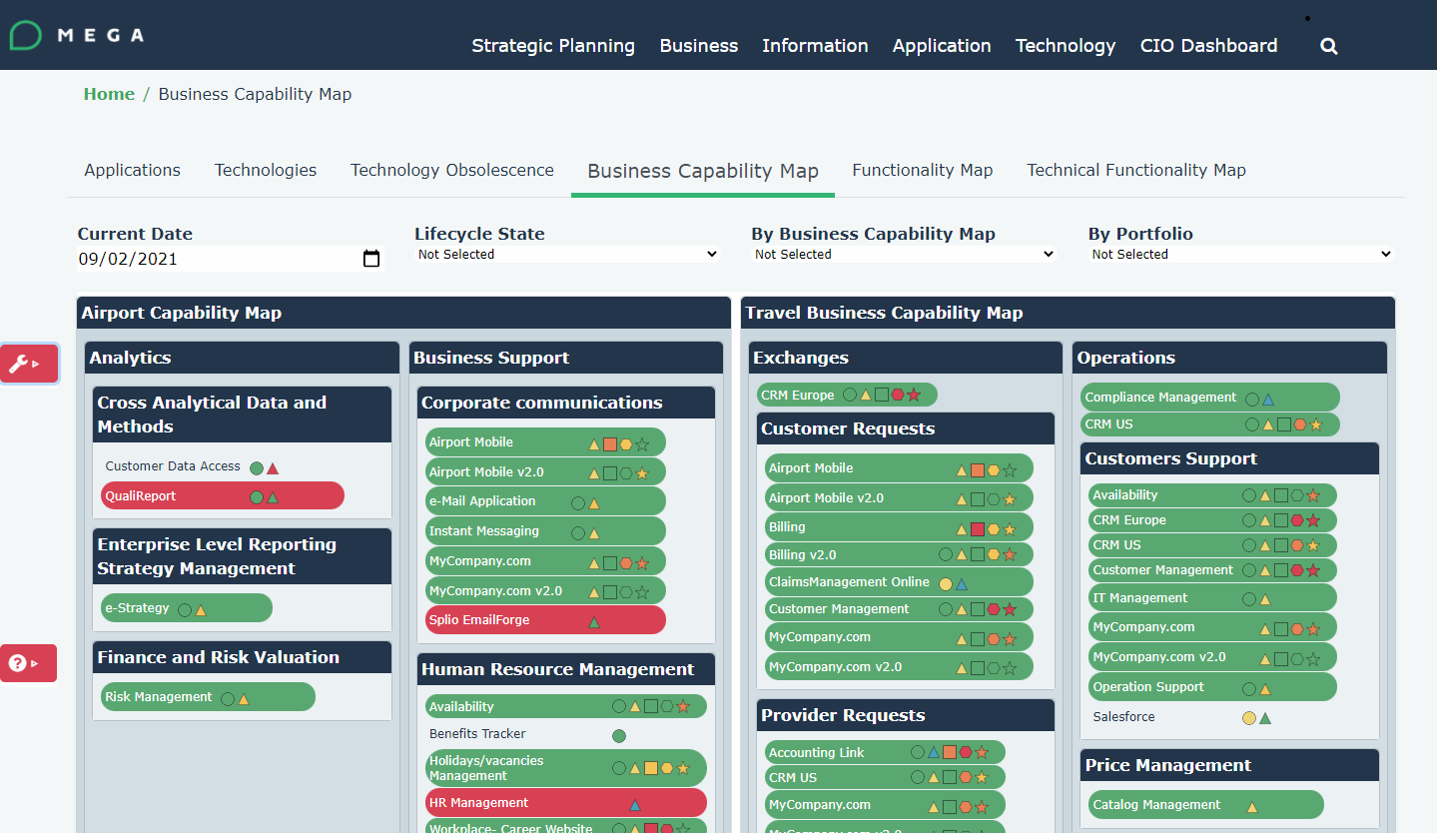

* Functionality Map: same as above with Functionality Maps and applications overlay
* Technical Functionality Map: same as above with Technical Functionality Maps and technologies overlay

## Structure

All those reports (except for the Tech Obsolescence) are built upon:

* A HOPEX descriptor, which calls a Macro with a HexaIdAbs parameter that refers to a _CodeTemplate
* A Macro, which is the same one for all dashboard
* A _CodeTemplate which is specific for each dashboard

# How to Customize the Dashboard

First retrieve the right _CodeTemplate, they are located in Utilities > Code Template > HOPEX360 > Dashboard Templates

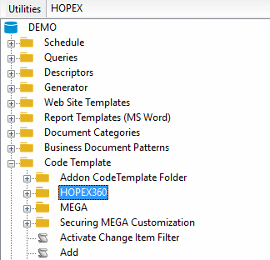

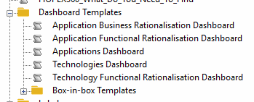

## Export the data

Once you retrieved the right _CodeTemplate, just go to the properties > Template

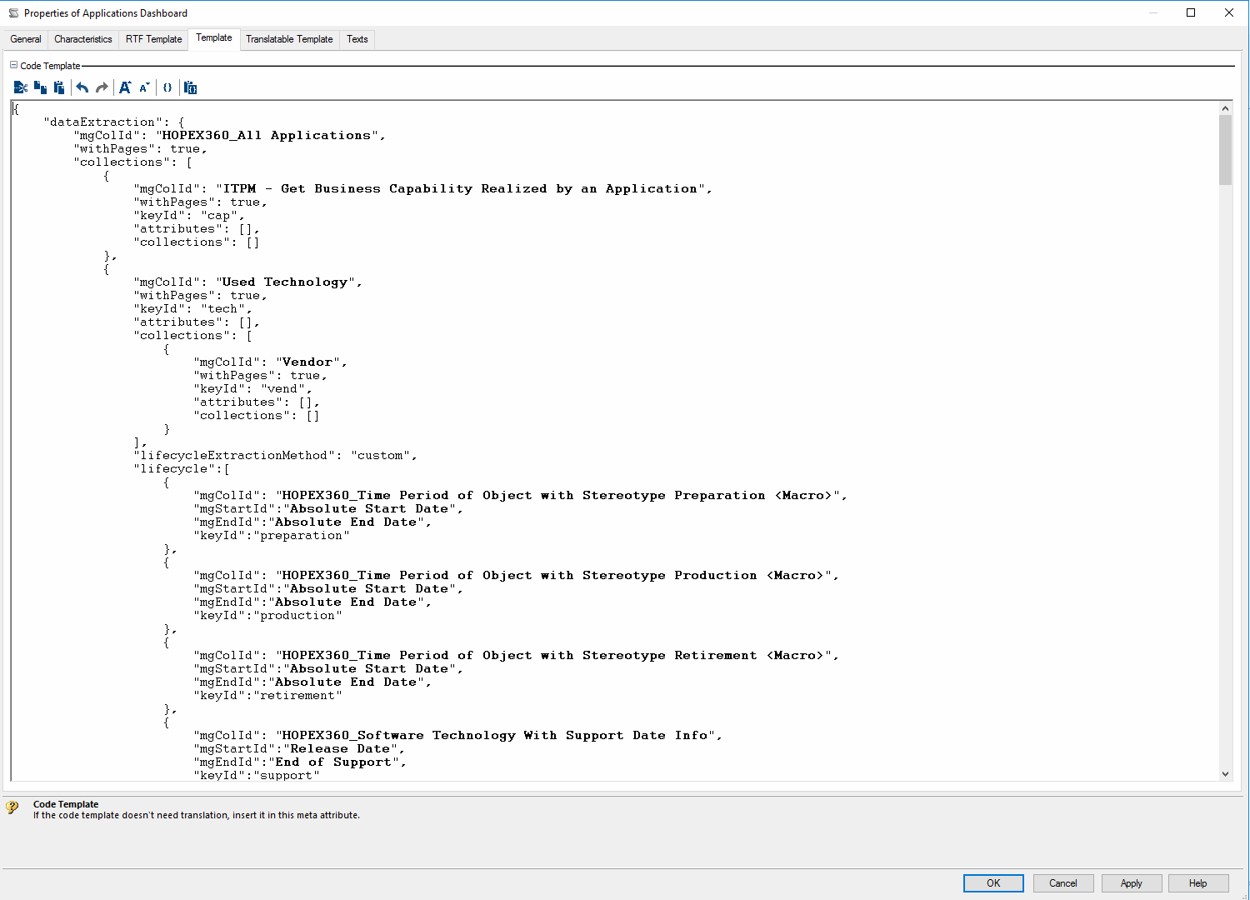

You can see a JSON structured text, with the following section:

* dataExtraction 🡺 here you define the data to be considered in the report. It can start with a collection on which you can add attributes and related collections
* optionsExtraction 🡺 this allows to add filters onto the dashboard, according to the extracted data
* buttons 🡺 this shows buttons on top of the dashboard to highlight collections counts
* charts 🡺 this is where you can add widget with a copy and paste of an existing section.

## Configure the Report

First make sure that the data you want to report on is part of the dataExtraction.

Then you can just add the relevant widget where you need. You will have to refer to the extracted data

|  |
| --- |
| {  "name": "Applications by Process",  "type": "bar",  "x": {  "label": "Process",  "logic": {  "fields": "collections.proc.name"  }  },  "collectionName": "Applications"  }, |

The available widgets format types are:

* Doughnut

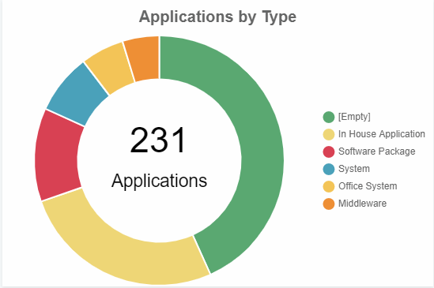

* Bar

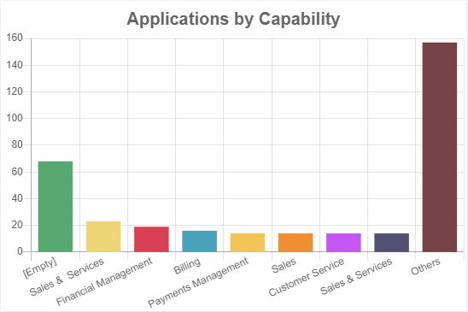

* Heat-matrix

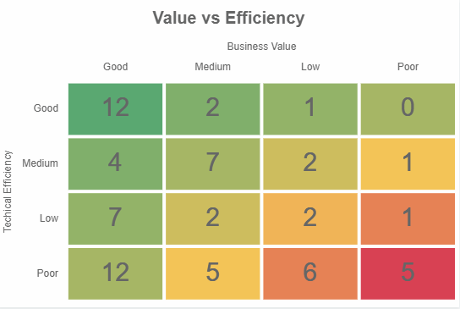

* Object-life

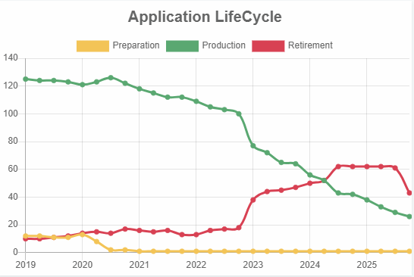

# How to Translate the Dashboards

Just retrieve the relevant _CodeTemplate according to the section 2.

Go to the Properties > General > Translation

You can then copy the English content and copy onto the relevant language (assuming that the language has been made available)

You can now proceed in translating the labels

