

FBT

V2

2020/11/18

HOPEX360

Website Template documentation

Content

1. Overview 4

1.1. Technical limitations 4

1.1.1. HOPEX Version 4

1.1.2. Web browser Version 4

1.1.3. Resolution 4

1.1.4. Licensing 4

1.1.5. Deployment 4

1.1.6. Languages 5

1.2. Data scope 5

1.3. Homepage 6

1.3.1. Overview 6

1.3.2. Client specific 6

1.4. Site Map 7

1.5. List index 7

1.6. Tree list index 8

1.7. Search 9

2. Configuration 9

2.1. Installation 9

2.2. Required files 10

2.3. Translation 11

2.4. Post-generation script JSON files 12

2.4.1. CIO Dashboard JSON 13

2.4.2. Tree list JSON 15

2.4.3. Application page JSON 16

2.4.4. Search 17

3. CIO Dashboard 17

3.1. Main dashboard 17

3.1.1. Portfolio filter 17

3.1.2. Drill down 17

3.1.3. Indicators 18

3.1.4. Application Evolution 19

3.1.5. Technology Compliance 20

3.1.6. Privacy management 20

3.1.7. Applications per Capability 21

3.1.8. Applications per Vendors 22

3.1.9. Hosting model 22

3.2. Technology Obsolescence 23

3.3. Strategic Planning 23

3.4. Rationalization 24

3.4.1. Rationalization Map 24

3.4.2. Rationalization Table 25

4. Indexes Details 25

4.1. Tree lists 25

4.1.1. Overview 26

4.1.2. Structure 26

4.1.3. Capabilities Tree list 26

4.1.4. Processes Tree list 27

4.2. Lists 28

4.2.1. Overview 28

4.2.2. Structure 28

4.2.3. Capabilities list 28

4.2.4. Processes list 28

4.2.5. Concepts list 29

4.2.6. Application portfolios list 29

4.2.7. Applications list 29

4.2.8. Projects list 29

4.2.9. Technology Portfolios list 30

4.2.10. Technologies list 30

4.2.11. Vendors list 30

5. Object pages details 30

5.1. Overview 30

5.2. Business Capability Map 31

5.3. Business Capability 31

5.4. Business Process 31

5.5. Concept 32

5.6. Application portfolio 32

5.7. Technology portfolio 32

5.8. Application 32

5.9. Project 33

5.10. Technology 33

5.11. Vendor 34

# Overview

## Technical limitations

### HOPEX Version

This HOPEX360 for V4 website template is qualified against the HOPEX V4 version.

### Web browser Version

This website template is qualified against the following web browser:

* Firefox 75 and above
* Chrome 81 and above

### Resolution

This website is optimised for a 1920 x 1080

### Licensing

It only considers the scope of the ITPM and ITBM licence.

### Deployment

Once generated, the static website needs to be hosted on an IIS webserver to enable all the functionalities.

The functionalities that require IIS include but are not limited to:

* Application Force Diagram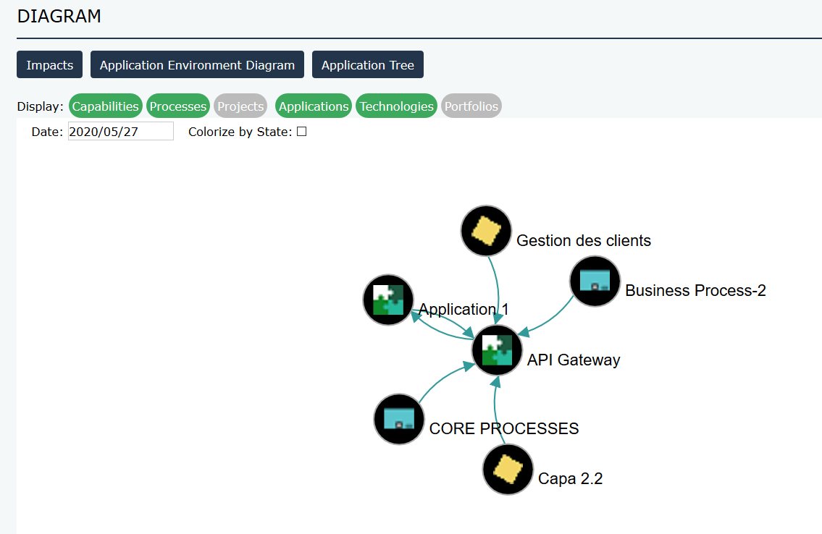
* Capabilities and Process Tree List
* 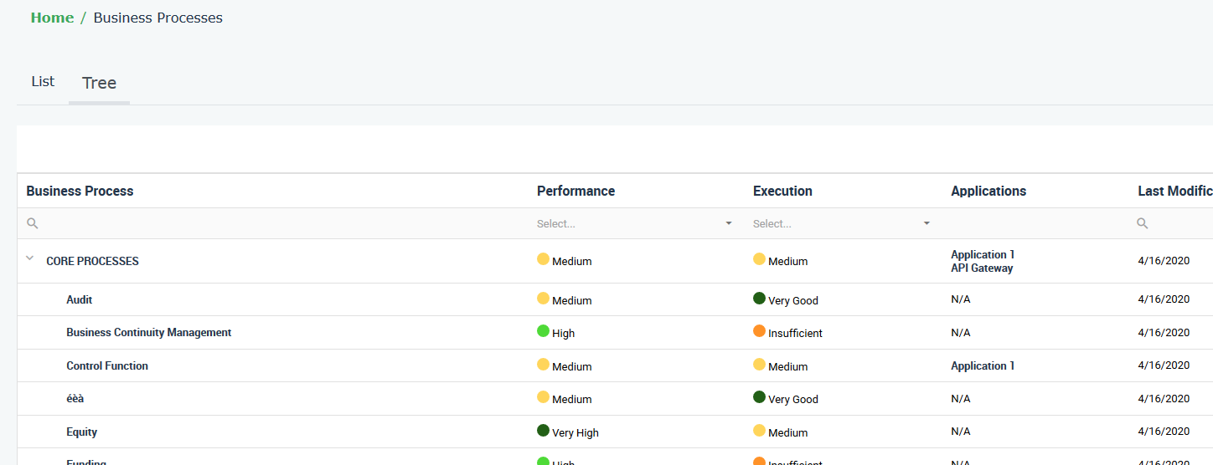

### Languages

The website structure is available in both English and French. The translations can be amended using the _Code Templates referenced in the descriptors.

The website will be generated in the language set on the user running the web generation.

The translation of the content itself relies on the available languages of HOPEX.

## Data scope

HOPEX360 covers the following data. For more details, refer to the tables at the end of the document.

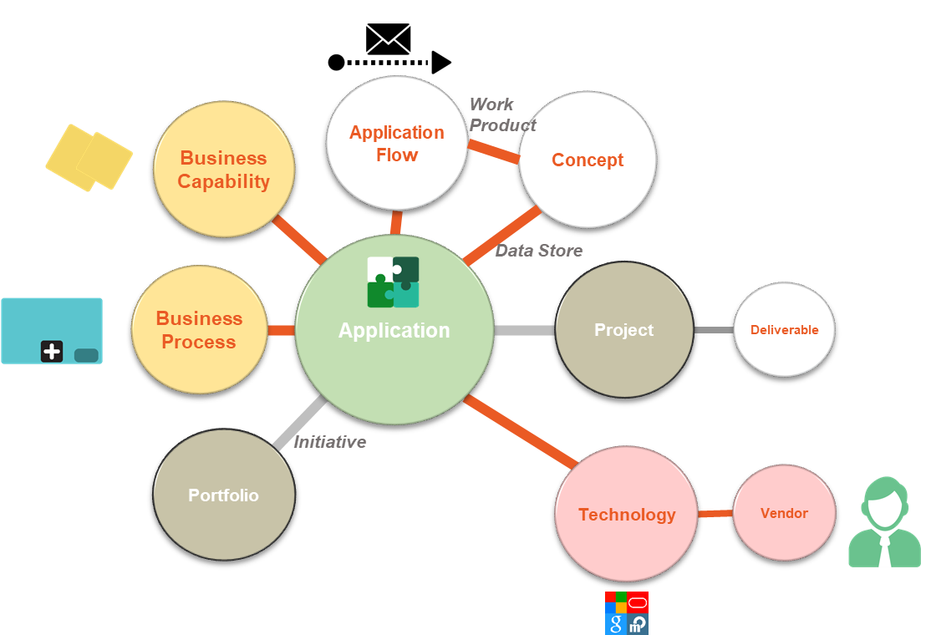

## Homepage

### Overview

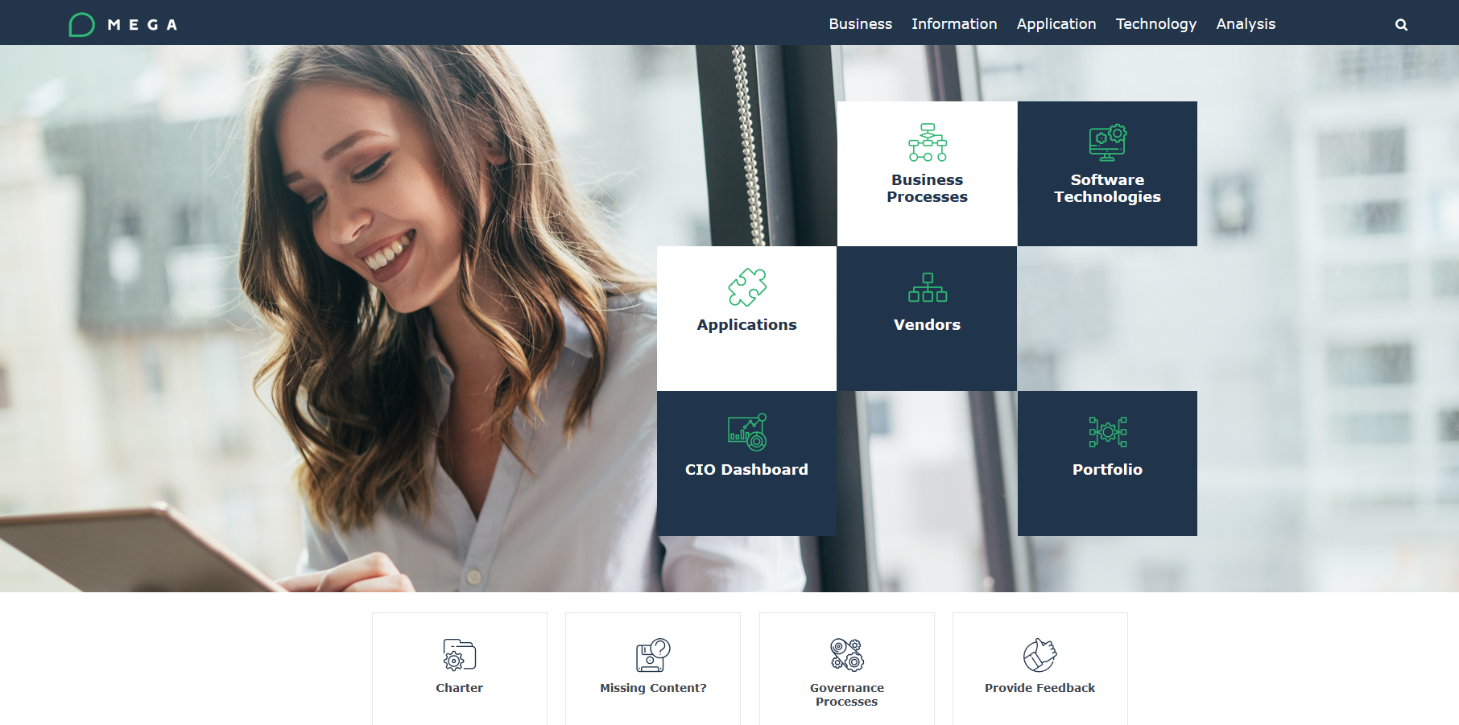

### Client specific

#### Description

The 4 tiles down the tiles will not point anywhere. It is up to the consultant and/or the client to update the links in the Homepage descriptor.

The purpose of these links is to point to:

* Client specific charter: online document
* Missing content: email to a dedicated email address
* Governance Process: online document
* Provide feedback: email to a dedicated email address

#### Customisation

To modify:

* Open the “HOPEX EA_General Menu” Descriptor
* Open the “Bottom Tiles” text
* Add a link within the <h6> tag:
  + Client specific charter: line 47
  + Missing content: line 92
  + Governance Process: line 145
  + Provide feedback: line 188

## Site Map

The top menu allows to navigate through the pages.

Here is a breakdown of the navigation:

|  |  |  |  |
| --- | --- | --- | --- |
| **Navigation menu** | | | **Associated Object** |
| Strategic Planning | Enterprises | Enterprises list: searchable hierarchical list | Enterprises |
| Business | Capability | Capabilities Tree list: searchable hierarchical list | Business Capability Maps  Business Capabilities |
| Capabilities list: alphabetically sorted flat list |
| Process | Processes Tree list: searchable hierarchical list | Business Processes |
| Processes list: alphabetically sorted flat list |
| Information | Dictionary | Concepts list: alphabetically sorted flat list | Concept |
| Business Information Maps | Business Information Map list: searchable hierarchical list | Business Information Maps |
| Application | Portfolios | App portfolios list: alphabetically sorted flat list | Portfolio typed as Application |
| Applications | Applications list: alphabetically sorted flat list | Application |
| Projects | Projects list: alphabetically sorted flat list | Project |
| Technology | Portfolios | Tech portfolios list: alphabetically sorted flat list | Portfolio typed as Technology |
| Technologies | Technologies list: alphabetically sorted flat list | Technology |
| Vendor | Vendors list: alphabetically sorted flat list | Org Unit typed Vendor |
| Analysis | CIO Dashboard | Main dashboard | Specific report page |
| Technology Obsolescence | Specific report page |
| Strategic Planning | Specific report page |
| Rationalization | Specific report page |
| Reports | Reports list: alphabetically sorted flat list | Specific report page |
| Search |  | Pop up to type in key words | Results shown in table |

## List index

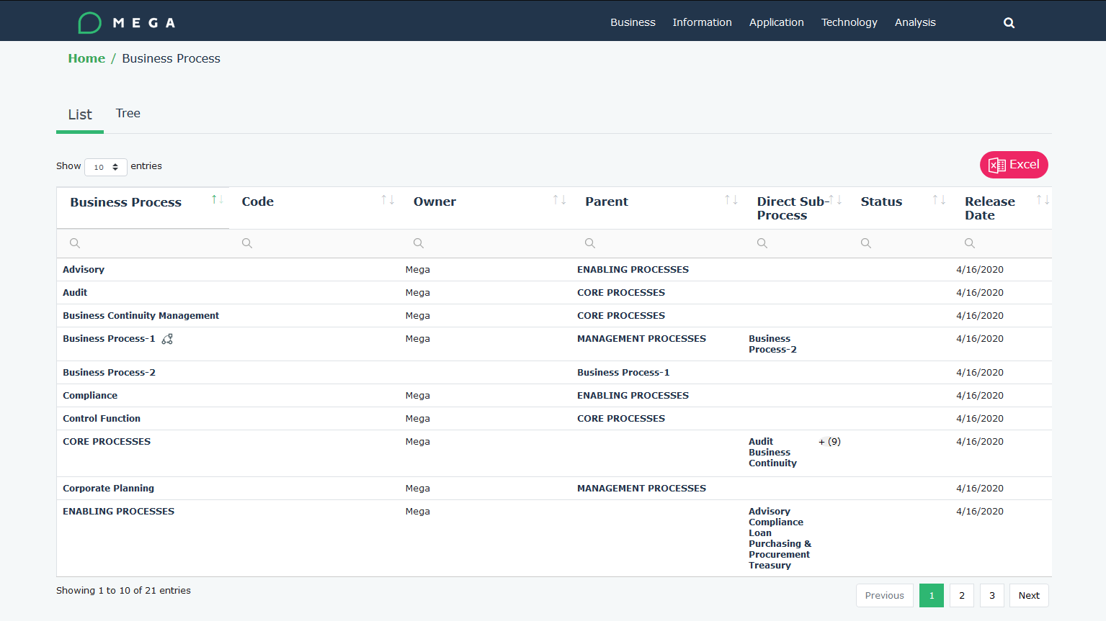

## Tree list index

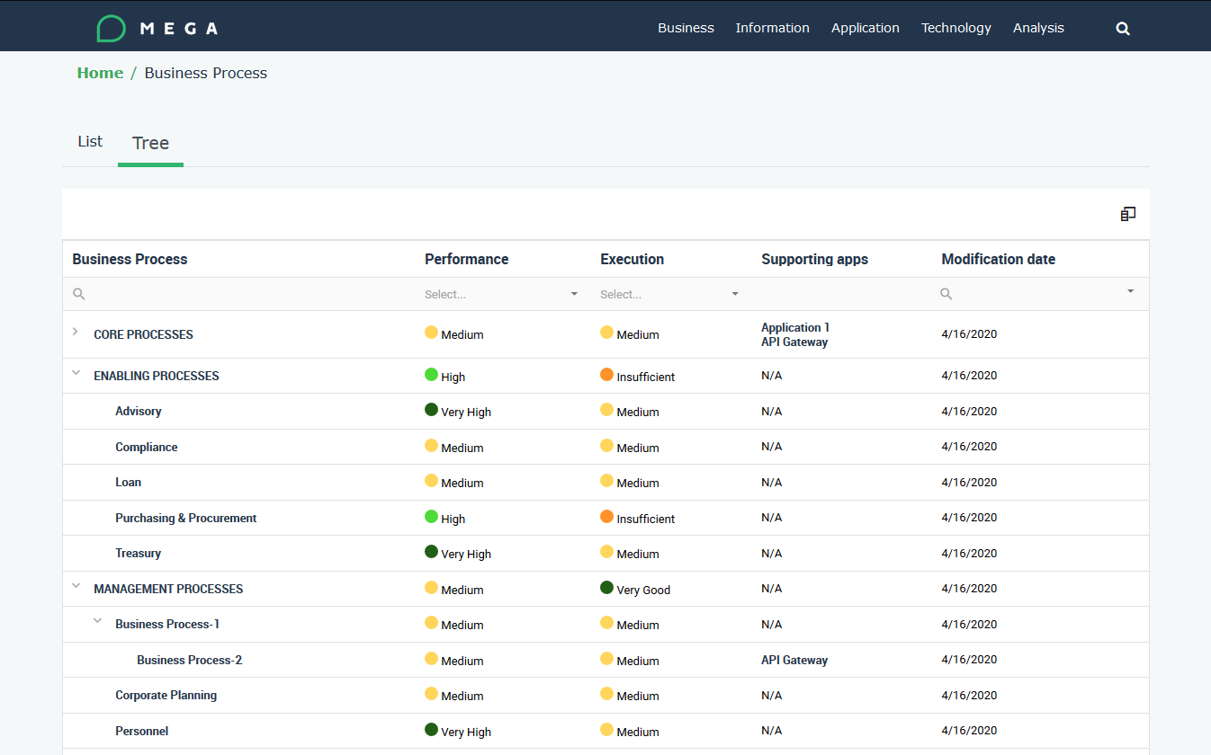

## Search

The search is implemented by the Fusejs library (https://fusejs.io/)

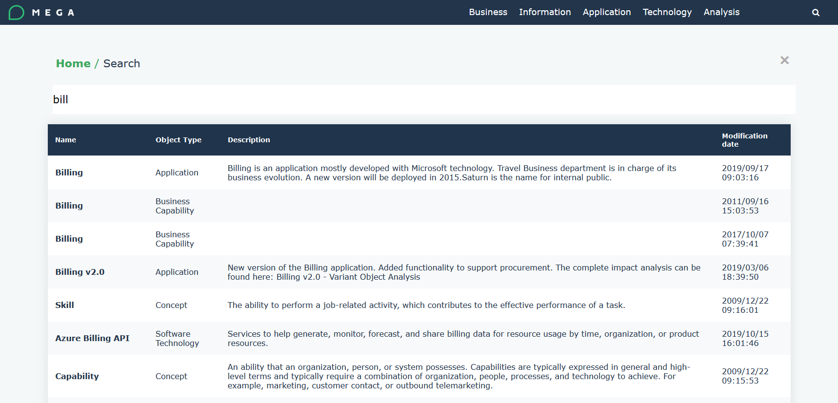

# Configuration

## Installation

The website template is delivered as a Solution Pack. So the steps are as follows:

* Download the package from the HOPEX Store into the <HOPEX Installation folder>\Utilities\Solution Pack
* Unzip it in the same location
* Open the HOPEX Admin module

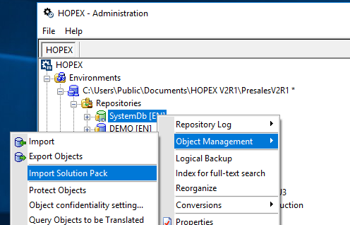

* Select HOPEX360_V4 and click OK

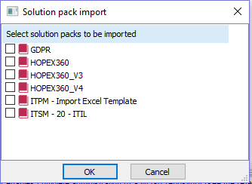

* The Website Template and all its components will be installed

## Required files

The HOPEX environment Mega_Usr folder will be updated with the files required by the website template. This includes:

* CSS files
* JS files
* Images
* Fonts

## Translation

Translations is available on the following items:

* Menu
* Section
* Widget
* Table header

For each of them, a reference is written in the code to the relevant Code Template, as such:

|  |
| --- |
| [Variable=CodeTemplate Id=8F68A4995E7868E4/] |

Where the Id is the hexaidabs of the code template, as shown below in the Code template properties page

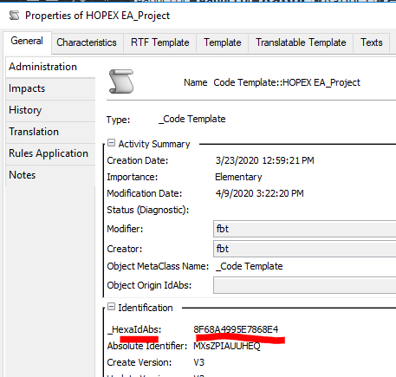

The text can be modified in General > Translation

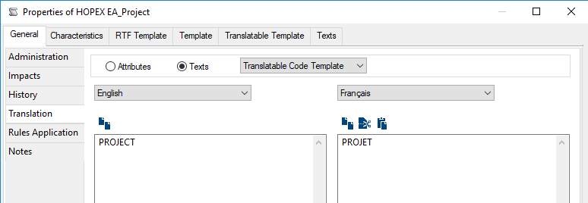

## Post-generation script JSON files

JSON files are generated as part of the website generation to cover different functionalities. These files are stored in the \json folder of the generated website.

Those JSON files contain the key data used in the reporting, via java script functions.

This is implemented through 4 MetaCommand Managers triggering the relevant macros:

* HOPEX EA_Post Generation Script App JSON. This generated on JSON per Application to enable the Application Impact force diagram. The files are named as follows:
  + <Application hexaidabs>_integration.json
* HOPEX EA_Post Generation Script CIO Dashboard JSON: this generates 4 JSON files:
  + DatasArrayCapabilityMap.js
  + DatasArrayPortfolioBusinessCapability.js
  + DatasArrayPortfolioTechnology.js
  + DatasArrayPortfolioTimePeriod.js
* HOPEX EA_Post Generation Script Process and Capa Trees JSON
  + DatasArrayBCMHierarchy.js
  + DatasArrayProcessHierarchy.js
  + DatasArrayBCMRationalization.js
* “HOPEX EA_Post Generation Script_Search Indexing” (/!\ : for relative links reason, this JSON is stored in the \standard\assets\js folder
  + searchindexcontent.json

### CIO Dashboard JSON

The ‘HOPEX EA_Post Generation Script CIO Dashboard JSON’ MetaCommand Manager generates 4 JSON files

#### DatasArrayCapabilityMap.js

|  |  |
| --- | --- |
| Topic | Key information |
| Purpose | This is a list of Business Capability Maps including:   * Name * HexaIdAbs   The main purpose is to enable a filter for key reports |
| Pages using the file | The following 2 pages use this data as a filter on the Box in Box:   * Strategic Planning * Rationalization |
| JSON data structure | var datasArrayCapabilityMap = [  {  capabilityMapName: "BCM To Be (EN) ", capabilityMapHexaIdAbs: "726B7F225E84F5C5",  },  ]; |

#### DatasArrayPortfolioBusinessCapability.js

|  |  |
| --- | --- |
| Topic | Key information |
| Purpose | This is a list of Applications, the Portfolios they are connected to and the Business Capabilities they support. |
| Pages using the file | The following pages use this data:   * Main Dashboard: in the Application per Capability Widget * Main Dashboard: in the Capabilities indicator * Rationalization: to filter out the Applications overlayed on the BCM box in box |
| JSON data structure | var datasArrayPortfolioBusinessCapability = [  {  portfolioName: "_Toutes les Applications",  portfolioHexaIdAbs: "#",  applicationName: "API Gateway (EN) ",  applicationHexaIdAbs: "D37AD7455CF088CA",  applicationType: "D\u00e9veloppement Sp\u00e9cifique",  currentState: "Production",  applicationHosted: "Nuage : IaaS",  dataFreshness : "<6M",  gdprCompliance: "App OK",  overallCompletness: "75",  businessCapabilityName: "Gestion des clients (EN) ",  businessCapabilityHexaIdAbs: "F034F0705CF050BA",  },  ]; |

#### DatasArrayPortfolioTechnology.js

|  |  |
| --- | --- |
| Topic | Key information |
| Purpose | This is a list of Applications, the Portfolios they are connected to and the supporting Technologies. |
| Pages using the file | The following pages use this data:   * Main Dashboard: in the Technology Compliance Widget * Main Dashboard: in the Obsolete Applications indicator * Main Dashboard: in the Vendors indicator * Main Dashboard: in the Application per Vendor widget |
| JSON data structure | var datasArrayPortfolioTechnology = [  {  portfolioName: "_Toutes les Applications",  portfolioHexaIdAbs: "#",  applicationName: "API Gateway (EN) ",  applicationHexaIdAbs: "D37AD7455CF088CA",  applicationType: "D\u00e9veloppement Sp\u00e9cifique",  currentState: "Production",  applicationHosted: "Nuage : IaaS",  dataFreshness : "<6M",  gdprCompliance: "App OK",  overallCompletness: "75",  technologyName: "No technology",  technologyHexaIdAbs: "",  companyStandard: "",  technologyEndOfSupport: "", technologyEndOfExtendedSupport: "",  obsolescenceDate: "",  vendor: "",  },  ]; |

#### DatasArrayPortfolioTimePeriod.js

|  |  |
| --- | --- |
| Topic | Key information |
| Purpose | This is a list of Applications, the Portfolios they are connected to and the attached Time Periods |
| Pages using the file | The following pages use this data:   * Main Dashboard: in the Application Evolution widget |
| JSON data structure | var datasArrayPortfolioTimePeriod = [  {portfolioName: "_Toutes les Applications",  portfolioHexaIdAbs: "#",  applicationName: "API Gateway (EN) ",  applicationHexaIdAbs: "D37AD7455CF088CA",  applicationType: "D\u00e9veloppement Sp\u00e9cifique",  currentState: "Production",  applicationHosted: "Nuage : IaaS",  dataFreshness : "<6M",  gdprCompliance: "App OK",  overallCompletness: "75",  timePeriodName: "API Gateway (EN) [Pr\u00e9paration]",  timePeriodHexaIdAbs: "F5AD10F15E7ECB46",  timePeriodStatus: "Pr\u00e9paration",  timePeriodAbsoluteStartDate: "2016/10/04 12:00:00",  timePeriodAbsoluteEndDate: "2018/01/01 12:00:00",  },  ]; |

### Tree list JSON

The ‘HOPEX EA_Post Generation Script Process and Capa Trees JSON’ MetaCommand Manager generates 2 JSON files

#### DatasArrayBCMHierarchy.js

|  |  |
| --- | --- |
| Topic | Key information |
| Purpose | The purpose is to provide the full hierarchical structure of the Business Capabilities and their supporting applications. |
| Pages using the file | The following page uses this JSON data:   * Business Capability Tree List |
| JSON data structure | var products = [  {text: "BCM To Be (EN) ",  modification_date:"2020/04/14 08:06:47",  performance:"", execution:"",  link: "726B7F225E84F5C5.htm",  id: "726B7F225E84F5C5",  parent:"0",  applications: [  {text:"N/A"}  },  ]; |

#### DatasArrayProcessHierarchy.js

|  |  |
| --- | --- |
| Topic | Key information |
| Purpose | The purpose is to provide the full hierarchical structure of the Business Processes and their supporting applications. |
| Pages using the file | The following page uses this JSON data:   * Business Process Tree List |
| JSON data structure | var products = [  {text: "Business Process-2 (EN) ",  modification_date:"2020/04/16 10:48:07",  performance:"3",  execution:"3",  link: "51797E5D5E77826E.htm",  id: "51797E5D5E77826E",  parent: "9ACC0F275D444F86",  applications:  [{  text:"API Gateway (EN) ",  link: "D37AD7455CF088CA.htm"  },]  },  ]; |

#### DatasArrayBCMRationalization.js

|  |  |
| --- | --- |
| Topic | Key information |
| Purpose | The purpose is to provide the full hierarchical structure of the Business Capabilities and the applications decommissing date |
| Pages using the file | The following page uses this JSON data:   * Rationalization Table |
| JSON data structure | var sales = [{  BCM: "BCM As Is",  BC1:"Market Access",  BC2:"Gestion des clients",  link: "F034F0705CF0502C.htm",  id: "F034F0705CF0502C",  date:"2020/06/27 12:00:00",  amount:"1"  }] |

### Application page JSON

The ‘HOPEX EA_Post Generation Script App JSON’ MetaCommand Manager generates one JSON file per Application.

|  |  |
| --- | --- |
| Topic | Key information |
| Purpose | The JSON file enables the Impact force diagram on each Application page |
| Pages using the file | Each Application Object Page |
| JSON data structure | {"root" :  {"id":"D37AD7485CF08ECB",  "name":"service-draws (EN) ",  "type_id":"B1EDB2562C14016F",  "type_name":"Application",  "href":"D37AD7485CF08ECB.htm",  "image":"../standard/appl.ico.gif",  "states":[ ]  },  "sources":  {},  "targets":  {"FD280B395C926AC9":  {"id":"FD280B395C926AC9",  "name":"AngularJS 1.7 (EN)",  "type_id":"2885299152A85717",  "type_name":"Technology",  "href":"FD280B395C926AC9.htm",  "image":"../standard/technology.ico.gif"  },  },]; |

### Search

The “HOPEX EA_Post Generation Script_Search Indexing” MetaCommand Manager has a Macro attached which generates a ‘searchindexcontent.json’ file

|  |  |
| --- | --- |
| Topic | Key information |
| Purpose | This JSON file is used to reference all the objects included in the website to enable a full text search |
| Pages using the file | In every page, the menu includes a magnifying glass to toggle the search tool.  This search is implemented using the Fuse library (https://fusejs.io/) |
| JSON data structure | {pages":  [{  "title":"",  "Object type":"",  "Modification Date":"",  "text":"",  "tags":"",  "url":""  },  {  "title":"<img src='../standard/APPL.ICO.gif'> API Gateway",  "ObjectType":"Application",  "ModificationDate":"2020/04/16 10:14:30",  "text":"",  "tags":"",  "url":"D37AD7455CF088CA.htm"  },  ],}; |

# CIO Dashboard

## Main dashboard

### Portfolio filter

All the widgets shown on this page are filtered by Portfolio. This options list shows the following values:

* _All Applications
* _All Applications without Portfolio
* Each Portfolio

On load, the page will consider the “All Applications” as default.

### Drill down

On click, all the widgets but the Application Evolution can be drilled down. A detailed list will be shown at the bottom of the page, as shown below.

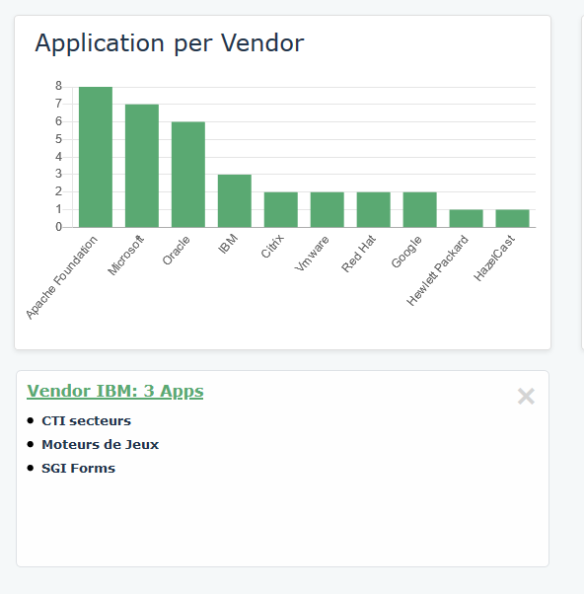

### Indicators

#### Applications

|  |  |
| --- | --- |
|  | Key information |
| Purpose | This widget shows the number of Applications in the selected Portfolio |
| Source JSON file | DatasArrayPortfolioTechnology.js |
| Data structure | * (optional) Portfolio * Application |
| Example |  |

#### Obsolete Applications

|  |  |
| --- | --- |
|  | Key information |
| Purpose | This widget shows the number of Obsolete Applications. This is the list of Applications linked to a Prohibited Technology (linked Software Technology with a ‘Prohibited’ Company Standard) |
| Source JSON file | DatasArrayPortfolioTechnology.js |
| Data structure | * (optional) Portfolio * Application * Technology – Company Standard = Prohibited |
| Example |  |

#### Capabilities

|  |  |
| --- | --- |
|  | Key information |
| Purpose | This widget shows the number of Capabilities supported by the Applications of the selected Portfolio. This is the list of Capabilities linked to at least one Application of the Portfolio. |
| Source JSON file | DatasArrayPortfolioBusinessCapability.js |
| Data structure | * (Optional) Portfolio * Application * Business Capability |
| Example |  |

#### Vendors

|  |  |
| --- | --- |
|  | Key information |
| Purpose | This widget shows the number of Vendors providing Technologies supporting the Applications of the selected Portfolio. This is the list of Org Units typed as Vendor linked to at least one Technology supporting at an Application of the Portfolio. |
| Source JSON file | DatasArrayPortfolioTechnology.js |
| Data structure | * (Optional) Portfolio * Application * Technology * Vendor |
| Example |  |

### Application Evolution

This widget cannot be drilled down.

|  |  |
| --- | --- |
|  | Key information |
| Purpose | This shows the number of Applications by state over time for the selected perimeter(s) |
| Source JSON file | DatasArrayPortfolioTimePeriod.js |
| Data structure | * (optional) Portfolio * Application * Object Life * Time Periods |
| Example |  |

### Technology Compliance

|  |  |
| --- | --- |
|  | Key information |
| Purpose | This shows the number of Technologies supporting Applications of the selected perimeter(s) broken down by Company Standard |
| Source JSON file | DatasArrayPortfolioTechnology.js |
| Data structure | * (optional) Portfolio * Application * Technology – Company Standard |
| Example |  |

### Privacy management

|  |  |
| --- | --- |
|  | Key information |
| Purpose | This shows the number of Application within the selected perimeter(s) that are compliant to the privacy management |
| Source JSON file | DatasArrayPortfolioTechnology.js |
| Data structure | * (Optional) Portfolio * Application   + GDPR Content of Notice   + GDPR Content   Logic   |  |  |  |  | | --- | --- | --- | --- | | Content of Notice / Consent | <empty> | Y | N | | YW | App OK | App OK | App at Risk | | YO | App OK | App OK | App at Risk | | NR | App OK | App OK | App at Risk | | N | App at Risk | App at Risk | App at Risk | | DK | Unknown | Unknown | Unknown | | <empty> | Unknown | Unknown | Unknown | |
| Example |  |

### Applications per Capability

|  |  |
| --- | --- |
|  | Key information |
| Purpose | Shows the number of Applications by Capability. The output is a bar chart filtered on the top 10 Capabilities sorted by descending number of supporting Applications |
| Source JSON file | DatasArrayPortfolioBusinessCapability.js |
| Data structure | * Application * Business Capability |
| Example |  |

### Applications per Vendors

|  |  |
| --- | --- |
|  | Key information |
| Purpose | Shows the number of Applications by Vendor. The output is a bar chart filtered on the top 10 Vendors sorted by descending number of supported Applications |
| Source JSON file | DatasArrayPortfolioTechnology.js |
| Data structure | * Application * Technology * Vendor |
| Example |  |

### Hosting model

|  |  |
| --- | --- |
|  | Key information |
| Purpose | Shows the number of Applications by Hosting model |
| Source JSON file | DatasArrayPortfolioTechnology.js |
| Data structure | * Application – Hosting Model |
| Example |  |

## Technology Obsolescence

|  |  |
| --- | --- |
|  | Key information |
| Purpose | Shows the number of Applications by Technology Obsolescence, which |
| Filter | Lifecycle status |
| Source JSON file | None. The data is generated within the Hopex Descriptor |
| Data structure | * Application – Application Type * Object Lifecyle - Time Period * Technology – End of Support / End of Extended Support   Logic: At a given point in time, if a Technology linked to a given Application is no longer supported, then this Application is obsolete |
| Example |  |

## Strategic Planning

|  |  |
| --- | --- |
|  | Key information |
| Purpose | The report shows an automatic box in box report. This is a graphical view of the Business Capability Map hierarchy.  This is a standard Hopex Report |
| Filter | A list of existing Business Capability Map allows to switch from one to another |
| Source JSON file | None |
| Data structure | * Business Capability Map * Business Capability and their Components to the 4th level |
| Example |  |

## Rationalization

### Rationalization Map

|  |  |
| --- | --- |
|  | Key information |
| Purpose | The report shows an automatic Timed box in box report. This is a graphical view of the Business Capability Map hierarchy, overlayed with the supporting Applications.  This is a standard Hopex Report |
| Filter | * A list of existing Business Capability Map allows to switch from one to another * Portfolio to narrow down the overlayed Applications * Time spots to assess the evolution over time |
| Source JSON file | None |
| Data structure | * Business Capability Map * Business Capability and their Components to the 4th level * For each Business Capability, the supporting Applications within the selected Portfolio, colour coded with their lifecycle status at the selected Time sport |
| Example |  |

### Rationalization Table

|  |  |
| --- | --- |
|  | Key information |
| Purpose | This shows the Application Retirement Plan per Capability |
| Filter | None |
| Source JSON file | DatasArrayBCMRationalization.js |
| Data structure | * Business Capability Map * Business Capability level 1 * Business Capability level 2 * Application – Decommission Date |
| Example |  |

# Indexes Details

## Tree lists

### Overview

A Tree List displays a hierarchical structure through a table. The end user can filter, expand / fold and search.

Only two lists use this rendering:

* Business Capability Maps / Business Capability
* Business Processes

### Structure

These pages which implements jQuery. More details can be found at the following URL <https://js.devexpress.com/Demos/WidgetsGallery/Demo/TreeList/Overview/jQuery/Light/>

The data is generated from an HOPEX post generation script and is stored under the <website folder>/json/

### Capabilities Tree list

#### Rendering

The Capabilities Tree list shows the following information

|  |  |
| --- | --- |
| Column | Key information |
| Business Capability | Business Capabilities hierarchy starting from the Business Capability Maps, through the Business Capability Composition |
| Performance | Performance assessment of relevant Business Capability |
| Execution | Execution assessment of relevant Business Capability |
| Supporting Apps | List of applications linked to the Business Capability as Realisers |
| Modification Date | Last modification date of the Business Capability |

#### Customisation

This page uses the DevEpress JS library. For more details : <https://js.devexpress.com/Demos/WidgetsGallery/Demo/TreeList/Overview/jQuery/Light/>

This page relies on two components:

* The HOPEX Descriptor : HOPEX EA_Index Business Capa Tree List. This contains the HTML and thee Javascript part
* A post generation script “HOPEX EA_Post Generation Script Process and Capa Trees JSON.Macro”. This generates a JSON file containing the data: ../json/DatasArrayBCMHierarchy.js

The structure of this file is as follows:

|  |
| --- |
| var products = [  {  text: "Business Capability Name",  modification_date:"2020/04/14 08:06:35",  performance:"",  execution:"",  link: "F034F0705CF0502C.htm",  id: "F034F0705CF0502C",  parent:"F03JKSLMP5CF0502C ",  applications: [  {text:"Application Name"}  ]  },  ] |

### Processes Tree list

#### Rendering

The Processes Tree list shows the following information

|  |  |
| --- | --- |
| Column | Key information |
| Business Process | Business Process hierarchy, through the Owner Business Process link |
| Performance | Performance assessment of relevant Business Process |
| Execution | Execution assessment of relevant Business Process |
| Supporting Apps | List of applications linked to the Business Process |
| Modification Date | Last modification date of the Business Process |

#### Customisation

This page uses the DevEpress JS library. For more details : <https://js.devexpress.com/Demos/WidgetsGallery/Demo/TreeList/Overview/jQuery/Light/>

This page relies on two components:

* The HOPEX Descriptor : HOPEX EA_Index Business Process Tree List. This contains the HTML and thee Javascript part
* A post generation script “HOPEX EA_Post Generation Script Process and Capa Trees JSON.Macro”. This generates a JSON file containing the data: ../json/DatasArrayBCMHierarchy.js

The structure of this file is as follows:

|  |
| --- |
| var products = [  {  text: "Business Process Name",  modification_date:"2020/04/14 08:06:35",  performance:"",  execution:"",  link: "F034F0705CF0502C.htm",  id: "F034F0705CF0502C",  parent:"F03JKSLMP5CF0502C ",  applications: [  {text:"Application Name"}  ]  },  ] |

## Lists

### Overview

These are flat list of items, showing key attributes or associations

### Structure

The data is being generated from the relevant HOPEX Descriptor.

The rendering is managed by a single HOPEX Descriptor for all lists (HOPEX EA_General_DataTable_JS) and includes:

* Filtering
* Excel export
* Pagination

More information on the “Datatable” java script library: <https://datatables.net/>

### Enterprises list

|  |  |
| --- | --- |
| Column | Key information |
| Business Capability | Name of the Enterprise |
| Comment | Comment of the Enterprise |
| Transformation phase | Transformation Stage defined against the Enterprise |

### Capabilities list

|  |  |
| --- | --- |
| Column | Key information |
| Business Capability | Name of the Business Capability |
| Comment | Comment of the Business Capability |
| Parent | Parent Business Capability |
| Components | List of the Business Capability Components |
| Supporting Applications | List of the supporting Applications (realizer) |

### Processes list

|  |  |
| --- | --- |
| Column | Key information |
| Business Process | Name of the Business Process |
| Code | Comment of the Business Process |
| Owner | Person defined as the Business Process Owner |
| Parent | Parent Business Capability |
| Direct Sub-Process | List of the Business Capability Components |
| Status | Current workflow status of the Business Process |
| Release | Modification date |

### Concepts list

|  |  |
| --- | --- |
| Column | Key information |
| Name | Name of the Concept |
| Subject Area | Business Dictionary containing the Concept |
| Comment | Comment of the Concept |
| Storage Implementation | Business Information Realizing the Concept |
| Implementation | Embedding Business Work Product with their sending and receiving Applications |

### Business Information Map list

|  |  |
| --- | --- |
| Column | Key information |
| Name | Name of the Business Information Map |
| Comment | Comment of the Business Information Map |

### Application portfolios list

|  |  |
| --- | --- |
| Column | Key information |
| Portfolio | Name of the Portfolio typed as Application Portfolio |
| Parent Portfolio | Parent Portfolio |
| Sub Portfolio | List of the Sub Portfolios |
| Applications | List of the Applications listed in the Portfolio |

### Applications list

|  |  |
| --- | --- |
| Column | Key information |
| Application | Name of the Application |
| Code | Code of the Application |
| Version | Version of the Application |
| Current State | Current workflow status of the Application |
| Business Capability | List of Business Capabilities supported by the Application |
| Technology | List of Technologies supporting the Application |

### Projects list

|  |  |
| --- | --- |
| Column | Key information |
| Project | Name of the Project |
| Project Domain | Project Domain the Project belongs to |
| Project Deliverable | List of the Project Deliverable : Application and Project Impact |

### Technology Portfolios list

|  |  |
| --- | --- |
| Column | Key information |
| Portfolio | Name of the Portfolio typed as Technology Portfolio |
| Parent Portfolio | Parent Portfolio |
| Sub Portfolio | List of the Sub Portfolios |
| Technology | List of Technologies listed in the Portfolio |

### Technologies list

|  |  |
| --- | --- |
| Column | Key information |
| Technology | Name of the Technology |
| Vendor | Org Unit typed as Vendor providing the Technology |
| Technology Compliance | Company Standard of the Technology |
| End of Support | End of the Support of the Technology |
| End of Extended Support | End of the Extended Support of the Technology |

### Vendors list

|  |  |
| --- | --- |
| Column | Key information |
| Vendor | Name of the Org unit typed as Vendor |
| Software Technology | List of the Technologies provided by the Vendor |

# Object pages details

## Overview

An Object page is broken down into:

* A breadcrumb on top, showing the hierarchical structure
* A sections menu, allowing quick access to relevant data:
* The sections:
  + Identity: this section displays key attributes
  + Specific sections showing key links around a given object

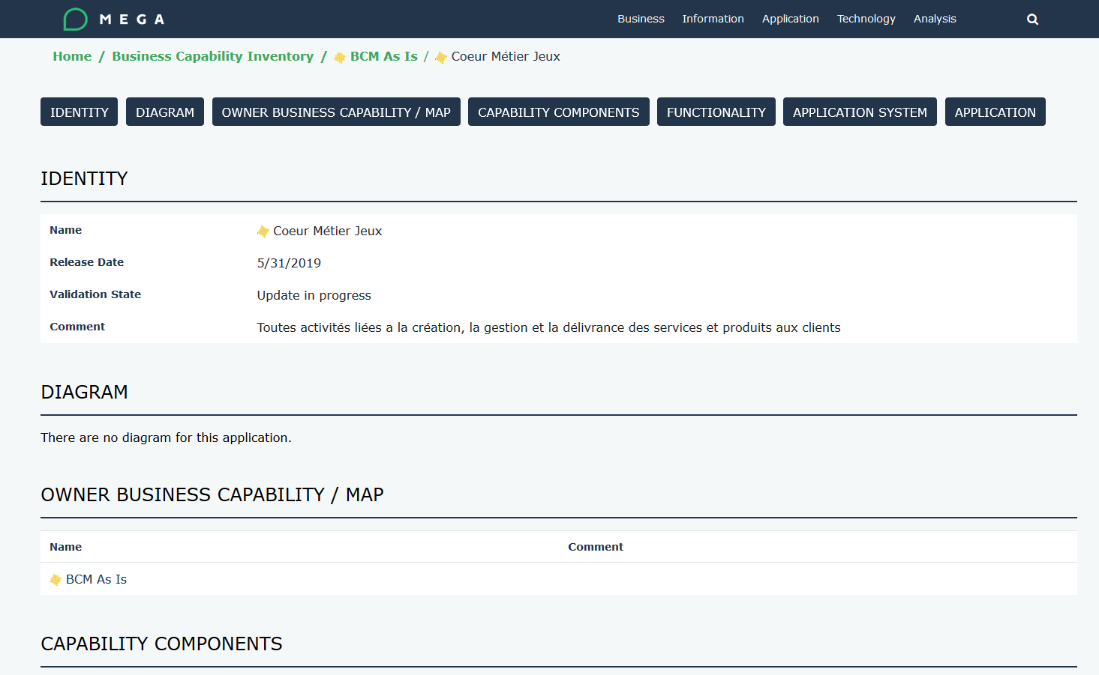

## Business Information Map

|  |  |
| --- | --- |
| Section | Key information |
| Identity | Name  Vision  Mission  Table showing the Theme Goal and Strategy  Business Capability Map |
| Diagram | Enterprise Diagram |
| Transformation Stage | One sub tab per Transformation Stage showing   * Name * Comment * Goal / Objective and Tactic * Projects |
| Reports | * TreeMap * Box in Box * Chord |

## Business Capability Map

|  |  |
| --- | --- |
| Section | Key information |
| Identity | Name  Comment |
| Diagram | Describing diagram |

## Business Capability

|  |  |
| --- | --- |
| Section | Key information |
| Identity | Name  Release Date  Validation State  Comment |
| Diagram | Describing diagram |
| Owner Business Capability / Map | Parent BCM or  Parent Business Capability |
| Functionality | Functionality attached to the Business Capability |
| Application System | Application system supporting the Business Capability |
| Application | Application supporting the Business Capability |

## Business Process

|  |  |
| --- | --- |
| Section | Key information |
| Identity | Name  Code  Parent (link to the Parent Business Process)  Comment  Status  Release Date |
| Diagram | Describing diagram |
| Owner | Person linked to Business Process |
| Sub-process | Component of the Business Process |
| Application | Application supporting the Business Process |

## Concept

|  |  |
| --- | --- |
| Section | Key information |
| Identity | Name  Comment |
| Store | Application store recording the Concept |
| Application Flow | Application flow carrying the Concept through Business Work Product |

## Business Information Map

|  |  |
| --- | --- |
| Section | Key information |
| Identity | Name  Comment |
| Reports | * TreeMap * Box in Box * Chord |

## Application portfolio

|  |  |
| --- | --- |
| Section | Key information |
| Identity | Name  Comment |
| Applications | Application grouped into the Portfolio |
| Lifecycle | Gantt chart of all Application lifecycles of the considered portfolio |

## Technology portfolio

|  |  |
| --- | --- |
| Section | Key information |
| Identity | Name  Comment |
| Technologies | Technologies grouped into the Portfolio |
| Lifecycle | Gantt chart of all Technologies lifecycles of the considered portfolio |

## Application

|  |  |
| --- | --- |
| Section | Key information |
| Identity | Name  Comment |
| Diagram | This section shows:   * First the Impact Force diagram, which is auto generated. This relies on:   + The JSON generated against each App   + The use of a webserver such as IIS      * A tab per Diagram attached to the App |
| Owner | Responsibility Assignments and the relevant users |
| Business Capability | Business Capabilities supported by the Application |
| Business Process | Business Process supported by the Application |
| Project | Projects impacting the Application |
| Version | Versions of the Application, which means Applications linked via the Variations mechanism |
| Interface | List of sent and received application flows |
| Data Store | Data stores touched by the Application |
| Functionality | Functionalities offered by the application |
| Technologies | Technologies grouped into the Portfolio |
| Lifecycle | Gantt chart of all Technologies lifecycles of the considered portfolio. Standard HOPEX Report |
| Technology conflict | Gantt chart highlighting the conflicts between the lifecycles of the Application and its supporting Technologies |

## Project

|  |  |
| --- | --- |
| Section | Key information |
| Identity | Name  Comment |
| Deliverables | List of all deliverables provided by the Project and their Impact |

## Technology

|  |  |
| --- | --- |
| Section | Key information |
| Identity | Name  Code  Company Standard  Vendor (link to the Org Unit typed Vendor)  Type (link to the _Type)  Comment |
| Owner | Person linked to the Technology |
| Lifecycle | Lifecycle of the Technology |
| Using Application | Applications supported by the Technology |

## Vendor

|  |  |
| --- | --- |
| Section | Key information |
| Identity | Name  Email address  Comment |
| Technologies | List of all technologies provided by the Vendor |