STUDY BUDDY PROJECT
MongoDB Connection and Authentication Module
Project Documentation

Introduction
Study Buddy is a web application developed using Node.js, Express.js and MongoDB. This document explains the basic authentication and user-management operations demonstrated in the project. The screenshots are arranged in the same order as the implementation: MongoDB connection, user registration, login, logout, admin registration, user deletion, and the final MongoDB output.

1. MongoDB Connection
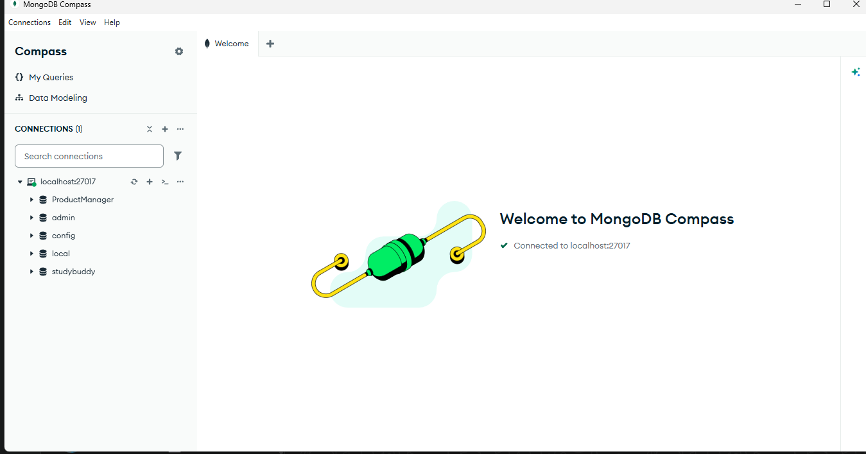
Figure 1: MongoDB Connection
Explanation: The first screenshot shows MongoDB Compass connected successfully to the local MongoDB server at localhost:27017. The Study Buddy database is available in the connection, along with the users and materials collections.
Key points:
- MongoDB Compass is used to view and manage the database.
- The local MongoDB server is running on port 27017.
- The studybuddy database is visible in the left panel.
- The connection is confirmed by the green connected status.

2. User Registration
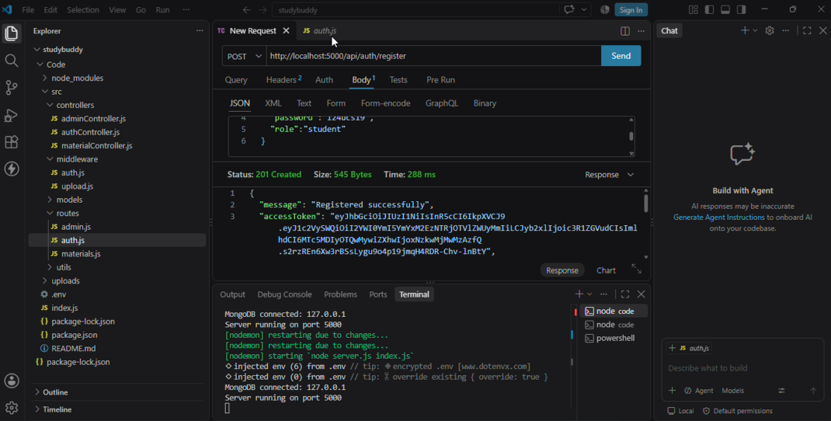
Figure 2: User Registration
Explanation: The second screenshot shows a POST request sent to the registration API endpoint http://localhost:5000/api/auth/register. The request contains user information such as name, email, password and role. The API returns status 201 Created and the message "Registered successfully", which confirms that the new user was created.
Key points:
- HTTP method: POST.
- Registration endpoint: /api/auth/register.
- The user role shown in the request is student.
- A successful registration returns status 201 Created.
- An access token and refresh token are returned by the API.

3. User Login
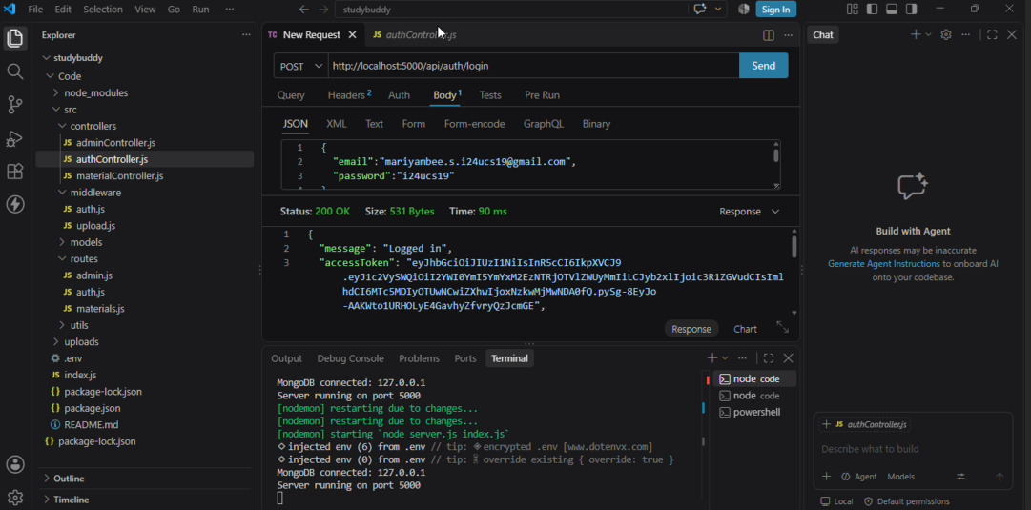
Figure 3: User Login
Explanation: The third screenshot shows the login operation using the authentication API. The request contains the registered email and password. The server returns status 200 OK and the message "Logged in", indicating that the credentials were accepted successfully.
Key points:
- HTTP method: POST.
- Login endpoint: /api/auth/login.
- Email and password are submitted in JSON format.
- A successful login returns status 200 OK.
- The response includes an access token for authenticated requests.

4. User Logout
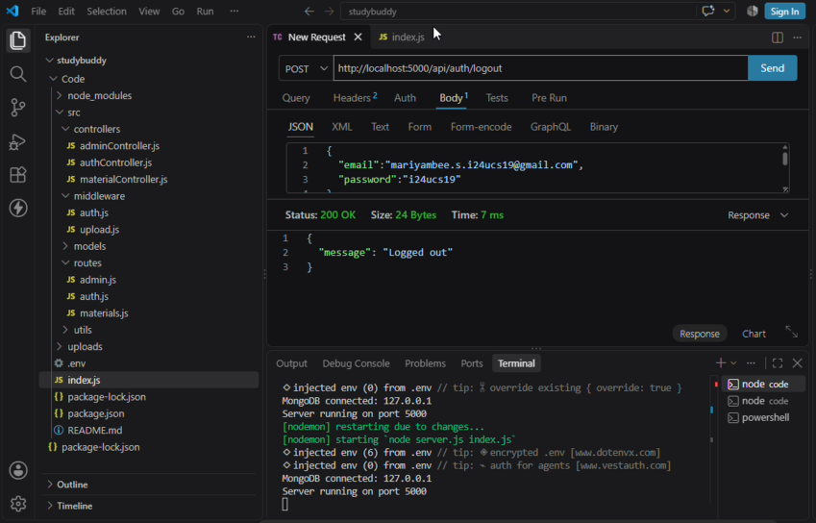
Figure 4: User Logout
Explanation: The fourth screenshot shows the logout operation. A POST request is sent to the logout endpoint. The server returns status 200 OK with the message "Logged out", confirming that the logout request was processed successfully.
Key points:
- HTTP method: POST.
- Logout endpoint: /api/auth/logout.
- The server returns status 200 OK.
- The response message confirms that the user has logged out.

5. Admin Registration
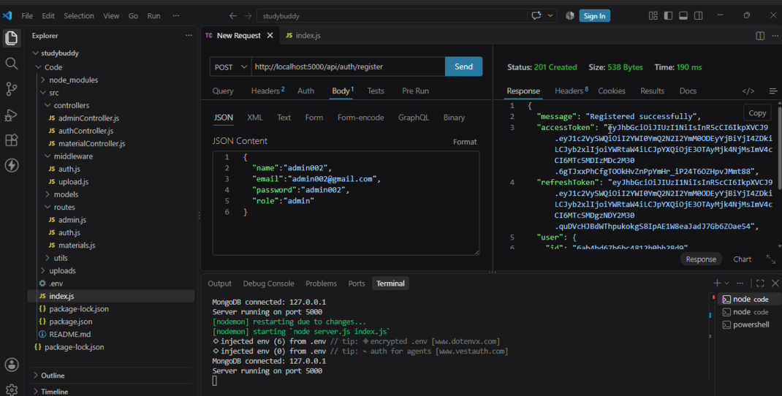
Figure 5: Admin Registration
Explanation: The fifth screenshot shows registration of an administrator account. The JSON request contains the admin name, email, password and the role value "admin". The API returns status 201 Created and a successful registration message. This creates an admin user in the Study Buddy system.
Key points:
- The role is explicitly set to admin.
- The registration request is sent to /api/auth/register.
- The server returns status 201 Created.
- The response contains authentication tokens and user information.

6. User Delete
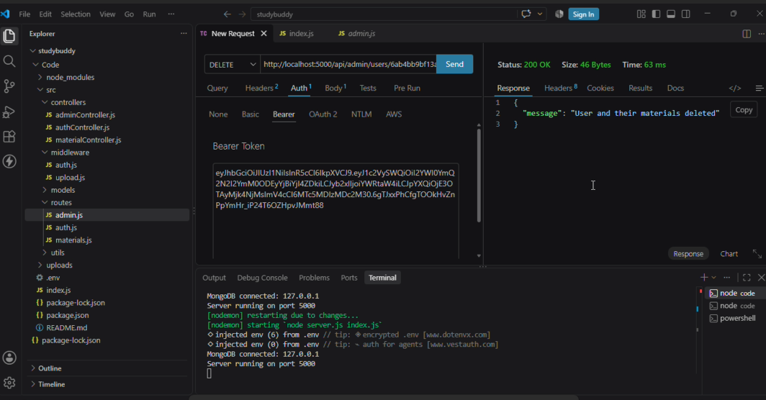
Figure 6: User Delete
Explanation: The sixth screenshot shows the admin delete operation. A DELETE request is sent to the admin API with the selected user's ID. A Bearer access token is supplied for authorization. The server returns status 200 OK and the message "User and their materials deleted", confirming that the selected user and associated materials were removed.
Key points:
- HTTP method: DELETE.
- The request uses an admin API endpoint with a user ID.
- Bearer token authentication is used.
- Status 200 OK confirms successful deletion.
- The response confirms deletion of the user and their materials.

7. MongoDB Output
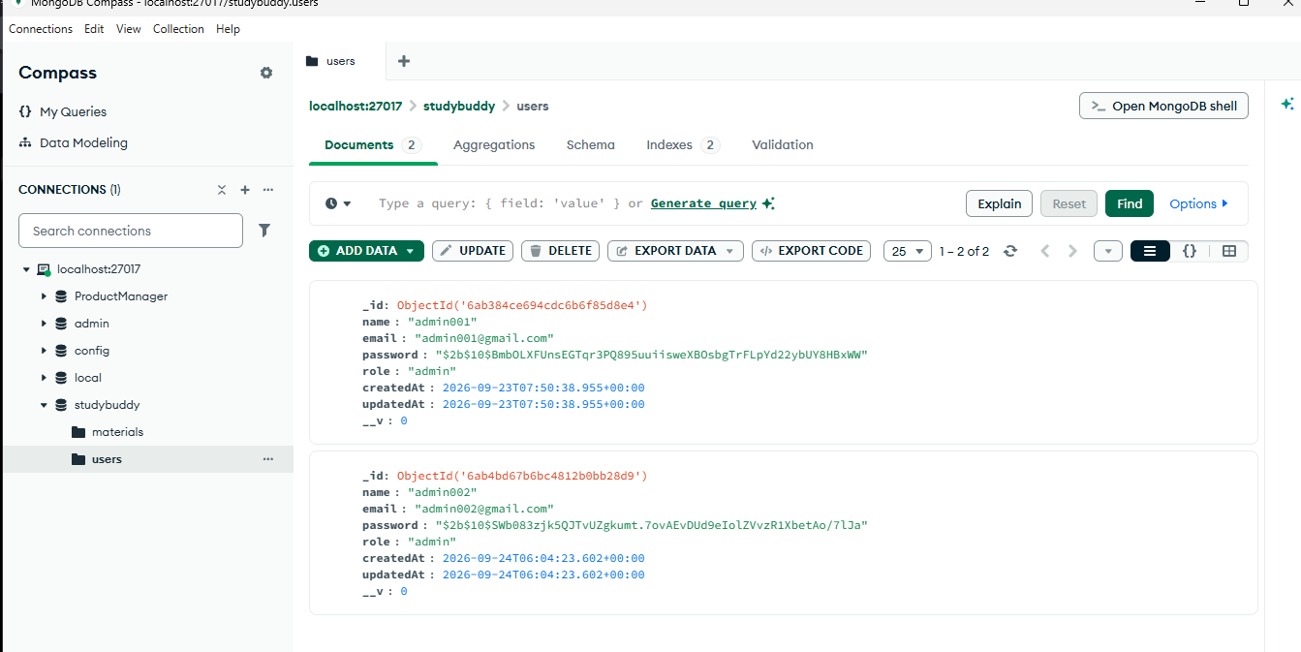
Figure 7: MongoDB Output
Explanation: The final screenshot shows the users collection in MongoDB Compass under the studybuddy database. The collection displays the stored user documents. Each document contains fields such as _id, name, email, password hash, role, createdAt, updatedAt and __v. The screenshot demonstrates that the registered admin users are stored successfully in MongoDB.
Key points:
- Database: studybuddy.
- Collection: users.
- MongoDB automatically provides the _id field for each document.
- The role field identifies the type of user, such as admin.
- Passwords are stored as hashed values rather than plain text.

Authentication Module Flow
- 1. Connect the Node.js application to MongoDB.
- 2. Register a new user with name, email, password and role.
- 3. Login using the registered email and password.
- 4. Receive an access token after successful authentication.
- 5. Logout through the logout API.
- 6. Register an administrator account when required.
- 7. Use authorized admin access to delete a selected user and related materials.
- 8. Verify the stored user data in MongoDB Compass.

Conclusion
The screenshots demonstrate the main authentication and user-management features of the Study Buddy project. MongoDB is successfully connected to the Node.js backend, users can be registered and authenticated, users can log out, administrators can be registered, and authorized administrators can delete users and their associated materials. MongoDB Compass is used to verify the resulting data stored in the users collection.

