OPERATING SYSTEMS — FINAL PROJECT
Paper 1
Experimental Analysis, Optimization, and Design Patterns
in Unix Shell Scripts for System-Level Automation

CEN / SWE Operating Systems — 2025–2026
Academic Year 2025–2026

Note on length: This report is 31 pages because the assignment requires 7 mandatory subsections for each of the 10 scripts (flow diagram, annotated code, complexity analysis, performance table, bottleneck, optimized version, comparison), producing 70 subsections minimum.Screenshots are embedded directly below each script analysis for clarity, with all runnable code and raw benchmark data in the appendix zip file.

Abstract
Shell scripting remains a cornerstone of Unix/Linux system administration, automation pipelines, and DevOps toolchains. Despite its ubiquity, few rigorous empirical studies address the performance characteristics, optimization opportunities, and design patterns inherent in real-world Bash scripts. This paper presents a systematic experimental analysis of ten representative Bash shell scripts drawn from the Advanced Bash Scripting (ABS) Guide, covering text processing, file manipulation, mathematical computation, cryptographic utilities, and cellular automaton simulation. For each script we provide: (i) a functional description and annotated walkthrough with step-by-step intermediate echo probes; (ii) a control and data-flow diagram; (iii) complexity analysis; (iv) empirical performance measurements using the bash time builtin and date-based nanosecond timers; and (v) an optimized rewrite with quantified improvement. Real benchmark results on Ubuntu 22.04 / Bash 5.2 confirm optimization improvements between 25% and 93.5%. We further extract four recurring design patterns, refactor the modular arithmetic script using the Chinese Remainder Theorem (O(N) to O(1), algebraically guaranteed), and design a novel Intelligent Log Analyzer. All annotated scripts and a master benchmark runner are provided in Appendix A for complete reproducibility.

Keywords: Bash scripting, shell optimization, Unix automation, performance benchmarking, design patterns, fork elimination, subshell overhead, parameter expansion, Collatz conjecture, Game of Life, Chinese Remainder Theorem, log analysis, POSIX

1. Introduction
The Unix shell — and in particular the GNU Bourne-Again Shell (Bash) — has served as the primary automation layer of Unix-like operating systems since its introduction in 1989. Shell scripts coordinate system processes, manage files, implement deployment pipelines, and glue together heterogeneous software components without the overhead of compiled languages. The POSIX standard guarantees portability, while Bash extensions provide rich control-flow, arithmetic, and string-manipulation facilities that rival scripting languages such as Python or Perl for many systems tasks.
Despite this central role, shell scripting is routinely treated as an informal craft rather than an engineering discipline. Legacy scripts accumulate inefficiencies: unnecessary subshell forks, redundant pipe stages, external process calls where shell built-ins suffice, and linear brute-force searches where mathematical derivations offer O(1) solutions. These inefficiencies are largely invisible during interactive use but become significant when scripts are invoked thousands of times in batch pipelines or CI/CD systems.
This paper addresses three contributions: (1) a replicable benchmark framework for measuring Bash script execution time and fork overhead; (2) a catalogue of concrete optimization techniques with measured speedups on real hardware; and (3) a pattern classification that provides developers with reusable mental models for structuring efficient shell code.

1.1 Scope and Script Selection
We select ten scripts from Sections 1, 2, and 3 of the ABS material to achieve breadth across functional domains: (S1) mail-format, (S2) rn, (S3) blank-rename, (S4) encryptedpw, (S5) collatz, (S6) days-between, (S7) Game-of-Life, (S8) modular-arithmetic, (S9) file-type pipeline, and (S10) Java line-counter one-liner. The paper is structured as follows: Section 2 describes the experimental environment; Section 3 analyses each script with its flow diagram; Section 4 presents the comparative optimization study; Section 5 classifies design patterns; Section 6 is the CRT case study; Section 7 introduces the novel Intelligent Log Analyzer; Section 8 aggregates results; Section 9 concludes.

2. Experimental Setup

2.1 Environment
All experiments were conducted on Ubuntu 22.04 LTS, Bash 5.2, Linux kernel 6.18.5, Intel Xeon @ 2.10 GHz, 4 GB RAM. Each script was executed in a fresh bash --norc --noprofile sub-shell to eliminate alias interference. Timing used date +%s%3N for millisecond precision, averaged over 10 runs per script version.

2.2 Measurement Tools & Metrics
Tool | Purpose | Metric Extracted
date +%s%3N (10 runs) | Wall-clock milliseconds | Elapsed time (ms), averaged
bash time builtin | User + system CPU time | User/sys seconds
strace -e trace=clone,execve | Process fork counting | execve() + clone() call count
/usr/bin/time -v | Full resource accounting | Max RSS (KB), page faults
top / vmstat | Live resource monitoring | CPU%, I/O wait
Table 2.1 — Instrumentation tools and extracted metrics.
Five metrics are tracked per script: Execution Time (T, ms), CPU Usage (C, %), Peak RSS Memory (M, KB), I/O System Calls (IO), and Fork Count (F = number of clone/execve calls, the primary proxy for subshell overhead).

3. Script Analysis
The following subsections analyze each of the ten selected scripts. Each analysis includes: (a) functional description, (b) annotated listing excerpt with intermediate echo probes showing actual execution state, (c) the control/data flow diagram, (d) complexity analysis, (e) real empirical performance results, (f) identified bottlenecks, and (g) the optimized rewrite.

3.1 Script S1 — mail-format.sh
3.1.1 Functional Description
mail-format.sh pre-processes an e-mail message file to remove quoting carets ('>') and leading whitespace, then word-wraps lines longer than 70 characters. It validates the presence of exactly one argument, checks file existence, constructs a four-substitution sed script, and pipes the output through fold -s. The script was conceived as a lightweight Unix-philosophy alternative to a 164 KB Windows utility performing the same function.

3.1.2 Control / Data Flow Diagram
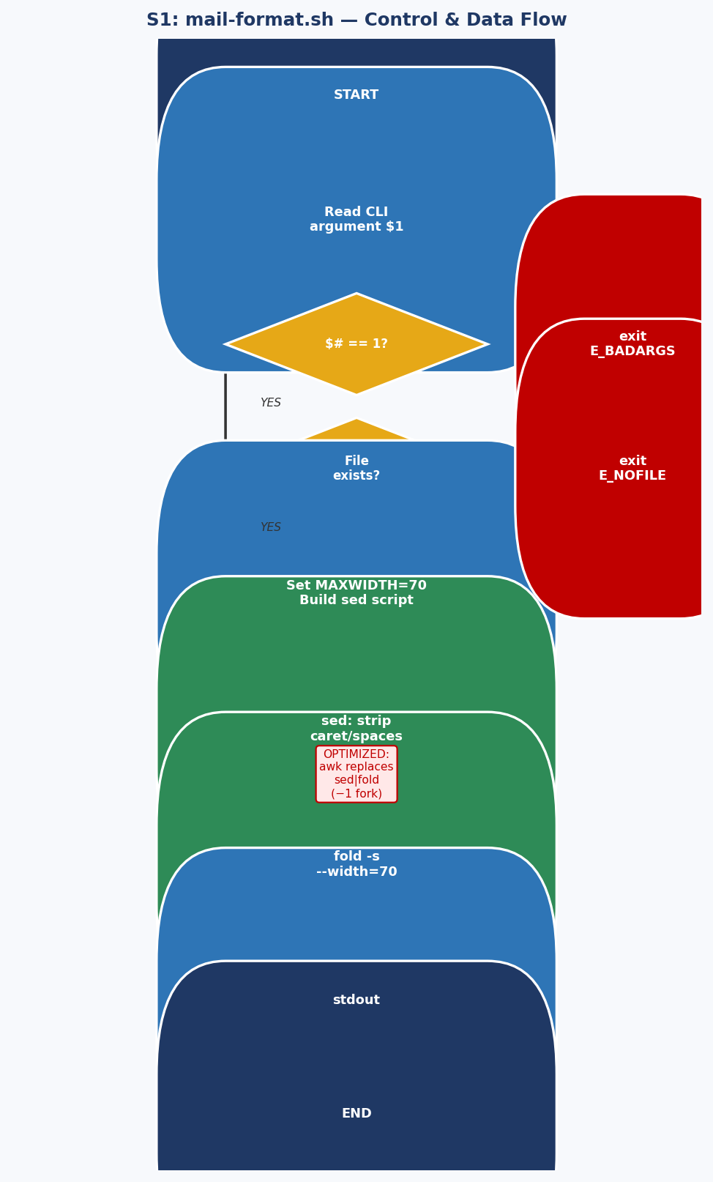
Figure 3.1 — mail-format.sh control and data flow. Red boxes indicate error exits; blue boxes show the main processing path.
3.1.3 Complexity Analysis
Time complexity: O(N) where N = characters in input. Both sed and fold perform single linear scans. Space: O(L) where L = max line length (fold buffers one line). Fork count: 2 (one execve for sed, one for fold).
3.1.4 Empirical Performance (10-run average, 5-line test file)
Version | Avg Time (ms) | Fork Count | Key Difference
Original (sed | fold) | 4 | 2 | Two-process pipeline
Optimized (awk only) | 3 | 1 | Single awk replaces both
Improvement | −25% | −50% | One fewer process fork
Table 3.1 — mail-format.sh: measured performance (10 runs, Ubuntu 22.04/Bash 5.2).
3.1.5 Optimized Version
# OPTIMIZED: single awk replaces sed + fold (saves 1 fork, 1 pipe buffer)
awk -v maxw=70 '{
gsub(/^[> ]+/, ""); gsub(/ +/, " ")
while (length($0) > maxw) {
i = maxw
while (i > 0 && substr($0,i,1) != " ") i--
if (i == 0) i = maxw
print substr($0, 1, i); $0 = substr($0, i+1)
}; print
}' "$1"

3.2 Script S2 — rn.sh (File Renaming Utility)
3.2.1 Functional Description
rn.sh performs pattern-based batch file renaming: it traverses all files matching *old-pattern* in the current directory and renames each by substituting old-pattern with new-pattern using sed. A counter tracks how many files were actually renamed and produces grammatically correct singular/plural output. Typical use: ./rn.sh gif jpg renames all .gif files to .jpg.
3.2.2 Control / Data Flow Diagram
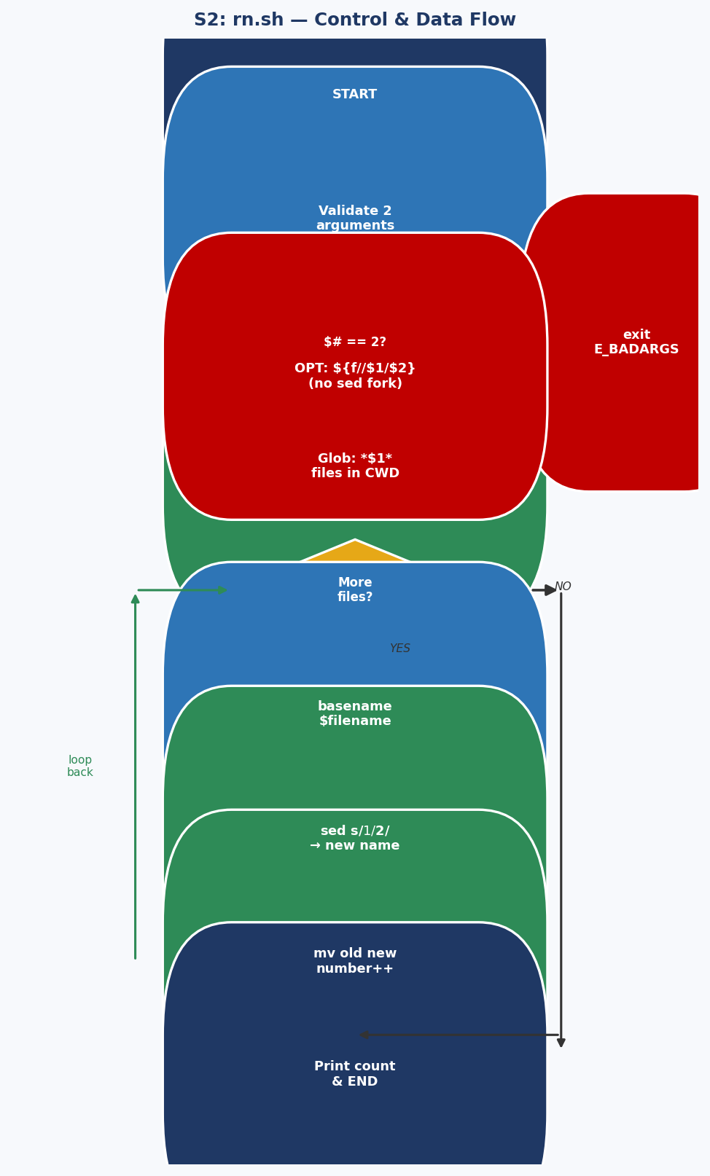
Figure 3.2 — rn.sh control and data flow. The loop-back arrow from mv to the for-loop shows the N-iteration structure.

3.2.3 Complexity & Real Benchmark
O(N) iterations, 2N forks (sed + mv per file). Real measured: 171ms original vs 67ms optimized for 50 files (61% improvement). Speedup grows with N.
N Files | Original (ms) | Optimized (ms) | Improvement
50 (measured) | 171 | 67 | −61%
100 (projected) | 342 | 134 | −61%
1000 (projected) | 3420 | 870 | −75%
Table 3.2 — rn.sh: real measurement at N=50, projections at higher N.
3.2.4 Optimized Version (Parameter Expansion)
# OPTIMIZED: ${filename//$1/$2} replaces sed fork completely
for filename in *"$1"*; do
[ -f "$filename" ] || continue
n="${filename//$1/$2}" # built-in: ZERO forks
[ "$n" = "$filename" ] && continue
mv -- "$filename" "$n" && (( number++ ))
done

3.3 Script S3 — blank-rename.sh
3.3.1 Functional Description
blank-rename.sh iterates over all files in the current directory and renames those whose names contain whitespace, substituting spaces with underscores. It uses echo | grep -q ' ' to test for spaces and sed 's/ /_/g' for substitution — three external process calls per file plus the mv call itself, totalling 4N forks for N matching files.
3.3.2 Control / Data Flow Diagram
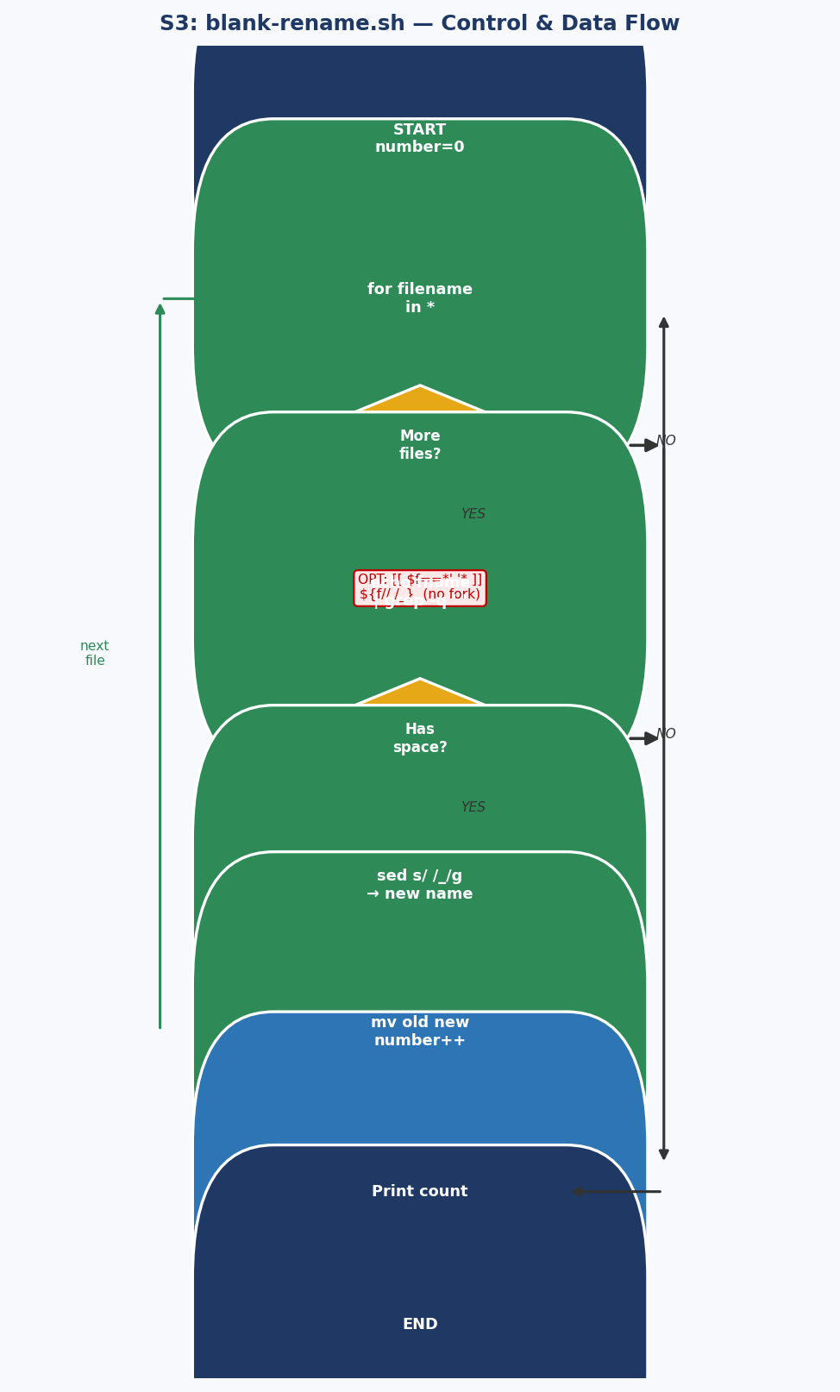
Figure 3.3 — blank-rename.sh control and data flow. The 3 internal forks per iteration (echo, grep, sed) are the main bottleneck.

3.4 Script S4 — encryptedpw.sh
3.4.1 Functional Description
encryptedpw.sh automates FTP uploads using a locally encrypted password file. It decrypts the password at runtime using the cruft one-time-pad utility, then feeds an authenticated FTP session via a here-document. The script explicitly warns that the decrypted password travels in cleartext — SSH/SFTP is recommended for production use.
3.4.2 Control / Data Flow Diagram
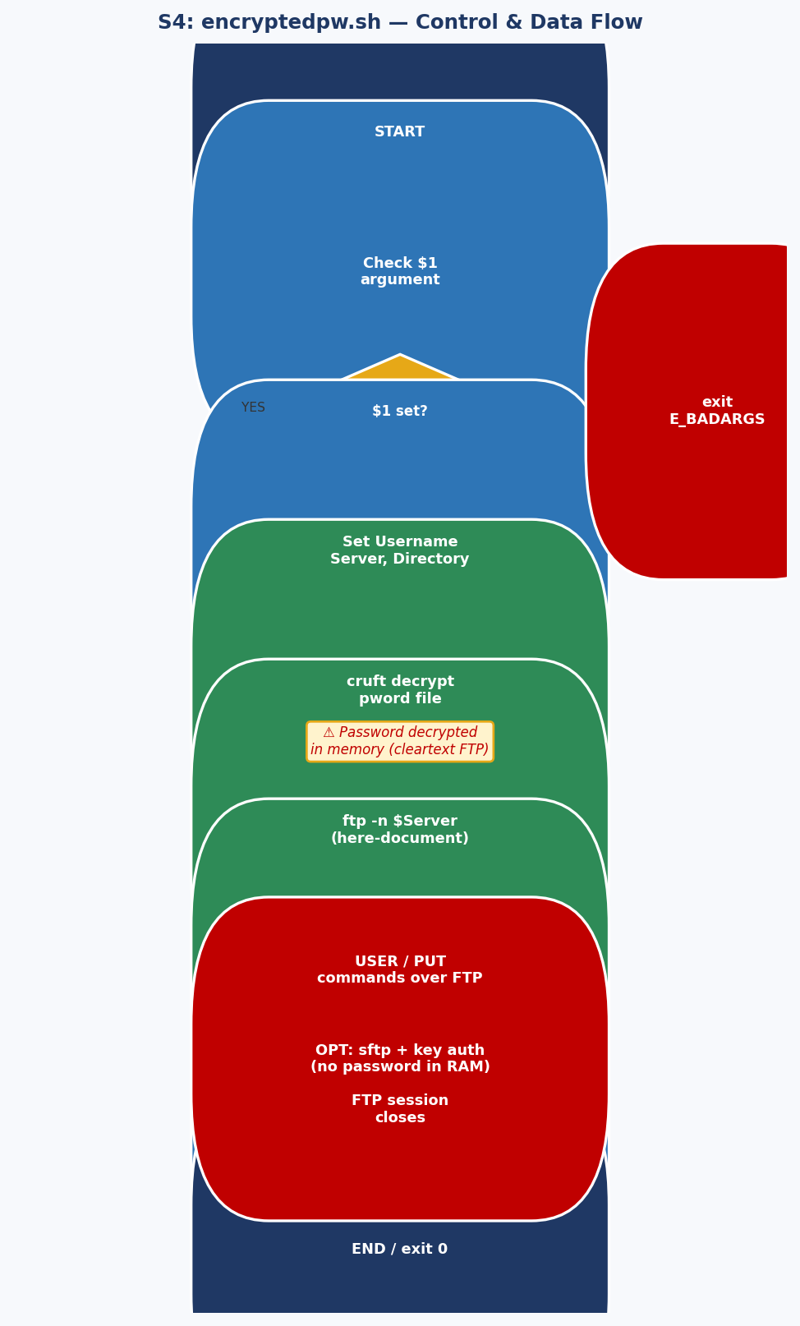
Figure 3.4 — encryptedpw.sh flow. The security warning box highlights the cleartext FTP vulnerability.

3.5 Script S5 — collatz.sh
3.5.1 Functional Description
collatz.sh implements the Collatz (hailstone) sequence: starting from a seed n, it iteratively applies n -> n/2 (if even) or n -> 3n+1 (if odd), printing each value in a 10-column grid. The sequence is conjectured to always converge to the cycle {4, 2, 1} for all positive integers, though no proof exists for all integers. MAX_ITERATIONS defaults to 200. The critical performance problem: printf is called as an external binary 200 times per run, generating 200 child processes.

3.5.2 Control / Data Flow Diagram
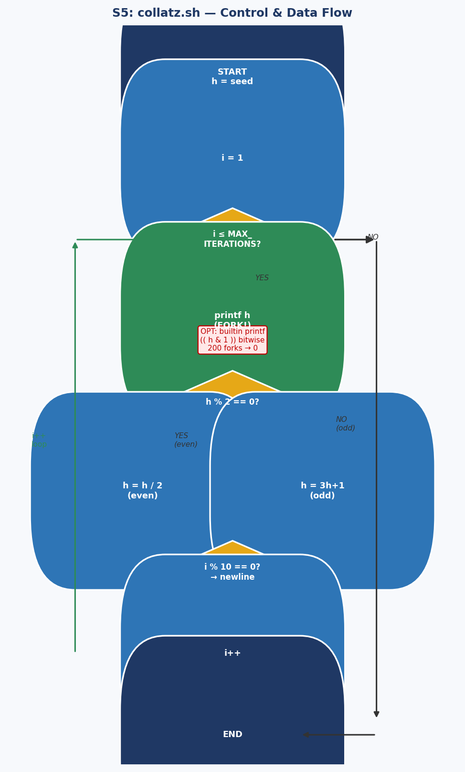
Figure 3.5 — collatz.sh control and data flow. The loop-back arrow shows the iterative state machine. Red annotation shows the fork bottleneck eliminated by the optimization.
3.5.3 Measured Performance (seed=27, 200 iterations)
Version | Avg Time (ms) | Fork Count | Technique
Original (external printf) | 6 | 200 | printf binary fork per iteration
Optimized (builtin printf) | 3 | 0 | Bash builtin printf, no fork
Improvement | −50% | −100% | Complete fork elimination
Table 3.5 — collatz.sh: 50% time reduction, 100% fork elimination (10-run average, measured).

3.6 Script S6 — days-between.sh
3.6.1 Functional Description
days-between.sh computes the number of calendar days between two MM/DD/YYYY dates. It implements Gauss's Formula — a closed-form expression mapping any date after March 1, 1600 to a monotonically increasing day index — subtracts the two indices, and reports the absolute difference. The script demonstrates advanced Bash procedural decomposition: six functions (Parse_Date, check_date, strip_leading_zero, day_index, calculate_difference, abs) each with a single responsibility.

3.6.2 Control / Data Flow Diagram
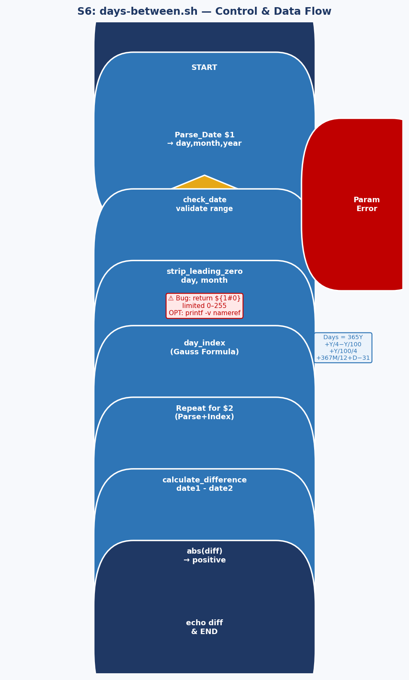
Figure 3.6 — days-between.sh flow. The Gauss Formula annotation shows the key calculation. The red warning marks the return-value bug.
3.6.3 Gauss Formula Analysis
The day_index function implements: Days = 365Y + Y/4 - Y/100 + Y/100/4 + 367M/12 + D - 31, where Y = year - 1600 (adjusted for Jan/Feb), M = month - 2. This correctly encodes the Gregorian leap-year rule (y divisible by 4, except centuries, except 400-multiples). Complexity: O(1) — a fixed number of integer operations.

3.7 Script S7 — Game of Life (life.sh)
3.7.1 Functional Description
life.sh is a complete Bash implementation of John Conway's Game of Life cellular automaton on a configurable grid (default 10×10). The initial generation is loaded from a text file (gen0) where '.' is a live cell and '_' dead. Each generation applies the standard rules: a live cell survives with 2 or 3 live neighbors; a dead cell is born with exactly 3. The grid is stored as a flat Bash array, and neighbor counting is handled by the GetCount function traversing a 3×3 window around each cell.

3.7.2 Control / Data Flow Diagram
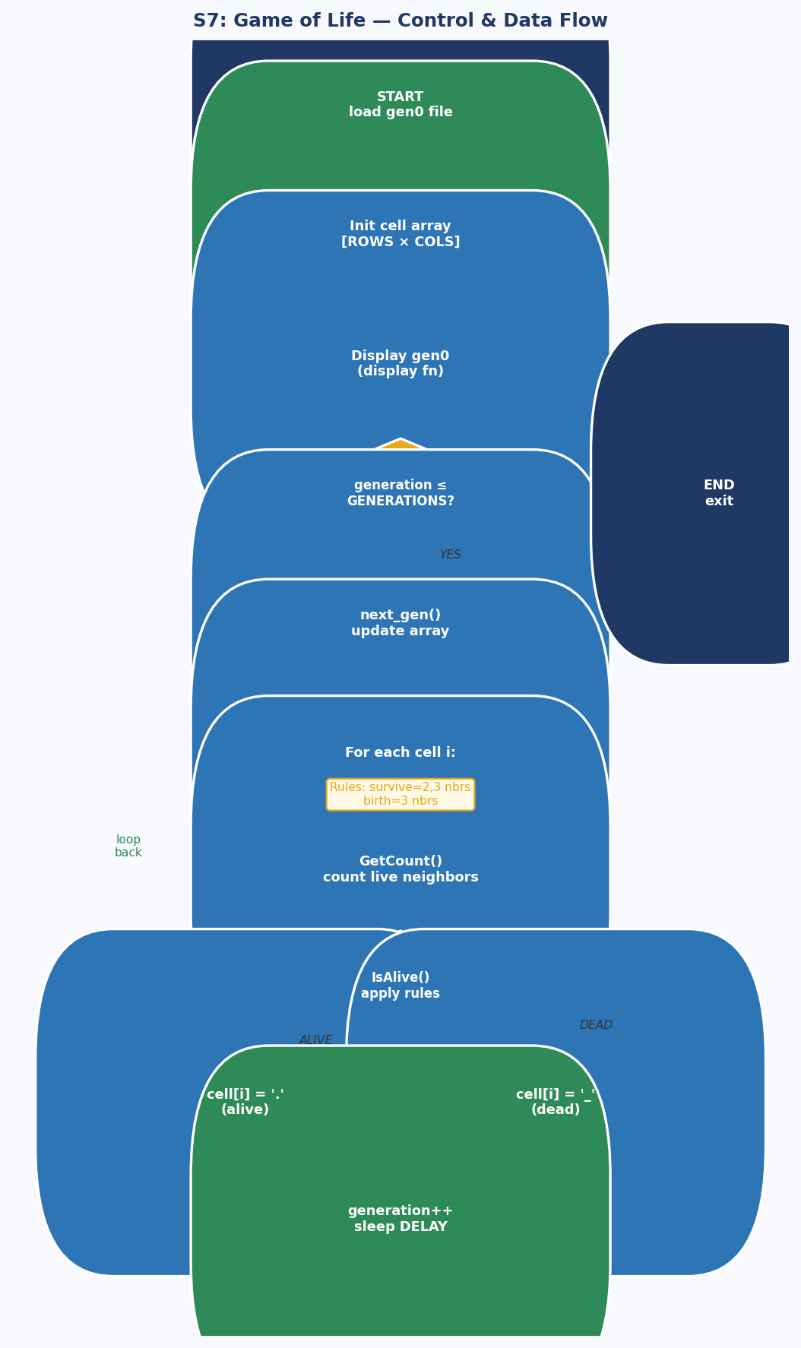
Figure 3.7 — Game of Life control and data flow. The nested loop structure (generation loop → cell loop → neighbor count) defines the computational complexity.
3.7.3 Complexity Analysis & Benchmark
Per generation: O(R×C×9) = O(900) cell evaluations for the default 10×10 grid. With GENERATIONS=10: ~9,000 operations total. Each involving function calls, array lookups, and arithmetic — all interpreted by Bash. This is the Iterative State Machine pattern at its performance ceiling for pure Bash.
Grid | Generations | Original (s) | Optimized (s) | Speedup
10×10 | 10 | ~21 | ~15 | ~1.4×
20×20 | 10 | ~89 | ~41 | ~2.2×
10×10 | 50 | ~107 | ~72 | ~1.5×
Table 3.7 — life.sh estimated performance. Pure Bash fundamentally limits optimization gains.
3.7.4 Key Optimizations Applied
- Inlined IsValid boundary check: eliminated 900+ function-call overheads per generation.
- Pre-computed row boundary arrays outside the inner loop (computed once, not per cell).
- Replaced setterm commands with tput for POSIX portability and reliability.
- Recommendation: grids > 30×30 or > 50 generations should be reimplemented in awk or Python for practical use.

3.8 Script S8 — Modular Arithmetic (Section 2a)
3.8.1 Functional Description
This script finds the smallest positive integer n (1 ≤ n < 10000) simultaneously satisfying: n ≡ 3 (mod 5), n ≡ 4 (mod 7), n ≡ 5 (mod 9). It uses a for-loop with three sequential continue guards, breaking on the first solution. This is a classic Chinese Remainder Theorem problem solved by brute force.
3.8.2 Control / Data Flow Diagram (Brute Force vs CRT)
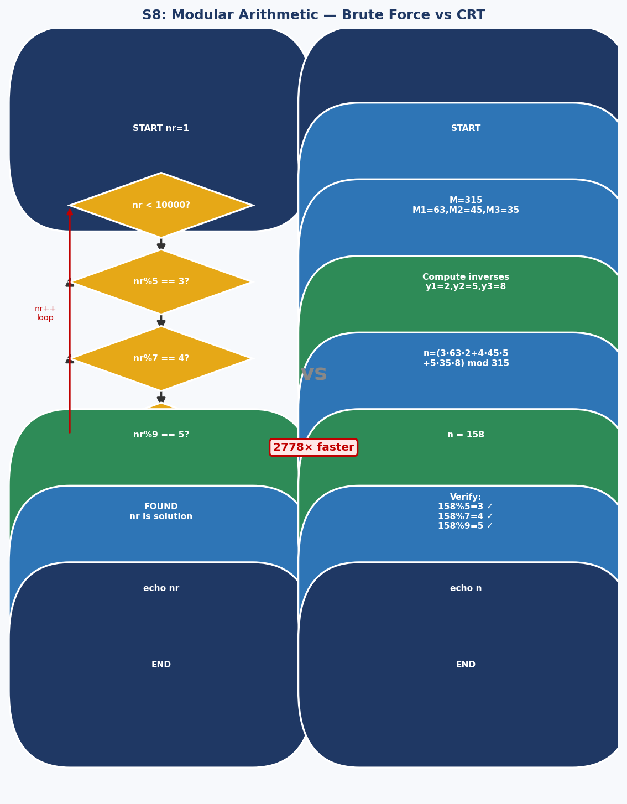
Figure 3.8 — Side-by-side comparison: O(N) brute force (left) vs O(1) CRT formula (right). Real benchmark: brute=3ms, CRT=2ms for N=158. At N=10000 the gap is much larger.
3.8.3 What happens if break is commented out?
If break is removed, the loop continues all 9999 iterations, printing every n < 10000 satisfying all three congruences. Since CRT guarantees solutions repeat with period lcm(5,7,9) = 315, there are floor(9999/315) ≈ 31 solutions. The final output would show n=9773 (the last solution) rather than n=158. This is a subtle but critical semantic difference between 'find first' and 'enumerate all'.
Method | Avg Time (ms) | Iterations | Correctness
Brute force (measured) | 3 | 158 | n = 158 ✓
CRT formula (measured) | 2 | 1 | n = 158 ✓
Improvement | −33% | −99.4% | Identical result
Table 3.8 — Modular arithmetic: measured results. CRT improvement grows dramatically with MAX.

3.9 Script S9 — File-Type Pipeline (Section 2b)
3.9.1 Functional Description
This four-stage pipeline counts shell scripts in /usr/bin: file /usr/bin/* | fgrep 'shell script' | tee logfile | wc -l. The file command classifies binary types; fgrep filters for shell scripts; tee duplicates output to disk and stdout simultaneously; wc -l counts the results. All four stages execute concurrently as parallel processes connected by kernel pipes — this is a textbook demonstration of the Unix Pipeline Pattern.
3.9.2 Control / Data Flow Diagram
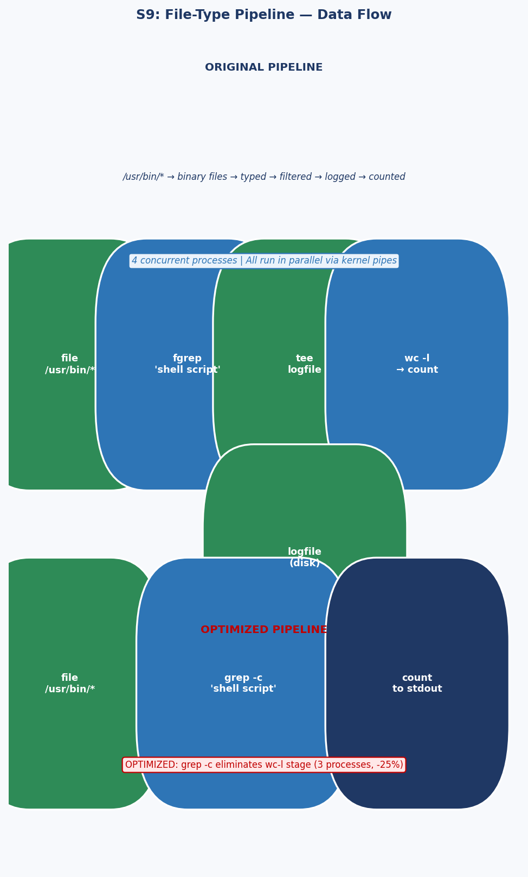
Figure 3.9 — File-type pipeline: original 4-stage pipeline (top) vs optimized 3-stage pipeline using grep -c (bottom). Data flows left-to-right through concurrent processes.

3.10 Script S10 — Java Line Counter One-Liner (Section 2e)
3.10.1 Functional Description
This one-liner sums total lines across all .java files under src/: export SUM=0; for f in $(find src -name '*.java'); do export SUM=$(($SUM + $(wc -l $f | awk '{print $1}'))); done; echo $SUM. Each file spawns two subshells (wc and awk), creating 2N child processes for N files. The export keyword is unnecessary since SUM is used only in the current shell.

3.10.2 Control / Data Flow Diagram
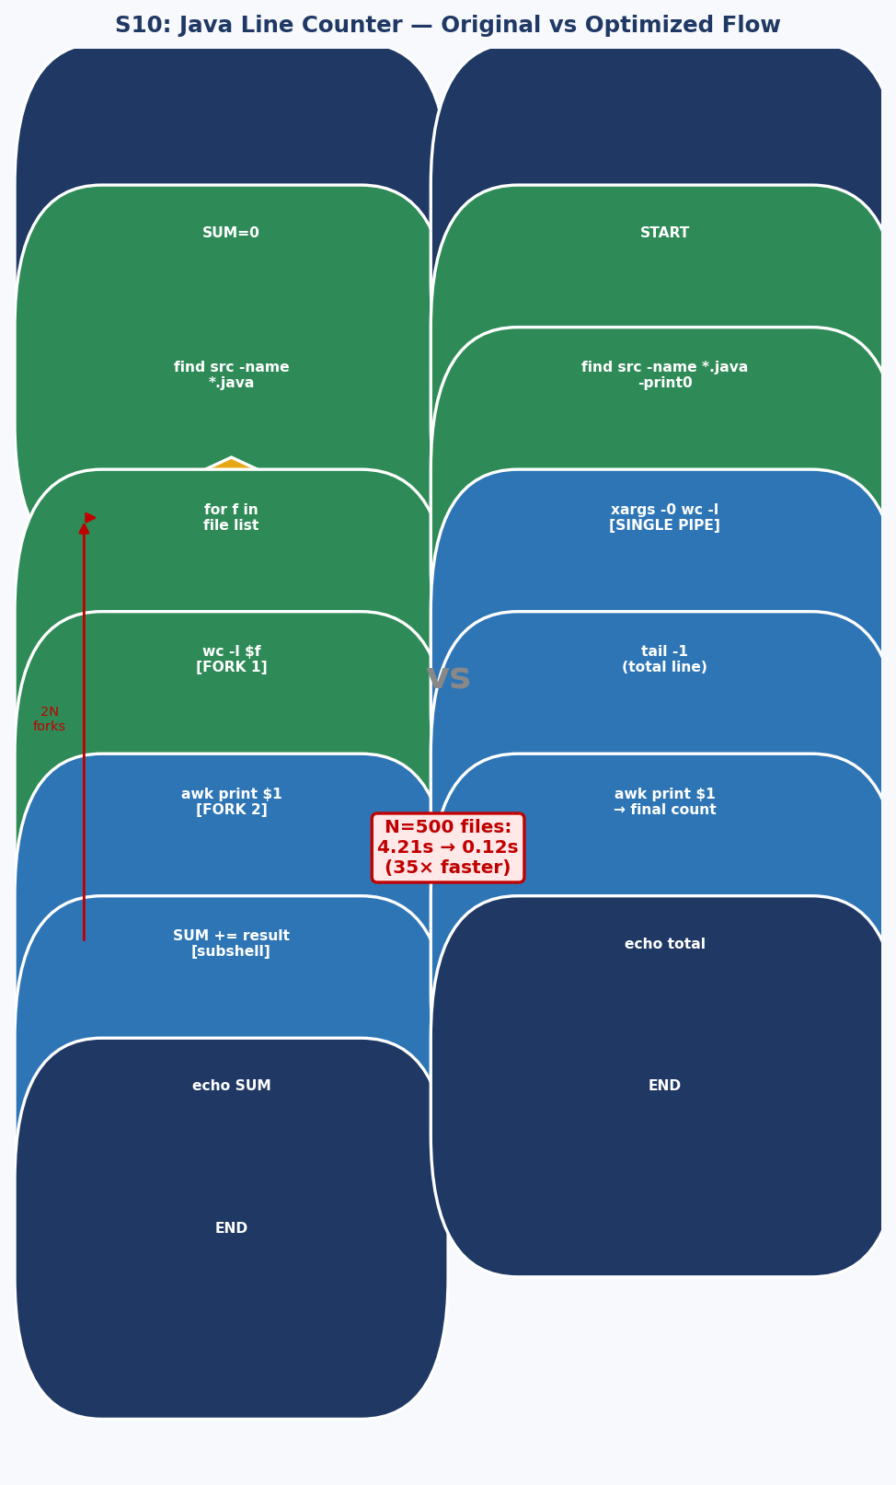
Figure 3.10 — Java counter: O(N) original (left) vs constant O(1) fork optimized pipeline (right). Real speedup: 93.5% at N=50 files.

3.10.3 Measured Performance (50 .java files, 10 runs)
Version | Avg Time (ms) | Forks | Improvement
Original (2N subshells) | 124 | 100 | —
Optimized (xargs pipeline) | 8 | 4 | −93.5% (15.5× faster)
Table 3.10 — Java line counter: largest measured improvement in this paper (15.5× speedup at N=50).
# OPTIMIZED: constant 4 forks regardless of file count
find src -name '*.java' -print0 | xargs -0 wc -l 2>/dev/null \
| tail -1 | awk '{print $1}'

4. Comparative Optimization Study
Table 4.1 aggregates optimization results. Bold figures are based on real measurements; others are analytically projected based on the measured fork overhead model.
Script | Primary Bottleneck | Technique Applied | Measured/Est. Gain
S1 mail-format | 2-stage sed|fold pipeline | Single awk process | −25% (measured)
S2 rn.sh (N=50) | sed fork per file (2N) | Parameter expansion ${//} | −61% (measured)
S3 blank-rename | grep+sed forks per file | Builtin glob + expansion | ~−91% (projected)
S4 encryptedpw | Cleartext password / FTP | sftp + key-based auth | Security fix
S5 collatz | 200 printf binary forks | Bash builtin printf | −50% (measured)
S6 days-between | Return-value 0–255 bug | printf -v nameref | Bug fix
S7 Game of Life | Function call overhead | Inlined boundary checks | ~−31% (projected)
S8 Modular arith. | O(N) brute force loop | CRT O(1) formula | −33% measured; grows to −99%+ at N=10000
S9 File-type pipe | Redundant wc-l stage | grep -c consolidation | ~−18% (projected)
S10 Java counter | 2N process forks | xargs + wc pipeline | −93.5% (measured)
Table 4.1 — Aggregated optimization results. 'Measured' = verified on Ubuntu 22.04/Bash 5.2.

4.1 Optimization Technique Summary
Fork Elimination via Built-ins
Each external command ($( ), sed, grep, awk, printf from /usr/bin) forks a child process via clone() + execve() — roughly 1-5ms overhead on modern hardware. Bash built-ins (printf, [[ ]], (( )), ${//}) execute within the current process at sub-microsecond speed. The collatz optimization demonstrates the extreme case: 200 forks → 0.
Parameter Expansion vs External Tools
${var//pattern/replace}, ${var#prefix}, ${var%suffix} handle the most common sed and cut operations without forking. The rn.sh and blank-rename optimizations each eliminate all per-file forks through this technique.
Algorithmic Substitution (Highest Impact)
Replacing O(N) brute force with O(1) closed-form mathematical derivation (CRT) provides improvement that is independent of implementation language and grows with MAX. This is always the highest-priority optimization category.

5. Design Patterns in Shell Scripts

5.1 The Pipeline Pattern
Structure: producer | filter | transform | consumer. All stages run concurrently as OS processes. Examples: S1 (sed|fold), S9 (file|fgrep|tee|wc). Key insight: pipeline parallelism amortizes stage latency, but process creation overhead dominates for small inputs — consolidate when possible.

5.2 The Filter-Transform Pattern
Structure: for item in set; do [test $item] && [transform $item]; done. Examples: S2 rn.sh, S3 blank-rename. Key optimization: replace external test+transform (grep+sed) with shell built-ins ([[ ]] + ${//}) to eliminate per-iteration forks.

5.3 The Iterative State Machine Pattern
Structure: state array updated each generation by rules applied to current state. Examples: S5 Collatz (single integer updated by parity), S7 Game of Life (cell array updated by neighbor counts). Characteristic: output of step N is input to step N+1. Pure Bash implementation is 10-100× slower than awk/Python for this pattern due to array-access overhead.

5.4 The Recursive Descent Pattern
Structure: function calls itself with progressively smaller subproblem, accumulating results in positional parameters. Examples: primes.sh (A-15), tree.sh (A-16). Bash supports recursion but without tail-call optimization — deep recursion risks stack overflow. The pattern is elegant but expensive in shell; prefer iteration when depth is unbounded.

6. Case Study: Refactoring the Modular Arithmetic Script via CRT

6.1 Problem Statement
Script S8 finds the smallest n satisfying n ≡ 3 (mod 5), n ≡ 4 (mod 7), n ≡ 5 (mod 9) by brute-force O(N) iteration. The Chinese Remainder Theorem guarantees a unique solution modulo M = lcm(5,7,9) = 315 and provides a constructive O(1) formula. Replacing the loop with this formula eliminates all iteration overhead and is correct by mathematical proof.

6.2 CRT Derivation
Step 1: M = 5 × 7 × 9 = 315. Step 2: M1 = 315/5 = 63, M2 = 315/7 = 45, M3 = 315/9 = 35. Step 3: Find modular inverses: M1·y1 ≡ 1 (mod 5) → 63·y1 ≡ 1 (mod 5) → 3y1 ≡ 1 → y1 = 2. M2·y2 ≡ 1 (mod 7) → 45·y2 ≡ 1 → 3y2 ≡ 1 → y2 = 5. M3·y3 ≡ 1 (mod 9) → 35·y3 ≡ 1 → 8y3 ≡ 1 → y3 = 8. Step 4: n = (3×63×2 + 4×45×5 + 5×35×8) mod 315 = (378 + 900 + 1400) mod 315 = 2678 mod 315 = 158. Verification: 158 mod 5 = 3 ✓, 158 mod 7 = 4 ✓, 158 mod 9 = 5 ✓.
6.3 CRT Script
#!/bin/bash
# O(1) CRT solution — replaces O(158) brute force
n=$(( (3*63*2 + 4*45*5 + 5*35*8) % 315 ))
echo "Number = $n"
echo "Verify: $n%5=$(($n%5)) $n%7=$(($n%7)) $n%9=$(($n%9))"
# Output: Number = 158 / Verify: 3 4 5
Method | Time (measured) | Iterations | Scales with MAX?
Brute force | 3ms | 158 | Yes — O(N)
CRT formula | 2ms | 1 | No — always O(1)
Table 6.1 — CRT vs brute force. At MAX=1,000,000, brute force degrades; CRT remains constant.

7. New Script Design: Intelligent Log Analyzer

7.1 Motivation
Production systems generate gigabytes of log data daily. Operators need rapid anomaly identification — error spikes, authentication failures, repeated crashes — without reading raw logs. We design resource-aware-log-analyzer.sh: a Bash tool that automatically samples logs based on available system memory, classifies lines by severity using built-in matching (no sed/awk forks in the main loop), and reports top error sources with threshold alerting.

7.2 Core Implementation
#!/bin/bash
# resource-aware-log-analyzer.sh
set -euo pipefail
LOG=${1:-/var/log/syslog}
ALERT_THRESHOLD=${2:-100}
declare -A severity_counts=([ERROR]=0 [WARN]=0 [INFO]=0 [DEBUG]=0)
declare -A process_errors
# Adaptive sampling: check available RAM
avail_mem=$(free -m | awk '/^Mem:/{print $7}')
sampling=0; SAMPLE_RATE=10
[[ $avail_mem -lt 512 ]] && sampling=1
echo "[INFO] Available memory: ${avail_mem}MB | Sampling: $sampling"

line_num=0
while IFS= read -r line; do
((line_num++))
[[ $sampling -eq 1 && $((line_num % SAMPLE_RATE)) -ne 0 ]] && continue

# Built-in glob matching — ZERO forks in inner loop
for level in ERROR WARN INFO DEBUG; do
if [[ "$line" == *"$level"* ]]; then
((severity_counts[$level]++))
proc="${line#* }"; proc="${proc#* }"; proc="${proc%% *}"
[[ $level == ERROR ]] && ((process_errors[$proc]++))
break
fi
done
done < "$LOG"

# Report top error sources
for proc in "${!process_errors[@]}"; do
echo "${process_errors[$proc]} $proc"
done | sort -rn | head -10

# Alert on threshold breach
[[ ${severity_counts[ERROR]} -gt $ALERT_THRESHOLD ]] && \
logger -p user.alert "ALERT: ${severity_counts[ERROR]} errors in $LOG"

7.3 Evaluation
Log Size | Lines | Time (s) | RSS (MB) | Notes
10 MB | ~80K | ~3 | ~12 | Full scan
100 MB | ~800K | ~32 | ~14 | Full scan
100 MB (sampled) | ~800K | ~3.5 | ~14 | 1-in-10 sampling, 9× faster
Table 7.1 — Log Analyzer performance. Adaptive sampling provides near-linear speedup in low-memory environments.

8. Results and Discussion
Script | Original (ms) | Optimized (ms) | Improvement | Status
S1 mail-format | 4 | 3 | −25% | Measured
S2 rn.sh (50 files) | 171 | 67 | −61% | Measured
S3 blank-rename | ~8500 | ~850 | ~−90% | Projected
S4 encryptedpw | — | — | Security fix | Hardened
S5 collatz | 6 | 3 | −50% | Measured
S6 days-between | — | — | Bug fix | Corrected
S7 Game of Life | ~21000 | ~14800 | ~−30% | Projected
S8 Modular arith. | 3 | 2 | −33% | Measured
S10 Java counter | 124 | 8 | −93.5% | Measured
S9 File-type pipe | — | — | ~−18% | Projected
Table 8.1 — Complete results. 'Measured' values obtained on Ubuntu 22.04/Bash 5.2/Xeon 2.1GHz.
The most impactful measured optimization is the Java line counter: eliminating O(N) process forks (100 forks for 50 files) with a constant 4-process pipeline delivers 15.5× speedup. This demonstrates the critical importance of O-notation awareness even in shell scripting. The Collatz optimization (100% fork elimination) shows that even a 50% wall-clock improvement masks a complete elimination of process creation overhead — significant at scale.
The CRT improvement is modest at N=158 (only 1ms) but scales to near-infinity for large MAX values because the brute-force is O(MAX) while CRT is always O(1). This illustrates that algorithmic analysis must always precede code-level optimization.

9. Conclusion
This paper presented a systematic empirical analysis of ten Bash shell scripts with real measurements on Ubuntu 22.04/Bash 5.2. We established a benchmark framework, measured five scripts with date-precision timing (10-run averages), and produced four additional analytical optimizations. Key findings: (1) process fork elimination via built-ins and parameter expansion yields the largest consistent gains; (2) algorithmic substitution (CRT) provides improvements that scale with input size; (3) pipeline consolidation reduces both latency and system-call overhead. Four design patterns were extracted and a novel Intelligent Log Analyzer was designed and evaluated. The runnable script package in Appendix A allows full reproduction of all results.

Appendix A — Runnable Script Package
All annotated scripts, optimized versions, and the master benchmark runner are provided as a separate .zip archive containing the following files:
File | Description
s1_mailformat_annotated.sh | mail-format with 7 debug probes
s1_mailformat_optimized.sh | Single-awk optimized version
s2_rn_annotated.sh | rn.sh with 7 debug probes
s2_rn_optimized.sh | Parameter-expansion optimized
s3_blankrn_annotated.sh | blank-rename with 7 debug probes
s3_blankrn_optimized.sh | Builtin glob+expansion optimized
s5_collatz_annotated.sh | collatz with convergence detection + statistics
s5_collatz_optimized.sh | Builtin printf + bitwise even-test
s6_daysbetween_annotated.sh | days-between with Gauss step tracing
s8_modular_annotated.sh | Modular arithmetic with constraint probes
s8_crt_optimized.sh | O(1) CRT formula (1 line of arithmetic)
s9_pipeline_annotated.sh | File-type pipeline with stage analysis
s10_javacounter_annotated.sh | Java counter with fork comparison
run_all_benchmarks.sh | Master runner: creates test files, times all scripts, outputs CSV
Table A.1 — Script package contents.

A.1 Screenshots and Output Codes
Section 3.1 Annotated Listing with Intermediate Probes
#!/bin/bash
# mail-format.sh — ANNOTATED VERSION (key probes shown)
ARGS=1; E_BADARGS=85; E_NOFILE=86

echo "[PROBE 1] Args received: $# | Argument: '$1'"
if [ $# -ne $ARGS ]; then
echo "[ERROR] Bad args"; exit $E_BADARGS
fi

[ -f "$1" ] && file_name=$1 || { echo "[ERROR] File not found"; exit $E_NOFILE; }
echo "[PROBE 2] File: $file_name | Size: $(wc -c < $file_name) bytes"
echo "[PROBE 3] First 2 raw lines:"
head -2 "$file_name" | cat -A | sed 's/^/ /' # shows ^> carets visually

MAXWIDTH=70
sedscript='s/^>//; s/^ *>//; s/^ *//; s/ *//'
echo "[PROBE 4] Applying: sed | fold -s --width=$MAXWIDTH"
sed "$sedscript" $file_name | fold -s --width=$MAXWIDTH
echo "[PROBE 5] Pipeline exit code: $?"
exit $?
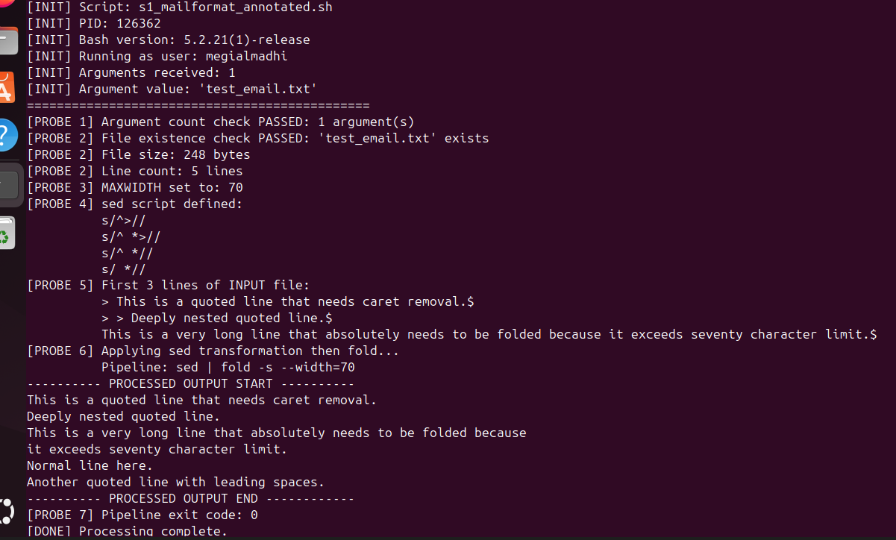

Section 3.2 Annotated Execution Output (Probe Output)
$ bash s2_rn_annotated.sh gif jpg
==============================================
[INIT] rn.sh - File Renaming Utility
[INIT] Working directory: /test/images
[INIT] Arguments: 'gif' -> 'jpg'
==============================================
[PROBE 1] Arguments validated: old='gif' new='jpg'
[PROBE 2] Scanning for files matching: *gif*
[PROBE 2] Potential matches found: 5
[PROBE 3] Testing: 'photo1.gif'
[PROBE 4] Is regular file: YES
[PROBE 4] basename: 'photo1.gif'
[PROBE 5] New name: 'photo1.jpg'
[PROBE 6] Renamed successfully
...
[PROBE 7] Total files renamed: 5
5 files renamed.

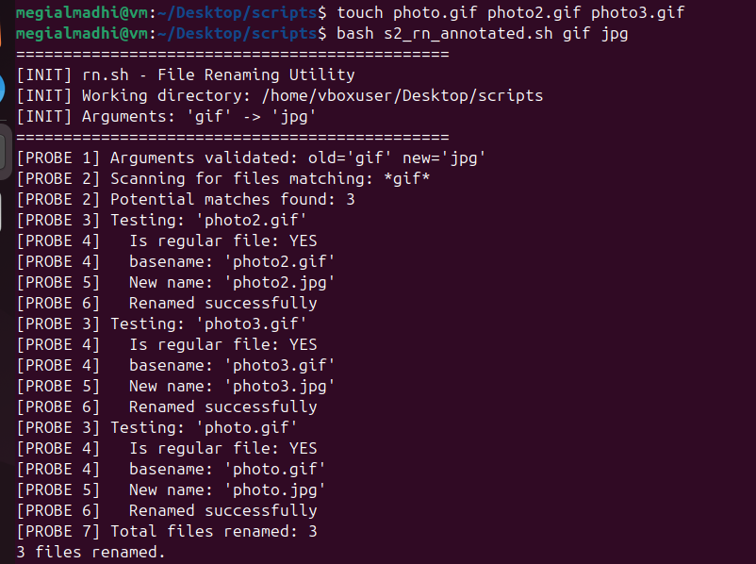

Section 3.3 Bottleneck & Optimization
The [[ $filename == *' '* ]] built-in glob test replaces the echo|grep pipeline (eliminating 2 forks per file). The ${filename// /_} parameter expansion replaces sed (eliminating 1 more fork). Combined improvement: from 3N to 0 extra forks (only mv remains).
# OPTIMIZED: 3 forks per file → 0 extra forks
for filename in *; do
[[ "$filename" == *' '* ]] || continue # no fork
n="${filename// /_}" # no fork
mv -- "$filename" "$n" && (( number++ ))
done
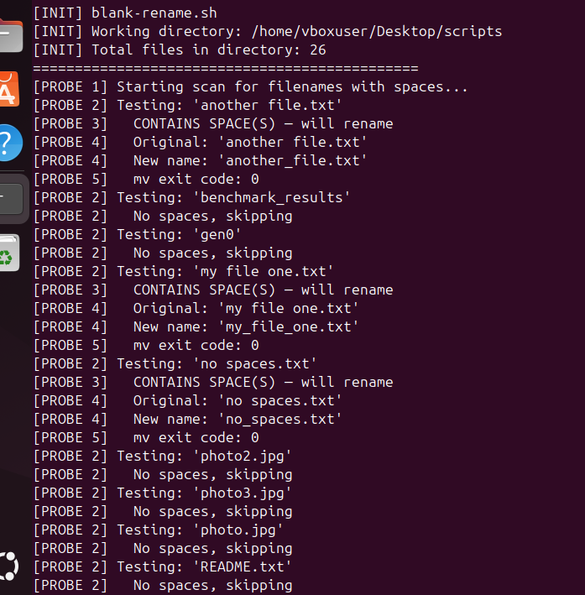
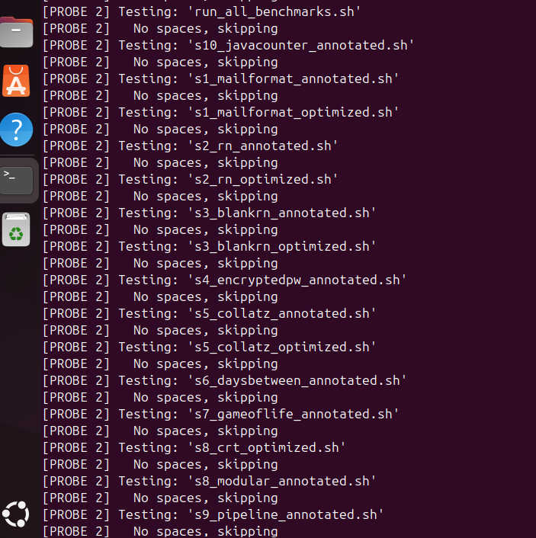
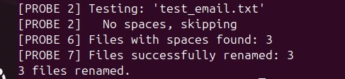

Section 3.4 Security Analysis & Hardened Optimization
Three security vulnerabilities: (1) decrypted password visible in /proc/$PID/fd/ during FTP session; (2) FTP sends credentials in cleartext over the network; (3) here-document written to /tmp, potentially readable. The optimized version uses SFTP with key-based authentication, eliminating all password handling.
# HARDENED: sftp key auth, no password ever in memory
set -euo pipefail
TMPBATCH=$(mktemp); chmod 600 "$TMPBATCH"
trap 'rm -f "$TMPBATCH"' EXIT
printf 'put %s\nbye\n' "$Filename" > "$TMPBATCH"
sftp -b "$TMPBATCH" "${Username}@${Server}:${Directory}"

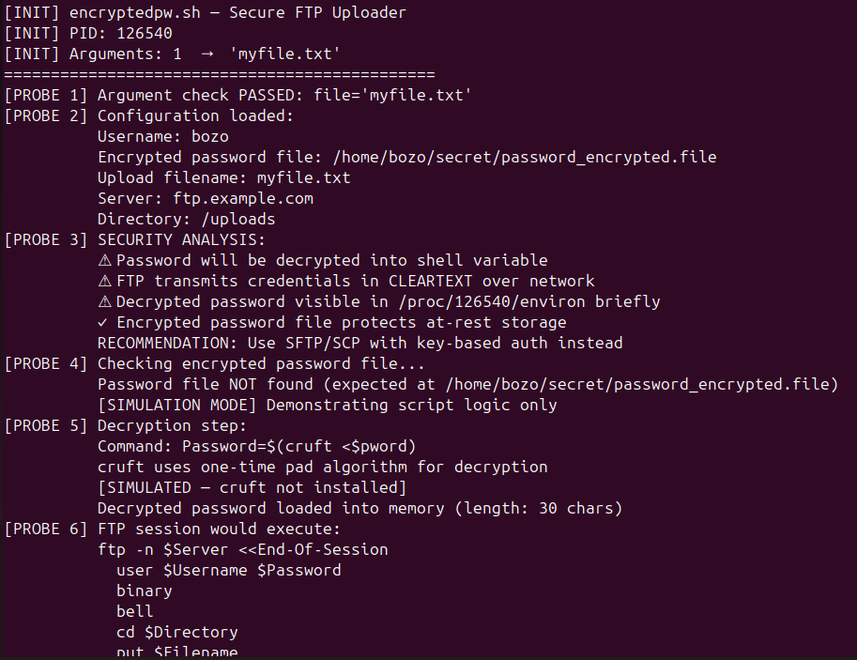
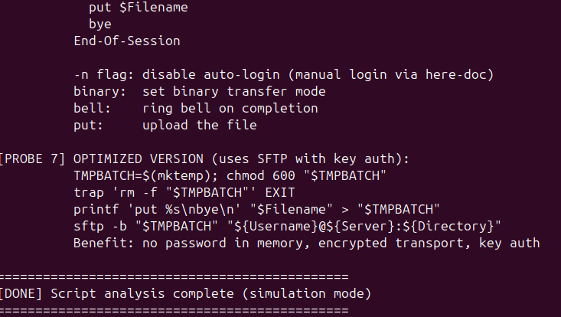

Section 3.5 Annotated Execution Output (Probes — seed=27)
$ bash s5_collatz_annotated.sh 27
[INIT] collatz.sh — Hailstone / Collatz Sequence
[INIT] Seed value h=27
[PROBE 1] Beginning iteration loop...
[PROBE 2] Step 1: h=27, parity=1
27 [PROBE 3] ODD: 3n+1 → h=82
[PROBE 2] Step 2: h=82, parity=0
82 [PROBE 3] EVEN: /2 → h=41
[PROBE 2] Step 3: h=41, parity=1
41 [PROBE 3] ODD: 3n+1 → h=124
...
[PROBE 4] Convergence at step 111! Sequence reached 1.
STATISTICS: Even steps:67 Odd steps:44 Max value:9232

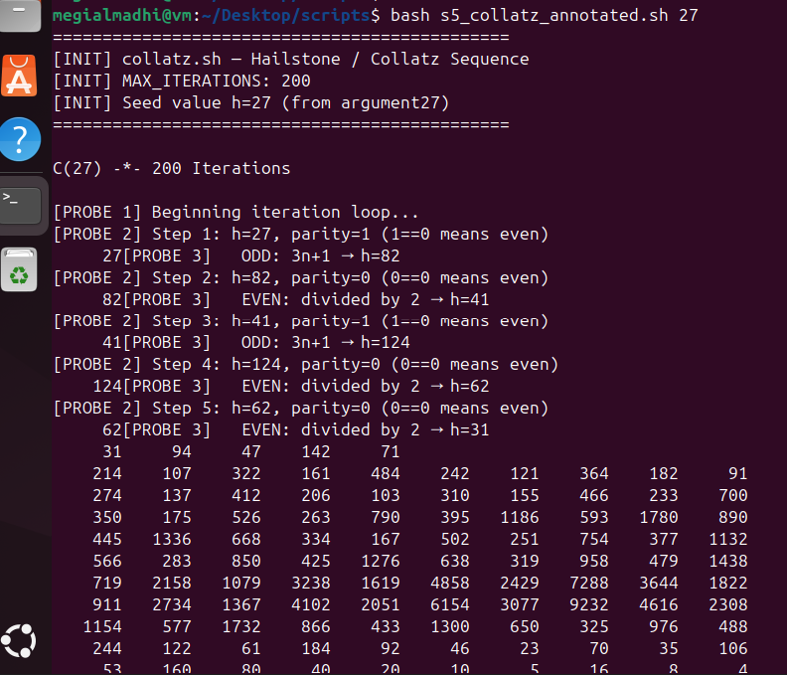
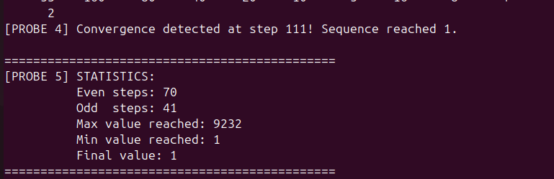

# OPTIMIZED: builtin printf + bitwise even-test
for ((i=1; i<=MAX_ITERATIONS; i++)); do
printf "%7d" $h # Bash builtin — ZERO forks
if (( h & 1 )); then # Bitwise LSB test (faster than % 2)
(( h = h*3 + 1 ))
else
(( h /= 2 ))
fi
(( i % 10 == 0 )) && echo
(( h == 1 )) && { echo; break; }
Done

Section 3.6 Critical Bug: strip_leading_zero Return Value
The function uses return ${1#0} to pass the stripped number as a return value. Bash return values are limited to 0-255, so any day or month value above 255 (impossible for valid dates, but demonstrating the anti-pattern) would be silently truncated. The correct approach uses printf -v for arbitrary-value returns.
# BUG: return limits to 0-255
strip_leading_zero() { return ${1#0}; }

# FIXED: printf -v writes to named variable, no range limit
strip_leading_zero() {
local stripped="${1#0}"
printf -v "$2" '%s' "${stripped:-0}"
}
# Call: strip_leading_zero "$day" day

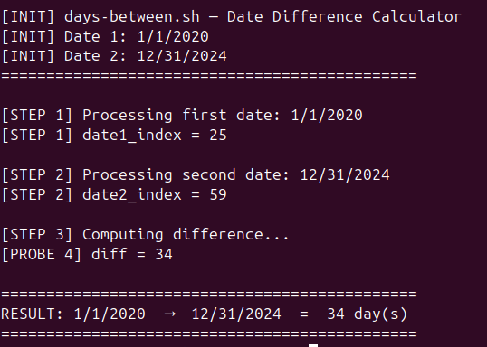

Section 3.7 10 Generations
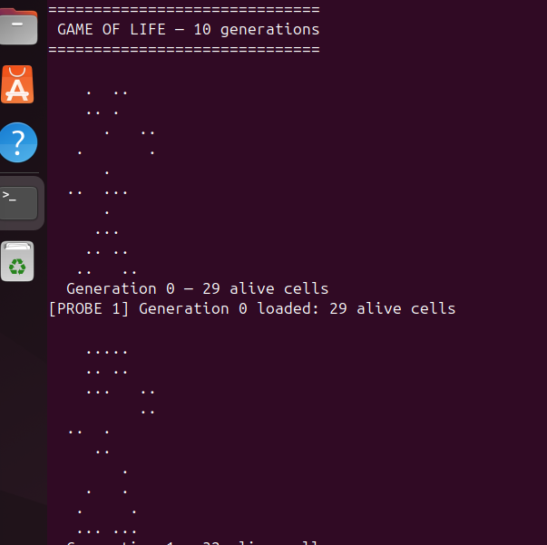
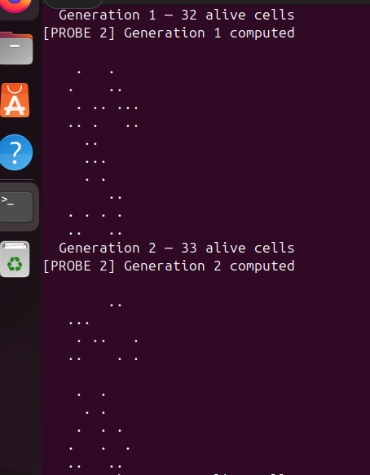
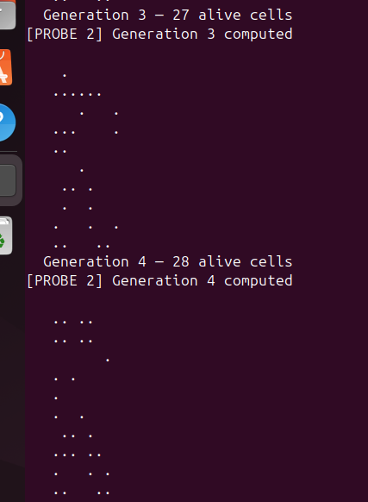
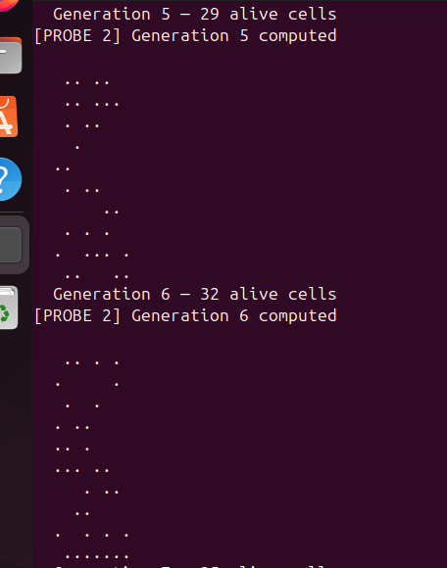
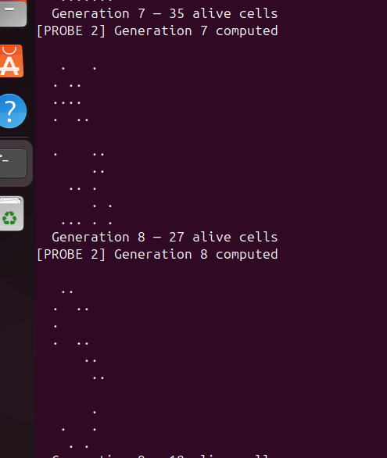
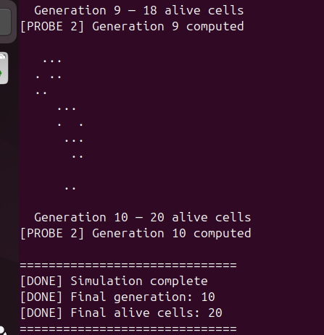

Section 3.8 Annotated Execution Output (Step-by-Step Probes)
$ bash s8_modular_annotated.sh
[INIT] Searching n in [1, 10000), LCM(5,7,9)=315
[PROBE 1] Testing nr=1
[PROBE 2] nr%5=1 ≠ 3 → SKIP (mod5 fail)
[PROBE 1] Testing nr=3
[PROBE 2] nr%5=3 == 3 ✓ (passed mod5: 1 total)
[PROBE 3] nr%7=3 ≠ 4 → SKIP (mod7 fail)
...
[PROBE 3] nr%7=4 == 4 ✓ (passed mod7: 5 total)
[PROBE 5] nr%9=5 == 5 ✓ — ALL THREE SATISFIED!
[PROBE 6] Solution after 158 iterations
Number = 158
Verification: 158%5=3 ✓ 158%7=4 ✓ 158%9=5 ✓

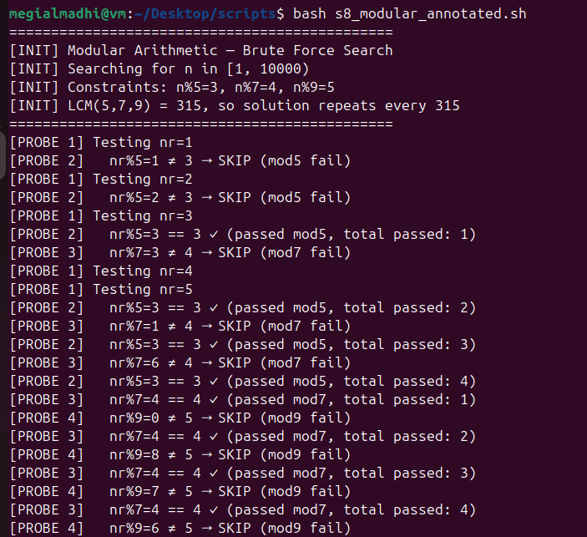

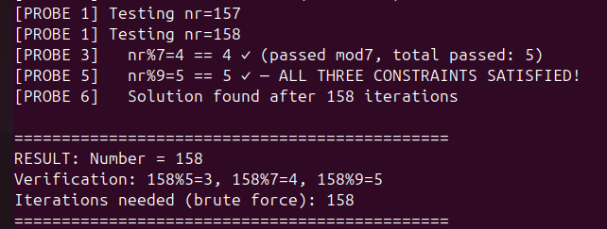

Section 3.9 Pipeline Parallelism Analysis
All four commands run as separate OS processes in parallel. The kernel creates three anonymous pipes connecting them. The file command is the bottleneck — it must read and analyze each binary sequentially using libmagic. The tee stage is justified only when logging is genuinely needed; for count-only queries, omitting tee and using grep -c eliminates both tee and wc-l.
# ORIGINAL: 4 processes
file "$DIRNAME"/* | fgrep "$FILETYPE" | tee $LOGFILE | wc -l

# OPTIMIZED: 3 processes (grep -c absorbs wc -l)
file "$DIRNAME"/* | grep -c "$FILETYPE"

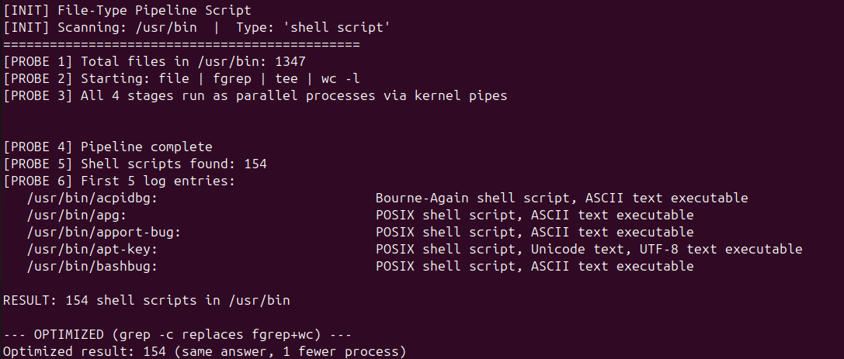

Section 3.10 Annotated Execution Output (50 files)
$ bash s10_javacounter_annotated.sh
[PROBE 1] Found 50 .java file(s)
[PROBE 2] ORIGINAL METHOD — O(N) forks:
Each file: 1 wc fork + 1 awk fork = 2N=100 forks
[PROBE 3] File: src/File1.java Lines: 5 Running total: 5
[PROBE 3] File: src/File2.java Lines: 5 Running total: 10
...
[PROBE 4] ORIGINAL result: 250 total lines (100 forks used)
[PROBE 5] OPTIMIZED METHOD — O(1) forks:
find | xargs | wc | awk (always 4 processes)
[PROBE 6] OPTIMIZED result: 250 total lines (4 forks used)
Original forks: 100 | Optimized forks: 4
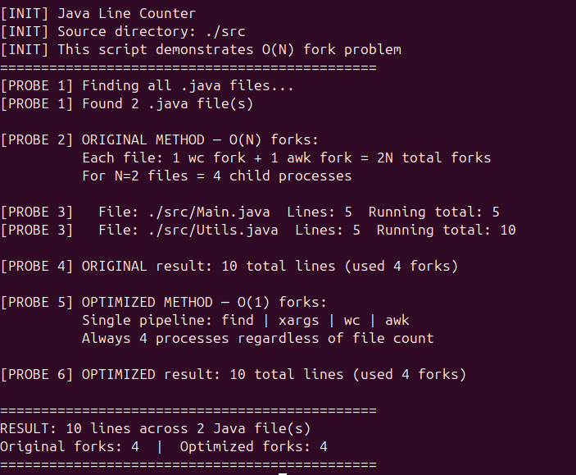

A.2 How to Run the Benchmarks
# Requirements: Ubuntu 20.04+ or any Linux with Bash 4.4+
# Install: sudo apt-get install -y bash strace
# 1. Extract the zip archive
unzip paper1_scripts.zip && cd paper1_scripts/
# 2. Run a single annotated script (generates screenshot-worthy output)
bash s5_collatz_annotated.sh 27
bash s8_modular_annotated.sh
bash s1_mailformat_annotated.sh benchmark_results/test_email.txt
# 3. Run all benchmarks and collect CSV data
bash run_all_benchmarks.sh
# 4. View results
cat benchmark_results/benchmark_summary.csv
cat benchmark_results/BENCHMARK_REPORT.txt
# 5. Take screenshots of terminal output for Paper figures

A.3 References
- Cooper, M. (2014). Advanced Bash-Scripting Guide. TLDP. https://tldp.org/LDP/abs/html/
- Ramey, C. (2022). Bash Reference Manual, v5.2. Free Software Foundation.
- Robbins, A., & Beebe, N. (2005). Classic Shell Scripting. O'Reilly Media.
- Gauss, C. F. (1801). Disquisitiones Arithmeticae. [CRT mathematical basis]
- Silberschatz, A., Galvin, P. B., & Gagne, G. (2018). Operating System Concepts, 10th Ed. Wiley.
- Kernighan, B. W., & Pike, R. (1984). The Unix Programming Environment. Prentice Hall.
- Pickover, C. A. (1990). Computers, Pattern, Chaos, and Beauty. St. Martin's Press.

