DESIGN DOCUMENT

Description:

Online Test Exam Maker is a simple web application that allows users to take exams, and determines the grade right after the submission.

High Level Overview:

Spring MVC is used in order to implement this application therefore the MVC pattern is implemented where we have a main controller:

ExamControler where we map all our possible requests to the server and implement the actions on it by using the services provided by:

ExamService provides the required methods in order to obtain and modify the information related to exams questions and attempts.

TimerService provides functionality on order to start and stop timer for every attempt.

UserService provides functionality in order to validate users.

Here is a small diagram representing all this components:

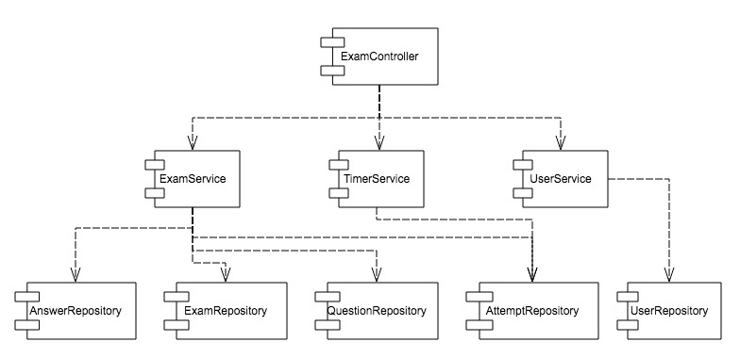

Spring Data is used to design data access. Repositories in this appication implement the CrudRepository interface from spring in order to auto generate the appropriate queries.

Data Model:

On top of the entities proposed by the description for this assignment a new entity called attempt, that represents the status of an ongoing exam and where we also store the selected answers, final score and time left information for each of this attempts, is introduced. Here is how our data will look like including assumed cardinalities:
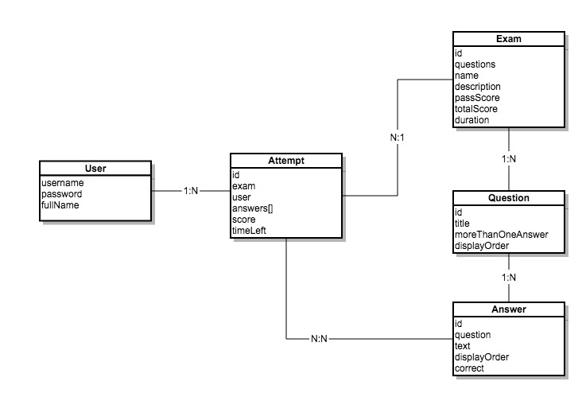

In the test data provided we only introduce one exam but this model will also support a system with several different exams.

As the persisting technology I use JPA and in particular hibernate implementation is used in order to define entities with annotation style.

