Programing for Computer Games

Question 1

Game engines: Unity and Frost Bite

For this project the game engine called Unity was chosen and the reasons are.

A: Pros for choosing Unity.

1. Platform support. Unity can be supported on a variety of 27 platforms and is highly preferred, it can be easily shared between pc , web and mobile platforms. Lastly because it enables fast prototyping which means it increases the speed of game development. (Potenza, 2005)
2. IDE. The coding language used in the IDE (Integrated Development Environment) is made up or JavaScript and C# for scripting which offers ideal features for game development. (Potenza, 2005)
3. Graphics. The graphics and audio quality of the game engine offer quite a high quality for game development and the visuals are adapted on every screen and device to keep optimum quality. (Potenza, 2005)
4. Debugging. Debugging in Unity is significantly easier and makes fixing code a much easier task which in turn allows to developers to debug the process and the run time. (Potenza, 2005)

Cons for choosing Frost Bite

Frost Bite engine is exclude only to pc and Xbox platforms. It is not very good with console platforms and is only available to EA Dice gaming company. (Mark, 2015).

B: Programing Languages

1. Some of the programing languages used in game programing are C# and Java.  
   C# is quite a simple programing language to learn, it is syntax based, it is object oriented and it is a powerful programing language to use. (Anon., 2017)

Question 2

Detailed diagrams

A.

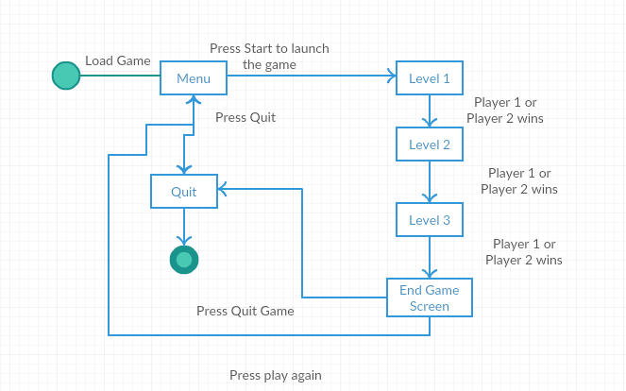

B.

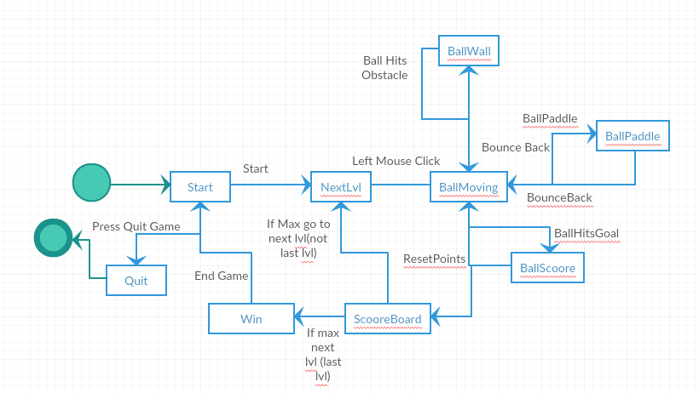

Question 3

File Compression

File compression is the process of compressing files making them smaller in the number of bytes of data that they contain. Some advantages that involve file compression of media assets are, storage space. Storage space that is provided by the computer doesn’t come free and most of the time if the limit is reached one must purchase more storage to hold this data. Bandwidth and transfer speed is another reason why it is needed. To download a file you must use a network bandwidth such as an MP3 audio file or a JPEG image file. Network speed works in Mbps (megabits per second), by compressing the file you allow the transfer of the file to be much faster and less time consuming. Below are some examples of image file compression. (Lancett, n.d.)

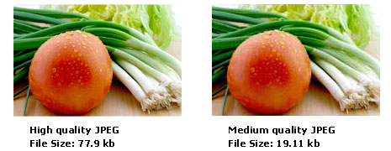

# Bibliography

Anon., 2017. *GameDesigning.* [Online]   
Available at: https://www.gamedesigning.org/career/programming-languages/

Lancett, P., n.d. *Tehcwalla.* [Online]   
Available at: https://www.techwalla.com/articles/the-advantages-of-file-compression

Mark, 2015. *Quora.* [Online]   
Available at: https://www.quora.com/Why-EAs-Frostbite-engine-is-so-bad

Potenza, 2005. *Potenza.* [Online]   
Available at: http://www.potenzaglobalsolutions.com/blogs/5-rarely-known-advantages-and-disadvantages-of-unity-game-development