# The influence of sarcomere shortening velocity on the end-systolic force-length relationship in simulated cardiomyocytes

Megan E. Guidry1, Denis S. Loiselle1,2, Martyn P. Nash1,3, Edmund J. Crampin4, David P. Nickerson1, Kenneth Tran1

1. Auckland Bioengineering Institute, The University of Auckland, New Zealand
2. Department of Physiology, The University of Auckland, New Zealand
3. Department of Engineering Science, The University of Auckland, New Zealand
4. University of Melbourne, Australia

# Key points summary

# Abstract

In a number of experimental studies, end-systolic curves, which quantify cardiac contractility, have been shown to depend on the type of contraction: isometric or isotonic. In isotonic contractions, the muscle decreases in length; an isometric contraction, conversely, is characterised by zero change of length. Thus, the presence or absence of sarcomere shortening is a fundamental characteristic that differentiates these two modes of contraction. We predict that the dependence of cross-bridge kinetics on sarcomere shortening velocity is the cause of the differing isometric and work-loop end-systolic curves. To test this prediction, a cell-level cardiac model was constructed to simulate cardiomyocyte contractions undertaking an isometric or a work-loop protocol and in the presence or absence of velocity dependence.

The mathematical model consists of three major components that concurrently simulate electrical depolarisation, Ca2+ kinetics and cross-bridge mechanics. Velocity-dependence features in the latter component in two ways: shortening velocity modulates the rate of rotation of the cross-bridge in the bound, force-bearing state and the rate of detachment from this state. Its effect on contributing to the difference between the end-systolic force-length relations was examined by sequentially activating it in work-loop simulations, thereby progressively converting the end-systolic force-length relationship of a work-loop contraction into an isometric regime. Using this computational modelling approach, we show that the increase in cross-bridge detachment associated with sarcomere shortening velocity is the primary cause of the right-shifted location of the work-loop end-systolic curve *vis-à-vis* that of isometric contractions.

# Introduction

End-systolic force-length (or pressure-volume) relationships occupy a special place in cardiovascular physiology, often serving as proxies for cardiac contractility. It is sobering to reflect that the existence of two distinct relationships, one for isometric (or isovolumic) contractions and a distinctly separate one for isotonic (or ejecting) contractions has been recognised since the 1899 publication by Otto Frank (1899) but remains unexplained. Frank’s findings (reproduced in Figure 1A) arose from experiments performed in the isolated heart of the frog and clearly reveal the existence of two distinct, contraction profile-dependent, end-systolic relations. Despite Frank’s insight and over 100 years of research, the mechanisms responsible for this phenomenon are still not well understood. But findings in the subsequent literature are remarkably consistent: the isometric end-systolic relation lies to the left and above that of the equivalent isotonic (or work-loop) curve (see Figure 1). This suggests that shortening itself reduces the ability of a muscle to maintain force as it undergoes shortening (Edman & Nilsson, 1971).

While this phenomenon is readily replicated the cellular mechanism remains elusive. Various explanations have been proffered: loading history (Taylor & Burrows, 1970; Sørhus et al., 2000), inotropic state (Taylor & Burrows, 1970), differing energy requirements (Taylor & Burrows, 1970), and muscle shortening per se (Brady, 1967). We have focussed attention strictly on mechanics, recognising that cross-bridge cycling, the essential aspect of force generation, takes a finite amount of time to occur. Thus, when filaments slide past each other, as they do during muscle shortening, cross-bridges have a limited window of time in which to form (Brady, 1967). This means that, for any given sarcomere length, the number of attached cross-bridges decreases as sarcomere shortening velocity increases. Hence, sarcomere shortening velocity directly influences the formation of cross-bridges as well as the amount of force these cross-bridges can collectively generate. Thus we arrive at the question that motivates our investigation: ”Does sarcomere shortening velocity contribute substantially to the differing end-systolic force-length relations observed experimentally between isometric vs. work-loop contractions?” Our method of investigation is mathematical modelling.

A.

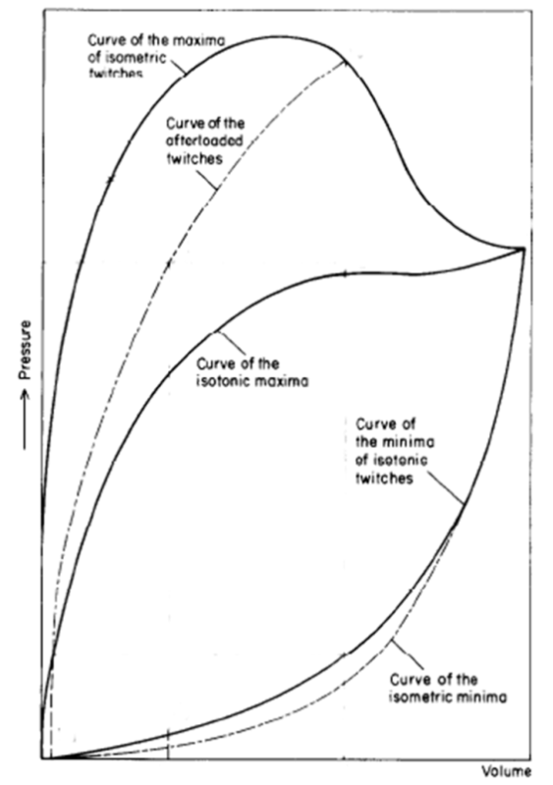

B.

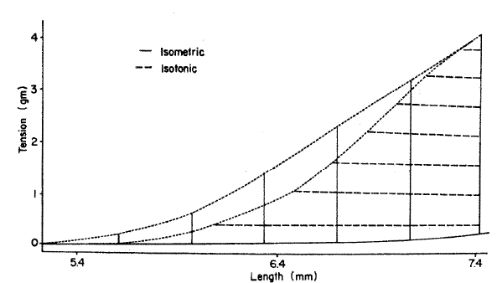

Figure 1

*A: Stylised plot of passive (end-diastolic: lower-most two curved lines) and active (end-systolic: upper-most three curved lines) pressure-volume relationships of excised frog heart. Note the separate end-systolic relationship for isometric (solid line) and afterloaded (broken line) twitches. Modified from Figure 3 of Frank (1899), with permission of the Copyright Clearance Center via RightsLink: License Number 3840330537202. B: Example of the relative difference in end-systolic curves between isometrically and isotonically contracted rabbit papillary muscle. Reproduced from Figure 7 of Brady (1967), with permission of Oxford University Press.*

# Methods

To explore the effect of velocity-dependence on the end-systolic force-length relationship, a novel integrated model of cardiac cellular mechanics was developed. The model was required to encapsulate sufficient biophysical detail to enable the current study, but we aimed to achieve this in a computationally efficient manner so that it could be integrated into larger- scale models in future studies. The Tran *et al.* (2010) mechano-energetics model forms the basis of the coupled model since it captures the detailed biophysical interdependencies of cross-bridge cycling. It has been parameterised to simulate a wide range of experimentally-observed cardiac myofilament behaviour, including steady-state, force-length and force-Ca2+ relations, as well as dynamic force transients (Rice *et al.*, 2008). The force-dependent binding of Ca2+ to troponin C is also explicitly captured allowing cross-bridge force production to modify the intracellular Ca2+ transient. To enable the required range of simulations, the cross-bridge model was driven by a Ca2+-induced-Ca2+-release (CICR) model. The well-known Hinch *et al.* (2004) model was chosen as it encapsulates sufficient biophysical detail while maintaining a low computational cost during numerical simulation. To complete the anticipated range of simulation protocols, we modified the Hinch *et al.* (2004) model to be driven by a simulated cardiac action potential rather than by a voltage-clamp. Since our study did not require detailed cellular electrophysiology, we parameterised the phenomenological Rogers and McCulloch (1994) model to simulate a rat cardiac action potential and used it to drive the cellular contraction cycle. The other two components are also parameterised for rat heart. A diagrammatic representation of the integrated Hinch-Rogers-Tran (HRT) model is shown in Figure 2.

Each of the Tran *et al.* (2010), Hinch *et al.* (2004), and Rogers and McCulloch (1994) models is available in the Physiome Model Repository (see Appendix A2). We capitalised on the modular features of the CellML standard (Cuellar *et al.*, 2003) and the software tool OpenCOR (Garny & Hunter, 2015) to integrate these disparate models to form the coupled Hinch-Rogers-Tran (HRT) model of excitation-contraction. See Terkildsen *et al.* (2008) for details on the approach used to achieve this.

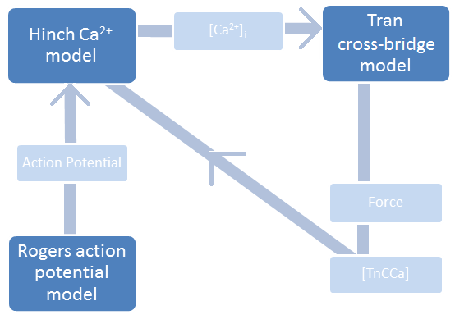

Figure 2

*High-level coupling between the Tran et al.* (2010) *cross-bridge, the Hinch et al.* (2004) *Ca2+, and the Rogers and McCulloch* (1994) *action potential models.* [TnCCa] represents the intracellular concentration of Ca2+ bound to troponin-C.

## Model validation:

The HRT model was validated prior to addressing the hypothesis in this study. Validation took the form of duplicating, *in silico*, the magnitude and kinetics of quick-release experiments executed by Kurihara and Komukai, (1995). For a complete analysis and comparison between HRT model data and Kurihara and Komukai (1995) experimental data please refer to ___. Additionally, validation data can be recreated by using the HRT model at ___. [come back and add correct links]

In these experiments, step length changes were applied to a ventricular muscle preparation. The preparation started at length Lmax and at varying times before and after tissue stimulation (50ms before, 22ms after, 75ms after, and 138ms after the stimulus) a 3ms step length change to 92% of Lmax was applied to the muscle. Figure 3(Left) shows the original Kurihara quick release results for a quick-release shortening step that occurs 75ms after muscle stimulation. The data contained in this Figure reflects an essential relationship between force, sarcomere length, and intracellular Ca2+ concentration during a step change in sarcomere or tissue length. Thus, we replicated the Kurihara data with the HRT model to verify the model behaves like the ventricular tissue it is intended to imitate.

Using the conditions of the above experiment as a template, the HRT model was configured to recreate the Kurihara quick release protocol. The simulation in Figure 3 (Right) shows an 8% sarcomere length shortening 56 ms after the stimulus. The Kurihara and equivalent HRT simulation are kept side-by-side for easier comparison (Kurihara data to the left in each figure and HRT data to the right[1]).

|  |  |
| --- | --- |
| Figure 3 |  |

Experimental quick-release shortening of ferret papillary muscle (left; (Kurihara & Komukai, 1995)) and the simulated quick-release shortening of a single sarcomere (right).

The quick release protocol represented in Figure 5 allowed stress in the muscle tissue to build up a significant amount before shortening occurred (75 ms after stimulation). In both experimental and simulated scenarios, stress quickly dropped to zero kPa with the quick release, releasing the Ca2+ that had been bound to troponin-C back into the intracellular space. Such a quick sliding movement gave rise to the dissociation of essentially all cross-bridges and, without cross-bridges, the affinity of troponin for Ca2+ plummeted (Kurihara & Komukai, 1995). The result of this Ca2+ shift back to the cell cytoplasm can be seen in the [Ca2+]i transient as a “bump” that occurs in time with the quick release. Both the Kurihara experimental data and HRT simulated quick release show this bump in Figure 5.

Along with causing a bump in the [Ca2+]i transient, the dissociation of most cross-bridges affects the sarcomere’s ability to generate force. After a quick release, the sarcomere begins to redevelop tension again; however, unlike at the start of a stimulation, there is no wave of Ca2+ to pave the way for force development. In fact, by 75 ms after stimulation, intracellular Ca2+ levels are already significantly lower. This limits the level of Ca2+ activation and, as a result, limits cross-bridge formation and force development. The consequence of this lack of cross-bridge formation following a late-stage quick release is a stress transient that is significantly stunted following the quick release. In the Kurihara data, the stress transient following the quick release is at least 50% smaller than it would be in an equivalent isometric scenario, while the HRT stress transient is 30% smaller. Thus, the HRT model is capable of producing data that reflects the intricate events of quick release sarcomere shortening.

The only discrepancy between experimental and simulated data exists in the magnitude of the calcium ‘bump’ following the quick-release shortening. In the HRT simulation, the intracellular Ca2+ bump is sharp and has a magnitude that is roughly 0.5 μM greater than isometric Ca2+ levels. While this is larger than the 0.3 μM bump observed by Kurihara and Komukai (1995), the precision and scale of the HRT simulated quick-release does not take into account two physiological phenomena that are at play in the experiments.

First, the Kurihara and Komukai (1995) quick-release experiment is performed on thin papillary muscle samples while the HRT model simulates a quick-release in a single sarcomere. Thus, in a 3ms step length change, the intracellular Ca2+ concentration of a papillary muscle sample is the average of many contractile units and; therefore, data at the sarcomere level is, in essence, passed through a low-pass filter . This could account for the sharp point we see in the HRT simulated Ca2+ transient, where there is no “averaging” effect.

Second, the smaller magnitude of the Kurihara and Komukai (1995) Ca2+ bump following the quick-release shortening may also be related to physiological differences between sarcomere and whole muscle contractions. In the HRT model, when the sarcomere is set to shorten for 3ms during the quick-release, this is precisely what occurs. On the other hand, a 3ms shortening length step applied to a papillary muscle does not guarantee all sarcomeres that constitute the sample are shortening during those 3ms. Connective tissue…. accounts for a significant portion of papillary muscles, and such tissues are known to exhibit heterogeneous behaviours. Hence, the extent of sarcomere shortening varies throughout the tissue sample, as does the bump in intracellular Ca2+ following a quick-release change in sarcomere length. The result is a smaller overall Ca 2+ bump magnitude.

## Work-loop protocol

The work-loop protocol is designed to mimic the pressure-volume relationship observed in the whole heart. It is implemented in the HRT model by dividing the protocol into four phases:

|  |  |  |
| --- | --- | --- |
|  |  |  |

Phase 1: Isometric contraction

Following CICR, the HRT model begins generating force while the sarcomere length is held constant to simulate isometric contraction. This phase continues until the total muscle force, Ftotal (the sum of active and passive force) exceeds the afterload (set by the user).

Phase 2: Isotonic contraction

Following isometric contraction, the sarcomere shortening velocity (*dSL*) is determined by:

|  |  |  |
| --- | --- | --- |
|  | $dSL=\frac{{integral}_{force}+viscosity*(L_{rest}-L)}{mass}$ | (1) |

where *dSL* is the rate of change of the sarcomere length, *Lrest* is the initial sarcomere length, *L* is the current sarcomere length, *integralforce*is the time integral of force and viscosity and mass are preset values taken from the original Rice *et al.* (2008) cross-bridge model.

During this phase, the muscle contracts isotonically against the afterload (see point B in Figures 3 and 4). The simulation continues in this state for as long as the force generated by the muscle exceeds the user-specified afterload.

Phase 3: Isometric relaxation

When the force generated by the sarcomere falls below the afterload, it is determined to have reached end-systole (point C in Figures 3 and 4). During relaxation, the force decreases isometrically until [Ca2+]i reaches diastolic levels (point D in Figures 3 and 4).

Phase 4: Re-stretch

When [Ca2+]i reaches diastolic levels, the quiescent sarcomere is re-stretched back to its starting length prior to the subsequent action potential. A constant-velocity stretch is applied during this phase.



Figure 4

*A force-length work-loop generated by the HRT model with afterload = 22.4kPa. The work-loop comprises four phases: Phase 1 = isometric contraction; Phase 2 = isotonic contraction; Phase 3 = isometric relaxation; Phase 4 =re-stretch. A denotes the start of systole, B the start of isotonic contraction, C the end systolic point, and D the start of re-stretch to end-diastole (L0 = 2.27 μm).*



Figure 5

*Normalised sarcomere length versus time (A) and stress versus time (B) for the work-loop shown in Figure 3. Total stress is the sum of active stress, passive stress and afterload (Afterload is set at 22.4 kPa).*

## Velocity-dependence of shortening

In the HRT model, the shortening velocity affects the *distortion* of the cross-bridge in the pre- (*XBpreR*) and post-rotated (*XBpostR*) states (Figure 5). In state *XBpreR*, the myosin head has bound to the actin filament but has not yet undertaken the power-stroke. The power-stroke is undertaken when the cross-bridge transitions from state *XBpreR* to state *XBpostR*. During an isometric contraction, force is generated from state *XBpostR* only, via the distortion arising from the power-stroke. No force is generated from state *XBpreR* as there is no myosin head distortion arising from the binding of the myosin head to actin. During a shortening contraction, the relative sliding of the actin and myosin filaments generates a distortion in the attached cross-bridges in state *XBpreR* and increases the distortion of cross-bridges in state *XBpostR*. These distortions directly affect two kinetic rate constants (see Figure 5):

1. *hfT*, which governs the transition from state *XBpreR* to *XBpostR* (myosin head rotation) and
2. *gxbT* which governs the transition from state *XBpostR* to *Pxb* (myosin head detachment).

We investigated the dependence of the work-loop end-systolic force-length relationship on shortening velocity by progressive deactivation of the velocity dependencies of *hfT* and *gxbT*. See Appendix A1 for the adjusted shortening-velocity equations.

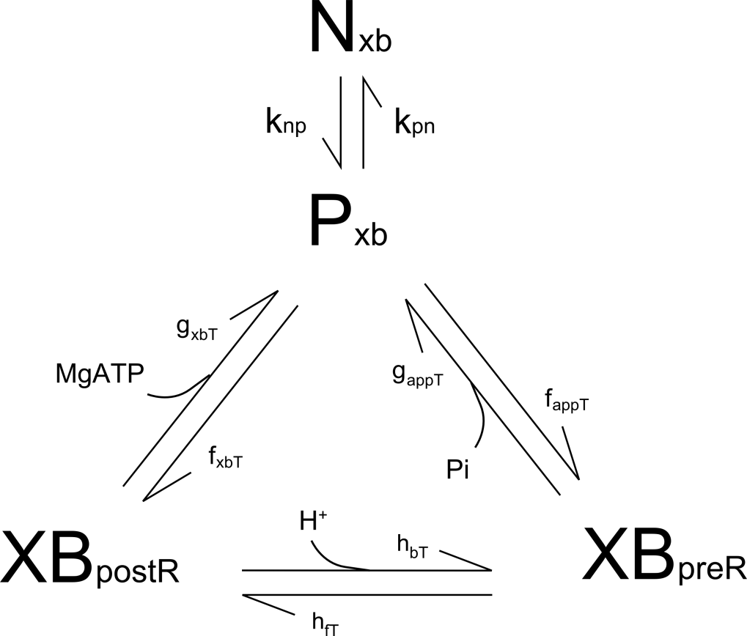

Figure 6

*Schematic of the* Tran *et al.* (2010) *cross-bridge model.*

## Ca2+ dependence of shortening

[talk about the Ca2+ transient and how its shape affects the extent of shortening a sarcomere can accomplish. Why is an isometric calcium transient “wider”? 🡪 it depends on the overlap region of the sarcomere and how much sarcomere shortening occurs].

* the work-loop calcium transient mirrors the isometric calcium transient at SL=2.27 until sarcomere shortening occurs. The detachment of cross-bridges associated with sarcomere shortening causes a “bump” in the Ca2+ transient; however, the timing of the bump

# Results

In this investigation, the end-systolic curves generated by the HRT model provide the standard for comparing isometric and isotonic contractions. The isometric end-systolic force-length relationship was simulated at varying sarcomere lengths while the work-loop equivalent was generated at various afterloads. Figure 6 shows that the end-systolic force-length curve for a muscle performing a series of work-loops (solid line) lies to the right of the end-systolic force-length curve for the same sarcomere performing a series of isometric contractions (dotted line). For a given muscle length, the end-systolic force is always higher for the isometric protocol.

Our simulation results are consistent with experimental reports from the literature (Brady, 1967; Taylor & Burrows, 1970; Suga *et al.*, 1977; Sørhus *et al.*, 2000), although the mechanism(s) responsible for the observed difference is difficult, if not impossible, to isolate via experimentation. The HRT model provides an ideal tool with which to mimic these experimental results and to isolate the underlying cause(s).



Figure 7

*The HRT isometric end-systolic curve (dotted lines), HRT work-loop end-systolic curve (solid lines)*, *and corresponding stress-length contraction paths.*



Figure 8

Ca2+ transients for workloops completed with varying afterloads (top) and Ca2+ transients of isometric contractions completed at varying sarcomere lengths (bottom).

[explain that calcium is not the reason for the different end-systolic curves for isometric and work loop contractions]

To be sure waning intracellular Ca2+ concentration is not the cause of the differing isometric and work-loop end-systolic curves (Figure 7), we compare the Ca2+ transients for a multiple work-loop and isometric scenarios. Figure 8 shows that decreasing the afterload in the work-loop protocol or decreasing the sarcomere length in the isometric protocol causes the duration of the intracellular Ca2+ transient to increase similarly for both. However, the intracellular Ca2+ transients for isometric contractions maintain near maximum Ca2+ concentration longer than the work-loop contractions. To see how this difference in intracellular Ca2+ affects the work-loop end-systolic curve each HRT work-loop was run with the Ca2+ transient from its stress-equivalent isometric contraction (the isometric contraction resulting in an end-systolic stress equivalent to the work-loop afterload value).



Figure 9

*The end-systolic curve for work-loops run with isometric Ca2+ (thick gray line) compared to the isometric end-systolic force-length curve* (dotted line) and *the end-systolic work-loop force-length curve (solid line)*

The work-loops run with isometric Ca2+ produce the end-systolic curve depicted by the dashed line in Figure 9. The work-loop end-systolic curve is shifted leftward towards the isometric end-systolic curve, meaning differences in intracellular Ca2+ transients do contribute to the relative positioning of isometric and work-loops end-systolic curves.

During a typical HRT work-loop, the sarcomere shortens between 40 and 75ms. It shortens until the sarcomere can no longer maintain the afterload. This inability to maintain the afterload is dependent on many factors, one being the amount of intracellular calcium available for generating cross-bridges. Higher intracellular Ca2+ allows for more crossbridges and force development and the isometric Ca2+ transients show larger concentrations of intracellular Ca2+ during the critical 40-75 ms period. Hence, when the isometric calcium transients from Figure 8 are used in the work-loops, the HRT model is able to use the increased intracellular Ca2+ concentration to maintain stress during the isotonic shortening phase, allowing the sarcomere to shorten more before the afterload can no longer be maintained.



Figure 10

Figure 9 shows that differences between isometric and work-loop intracellular Ca2+ transients accounts for part of the disparity between the isometric and work-loop end systolic curves, but using isometric calcium levels in a work-loop contraction does not result in the unification of the end-systolic curves. Hence, another mechanism must also contribute to the difference in isometric and work-loop end-systolic curves.

A key difference between the dynamics of isometric and work-loop contractions, and therefore a potential cause of their differing end-systolic curves, is the presence of a shortening velocity in the latter. We inactivated the velocity-dependencies of the rates gxbT (cross-bridge detachment) and hfT (cross-bridge rotation, refer to Figure 6) in the cross-bridge model to investigate the effects on the end-systolic force-length relationship of the work-loop protocol. Surprisingly, removing velocity dependence from gxbT and hfT resulted in very little change in the work-loop end-systolic curve (Figure ).



Figure

*The isometric end-systolic force-length curve* (🞨) *compared to the end-systolic force-length curve for work-loops without velocity dependence* (🗆).

A leftward shift of the work-loop end-systolic curve results, implying that the absence of velocity dependence ([- -] in Figure 10) permits the muscle to shorten further for a given afterload. This brings the end-systolic curve closer to its isometric counterpart, a result which is consistent with our initial prediction; however, the extent of the leftward shift was not predicted, with the work-loops without velocity dependence shortening past the stress-equivalent isometric end-systolic length. The main mechanisms leading to this velocity-dependent response are shown in Figure 11.

Removing shortening deactivation involved removing the effect of sarcomere shortening velocity on the distortion levels of cross-bridges. In other words, despite the movement of thick and thin filaments past each other during shortening, the cross bridge heads were able to fully distort (rotate) for each power-stroke completed. Thus, compared to the work-loops that contain shortening deactivation, distortion values are constant and high. Along with the large initial overlap fraction, these high distortion values result in a large number of cross-bridges able to maximally contribute to the production of force, Culminating in greater total force, a greater shortening velocity (Figure 11 C), greater overall muscle shortening (Figure 11 D) and a decreased duration of the isotonic shortening phase ( *t1* < *t2* in Figure 11 C). The inflated sarcomere shortening velocity results in the work-loop reaching the isometric end-systolic sarcomere length so quickly that intracellular Ca2+ levels are still high and the sarcomere shortening velocity itself is still relatively large. In other words, the overlap fraction in an isometric scenario would be too small to maintain the afterload; however, the high levels of intracellular Ca2+ and nonzero sarcomere shortening velocity allows force to be maintained and sarcomere length to decrease. The result is a work-loop end-systolic curve that is shifts to the left and actually surpasses the isometric end systolic curve.

end-systole is reached much earlier in the absence of velocity-dependence. The leftward shift of the work-loop end-systolic curve in Figure 7 is due to the inactivation of velocity-dependence from both kinetic rate constants (*hfT* and *gxbT*). The next section quantifies the contributions of each of these two velocity-dependent effects to the overall leftward shift of the end-systolic curve.



Figure 11

*The effect of velocity-dependence on the cross-bridge detachment rate (A), active stress production (B), shortening velocity (C) and muscle length (D) during a work-loop protocol simulated in the HRT model (afterload of 22.4 kPa). In C, t1 and t2  indicate the durations of the shortening phase, visually demonstrating the decrease in the period of isotonic shortening when velocity dependence is inactivated. The re-stretch phase of the work-loop takes place at t = 800 ms and is not shown in these plots.*

Figure 12 shows how individual inactivation of the two velocity dependencies affects the work-loop end-systolic curve. The most notable result is the fact that *both* instances of inactivating velocity dependence caused a leftward shift of the end-systolic work-loop relation. Inactivating the effect of velocity dependenceon *hfT* reduces the number of cross-bridges reaching state *XBpostR*, while more are retained in *XBpreR*. Since both of these states are force-producing under a shortening contraction, the overall effect on force generation is likely unchanged. This is reflected in the minimal leftward shift of the end-systolic curve (Figure 12, (o)).

On the other hand, removing velocity dependence on *gxbT* decreases the rate of cross-bridge detachment, thus increasing the number of cross-bridges in state *XBpostR*. More cross-bridges in this force-producing state allow more active force to be generated, leading to a greater extent of shortening. This is reflected in a substantial leftward shift of the work-loop end-systolic curve, as seen in Figure 12(◇). Our simulations indicate that the difference is the consequence of an additive effect of velocity-dependence on *hfT* and *gxbT* in which *gxbT* dominates.



Figure 12

*The effect of velocity-dependence on work-loop end-systolic curves: Velocity dependence present (🞶); Velocity dependence inactivated (🗆); Velocity dependence inactivated from cross-bridge dissociation, gxbT, (◇); and* Velocity dependence inactivated from cross-bridge rotation, *hfT*, (o).

# Discussion

In this investigation, we have shown that the dependence of cross-bridge kinetics on sarcomere shortening velocity can explain the difference between the end-systolic force-length relations of an isometric and a work-loop contraction. Our biophysical model simulations show that sarcomere shortening velocity influences contractility via modulation of cross-bridge cycle kinetics. Sarcomere shortening velocity directly modulates the distortion of the bound cross-bridge. Thus, two identical sarcomeres, one that contracts isotonically and shortens to a final length, *L,* compared to one that contracts isometrically at *L*, will differ in the number of attached cross-bridges because of their differing histories leading to that sarcomere length. The sarcomere that experiences a shortening contraction to reach *L* will have a lesser proportion of attached cross-bridges and, therefore, will generate less force compared to its isometrically contracting counterpart. This is consistent with our model simulations. In the HRT model, sarcomere shortening velocity increases the rate of cross-bridge rotation (*hfT* in Figure 5) and the cross-bridge detachment rate (*gxbT* in Figure 5). This results in a reduction of the overall number of attached cross-bridges thereby impairing force sustainment during the isotonic shortening phase of a work-loop contraction. Hence, the end-systolic point occurs earlier in the cycle (see Figure 8C), causing the work-loop end-systolic curve to lie to the right of the isometric end-systolic curve (Figure 6). Conversely, removing the effect of velocity dependence from the HRT model reduces the rate of cross-bridge myosin head rotation (*hft*) and the rate of cross-bridge detachment (*gxbt*) resulting in similar isometric and work-loop end-systolic force-length relations (Figure 7).

Using the HRT model we analysed how removing velocity-dependence from the kinetic rate constants hfT or gxbT (see Figure 5) individually contribute to the overall effect of shortening deactivation displayed in Figure 6. Figure 12 shows that both instances of removing velocity dependence cause a leftward shift of the work-loop end-systolic curve. When velocity dependence is removed from the rate of cross-bridge detachment, the amount of time a cross-bridge spends in the *XBpostR* force-producing state increases. Thus, the cross-bridge is able to sustain force at the given afterload for longer, increasing the extent of shortening. The end-systolic point of each work-loop reaches a lower value of sarcomere length (L/L0), resulting in a leftward shift of the end-systolic curve. This was the dominant effect. Removal of velocity dependence from the rate of cross-bridge head rotation caused only a slight leftward shift of the work-loop end-systolic curve. The reduction of *hfT* meant that more cross-bridges remained in state *XBpreR* than transitioned to state *XBpostR* but, since both these states are force-producing, the overall effect on the end-systolic curve is minor. The simulations in Figure 12 demonstrate that the effect of sarcomere shortening velocity on cross-bridge detachment accounts for most of the velocity dependent behaviour of work-loop contractions vis-à-vis isometric contractions.

Inactivation of velocity dependence from the HRT model results in significant changes to the isotonic contraction phase of the work-loop. The greater level of active stress achieved during this phase (Figure 8B) generates a much higher shortening velocity (Figure 8C), such that end-systole is achieved at a much earlier stage, relative to the simulation with velocity-dependence intact. The end of systole is reached when the active stress generated by the cross-bridges can no longer sustain the afterload. In the simulation with velocity dependence inactivated, end-systole is reached so early that a declining [Ca2+]i has not had the chance to affect the active stress such that the dominant factor determining the end-systolic point is the force-length relationship. It is therefore not a surprise that velocity-dependent inactivation brings the work-loop end-systolic force-length relationship closer to that of its isometric counterpart, since the latter is determined solely by the filament overlap fraction given by the force-length relation.

Our results are consistent with those of Landesberg and Sideman (2000), who showed that increasing the velocity-dependent transition rate between the Ca2+ bound force-producing and the non-force-producing states in their four state model results in a rightward shift of a shortening end-systolic curve relative to its isometric equivalent. This result is comparable to an increase in *gxbT* (Figure 5) in the HRT model (Figure 6), that is, despite the presence of a force producing state in the absence of bound Ca2+ in the Landesberg model

Experimental results recently published by Pavlov and Landesberg (2016) who, using isovelocity (ramp) stretches of isolated, tetanised, right-ventricular rat trabeculae at different sarcomere lengths, indicated that the rate of cross-bridge cycling is length-independent. Likewise, none of the cross-bridge kinetic rate constants in our HRT model depend directly on sarcomere length. The two velocity-dependent rate constants in the cross-bridge model are each a function of cross-bridge distortion, which is modulated by sarcomere shortening velocity and not sarcomere length per se.

Overall, our model has determined that the effect of sarcomere shortening velocity on sarcomere contractility is sufficient to explain the disparity between isometric and work-loop end-systolic curves, which has been demonstrated experimentally in excised frog heart (Frank, 1899), isolated rabbit papillary muscle (Brady, 1967; Sørhus *et al.*, 2000), and isolated cat papillary muscle (Taylor & Burrows, 1970). It is interesting to note that some experimental studies show end-systolic curves to be independent of contraction type and appear unified (Cross *et al.*, 1961; Downing & Sonnenblick, 1964; Taylor *et al.*, 1969; Suga & Sagawa, 1974; Suga *et al.*, 1981, 1983; Hisano *et al.*, 1987;). We emphasize that our cross-bridge model was not parameterized with a view to have separate end-systolic force-length curves; on the contrary, the two different end-systolic curves appeared as an emergent property of the coupled model. Thus, we cannot speculate on the differences observed in the experimental literature. Of course, other factors may also contribute to the lack of alignment of isometric and work-loop end-systolic curves, including a prolongation of the intracellular Ca2+ transient, the effect of muscle internal viscosity, and an auxotonic shortening phase during the work-loop. However, our simulations have demonstrated that velocity-dependence alone is sufficient to unify the isometric and work-loop end-systolic force-length relationships.

Overall, our model has determined that the effect of sarcomere shortening velocity on sarcomere contractility can sufficiently explain the disparity between isometric and work-loop end-systolic curves which has been demonstrated experimentally in excised frog heart (Frank, 1899), isolated rabbit papillary muscle (Brady, 1967; Sørhus *et al.*, 2000), and isolated cat papillary muscle (Taylor & Burrows, 1970). That being said, there are many mechanisms involved in sarcomere contraction, and other factors may also contribute to the presence or absence of alignment between isometric and work-loop end-systolic curves. Thus, we cannot speculate on each of the numerous possible factors that may account for the apparent unification of the isometric and work-loop end-systolic curve (Cross *et al.*, 1961; Downing & Sonnenblick, 1964; Taylor *et al.*, 1969; Suga & Sagawa, 1974; Suga *et al.*, 1981, 1983; Hisano *et al.*, 1987). We can, however, emphasize that our cross-bridge model was not parameterized with a view to have separate end-systolic force-length curves; on the contrary, the two different end-systolic curves appeared as an emergent property of the model. Hence, our simulations have demonstrated that velocity-dependence alone is sufficient to unify naturally divergent isometric and work-loop end-systolic force-length relations.

# References

Brady A (1967). Length-Tension Relations in Cardiac Muscle. *Am Zool* **7,** 603–610.

Cross CE, Rieben PA & Salisbury PF (1961). Influence of coronary perfusion and myocardial edema on pressure-volume diagram of left ventricle. *Am J Physiol Content* **201,** 102–108.

Cuellar AA, Lloyd CM, Nielsen PF, Bullivant DP, Nickerson DP & Hunter PJ (2003). An Overview of CellML 1.1, a Biological Model Description Language. *SIMULATION* **79,** 740–747.

Downing SE & Sonnenblick EH (1964). Cardiac muscle mechanics and ventricular performance: force and time parameters. *Am J Physiol Content* **207,** 705–715.

Edman KAP & Nilsson E (1971). Time course of the active state in relation to muscle length and movement: a comparative study on skeletal muscle an myocardium. *Cardiovasc Res*.

Frank O (1899). Die Grundform des arteriellen Pulses. *Z Biol* **37,** 483–526.

Garny A & Hunter PJ (2015). OpenCOR: a modular and interoperable approach to computational biology. *Front Physiol*; DOI: 10.3389/fphys.2015.00026.

Hinch R, Greenstein JL, Tanskanen AJ, Xu L & Winslow RL (2004). A Simplified Local Control Model of Calcium-Induced Calcium Release in Cardiac Ventricular Myocytes. *Biophys J* **87,** 3723–3736.

Hisano R, Cooper GT & others (1987). Correlation of force-length area with oxygen consumption in ferret papillary muscle. *Circ Res* **61,** 318–328.

Iribe G, Helmes M & Kohl P (2006). Force-length relations in isolated intact cardiomyocytes subjected to dynamic changes in mechanical load. *AJP Heart Circ Physiol* **292,** H1487–H1497.

Kurihara S & Komukai K (1995). Tension-dependent changes of the intracellular Ca2+ transients in ferret ventricular muscles. *J Physiol* **489,** 617–625.

Landesberg A & Sideman S (2000). Force-velocity relationship and biochemical-to-mechanical energy conversion by the sarcomere. *Am J Physiol-Heart Circ Physiol* **278,** H1274–H1284.

Rice JJ, Wang F, Bers DM & de Tombe PP (2008). Approximate Model of Cooperative Activation and Crossbridge Cycling in Cardiac Muscle Using Ordinary Differential Equations. *Biophys J* **95,** 2368–2390.

Rogers JM & McCulloch AD (1994). A collocation-Galerkin finite element model of cardiac action potential propagation. *Biomed Eng IEEE Trans On* **41,** 743–757.

Sørhus V, Sys SU, Natåns A, Demolder MJ & Angelsen BAJ (2000). Controlled Auxotonic Twitch in Papillary Muscle: A New Computer-Based Control Approach. *Comput Biomed Res* **33,** 398–415.

Suga H, Hayashi T, Shirahata M, Suehiro S & Hisano R (1981). Regression of cardiac oxygen consumption on ventricular pressure-volume area in dog. *Am J Physiol-Heart Circ Physiol* **240,** H320–H325.

Suga H, Hisano R, Hirata S, Hayashi T, Yamada O & Ninomiya I (1983). Heart rate-independent energetics and systolic pressure-volume area in dog heart. *Am J Physiol-Heart Circ Physiol* **244,** H206–H214.

Suga H, Saeki Y & Sagawa K (1977). End-systolic force-length relationship of nonexcised canine papillary muscle. *Am J Physiol-Heart Circ Physiol* **233,** H711–H717.

Suga H & Sagawa K (1974). Instantaneous pressure-volume relationships and their ratio in the excised, supported canine left ventricle. *Circ Res* **35,** 117–126.

Taylor R, Covell J & Ross J (1969). Volume-tension diagrams of ejecting and isovolumic contractions in left ventricle. *Am J Physiol*.

Taylor RR & Burrows P (1970). Active Length-Tension Relations Compared in Isometric, Afterloaded and Isotonic Contractions of Cat Papillary Muscle Their Dependence on Inotropic State. *Circ Res* **26,** 279–288.

Terkildsen JR, Niederer S, Crampin EJ, Hunter P & Smith NP (2008). Using Physiome standards to couple cellular functions for rat cardiac excitation-contraction: Methodology for model combination using Physiome standards. *Exp Physiol* **93,** 919–929.

Tran K, Smith NP, Loiselle DS & Crampin EJ (2010). A Metabolite-Sensitive, Thermodynamically Constrained Model of Cardiac Cross-Bridge Cycling: Implications for Force Development during Ischemia. *Biophys J* **98,** 267–276.

# Additional information

## Competing interests

No competing interests

## Author contributions

## Funding

The completion of this research was possible because of funding from the Whitaker Foundation.

## Acknowledgements

# Tables

# Figures and legends

# Appendix

## A1. Modification of equations to control velocity-dependence in the cross-bridge model

$$dxXBprer= \frac{v_{1}×dSL}{2}+\frac{xPsi}{dutyprer}(-α_{1}^{+}×xXBprer+α_{2}^{-}×\left(xXBpostr-x_{0}+xXBprer\right))$$

$$dxXBpostr= \frac{v_{2}×dSL}{2}+\frac{xPsi}{dutypostr}×α_{2}^{+}(xXBprer+x_{0}-xXBpostr$$

where $v_{1}$ and $v_{2}$ are set to 0 or 1 to inactivate or activate velocity-dependence, respectively. To inactivate velocity-dependence of cross-bridge rotation only (*hfT*), and $v_{2}=1$. To inactivate velocity-dependence of cross-bridge detachment only (*gxbt*), and $v_{2}=0$.

## A2 Link to models and codes:

Tran *et al.* (2010): https://models.physiomeproject.org/exposure/cfa,

Hinch *et al.* (2004): https://models.physiomeproject.org/exposure/8e1a

## Rogers and McCulloch (1994): https://models.physiomeproject.org/exposure/e48

1. The quick release times for the HRT model are not the same as the quick release times in the Kurihara paper. This is because force development in the Hinch-Rogers-Tran model does not occur the same way/ at the same rate as it does in the Kurihara experiments. Thus, the quick release for the HRT model is adjusted to occur at the equivalent level of tension development as the Kurihara scenario it is replicating. 50ms before stimulus stays the same, 22ms after stimulus changes to 28ms, 75ms changes to 46, and 138 changes to 56.