The affinity of Troponin-C for Cai2+, a sufficient explanation for the century-old conundrum: What causes the differing force-length relationship in work-loop vs. isometric contractions? aslfsdlfj (Hinch *et al.*, 2004). The model from Hinch *et al.* (2004). (Hinch *et al.*, 2004; Rice *et al.*, 2008)

**FIGURE 2**

The complexity of the force-length relationship reflects the complex nature of a cardiomyocyte contraction. Length, tension, cai2+ concentration, and other parameters change continuously and dynamically. However, the ES curve is often considered an indicator of cardiac contractility so it is imperative that the understanding of the complex nature of the force-length relationship evolves as models, tools, and technology improve.

Force, sarcomere length, and intracellular calcium concentration are deeply interrelated in the cardiomyocyte contraction process. The combined model used for this manuscript captures this interconnectivity as demonstrated by reproducing experimental quick-release data collected by Kurihara et al (year). Figure ___, included in this article for model validation purposes, shows the comparison between the experimental data and simulated data.

WC?

**FIGURE 3**

Replicating experimental quick release data verifies the data produced by the model reflect biological mechanisms.

Because simulations are not limited by physical or biological constraints, Modeling allows for researchers to explore relationships that are difficult to access experimentally. In this paper we have

1. Verified the combined model works (quick release)

2) Call the model within a larger-scale protocol, allowing the model to switch between isometric and isotonic contraction, to achieve a work-loop contraction **FIGURE 4**

3) explored intracellular calcium levels during a work-loop contraction

4) inserted isometric calcium transients into work-loop contraction scenarios.

We are able to run these simulations and transcend current experimental limitations because the combined X-Calcium model has proven to be sufficiently detailed and mechanically accurate. The model captures the complexity of the relationships between force generation, calcium concentration, calcium affinity, and sarcomere length

WC?

When isometric and work-loop contractions are simulated, contraction-mode-dependent force-length ES curves are an emergent phenomenon. Our hypothesis is that contraction-mode-dependent TnC affinity for Cai2+, as reflected by the shape of the intracellular calcium transient, is sufficiently responsible for this difference **FIGURE 5**

From **FIGURE 6** it is clear that the recovery phase of the intracellular calcium transient varies considerably between contraction modes (compare isometric A and work-loop B) and within the modes as sarcomere length (isometric) or afterload value (work-loop) is varied.

For example, “it has been suggested that the CA2+ affinity of TnC on the thin filament increases with increasing strain on the thin filament” (Gordon, regulation of contraction in striated muscle 2000. Yasuda 2003). The combined model includes this and other mechanical relationships, giving researchers an opportunity to dissect and explore interconnected mechanisms.

(Search Hinch paper for strain dependent affinity?)

WC?

If the Ca2+ affinity of TnC on the thin filament increases with increasing strain, that could explain why Ca2+ transient width changes with 1) WL afterload and 2) sarcomere length for isometric contraction. Generation of strain, muscle shortening, (other things??) what things affect TnC affinity for Ca2+ Look at: Gordon 2000, PanBS 1987, Hofmann PA 1987

What things affect TnC affinity for Ca2+:

* affinity increases (A^) calcium binding to adjacent TnC sites along thin filament (Gordon 2000)
* Affinity decreases via “inhibition of cycling cross bridges by Vi or extensive muscle shortening decreases Ca2+ binding in cardiac muscle preparations (197 of Gordon 2000), but not in either fast or slow mammalian skeletal muscle preparations.”
* “The generation of force is associated with an enhanced binding of Ca2+ to the Ca2+ specific regulatory site of cardiac troponin C. These data provide direct evidence that feedback between force and activation in the heart may be mediated by the Ca2+ -regulatory site of troponin C” 🡪 this is why dtroptot is connected to the hinch calcium model to provide activation feedback to the force generation process… more TnC bound to Cai2+ reflects a higher level of activation, and higher activation increases TnC affinity for Cai2+ (PA HOFMANN 1987)

me: activation is the term that reflects the amount of Ca2+ that is bound to TnC (PA Hofmann 1987). It is well known that activation and force generation are related via a feedback mechanism (more citations Hofmann 1987). The mechanism is the affinity of TnC for Ca2+. This affinity has contraction mode dependent properties, providing an opportunity to explain the contraction mode dependent behaviour of the force-length ES relation.

Many factors affect TnC affinity for Ca2+ (list some of these) and all of these factors are reflected in the intracellular Ca2+ concentration. The Cai2+ transient is an artefact that exhibits the amount of CA2+ in the cardiomyocyte cytoplasm that has not bound to TnC. Thus, the shape of the CAi2+ transient, reflects the dynamic affinity of TnC for Ca2+ throughout a contraction cycle.

Thus the Cai2+ transient is an artefact of Ca2+ binding to TnC. It shows the Ca2+ within the cell cytoplasm that is unbound

If maximum Troponin bound to Ca2+ is 13x larger than the maximum unbound ca2+ in the cell, why am I looking at calcium as a proxy for bound calcium… actually, does it make more sense for me to look at dtroptot?? dtroptot is the rate of change of Ca2+ bound to TnC so this would be reflecting the affinity of TnC for CA2+? As in a a higher rate of change of dtroptot means there is more affinity?

dtroptot (AKA affinity) during the downturn of the ca2+ transient (the period we are most interested in) changes a lot with various Sarcomere lengths (for isometric contraction)… my question would be what factors affect dtroptot calculations? From the Rice paper: High affinity troponin for Ca2+ depends on the fraction of strongly bound XBs and the thin filament overlap fraction.

With Cai2+ transients representing Ca2+ affinity of TnC, we look to understand the role TnC affinity for Ca2+ has in influencing the ES force length relation of work-loop contractions.



“cai2+ transients in cardiac muscle are determined not only by the Ca2+ influx across the sarcolemma (LCC) and the Ca2+ release from the SR (RyR) but also by the Ca2+ buffering action of the TnC (dTroptot) on the thin filament” –Bers DM 2001 sources and sinks of activator calcium (in Yasuda 2003)

ILCC = flow through L-Type Ca2+ channels (LCCs) located in t-tubules

IRyR = flow through ryanodine receptors “located in the closely apposed junctional sarcoplasmic reticulum”

Ca2+ is resequestered into the SR via the SERCA pump (ISERCA­)

ISR is a leak current from the SR to the bulk myoplasm

The principle mechanism for Ca2+ removal from the cell is the NaCa exchanger (INaCa) (Why is this positive?--> perhaps it is a negative value)

IpCa = a secondary transporter which removes Ca2+ from the cell

ICab = background leak current

dTropTot = TnC bound to Ca2+

BCMDN represents buffering by calmodulin (which is rapid compared with the evolution of the Ca2+ transient, so the effect of the buffer can be modelled using the rapid buffer approximation.

# Introduction

There has been a conundrum confusing researchers for decades now. The force-length relationship of a cardiomyocyte contraction appears to be contraction mode dependent. First spotted in by Otto Frank in 1899, many have contributed to the current understanding of the mechanisms involved in the force-length curve. Possible citations:

A.

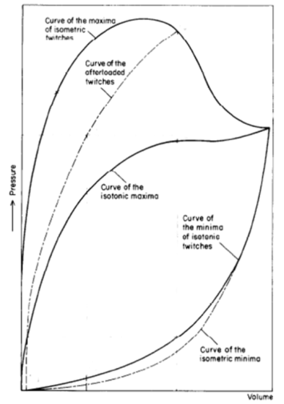

B.

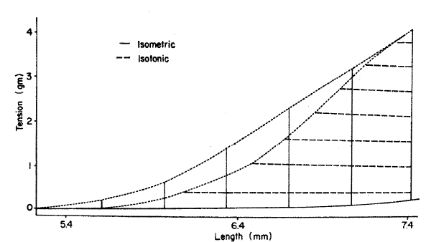

Figure

*A: Stylised plot of passive (end-diastolic: lower-most two curved lines) and active (end-systolic: upper-most three curved lines) pressure-volume relationships of excised frog heart. Note the separate end-systolic relationship for isometric (solid line) and afterloaded (broken line) twitches. Modified from Figure 3 of Frank (1899), with permission of the Copyright Clearance Center via RightsLink: License Number 3840330537202. B: Example of the relative difference in end-systolic curves between isometrically and isotonically contracted rabbit papillary muscle. Reproduced from Figure 7 of Brady (1967), with permission of Oxford University Press.*

Our goal is to understand the potential mechanisms that result in contraction-mode dependent end-systolic force-length curves.

# Methods

The complexity of the force-length relationship is the result of the dynamic nature of a cardiomyocyte contraction. Length, tension, cai2+ concentration, and other parameters change continuously.

Models are more capable than ever to capture this complexity, with the understanding of the complex nature of the force-length relationship evolving as models, tools, and technology improve.

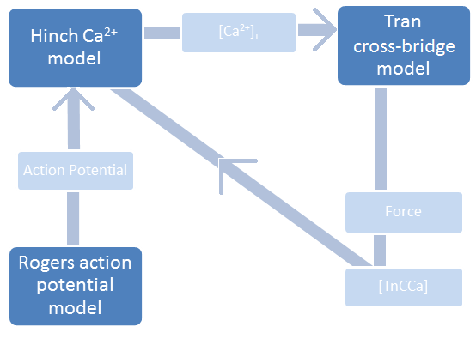

Figure

*High-level coupling between the Tran et al.* (2010) *cross-bridge, the Hinch et al.* (2004) *Ca2+, and the Rogers and McCulloch* (1994) *action potential models.* [TnCCa] represents the intracellular concentration of Ca2+ bound to troponin-C.

Force, sarcomere length, and intracellular calcium concentration are deeply interrelated in the cardiomyocyte contraction process. Figure 2 shows a high-level visual of how the combined model captures these relationships via feedback. The rate of change of Ca2+ bound to troponin, calculated in the XB model ([TnCCa]), feeds into the Hinch Ca2+ component, influencing the shape of the [Ca]i2+ transient.

# Results

The accuracy of this model configuration is verified by simulating quick-release experiments collected by Kurihara et al (year). Figure 3 shows the comparison between the experimental data and simulated data.

|  |  |
| --- | --- |
| Figure |  |

Experimental quick-release shortening of ferret papillary muscle (left; (Kurihara & Komukai, 1995)) and the simulated quick-release shortening of a single sarcomere (right).

*Describe the WL protocol here*

This paper focuses on the current understanding of the cardiomyocyte end-systolic force-length curve. Often considered an indicator of cardiac contractility, there are many reasons to better understand factors that influence the ES curve (explain). We are particularly interested the mechanisms that make the end-systolic force-length curve contraction-mode dependent.

When isometric and work-loop contractions are simulated, contraction-mode-dependent force-length ES curves are an emergent phenomenon. Our hypothesis is that contraction-mode-dependent TnC affinity for Cai2+, as reflected by the shape of the intracellular calcium transient, is sufficiently responsible for this difference **FIGURE 5**



*Figure 4*

*Two distinct, contraction-mode dependent end-systolic curves are an emergent property of the combined model. The Isometric end-systolic curve (grey) lies to the left of the work-loop end-systolic curve (black).*

Our hypothesis is that contraction-mode-dependent TnC affinity for Cai2+, as reflected by the shape of the intracellular calcium transient, is sufficiently responsible for this difference.



The cross-bridge is the fundamental mechanism responsible for force generation in the cardiomyocyte. For cross-bridges to generating force, it is first necessary for intracellular Ca2+ to bind to troponin-C. This results in [the troponin complex to moving from a non-permissive to permissive state]. The affinity of troponin-C for Ca2+ captures the state of contraction with its value dependent on neighbouring XBs and influences the progression of the contraction by altering the amounts of bound and unbound Ca2+.

**At what point does the affinity traces diverge, and what is occurring with force generation at this point in time?**

BUT the only flux that varies with force/ activation is dTropTot.  The other fluxes varying with contraction type is an *effect* of the changing Cai2+ transient width, NOT the *cause* of the change.  In other words, it is reasonable to use the changing width of the Cai2+ transient to represent/ reflect a activation-drive, contraction-mode dependent change in troponin affinity for Ca2+... This is not really surprising since dTropTot is the only one of the fluxes that is calculated within the XB model.



*Figure 5*

*The shape of the intracellular [Ca2+] transient depends on the contraction mode (gray vs. white). Additionally, sarcomere length (for isometric contractions-grey) and afterload (for work-loop contractions-black) affect the width of the intracellular [Ca2+] transient*

1. I need to articulate how/ why TnC affinity for [Ca2+] changes with the mode of contraction (the difference between grey and black)
2. Also include how SL and Afterload impact TnC affinity for [Ca2+]

Isometric contractions have consistently wider intracellular [Ca2+] transients, suggesting the unbinding of [Ca2+] from TnC happens over a longer time-span. With [Ca2+] stay bound to TnC, activation/ force generation is prolonged. (Show force traces?) To see if the prolonged state of activation is responsible for the contraction-mode dependency of the end-systolic curve, fixed isometric intracellular [Ca2+] transients are inserted into work-loop simulations.

force profiles

Figure 5 shows that the maximum amount of Ca2+ that enters the cell from CICR is independent of contraction mode, sarcomere length, and afterload. Thus, contraction mode dependent variations in intracellular Ca2+ transient shape is the result of existing intracellular Ca2+ binding to troponin-C or exiting the cell.

The initial sarcomere length is the most important factor in determining the width of the intracellular Ca2+ transient. (I should probably plot N, P, XBprer, XBpostr to see exactly how Cai2+ values

From **Figure___** it is clear that the recovery phase of the intracellular calcium transient varies considerably between contraction modes (compare isometric A and work-loop B) and within the modes as sarcomere length (isometric) or afterload value (work-loop) is varied.

“cai2+ transients in cardiac muscle are determined not only by the Ca2+ influx across the sarcolemma (LCC) and the Ca2+ release from the SR (RyR) but also by the Ca2+ buffering action of the TnC (dTroptot) on the thin filament” –Bers DM 2001 sources and sinks of activator calcium (in Yasuda 2003)

* How can we be sure it is the buffering action of troponin affecting the shape of the Ca2+ transient?
* “The three main mechanisms for Ca2+ removal from the intracellular space are the sodium CA2+ exchanger, the sarcolemmal Ca2+ ATPase, and the background leak current”
* How can I be sure the wider Ca2+ transient is the result of TnC affinity (the assumption 6-7)



me: activation is the term that reflects the amount of Ca2+ that is bound to TnC (PA Hofmann 1987). It is well known that activation and force generation are related via a feedback mechanism (more citations Hofmann 1987). The mechanism is the affinity of TnC for Ca2+. This affinity has contraction mode dependent properties, providing an opportunity to explain the contraction mode dependent behaviour of the force-length ES relation.

Many factors affect TnC affinity for Ca2+ (list some of these) and all of these factors are reflected in the intracellular Ca2+ concentration. The Cai2+ transient is an artefact that exhibits the amount of CA2+ in the cardiomyocyte cytoplasm that has not bound to TnC. Thus, the shape of the CAi2+ transient, reflects the dynamic affinity of TnC for Ca2+ throughout a contraction cycle.

Thus the Cai2+ transient is an artefact of Ca2+ binding to TnC. It shows the Ca2+ within the cell cytoplasm that is unbound



FIGURE 7

**Potential Discussion Info**

Replicating experimental quick release data verifies the data produced by the model reflect biological mechanisms.

Because simulations are not limited by physical or biological constraints, modeling allows for researchers to explore relationships that are difficult to access experimentally. In this paper we have

1. Verified the combined model works (quick release)

2) Call the model within a larger-scale protocol, allowing the model to switch between isometric and isotonic contraction, to achieve a work-loop contraction **FIGURE 4**

3) explored intracellular calcium levels during a work-loop contraction

4) inserted isometric calcium transients into work-loop contraction scenarios.

We are able to run these simulations and transcend current experimental limitations because the combined XB-Calcium model has proven to be sufficiently detailed and mechanically accurate. The model captures the complexity of the relationships between force generation, calcium concentration, calcium affinity, and sarcomere length

For example, “it has been suggested that the CA2+ affinity of TnC on the thin filament increases with increasing strain on the thin filament” (Gordon, regulation of contraction in striated muscle 2000. Yasuda 2003). The combined model includes this and other mechanical relationships, giving researchers an opportunity to dissect and explore interconnected mechanisms.

We suspect troponin affinity for Ca2+ is responsible for the contraction-mode dependent behaviour of the ES curves. If this is the case, affinity traces for an isometric contraction and a force-equivalent work-loop contraction will be very similar if the contraction pair have similar end systolic points (the blue star in Figure 1 below). Conversely, contraction pairs that have very different end-systolic points (the red stars in Figure 1 below) will have very different affinity traces. Figure 2 below shows that this does appear to be the case!

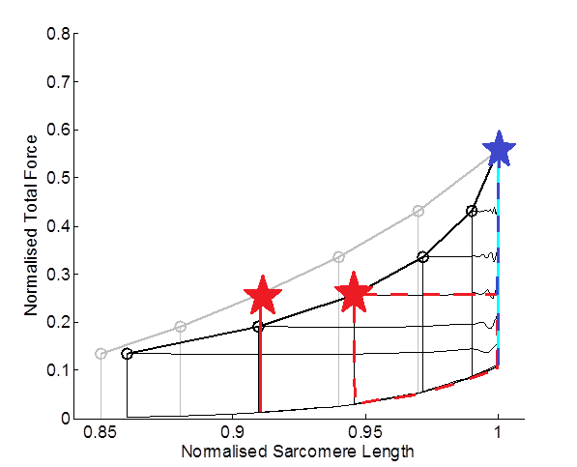

Figure 1

# Discussion

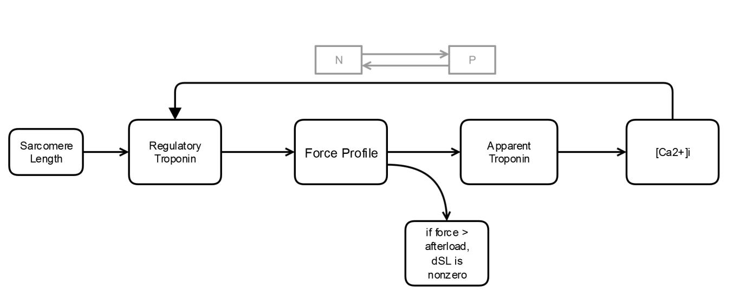

For thick and thin filaments to slide past each other during isotonic shortening, cross bridges unbind and Ca2+ detaches from troponin-C (citation). The result is an increase in free intracellular [Ca2+].

Concurrently, Ca2+ flows from the intracellular space via SERCA, NaCa pump, and pCa. Therefore, while shortening results in more free Ca2+, it only slightly slows the dwindling intracellular Ca2+ concentration (Figure 5).

Thus, as time elapses, the sarcomere gets shorter but there are less Ca2+ ions to form cross bridges.

With the number of possible XBs dwindling, the force level required for continued shortening cannot be maintained. Thus, the lack of free [Ca2+] is the determining factor in the location of the ES point. The number of potential XBs in the thick/ thin filament overlap would allow for the generation of force sufficient for continued shortening, but the lack of free [Ca2+] causes the sarcomere to stop shortening ‘prematurely’.

This is why inserting an isometric Cai2+ transient into a work-loop protocol shifts the work-loop ES curve leftward. The extended duration of high intracellular Ca2+ allows for more XBs to activate, develop force, and maintain force for a longer period of time. The result is a sarcomere that shortens more efficiently (quicker) and for a longer duration.



Discussion/ Explanation of Figure:

The results show that inserting fixed isometric Ca2+ transients into work-loop contractions can shift the work-loop end-systolic curve substantially leftward. The leftward shift is capable of unify isometric and work-loop end-systolic force-length curves, with the magnitude of the shift proportional to the width of the fixed Ca2+ transient.

Contraction-mode differences in intracellular Ca2+, therefore, can sufficiently explain the differing end-systolic curves for isometric vs. work-loop contractions. To explain the underlying mechanism for this phenomenon, we will focus on answering two questions:

1. Why is the intracellular Ca2+ transient contraction-mode dependent?
2. How can an adjustment to the intracellular Ca2+ contraction unify the isometric and work-loop end-systolic curves?

Why is the intracellular Ca2+ transient contraction-mode dependent?

**0ms:** **Figure 8, A** shows that work-loop and isometric contractions start with the accumulation of intracellular Ca2+. At this point isometric and work-loop intracellular Ca2+ transients are essentially equal. Generation of force has not started.

Generating an isometric end-systolic force-length curve requires varying the initial (preset) sarcomere length, while work-loop contractions always start at the same sarcomere length. Thus, unless an isometric contraction occurs at 2.3 (the maximum sarcomere length for this paper), its force-equivalent work-loop will start with a larger sarcomere length.

**18ms:** At 18ms, force generation begins. The rate of Force development is larger for the work-loop contraction than it is in the isometric contraction **(Figure 8, C)**. This is because the rates governing cross-bridge state change from “non-permissive” to “permissive” is dependent on sarcomere length. Thus, the initial value for sarcomere length affects the force profile of a contraction.

The force profile affects the concentration of free, intracellular Ca2+ via apparent Ca2+ binding to troponin.

So the first part of our answer is, the different starting lengths of sarcomeres undergoing work-loop or isometric contractions influences the rate of force generation. The contraction-mode dependent force profile further influences the process of Ca2+ binding to troponin. If the flux of Ca2+ binding to troponin-C increases, there is less free intracellular Ca2+. The result is a steeper recovery phase on the intracellular Ca2+ transient (a “thinner” transient).

The “width” of the intracellular Ca2+ transient is largely dependent on the initial length of the sarcomere undergoing contraction. Since initial sarcomere length is contraction-mode dependent, the shape of the Intracellular Ca2+ expresses behaviour that is contraction-mode dependent.

How can an adjustment to the intracellular Ca2+ contraction unify the isometric and work-loop end-systolic curves?

Our previous question and answer addresses the cause of differing intracellular Ca2+ transients for isometric and work-loop contractions (seen in Figure 5). Our results show that inserting a fixed isometric Ca2+ transient into a work-loop contraction can increase duration of isotonic shortening during the work-loop.

Essentially, we are concerned with understanding the mechanism that allows intracellular Ca2+ concentration to influence the magnitude of cellular force. In the Rice-Tran model, the intracellular Ca2+ concentration affects regulatory troponin. By influencing regulatory troponin, Ca2+ affects the probability of a cross-bridge going from a non-permissive state to a permissive state. For a cross-bridge to achieve a state of force production, it must first pass from the non-permissive to permissive state. Hence, Ca2+ influencing the rates between the “N” and “P” states also influence the probability of a cross-bridge reaching a force-producing state.

Other points of discussion:

1. Passive force removal?
2. These results informing possibilities for future experimentation

References

Hinch R, Greenstein JL, Tanskanen AJ, Xu L & Winslow RL. (2004). A simplified local control model of calcium-induced calcium release in cardiac ventricular myocytes. *Biophysical journal* **87,** 3723-3736.

Rice JJ, Wang F, Bers DM & de Tombe PP. (2008). Approximate model of cooperative activation and crossbridge cycling in cardiac muscle using ordinary differential equations. *Biophysical journal* **95,** 2368-2390.

Manuscript Figures (rough GUIDE):

1. Keep the same
2. Keep mostly the same (perhaps change [TnCCa] label)
3. Rerun the Kurihara validation
4. Emergent ES curves
   1. Iso ES curve:
      1. Grey
      2. thick
      3. circles
   2. WL ES curve:
      1. Black
      2. thick
      3. circles (keep)
   3. iso bars:
      1. grey
      2. thin
   4. WL:
      1. black
      2. thin
   5. Axes:
      1. x: 0.84-1.1 with [0.85, 0.9, 0.95, 1]
      2. y: 0-0.8 every 0.1
      3. Y: “Normalised Total Force
      4. X: “Normalised Sarcomere Length”
5. Overlay of Cai2+ transients:
   1. Iso:
      1. gray
      2. thin
      3. with gray arrow
   2. WL:
      1. black
      2. thin
      3. with black arrow
   3. time = 0-300 every 50 ms “Time (ms)”
   4. Y: 0-1.4 every 0.2 uM “[Ca2+]I (uM)”
6. WL with fixed Cai2+
   1. black
   2. thin
   3. circles at points (this will be inserted with ES curves)
   4. arrow with “Wider [Ca2+]I transient
   5. fix the axes to match figure 4
   6. “Normalised Total Force” and “Normalised Sarcomere Length”
7. Get axes to match 4 and 6
   1. Iso ES:
      1. gray
      2. solid
      3. thick
      4. NO points
   2. WL ES
      1. black
      2. solid
      3. thick
      4. NO points (?) maybe points…
   3. WL with fixed Cai2+
      1. black
      2. solid
      3. thin
      4. WITH CIRCLES at ES points