# Introduction

Brief literature review on ES isometric vs. work-loop/ isotonic ES curves

A.

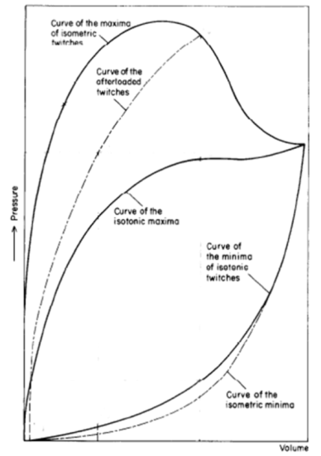

B.

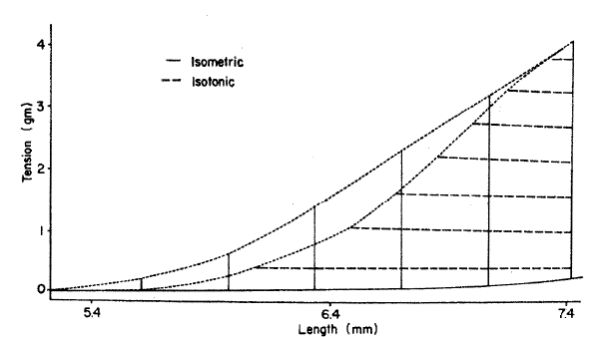

Figure 1

*A: Stylised plot of passive (end-diastolic: lower-most two curved lines) and active (end-systolic: upper-most three curved lines) pressure-volume relationships of excised frog heart. Note the separate end-systolic relationship for isometric (solid line) and afterloaded (broken line) twitches. Modified from Figure 3 of Frank (1899), with permission of the Copyright Clearance Center via RightsLink: License Number 3840330537202. B: Example of the relative difference in end-systolic curves between isometrically and isotonically contracted rabbit papillary muscle. Reproduced from Figure 7 of Brady (1967), with permission of Oxford University Press.*

# Methods

How the model works. Details of the simulations:

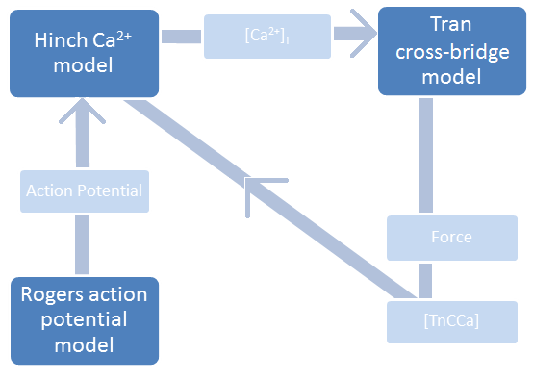

Figure 2

*High-level coupling between the Tran et al.* (2010) *cross-bridge, the Hinch et al.* (2004) *Ca2+, and the Rogers and McCulloch* (1994) *action potential models.* [TnCCa] represents the intracellular concentration of Ca2+ bound to troponin-C.

# Results

|  |  |
| --- | --- |
|  |  |

*Figure 3*

*Experimental quick-release shortening of ferret papillary muscle (left; (Kurihara & Komukai, 1995)) and the simulated quick-release shortening of a single sarcomere (right).*

The combined Tran-Rice-Hinch (TRH) model is used to examine the role Ca2+ plays in the end-systolic force-length relation of a cardiomyocyte contraction. But before any data is collected, we test the model’s ability to replicate experimentally collected data. In doing so, we verify the combined model is mechanistically accurate.

This paper focuses on the interplay between cardiomyocyte force, sarcomere length, and intracellular Ca2+. Accordingly, model validation is focused on assessing the mechanisms responsible for force-dependent Ca2+ binding to troponin.

The experiment conducted by Kurihara et al provides data for model validation. In this paper, tension-dependent changes of the intracellular Ca2+ transient are analysed by imposing quick-releases on isometric contractions. The sudden length change from a quick release results in an immediate drop in developed force and subsequent surge of intracellular [Ca2+]. Kurihara et al attribute this behaviour to ______ .

Replicating the Kurihara experiment with the combined model generates quantitatively similar results. A quick-release change in length causes a decrease in force and increase in Ca2+. The extent of the Ca2+ surge and redevelopment of force depends on the timing of the quick release, as expected. Figure 3 shows the comparison between experimental and model data.



*Figure 4*

*Two distinct, contraction-mode dependent end-systolic curves are an emergent property of the combined model. The Isometric end-systolic curve (grey) lies to the left of the work-loop end-systolic curve (black).*

From the validated model emerges two, contraction-mode dependent end-systolic curves (Figure 4).

This phenomenon was first spotted by ____. Additionally, recent experiments corroborate these findings (Kenneth, JC data).

Experimental evidence shows that calcium handling affects cross bridge activation and force generation (citations). We suspect that differences in the intracellular Ca2+ transients can sufficiently explain the presence of two distinct, contraction-mode dependent end-systolic curves. Figure 5 shows the contraction-mode dependent behaviour of the Ca2+i transients.



*Figure 5*

*The shape of the intracellular [Ca2+] transient depends on the contraction mode (grey vs. black). Additionally, sarcomere length (for isometric contractions-grey) and afterload (for work-loop contractions-black) affect the width of the intracellular [Ca2+] transient*

The simulated intracellular [Ca2+] transients vary according contraction mode (grey vs. black Figure 5) and initial parameter values. The most notable trends from Figure 5 are listed below.

1. **Variation in Isometric Ca2**+: Initial SL affects Ca2+ width (before t=48ms / shortening)
2. **Variation in Work-loop Ca2+:** For lower afterloads, the isotonic phase of a work-loop contraction is characterized by a correspondingly lower rate of Ca2+ binding to troponin-C. This appears as a ‘bump’ in the intracellular Ca2+ transient during sarcomere shortening.
3. **General difference between Isometric and WL Ca2+:** Intracellular Ca2+ levels, for the most part, decrease quicker in work-loop contractions (steep black lines, Figure 5) than in isometric contractions (less-steep grey lines, Figure 5). Intracellular Ca2+ levels affect XB activation. A lack of activated XBs resulting from a quick drop-off in intracellular Ca2+ could affect the sarcomere’s ability to maintain force.

We believe the relative lack of free [Ca2+] in work-loop contractions (black lines, Figure 5) is the main determining factor in the location of the ES point. The physical number of XBs in the thick/ thin filament overlap region would allow for the generation of force sufficient for continued isotonic shortening, but we believe the lack of free [Ca2+] causes the sarcomere to stop shortening ‘prematurely’.

To test our hypothesis, isometric Ca2+ transients are inserted into WL contractions with the belief that the ‘wider’ isometric Ca2+ transients will allow for further isotonic shortening within work-loops. We expect a leftward shift of the ES curve and ultimately aim to unite the isometric and work-loop ES curves.



*Figure 6*

*Inserting isometric [Ca2+] transients into work-loop simulations cause a leftward shift in the work-loop end-systolic force-length curve. Wider [Ca2+] transients result in a larger leftward shift.*

Figure 6 shows that inserting wider, isometric [Ca2+]i into work-loop contractions cause a leftward shift in work-loop end-systolic force-length curves. The duration/ width of the fixed intracellular [Ca2+] transient determines how far the ES curve moves. A wider transient corresponds to more isotonic shortening, and a larger leftward shift (Figure 6).

Tailoring the [Ca2+] transient shape to the afterload of individual work-loops affords us the ability to specify the end-systolic length. With this ability, the isometric and work-loop end systolic curves can be united (Figure 7).



*Figure 7*

*By Inserting fixed [Ca2+] transients that are tailored to each work-loop afterload, it is possible to unite isometric and work-loop end-systolic force-length curves.*



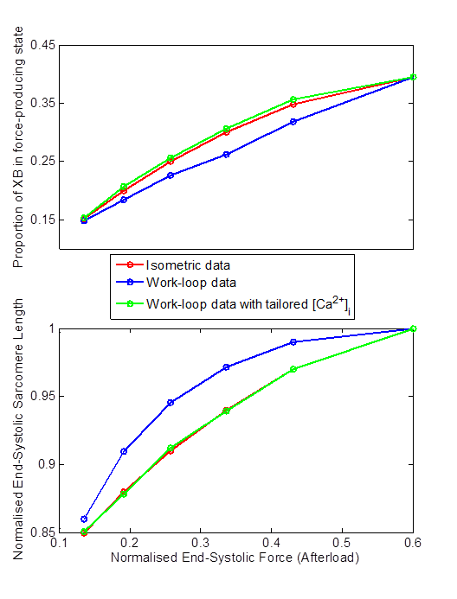

*Figure 8*

*Compared to work-loop contractions, isometric contractions have more cross bridges (XB) in a force-producing state at end-systole (subplot 1).  This means that isometric contractions, compared to work-loop contractions, require less sarcomere length to produce the same amount of end-systolic force (subplot 2).  Boosting the proportion of XBs in a force-bearing state at end-systole for a work-loop contraction, therefore, allows sarcomeres to maintain isotonic shortening until the force-equivalent isometric sarcomere length is reached.*

# Discussion

To understand why the location of the end-systolic force-length relation is contraction-mode dependent, it is helpful to consider the factors that determine end systolic length for each of the contraction types:

1. **Isometric:** The sarcomere-lengths for the isometric contractions (grey, Figure 4) are fixed during the contraction. The specific value is predetermined by the user.
2. **Work-loop:** The end-systolic sarcomere lengths for work-loop contractions (black, Figure 4) depend on the sarcomere’s ability to maintain force. During the flat-top, isotonic phase, a sarcomere length will decrease as long as the total generated force is greater than the afterload.

Sustained force, then, is critical in determining the location of work-loop end-systolic, force-length curves. Equation 1 shows how force is calculated in the TRH model.

|  |  |
| --- | --- |
|  | [1] |

*Force is proportional to the fractional occupancy of the strongly-bound states (XBprer and XBpostr) multiplied by the average distortion of these states (xXBprer and xXBpostr). SOVFthick is a scaling factor for the contribution of sarcomere geometry to the number of recruitable crossbridges (Rice et al., 2008). “kxb” is also a scaling factor that is set to 1 in for all simulations discussed in this paper.*

Two main mechanisms determine whether total force is above or below the afterload value:

1. The overlap fraction (SOVFThick in equation [1])

The number of recruitable crossbridges decreases as sarcomere length decreases

However, an additional mechanism exists that enables a cardiomyocyte to generate different levels of force for the same sarcomere length. We see this in figure 4 where the same end-systolic sarcomere length is capable of generating vastly different end-systolic force levels (depending on contraction-mode).

Sarcomere length, therefore, is not the limiting factor in force production for a work-loop contraction. Thus, our attention will be focused on the second mechanism at play in generating and maintaining force.

1. The proportion of XBs that occupy a force-producing state.

A sarcomere generates force via strongly bound crossbridges. In equation 1, strongly-bound crossbridges are represented by two states, XBpostr and XBprer. The flux of crossbridges going in and out of these strongly bound states depends on intracellular [Ca2+].

[Ca2+]i significantly influences the proportion of XBs in a permissive or non-permissive state. Only the XBs that move from a nonpermissive (NXB) state to a permissive (PXB) state can be recruited for cycling and force development (see figure below ADD figure label). (citation… Ca2+ affects activation)

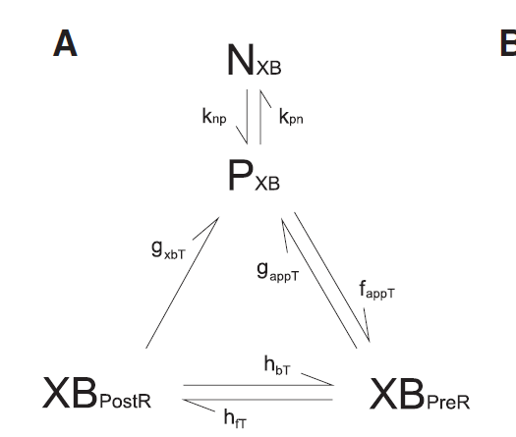

Figure label



Work-Loop

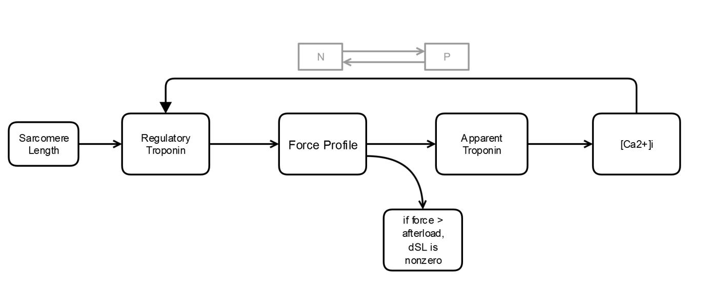

Work-Loop with fixed Ca2+







Rice JJ, Wang F, Bers DM & de Tombe PP. (2008). Approximate model of cooperative activation and crossbridge cycling in cardiac muscle using ordinary differential equations. Biophysical journal 95, 2368-2390.

DISCUSSION NOTES/ THOUGHTS

____

For an isometric contraction sarcomere length is fixed. End systole occurs when the greatest proportion of XBs in the filament overlap region are force-producing.

A sarcomere performing a work-loop contraction achieves a higher peak proportion of force-producing cross-bridges, but is actively shortening when this peak is reached. In fact, cross-bridge activation is significantly diminished before the sarcomere reaches the force-equivalent isometric length.

At work-loop end-systole, the physical number of cross-bridges in the thick/ thin filament overlap region would allow for the generation of force sufficient for continued isotonic shortening, but a lack of activated cross-bridges causes the sarcomere to stop shortening ‘prematurely’.  This a major contributing factor to the work-loop end-systolic force-length curve lying to the right of the isometric end-systolic force-length curve.

Manipulating the Ca2+transient profile resulted in an increase and prolongation of the proportion of cross-bridges in a force-producing state.  This facilitated isotonic shortening at lower sarcomere lengths and allowed for the isometric and work-loop end-systolic curve to be united.

## Incomplete Thoughts: (WORK IN PROGRESS)

fig5

Form this data, we predicted the relative lack of free [Ca2+] in work-loop contractions (black lines, Figure 5) to be the main determining factor in the location of the ES point.  The physical number of XBs in the thick/ thin filament overlap region would allow for the generation of force sufficient for continued isotonic shortening, but a mechanism related to the lack of free [Ca2+]i causes the sarcomere to stop shortening ‘prematurely’.

Isometric Ca2+ transients were inserted into WL contractions with the belief that the ‘wider’ isometric Ca*2+* transients will allow for further isotonic shortening within work-loops. We expected a leftward shift of the ES curve and ultimately aimed to unite the isometric and work-loop ES curves.

________________

To understand why the location of the end-systolic force-length relation is contraction-mode dependent, it is helpful to consider the factors that determine end systolic length for each of the contraction types:

1)      **Isometric:** The sarcomere-lengths for the isometric contractions (grey, Figure 4) are fixed during the contraction.  The specific value is predetermined by the user.

2)      **Work-loop:** The end-systolic sarcomere lengths for work-loop contractions (black, Figure 4) depend on the sarcomere’s ability to maintain force.  During the flat-top, isotonic phase, a sarcomere length will decrease as long as the total generated force is greater than the afterload.

Sustained force, then, is critical in determining the location of work-loop end-systolic, force-length curves.  Equation 1 shows how force is calculated in the THR model.

https://lh6.googleusercontent.com/7XVc2UN2fHcDFJa9ioixHTpEcSP2EpltKcxQC9X4kKFNXCz38_5WXRjn86k3mmF4sZG2vfrO0lqlvgH90GRepqMe8SehPDiHpHz4x9XKUQ1zAeSsuJ3p5z-aLsdbOC2EtcYkIb8g         [1]

*Force is proportional to the fractional occupancy of the strongly-bound states (XBprer and XBpostr) multiplied by the average distortion of these states (xXBprer and xXBpostr).  SOVFthick is a scaling factor for the contribution of sarcomere geometry to the number of recruitable crossbridges (Rice et al., 2008). “kxb” is also a scaling factor that is set to 1 in for all simulations discussed in this paper.*

Two main mechanisms determine whether total force is above or below the afterload value:

1)      The overlap fraction (SOVFThick in equation [1])

The number of recruitable crossbridges decreases as sarcomere length decreases

However, an additional mechanism exists that enables a cardiomyocyte to generate different levels of force for the same sarcomere length. We see this in figure 4 where the same end-systolic sarcomere length is capable of generating vastly different end-systolic force levels (depending on contraction-mode).

Sarcomere length, therefore, is not the limiting factor in force production for a work-loop contraction.  Thus, our attention will be focused on the second mechanism at play in generating and maintaining force.

2)      The proportion of XBs that occupy a force-producing state.

A sarcomere generates force via strongly bound crossbridges.  In equation 1, strongly-bound crossbridges are represented by two states, XBpostr and XBprer.  The flux of crossbridges going in and out of these strongly bound states depends on intracellular [Ca2+].

[Ca2+]i significantly influences the proportion of XBs in a permissive or non-permissive state.  Only the XBs that move from a nonpermissive (NXB) state to a permissive (PXB) state can be recruited for cycling and force development (see figure below ADD figure label).  (citation… Ca2+ affects activation)

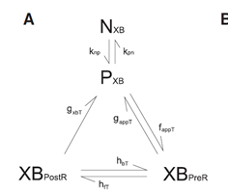

Isometric contractions, compared to work-loop contractions, have a larger proportion of XBs in a force producing state at end-systole (red vs. blue lines in subplot 1).

Therefore, end-systole in an isometric contraction is characterized by a more efficient use of sarcomere length (subplot 2, the isometric data (red) requires less length than the work-loop data (blue) to produce equivalent ES force.

To unite the isometric and WL end-systolic force-length curves, work-loops have to maintain force at shorter sarcomere lengths.

fig7

Tailoring the [Ca2+]i transient shape to the afterload of individual work-loops allowed for prolongation of the phase of isotonic shortening until the force-equivalent isometric sarcomere length was reached.  With this result, the isometric and work-loop end systolic curves were united (Figure 7).

______

We achieved this by boosting magnitude and duration of XB recruitment (resulting in the green lines in figure 8)

With a larger proportion of XBs in a force-producing state, isotonic force is maintained at lower sarcomere lengths.  This adjustment allows sarcomeres to maintain isotonic shortening until the force-equivalent isometric sarcomere length is reached (the green line matches the red line in subplot).

Interestingly, to achieve the same end-systolic force-length, sarcomeres that undergo isotonic shortening require a larger proportion of XBs in a force-producing state at end-systole (subplot 1: the green line is above the red line).

Other mechanisms involving XB distortion must be at play.

Hi Megan and Denis,

I have come across a conference proceedings paper published the European heart journal (Baan, 1992) that highlights a number of phenomena that affects the ESFLR and mentions ‘shortening deactivation’ as one of these mechanisms.  Moreover, the figure of Brady, 1967 was also used to illustrate this effect!  I think this was taken from Lab  et al. (1984) [Allen and Orchard’s group] where the reference to Brady is made in the opening paragraph along with the definition of ‘shortening deactivation’.  Lab et al., (1984) also show, experimentally, the Ca, Force and length profiles of papillary muscles, for a lightly loaded contraction (Fig. 1), for quick releases during a twitch(Fig. 2) and for delayed quick releases (Fig. 3).  Both papers are attached here.

So, it seems a number of pieces of the puzzle have been reported in the literature:

-        Different isometric and isotonic ESFLRs (Brady, 1967).

-        Shortening deactivation abbreviates isotonic contractions and has been proffered as a mechanism to explain the difference in the ESFLRs between isometric and work-loop contractions (Bann, 1992).

-        Shortening deactivation arises from force-dependent binding of Ca to troponin (Housmans, 1983).

But does this mechanism actually account of the difference in the ESFLRs?

The isometric ESFLR is derived from isometric contractions at different muscle lengths, from Lmin to Lo.  The work-loops for the ESFLR are all derived from the same initial muscle length, Lo.  Hence, there are two effects here: 1) effect of length on the isometric contractions and 2) effect of shortening on the work-loop contractions; both of which act on the Ca transient via the force-dependent binding of Ca to troponin.

Our simulation results suggest that the contribution of 'shortening deactivation' is almost negligible.  It is the effect of force-dependent binding of Ca to troponin on the isometric contractions that offer the largest impact.  At decreasing SL, the Ca transient widens much more than the effect of a decrease in afterload on the work-loop contractions.

For an equivalent force, the work-loop contraction will always have a more abbreviated Ca transient because it is operating at Lo while the force-equivalent isometric contraction operates at a length < Lo.

These are the points I have come up with after doing a bit of trawling through the literature.  I don’t think we can claim that no one has looked at this issue and that we are the first to address it.  It seems that a lot of studies have focussed on the force-dependent binding of Ca to troponin, mainly in the context of ‘shortening deactivation i.e. shortening during a contraction, whether it be a quick release or an isotonic contraction. There has been much less focus on the isometric ESFLR. Our study treats both theses contraction modes equally and in doing so, we demonstrate that (in the presence of the same force-dependent binding of Ca troponin mechanism) it is the isometric contractions that have the largest effect on the Ca.  How does this sound for the angle of the paper? Does it makes any sense??

Cheers,

Kenneth

Part 1 (figures 4-6)

1. different contraction modes have different Ca2+ transient shapes.
2. the width of the Ca2+ transient is related to the force generated by the contraction, although the width of WL Ca2+ varies much less than the width of isometric Ca2+
   1. in this scenario, wider ca2+ is associated with less activation (because wider Ca2+ is attached to a smaller force) Housmans
   2. It is not useful to look at only

Previous data gave us the impression that Isotonic Ca2+ was WIDER than isometric Ca2+… Because of this, wider Ca2+ was associated with more deactivation.

The reality is a lower afterload (force) is responsible for less activation and more free Ca2+. But for a given afterload, a wider Ca2+ transient allows for more XB activation

DISCUSSION POINTS:

Shortening deactivation, as it is defined in the literature, describes how active shortening of a muscle during a contraction reduces the affinity of Ca2+ for troponin C, resulting in an offloading of Ca2+ into the cytosol and reduction in the level of cross-bridge activation.

The results ____ show that this understanding of shortening deactivation is not complete, because it does not take into account the deactivation associated with isometric contractions performed at lower sarcomere lengths (Figure 5).

Cross-bridge deactivation is present in work-loop contractions (shortening deactivation) and in isometric contractions.

A work-loop with infinite afterload is equivalent to an isometric contraction occurring at L0.  Shortening does not occur in this type of contraction and the sarcomere is at its maximal (not the right word?) length, thus activation levels are at their maximum.  Any factor that causes a deviation from this max-force scenario can be considered a source of deactivation.  Afterload-dependent shortening deactivation in isotonic contractions is one of these factors, but deactivation is not limited to shortening muscles.  Isometrically contracting muscles experience length-dependent deactivation.  In fact, the cross-bridge deactivation associated with varying isometric sarcomere length is much more significant than shortening deactivation.

Deactivation explains the variations in intracellular Ca2+ transients, but how does this relate to the location of the end-systolic force-length curve?

Intracellular Ca2+ levels affect cross-bridge recruitment.

The Ca2+ transient reflects the level of activation in the muscle.  Isometric contractions, unless performed at L0, have wider Ca2+ transients than work-loop contractions.  This reflects the lower force/ activation levels experienced at shorter sarcomere lengths.

…...Ca2+ binding to troponin depends on 1) force and 2) the amount of intracellular Ca2+.  In the past, these dependencies have been explored independently and incompletely.  We explored both and, in doing so, uncovered one possible explanation for the contraction-mode dependency of the force-length end-systolic curve.

In previous experiments, work-loops were analysed only in relation to the Lo isometric contraction (citations). Such data gave the impression that a “Ca2+ transient recorded during isotonic shortening declines later than that accompanying the rise of force in isometric contractions” (Housmans 1983).  This is not entirely true.

if the a work-loop Ca2+ transient is compared to the Ca2+ transient of its force-equivalent isometric counterpart.