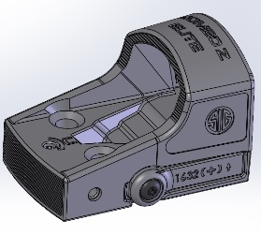Romeo Zero Gen II (ROMEO Z) Design Document

# Product Description

The gen II product will be based on the gen I design. Nomenclature will call this a RomeoZ. This design will move the button from the center top as in the gen 1, to the side for easier customer access. The battery will also change from bottom load that requires removing it from the firearm each time to a side load with battery door, making it easier for the customer to change the battery. The board be shaped to fit all three mechanical footprints, R, Elite, Pro. Available in Circle dot, 3MOA and 6MOA. The RomeoZ will feature MOTAC but will remove tap, as the button is now on the side and easier to get to. There will be one firmware version that will work on all combinations of boards.

# Part Numbers

7404337 Raw board (PCB)

7404337-01 3MOA board assembly (PCA)

7404337-02 6MOA board assembly (PCA)

7404337-03 Circle Dot board assembly (PCA)

SOR02000 – ROMEOZERO-ELITE, CIRCLE/DOT

SOR02030 – ROMEOZERO-ELITE, 3 MOA

SOR02100 – ROMEOZERO-PRO, CIRCLE/DOT

SOR02160 – ROMEOZERO-PRO, 6 MOA

SOR02200 – ROMEOZERO-R, CIRCLE/DOT

SOR02260 – ROMEOZERO-R, 6 MOA

Possibly a few more numbers for OEM parts for circle dot elite and pro.

# Initial Forecast

Approx 10k per month

## Finished goods

CD for Pro/R/Elite 1225 per month

3MOA Pro/Elite 1350

6MOA 200

## New Hampshire Consumption

~6650

# Project Documents and Storage

## HW Project

The schematic design project and documentation will be stored in the RZ_G2_HW project in the GIT repository for Sig Sauer.

## HW Project Documents

Project documents should include:

Project Design Document (this document)

Qualification/Prototype build information and tracking

Test Requirement Document and Test Results for each build

Schematics

Bill of Materials (BOM’S)

Altium Output files for FAB

Altium Output files for Assembly

Mechanical drawing from the mechanical design engineer

Production Test and programming procedure

Manufacturing Test Fixture information

Feedback/Input/review info from any downstream customer this can be mechanical engineer, manufacturing engineer, quality engineer, live fire testing operator, etc, and actual customer if applicable.

## FW Project

The firmware project and documentation will be stored in the RZ_G2_FW project folder in the GIT repository for Sig Sauer

## FW Project Documents

FW Design Document

Programming file

# HW Design

## General Description

The HW for the Romeo Z is based on the gen 1 design but with different MCU and accelerometer. The board will use a ATtiny1616 microcontroller with and ST LIS2DE12. This raw board design should be able to use other variations of ATtiny MCU’s that have the same footprint with the same FW but this needs to be verified. This board can also use different variations of the LIS2 ST accelerometer with the same footprint, but the FW will have to be updated due to register sets being different.

## BOM OPTIONS

This board design uses one raw board for all three footprints of Romeo Z (R, Elite, Pro). There will be different bill of materials (BOM’s) for the 3 different emitters. (CD, 3MOA, 6MOA). These different BOM’s have several components that are placed or not placed depending on the emitter used. These are referred to as BOM optioned components. The base schematic has a legend for the different BOM options and each component that can be changed for these BOM options is labeled on the schematic with the BOM option name and either =1(installed), or =0 (not installed). There is also a third BOM option for alternate parts numbers. This will allow the board assembly house to use other variations of MCU’s or Accelerometers as instructed by Sig for future flexibility.

## Block Diagram

## Decisions along the way for Reference

# OPAMPTerem

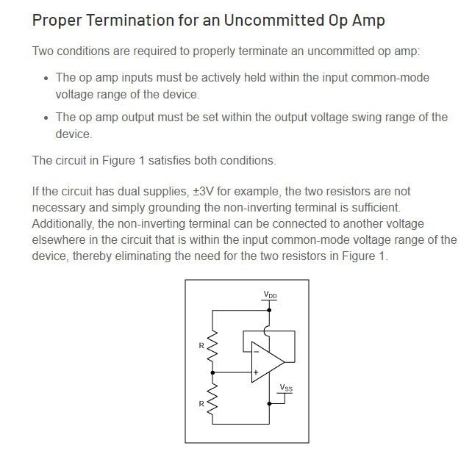

# FW

## Accelerometer

Registers needing to be set:

CTRL_REG1 0x20 = 0x31 for ODR 25Hz and only X axis enabled.

CTRL_REG3 0x22 = 0x10 to set xyz interrupt

CTRL_REG5 0x24 = 0x08 for latch interrupt on int1 must then be cleared by reading the int register, not sure if we need this. The active low unlatched maybe is fine as in interrupted input on the MCU.

INT1_CFG 0x30 = need to determine this, not sure what high or low event means

INT1_THS 0x32 = TBD N/ODR, current above setting has ODR at 25 How long does the int need to stay low?

ACT_THS 0x3E = TBT

ACT_DUR 0x3F =TBT

How does memsic go to sleep and wake, and how does it handle tap. What about button press?

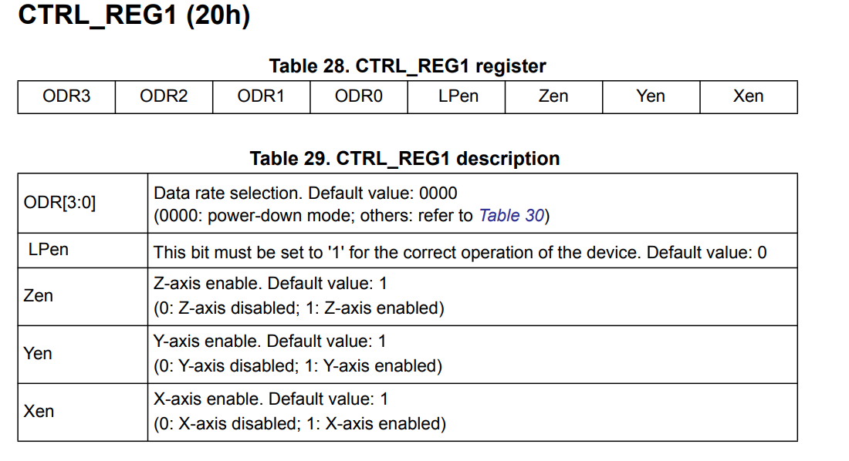

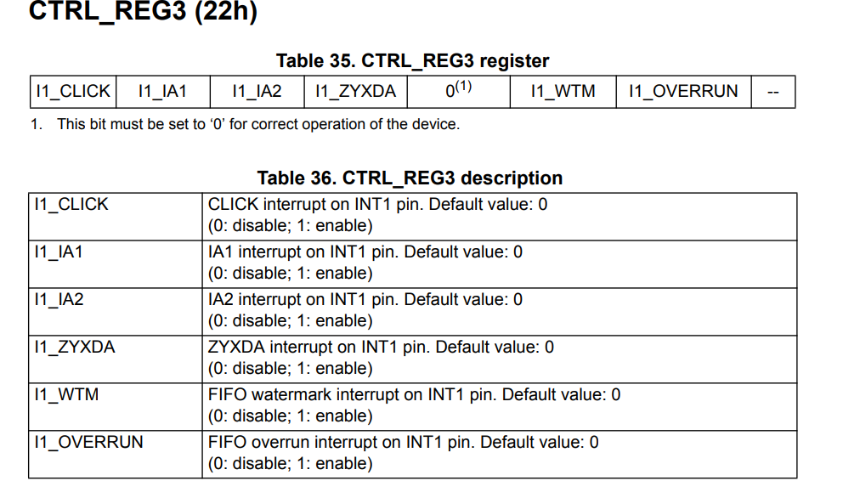

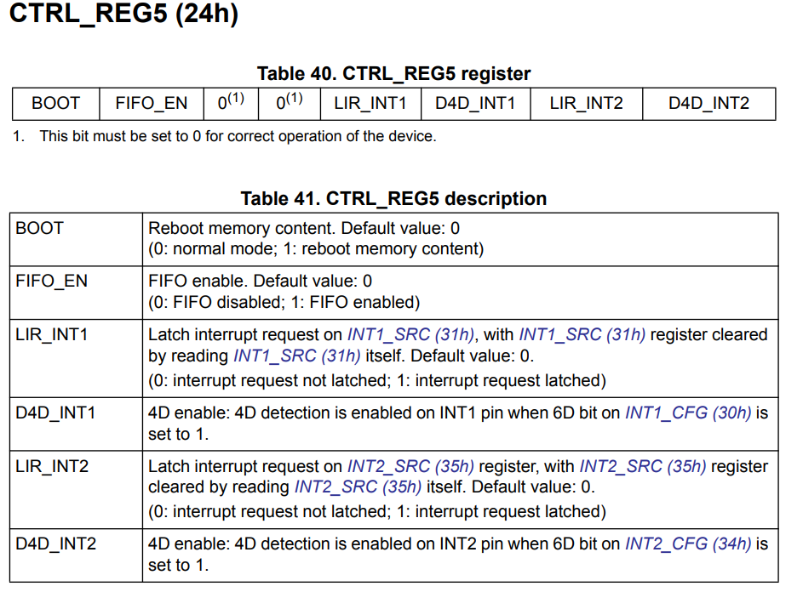

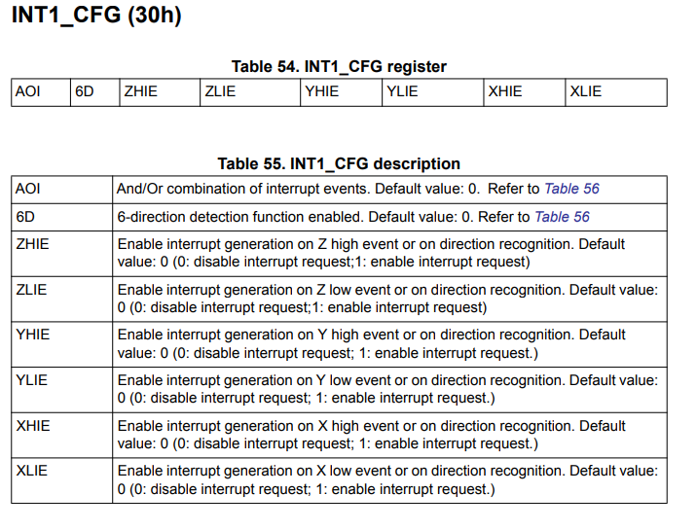

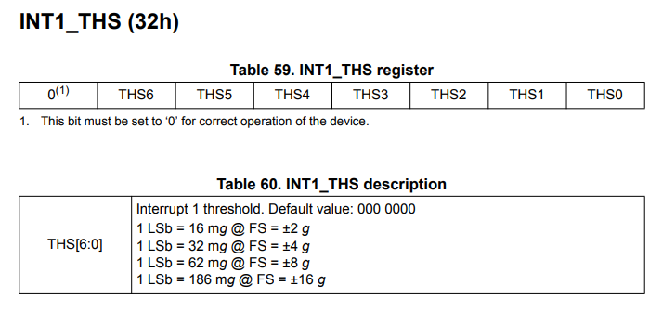

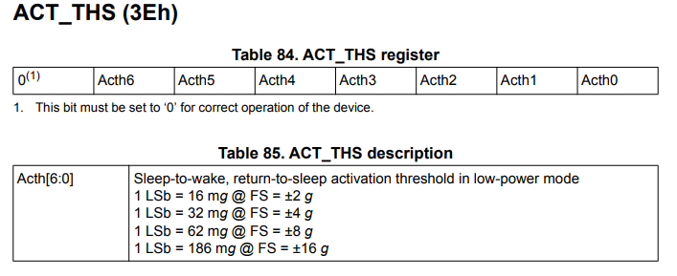

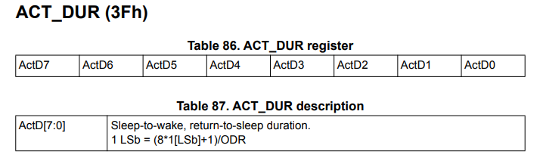

## MCU

4 modes of operation page 91

Run

Idle Sleep

Standby Sleep

Power Down Sleep

## Adding ADC

On very first power up at vendor the MCU will get programmed, I want main to check if eeprom value for IDSet is true. It should be false the very first time. If false then it needs to setup A2D check the ID of the board by reading the input. If it’s 0 that means it’s a dot board and isDot = true. This true value will get written to the eeprom and be set for life. So then IDset will also need to be set to true so that subsequent power ups will skip checking the ID. So isDot and IDSet will need to be read into a local variable each power up. So the PWM will not be setup and run for the circle output and the user can’t enter reticle change mode. The other option is to read it each time the unit is powered up, which should only usually happen when the battery is changed.

# Mechanical Drawings

## Initial Mechanicals



