Instructions:
The database must hold:

- raw experimental analysis data held in the original .csv

mysql> SELECT * FROM IMPC_analysis_raw LIMIT 2;

- Additional information on the phenotype procedure

Search Procedure for specific impc_parameter_orig_id (picked from IMPC_analysis)
mysql> select procedure_name from IMPC_procedure where procedure_id = (select procedure_id from IMPC_procedure_parameter where impc_parameter_orig_id='21469');

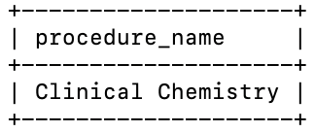

View parameter_name and procedure_name for all analysis_id
mysql> SELECT DISTINCT
-> a.analysis_id,
-> p.parameter_name,
-> pr.procedure_name
-> FROM IMPC_analysis a
-> JOIN IMPC_parameter p
-> ON a.impc_parameter_orig_id = p.impc_parameter_orig_id
-> JOIN IMPC_procedure_parameter pp
-> ON a.impc_parameter_orig_id = pp.impc_parameter_orig_id
-> JOIN IMPC_procedure pr
-> ON pp.procedure_id = pr.procedure_id
-> LIMIT 5;

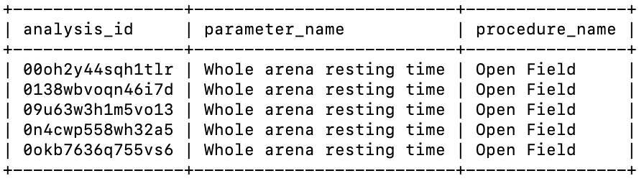

- The parameters belonging to each procedure

View procedure names and their corresponding parameter names
mysql> SELECT DISTINCT
-> pr.procedure_name,
-> pa.parameter_name
-> FROM IMPC_procedure pr
-> JOIN IMPC_procedure_parameter pp
-> ON pr.procedure_id = pp.procedure_id
-> JOIN IMPC_parameter pa
-> ON pp.impc_parameter_orig_id = pa.impc_parameter_orig_id
-> ORDER BY pr.procedure_name, pa.parameter_name
-> LIMIT 5;

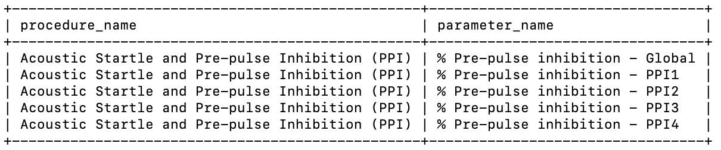

- The human disease associated with the gene

View all gene and disease associations
mysql> SELECT
-> IMPC_disease.disease_id,
-> IMPC_disease.disease_name,
-> IMPC_human_gene_disease.omim_ids,
-> IMPC_gene_disease.mgi_accession_id
-> FROM IMPC_disease
-> LEFT JOIN IMPC_human_gene_disease
-> ON IMPC_disease.disease_id = IMPC_human_gene_disease.disease_id
-> LEFT JOIN IMPC_gene_disease
-> ON IMPC_disease.disease_id = IMPC_gene_disease.disease_id
-> LIMIT 2;

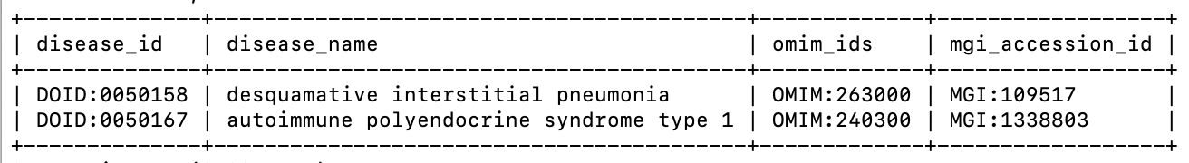

View gene and disease association for a specific disease
mysql> SELECT
-> IMPC_disease.disease_id,
-> IMPC_disease.disease_name,
-> IMPC_human_gene_disease.omim_ids,
-> IMPC_gene_disease.mgi_accession_id
-> FROM IMPC_disease
-> LEFT JOIN IMPC_human_gene_disease
-> ON IMPC_disease.disease_id = IMPC_human_gene_disease.disease_id
-> LEFT JOIN IMPC_gene_disease
-> ON IMPC_disease.disease_id = IMPC_gene_disease.disease_id
-> WHERE IMPC_disease.disease_id ='DOID:0050167';
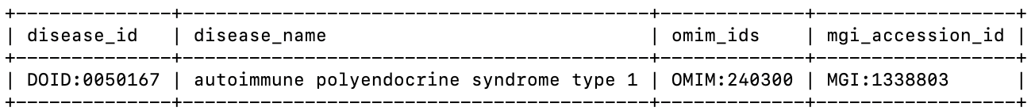

Additional DB requirements:

To reduce the parameter space, the collaborator would like to start grouping parameters together based on phenotype test similarity and/or naming similarity. Design the database to reflect new groupings for weight, images and brain parameters, plus at least 3 others of your choice (refer to below).

mysql> SELECT * FROM IMPC_parameter_group ORDER BY parameter_group_id;
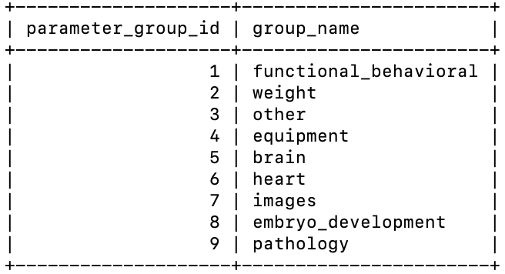

mysql> select * from IMPC_parameter_group_member limit 2;
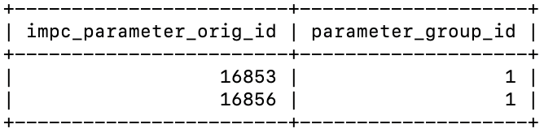

View group name and its corresponding parameter id and name
mysql> SELECT
-> pg.group_name,
-> p.parameter_code,
-> p.parameter_name
-> FROM IMPC_parameter_group pg
-> JOIN IMPC_parameter_group_member pgm
-> ON pg.parameter_group_id = pgm.parameter_group_id
-> JOIN IMPC_parameter p
-> ON pgm.impc_parameter_orig_id = p.impc_parameter_orig_id
-> WHERE pg.group_name = 'weight'
-> ORDER BY p.parameter_name
-> LIMIT 5;

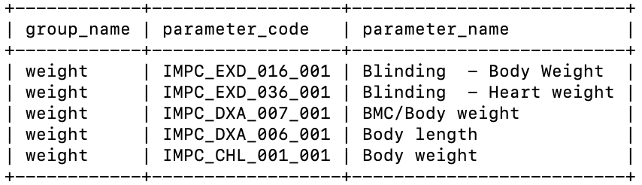

“They want to know the command(s) they
should use to query the MySQL database for all information on their genotypes of interest,
e.g. what parameter and parameter groups were used, what was the p-value achieved, is it
linked to disease, what procedure do the parameters belong to.”

mysql> SELECT DISTINCT
-> g.gene_symbol,
-> p.parameter_name,
-> pg.group_name AS parameter_group,
-> pr.procedure_name,
-> a.p_value,
-> CASE
-> WHEN d.disease_id IS NULL THEN 'No'
-> ELSE 'Yes'
-> END AS is_linked_to_disease,
-> d.disease_id,
-> d.disease_name
-> FROM IMPC_gene g
-> JOIN IMPC_analysis a
-> ON g.mgi_accession_id = a.mgi_accession_id
-> JOIN IMPC_parameter p
-> ON a.impc_parameter_orig_id = p.impc_parameter_orig_id
-> LEFT JOIN IMPC_parameter_group_member pgm
-> ON p.impc_parameter_orig_id = pgm.impc_parameter_orig_id
-> LEFT JOIN IMPC_parameter_group pg
-> ON pgm.parameter_group_id = pg.parameter_group_id
-> LEFT JOIN IMPC_procedure_parameter pp
-> ON p.impc_parameter_orig_id = pp.impc_parameter_orig_id
-> LEFT JOIN IMPC_procedure pr
-> ON pp.procedure_id = pr.procedure_id
-> LEFT JOIN IMPC_gene_disease gd
-> ON g.mgi_accession_id = gd.mgi_accession_id
-> LEFT JOIN IMPC_disease d
-> ON gd.disease_id = d.disease_id
-> WHERE g.gene_symbol IN ('Htr1a', 'Dcx', 'Setd4', 'Usp4')
-> ORDER BY
-> g.gene_symbol,
-> pg.group_name,
-> p.parameter_name,
-> pr.procedure_name,
-> d.disease_name
-> LIMIT 10;

