Megan Alfi

November 28 2022

IT FDN 110 Foundations of Programming: Python

Module 5 Assignment 05

Dictionaries

Introduction

In this document, I will cover information I learned in Module 5 of Foundations to Python Programming. I will discuss how dictionaries compare to list types, an introduction to GitHub, and explain how I approached assignment 5.

Dictionaries vs Lists vs Indexes

Lists are sequence types, and can be accessed by an index. Dictionaries are similar to lists, but instead of sequencing stored data, dictionaries map specific keys to specific values. The key replaces the index and is defined by the programmer.

GitHub

This week, we started using a version control software called Git which GitHub is built on. This system keeps modifications to code in a central place so that multiple people can be working on it simultaneously, and so that each modified version can be revisited if needed. Once I got started with GitHub, I created my first repository of assignment 5. .

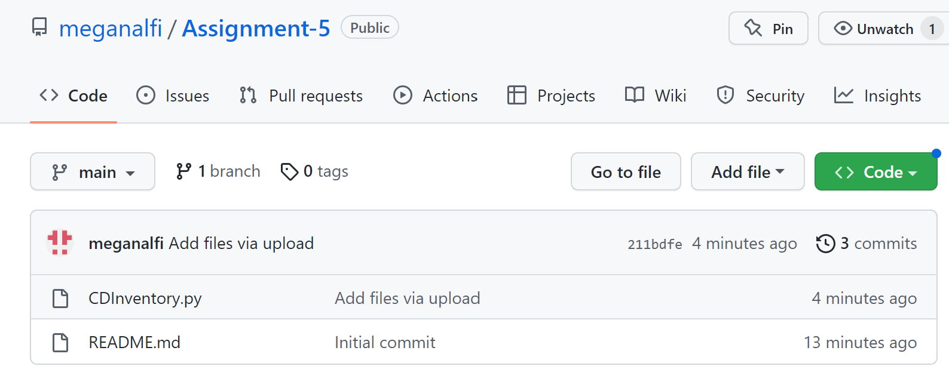

Figure - Assignment 5 repository in GitHub

Assignment 5

The objective for assignment 5 was to modify and add onto the assignment from last week, using an example solution. This provided insight into other ways the assignment could have been executed, as well as the practical application of working with and modifying another person’s code. The required steps were to replace the inner data structure with dictionaries, add the functionalities of loading existing data and deleting an entry, and use a list of dictionaries in the finalized script.

The first addition was to load existing data in the form of a previously saved .txt file. To do this I used a similar method to what I did in Lab 05-A, by creating a for loop to iterate through the rows of a file containing data. Using the strip() function removes the whitespaces within each line, and split(‘,’) specifies to break up the row of string data into a list separated by commas.

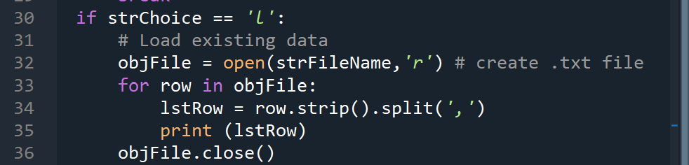

Figure - Loading existing data files

Next, I added the functionality of deleting an entry. In this block the program prompts the user to input the ID of the entry they want to delete, then stores the string entry as an integer. The program then goes through the rows to find if there is a matching integer ID and deletes the entry.

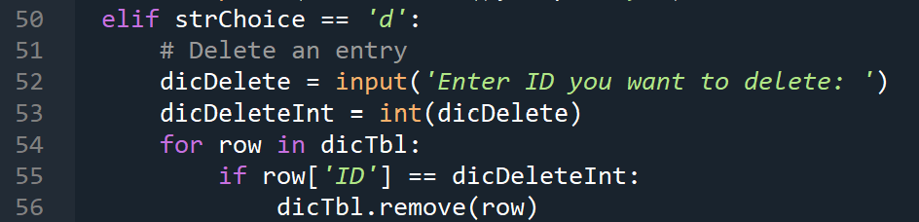

Figure - Deleting existing entries

The final task was to replace the inner data structure with a list of dictionaries as a 2D table. The previous data structure was a list of lists, and replacing it with a list of dictionaries required a few steps. Dictionaries utilize {} brackets, and have key values pairs. In this program, the keys are ‘ID’, ‘Title’, and ‘Artist’. The values are entered by the user and tied to their specified key. Each dictionary is then appended to the dictionary table ‘dicTbl’.

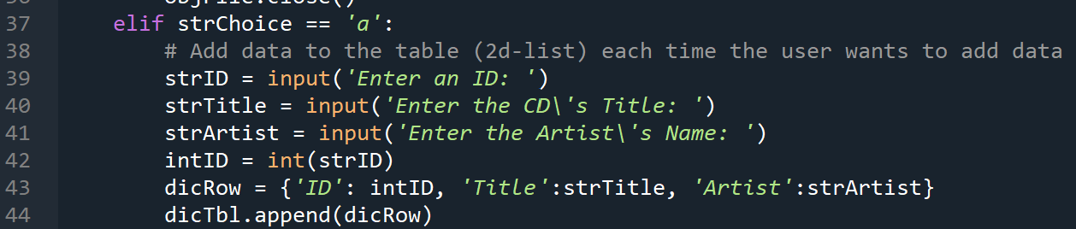

Figure - Utilizing dictionaries

Summary

In this document I reviewed dictionaries, GitHub and the steps I took to complete assignment 5. It was helpful to practice with editing and building off of another person’s script by both adding and changing functionality. This will be a helpful skill beyond this class and in the upcoming modules.

# Appendix

Figure 5 - Image of CDInventory.py working in Spyder

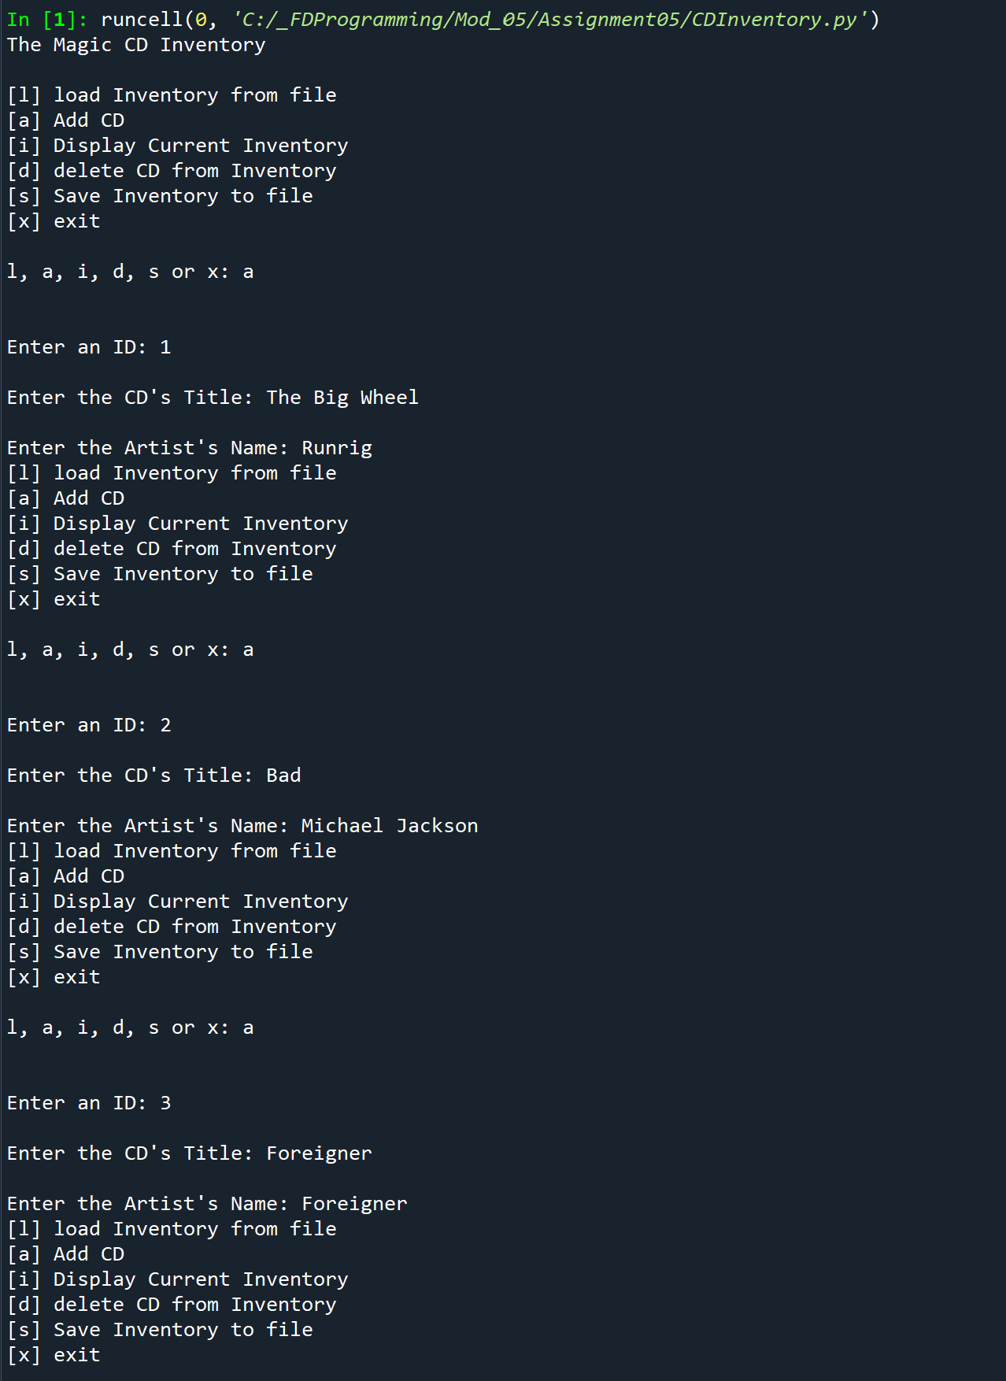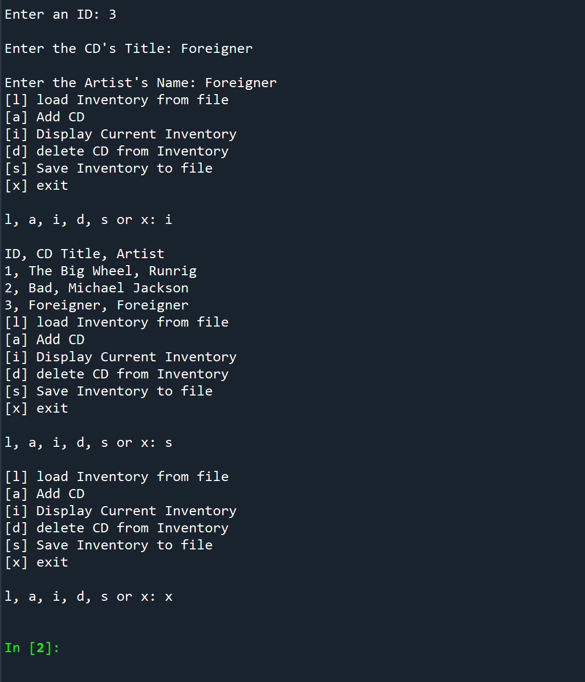

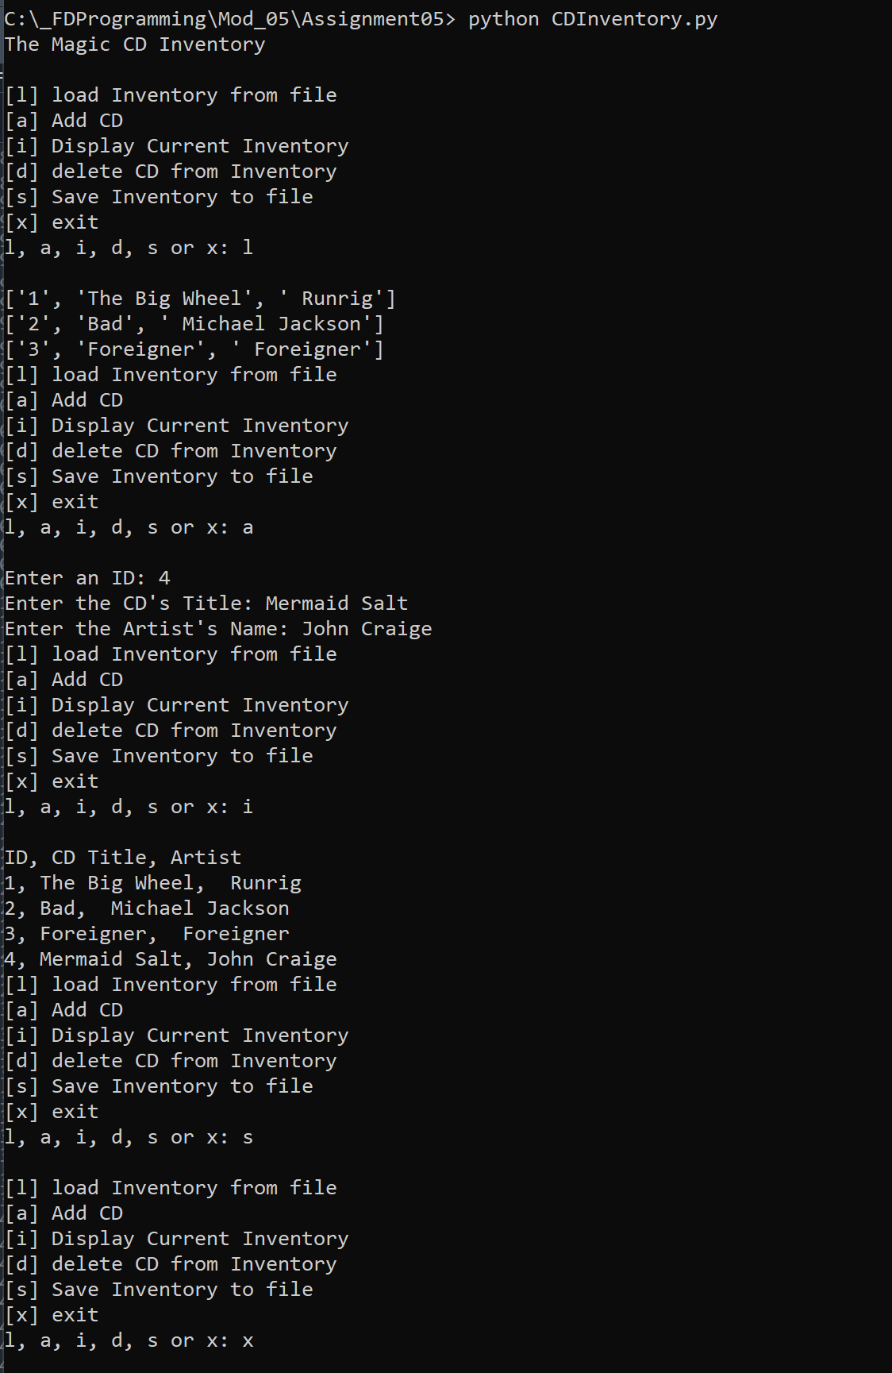

Figure 6 - Image of CDInventory.py working in command prompt

Link to GitHub repository: https://github.com/meganalfi/Assignment-5