Mapping MinIon Reads to Assemblies - Figure 4

# NOTE

Due to wierd markdown stuff that I don’t fully understand the setwd() won’t work unless you save the markdown document in the folder below. Rmkd automatically makes the folder where the mkd document is saved the working directory.

If you want to change this you need to set it up in the R setup chunk at the very top of the document.

Something like this:

“{r setup}

knitr::opts_chunk$set(echo = TRUE)

knitr::opts_knit$set(root.dir = normalizePath(“Desired/working/directory/here”))

getwd()"

(but I find it’s just easiest to save the mkd document in the folder where your data is…)

# Set up libraries and working directory

library(ggplot2)  
library(scales)  
library(cowplot)

##   
## Attaching package: 'cowplot'

## The following object is masked from 'package:ggplot2':  
##   
## ggsave

setwd("~/Dropbox (Solomon lab)/Movement_of_ToxA/Figure_ConfirmTranslocations")  
getwd()

## [1] "/Users/meganm/Dropbox (Solomon lab)/Movement_of_ToxA/Figure_ConfirmTranslocations"

# Import Data

PAFhead<-c("query", "Q_length", "Q_start", "Q_end", "Q_strand", "Target", "T_length", "T_start", "T_end", "N_res_matches", "Alignment_length", "Mapping_quality")  
## WAI2406 mapped to itself, filter reads with mapping quality <50 and alignments less than 10000bp  
WAI2406_racon<-read.delim("WAI2406_Chr01racon5.txt", sep="\t", header=T)  
WAI2406_racon<-WAI2406_racon[WAI2406_racon$Mapping_quality>=50,]  
WAI2406_racon<-WAI2406_racon[WAI2406_racon$Alignment_length>=10000,]  
  
  
## WAI2406 mapped to CS10, filter reads with mapping quality <50 and alignments less than 10000bp  
WAI2406toCS10<-read.delim("WAI2406reads_to_CS10.paf", sep="\t", header=T)  
WAI2406toCS10<-WAI2406toCS10[,1:12]  
WAI2406toCS10<-WAI2406toCS10[WAI2406toCS10$Target=="CS10_Chromosome_08",]  
WAI2406toCS10<-WAI2406toCS10[WAI2406toCS10$Mapping_quality>=50,]  
WAI2406toCS10<-WAI2406toCS10[WAI2406toCS10$Alignment_length>=10000,]  
  
### WAI2411 Aligned to itself , filter reads with mapping quality <50 and alignments less than 5000bp  
WAI2411_toSelf<-read.delim("WAI2411_try2_racon_5.paf", sep="\t", header=T)  
WAI2411_toSelf<-WAI2411_toSelf<-WAI2411_toSelf[,1:12]  
WAI2411_toSelf<-WAI2411_toSelf[WAI2411_toSelf$Mapping_quality>=50,]  
WAI2411_toSelf<-WAI2411_toSelf[WAI2411_toSelf$Alignment_length>=5000,]  
WAI2411_toSelf<-WAI2411_toSelf[WAI2411_toSelf$Target=="WAI2411_contig_17",]  
  
## WAI2411 mapped to CS10, filter reads with mapping quality <50 and alignments less than 5000bp  
WAI2411_toCS10<-read.delim("WAI2411_to_CS10.paf", sep="\t", header=T)  
WAI2411_toCS10<-WAI2411_toCS10[,1:12]  
WAI2411_toCS10<-WAI2411_toCS10[WAI2411_toCS10$Mapping_quality>=50,]  
WAI2411_toCS10<-WAI2411_toCS10[WAI2411_toCS10$Alignment_length>=5000,]  
WAI2411_toCS10<-WAI2411_toCS10[WAI2411_toCS10$Target=="CS10_Chromosome_08",]

# Add columns to data

Percent Identity of Aligned read (**Identity**), Slope of Aligned Read (**Slope**)

### Extra Columns for WAI2406 aligned to itself Chr_01 ###  
perc_aligned1<-c(round(((WAI2406_racon$Q_end-WAI2406_racon$Q_start)/WAI2406_racon$Q_length),digits=3))  
slope1<-c(round(((WAI2406_racon$Q_end-WAI2406_racon$Q_start)/(WAI2406_racon$T_end-WAI2406_racon$T_start)),digits=2))  
identity1<-c(round((WAI2406_racon$N_res_matches/(WAI2406_racon$T_end-WAI2406_racon$T_start)),digits=2))  
WAI2406_racon<-cbind(WAI2406_racon,perc_aligned1,slope1,identity1)  
  
### Extra Columns for WAI2406 aligned to CS10 Chr_08 ###  
perc_aligned2<-c(round(((WAI2406toCS10$Q_end-WAI2406toCS10$Q_start)/WAI2406toCS10$Q_length),digits=3))  
slope2<-c(round(((WAI2406toCS10$Q_end-WAI2406toCS10$Q_start)/(WAI2406toCS10$T_end-WAI2406toCS10$T_start)),digits=2))  
identity2<-c(round((WAI2406toCS10$N_res_matches/(WAI2406toCS10$T_end-WAI2406toCS10$T_start)),digits=2))  
WAI2406toCS10<-cbind(WAI2406toCS10,perc_aligned2,slope2,identity2)  
  
## Extra Columns for WAI2411 aligned to itsef, contig_17  
perc_aligned3<-c(round(((WAI2411_toSelf$Q_end-WAI2411_toSelf$Q_start)/WAI2411_toSelf$Q_length),digits=3))  
slope3<-c(round(((WAI2411_toSelf$Q_end-WAI2411_toSelf$Q_start)/(WAI2411_toSelf$T_end-WAI2411_toSelf$T_start)),digits=3))  
identity3<-c(WAI2411_toSelf$N_res_matches/WAI2411_toSelf$Alignment_length)  
WAI2411_toSelf<-cbind(WAI2411_toSelf,perc_aligned3,slope3,identity3)  
  
## Extra Columns for WAI2411 aligned to CS10 Chr_08  
perc_aligned4<-c(round(((WAI2411_toCS10$Q_end-WAI2411_toCS10$Q_start)/WAI2411_toCS10$Q_length),digits=3))  
slope4<-c(round(((WAI2411_toCS10$Q_end-WAI2411_toCS10$Q_start)/(WAI2411_toCS10$T_end-WAI2411_toCS10$T_start)),digits=3))  
identity4<-c(WAI2411_toCS10$N_res_matches/WAI2411_toCS10$Alignment_length)  
WAI2411_toCS10<-cbind(WAI2411_toCS10,perc_aligned4,slope4,identity4)

## Plot WAI2406 Aligned to Self and CS10

## Set up Breaks for Slope colors  
breakList<-seq(0.6,1.6,by=0.2)  
IdentityBreaks<-seq(0,1,by=0.2)  
## Set up ToxA region on Chr1 in isolate WAI2411 for coloring, these coordinates were pre-detirmined using MAUVE ###  
ToxA_block<-data.frame(xpos=c(1434925,1449002),y1=c(0,0),y2=c(40000,40000))  
## Set up WAI2411 Chr1 translocation for coloring, these coordinates were pre-detirmined using MAUVE ###  
Translocation_block1<-data.frame(x1pos=c(1407479,1498830))  
Translocation_block2<-data.frame(x2pos=c(1498831,1591597))  
  
### plot Read Color based on Alignment Slope ####  
WAI2406slope<-ggplot(ToxA_block,aes(x=xpos,ymin=0,ymax=120000))+geom_ribbon(color="red",size=0.2,fill="red",alpha=.3)+geom_ribbon(data=Translocation_block1,aes(x=x1pos,ymin=0,ymax=120000),color="blue",size=0.2,fill="blue",alpha=0.1)+geom_ribbon(data=Translocation_block2,aes(x=x2pos,ymin=0,ymax=120000),color="blue",size=0.2,fill="blue",alpha=0.1)+geom_segment(data=WAI2406_racon,aes(x=T_start,xend=T_end,y=Q_start,yend=Q_end,color=slope1,linetype=Q_strand),size=0.3)+scale_colour_gradient2(low ="blue",mid = "lightgreen",high = "red",midpoint=1, name="Slope",breaks=breakList,limits=c(0.5,1.5))+coord_cartesian(xlim = c(1390000,1620000),ylim = c(0,100000))+xlab("Position Aligned to WAI2406 Chr01 (bp)")+ylab("Position of Alignment Start on Read (bp)")+geom_abline(intercept=-1400000,slope=1, color="black",size=1,linetype="dashed")  
WAI2406slope

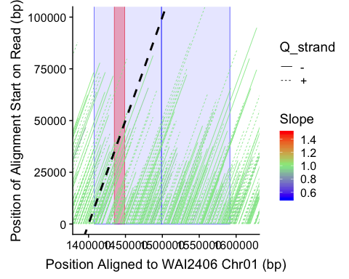

### Plot WAI2406 aligned to CS10 with Read Color based on Slope #####  
Chr08_toxA<-data.frame(xpos=c(2029863,2043923))  
Chr08_TransRegion1<-data.frame(xpos2=c(1875316,1967969))  
Chr08_TransRegion2<-data.frame(xpos2=c(1974030,2071323))  
Chr08_plot<-ggplot(Chr08_toxA,aes())  
breakList<-seq(0.6,1.6,by=0.2)  
IdentityBreaks<-seq(0,1,by=0.2)  
  
WAI2406_CS10slope <-ggplot(Chr08_toxA, aes(x=xpos,y=100000))+geom_area(alpha=0.3,fill="red",color="red",size=0.2)+geom_ribbon(data=Chr08_TransRegion1,aes(x=xpos2,ymin=0,ymax=100000),color="blue",size=0.2,fill="blue",alpha=0.1)+geom_ribbon(data=Chr08_TransRegion2,aes(x=xpos2,ymin=0,ymax=100000),color="blue",size=0.2,fill="blue",alpha=0.1)+geom_segment(data=WAI2406toCS10, aes(x=T_start,xend=T_end,y=Q_start, yend=Q_end,color=slope2, linetype=Q_strand),size=0.3)+scale_colour_gradient2(low ="blue",mid = "lightgreen",high = "red",midpoint=1, name="Slope",breaks=breakList,limits=c(0.5,1.5))+coord_cartesian(xlim=c(1790000,2100000),ylim = c(0,100000))+xlab("Position Aligned to CS10 Chr08 (bp)")+ylab("Position of Alignment Start on Read (bp)")+geom_abline(intercept=-1800000,slope=1, color="black",size=1, linetype="dashed")  
WAI2406_CS10slope

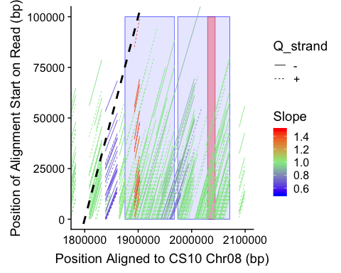

## Plot WAI2411 Aligned to Self and CS10

###WAI2411 to SELF Color by Slope ###  
tig17_toxA<-data.frame(xpos=c(728980,743052))  
  
##Plot WAI2411 Aligned to self by Slope  
WAI2411_selfslope<-ggplot(tig17_toxA, aes(x=xpos,y=100000))+geom_area(alpha=0.1,fill="red",color="red",size=0.2)+geom_segment(data=WAI2411_toSelf, aes(x=T_start,xend=T_end,y=Q_start, yend=Q_end,color=slope3, linetype=Q_strand),size=0.3)+scale_colour_gradient2(low ="blue",mid = "lightgreen",high = "red",midpoint=1, name="Slope",breaks=breakList,limits=c(0.5,1.5))+xlab("Position Aligned WAI2411 tig17 (bp)")+ylab("Position of Alignment Start on Read (bp)")+coord_cartesian(xlim = c(610000,760000),ylim = c(0,100000))+ geom_abline(intercept=-710000,slope=1, color="black",size=1,linetype="dashed")  
WAI2411_selfslope

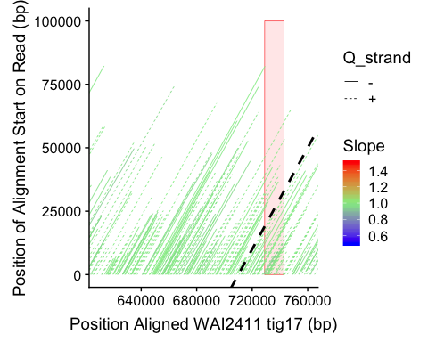

##Plot WAI2411 Aligned to CS10 by Slope  
WAI2411_toCS10slope<-ggplot(Chr08_toxA, aes(x=xpos,y=100000))+geom_area(alpha=0.1,fill="red",color="red",size=0.2)+geom_segment(data=WAI2411_toCS10, aes(x=T_start,xend=T_end,y=Q_start, yend=Q_end,color=slope4, linetype=Q_strand),size=0.3)+scale_colour_gradient2(low ="blue",mid = "lightgreen",high = "red",midpoint=1, name="Slope",breaks=breakList,limits=c(0.5,1.5))+xlab("Position Aligned to CS10 Chr08 (bp)")+ylab("Position of Alignment Start on Read (bp)")+coord_cartesian(xlim = c(1990000,2075000),ylim = c(0,100000))+ geom_abline(intercept=-1990000,slope=1, color="black",size=1,linetype="dashed")  
WAI2411_toCS10slope

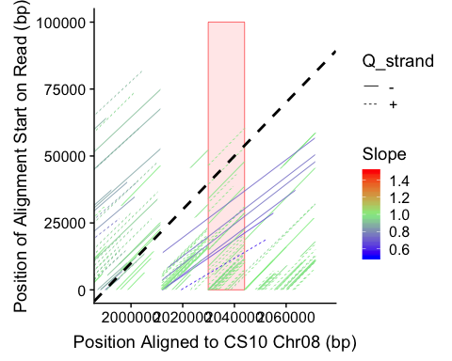

## All together now

## Use cowplot to put 4 figures together based on SLOPE  
  
Fig4slope<-plot_grid(WAI2406slope,WAI2411_selfslope,WAI2406_CS10slope,WAI2411_toCS10slope,ncol=2,align="v",labels=c("A","B","C","D"))  
Fig4slope

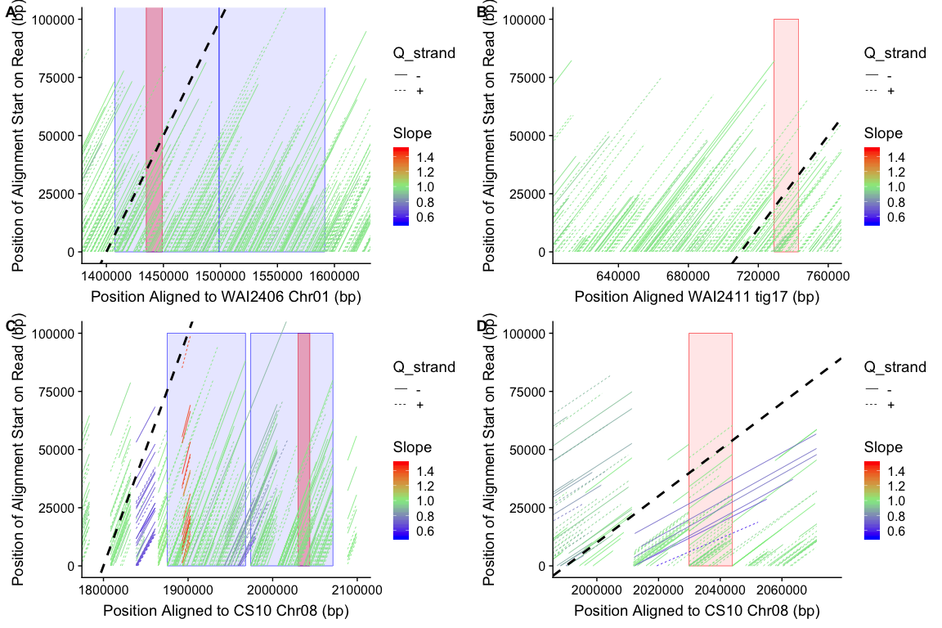

ggsave("Fig4_slope.pdf", Fig4slope, width = 40, height =30, units=c("cm"),dpi=600 )