/*
* NAME: Megan Chu
* PID: A12814536
* LOGIN: cs12waot
*/

What command line is used to create the javadoc documentation in HW1?

"javadoc Stats.java"
for the javadoc documentation without the version and author
"javadoc -d ~/path/to/directory Stats.java"
to specify the directory you want to generate the documentation in if it
is not the current directory
"javadoc -version -author Stats.java"
for the javadoc documentation with the version and author listed

What command-line flag(s) is/are used to create the author and version
entries for the class?

"-version" is used to create the version entry
"-author" is used to create the author entry
we can put these flags in the command line as shown above to generate a
javadoc with the version and author entries

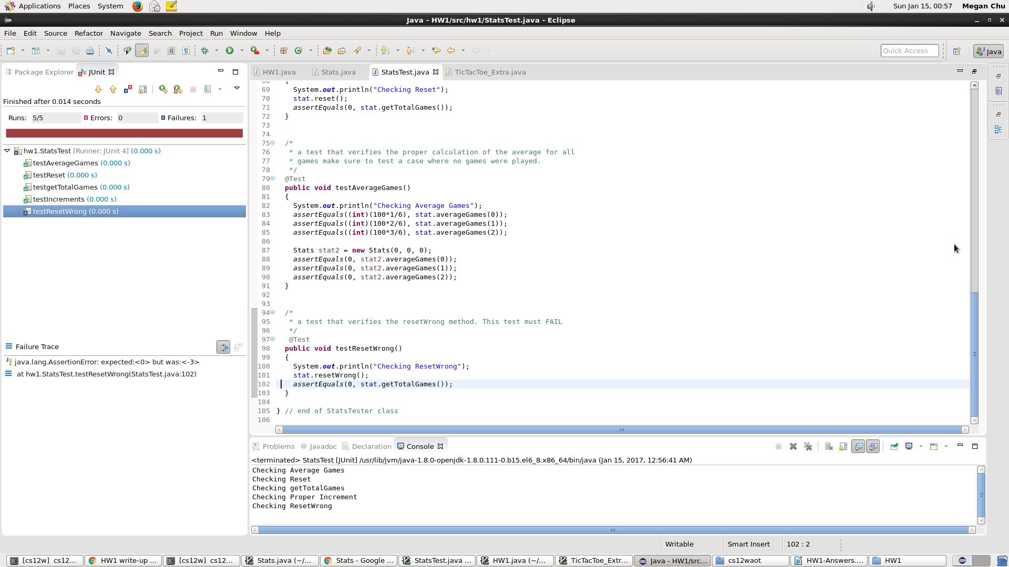
Find such an algorithm ( algorithm, not the code!) by Googling. Add the link to your algorithm to HW1-Answers.pdf.

http://stackoverflow.com/questions/125557/what-algorithm-for-a-tic-tac-toe-game-can-i-use-to-determine-the-best-move-for

Describe the major changes that you’ve made and put your answers to HW1-Answers.pdf

Major changes I made included first checking if there was a move to make that would make the computer win. If there was no such move, the computer would check if the opponent could win on the next turn so it could block the opponent. If there was nothing to block, the computer would then choose a random empty box.

