Comparison of Various Meta-Reinforcement Learning Algorithms’

Megan Gross Vikasni Kalahasthi
San Jose State University San Jose State University
Engineering Department Engineering Department
megan.gross@sjsu.edu vikasni.kalahasthi@sjsu.edu

Ashley Irawan Idris El Ashmawi
San Jose State University San Jose State University
Engineering Department Engineering Department
ashley.irawan@sjsu.edu idris.elashmawi@sjsu.edu

Abstract
Meta-learning has revolutionized the field of reinforcement learning (RL) by remedying a key weakness of RL algorithms: the inability to adapt to new environments quickly without retraining. Meta-learning prioritizes quick adaptation via training on a distribution of tasks and teaching the agent how to learn. In order to better understand how this ideology works, we will implement a Multi-Task PPO, RL², and MAML in MetaWorld environments. We will train on MetaWorld’s ML10’s training set, and validate on the ML10 validation set. Our focus is on comparing these algorithms and understanding the inner workings of them. Link to Google Drive Folder.
Index Terms— meta-learning, metaworld, reinforcement learning

- INTRODUCTION
Reinforcement learning (RL) is an ever growing field that finds many uses in different areas of Artificial Intelligence (AI). For example, RL has been used with Large Language Models (LLMs) to train the models to adapt and align more closely with human feedback [1]. Throughout the research in RL, one key weakness has been repeatedly identified: the inability to adapt quickly to new unseen environments without the need to be retrained. This lack of adaptability causes long training to be needed to prepare for many environments, and even then the agent can only excel in these environments. Generalizability is an incredibly desired trait in AI, as environments can be unpredictable and we want agents who are capable of succeeding regardless. This is where meta-learning comes in as a proposed solution to this problem. First introduced in [2], meta-learning focuses on agents learning to learn. Agents are trained in a way that prioritizes learning the best _ for the distribution of tasks so it can then succeed on unseen tasks. This training process can take a long time with the trade-off being faster inference time.
- DATA SOURCE OVERVIEW
Meta-World is a collection of 50 simulated robotic tasks built to benchmark multi-task and meta-reinforcement learning. Built on top of the MuJoCo physics engine, it provides a shared environment where a robot arm interacts with many different objects. This allows metaworld to offer a diverse set of tasks for training and evaluating agents on various robotic goals, such as moving objects, turning a dial, flicking switches, or opening drawers. The goal of Meta-World is to offer a diverse but structured set of manipulation tasks so algorithms can transfer, generalize, or adapt across tasks [3]. MetaWorld is especially valuable for testing the generalization abilities of RL agents, helping to evaluate how well they perform across multiple tasks or when transferring knowledge from one task to another.
Meta-World uses a simulated 7-DoF Sawyer robotic arm designed to provide a uniform, manipulation-focused interface across all tasks (Fig. 1). The arm is controlled through a simple 4-dimensional continuous action space consisting of 3D end-effector movements and a normalized gripper effort. Its observations are encoded in a fixed 39-dimensional vector that includes the end-effector pose, gripper state, object positions and orientations, optional second-object information, and the task’s goal position, with unused fields zero-filled to maintain consistency. This shared action and observation space ensures that all 50 tasks can be learned by a single policy class, despite differences among the tasks. The robot model uses stable physics and realistic contact dynamics, making it well-suited for multi-task and meta-reinforcement learning [3].
For our project, we use the Meta-Learning 10 (ML10) environment from MetaWorld to compare different meta-learning algorithms. The ML10 is a collection of 10 related tasks for training, followed by 5 unseen tasks designed to evaluate the agent’s ability to generalize and adapt quickly. These tasks challenge agents to learn efficiently with few-shot learning and to develop a generalizable policy that performs well across various manipulation tasks. By using a variety of meta-learning methods with the ML10 environment, we aim to both better understand these meta-learning algorithms, as well as see how they rank against one another. Additionally, use the Multitask 10 (MT10) benchmarks from Meta-World to better understand how a multitask function learns and functions. Similar to the ML10, the MT10 is a collection of 10 tasks for training and evaluation, but lacks any hidden tasks. For parity, we instantiate hidden task environments for our multitask policy to evaluate on.
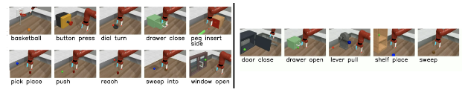
Fig. 1. Collection of 10 Training Tasks and 5 Unseen Tasks for Evaluation
- TECHNICAL OVERVIEW
A. PPO
Proximal Policy Optimization, or PPO, is an algorithm that prioritizes making smooth, gradual policy updates in order to stay relatively stable [7]. It achieves this through constraining how much a new policy can change from the previous policy when doing its policy updating using a ‘clipped surrogate objective function.’ This clipped function is the heart of policy optimization (Formula 1).
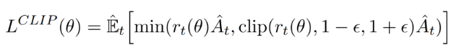
Formula 1, Clipped Objective Formula
Multi-Task PPO is an extension of PPO that applies the PPO algorithm to multiple tasks as opposed to just one. The idea of a shared policy for multiple tasks is described in [8]. Instead of training one policy for each task, it aims to train one shared policy that can perform well on multiple tasks. It samples trajectories from multiple tasks and maximizes the average PPO objective over the task-specific rollouts. This shared parameter set allows the policy to generalize across tasks and allow knowledge transfer through the shared gradient updates.

B. RL²
RL² has the goal of adapting quickly to new tasks with no gradient updates needed. Many Deep RL algorithms need many trials and iterations to learn which is a contrast to human and animal behaviors which both are quick adaptors. RL²’s solution is slow training and fast inference. The algorithm is encoded into the weights of an RNN, which are slowly learned through general training and retains the state through all episodes of a Markov Decision Process (MDP), while the activations store the state of the fast algorithm on the currently unseen MDP [9]. RL² assumes a knowledge of MDPs as well as a distribution over them which is then sampled from. A parameter n is defined as the number of total episodes that the model is allowed to spend with a particular MDP (Fig. 2). RL² learns how to effectively use its hidden activation states to adapt to a new environment.
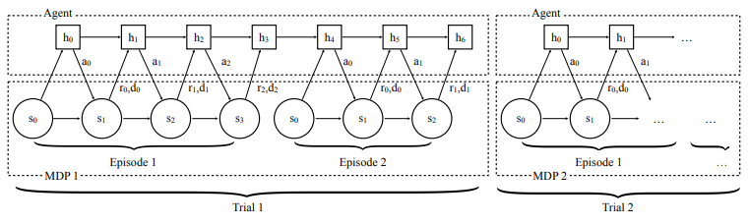
Fig. 2. RL² Agent-Environment Procedure Demonstration

C. MAML
Model-Agnostic Meta-Learning (MAML) is a general-purpose algorithm designed to find model parameters that can be rapidly adapted to a new task using only a few gradient updates. Rather than training a model to perform well on a fixed set of tasks, MAML trains a model such that it can quickly learn new tasks drawn from a broader task distribution. This shifts the objective from static performance to adaptability, allowing the system to effectively “learn how to learn.” [10] Importantly, the method is model-agnostic: it requires only that the underlying model be differentiable and trained with gradient descent. These minimal constraints allow MAML to be applied across different architectures and learning problems including classification, regression, and reinforcement learning, without modification to the model itself.
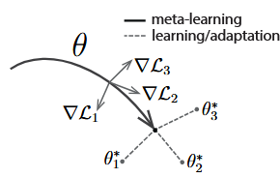
Fig. 3. Diagram of the model-agnostic meta-learning algorithm (MAML)
The meta-learning process consists of two nested levels of optimization: the inner loop and the outer loop. The inner loop represents how the model adapts to a particular task by treating each task as a training example. Given initial parameters, the model performs one or more gradient updates on data sampled from a specific task, producing a task-adapted parameter set that reflects how the model would update itself when exposed to that task’s data. The outer loop then evaluates the performance of these adapted parameters on new data from the same task, measuring how well the model learns after adaptation. The meta-objective minimizes this post-update loss across many tasks and requires differentiating through the gradient update itself, which introduces a second-order component into the meta-gradient. This meta-gradient is then used to adjust the initialization toward one that supports more effective learning. [10] This inner/outer loop structure is the source of MAML’s effectiveness: by explicitly searching for sensitivity in useful directions of parameter space, the algorithm identifies initial parameters from which small gradient steps yield meaningful reductions in loss across a wide range of tasks. As a result, MAML learns representations that capture broadly transferable structure while leaving task-specific refinement to minimal fine-tuning.
For our project, we implement a simplified variant of the MAML algorithm known as First-Order MAML (FOMAML). This approach removes the need to compute second-order derivatives by assuming that the meta-gradient does not depend on how the inner-loop updates change with respect to the initial parameters [10][11]. In practice, this means treating the inner adaptation step as a constant during the outer update. Despite this simplification, FOMAML has been shown to perform nearly as well as full MAML while being significantly more computationally efficient, making it an attractive choice for practical meta-learning applications.

- RELATED WORKS
Few previous works have compared the performance of PPO, RL², and MAML trained with PPO (MAML-PPO), in MetaWorld. The introductory paper of MetaWorld [3] compared multi-task learning with RL algorithms like Proximal Policy Optimization (PPO), trust region policy optimization (TRPO), Soft Actor Critic (SAC), and meta-learning on-policy RL algorithms like RL² training a Gated Recurrent Unit (GRU) with PPO (RL²-PPO), gradient-based MAML-TRPO, and off-policy probabilistic embeddings for actor-critic RL (PEARL). The MetaWorld paper evaluated the performance of these algorithms on various sized training/testing sets but for this paper, we will focus on the results of MT10 and ML10. The performance for MT10 is measured by the average training success rate over all tasks for MT10 while ML10 is the average success rate, both on 10 seeds. SAC outperformed Multi-task PPO in MT10. While in ML10, RL² outperformed MAML in ML10 for both meta-train and meta-test. However, they observed that RL²-PPO’s ability to generalize is not that much greater than MAML (35.8% for RL² and 31.6% for MAML).
Several works criticize the effectiveness of MetaWorld as an evaluation framework [4][5][6]. The most significant limitation highlighted is the historical inconsistency and lack of standardization in the benchmark, which compromised the reliability of published research results. The design of the reward functions within MetaWorld were changed at some point that inhibited accurate comparison of results against other related works [4]. Gradient-based meta-learning methods like MAML-TRPO, while demonstrating effective one-shot adaptation, show high variance in task-level success (ranging from 0% to 80%). They excel only on structurally similar tasks (e.g., door-open to door-close) but struggle with complex, sequential behaviors like lever-pulling or precise insertion [5]. While other works exist that evaluated gradient-based methods like MAML-TRPO [3][5] and MAML-PPO [6], it was difficult to take inspiration from the implementation of each work as results may not be comparable.

- METHODOLOGY
We use the following metrics for evaluation of each algorithm: adaptation performance, rewards after K adaptation episodes, and stability across random seeds. We also evaluate performance across varying tasks to see if the meta algorithms favor a particular task over others. The algorithms plan to be tested on 1 shot and 5 shot measuring the reward after each adaptation step.
All algorithms will have the same values for inner steps, batch size, gamma, clipping range, GAE lambda, policy hidden layers and K sample number (Appendix A). MAML is different from the other two algorithms as it requires an inner loop and an outer loop. The inner loop takes a copy of the generalized model, trains on a random task and fine-tunes the copied model to the task. The outer loop then updates the generalized model weights with the weights from the fine-tuned model. Since PPO and RL² do not share the same nested loop algorithm, their parameters can be matched. To maintain consistency, MAML parameters are matched as best they can be while PPO and RL² match almost exactly. To perform an adequate comparison, MAML utilizes PPO as the policy to match the use of PPO in multi-task scenarios and RL²‘s PPO policy in multi-learning scenarios.Ablation studies were also run on each algorithm for seed and learning rate. RL² also did critic and no critic evaluation, and K environment sampling ablations.

- RESULTS

A. Multi-Task PPO
For Multi-task PPO, multiple ablations were done along with the fixed parameter model. The clip value, batch size, and entropy coefficient were all varied as follows: the clip values tested were 0.20 and 0.50, the batch sizes tested were 256 and 512, and finally the entropy coefficients tested were 0.005 and 0.010. Across all ablations, a trend appears where there is a dropoff after about 400-450k steps. We suspect that this may be because of task interference as the policy tries to continue to specialize to each task.
Most parameter ablations did not yield any particular trend on performance. The graphs for the highest performing ablations are shown below (Fig 4). It is worth noting that the highest performing ablation was not the model used for evaluation; the highest performing parameter set had a clip value of 0.50 as to the evaluation model’s 0.20. Aside from this model, all other models performed better with a clip value of 0.20. The model’s performance on 5 unseen tasks is shown in Fig. 5. The model performed best on the door-close task, and worst on the shelf-place task. We suspect that since door-close,drawer-open, and lever-pull are all “one-phase” tasks with dense rewards, the MT-PPO was able to perform better on them as opposed to sweep-into and shelf-place, which have more steps to complete and sparser rewards.
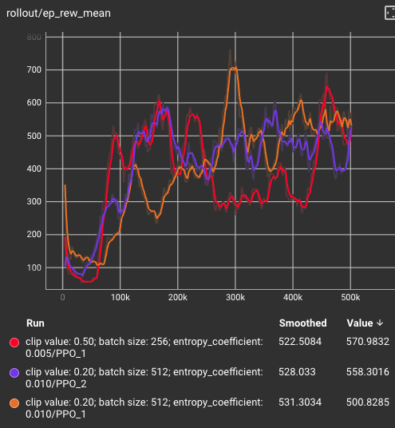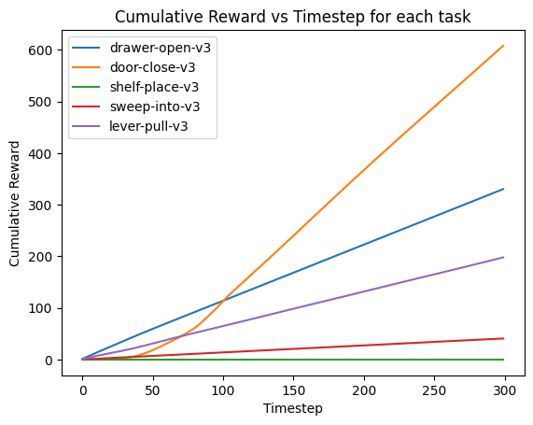 Fig. 4. MT-PPO Ablation Models Fig. 5. MT-PPO performance on unseen tasks
B. RL²
For RL², 10 ablations were run: a fixed parameter model, models with an inner episode of 1, 3 and 5, models that used two different seeds, a model with a learning rate of 1e-4 and 3e-4, a model with critic enabled and a model with no critic. Overall, no one model performed the best on all tasks, instead some models prevailed at certain tasks while the rest performed almost exactly the same as one another. For all tasks, over the course of the 5-shot learning, there was little to no positive increase in reward, showcasing that the hidden states and memory are not being used to their full potential. We would expect to see reward increase with each shot as the model learns and improves with each iteration. Graphs for the other tasks can be seen in Appendix B1.
Despite this, there were a few successful completions of the tasks. A seed model (seed=2) successfully completed the door close task and the fixed parameter model successfully completed the drawer open task (Fig. 6).
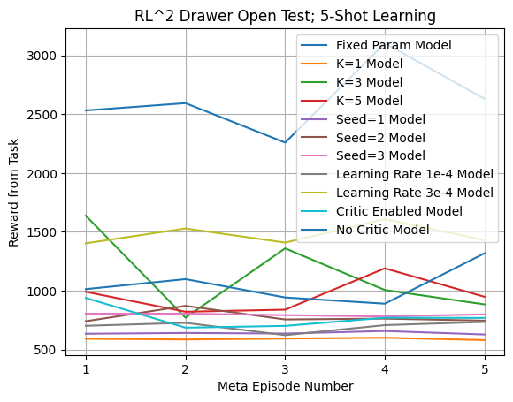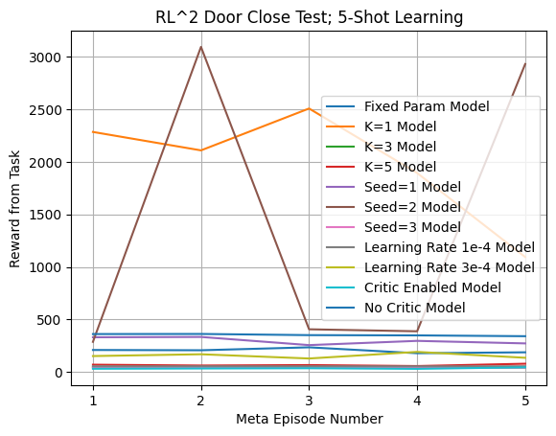
Fig. 6. RL² Ablation Models, 5-shot Learning on Drawer Open and Door Close
RL’s performance across the test tasks shows that the model is not as effective as it could be. The model succeeds at tasks closer to the training distribution (drawer open, door close), performs moderately well but not close to success on tasks that require similar movements but not exactly the same (sweep, lever), and performs poorly on difficult tasks that require more coordination and skill (shelf place). Perhaps with more training time and increasing the total training step count to 10 million like the MetaWorld paper did [3], would show more success on the moderate to difficult tasks.

C. FOMAML
For FOMAML, we focused on looking at the effect that one-shot learning had in finding the best initialization weights. Along with a baseline model, which we did our best to keep as many of the parameters shared with the other models as similar as possible, we explored several ablations (Appendix B2). These include modifying the inner model size, the sampled step size, the sampled task amount, and increasing the amount of inner updates (1-shot to 5-shot learning). For all experiments, the inner and out learning rates were kept the same, and each experiment underwent 1000 meta-iteration steps. This is the equivalent to about 8 million total steps, if attempting to compare to models that control training with this parameter.
The results were somewhat what we expected. Since the output of the MAML algorithm is initialization weights, we don’t expect to see large total rewards, but rather a noticeable improvement for total rewards from zero-shot to n-shot updates. What we saw is that some unseen tasks saw a small or moderate increase between updates, and some showed little or even worse improvement (Fig. 7).
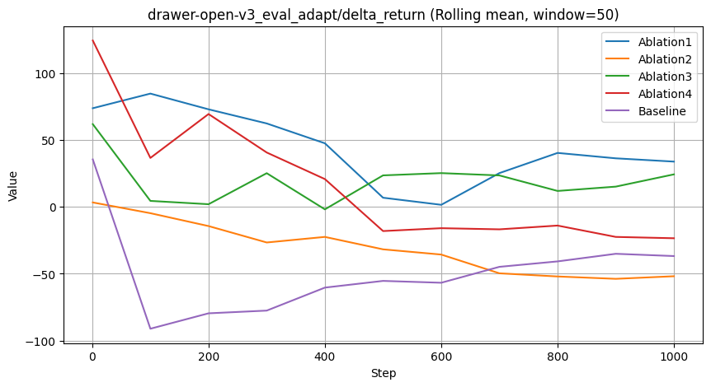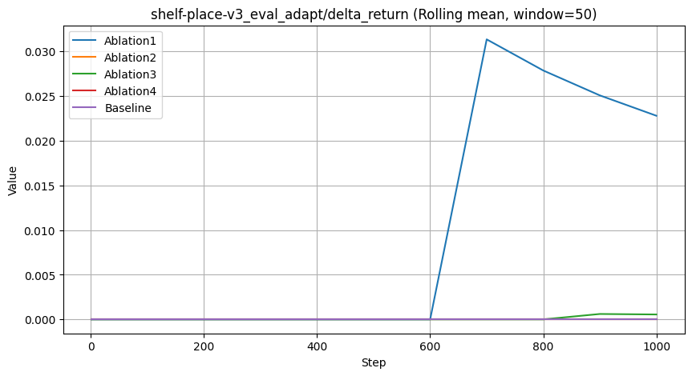
Fig. 7. Delta mean returns per evaluation tasks. Some tasks showed a positive signal, but others struggled for meaningful updates.
We suspect that, because of the complexity of a number of the Meta-world benchmarks tasks, our model needs even more iterations, as our reading suggested that 1000 meta-iterations was on the smaller side for meta-updates. This can be seen when looking at some of the training tasks, where we see huge improvements for some tasks like drawer_close_v3, and struggling with others like basketball (Fig. 8).
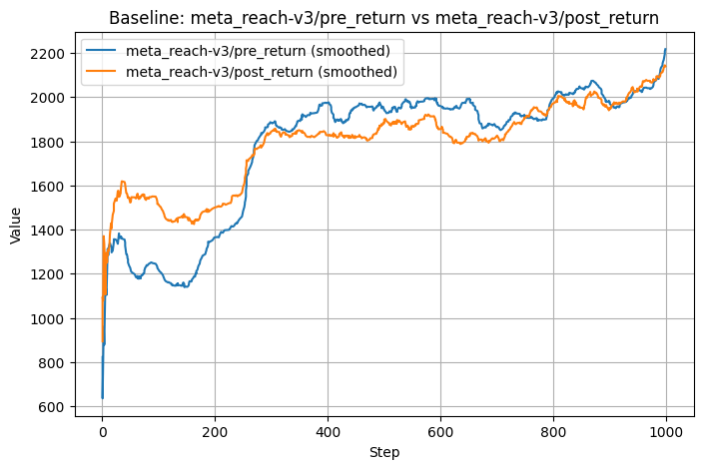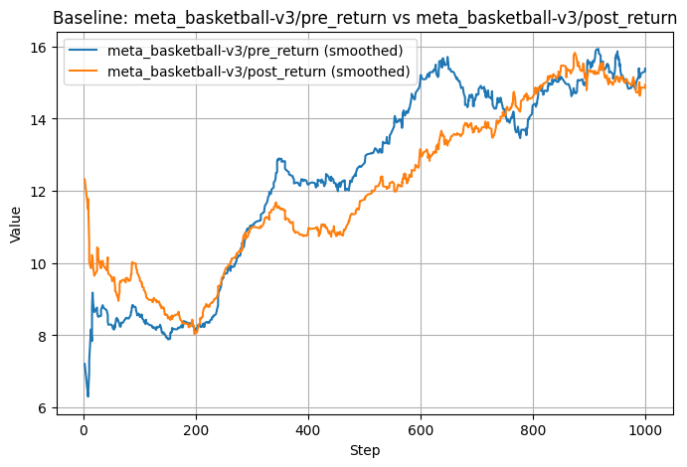
Fig. 8. Training pre and post update. Some tasks can be learned quickly, but the more difficult tasks grow much slower.
To us these training results signify that either, it's over-fitting some tasks and underfitting others, or it likely needs more meta-iterations to formulate better generalized initialization weights.

D. RL² versus MAML comparison
For comparing our two meta-learning algorithms, our expectations that on a pure total reward measurement, our RL² implementation would outperform our FOMAML implementation. This is due to the fact that fundamentally, the outputs for both models differ. The RL^i2 implementation puts out a trained model with the distribution of the tasks held within its memory, and therefore the model undergoes training. FOMAML however, outputs initialization model weights, which can be plugged into any PPO model designed for this distribution of tasks. Our results are reflected in the graphs (Fig. 9), where overall the RL² model outperforms a freshly initialized PPO model with learned weights. Positively, we do see that both models improve from their one-shot to their 5-shot updates, which is a good sign that our core model implementations were successful.
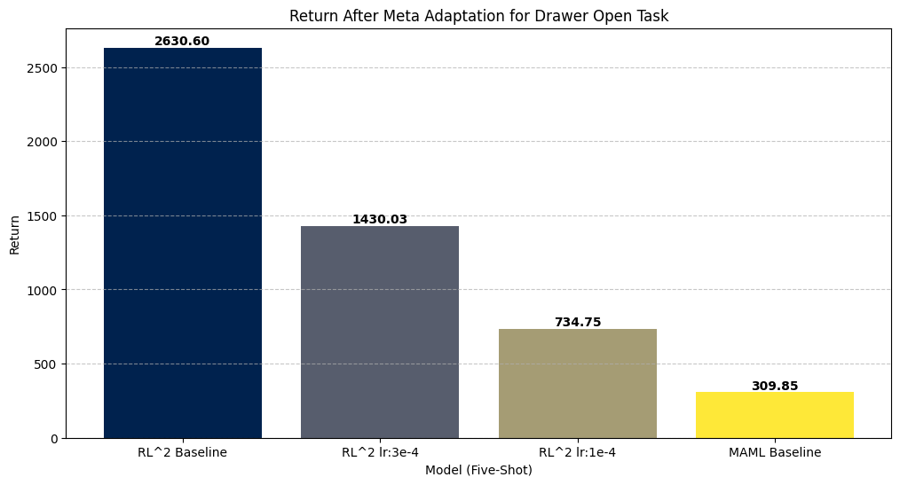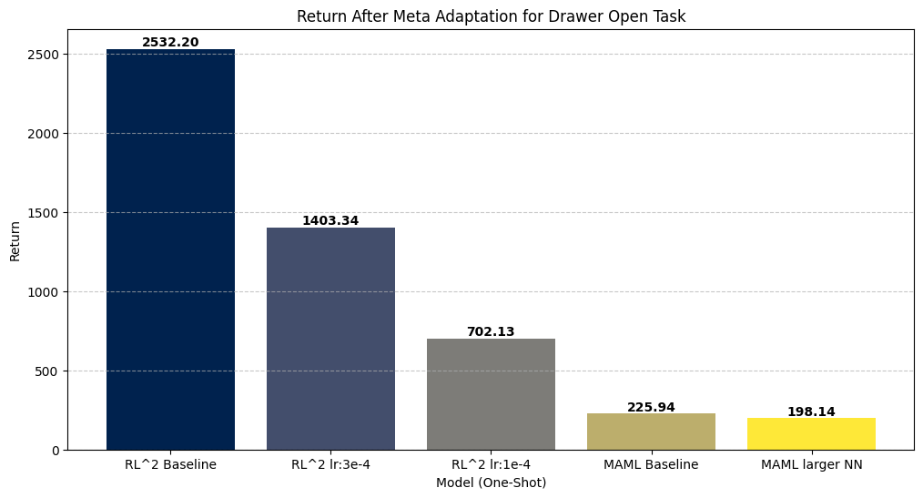
Fig. 9. Comparison between RL² and MAML for return on the Drawer open task.

- FUTURE WORK
This project was a dive into learning about a state of the art (SOTA) research area for us, and we have learned many things throughout the project process. Many lessons for us came in the form of learning how we could have planned this project better and evaluated our algorithms in different ways that could better showcase the algorithms strengths and weaknesses. Related works used success rate as an evaluation metric, in addition to average returns [3]. This is due to the hand crafted metrics of measuring the success rates in MetaWorld. The agents can accumulate high rewards while almost solving a task but receive a low success metric, indicating failure to adapt. Future work would add success rate as an evaluation metric to get a better view of the performance. Due to limitations in time and compute resources, training of these methods were kept minimal to garner results. However, results show improvement in performance when trained for longer, which suggests that these algorithms’ performance can be fully realized with longer training. Possible future exploration can be done with longer training time.
Furthermore, since MAML is a meta-learning algorithm and returns the ideal initial weights, our testing ran an untrained PPO with these weights against a trained RL² model. These results may not accurately reflect how well the MAML algorithm could perform at its full potential. Therefore, in future experiments we would like to test a trained PPO with the MAML weights against the trained RL² for a more fair and equitable comparison.

- CONCLUSION
This work was exploratory and informative and in the end, we achieved what we set out to do, which was to explore SOTA research and algorithms and everything that comes with implementing them. This project was directly linked to classroom topics of PPO, the struggle of algorithms that require parameter tuning, and even topics we didn’t cover like meta-learning. For our project we compared a gradient-based meta-learning algorithm versus a recurrent neural network meta-learning model. From this, we learned that both techniques take a long time to train and parameter fine-tuning is quite difficult. RL² is better for immediate benefits post-training, as a fully working model is outputted. However, it needs long training times to perform well across a wide range of tasks. MAML shows promise as a way to cut down on fine-tune training significantly for models, with the caveat that the fine-tune task is a part of the distribution of tasks the MAML weights were trained on.

- CONTRIBUTIONS
Megan: Team leader, overall superstar. Implemented RL² in MetaWorld and did training and testing on it. Wrote abstract, introduction RL²sections, and conclusion. Wrote powerpoint slides.
Idris: Implemented FOMAML in MetaWorld and did training and testing on it. Made graphs for FOMAML versus RL² comparison. Wrote sections for Metaworld, MAML, FOMAML and FOMAML versus RL² comparison. Wrote powerpoint slides.
Vik: Implemented Multi-Task PPO in Metaworld and did training and testing on it; wrote all MT-PPO sections.Wrote powerpoint slides.
Ashley: Research and write related works and future explorations. Wrote powerpoint slides.Support other team members in any way they need. Implemented Reptile in MetaWorld. However, upon poor training results and further research, we discovered that Reptile has not been widely used in meta-reinforcement learning, and is only effective for few-shot classification problems [12]. Thus, the paper’s focus shifted away from the evaluation of Reptile in Meta-World.

- REFERENCES
[1] L. Ouyang, J. Wu, X. Jiang, D. Almeida, C. Wainwright, P. Mishkin, C. Zhang, S. Agarwal, K. Slama, A. Ray, and J. Schulman, "Training language models to follow instructions with human feedback," Advances in Neural Information Processing Systems, vol. 35, pp. 27730–27744, Dec. 2022
[2] J. X. Wang, Z. Kurth-Nelson, D. Tirumala, H. Soyer, J. Z. Leibo, R. Munos, C. Blundell, D. Kumaran, and M. Botvinick, "Learning to reinforcement learn," arXiv preprint arXiv:1611.05763, Nov. 2016.
[3] T. Yu, D. Quillen, Z. He, R. Julian, K. Hausman, C. Finn, and S. Levine, "Meta-World: A benchmark and evaluation for multi-task and meta reinforcement learning," in Proc. Conf. Robot Learn., PMLR, May 12, 2020, pp. 1094–1100.
[4] R. McLean et al., “Meta-World+: An Improved, Standardized, RL Benchmark,” arXiv.org, 2025. https://arxiv.org/abs/2505.11289 (accessed Dec. 01, 2025).
[5] S. Atamuradov, “Evaluating Model-Agnostic Meta-Learning on MetaWorld ML10 Benchmark: Fast Adaptation in Robotic Manipulation Tasks,” arXiv.org, 2025. https://arxiv.org/abs/2511.12383 (accessed Dec. 01, 2025).
[6] J. Chen, A. Ma, S. Chen, W. Yuan, Z. Hu and P. Li, "Meta-Reinforcement Learning With Evolving Gradient Regularization," in IEEE Robotics and Automation Letters, vol. 10, no. 6, pp. 6280-6287, June 2025, doi: 10.1109/LRA.2025.3566585.
[7] J. Schulman, F. Wolski, P. Dhariwal, A. Radford, and O. Klimov, "Proximal policy optimization algorithms," arXiv preprint arXiv:1707.06347, Jul. 2017.
[8] M. P. Deisenroth, P. Englert, J. Peters, and D. Fox, “Multi-task policy search for robotics,” in 2014 IEEE International Conference on Robotics and Automation (ICRA), May 2014, pp. 3876–3881. doi: 10.1109/ICRA.2014.6907421.
[9] Y. Duan, J. Schulman, X. Chen, P. L. Bartlett, I. Sutskever, and P. Abbeel, "RL²: Fast reinforcement learning via slow reinforcement learning," arXiv preprint arXiv:1611.02779, Nov. 2016.
[10] C. Finn, P. Abbeel, and S. Levine, “Model-agnostic meta-learning for fast adaptation of deep networks,” Proc. Int. Conf. Mach. Learn. (ICML), PMLR, pp. 1126–1135, Jul. 2017. [Online]. Available: https://arxiv.org/pdf/1703.03400
[11] A. Nichol, J. Achiam, and J. Schulman, “On first-order meta-learning algorithms,” arXiv preprint arXiv:1803.02999, 2018. [Online]. Available: https://arxiv.org/pdf/1803.02999v2
[12] J. Chen, W. Yuan, S. Chen, Z. Hu, and P. Li, “Evo-MAML: Meta-Learning with Evolving Gradient,” Electronics, vol. 12, no. 18, pp. 3865–3865, Sep. 2023, doi: https://doi.org/10.3390/electronics12183865.
‌

- APPENDIX

A. Parameters
Shared parameters across all experiments:
Steps/Epochs = 256
batch size = 256
gamma = 0.99
clipping range = 0.2
gae_lambda = 0.95
Policy network architecture (hidden layers) = [128, 128]
K sample number = 8
Learning rate = 3e-4
entropy coefficient = 0.005

MAML specific parameters:
Inner steps = 256
Outer steps = 1000
Outer learning rate = 1e-3
Inner learning rate = 7e-4
Entropy coefficient = 0.1

B. Model Performance
- RL²
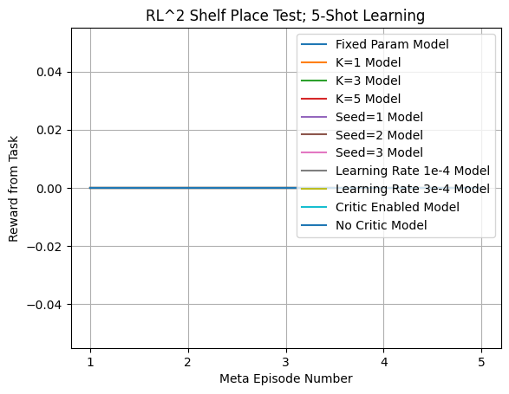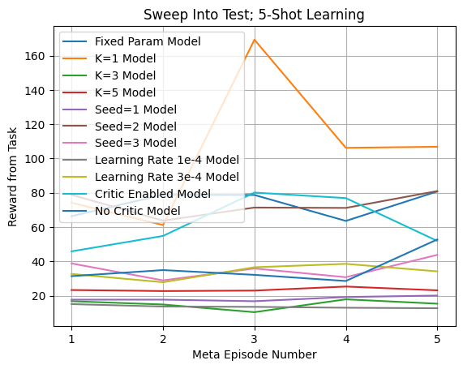
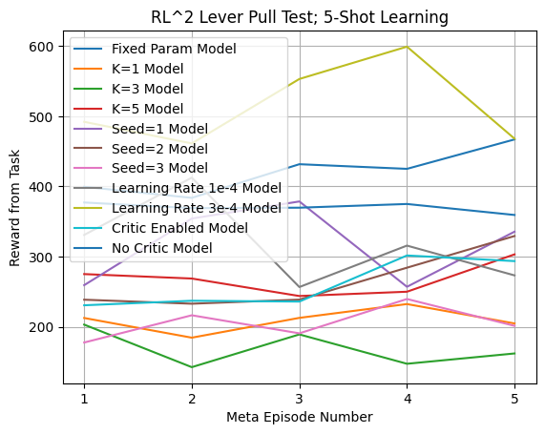
Shelf-place was the lowest performing task with 0 return for all models. Sweep-Into was the second-most challenging task for RL² with 4 models scoring around 20 returns. Lever-pull was a moderately hard task but all returns for models were over 200.

- Ablations for MAML
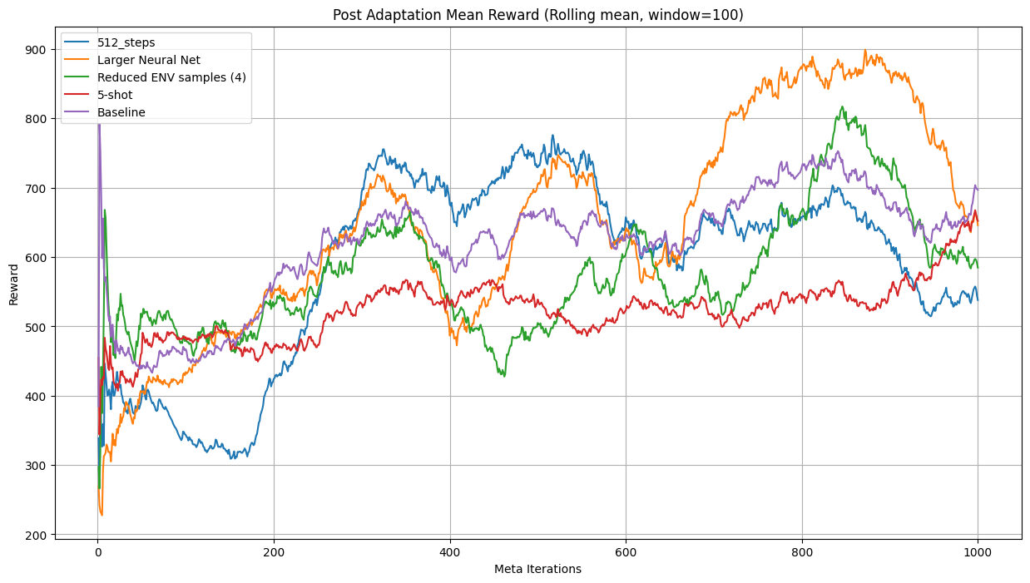
C. REPTILE
Link: https://colab.research.google.com/drive/1jslxjAHyZ_CoQckshui4SPwT77ABpCHJ?usp=drive_link
Training results can be found below. Poor training results indicated an issue that led to research, where we discovered that Reptile has not been widely used in meta-reinforcement learning, and is only effective for few-shot classification problems [12]. Thus, the paper’s focus shifted away from the evaluation of Reptile in Meta-World.
