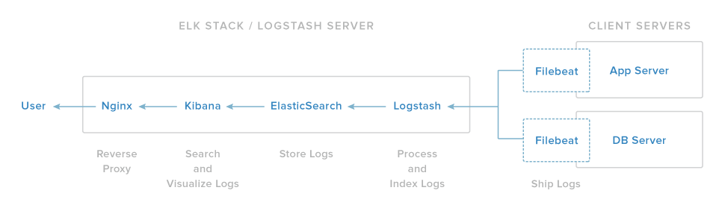

1. run the following command to start Elasticsearch on boot up
sudo systemctl enable elasticsearch

2.Now enable the Kibana service, and start it:
sudo systemctl start kibana

3.Load Kibana Dashboards

cd ~
curl -L -O https://download.elastic.co/beats/dashboards/beats-dashboards-1.2.2.zip
sudo apt-get -y install unzip
unzip beats-dashboards-*.zip

cd beats-dashboards-*
./load.sh

curl -XPUT 'localhost:9200/happy/external/1?pretty' -d '
{
"terms": "jolly,joyful,lighthearted,chirpy,effervescent,enthusiastic, peppy, optimistic, merry, lively, sunny, pleasant, sparkling, up, in good spirits, hopeful, hilarious, zappy, winsome, vivacious, sunny side up, happy, enlivening, contented, bucked"
}'
{
"_index" : "happy",
"_type" : "external",
"_id" : "1",
"_version" : 1,
"created" : true
}

