Class 5

Megan Hayes

January 25th, 2019

# Class 5 Graphics and Plots with R

**bold** *italic*

# Section 2A: line plot  
weight <- read.table("bimm143_05_rstats/weight_chart.txt", head = TRUE)  
plot(weight, typ = "o", pch = 15, col = "blue", cex = 1.5, lwd = 2, ylim = c(2, 10), xlab = "Age (months)", ylab = "Weight (kg)", main = "Baby weight with age")

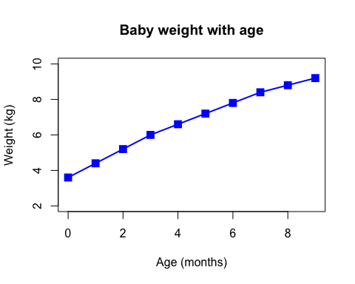

# Barplot  
feature_counts <- read.table("bimm143_05_rstats/feature_counts.txt", head = TRUE, sep = "\t")  
par(mar = c(5, 12, 4, 2))  
barplot(feature_counts$Count, names.arg = feature_counts$Feature, las = 2, horiz = TRUE, xlab = "Count", col = c("red", "orange", "yellow", "green", "blue", "purple"), border = c("purple", "blue", "green", "yellow", "orange", "red"))

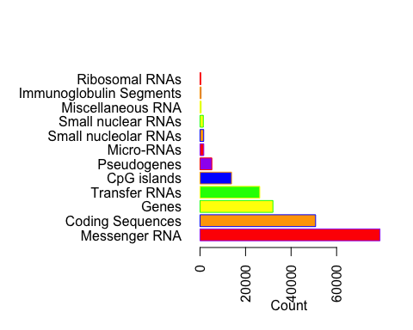

#Histograms  
MF <- read.table("bimm143_05_rstats/male_female_counts.txt", sep = "\t", head = TRUE)  
barplot(MF$Count, names.arg = MF$Sample, las = 2, col = rainbow(30, start = .5, end = 1, s = 0.5))

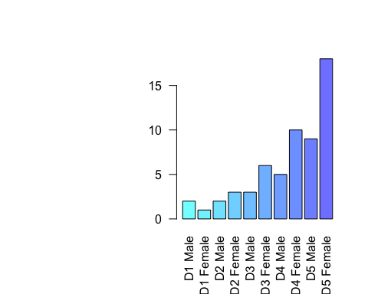

# Genes  
genes <- read.delim("bimm143_05_rstats/up_down_expression.txt")  
  
table(genes$State)

##   
## down unchanging up   
## 72 4997 127

palette(c("red", "grey", "blue"))  
plot(genes$Condition1, genes$Condition2, col = genes$State)

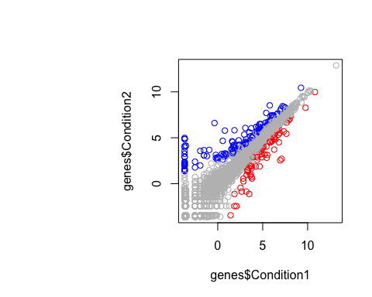

# Methylation  
methylation <- read.delim("bimm143_05_rstats/expression_methylation.txt")  
plot(methylation$gene.meth, methylation$expression)

