How To Run:
- unzip project
- open project in IntelliJ
- run in an emulator running at least Android SDK 15

User Assumptions:
I thought about two possible target audience for this app: older teenagers/20-somethings who go on small adventures (road trips, day trips, beach days, theme parks, etc) with their friends, and people going on holidays in general. I decided to go with the teenagers as my target audience, as they tend to be first in line to download new photography apps.

Design Decisions:
I originally tried to brainstorm a design that was "breezy" and "fun", but everything I came up with seemed a little young for my target audience. I was originally using colours like orange, blue, white and yellow – "beach colours" – but they, too, seemed a little young. I ended up changing my colour palette to white and teal, with black and gray text, for a slightly more sophisticated feel.

I also originally was just going to have image buttons instead of text buttons. I still think that might have looked nicer, but I had some issues with getting the buttons to be the right size, so I changed my original idea and just made my buttons kind of the focal point of the app. I changed the text into an elegant serif font, and added a border of the teal colour to make it all look kind of fancy. I also decided to try to keep the teal colour as a theme throughout the whole app, and tried to change the tab indicator to that colour.

Prototype Uis:
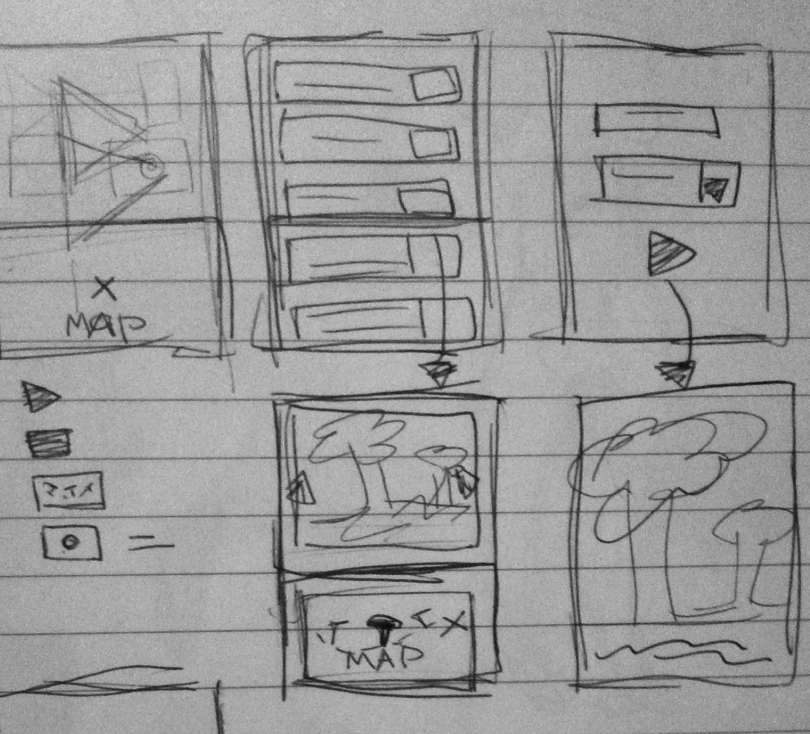
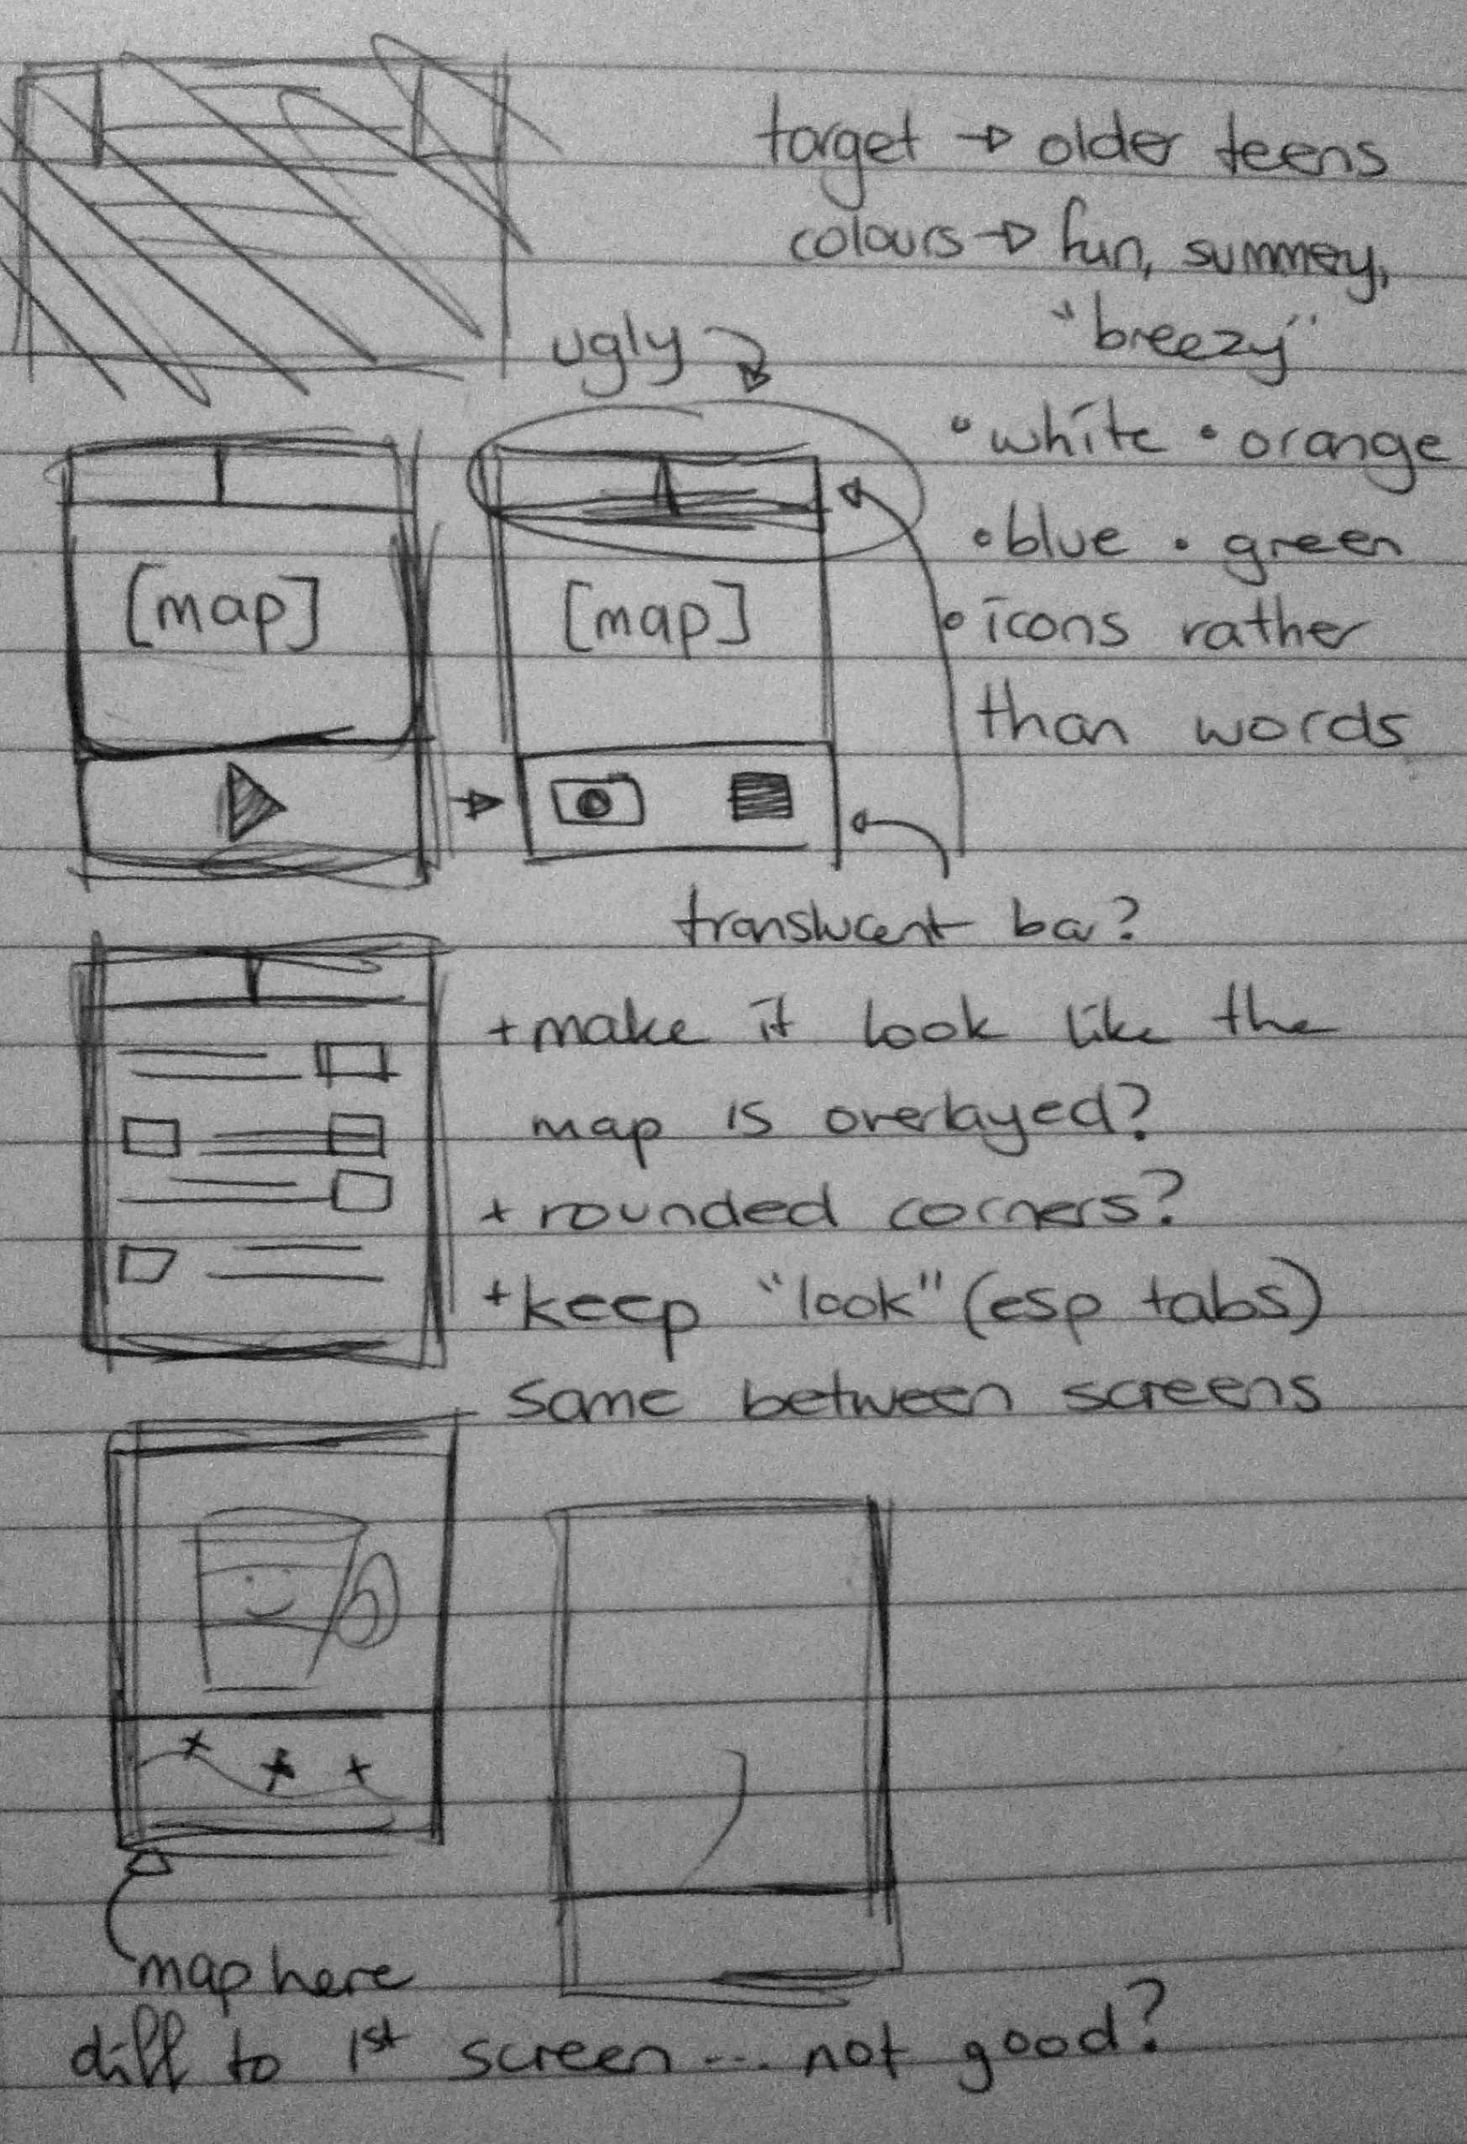

Classes:

