Diabetes Report
This trial review analyzes the results of a clinical study on pre-diabetes treatments. There were three groups, one given metformin, one given rosiglitazone, and one with lifestyle adjustments. There were 234 patients in the lifestyle group, 232 in the metformin group, and 233 in the rosiglitazone group. Each of these patients was labelled as either success or failure. The goal of my analysis was to determine if any of the treatments had enough support to start adopting them for future patients. The raw numbers of success and failures in each group are below:
outcome failure success
treatment
lifestyle 109 125
met 120 112
rosi 90 143

The success rate for metformin was 48%, lifestyle was 53% and rosiglitazone was 61%. To further analyze the results, I bootstrapped the success rates by the treatment arm, resampling 10,000 times. I then computed the average treatment effect for each pairwise combination of the treatments and built confidence intervals for the distributions and densities.
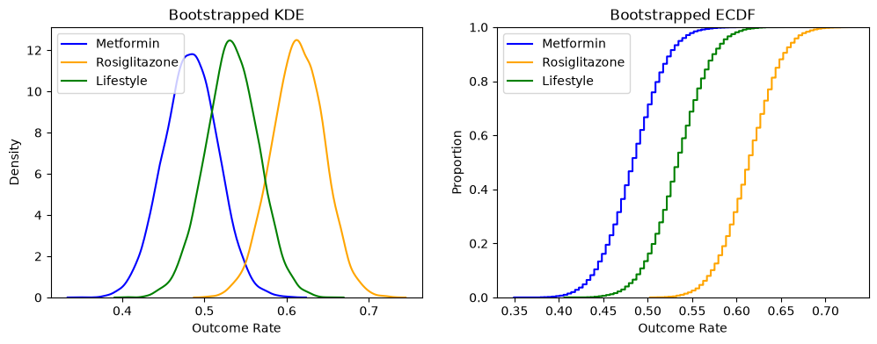

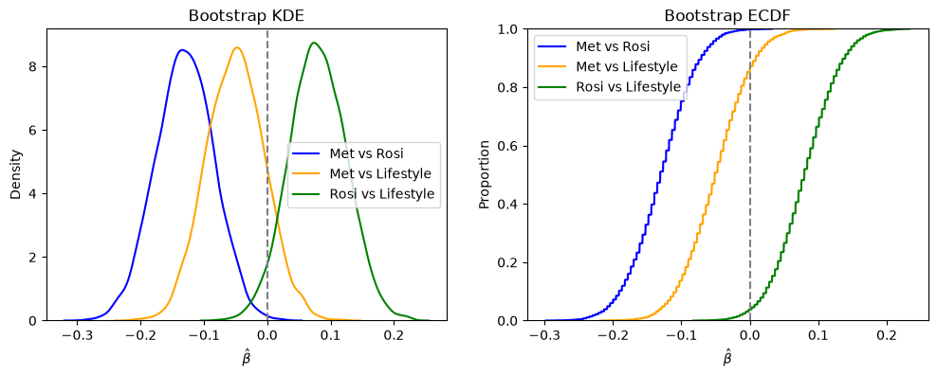

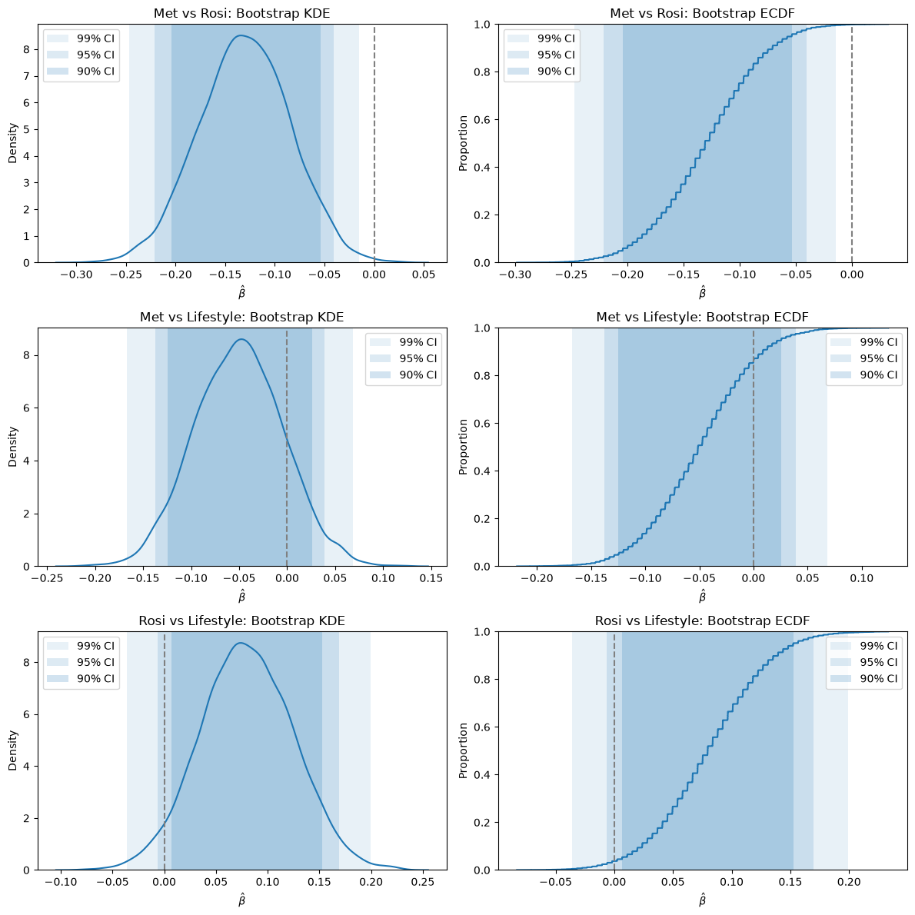
These graphs can be interpreted to show that Met vs Rosi gives the most statistically significant differences. All the confidence intervals are below 0, which suggests that Metformin’s success rate is lower than rosiglitazone's. There is no statistical significance for met vs lifestyle, it is not significant at any level. Rosi vs lifestyle is significant at the 90% confidence interval, but not at the others. This all supports that rosi is the most effective intervention, with a success rate of about 61%, compared with 53% for lifestyle and 48% for metformin. The difference and advantage over met is strongly supported and the difference over lifestyle is weakly supported. The evidence supports adopting the rosi treatment for pre diabetes. There is some evidence to suggest that lifestyle adjustments can also be beneficial.

