

Faculty of Arts, Humanities. Education and Social Sciences
Cambridge School of Art

MOD011410
Academic Skills for Games

Element 010
Portfolio

SID: 2508742

Academic Year 2026/27

Declarations

Course
I am a student on BA (Hons) Computer Games Art

External Sources
Except where a challenge told me otherwise, my external sources are cited properly and listed in the References section, using CTR Harvard Referencing.

AI Tools
I have used no AI tools in the creation of the report or the artefact.

Contents
Declarations 3
External Sources 3
External Assets and Code 3
Tutorials 3
Contents 1
Table of Figures 1
Introduction 2
Investigation Aims 2
The Artefact 2
Background and Context 3
Approach 5
Artefact Outcomes 6
Conclusion and Reflection 7
References 8
External Resources 9

[Wk1, LO4] Study Agreement
[A copy of the agreed statement, included in your portfolio, with some notion of 'signature' as described above. I'm not worried about the word count, because you should end up with the same text as everyone else (plus a couple words worth of your name, or a small image).]
I understand and agree that to secure the best chances at good grades, skills, employability and other academic benefits, I should do the following things, suggested by my class and compiled/summarised by the lecturer:
- Sessions: Show up on time when scheduled; pay attention; use the time well
- Deadlines: Meet them; make sure I know when they are
- Study Time: Manage my time, including independent study time (40-50 hours if possible)
- Catch up: …with things I miss (but keep up if possible)
- Respect: Be respectful & tolerant; cultivate an open environment & let everyone speak; communicate and contribute; take care of the computers
- Self-Care: Look after myself; eat, drink responsibly; keep a good work/life balance
- Ask for help
Signed:

[Wk1, LO1] Group Discussion: Games Likes/Dislikes
[Put the written notes into your portfolio. You have a limit of 50 words per person you're making notes about.
As in MoSCoW, above, aim to make a useful note of who they are, and to pay attention to why they like (or dislike) the games they do.]
Gaming likes/dislikes

Likes/Dislikes Games
Noah: Computer Games Design
Dislikes:
Puzzle and Strategy as he cannot suspend his reality- often puzzles are unrealistic
Likes:
Enjoys a sense of escapism within games but still grounded in a sense of reality.
Phillip: Computer Games Design
Grim world
Enjoys how the narrative develops and how characters can progress within their own world.
Dislikes:
Escort missions in games – can be tedious, impeding on the enjoyability of the gameplay as it often presents an uncontrollable variable to the player.
Chai: Computer Games Art
Likes:
First person shooter, story driven games – sci fi genre. Cs go Enjoys the variety of choice e.g. skins and different weapons.
Dislikes:
Close combat games- reduced enjoyability when playing multiplayer, difficult
Marshall: Computer Games Art
Likes:
Open world, survival horror – specifically first person – more immersive, easier to suspend reality. Mimics facing a game head on – grounded in some semblance of reality.
Repetitive game tutorial pop ups. – Breaks the immersion – affects the player experience- sort of insulting?
Melissa: Computer Games Art
Likes:
Close range combat, RPG games/ She enjoys discovering the tactic to defeat an enemy/when an enemy follows a recognisable attack pattern.

Dislikes:
Ice physics in games, often not integrated properly into the gameplay with previously introduced mechanics – giving an arduous experience.

[Wk1, LO4] Getting Organised
[Take a couple of screenshots of your calendar, showing the events you've made. How many you need may depend on the UI: if you have named them well you might be able to do screenshots by month, in which case 2-4 should be plenty. Feel free to highlight some busy weeks (such as the one after week 12).]

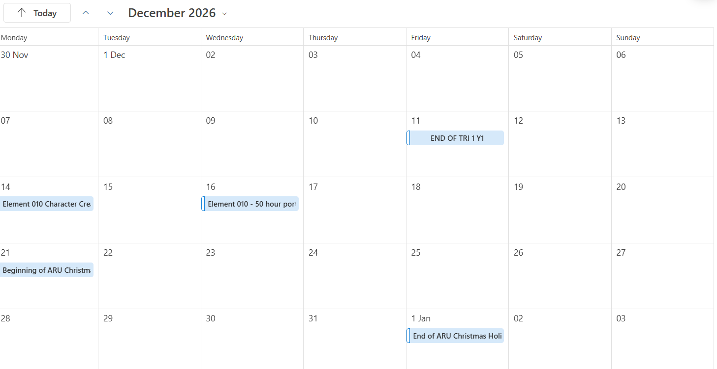
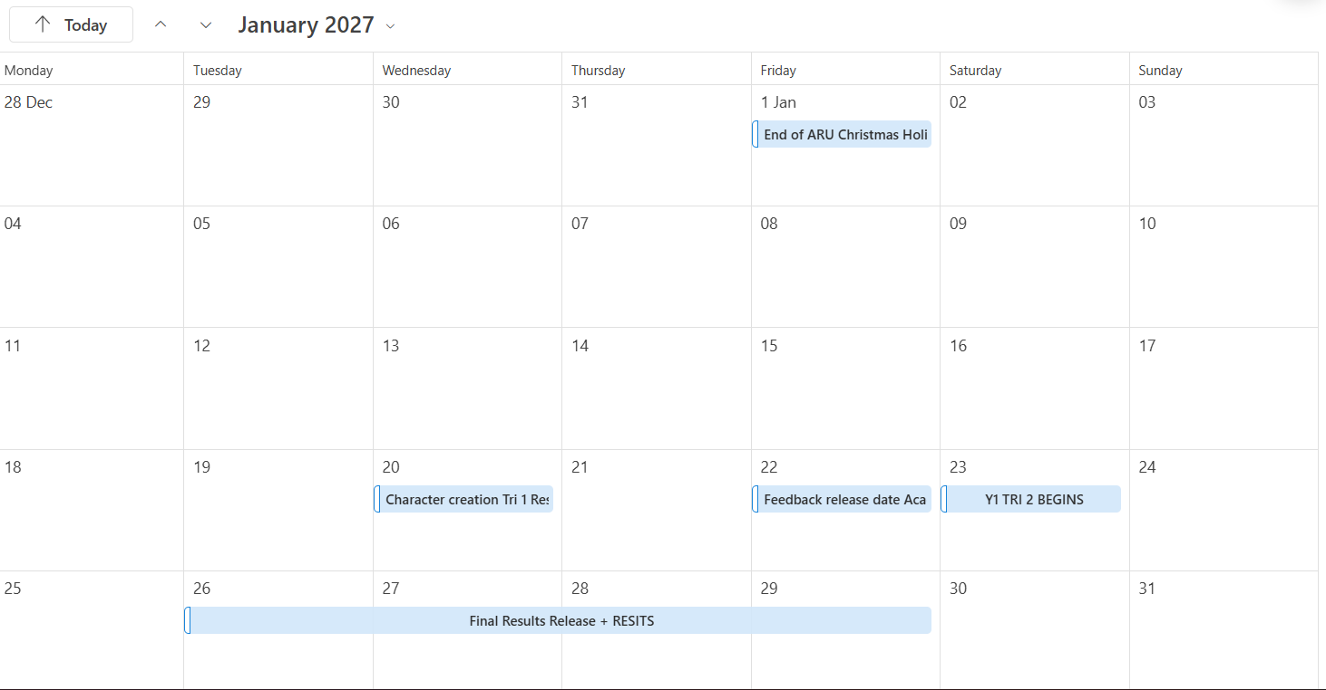

[Wk1, LO1,4] Preparation: Game Developer Roles
[Put the summaries in your portfolio, with their URLs. Give each one a sensible section heading so we can see at a glance what each role is. There is no word count limit for this section but try to include only a reasonable summary of each, and make sure each role is relevant.
Write a sentence or two about why you have joined your course, including a role that appeals to you. You have a limit of 50 words for this.]
Roles in the Gaming industry:
Game artist:
The job consists of storyboarding, creating designs for packaging and collating marketing materials. (Higginbotham, 2024) Thay often hold high technical and specialised skills in software for modelling such as Zbrush, Maya, Photoshop, Substance Painter, and Mudbox. They follow a guided process to produce the visual assets of the game often working in close collaboration with other roles.
Game designer:
The role consists of developing original unique ideas for games including the concepts and rules that underpin the basis of the game. Designers focus on the experience developing gameplay, mechanics and a system which make up a game. (HitMarker, 2022) It requires a mix of creative and technical skills and understanding of a range of programming language and software like C#, C++ and Python. (Higginbotham, 2024)
Games Programmer:
Also dubbed ‘games engineering’ is the process adopting the ideas of the game designer into code, so it is playable. An adept knowledge in game programming languages and specialisation in a particular platform such as PC, mobile or console. (Higginbotham, 2024)

I am currently interested in the Games art course as I wish to learn the skills necessary to become an environmental designer, to create immersive 3D modelled sets that strengthen an evocative narrative.

References
Higginbotham, D. (2024) Video game careers, Prospects.ac.uk. Prospects. Available at: https://www.prospects.ac.uk/jobs-and-work-experience/job-sectors/information-technology/video-game-careers/ (Accessed: September 23, 2026).

HitMarker (2022) The complete list of gaming jobs, Hitmarker. Available at: https://hitmarker.net/career-advice/the-complete-list-of-gaming-jobs (Accessed: September 23, 2026).

[Wk2, Priority, LO1,2,] Dream Job Report
[Written report of up to 400 words (plus 10%, for 440 total, if you need it).
I won't publish a full template, but please include:
- What the role is. State its title, and which studio it's in. Include a proper reference to the advert.
  - Use up to half the words to tell us about the role and the studio. You might do better if you can reduce the size of this section and leave more for the next.
- Why do you want it? Use the rest of the words. You might consider:
  - Why do these duties appeal to you? Think about what's specific to your interests, preferences and skills (including the skills you hope to learn throughout the degree), and put less emphasis on things that might be true for your whole course.
  - Why would this studio be a good fit? Does the advert say anything that makes the studio sound appealing? (Or can you find an additional source about the studio?)
  - How does this role fit into your longer-term plans? Is this a role you could progress through the grades in, or is it a route to something different?
This is a personal report and you may write it relatively informally (but be accurate and specific where possible) and in first person. We are interested in your own thoughts and reflections, but also the facts of the job as described in your sources. There will be more about writing styles later.]
Junior environmental artist: Pixel Mafia
The position I would hope to achieve in my early career is an opening as a junior environmental artist at Pixel Mafia. As a company Pixel Mafia specialises in AAA video game content, outsourcing their skills to work with high profile games and studios to produce both varied and highly polished assets and characters. They are an art service studio prioritising creativity and compassion to art, promising an innovative community dedicated to their craft. (We Are Pixel Mafia, 2023) The role shown consists of having the correct technical ability such as being able to work in multiple engines and 3D softwares and understanding the limitations of an engine. The role also emphasises having strong sociability, staying communicative with other members of the team as well as the lead to track progress. It also reinforces having resilience to both self-assess and rationalise criticism to your work. (We Are Pixel Mafia, 2023)
I was drawn to this position in Pixel Mafia after reviewing their portfolio and previous projects. Pixel Mafia has an impressive and extensive portfolio detailing their range from assets on Horizon Forbidden West (Guerilla Games, 2022) to Diablo 2: Resurrected (Blizzard Entertainment, 2021). Both the refinement and variation between their project work interested me further as it presented a greater set of challenges of adequately learning to have an adaptive and flexible art style that can fit the brief presented. Moreover, the assets Pixel Mafia portrays in their projects seem to have a focus on weaponry which appeals to my personal interests, with designs that are both grounded in realism whilst maintaining a sense of the fantastical. The company also has worked on a game I was personally interested in Horizon Forbidden West which furthered my interest to gain an understanding how some of the elements were made of a game and visual style I enjoy.
Pixel Mafia feels like an appropriate company as it consolidates a community of avid video game artists who are similarly passionate regarding the creative process. It aims to transgress the traditional definition of an outsourcing company to become more integrated in the developmental process. (Agustin, 2023) Further in the article written by Carl Agustin (2023) The founder of the company Coby Chan has also prolifically supported maintaining a sustainable working environment for their employees have experienced them himself constituting of fried chicken Fridays, shuttle service and free lunch. I would hope to use this position as a starting point to progress through the ranks, to a more senior role, however as an artistic company I would hope to utilise the experience to gather an understanding of a variety of creative roles like a concept artists and character designers.

References
Agustin, C.M. (2023) Pixel Mafia is Cultivating a Brand-New Generation of Filipino Game Developers | Lifestyle.INQ, Lifestyle.INQ. Available at: https://lifestyle.inquirer.net/479768/pixel-mafia-is-cultivating-a-brand-new-generation-of-filipino-game-developers/ (Accessed: October 8, 2026).

Blizzard Entertainment (2021) Diablo 2: Resurrected [Video Game]. Blizzard Entertainment. Available at: https://store.steampowered.com/app/2536520/Diablo_II_Resurrected__Infernal_Edition/

Guerilla Games (2022) Horizon Forbidden West [Video Game]. Sony Interactive Entertainment. Available at: https://store.steampowered.com/app/2420110/Horizon_Forbidden_West__Edicao_Completa/

We Are Pixel Mafia (2023) Pixelmafia.com. Available at: https://www.pixelmafia.com (Accessed: October 8, 2026).

[Wk3, Priority, LO2] Good Academic Practice assignment

[Make a new Heading 1, similar to other challenges, and simply paste in a screenshot that shows some progress on the quiz. A picture of the pass screen (or Canvas should be able to confirm a pass afterward) would be ideal, but if you are giving up, take a picture of wherever you get to.
If you are in a hurry for Progress Check 1, take a picture of where you get to, and set yourself a task (a calendar event, a to-do list item, etc.) to finish it later and replace the image.]

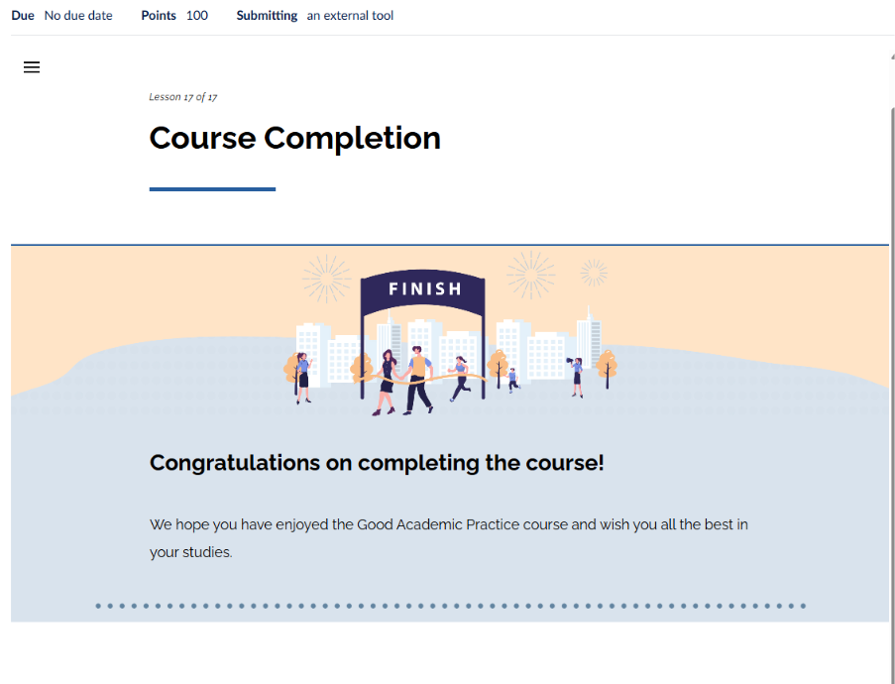

[Wk3, Priority, LO2,3] Referencing Practice
[Start a new section (with Heading 1) and add the sentences above to your portfolio. Use a paragraph for each source, even if you end up with a one-sentence paragraph.
Make a heading for the reference list (in Heading 2), and add your reference list. Each reference must be its own paragraph.
Word count: The total word count for this task is 200; you are allowed to be over by 10% (for a total of 220). Note that according to the academic regulations (6.90), the following things (and some others) do not count toward word counts:
- in-text references/citations in parenthesis - e.g. “(Baxter, 2024, p. 52)”
- list of references and/or bibliography
So note that in a direct citation the author's name still counts (and worse for multiple authors). The whole reference list is immune.]
Game
Dark Souls (FromSoftware, 2011) is a video game developed game by Hidetaka Miyazaki. It was a revolutionary game atypical for its period and consolidated a whole new genre tag classified as ‘soulslike’. The atmospheric designs and visuals seen in the game transformed the visual language of games and their approach.
Webpage
Macdonald (2011) discusses in her article titled ‘Dark Souls Review – are you prepared to die?’ the progression of Fromsoftware from Demons Souls (FromsSoftware, 2009) to Dark Souls (FromSoftware, 2011). She is a reputable writer with history of covering previous works of the studio and her background suggests she was the games editor of IGN. IGN themselves are a renowned agency in producing reviews for many prominent games.
Video
The following video from Matthewmatosis (2015) is a commentary discussing the lore, gameplay and design of Dark Souls (FromSoftware, 2011) during a playthrough. The previous history of this channel suggests that he has experience covering previous games by Fromsoftware solidifying his credibility which is further reinforced by the viewership of this commentary totalling approximately 2.5 million views. This highlights he has a well-established and well-received understanding of the topic.

References
FromSoftware (2009) Demon Souls [Video Game]. Bandai Namco Entertainent.

FromSoftware (2011) Dark Souls: Prepare to Die [Video Game]. Bandai Namco Entertainent. Available at: https://store.steampowered.com/app/211420/DARK_SOULS_Prepare_To_Die_Edition/

Macdonald, K. (2011) Dark Souls Review - IGN, www.ign.com. Available at: https://www.ign.com/articles/2011/09/30/dark-souls-review (Accessed: October 8, 2026).

Matthewmatosis (2015) “Dark Souls Commentary.” YouTube. Available at: https://www.youtube.com/watch?v=EV16ROaHVfo (Accessed: October 8, 2026).

Isugpoonifnhnpsign

