Guide
A. The relation between test module(simple_client) and SDKlib. 2
B. API unit test 3
1. generate data(increment packet data) 3
2. Invoke API in main(): 4
3. Test result 6
4. Special Note 6

The relation between test module(simple_client) and SDKlib.
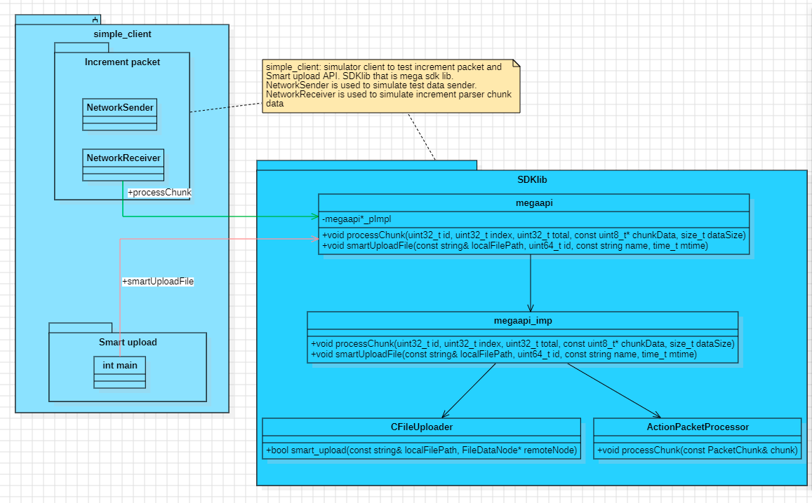

- Simple_client: simulator client to test increment packet and Smart upload API.
- NetworkSender is used to simulate test data sender.
- NetworkReceiver is used to simulate increment parser chunk data
- SDKlib that is mega sdk lib. API:

- Increment packet processing API
// precess the received chunk
void processChunk(uint32_t id, uint32_t index, uint32_t total, const uint8_t* chunkData,size_t dataSize);
// set a callback for when a packet is complete
void setPacketCompleteCallback(
std::function<void(uint32_t, const std::vector<uint8_t>&)> callback);
// set a callback for packet progress updates
void setPacketProgressCallback(std::function<void(uint32_t, double)> callback);
// clear all pending packets
void clearPendingPackets();
// get the state of a specific packet
size_t getPendingPacketCount() const;

- smart upload file API
void smartUploadFile(const std::string& localFilePath,
uint64_t id,
const std::string name,
time_t mtime,
const std::string fingerprint,
const std::string parenthandle,
const std::string encryption_key,
const std::string nonce,
const std::string mac);

API unit test

generate data(increment packet data)
void simulatePacketData::simulateDataToUnitTest(MegaApi* megaApi)
{
std::cout << "=== ActionPacket Incremental Processing Demo ===" << std::endl;

// create sender and receiver instances
NetworkSender sender(1024, 0.1, megaApi); // chunk size of 1024 bytes, 10% packet loss
NetworkReceiver receiver(megaApi);

// start the receiver to process incoming packets
receiver.start();

// create a vector to hold test packets
std::vector<std::vector<uint8_t>> testPackets;

// test data packets1: small text data
std::string textData = "Hello, this is a test packet for incremental processing demonstration!";
testPackets.push_back(std::vector<uint8_t>(textData.begin(), textData.end()));

// test packets2: large binary data
std::vector<uint8_t> binaryData(8192);
for (size_t i = 0; i < binaryData.size(); ++i)
{
binaryData[i] = static_cast<uint8_t>(i % 256);
}
testPackets.push_back(binaryData);

// test packets3: random data
std::vector<uint8_t> randomData(4096);
std::random_device rd;
std::mt19937 gen(rd());
std::uniform_int_distribution<> dis(0, 255);
for (size_t i = 0; i < randomData.size(); ++i)
{
randomData[i] = static_cast<uint8_t>(dis(gen));
}
testPackets.push_back(randomData);

// send each packet using the sender
for (const auto& packet: testPackets)
{
sender.sendPacket(packet,
[&](const PacketTestChunk& chunk)
{
receiver.receiveChunk(chunk);
});

// data loss simulation
std::this_thread::sleep_for(std::chrono::milliseconds(200));
}

// wait for all packets to be processed
std::this_thread::sleep_for(std::chrono::seconds(2));

// stop the receiver
receiver.stop();

std::cout << "=== Demo completed ===" << std::endl;
}

Invoke API in main():

int main(){
//Test Increment action packet interface
std::cout << "Test Increment action packet interface begin:" << std::endl;
simulatePacketData simPacketData;
simPacketData.simulateDataToUnitTest(megaApi);
std::cout << "Test Increment action packet interface end!" << std::endl;
std::cout << std::endl;
std::cout << std::endl;

std::cout << "Test smartuploadFile interface begin:" << std::endl;
// Test smartuploadFile interface
std::string localFilePath = "/path/to/local/file";
uint64_t id = 10000;
std::string name = "localfilename";
time_t mtime = 0;
std::string fingerprint = "fingerprint";
std::string parenthandle = "parenthandle";
std::string encryption_key = "encryption_key";
std::string nonce = "nonce tag";
std::string mac = "mac adr";

megaApi->smartUploadFile(localFilePath,
id,
name,
mtime,
fingerprint,
parenthandle,
encryption_key,
nonce,
mac);

std::cout << "Test smartuploadFile interface end!" << std::endl;
std::cout << std::endl;
std::cout << std::endl;
}

Test result
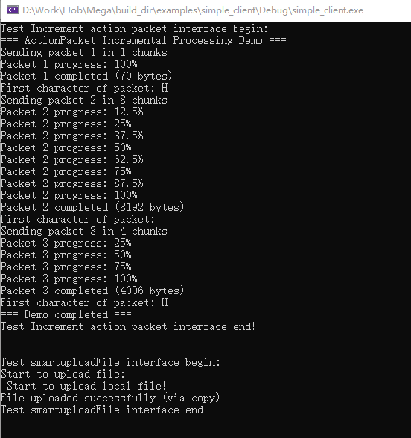

Special Note
In the remote copy file function, this remote copy action should be copied from server side. From client that just need to check the validate of localfile and create new file id, mac etc. Then send message(new file id, mac etc.) to server side to ask server copy file by-self. So the function apicopyremotefile is an api that is provide by server(assumption in yellow background color).

// Copy remote files
bool CFileUploader::copy_remote_file(const std::string& localFilePath, FileDataNode* remoteNode)
{
if (!client)
{
std::cerr << "MegaClient is not initialized." << std::endl;
return false;
}

if (!remoteNode)
{
std::cerr << "Invalid remote node." << std::endl;
return false;
}

std::cout << "Starting remote file copy for node: " << remoteNode->get_nonce() << std::endl;

// get remote node's encryption parameters
std::string sourceKey = remoteNode->get_encryption_key();
std::string sourceNonce = remoteNode->get_nonce();
std::string sourceMac = remoteNode->get_mac();

if (sourceKey.empty() || sourceNonce.empty() || sourceMac.empty())
{
std::cerr << "Missing encryption parameters for source node." << std::endl;
return false;
}

// create new encryption parameters for the target node
std::string targetKey = client->rng.genstring(SymmCipher::KEYLENGTH); // CryptoUtils::generate_new_key();
std::string targetNonce = client->rng.genstring(SymmCipher::KEYLENGTH);

// real implementation should generate a new key and nonce
std::string parentHandle = remoteNode->get_parenthandle(); // auuxiliary function to get the parent folder handle
std::string newName = remoteNode->get_name() + "_copy"; // copy file name

// validate the source MAC
bool macValid = CryptoUtils::verify_mac(remoteNode->get_file_size(),
localFilePath,
sourceKey,
sourceNonce,
sourceMac);

if (!macValid)
{
std::cerr << "Source file MAC verification failed. Possible data corruption." << std::endl;
return false;
}

// excute the remote copy operation
// apicopyremotefile: should be provided by client and will ask copy file on server by theget
// key and nonce
std::string newNodeHandle;
bool success = true;
/* bool success = client->apicopyremotefile->copy(remoteNode->get_handle(),
parentHandle,
newName,
targetKey,
targetNonce,
&newNodeHandle);*/

if (!success)
{
std::cerr << "Failed to copy remote file." << std::endl;
return false;
}

