 

**COMPUTER STUDIES GOVERNMENT PROJECT MANAGEMENT SYSTEM**

**SOFTWARE REQUIREMENTS SPECIFICATION**

**Team Name :** House of Megan

**Section :** S23

**Team Members:** Avanceña, Margaret Ann

Bautista, Carlo Migel

Chua, Ralph

Dimanarig, Edgar

Garcia, Daniel Jaspher

Mañalac, Miguel

Medel, Rheygine Kim

Ongsingco, Joseph

Partosa, Brandon

Tiu, Kenywil

**Date Submitted:** Feb 2, 2016

**TABLE OF CONTENTS**

|  |  |
| --- | --- |
| 1 Executive Summary | 1-1 |
| 2 Overview | 2-1 |
| 2.1 Existing Business Process | 2-1 |
| 2.2 Data Requirements | 2-2 |
| 2.3 Roles in the Business Process | 2-3 |
| 3 Problem Analysis | 3-1 |
| 4 Software Solution | 4-1 |
| 4.1 Objectives | 4-1 |
| 4.2 Characteristics | 4-1 |
| 5 User Stories | 5-1 |
| 5.1 <User Story 1> | 5-1 |
| Appendix A - Improved Business Process | A-1 |
| Appendix B - Interview Transcript | B-1 |
| Appendix C - Sample Forms and Reports | C-1 |
| Appendix D - References and Acknowledgements | D-1 |

**1 Executive Summary**

Computer Studies Government, also knowns as the CSG, is a college-wide organization that focuses on the development of the entire College of Computer Studies (CCS), including the undergraduate students under it. CSG is composed of undergraduate students taking courses under CCS that have went through the application process. Students with the desire to part of an organization that centers on college-wide development and the eagerness to gain leadership skills are welcome to join.

CSG plans, organizes and conducts various student activities for the benefit of the undergraduate students. By regulating peer tutorials, the organization aims to help the students with their academics with the hope of getting their grades up. By organizing seminars and talks, the organization intends on informing the students with updates and relevant news in the IT industry. And by conducting charity events, the organization wishes to teach the students the true meaning of being a Lasallian by helping the less fortunate.

CSG officers are the ones responsible for the planning and execution of these activities. It is their duty to accomplish the necessary documents, to pass them to the office assigned to handle all the paperwork, and to execute the events and activities successfully. By applying to become a CSG officer, it is their job to achieve the main goal of the organization: to promote college-wide development.

**2 Overview of the Business Process**

*In this section, the current business process of the Computer Studies Government is discussed as well as the data required during the process and the different roles in the business process.*

This chapter presents the company’s business process and goals as an organization/department. Included in

this chapter are the following items:

* Description of the company's existing process and business requirements
* Data requirements as part of the business process, including data that are captured, stored and
* Existing software or tools used as part of the business process, if any
* Different roles in the business process

Notes:

* You can use subsections, e.g., 2.1 Existing Business Process; 2.2 Data Requirements; 2.3 Roles in the
* Sample forms and reports should be included in the Appendix, for example, you can write your generated (report formats should be placed in the Appendix) Business Process.

business process as follows:

Weekly sales reports are prepared by each Account Executive and submitted to his/her immediate

**2.1 Existing Business Process**

Currently, the business process of the Computer Studies Government can be segregated into four — conceptualizing the project, Before event execution, during the event and after the event.

1. **Conceptualizing the Project**

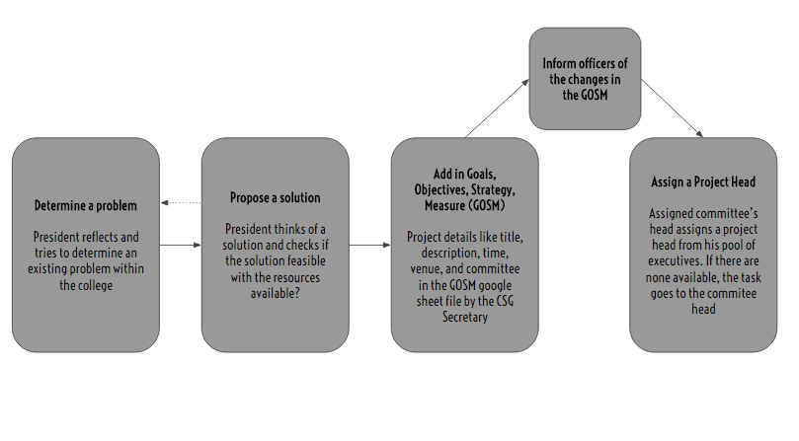

During the initial interview with the President, there is no exact process as to how they determine a problem in the college. The president simply reflects and tries to determine an existing problem. After that, he proposes

1. **Before Event Execution**

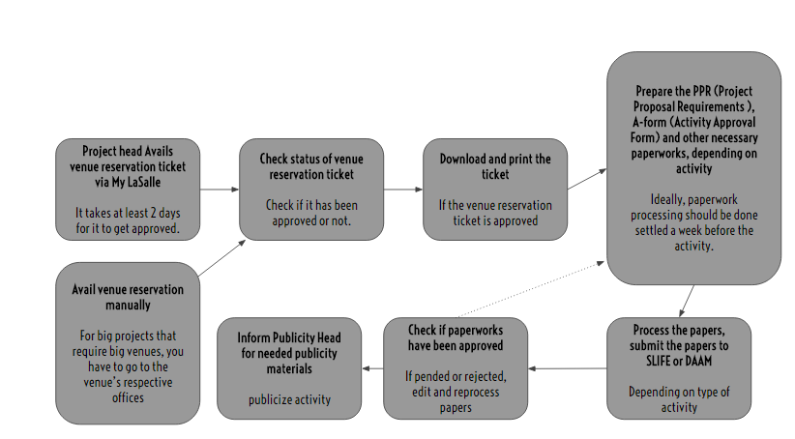

1. **During the Event**

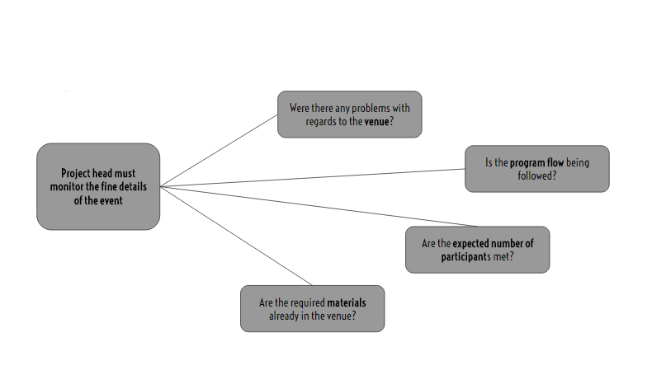

1. **After the Event**

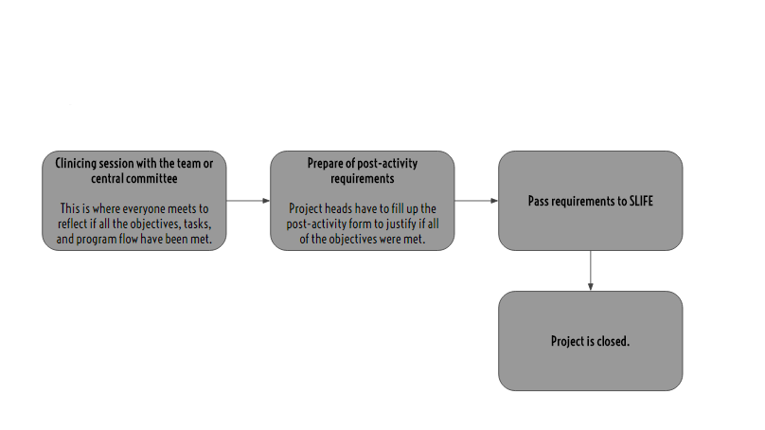

***2.2 Data Requirements***

***2.3 Roles in the Business Process***

|  |  |
| --- | --- |
| ***Role*** | ***Description of Tasks*** |
|  |  |
|  |  |

**3 Problem Analysis**

|  |  |  |  |
| --- | --- | --- | --- |
| **Description** | **Cause** | **Symptoms** | **Impact** |
| Difficult to monitor projects | - No automated process for project management, only the president’s planner | - Officers can’t inform and update everyone about the current status of the project because of their schedules. | - Due to mismanagement of the projects, they may be cancelled or end up as failures. |
| Difficult to manage the paperwork | - DAAM’s paperwork notification is currently under construction, while the paperwork notification for SLIFE is simply not being used by the USG. | - Officers have to personally go to the office and check for the updates.  - The project heads are not informed if their paperworks have been processed by SLIFE or DAAM. | - Delays in preparing paperwork and processing, which may delay the activity. |
| Delays in preparing paperwork and processing | - No checklist that specifies the papers to be processed and completed  - Denied proposals/paperwork | - Project heads clarifying which additional paperworks to pass, when activity is different.  - Paperworks are either denied or pended by the office. | - Deduction of points of the organization  - Paperwork are processed late therefore it can delay the event. |
| Late submission of pre-activity requirements | - Paperworks are not processed early and did not give allowance for pending or rejected papers  - There are different requirements for different types of activity and the project heads are not very familiar on the paperworks they needed. | - President goes to consultation with the offices to justify lateness  - The president reminds officers to submit paperworks on time | - Activities could get cancelled or moved to another day  - Speakers, may not be informed of the changes on the event / talk |
| Late submission of post-activity requirements | - Project heads sometimes pass the work to the documentations committee | - President has to remind project heads that they need to submit post-activity requirements | - Deduction of points for the organization  - Organization may have a negative standing because of the last submission of paperworks |

**4 Software Solution**

**4.1 Objectives**

The Computer Studies Government Project Management System (CSG-PMS) aims to ease the difficulty of managing and monitoring of projects and activities within the college.

* To provide a facility for monitoring the status of the required paperwork;
* To provide a facility for tracking of the necessary paperwork for a project;
* To notify the users regarding updates and changes in a project;

**4.2 Characteristics**

**Appendix A - Improved Business Process**

**Appendix B - Interview Transcript**

**INTERVIEWING THE CSG PRESIDENT**

M - Miguel Torres, CSG President

I - Interviewers

**I**: Ok, Good afternoon I am Margaret Avancena and this is my teammate, Kenywil. First of all, we would like to thank you for letting us have this time to conduct this interview. Are you ready?

**M**: Yes.

**I**: How long have you been in the student government?

**M**: I’ve been active in the student government ever since I was a freshman in the college. This is my 4th year in the student government.

**I:** Nice, yes president! How’s it being the president, is it stressful?

**M:** Medyo, yeah, there’s a lot to think about.

**I:** Can you describe what you do for the CSG?

**M:** So basically, I was elected a CSG President, college president. Halos lahat ng processes kailangan ko imonitor. There are different departments under the organization. Internals, Externals, University Affairs, Admin Affairs, and the different committees under it. I basically have to monitor all the processes if they are still active and to make sure if all the projects are implemented well. Also, my basic role as CSG president is juggling my task, internally and externally of the college [affairs], I also have to represent the college and voice out concerns in the different sectors of the university. What makes it difficult is that I have to do that and at the same time monitor the internal processes of the college.

**I:** Ah, so it’s difficult to monitor-

**M:** Yes, especially when the officers have their own schedules that can’t match.

**I:** Can you describe us the process of project making? to the point of coming up of the with the idea and to the end of the activity?

**M:** Coming up with the idea, syempre you can’t make projects na “bara-bara” lang just for the college. You have to determine what’s it for, what’s the purpose of the activity and how is it relevant to the students, how are they going to benefit from it. So basically, me, the easy way to determine what my project’s going to be, I determine muna a problem. A specific problem that we target on in the college. For example, a projects as simple as this, it’s called “Hello from the Andrew side”. What’s the problem there? Students have the hassle of parang, they can’t contact the administration as easy as it was before. Since they transferred already to andrew and how are we going to contact them from gox? So syempre, kailangan kang umakyat dun, diba? So “Hello from the Andrew side” is an installation of telephone systems, here in gox. So yun, that’s how I determined it. One, the problem, then propose a solution. Then after proposing a solution, check if it is feasible with the available resources you have. For example, are there any offices willing to provide a set of telephones? Yes, physical facilities office. After that, determine the details of the project. Program flow, date of installation, basics naman yung project details, yung venue, date, details like how are you going to manage the project, time, and other needs. Other needs, depends on the type of project. This one, it’s a special case project because it is not a regular event that people really go to, it is something they really need in the college. It depends talaga, that’s why we have the student’s activity manual. I’ll give you a copy of it, maybe tomorrow?

**I:** Okay!

**M:** To continue, the processes naman, let’s say you have the basic ideas you want for the project, you have this concept, you have a nutshell of what your project is going to be. Syempre, in processing an activity, you have to have this, the “PPR”, Pre-activity requirements. It’s composed of, mainly, the A-form or activity form, the project in a bird’s eye view. Next is the Project proposal form “PPR”, and the venue reservation ticket, where your project is going to be. Those are the three main components of the activity requirements but it may also depend on the type of activity. Let’s say it’s a sponsorship activity, kailangan mo din ng Memorandum of Agreement.

**I:** But does it require the same basic requirements even if it's a different type of activity?

**M:** Yes, for all activities, the all need the Venue reservation ticket, PPR and A-form. Standard yung tatlong yun, but for every other activity, depending on the type, there may be more requirements to add on. Like, MOA, Memorandum of Agreement, if sponsorship. If it is a sports fest, you need waivers - notarized waivers. If it’s ticket selling, you need to have the design of the tickets and the price quotation.

**I:** Is there a form for those?

**M:** Yes, all of them, they all have a template. Another example is talks, you need to have the credential of the speakers. Basically, it depends, you can look it up on the students activity manual. But the 3 basic needs for the pre-activity requirements is the a-from, the project proposal form and the venue reservation ticket.

**I:** How about the processing of the papers?

**M:** So step by step, first you have to avail of the venue reservation ticket. You can get this by process this through My LaSalle. It could get approved in 2 days. After availing for the venue, after 2 days, you have to check if it is approved. If it is approved, download and print the ticket. Once you have the venue reservation ticket, that’s the only time you can process the PPR and the A-form. After those, you process those papers through S-LIFE or DAAM, depends on the nature of activity. Makikita mo naman sa A-form, type of activity. If it’s an academic contest, general assembly, etc all the activities that fall under this should be processed by DAAM, for the USG. For CSO, it’s CSO. In our case, it’s DAAM, their activity monitoring team. For the activities that involve external relations, or external partnerships, like selling, donation drives, conferences, off-campus activities, they have to be processed through S-LIFE. Why S-LIFE? They have this legal processing that if something goes wrong, we will still be liable, but they will help us with it. It’s also one of the reasons why the waivers right now needs to be notarized.

**I:** Has it always been like that? That it needs to be notarized?

**M:** No, it’s a new process since the legal management team added it just to have a second check. After processing the papers, you have the activity itself. Once the event is already being done, the office or the project head has to monitor everything. Is the venue ok? Is the food ok?, if the activity has food. Was the program flow being followed? The program flow can be seen here, in the activity requirements. After the event, it is the responsibility of the project head to have a clinicing session with his team or his cencomm. That is where you catch up, if all the objectives, tasks, program flow, have been met. For example, the General Assembly, it says here in the program flow that there are 3 performers. You reflect is there were actually 3 performers. Were the expected number of participants reached? That’s how you reflect if the activity is successful. After that, you have to make the post-activity requirements. You fill up the post-activity form and that's where you can justify if all the objectives were met. That’s why it is important for the project head to make the clinicing session because that is how he’ll be able to answer the post-acts. After that, you have to pass it on to S-LIFE. That is when the entire account or project is closed.

**I:** How long usually processing ng projects?

**M:** For the venue processing, it takes at least 2 days. PPR, in processing the pre-activity requirements, diba you have the a-form and ppr, you pass it on to S-LIFE. S-LIFE takes about 3 days.

**I:** Do they notify you if na approve na nila or not?

**M:** No, you have to go there. That’s why it’s also hard monitoring the projects. But assumingly, dapat after 3 days, tapos na.

**I:** Are there times that it goes over 3 days?

**M:** Yes, depending if there is a holiday or if the director of activities is on leave. After that, all the paperworks must be done 3 days before the event itself. But in CSG, I give them a standard that 1 week before, everything must be settled, paperworks and all. Then the activity proper, depends on the project head and how long the event will last. After that post-activity requirements. In the A-form, there will be a due date. For example, you submit it on Jan 19. Usually, they give you a month long range before you can process the post-activity. Kunyari you process it January 22, you can process the post-acts until Feb 22. Month long. You can prepare it as early as the event is done. That’s it.

**I:** Are there times na hindi na fufulfill yung post-acts?

**M:** Yes, what happens is, you assign a project head, then what usually happens, I find it funny, that they generalize the task of documentations team that they will process the post-acts. Apparently, the task there is that, you’re a project head, you start the activity, you also end the activity. Once you process the pre-activity of the project, after the project, you will also be the one to process the post-acts. The documentations team’s assignment is to assure that everything or all the documents for the project is processed or is going smooth.

**I:** Are there also times na yung pre-acts naman hindi nasesettle, 1 week before the activity?

**M:** Yes, there are time, for example, hindi naapprove si venue reservation ticket, so you have to look for another venue, or you have to justify to the PFO why the venue was not approved and because of that, madedelay yung time mo. Let’s say your activity is already, Let’s say today is Monday and your activity is on Friday, if you got your pre-acts, you plan to pass your pre-acts on Monday, sakto lang, Tuesday, Wednesday, Thursday, before Friday. But then, let’s say you got delayed, hindi siya naapprove, so it takes another two days but that’s already 2 days before the activity. So what happens is that, there will be many consultations to be made. You have to go to the department and justify why you are passing the pre-acts requirements late. But basically, dapat talaga 3 days, it has always been a standard that 3 days before the activity itself.

**I:** Are there times na activities are not pushed through because of the papers?

**M:** Yes, let’s say you tried to consult the office for passing it late, sometimes, there are times that they become so strict that they will not allow the activity, because that’s the standard talaga. If it doesn’t push through, wala talaga.

**I:** In your 4 years of experience in the students government, what is the worst case scenario from what you remember?

**M:** Worst case scenario is that, we had a company talk at LSCS, all the pre-acts, okay na, venue reservation, okay na. It’s just that the project head, passed it 2 days before the activity. He passed it but then the activity was not yet checked by S-LIFE because they take about 3 days to process the papers. So, what happened was, we regret to inform the speaker that we had to extend the activity. So since nalate, we had to process another set of papers, like this one, we had to edit the A-form for scheduling the activity for another day. There’s a part here, in case of change slip. In may changes in date, venue, time, put it here and pass it again. That’s the worst case scenario and that could happen. Another is, well, denied. The activity will not push through at all.

**I:** Has it ever happened that the activity has been publicized even if the activity is denied?

**M:** Yes, if the activity is publicized but the verdict of the processing is denied, the activity monitoring team of the USG, they’re really, they will be very focused, tutok sila sa pubs mo sa facebook. If ever you disobey that, you publicized an activity and it’s been denied by S-LIFE, they generate an incident report. What happens in an incident report is that, this is the activity, these are the people involved, they will have a screenshot of the happenings on facebook, then they will justify why it is wrong. They staple on proofs that it is really wrong, based on the processing. They coordinate with S-LIFE. Para kang kinakasuhan, may mali kang ginawa, may kaso na.

**I:** Wow, that’s tough!! Anyway, what are the reasons why nadedelay yung projects?

**M:** There are a lot of reasons, one could be venue reservations, it’s really tough to have venue reservation because not all of the venues could be reserved through the MLS. For example, Henry Sy, you have to consult it at the 14th floor of Henry Sy. It’s not automated, you have to go there for manual reservation. Let’s say gox lobby, for reservation of the gox lobby you have to go to Ms. Sheng. But most of the venues are still in the MLS. It’s just that if you’re planning to implement a big project, in a big venue, you have to go to Henry Sy 14th floor and reserve it under Ms. Babes.

**I:** What else, aside from reservation?

**M:** Sponsors. If you have a set of sponsors for your activity, let’s say you have a competition. In passing the pre-activity requirements for that, you need to have the list of sponsors for the activity. But there are times that the sponsors don’t coordinate well with the project heads. For example they don’t reply agad so in turn, nadedelay yung process. They don’t know if confirmed na yung participation nila for the event. Third is, holidays, or storms. Let’s say there’s a storm and there’s not school, you don’t have a choice, you have to fill up the in case of change form or if it a holiday, and your activity is on a Friday, and it’s a holiday on Tuesday, it’s not part of the 3 day period for processing the papers. Another is management or coordination with the department or committees. For example, I’m a project head and then the publicity team. I’ve finished all the paper required for the project but I forgot to inform the publicity team that I need a pub for the event. Example, today is a Thursday, then Friday yung activity, hala, di pa nagrerelease ng pub. You have to consult with the publicity and then they have to rush it. Sometimes, it’s not properly disseminated and you won’t get the anticipated number of participants, so you have to delay the activity.

**I:** Do you always have to meet the number of participants?

**M:** As much as possible, yes, especially from the Council of Student Organizations, if you don’t reach it, you get a deduction.

**I:** Deductions for what?

**M:** Points, because at the end of the year, you get a score, it’s graded, everything is graded. Basically, it’s really important for me and the heads of the organization to monitor the projects under each department.

**I:** So, right now, what are you doing to monitor all of the departments?

**M:** I have a planner, haha, and I “tick box” it. For example, a project, the advanced placement program. I need to know if the pre-acts are okay, venue, project head, have I assigned a project head?, date, what specific date do I want it to be in, what time, food, if needed, all of the details, sponsors, if they’re okay, pub materials. I delegate it. You have all the tasks for this specific project. What I do, I delegate it to the different committees. For example, pubs, publicity committee. Sponsors, corporel. Food, Logistics. Pre-acts, project head, etc. This is my entire list, but I break it down to the different committees then that’s when I post. Here’s your task, here’s your task. So project management for the organization.

**I:** How do you determine the project heads for a project?

**M:** Let’s say the advanced placement program, that’s including or inclusive of the sponsors, so I put that under external affairs. External affairs for CSG is Chin, so who is under external affairs, it depends on the organizational structure. It depends on the committee who is most feasible for the project. Under external affairs, you have corporel, public relations, logistics. The most feasible one, since it has sponsors, would be corporel.

**I:** Oh, so it depends on the committee?

**M:** Yes and the nature of activity. And if corporel has a lot on their plate, I would give it to Chin, the external affairs officer. It has to be under a committee specialized for that activity.

**I:** So far, that’s the only way you do the management?

**M:** So far, yes, I list it down. No automated process, maybe excel. We have this thing called the GOSM, goals, objectives, strategy, measure. I’ll send you all the forms necessary tonight? All the activities are there. What in it are the objectives, title of activity, description of activity, venue of activity, target date and time, nature of activity, estimated number of participants and the committee assigned.

**I:** All of those are stated in the GOSM, right?

**M:** Yes, so for the advanced placement program, it is to be able to provide students opportunity, just in case for internship programs. So three of those, at least three. Nature of activity, it’s in the A-form. Committee, right we have an org structure in CSG, so who is the committee to be assigned for this project. From there, I determine who the project head will be.

**I:** Who should be able to see the GOSM?

**M:** Everyone in the organization. I upload the GOSM, then my college secretary, makes sure to put all the activities there, the committees will be able to see, parang test results, like “uy, dito ako assigned”, so syempre si committee head, let’s say corporel committee, corporel head is Amos, he will be in charge of delegating the activity to the project head, or if heavy na yung executives ng corporel, Amos will take over.

**I:** Through the GOSM, will the committees know if they have a project they’re supposed to do?

**M:** Not through the GOSM, what happens is, the committee head, he sees na it will be the responsibility of the committee head to post it in his facebook group of the committee and he’ll delegate it. Example, this project, person A is assigned, etc etc. They base it through the GOSM. So everything is manual right now. The checklist, the GOSM, the assignment of heads and projects.

**I:** If there are any additions or changes to the GOSM, would they know? or would they still have to check it themselves?

**M:** The GOSM is in the google drive, if there’s going to be an update, we will update it and then we’ll just post in the group na, “guys, we just updated the GOSM”.

**I:** Okay, so who is the most recent person who handled a project?

M: Most recent is Andrea Abad, university affairs. USG week yung project. There were some troubles in the activity because there was supposed to be a booth at the lobby. What went wrong there was venue, logistics and manpower. The venue, it was an agreement between OTREAS and the CSG that they will reserve it under their office and the logistics as well, the tables, chairs, steel panels. Steel panels were reserved but everything else, weren’t. I consulted the OTREAS, nagsorry sila because they didn’t get to reserve it. They thought that na-cancel na, but no. So there were misunderstandings for the venue and the logistics and then because of that, walang booth and nobody saw it that’s why nagkatrouble with manpower.

**I:** If you were going to describe the USG week, would you consider it as a success?

**M:** No, because the objective of the USG week, for CCS, depends on the objectives if the project was a success. The objective of the USG week is to inform the USG was before, here in CCS, to provide student services during that week the distribution of handbooks, and lastly, to give them the calendar of activities for the term. But since there wasn’t any booth, hindi naprovide, so it’s not a success.

**I:** What most recent activity would you consider a success?

**M:** I considered a success, last term, the Frosh Convocation. Successful siya because the venue was properly reserved, the pre-acts were properly processed no delays, it was processed 1 month before the activity. Venue was reserved properly through Henry Sy. Participants were insured because all of the students were required by the admin. Food was sponsored by the admin. Program flow was secured by CSG, LSCS, Sprint and admin. We have discussed it before hand. Consultation was needed for the program flow. Everything went well, everything in the program flow was met, aside from the objectives, every activity here should be met.

**I:** Who handled the frosh convocation?

**M:** Me, Jared and Joswin. But mostly me and Jared.

**I:** I think so far, we’ve got a lot.

**M:** Okay, I’ll give you sample forms tonight. I’ll send it to you nalang.

**I:** Yes, please, thank you! So, of course, we’re going to have some follow-up questions, when are you usually available for follow-ups?

**I:** Monday, Wednesday, I end at 2:15. Tuesday, Thursday, I end at 4.

**M:** Okay, so thank you!

**Appendix C - Sample Forms and Reports**

**Pre-Activity Requirements:**

Activity Approval Form (A-Form)

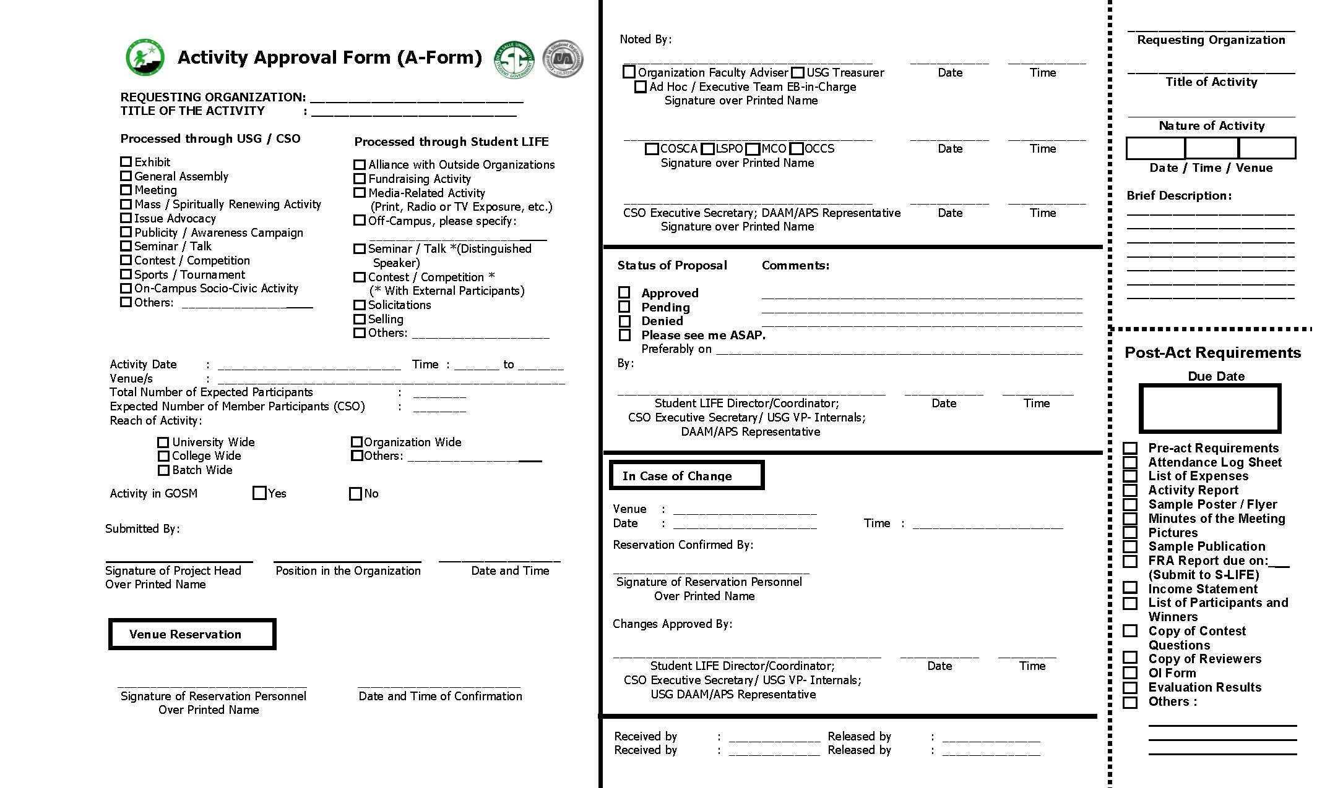

Memorandum of Agreement (MOA)

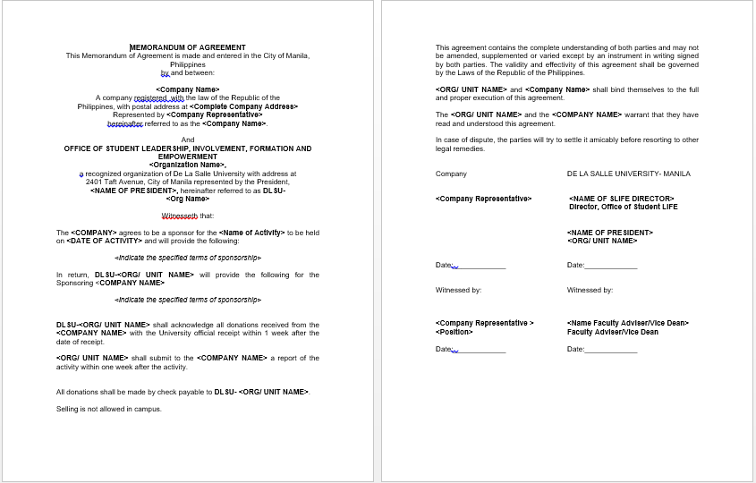

Project Proposal Form (PPR)

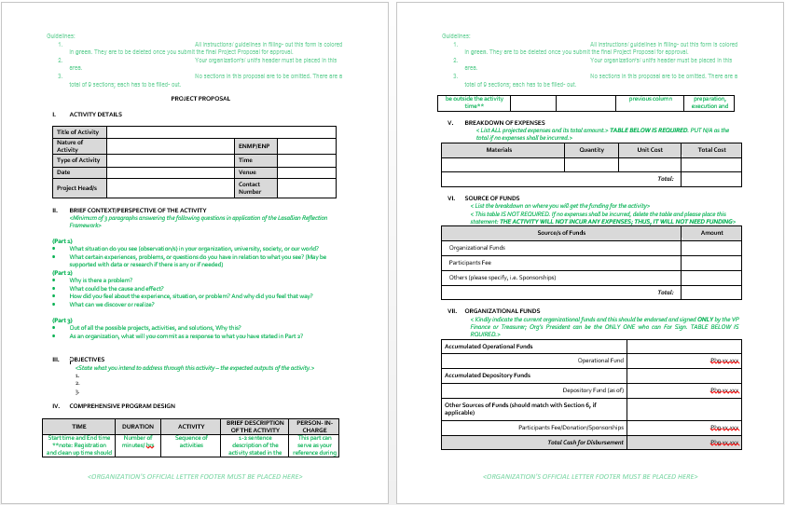

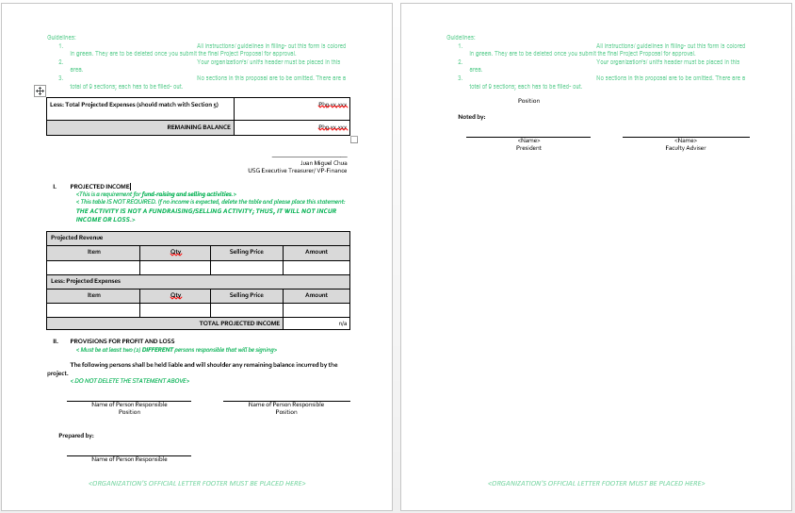

**Post-Activity Requirements**

Activity Report

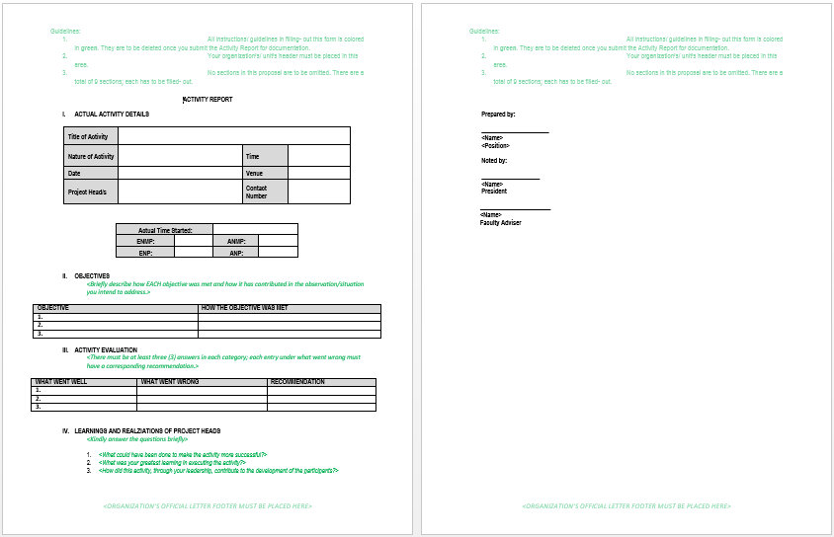

Fundraising Activity Report (FRA Report)

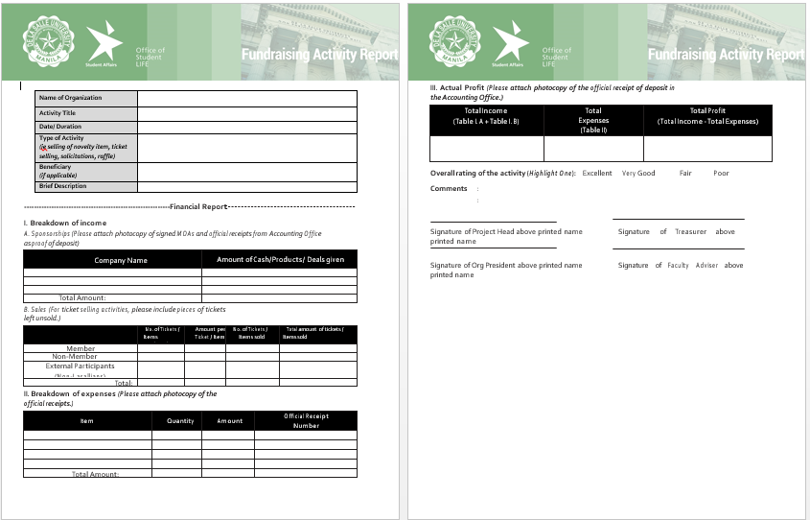

Media Activity Report

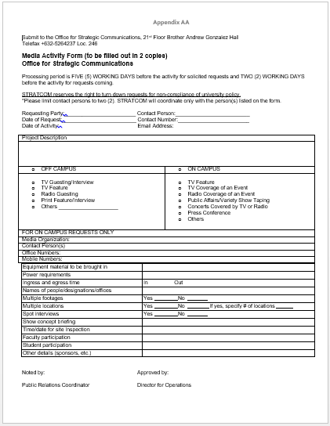

**Appendix D - References and Acknowledgment**

**References**

**Acknowledgment**

House of Megan would like to thank the CSG President, Miguel Torres, for taking a part of his busy schedule to accommodate us for interview. We would like to thank him for sharing with us all the relevant details regarding the organization and the processes inside and outside of it. And lastly, we would like to thank him for allowing us to help them by creating a software solution to the organization’s problems.