**MOBILE APP DEVELOPMENT**

**Scope of the work includes:**

* Creation of tracking for Point to Point Transportation
* Maintenance of stock data in warehouse
* Users’/Drivers’ Management and Job Allocation
* Report Generation
* Mobile App Development (Apple iOS)
  + Mobile App UI/UX Design
  + Functionality Support and Planning
  + Web Services Integration
  + SDK Integration & Support
  + Mobile App Development
  + Creation of Developer’s Account
  + Submission of App
* Mobile App Development (Google Android)
  + Mobile App UI/UX Design
  + Functionality Support and Planning
  + Web Services Integration
  + SDK Integration & Support
  + Mobile App Development
  + Creation of Developer’s Account
  + Submission of App
* Backend System Development
  + Backend System UI/UX Design
  + System Design
  + Infrastructure Design & Setup
  + Database Design & Setup
  + Web Services System Design & Setup
  + Backend System Design & Setup
* User Acceptance Test
* Production Acceptance Test

*Estimated time-frame:*  
70 man days / 20-25 calendar days

**CLOUD SERVER**

**WHAT IS CLOUD SERVER PLESK?**

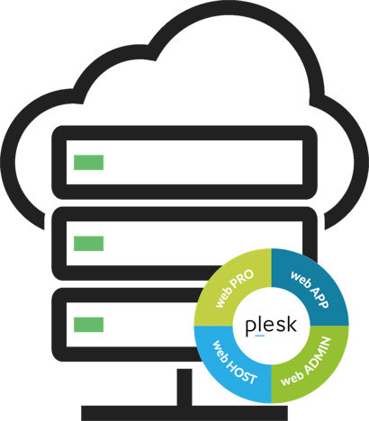

Plesk is the leading WebOps platform to run, automate and grow web applications and websites. Available in more than 32 languages across 140 countries in the world. Plesk is managing and securing more than 300,000 servers and automating over 10 Million websites. Besides simplifying complexity and saving time through automation for developers and sysadmins, Plesk increases the efforts to enable you to extend and customize Plesk as an open platform. The rich and open ecosystem over 50 Plesk extensions provide access to even more relevant features targeted at specific user cases.

Plesk can be deploy and run Plesk in minutes and available to run on high-performance servers and high-availability cluster. Connect multiple Plesk servers together at various geographical locations allows you to extend to localised customers or users with speed and reliability.

Specification:

* Server Software: Plesk Onxy Web Pro
* 2 Core Processor
* 2GB RAM Memory
* 40GB Hard disk SSD with HA
* 3000GB Bandwidth Transfer
* Singapore Datacentre

Estimated Cost: S$60.00 monthly

One time Setup Cost: S$300.00

This is the recommended server size for a new deployment. Specification may change as load or requirements changes.

**MOBILE APP DEVELOPER ACCOUNT**

Publishing is the general process that makes your mobile applications available to users. When you publish an application you perform two main tasks:

* You prepare the application for release.  
    
  During the preparation step you build a release version of your application, which users can download and install on their Android-powered devices.
* You release the application to users.  
  During the release step you publicize, sell, and distribute the release version of your application to users.

Usually, you release your application through an application marketplace, such as Apple AppStore or Google Play. You will need to have a developer account with these established marketplace

**Cost of developer account:**

**Apple Developer Program**

If you’re an individual or sole proprietor/single person business interested in creating apps for distribution on the App Store for iPhone, iPad, Mac, and Apple Watch, enroll in the Apple Developer Program. Membership includes access to beta OS releases, advanced app capabilities, and tools to develop, test, and distribute apps and Safari extensions. Developers enrolled as individuals will sell apps on the App Store using their personal name.

**99 USD per membership year  
200 SGD Setup Cost**

**Google Play Developer Account**

In order to publish apps to the Google Play market, you must sign up as a Google Play developer.

**23 USD one time payment  
200 SGD Setup Cost**

**MAINTENANCE**

Client shall have the option to engage the maintenance support yearly.

Scope for maintenance:

1. Bugs and issues arises from the current version of server OS and codes deployed during the period of development.
2. Provide bug fixes for existing features based on bug report. Excel file for issue list to be maintained.
3. Provide counter measure for security issues reported
4. Support investigation of issues suspected to be related to the implementation provided
5. Provided logging data that is not accessible by client directly for investigation

**Maintenance SLA requirement**

1. Bug tracking shall be tracked via an excel document based on issue reports from client through email.
2. Planning on the resolution of the issue will be updated within 2 working days
3. High impact issues on business will be resolved or provided with temporary fix within 3 working days

Feature request and change request

|  |  |
| --- | --- |
| Maintenance support provided after project roll-out  Maintenance support per year | **2 months**  **S$12800/year** |

**Feature request and change request is not included in the maintenance package.**

Feature request and change request

|  |  |
| --- | --- |
| For work that requires up to 10 man days:  For work that requires more than 10 man days | **S$800/man days**  **S$500/man days** |