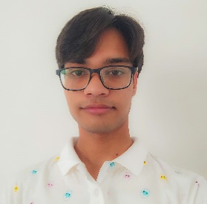

Registration Number: 21BCE10922

Email: [garvit.jain2021@vitbhopal.ac.in](mailto:garvit.jain2021@vitbhopal.ac.in)

Phone Number: 7037971974

LinkedIn: [LinkedIn](linkedin.com/in/%20garvit-jain-74856b246)

GitHub: [GitHub](https://github.com/megarvit)

**Garvit Jain**

**Skills:** DSA, C++, Java, Python, HTML/CSS, JavaScript, SQL

|  |  |  |  |
| --- | --- | --- | --- |
| **EDUCATION** | | | |
| **Board** | **Tenure** | **Educational institution** | **CGPA/Percentage** |
| B. Tech (CSE Core) | Expected May 2025 | VIT University, Bhopal | 9.2/10 |
| Class XII | Jul 2020 | Air Force School, Agra | 92% |
| Class X | Jul 2018 | Air Force School, Agra | 88% |

|  |  |
| --- | --- |
| PROJECTS | |
| Back End | * **Facial Attendance System** (Sept 2022)   + Description: It stores person’s face in the database. Upon next entry, if it recognizes the face, it will note down the date and time and can update the attendance status of that person.   + Technology: Python, OpenCV, Face Recognition   + Team Project: 5 members   + Role: Python Programmer   -Link: <https://github.com/megarvit/Facial-Attendance-System> |

|  |  |
| --- | --- |
| CO-CURRICULARS | |
| Coding | * LeetCode- DSA * Oracle- SQL/MYSQL |

|  |  |
| --- | --- |
| EXTRA-CURRICULARS | |
| Extracurricular | * First Place, Chess (Inter-School Championship) * Runner up, Taekwondo (Moon Olympics) * First Place, Group Dance and Best Troop (NCC CATC- Combined Annual Training Camp) |

|  |  |
| --- | --- |
| ADDITIONAL INFORMATION | |
| Hobbies | * Photoshop, Logo and Content Designing – member, CrazyVITians Graphic Team (Dec 2021) * Playing Games – participated in VIT Bhopal’s Gamers Arena (Apr 2022) |
| Languages | * Fluent in Hindi, English |