Solar-Powered Rover
  - Margaret Burkes (EE), Bowen Williamson (EE), Kenny Bui (EE), William Mancuso (EE), Keldon Ngo (EE)
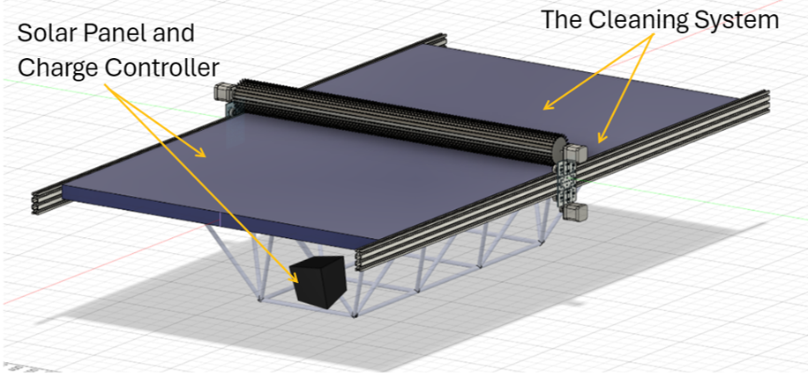

Abstract
The team has developed a testing and validation plan to ensure the criteria set out by our sponsor were met. To confirm conversion of solar energy to power for the rover, several tests will be conducted to measure the power production in sunny, cloudy, and indoor conditions using a solar panel tester/multimeter. Autonomous power switching will be evaluated through two tests: one that ensures the battery is charging while the rover is stationary and one that times the battery life during normal operation to compare it to the previous team’s results. The effectiveness of the cleaning system will be validated through comparing the power output before and after the cleaning system is activated, where flour will be simulating debris. The activation of the cleaning system will be tested using varying levels of flour in different environmental conditions to test for false-positive triggers. The compatibility with the existing design will be assessed by replicating the terrain test that the previous team conducted and comparing results. To evaluate its portability, an assembly test, where disassembly/assembly time will be recorded, will verify its functionality. From an environmental perspective, our design should decrease the power required from the grid when charging the battery, be emission free, test with biodegradable material, and refrain from harmful chemicals. Our team prioritizes safety, as well, by wearing the proper PPE when testing and manufacturing, grounded electrical connections, and incorporating fuses, a cancel button for the cleaning system, a buzzer alarm, and a kill switch for the rover.
Table of Contents
Abstract 1
Engineering Specification Summary 5
Objective Statement 5
Functional Requirements 5
Qualitative Constraints 5
Measurable Engineering Specifications 6
Testing and Validation Plan 6
Testing & Validation Plan for Function F#1 - Convert Solar Energy to Power the Rover 6
Objective and Rationale - F# 6
Brief Description - F# 6
Data Acquisition and Analysis – F# 6
Testing and Validation Results – F# 6
Testing & Validation Plan for Function F#2 – Autonomous Power Switching 7
Objective and Rationale - F#2 7
Brief Description - F#2 7
Data Acquisition and Analysis – F#2 8
Testing and Validation Results – F#2 8
Testing & Validation Plan for Function F#3 – Clean the Solar Panel 8
Objective and Rationale - F#3 8
Brief Description - F#3 8
Data Acquisition and Analysis – F#3 9
Testing and Validation Results – F#3 9
Testing & Validation Plan for Qualitative Constraint Q#1 – Compatibility with Existing Design 11
Objective and Rationale - Q#1 11
Brief Description - Q#1 11
Data Acquisition and Analysis – Q#1 11
Testing and Validation Results – Q#1 11
Testing & Validation Plan for Qualitative Constraint Q#2- Weather Proof Design 12
Objective and Rationale - Q#2 12
Brief Description - Q#2 12
Data Acquisition and Analysis – Q# 12
Testing and Validation Results – Q#2 12
Testing & Validation Plan for Qualitative Constraint Q#3- Portability 12
Objective and Rationale - Q#3 12
Brief Description - Q#3 12
Data Acquisition and Analysis – Q#3 12
Testing and Validation Results – Q#3 13
Testing & Validation Plan for Quantitative Constraint M#1 - Budget 13
Objective and Rationale - M#1 13
Brief Description - M#1 13
Data Acquisition and Analysis – M#1 13
Testing and Validation Results – M#1 13
Testing & Validation Plan for Quantitative Constraint M#2 - Name 13
Objective and Rationale - M# 13
Brief Description - M# 13
Data Acquisition and Analysis – M# 14
Testing and Validation Results – M# 14
Testing & Validation Plan for Quantitative Constraint M#3 - Name 14
Objective and Rationale - M# 14
Brief Description - M# 14
Data Acquisition and Analysis – M# 14
Testing and Validation Results – M# 15
Project Management 15
Schedule and Milestones 15
Budget 18
Safety Assessment 18
Manufacturing, Assembly and Testing Related Safety 18
Operation/Usage Related Safety 19
Environmental Impact Assessment 19
Manufacturing Related Environmental Impact 19
Operation/Usage Related Environmental Impact 19
End-Of-Life (Disposal) Related Environmental Impact 19
Appendix 20
Testing and Validation Plan Details 20
Testing & Validation Plan Details for Function F#1 - Function Name 20
Testing & Validation Plan Details for Function F#2 – Autonomous Power Switching 20
Testing & Validation Plan Details for Function F#3 – Clean the Solar Panel 21
Testing & Validation Plan Details for Qualitative Constraint Q#1 – Compatibility with Existing Design 22
Testing & Validation Plan Details for Qualitative Constraint Q#2 -Weather Proof Design 23
Testing & Validation Plan Details for Qualitative Constraint Q#3 – Portability 23
Testing & Validation Plan Details for Quantitative Constraint M#1 -Budget 24
Testing & Validation Plan Details for Quantitative Constraint M#2 -Name 24
Testing & Validation Plan Details for Quantitative Constraint M#3 -Name 25
Project Management Supplement 25
Schedule and Milestones Details 25
Budget Details 25
Reference Materials 26
Codes and Standards 26
References and Bibliography 26

Engineering Specification Summary

Objective Statement
The main objective of this project is enhancing the previously built rover, which is battery powered, by integrating solar power, autonomous power switching between solar and battery power, and an independent cleaning system for the solar panel.

Functional Requirements
Table III-1: Required Functions
# | Function | Type(s) of test(s)
F1 | Convert solar energy to power the rover. | An ideal (sunny), non-ideal (cloudy), and an indoor power production test to assess how much power is being generated in various environmental conditions.
F2 | Autonomously switch power between power sources. | A battery charging test to see if the solar power is sufficient to charge the battery when LOUIS is stationary. A battery operation test to see if the battery life is extended during normal operation due to the addition of the solar panel.
F3 | Clean the solar panels. | An effectiveness test to see how power generation is affected before and after cleaning, and an activation test to see if the cleaning system is activated only when it must be.
The above functions were chosen based on the demands of the sponsor.

Qualitative Constraints
Table III-2: Required Qualitative Constraints
# | Qualitative Constraint | Type(s) of test(s)
Q1 | Compatibility with Existing Design | Speed Test on an incline hill to see how the existing weight added affects the speed of the rover. These results will be compared to the previous teams incline speed test with 36kg of added weight
Q2 | Weatherproof Design | The group will be coating the electronics in a water-proof spray that we are safely assuming will protect the components rather than risk the components by testing them.
Q3 | Portability | The portability test was conducted by last year’s team, showing that it could be carried by 2 people. To retain this portability, the group plans to time, the assembly and disassembly of the added components.

Measurable Engineering Specifications
Table III3: Required Quantitative Constraints
# | Name | Symbol | Units | Value(s) | Type(s) of test(s)
M1 | Budget | B | $ | 4000 | Running total of expenses
M2 | Interior Space | S | M^3 | 0.977 | Measurements of added components
M3 | Weight Limit | W | Kg | <36.3 | Weighing of added components

Testing and Validation Plan

Testing & Validation Plan for Function F#1 - Convert Solar Energy to Power the Rover

Objective and Rationale - F#1
The main objective was for LOUIS to operate only using solar energy at some points depending on the amount of solar energy available at that time. To meet this requirement, we will be conducting a few solar energy tests to determine the power output at various times of day under different conditions. Such as 1) ideal - sunny day; 2) non-ideal- cloudy day; 3) artificial- indoor

Brief Description - F#1
The initial test will be an ideal conditions test in which the panel is placed outside during a sunny day with no cloud cover and the power output is to the measured via a solar panel tester. The same will be done on a day with light to heavy cloud cover as the reflection of sunlight through the clouds hinders solar irradiation. The final test will be an indoor test standard room lights to see if any power is produced while in storage.

Data Acquisition and Analysis – F#1
The data collected will be the current, voltage, and power produced under the previously mentioned conditions. These will then be compared to the required current, voltage, and power needed for the rover to operate.

Testing and Validation Results – F#1
N/A

Testing & Validation Plan for Function F#2 – Autonomous Power Switching

Objective and Rationale - F#2
For this function, testing will be done in the near future for the autonomous switching between the two on-board power sources for the rover, the battery and the solar panel. To confirm this aspect of functionality, two different tests will be conducted.
The first test is a simple one, confirming that the solar panel and solar charge controller we have chosen are capable of charging the battery when the rover is stationary. This is essential to verify before we proceed with our second phase of testing.
The second test will be focusing on the coordination between the battery and charge controller, ensuring that we are achieving autonomous power switching. The goal is to see that the majority of the current going to the load of the rover (motors and other electronic components) is being supplied by the solar panel. Thus, we expect to see significantly less current draw on the battery.

Brief Description - F#2
The first test will confirm that the battery is being charged by the solar panel when there is not significant load drawing current from the solar panel. The battery of the rover has intelligence and Bluetooth capabilities, so the state of charge will be monitored through use of the mobile app for the battery.
During the second test, the main concern will be the amount of current flowing in different parts of the system. The current supplied by the battery when the rover is in motion will be compared to the current supplied by the solar panel/charge controller. During times of bright sunlight, most of the current should be supplied by the solar power system. When less sunlight is available, the battery should make up the difference, increasing the current draw on the battery. This shift in the supply of current is what we are looking for to confirm autonomous power switching.

Data Acquisition and Analysis – F#2
As previously mentioned, the only data being gathered for the first test will be the state of charge of the battery over time. This data will be gathered using real time measurements from the mobile app that connects to the battery. Although we expect the battery to be charged slower than when it is connected to 120Vac with its dedicated charger, the battery state of charge should increase while there is ample solar radiation available for the solar panel.
The data for the second test will be current measurements of different wired connections throughout the power system. This will be accomplished through the use of a clamp-on multimeter, which is capable of measuring DC current. While a load is being supplied, such as the motors for movement of the rover, the current draw of the battery can be measured by the multimeter as well as the mobile app. Immediately following this measurement, the current supplied by the solar charge controller will be measured in the same manner with the same multimeter. The comparison of these two sets of data, as previously described, will confirm that we have achieved the functional requirement of autonomous power switching.

Testing and Validation Results – F#2
N/A

Testing & Validation Plan for Function F#3 – Clean the Solar Panel

Objective and Rationale - F#3
The goals are to ensure that the cleaning system: activates when triggered by a dirty solar panel and effectively removes debris from the solar panel with the goal of restoring the optimal power output given the weather conditions. To attain this goal, we will be conducting the following tests: 1) Activation Test: confirms that the cleaning system actuates properly 2) Effectiveness Test: analyzes the system’s ability to restore power generation after cleaning.

Brief Description - F#3
Test 1: Activation Test
The procedure is as follows: first, wire the pre-designed circuit to represent the brush cleaning system. Attach the circuit to the voltage source and connect the Arduino to its software on my computer. Begin the test by clicking the start button which represents the signal delivered from a dirty solar panel. Use a recording device to monitor how the cleaning system works and take note of the software for responses from the Arduino. Use the recording and the responses to fine tune the cleaning system code.
Test 2: Effectiveness test
The procedure is as follows: using a solar panel tester/multimeter, measure the power output of a clean solar panel at peak sunlight hours to ensure optimal conditions. This will be the base measurement for comparison purposes. Apply a measured amount of flour evenly across the panel and record power generation at varying levels of obstruction. Activate the cleaning system and re-measure power generation. Compare the power generation from before to after cleaning to assess effectiveness.

Data Acquisition and Analysis – F#3
Test 1: Activation Test
For the Activation test, I will be using a recording device to keep track and archive how the cleaning system reacts after tests. Using these recordings and notes, I can make adjustments to the cleaning system code and fine tune the cleaning system until it runs seamlessly.
Test 2: Effectiveness Test
For the effectiveness test, we will obtain data via the solar power tester or a multimeter. These devices will let us know the voltage and current so that we can calculate the power via the following equation: P=VI. We will analyze the results using the following equation:
$η_{cleaning}=\frac{P_{after}-P_{before}}{P_{before}} ×100\%$. We will use this equation to compare power output before and after cleaning, from when it was dirty to when it got cleaned, as well as the “cleaned” panel against the original clean panel’s performance. The performance ratio was also calculated by dividing the measured power by the rated power of 450W.

Testing and Validation Results – F#3
Test 1: Activation Test
I have currently run one test for the activation system, and learned that I need to make adjustments to the code for the cancel button feature when the motor has not reached the destination limit switch yet. I also need to make corrections to the speed that the motor is rotating; this will help with the cleaning efficiency.
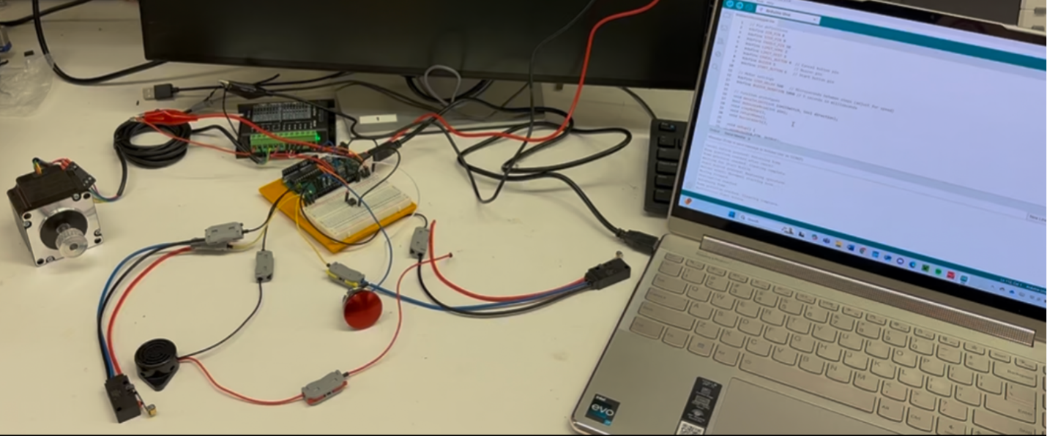
Table XII-2: Test Result Data Table
Test 2: Effectiveness Test Results:
To see the results that we have conducted so far, please refer to the appendix.

Testing & Validation Plan for Qualitative Constraint Q#1 – Compatibility with Existing Design

Objective and Rationale - Q#1
The objective of this test is to repeat the incline speed test from last year to see how compatible the additional load is with the existing design.

Brief Description - Q#1
This test was originally conducted with 36 kg of additional weight so we would like to see how much extra weight we are adding and is it drastically changes the results.

Data Acquisition and Analysis – Q#1
The test will be conducted on the levee and will use a tape measure and camera to track the exact distance and time to get the speed of the rover on the hill with the new weight. This will be compared to the speed calculated by last year’s group to determine compatibility.

Testing and Validation Results – Q#1
This hasn’t been conducted; however, the results the group are expecting is similar to what the previous test recorded. This can be further validated by the approximate weight of the added components which are estimated to be about 30kg-40kg.
Table XII-2: Test Result Data Table N/A

Testing & Validation Plan for Qualitative Constraint Q#2- Weather Proof Design

Objective and Rationale - Q#2
This was devised to protect the components from the Louisiana elements, even with the additional cover from the solar panel.

Brief Description - Q#2
This has no test to be conducted, but rather a constraint to protect the equipment.

Data Acquisition and Analysis – Q#2
To protect the equipment, we will make an assumption that the spray can be trusted to waterproof the electrical components from the elements.

Testing and Validation Results – Q#2
No Test Required.
Table XII-2: Test Result Data Table N/A

Testing & Validation Plan for Qualitative Constraint Q#3- Portability

Objective and Rationale - Q#3
The objective of this test is to demonstrate the ease of portability using two people even with the new additions.

Brief Description - Q#3
This test was performed by last year’s team and proved the rover could be carried by two people. We will attempt retain this by timing assembly and disassembly. This is because the new additions remove the existing portability

Data Acquisition and Analysis – Q#3
The data we are looking for here is timing the assembly and disassembly of the additional components. This will return the rover to a portable state.

Testing and Validation Results – Q#3
This test will be conducted when the rover is fully assembled, however we can expect this assembly disassembly to take around 7-8 minutes each.

Testing & Validation Plan for Quantitative Constraint M#1 - Budget

Objective and Rationale - M#1
Because the project has been given a strict budget, we must ensure that we can deliver the desired results within the budget given by our sponsor. We had the opportunity to increase the budget a few months ago, however we deemed it unnecessary and decided to move forward with the original budget.

Brief Description - M#1
We have been given $4000 with which to complete the project. This includes any and all purchases for the project, such as components, labor for work hired out such as work orders for the machine shop, and any tools that we do not already have access to that we need for manufacturing the project. The team must accurately keep track of the amount of money spent so as not to run out of funding before the project reaches completion.

Data Acquisition and Analysis – M#1
A master list of all purchases made by the team has been compiled and is consistently updated with each purchase or return. This spreadsheet includes the cost of items, quantity, delivery dates, and links to each individual item online.

Testing and Validation Results – M#1
Although this constraint can only be finally validated at the end of the project, the team can guarantee that the project will be delivered well under the $4000 limit. At the time of this writing, the cost of the project has not exceeded $1800, less than half of the budget.

Testing & Validation Plan for Quantitative Constraint M#2 - Name

Objective and Rationale - M#
Kenny Bui, fill out this entire thing

Brief Description - M#

Data Acquisition and Analysis – M#

Testing and Validation Results – M#
Table XII-2: Test Result Data Table
Column 1 Title | Column 2 Title


Figure XII-1: Test Results

Testing & Validation Plan for Quantitative Constraint M#3 - Weight

Objective and Rationale - M#3
Due to the weight limitation of the rover, we must consider the weight of all additions. The tested additional load of the rover was 36.3kg, so we would like to not exceed this weight when adding the solar power and power switching systems. Increasing the weight too much would hinder performance and structural integrity of the frame.

Brief Description - M#3
The previous team did not conduct a maximum weight test however we know that the rover was able to withstand 36.3kg of additional weight before suffering from additional power draw which we hope that the additional source of the solar panel will offset this.

Data Acquisition and Analysis – M#3
The weight of additional components has been considered when ordering and will conduct final weigh ins as through the manufacturing process some material has both been added and milled away. Such as the linear bars being cut to size. The final weight will be calculated after the initial assembly of the cleaning system.

Testing and Validation Results – M#3
The constraint can be validated throughout the manufacturing process. However, it was determined to be easier to assemble the cleaning system than adding the weight of the solar panel and the charge controller will be most efficient.

Project Management

Schedule and Milestones
During this semester, our most important milestones are the manufacturing and testing portions of our senior design process. During the manufacturing process we will be assembling and building the individual functional requirements that we have designed in the previous semester. For the testing phase, we will be placing these assembled functions under various test to ensure that they work the way we have planned and designed. These two milestones are very important to our team because without our manufacturing and testing phases, our team would not be able to produce a usable product that works correctly to our sponsor. All items listed on our Gantt Chart are critical because they all work together to fulfill our functional requirements and each part is needed to make functions perform properly. However, items like the pyranometer and the cleaning system can be identified as critical failure points because these may have a higher likelihood to need adjustments or finetuning. The pyranometer needs to be setup to be compared to the power output of our solar panel so we need to make sure that it is setup accurately. The cleaning system as a whole, needs to be physically set and adjusted if there are alignment issues. These two items were set as critical failure points due to their sensitivity in the project.

Figure IX-1: Gantt Chart for Testing and Validation with Project Time-Line

Budget
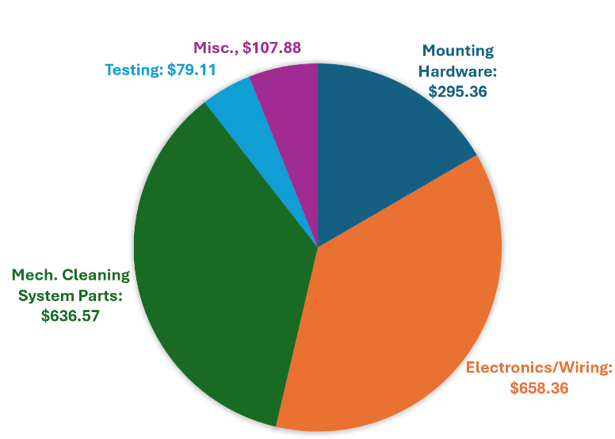
The chart above shows the current budget for the project. More details will be included in the Budget Details.

Safety Assessment

Manufacturing, Assembly and Testing Related Safety
For safety during manufacturing, assembly, and testing, we are planning to utilize all the safety considerations from operating the rover, but we also have additional safety considerations. For manufacturing and assembly, our group will be in a workshop, so making sure that we acknowledge proper workshop safety is essential. For example, proper PPE for our tasks as well as making sure to be aware of our surroundings are essential safety considerations that we should have. Our team has already completed a safety tour for the AMMF lab. We have also purchased properly rated measuring equipment for testing the solar power output. With these safety considerations in mind, our safety during manufacturing, assembly, and testing should be fulfilled.

Operation/Usage Related Safety
For operation/usage safety the first concern is an electrical shock and arc flash hazard. To prevent this hazard, we have made sure that all of our electrical connections are grounded properly and that any bus bars are insulated to prevent a short across the terminals. We also implemented properly sized fuse connections to important electrical connections to prevent overcurrent damages. We were also concerned with the moving parts of the brush cleaning system causing a hazard, so we added a cancel button and a buzzer to create a system to stop the process of the cleaning system and add an auditory warning to those nearby. Lastly, in the case of emergencies, we have kill-switches on the battery terminals to completely de-energize the rover. These factors were thought out to ensure operational safety for our rover and systems

Environmental Impact Assessment

Manufacturing Related Environmental Impact
Our group is expecting to perform some welding and metal cutting during the mounting of our solar panel. Welding does cause an expected release of some gas emissions to the atmosphere and also consumes a reasonable amount of energy. The cutting of metal also consumes an amount of energy; however, any remaining spare metal can be reused in the LSU machine shop as scrap metal. When it comes to wiring our electronics, we plan on stripping wires which may result in a very small amount of rubber being put to waste. These are the main manufacturing related environmental impactors from our project. Even though our manufacturing does result in some emissions, by-products, and waste, the amount is so small-scale that the overall negative impact to our environment is insignificant.

Operation/Usage Related Environmental Impact
It is expected that the addition of solar power to the rover will increase the intervals between charging the onboard battery, decreasing the total energy required from a utility company for charging during the life of the battery. The main advertised advantage for using solar power is that you will not have to consume as much power from the grid. There should not be any negative environmental impacts from the operation of the solar power system.

End-Of-Life (Disposal) Related Environmental Impact
The motors and electronics we use for the self-cleaning system should be recycled at their end-of-life, as they can be reused in the manufacturing of new devices. The solar panel should also be recycled once it becomes obsolete or no longer produces sufficient power. Solar panels contain heavy metals such as cadmium and lead, which will become hazardous materials if a solar panel is simply thrown away in a landfill. Recycling can also repurpose the rare elements used in photovoltaic cells such as gallium and indium, which could be used in the production of new solar panels.

Appendix

Testing and Validation Plan Details

Testing & Validation Plan Details for Function F#1 - Convert Solar Energy to Power the Rover

Test Protocol Description - F#1
The first test will have the solar panel lying flat on a sunny day as this will also be the position the panel will be when mounted the current, voltage and power will all be measured then.
The second test will again have the solar panel lying flat however the light to heavy cloud cover will hinder power production once again the current, voltage, and power will be measured. The final test will include the solar panel lying flat inside a well-lit room this will provide the best simulation to storage.

Equipment and Instrumentation - F#1
For all the test all that will be required is a solar panel and a solar panel tester. For the artificial lighting test, the only addition would be a well-lit room

Data Analysis Details – F#1
The data analysis will be done using the previous teams' calculations of power draw. the power draw of the entire cleaning system will be considered independently as the rover is planned to not move during the cleaning process

Results Details – F#1
N/A

Testing & Validation Plan Details for Function F#2 – Autonomous Power Switching

Test Protocol Description - F#2
For the first test, the charge of the battery will be tracked using live data from the battery’s mobile app. It is preferred that this test be conducted on a clear sunny day for optimal power production. The rover will be powered on, but no movement will be initiated by the controller and the rover will remain stationary for the duration of this test. Thirty minutes to one hour should be enough time to gather data on how quickly the solar panel is capable of charging the battery with no additional load.
The rover will be in motion/under load for the second test. We can walk alongside the rover as it drives forward, measuring current flowing through the power wires. Current will be measured flowing from the battery, and immediately after this measurement we will also measure current flowing from the charge controller. The same as the first test, the preference is that this test be conducted in bright, sunny conditions to get best-case-scenario measurements.

Equipment and Instrumentation - F#2
For the first test, all that is required is a mobile device to connect to the battery via Bluetooth. As for the second test, this requires the use of a clamp-on multimeter capable of DC current measurement. Both tests require the use of a notebook or electronic device to record the results.

Data Analysis Details – F#2
The data analysis for both tests is relatively simple, as we are just measuring battery state of charge and current. The first test will reveal to us how quickly the solar panel is capable of charging the battery, which will make for an interesting comparison to the regular battery charger that plugs into an electrical outlet. The current measurements of the second test will show us how much the solar power is diverting to the load rather than charging the battery. So, rather than the solar power charging the battery and then the battery powering the rover, the power from the solar panel will be going directly to the rest of the rover as needed.

Results Details – F#2
N/A

Testing & Validation Plan Details for Function F#3 – Clean the Solar Panel

Test Protocol Description - F#3
Test 1: Activation Test
Kenny Bui
Test 2: Effectiveness Test
Here are the following detailed steps for testing:
- Ensure the panel is completely clean by using a microfiber cloth.
- Measure its initial power output multiple times.
- Evenly apply 312 grams of flour across the panel. This is to simulate debris such as dust and pollen.
- Measure the power output, using a solar panel tester/multimeter, every 5 minutes until a stable value is found.
- Activate the cleaning system and allow it to run.
- Re-measure the power output and compare the results with the original clean panel and the dirty panel before cleaning.
- Repeat this test for 1560 grams of flour.

Equipment and Instrumentation - F#3
Test 1: Activation Test
Kenny Bui
Test 2: Effectiveness Test
As stated previously, a solar panel tester or multimeter is sufficient to test the voltage and current output of the solar panel. Flour was also selected to simulate debris, such as dust and pollen. These will be the typical forms of debris, given the Louisiana environment. Flour is easily accessible, nonabrasive, similar in form to debris, and is environmentally friendly, as it decomposes and can fertilize soil. This will ensure a proper test without damaging the solar panel or the environment. For the varying levels of flour, 312 grams and 1560 grams were chosen for the following reasons. The 312 grams were found by multiplying the surface area of the solar panel (20,793.4 cm^2), the lower expected thickness of debris (0.1 mm), and the density of dust/pollen (roughly 1.5 g/cm^3). The 1560 grams were found by multiplying the surface area of the solar panel (20,793.4 cm^2), the higher expected thickness of debris (0.5 mm), and the density of dust/pollen (roughly 1.5 g/cm^3).

Data Analysis Details – F#3
Test 1: Activation Test
Kenny Bui
Test 2: Effectiveness Test
Power for a DC circuit can be found using P=VI. To compare power output before and after cleaning, from when it was dirty to when it got cleaned, as well as the “cleaned” panel against the original clean panel’s performance, the following equation will be used:
$η_{cleaning}=\frac{P_{after}-P_{before}}{P_{before}} ×100\%$. The performance ratio will also be calculated using the following formula: $Performance Ratio={Measured Power}/{Rated Power}$, where the rated power is 450W.
A higher efficiency, which will be a number closer to 1, is the goal. Having an efficiency of 70% or higher will be seen as sufficient.

Results Details – F#3
Test 1: Activation Test
Kenny Bui
Test 2: Effectiveness Test Results:
 | Voltage | Current | Power | Day | Time | Performance Ratio
Trial 1 | 60.31 V | 6.99A | 421.57 W | 2/25/25 | 11:33 AM | 93.68%
Trial 2 | 60.56 V | 7.06A | 427.55 W | 2/25/25 | 11:39 AM | 95.01%
The above results, so far, were conducted to measure the base of our comparison for before and after cleaning. These results have verified the proper functionality of the solar panel. The average performance is 94.35% of the rated power.
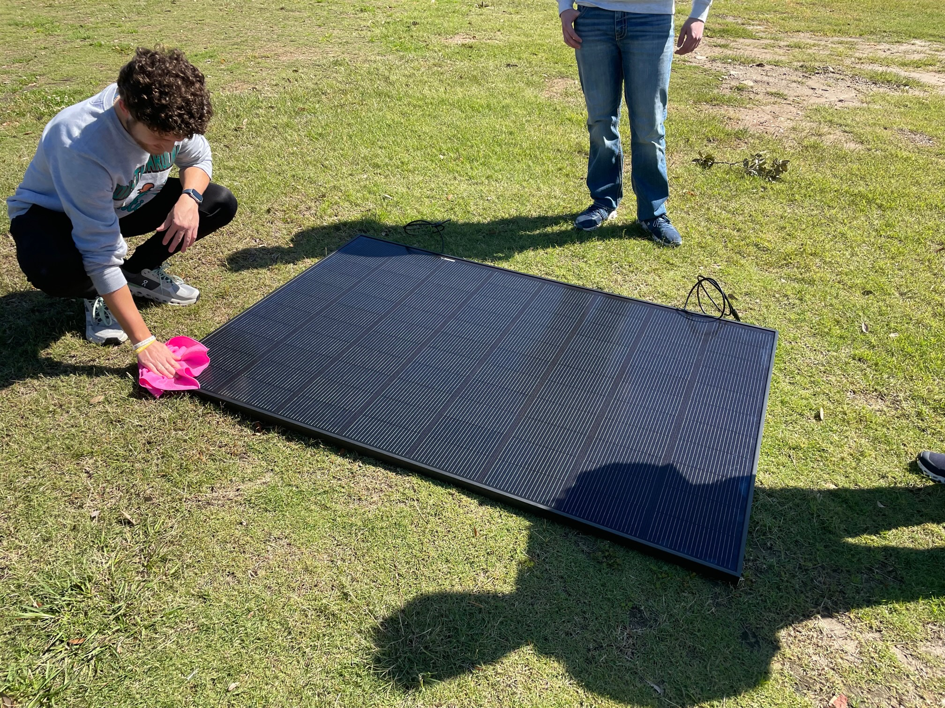
Figure XII-1: Prepping the Panel

Testing & Validation Plan Details for Qualitative Constraint Q#1 – Compatibility with Existing Design

Test Protocol Description - Q#1
For this test we will begin by transporting the rover to the levee, this will be done by loading it into a vehicle and driving it over. We will then set out a tape measure running up the levee to mark the exact distance traveled. Following this, one member will drive the rover up the levee, while two others work together to operate the timer and camera to capture the exact moment it crosses, giving us our speed.

Equipment and Instrumentation - Q#1
The equipment needed for this test will be as follows: An electronic device to connect to the rover to operate it (team members phone), tape measure, stopwatch, and a camera.

Data Analysis Details – Q#1
The data gathered from this test will be the distance traveled (d) in meters, and the time it takes to travel that distance (t) in seconds. The equation distance/time (d/t) will be used to calculate speed (S) in m/s. This data will then be compared to last year’s levee test to see how the additional weight effects the speed, and if the new additions a compatible with the existing design of the rover.

Results Details – Q#1
N/A

Testing & Validation Plan Details for Qualitative Constraint Q#2 -Weather Proof Design

Test Protocol Description - Q#2
A spray on coating is used to waterproof the electronics for the elements of Louisiana. To ensure the safety of the equipment no actual test will be performed. Rather the group has decided to make the assumption that the spray on coating for the electronics will protect it from the elements, rather than risk ruining the expensive electronics.

Equipment and Instrumentation - Q#2
Ducky Products spray on electro-seal

Data Analysis Details – Q#2
N/A

Results Details – Q#
N/A

Testing & Validation Plan Details for Qualitative Constraint Q#3 – Portability

Test Protocol Description - Q#3
The goal of this test is to prove that the rover can quickly and efficiently be returned to its previous portable state. The new additions were purposefully designed in such a way that they could be easily removed and reattached for transport. The goal of this test is to see how long that process takes, by timing the assembly and disassembly of the added components.

Equipment and Instrumentation - Q#3
First this test will require a wrench to undo the electrical straps on the underside of the frame. This test will require two people at least safely remove the solar panel from the rover. Once the PV and battery disconnect switches are used, the charge controller will require a screwdriver to remove the cover and disconnect the wires of the PV panel. The cleaning system wire will also need to be disconnected from the motor drivers and their bus bars, which will also require a screwdriver. Finally, this test will also require a stopwatch.

Data Analysis Details – Q#3
Since the new additions remove the portability of the rover, the data for this test will be to time how long it takes to make this rover portable and operational. Our only variable here is time (t) measured in seconds.

Results Details – Q#3
N/A

Testing & Validation Plan Details for Quantitative Constraint M#1 -Budget

Test Protocol Description - M#1
There will be no testing protocol for the budget, other than consistently monitoring spending to ensure a safe buffer for any last-minute or unaccounted-for purchases.

Equipment and Instrumentation - M#1
A lapKeltop and Excel spreadsheets are being used to keep track of purchases.

Data Analysis Details – M#1
The team must not only keep track of spending for the project’s sake but must also regularly update Shelby Scott on the spending thus far. The same spreadsheet used by the team is shared with Shelby so that she can also accurately track the team’s budget.

Results Details – M#1
N/A

Testing & Validation Plan Details for Quantitative Constraint M#2 -Name
Kenny Bui

Test Protocol Description - M#

Equipment and Instrumentation - M#

Data Analysis Details – M#

Results Details – M#

Testing & Validation Plan Details for Quantitative Constraint M#3 -Weight

Test Protocol Description - M#3
There is no testing protocol for the weight other than considering the initial weight of all additional components.

Equipment and Instrumentation - M#3
A large scale and all components to be weighed.

Data Analysis Details – M#3
The team will be constantly updated on the changing weight as throughout the manufacturing process most components have gotten lighter.

Results Details – M#3
N/A

Project Management Supplement

Schedule and Milestones Details
During the course of this semester’s Senior Design, our group has realized that manufacturing and testing time management is realistically sporadic. Hiccups during manufacturing and the results of certain tests may alter the predicted time of completion for certain manufacturing as well as testing which can be seen in our updated version of our Gantt Chart shown below. As we progress in testing, we may also discover that we may need to conduct new test, for example, a new test that Margaret will be conducting is for the efficiency of our cleaning system on the rover. At this current time, our group believes that we are a little behind when it comes to testing, but we are expecting to continue our testing plans in a timelier matter.

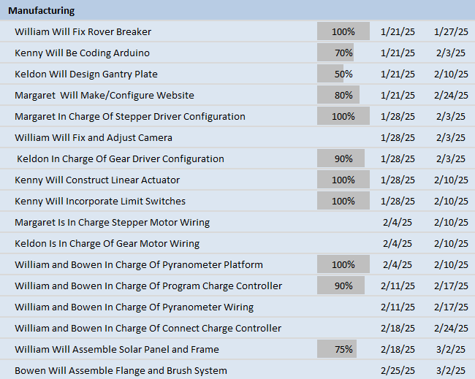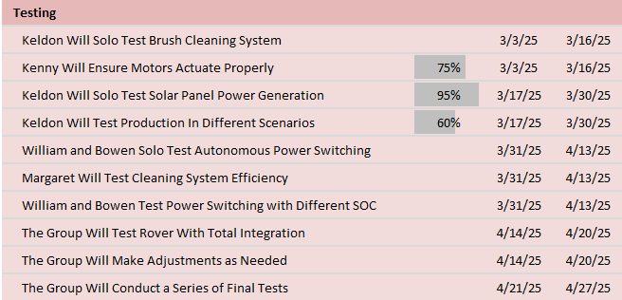

Budget Details
The total spending of the project as of right now stands at $1777.28. This leaves the team with over half of the given budget remaining. The team is very comfortable with the budget at the moment, as there is plenty of room for any unexpected expenses. $658.36 has been spent on electronic components and wiring, such as fuses, limit switches, and motors. $636.57 was spent on mechanical parts for the cleaning system such as the brush, linear actuators, and gantry plates for mounting the rotational motor. $295.36 was spent on mounting hardware for the solar panel, including extra railing from OpenBuilds similar to the linear actuators, t-track nuts which slide down slots in the rails, and conduit straps for securing the rails to the frame of the rover. $79.11 has been spent on testing, such as flour to simulate a dirty solar panel and a multimeter to measure current/voltage. Finally, $107.88 was spent on miscellaneous purchases, like microfiber cloths for cleaning the panel and QR code keychains that when scanned will take you to a website containing information on the project.

Reference Materials

Codes and Standards
The following codes will be considered in the design and execution process:
- NEC: This lays out the proper sizing of wiring and overcurrent protection, grounding, disconnects, proper labeling of equipment, and solar photovoltaic systems designs and considerations.
- UL 9540A: This highlights different ways to test to protect against thermal runaway risk.
- UL 1703/UL 61730: This describes PV module safety standards, including heat, cold, and humidity tolerance.
- UL 1742: This details how to safely integrate charge controllers into solar systems.
- EPA Guidelines: This details how to dispose of electrical components and restricts the use of lead, mercury, or cadmium for environmental safety.
- IEC 61508: This standard ensures that a given control system can detect faults and act appropriately.
- ISO 13849: This standard assesses the mechanical safety of the system with regards to emergency stops or other means of protecting the user and/or the rover.
- ISO 14120: This code shows how to ensure safeguards, like barriers, within mechanical systems for the safety of the user.
- IEC 61850: This code lays out communication protocols between intelligent electronic devices (IEDs) to ensure synchronization and reliability.

References and Bibliography
Keldon Ngo, Bowen Williamson, William Mancuso, and Kenny Bui

- Cohen.USA.Com. (n.d.). Electric Motor Recycling
https://www.cohenusa.com/recyclable-items/electric-motors
- “Free CAD Designs, Files & 3D Models: The Grabcad Community Library.” Free CAD Designs, Files & 3D Models | The GrabCAD Community Library, grabcad.com/library/c-beam-linear-actuator-1000mm-1. Accessed 14 Oct. 2024.

- Harbor.Aluminum.Com. (n.d). Aluminum Production & Manufacturing.
https://www.harboraluminum.com/en/aluminum-process

- IEEE Standards Association. IEEE Standards. Institute of Electrical and Electronics Engineers, standards.ieee.org.
- James, Kirsten. (July 19, 2024). The water challenge for semiconductor manufacturing: What needs to be done?
https://www.weforum.org/agenda/2024/07/the-water-challenge-for-semiconductor-manufacturing-and-big-tech-what-needs-to-be-done

- Marsh, Jacob. (March 1, 2023). Solar panel recycling: How does it work?
https://www.energysage.com/solar/recycling-solar-panels

- Myers, Justin. (December 9, 2022). Solar Panels and Their Effect on the Environment.
https://eponline.com/articles/2022/12/09/solar-panels-and-their-effect
- National Fire Protection Association. NFPA 70: National Electrical Code (NEC). 2020. NFPA, 21 Nov. 2022, www.nfpa.org/codes-and-standards/nfpa-70-standard-development/70.
- Posted by Tom Morton on undefined, et al. “V-Slot 20x20 Linear Rail.” OpenBuilds Part Store, openbuildspartstore.com/v-slot-20x20-linear-rail/. Accessed 14 Oct. 2024.
- “REC Group: Rec Alpha Pure-Rx Solar Panels.” REC Group | REC Alpha Pure-RX Solar Panels, www.recgroup.com/en-us/rec-alpha-pure-rx. Accessed 11 Dec. 2024.
- Underwriters Laboratories. UL Standards. UL Solutions, www.ul.com/offerings/standards.

