Pepper Pronunciation Tutor
System guide
Parts 1 and 2: how the system is built, and the data it collects
Parts 3 and 4 (the analysis, the interpretation) follow in later revisions of this document.
1 October 2026

Contents

Part 1
How the system is built, and how a session moves through it

1. What the system is for
The system runs a within-subject study of pronunciation feedback for Kenyan learners of English. A participant practises target words with the Pepper robot under two feedback conditions. In condition K the robot only re-models the word. In condition D the robot also says what it heard, names the sound to fix, and gives a cue. Production is measured before, after, and some weeks after training, with the robot silent on those occasions.
Everything described here exists to make three things true at once: the participant gets a fair verdict on what they said, the two conditions differ only in the feedback wording, and every number in the final analysis can be regenerated from the stored audio.

2. The parts
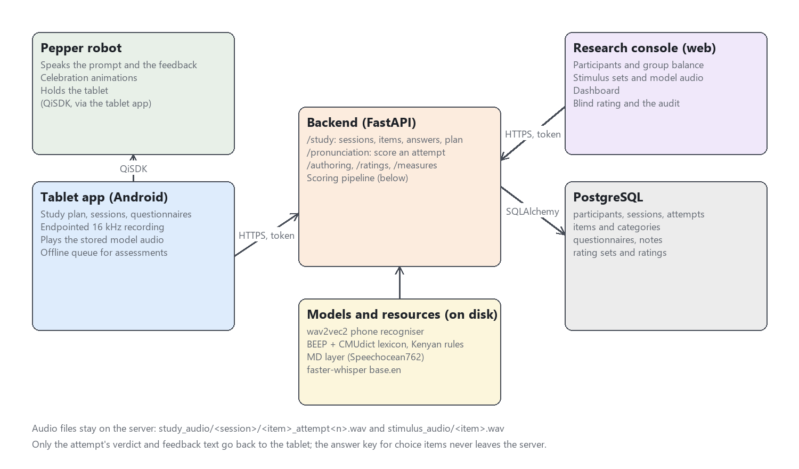
Figure 1. The five components and how they talk to each other.
Component | Technology | What it does
Tablet app | Android, Kotlin, Jetpack Compose, QiSDK | The participant's interface. Shows the item, records the attempt, plays the stored model audio, asks the questionnaires, and drives the robot through the QiSDK. Also runs standalone on a phone for testing, with the robot's speech skipped.
Pepper robot | SoftBank Pepper, NAOqi via QiSDK | Speaks the prompt and the feedback, performs the celebration, holds the tablet. It has no logic of its own; the tablet tells it what to say.
Backend | Python, FastAPI, SQLAlchemy | Owns every decision: which items a session gets, whether an attempt was correct, what the robot should say, who is in which group. Holds the scoring pipeline.
Research console | React, TypeScript, Material UI | The researcher's tool. Participants and group balance, stimulus sets with model audio, the dashboard, and the blind rating screen with its audit.
Database | PostgreSQL | Participants, sessions, attempts with their full scoring record, items, questionnaires, notes, ratings.

Where the audio lives. Every attempt's recording is kept on the server under study_audio/<session>/<item>_attempt<n>.wav, and every item's model recording under stimulus_audio/<item>.wav. The database stores the path, not the bytes. Nothing in the audio leaves the server except to a signed-in researcher or to a rater for a clip in a rating set whose participant consented to retention.
Who may do what. Accounts carry a role. A researcher reaches everything. A rater reaches only the rating screen. The tablet signs in as a researcher account. The one route open without a token is the model audio for an item, because the tablet's media player fetches it by bare URL.

3. A session, end to end
The sequence below is a training session. An assessment session is the same except that step 7 says a fixed acknowledgement instead of feedback and never offers a second attempt.
- Plan. On the tablet the researcher opens the participant's study plan. The backend reports which step is next (pre-test, block 1, block 2, post-test, delayed), from the participant's group and the sessions already completed.
- Start. The tablet posts the session. The backend stamps the session type, the condition (K or D), the block index and the word list, and draws the item order from a seed. None of that is chosen on the tablet.
- Items. The tablet fetches the session's items. Each comes with its exercise type and only the presentation it needs. For a choice item the correct answer is stripped out before sending, and the name is blanked, so the answer key never reaches the device.
- Prompt. The robot speaks the instruction. If the item has a stored model recording, that recording plays from the tablet and the robot does not say the word itself, so every participant hears the same model every time. The tablet notes when the prompt ended.
- Record. The tablet's recorder waits for speech, keeps a quarter second of pre-roll so the first consonant survives, and stops after a silence hangover sized to the item (longer for sentences). It notes when speech started and ended, and refuses only recordings that are silent or badly clipped.
- Score. The recording goes to the backend with the condition, the timestamps, the replay count, and whether the slow replay was used. The pipeline in section 4 produces a verdict, a graded score, and per-phone detail.
- Feedback. The backend composes what the robot says from the verdict and the condition. K hears a warmth marker and a re-model. D hears the same marker, then what the recogniser heard, the sound to fix, a cue, and the re-model. The text, the verdict and whether a retry follows all come from the server in one response.
- Retry or move on. A wrong first attempt in training gets one more try. A skip, with its reason, is recorded as a skip and never as an error. Choice items (minimal pair, syllable stress, schwa spot) are answered by tap and judged on the server; in D the correct answer is revealed after a wrong tap.
- Questionnaire and summary. After the last item the tablet asks the session questionnaire (Godspeed, intrinsic motivation and feedback trust items, seven-point, reversed items hidden), then shows a summary. In assessments the summary shows no scores.
- Complete. The tablet marks the session complete. If the network was down during an assessment, attempts were queued on the device and are uploaded now, with their original timestamps.

4. The scoring pipeline
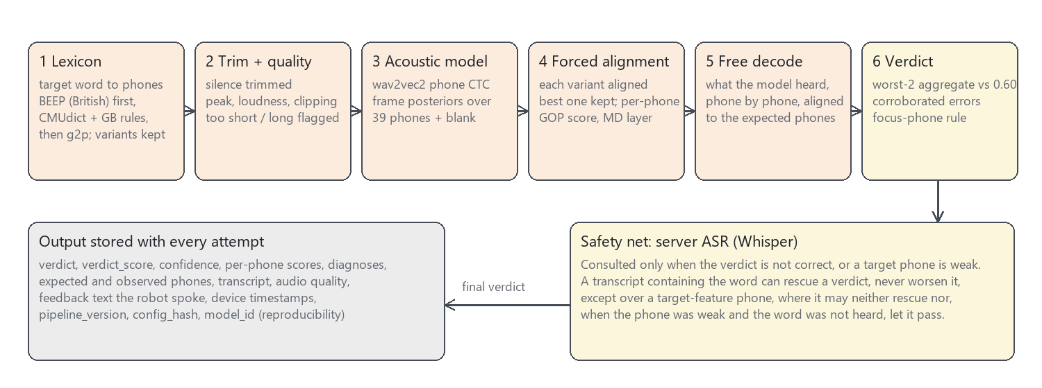
Figure 2. One attempt through the pipeline, and what is stored.

4.1 From the word to its phones
The target word is looked up in the BEEP British English dictionary first, then CMUdict with British adaptation rules, then a grapheme-to-phoneme model as a last resort. Every accepted pronunciation variant is kept, and the one that aligns best to the audio is the one scored. The source is recorded with the attempt, and a target that came from the g2p fallback is flagged for review.
A read-aloud item aligns the whole carrier sentence, with the carrier words as context, and judges only the target word. Before this was done every correctly read sentence was marked wrong, because the word alone was being aligned against three seconds of speech.

4.2 Acoustic scoring
The acoustic model is wav2vec2-large-robust fine-tuned for phone recognition on second-language English. It emits a probability over 39 phones for every 20 ms of audio. The expected phones are forced-aligned to those probabilities, and each phone gets a goodness-of-pronunciation score: how much more likely the expected phone was than the best competitor over its span.
A supervised layer on top, trained on the Speechocean762 corpus of rated second-language speech, turns the raw score into a calibrated 0 to 1 probability per phone. It is this calibrated score that the thresholds are set on. Its calibration is lenient on some vowel qualities, which matters in part 4.

4.3 The verdict
The verdict score is the mean of the two worst phone scores. The attempt is correct when that score is at least 0.60 and no phone is a corroborated error: a phone the free decode heard differently and the alignment scored below 0.45. Both signals must agree before a phone counts against the word, because the free decode alone is noisy (an unreleased final stop is routinely reported deleted).
The phones an item's target feature is about are held to a stricter standard, added on 1 October. For a KIT/FLEECE item that is the vowel; for a tapped-R item it is R. If the decode substituted or deleted such a phone and it scored below 0.60, the attempt fails whatever the aggregate said. A minimal pair differs in one phone, and the two-phone average could not see it: "bit" said as "bite" had passed at 0.74.

4.4 The safety net
A false rejection is the worst failure this system can have. A volunteer told they mispronounced a word they said correctly stops trusting the feedback, and the error count the analysis rests on is inflated. So when the acoustics say wrong, the server runs a speech recogniser (Whisper, base.en) on the trimmed audio. If the transcript contains the target word and most of its phones had acoustic support, the verdict becomes correct. A transcript can rescue; it can never condemn.
There are two exceptions, both from the same day. The rescue is refused over a target-feature phone, because the recogniser's language model restores exactly those contrasts ("tree" becomes "three") and so cannot vouch for them. And a target phone the decode matched but the acoustics scored as weak is failed if the recogniser, asked, does not hear the target word either. Two models must both miss the contrast.

4.5 What is stored
Every spoken attempt keeps the verdict, the verdict score, the graded score, the recogniser's confidence, the expected and observed phones, every phone's score, the diagnoses, the transcript and whether it matched, the recording's peak, loudness and clipping, the text the robot spoke, the device timestamps, and three provenance fields: the pipeline version, a hash of the full configuration, and the model identifier. Re-scoring a stored recording with the same hash must reproduce the stored verdict, and a script exists to check that and to write corrected verdicts back when the pipeline changes.

5. The study design, as the system enforces it
Design element | Where it lives | What the code guarantees
Two conditions, two lists, 2 x 2 counterbalance | study_design.py, study_assignments table | Groups K-A/D-B, K-B/D-A, D-A/K-B, D-B/K-A. Assignment goes to the least-filled group, ties broken from the participant's own id, so the balance survives N around 40.
Session types | therapy_sessions.session_type | training, pretest, posttest, delayed. Stamped by the server at creation; the analysis selects on it.
Assessment silence | feedback.py, study_summary.py | An assessment acknowledgement takes no verdict argument, so no later edit can make it leak. The summary after an assessment carries no scores.
Lists and the test set | activity_categories.study_role | Roles list_a, list_b, test are set on categories in the console. Sessions resolve items from the role, never from a name typed on the day.
Item identity over time | activity_items.spec, session_activities.exercise_type | An item's content cannot be edited once attempts exist. Each attempt copies the exercise type it was run as.
Target features | activity_items.target_feature | Seven Kenyan English transfer features. Every item names one, which is what makes a per-feature analysis and the focus-phone rule possible.
Retry budget | pronunciation.py | At most two scored attempts per item in training, one in assessments. A gated (unclear) recording does not consume a try.

6. Reproducibility
- Config hash. Every threshold, flag and model name is hashed into one string stored on each attempt. Two attempts with the same hash were judged by the same rules.
- Re-scoring. scripts/rescore_sessions.py re-runs the pipeline on stored audio and reports every verdict that differs. With --apply it updates the rows, after writing the old values to a backup that --restore reads.
- Deterministic recogniser. Whisper decodes at temperature zero, so a re-score sees the same transcript the session saw.
- Blind ratings. The rating queue sends the target and the clip and nothing else. Verdicts are shown beside labels only after the labels exist.
- Tests. 249 automated tests pin the behaviours above, including the ones that protect participants: the answer key never sent, the assessment never scored aloud, the audio route never put behind a login.

7. Glossary
Term | Meaning
Attempt | One recording of one item in one session. The unit the pipeline scores.
Verdict | correct, close, incorrect, stress_error, gated or unscorable. Close and incorrect are treated the same by feedback.
Verdict score | Mean of the two worst calibrated phone scores. Drives correct versus not.
Graded score | Duration-weighted mean over all phones. The continuous outcome.
Free decode | The phone sequence the acoustic model heard with no target imposed.
Forced alignment | Fitting the expected phones to the audio to find where each one was said.
GOP | Goodness of pronunciation: how much the expected phone beat its best competitor.
MD layer | The supervised calibration layer trained on Speechocean762.
Rescue | The recogniser's transcript turning an acoustic rejection into a correct verdict.
Focus phone | A phone belonging to the item's target feature, held to the verdict line on its own.
Gated | The recogniser was not confident enough to judge; the robot asks for a repeat and the attempt is excluded from error counts.
Condition K / D | Knowledge of correct response only (re-model) / diagnostic (what was heard, the sound, a cue, the re-model).

Part 2
The data collected, and why each piece is there
Every table below is read with the same question: what claim in the final paper rests on this column? A column with no claim behind it is not collected. The worked example throughout is participant P1, who completed the full sequence on 1 October: pre-test, condition D with list B, condition K with list A, post-test. P1 is the researcher's own end-to-end run, so the questionnaire answers are tap-throughs and the pronunciation errors are partly deliberate; the numbers show the shape of the data, not a result.

8. What is collected, at a glance
Table | One row per | Rows for P1 | Carries the evidence for
children | participant | 1 | Who the sample was; covariates for the mixed model; consent.
study_assignments | participant | 1 | Which group, so which condition and list came first.
therapy_sessions | session | 4 | The session type and condition every attempt inherits.
session_activities | attempt (spoken or tapped) | 89 | Everything about what was said and what the robot did. The central table.
activity_categories, activity_items | list and item | 3 lists, 63 items | What was asked, with its target feature and exercise type.
session_questionnaires | training session | 2 | Perception of the robot, motivation, trust in the feedback.
session_notes | session, when something happened | 0 | Interruptions, noise, equipment trouble, exclusion recommendations.
rating_sets, ratings | clip in a rating set; one judgement | 0 yet | Human ground truth: the false-correction rate and inter-rater agreement.

Audio is not in the database. Each attempt row points at its WAV file on the server, and the model recordings sit beside them. The database can be exported without the audio, and the audio can be re-scored without the database.

9. The participant record
The table is still called children for historical reasons; it holds adult volunteers. Names are not stored. The code-to-name link lives on paper with the researcher.
Column | P1 | Why it is collected
participant_code | P1 | The only identifier. Appears in every export; never spoken aloud by the robot.
age, gender | 24, Female | Sample description.
first_language | Gikuyu | The main predictor of which transfer features appear. Gikuyu speakers and Dholuo speakers do not make the same substitutions.
other_languages, home_language | English; Kiswahili | Kenyan multilingualism is the norm; a two-language model of the speaker is wrong.
region_of_upbringing | Kiambu | Dialect proxy.
english_onset_age, primary_medium_of_instruction | 4, english | Standard second-language covariates; both predict baseline accuracy.
self_rated_english | C2 | CEFR self-rating. A covariate and a check that the sample is who the paper says.
voice_assistant_use | never | Novelty control: someone who talks to a phone daily reacts differently to a talking robot.
hearing_or_speech_difficulty | false | Exclusion criterion.
consent_participation, consent_audio_retention, consent_date | true, true, 2026-10-01 | The ethics trail. Audio retention consent decides whether a clip may ever be served to an external rater.

Dropped on purpose: diagnosis date and therapy goals. They came from the clinical application this system grew out of, and a healthy volunteer's medical details are special-category data with no purpose behind them.

10. The assignment and the sessions

10.1 study_assignments
P1 is in group 3: block 1 is D-B, block 2 is K-A. The row is written once, by the server, when the participant is assigned, and carries both conditions and both lists so that the plan screen and the analysis never have to recompute them. An excluded flag and reason keep a withdrawn or unusable participant in the table rather than deleting them, because the balance report must still count them.

10.2 therapy_sessions
Column | Why
session_type | training, pretest, posttest or delayed. The analysis selects assessments for learning and training blocks for feedback effects. A session that cannot be told apart afterwards is unusable for either.
condition, block_index | K or D, and whether it was the first or second block. Stamped by the server from the assignment; the tablet cannot set them.
category_id | Which list (A, B or the test set) was used, through its study_role.
item_order_seed | The random order of items is reproducible from this one number.
start_time, end_time, is_completed, ended_early | Session duration and whether it was finished. An unfinished session is analysed as such, not silently included.

P1's four sessions:
Session | Condition / list | Minutes | Items | Attempts | Spoken | Tapped
pretest | test set | 4.6 | 21 | 21 | 21 | 0
training | D / LIST B | 7.6 | 21 | 24 | 17 | 7
training | K / LIST A | 12.6 | 21 | 23 | 16 | 7
posttest | test set | 5.2 | 21 | 21 | 21 | 0

The training sessions have more attempts than items because a wrong first attempt gets a second try. The assessments have exactly one attempt per item and no tapped items: assessment production is measured by recording only, so that every pre/post comparison is on the same kind of evidence.

11. Attempts: the central table
session_activities has one row per attempt, spoken or tapped. Its columns fall into six groups. The example beside each group is P1's pre-test attempt at "hat".

11.1 What was attempted
Column | Example | Why
session_id, item_id, attempt_number | pretest, hat, 1 | The keys. Attempt number distinguishes the retry.
exercise_type | repeat_word | Copied from the item at the time, so editing an item later cannot rewrite history.
condition | null (assessment) | Copied from the session for the same reason.
selected_answer | null | For tapped items: the option or syllable chosen. Null for spoken items, whose answer is the recording.
skipped, skip_reason | false | A declined item. Excluded from error rates; storing a skip as an error would be a false rejection by the back door.

11.2 The verdict
Column | Example | Why
verdict | close | correct, close, incorrect, stress_error, gated, unscorable. The categorical outcome.
is_correct | false | The binary outcome the correction-rate hypothesis uses.
verdict_score | 0.7495 | Mean of the two worst phone scores. The number the threshold is applied to.
pronunciation_score | 0.8704 | Duration-weighted mean over all phones. The continuous outcome for the graded hypothesis.
confidence | 0.9994 | How sure the recogniser was of its frames. Below the gate the attempt is gated and excluded, not marked wrong.
gated | false | The exclusion flag that keeps unclear recordings out of denominators.

11.3 The evidence behind the verdict
Column | Example | Why
expected_phones | HH AE T | The dictionary variant that aligned best.
observed_phones | HH AA T | What the free decode heard. Here AA for AE: the TRAP/PALM merger.
phone_scores | HH 0.95, AE 0.58, T 0.92 | Per-phone calibrated scores with GOP, span and competitor. This is what a per-feature analysis is computed from.
diagnoses | AE > AA (substitution, 0.58) | Which phones were substituted, deleted or weak, with the score that corroborates it.
transcript, transcript_matches | HUT!, false | What the recogniser wrote and whether it contained the target. The rescue and the focus rule read these; the D feedback quotes it.
reference_source, reference_needs_review | beep, false | Where the target pronunciation came from. A g2p-predicted target is flagged for a human check.
applied_folds, stress_error, named_phone | [], false, null | Phone contrasts the model cannot represent; whether stress was judged wrong; which phone the robot named in D.

11.4 What the robot did
Column | Example | Why
feedback | "Thank you. Here is the next one." | The exact utterance. In an assessment it is always the fixed acknowledgement.
feedback_word_count | 7 | K and D utterances differ in length; the count lets the length confound be reported and modelled.
celebration_shown | false | Whether the robot was told to celebrate. Three pilot participants named the celebration as what gave them confidence.
prompt_replays, slow_replay_used | 0, false | An item heard four times is a different trial from one heard once; the slow replay changes the stimulus itself.
feedback_helpful | null | A 1 to 5 tap, sampled after some corrections rather than every one.

11.5 Timing and recording quality
Column | Example | Why
prompt_ended_at, speech_started_at, speech_ended_at | 11:06:49.5, 11:06:50.8, 11:06:51.3 | Device-side instants. Response time is speech start minus prompt end, both measured on the tablet so wifi latency is not in it.
response_time_seconds | 1.271 | The derived latency. P1's K block has a mean of 31.65 s because of one long pause between items; part 3 deals with outliers like it.
audio_peak, audio_rms_dbfs, audio_clipped_fraction, audio_quality | 0.84, -8.8 dB, 0, ok | About the recording, not the speaker. Separates "said it oddly" from "microphone was far away". A batch on 15 September contained clucking and a bystander's conversation and nothing in the row said so.

11.6 Reproducibility
Column | Example | Why
audio_ref | study_audio/<session>/<item>_attempt1.wav | The recording. Re-scoring starts here.
pipeline_version, config_hash, model_id | 2.0.0-dev, 010efed66150, wav2vec2-large-robust | Which rules judged this attempt. Two rows with the same hash were judged identically; a re-score under the same hash must reproduce the verdict.
stage_timings_ms | lexicon 0, acoustic 240, ... | Per-stage latency for the latency table in the instrument paper.

12. Items and lists
Three categories carry a study role: list A, list B and the test set. Each has 21 items, three per target feature, and the two training lists are matched type for type so that list difficulty cannot masquerade as a condition effect.
List | Items | Spoken | Read aloud | Minimal pair | Stress / schwa taps | Model audio
Study List A | 21 | 7 | 7 | 5 | 2 | 5
Study List B | 21 | 7 | 7 | 5 | 2 | 5
Study Assessment Set | 21 | 21 | 0 | 0 | 0 | 0

Column | Why
exercise_type | repeat_word, read_sentence, minimal_pair_id, stress_place, schwa_spot and four others. Decides whether the microphone is used and how the answer is judged.
spec | The typed content: the word, the carrier sentence and target word, the pair and its answer, the syllables and the stressed index. Validated on entry; frozen once attempts exist.
target_feature | One of the seven Kenyan English transfer features. Every per-feature number and the focus-phone rule depend on it.
match_key | Pairs an item in list A with its counterpart in list B, so the lists can be checked for balance.
audio_url | The stored model recording. Required for a minimal-pair item, which has nothing to play otherwise.

13. Questionnaires and notes
After each training block the tablet asks eighteen seven-point items in three scales: Godspeed (likeability and competence of the robot, six items), intrinsic motivation (seven items, two reversed), and trust in the feedback (five items, one reversed). Reversed items are scored as 8 minus the answer; the tablet does not reveal which they are. The row stores the raw answers, the scale means, the instrument version, and how long the questionnaire took.
Block | Condition | Godspeed | Motivation | Feedback trust | Seconds
1 | D | 4.5 | 3.14 | 3.6 | 23
2 | K | 3.5 | 4.86 | 4.4 | 28

P1's answers were entered in sequence (7, 6, 5, ... then 1, 2, 3, ...) in under thirty seconds, which is what a tap-through looks like. The duration column exists so that such a questionnaire can be excluded by rule rather than by judgement.
Session notes are the researcher's record of anything that could explain an odd session: an interruption, a noisy room, an equipment problem, an unwell participant, instructions given in another language, and a recommendation to exclude. None were filed for P1.

14. Ratings
The pipeline's verdict is not the ground truth; a listener's judgement is. The rating tables hold that judgement, made blind. A rating set lists which clips are to be judged, in strata (session type, condition, feature) so that the sample covers the design, with a tenth repeated to measure each rater's consistency with themselves. A rating holds one person's verdict on one clip: correct or not, a 1 to 5 accuracy, the sound heard wrong, or unusable, plus how long they took. From these come the false-correction rate (how often the robot corrected something said right) and the inter-rater kappa. Nothing has been rated yet.

15. The worked example, read across
What P1's four sessions look like when the columns above are summarised. These are pipeline verdicts, unrated, from a run where some errors were made on purpose.
 | Pre-test | D block (list B) | K block (list A) | Post-test
Spoken attempts | 21 | 17 | 16 | 21
First attempts correct | 12 / 21 | 11 / 14 | 12 / 14 | 13 / 21
Verdicts correct / close / incorrect | 12 / 7 / 2 | 11 / 2 / 4 | 13 / 3 / 0 | 13 / 3 / 5
Retries taken | none offered | 3 | 2 | none offered
Tapped items correct | - | 7 / 7 | 4 / 7 | -
Mean graded score | 0.835 | 0.791 | 0.88 | 0.791
Mean feedback length (words) | 7 | 12.9 | 6.8 | 7
Prompt replays | 0 | 3 | 1 | 0
Gated or skipped | 0 / 0 | 0 / 0 | 0 / 0 | 0 / 0

Two things to read off this before any analysis. The D utterances average about twice the length of the K utterances, which is the confound the length-matching filler exists to reduce and which must be reported. And the per-feature view below is where the learning question actually lives; the totals above hide it.
Target feature | Pre-test correct | Post-test correct
TRAP / PALM / STRUT | 0 / 3 | 0 / 3
KIT / FLEECE | 3 / 3 | 2 / 3
FOOT / GOOSE | 2 / 3 | 2 / 3
Schwa and reduction | 2 / 3 | 3 / 3
Dental fricatives | 2 / 3 | 1 / 3
Polysyllabic stress | 3 / 3 | 3 / 3
Tapped /r/ | 0 / 3 | 2 / 3

The tapped /r/ row moves from 0 of 3 to 2 of 3. Part 1 explained why that is not yet evidence of learning: the model scores a Kenyan tapped R between R and L, and three of those verdicts were disagreements between the acoustic model and the recogniser. Part 3 shows how the analysis is set up so that a feature the instrument measures badly cannot carry a result on its own, and part 4 what the rated clips must show before the row above means anything.

